­­­­­

|  |  |
| --- | --- |
|  |  |

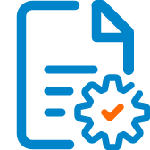

Solution Design

Document

Table of Contents

I. Purpose 3

II. Automated process details 4

3 Runtime guide 5

3.1 Architectural structure of the Master Project 5

3.2 Master Project Runtime Details 5

3.3 Project name 1 6

3.4 Project(s) workflows 6

3.5 Packages 7

3.6 Architectural structure of the Master Project 7

4 Other Details 8

Future Improvements 8

Other Remarks 8

5 Glossary 9

# Purpose



Outlines the major components of the Master Project (the overall output of the development, containing one or multiple projects that together cover the scope of the robotic process automation) taking into account all the business restrictions (scheduling, peaks, future increases in volume etc.). The focus of the Solution Architect will be on:

* Robustness;
* Scalability;
* Efficiency;
* Replicability;
* Reusability of component

The information herein is targeted primarily at the developers that will initially implement the solution and subsequently at the support developers in case of change requests.

# Automated process details

|  |  |
| --- | --- |
| Item | Description |
| Master Project Name | Computer Vision for Remote Connection |
| Robot Type | bot |
| Orchestrator used? | Yes |
| Scalable | No |
| UiPath version used | 2020.10.2 |

# Runtime guide

## Architectural structure of the Master Project

**Description:**

**Creating the assets in orchestrator using them in config file.**

The **Get App Credentials work flow** used in Studio request information from Orchestrator about a asset, according to a provided **AssetName**. If the **AssetName** provided in Studio coincides with the name of an asset stored in the Orchestrator database, and the Robot has the required permissions, the asset information is retrieved and used by the Robot when executing the automation project.

***To*** enable execution of job on the remote server using the UIPath Bot.

The **objective** of this project is to **automate**

* Sending Authentication Request from the Local Machine to the Remote Machine for Server Connectivity.
* Authentication Request Approved.
* Opening an application in remote system and get data from website or some a
* Calculator – calculate and show result in the Local system
* Notepad - read text and display on local system
* Close the connection with the Remote Machine
* *Sends the file over email to a recipient list*

Windows10,VNC-Viwer- 6.20.529 Windows, VNC-Server-6.7.2

## Master Project Runtime Details

|  |  |
| --- | --- |
| ITEM NAME | DESCRIPTION  *Fill in each bolded section - empty fields are not allowed. If the section does not apply to your automation then mark as n/a.* |
| Production environment details | *Running Virtual Remote Machine using VNC Client and VNC Server , Scrapping the Application running on the Remote Machine selected by the end user(WEB\Desktop app\Notepad).* |
| Prerequisites to run | ***Connections:***  ***1.Login in to VNC Client.***  ***2. VNC Client To VNC Server.***  ***3.Orchestrator Connection for Assets.*** |
| Input Data | ***Selection given for user (WEB\Calculator\Notepad) for scrapping in config file.*** |
| Expected output | ***Scrapped Data storing into Local Machine’s Notepad.*** |
| How to start the automated process | ***By Running the process*** |
| Reporting | *Notepad containing the scrapped data in it.* |
| (queues reporting, Kibana or another platform) | ***n/a.*** |
| How is Orchestrator used? | ***Assets Credentials are stored in the Orchestrator.*** |
| Password policies |  |
| (mention any specific compliance requests) | ***API Key from the Orchestrator. And all Assets credentials handled in the orchestrator. Using the Credentials from the config file.*** |
| Stored credentials | *Orchestrator used for asset passwords.* |
| (Never use hardcore credentials in the workflow!) | ***No.*** |
| List of queues names | ***n/a.*** |
| (Naming convention: ProcessName_QueueName) | *n/a.* |
| Schedule Details | ***n/a.*** |
| Multiple Resolutions Supported?  (in case of image automation / Citrix and VDI) | *Yes,.* |
| Recommended Resolution | *Google Cloud Vision OCR /Citrix(License Needed).* |

## Project name 1

|  |  |
| --- | --- |
| ITEM NAME | DESCRIPTION  *Fill in each section - empty fields are not allowed. If the section does not apply to your automation then mark as n/a.* |
| Environment used for development  (name, location, configuration details etc) | *VNC Viewer (VNC_Client and VNC Server)*  *Computer Vision Package*  *Orchestrator (Asset)*  *API Key*  *UIPATH 2020.10.2 Reframe work.* |
| Environment prerequisites  (OS details, libraries, required apps) | *Windows 10, VNC Viewer (VNC_Client and VNC Server), WEB\Desktop Applications and Notepad Reframe work..* |
| Repository for project  (where is the developed project stored) | ***GoogleDrive:***https://drive.google.com/drive/folders  /1Yyg6UFKl3rdWJQAjOBG5nChmTRmeetUW?usp=sharing.  ***GitHub:*** <https://github.com/shailajasunil>  /ComputerVisionUsingUIPath.git |
| Configuration method  (assets, excel file, Json file) | *Getting Asset Credentials from orchestrator into Config file.* |
| List of reused components | ***Computer Vision Package/ VNC Authentication workflow.***  **1.Web Application Workflow for Web Scrapping.**  **2.DeskTop Application Workflow for calculator Application Scrapping.**  **3.NotePad Scrapping Workflow.**  **All the above workflows integrated with main workflow.** |
|
| List of new reusable components | *VNC Viewer (VNC_Client and VNC Server)*  *Computer Vision Package*  *Config File*  *Orchestrator (Asset)*  *Reframe work.*  *API Key* |

## Project(s) workflows

|  |  |
| --- | --- |
| Workflow Name | Description |
| Main | *invokes all the other workflows.*  **1.Web Application Workflow for Web Scrapping.**  **2.DeskTop Application Workflow for calculator Application Scrapping.**  **3.NotePad Scrapping Workflow.**  **All the above workflows integrated with main workflow.**  **Main: CV_MultiActivity.xaml**  **Sub_Workflow1: CV_NotePad.xaml**  **Sub_Workflow1: CV_Calculator.xaml**  **Sub_Workflow1: CV_WebScraping.xaml** |

## Packages

|  |  |
| --- | --- |
| Package Name | Description |
| Computer Vision for Remote Connection | ***To*** enable execution of job on the remote server using the UiPath Bot.  The **objective** of this project is to **automate**   * Sending Authentication Request from the Local Machine to the Remote Machine for Server Connectivity. * Authentication Request Approved. * Opening an application in remote system and get data from website or some a * Calculator – calculate and show result in the Local system * Notepad - read text and display on local system * Close the connection with the Remote Machine * *Sends the file over email to a recipient list*   Windows10, VNC-Viewer- 6.20.529 Windows, VNC-Server-6.7.2 |
| Speech Package | ***Adding audio for process flow.*** |

## Architectural structure of the Master Project

## 

# Other Details

### Future Improvements

### *Example:*

*• Optimize the processing algorithm by adding PDF Automation*

*• Implement process error recovery (retry)*

*• Enable support for multiple Application Automation.*

### Other Remarks

The Cloud account is a [community](https://communityevents.uipath.com/) account and seems to have a limit to 240 Megapixels/Min. For a company with a lot of [robot](https://docs.uipath.com/robot/docs/introduction), if the same developer are developing all the bot it means same key will be used on all [robot](https://docs.uipath.com/robot/docs/introduction) and soon enough the threshold will be reached.

# Glossary

**Master project** – Containing:

Authentication workflow and 3 other work flows.This Project is connecting all the work flows based on the user selection..

***To*** enable execution of job on the remote server using the UIPath Bot.

The **objective** of this project is to **automate**

* Sending Authentication Request from the Local Machine to the Remote Machine for Server Connectivity.
* Authentication Request Approved.
* Opening an application in remote system and get data from website or some a
* Calculator – calculate and show result in the Local system
* Notepad - read text and display on local system
* Close the connection with the Remote Machine

**Packages** – UIPath.ComputerVision.LocalServer.

Uipath.System.Activities.

Uipath.Excel.Activities.

Uipath.PDF.Activities.

Uipath.UIAutomation.Activities.

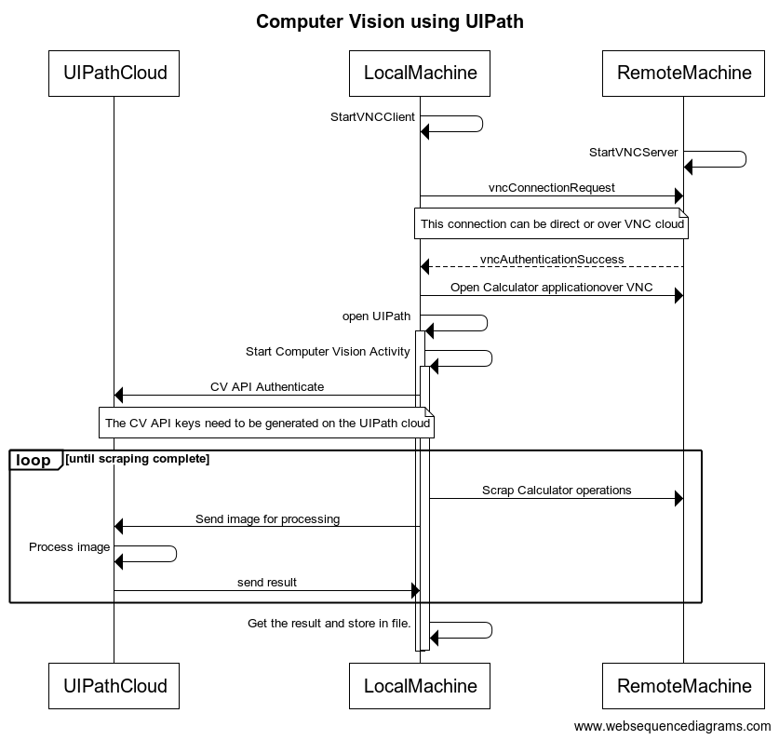

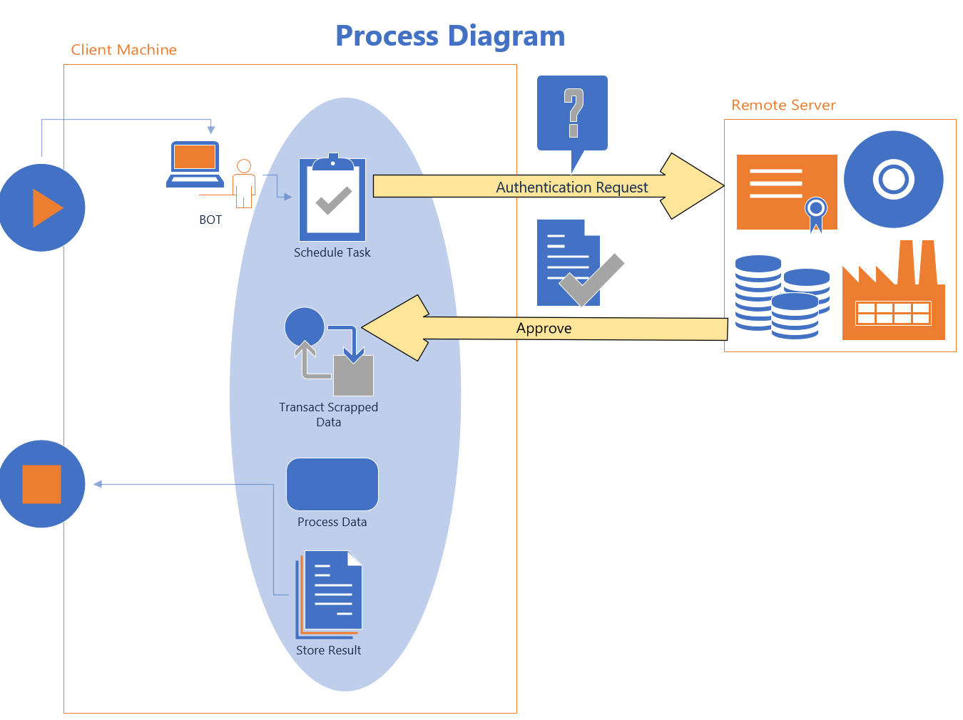

Workflow – WorkFlow1:Main:CV_MultiActivity.xaml

WorkFlow2: CV_CalculatorApp.xaml

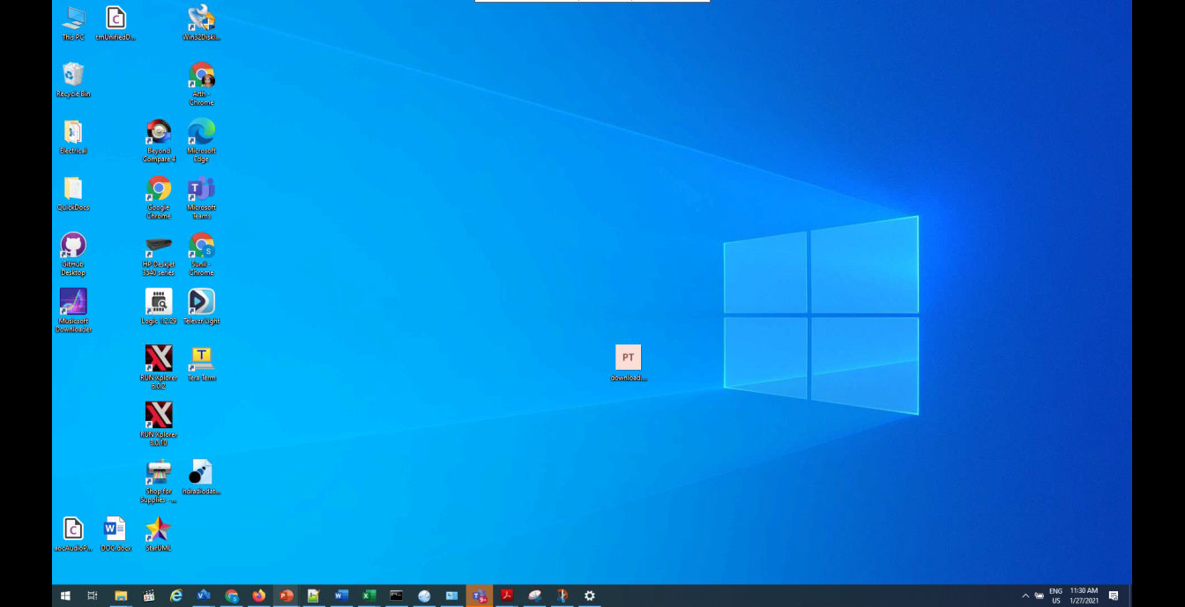

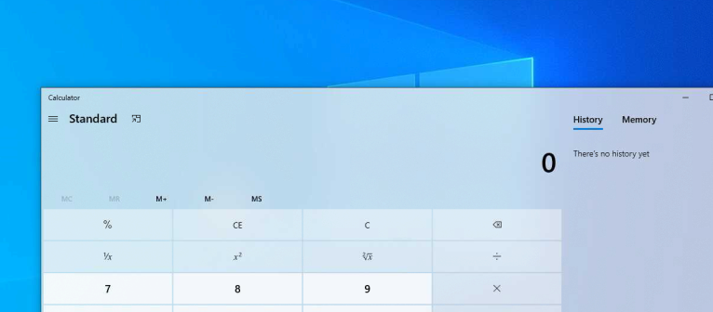

WorkFlow3: CV_WebScraping.xaml

Work Flow 4:CV_NotePad.xaml

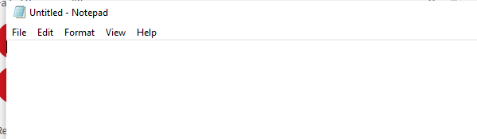

.

To enable execution of job on the remote server using the ui path bot

The **objective** of this project is to **automate**

* Sending Authentication Request from the Local Machine to the Remote Machine for Server Connectivity.
* Authentication Request Approved.
* Opening an application in remote system and get data from website or some a
* Calculator – calculate and show result in the Local system
* Notepad - read text and display on local system
* Close the connection with the Remote Machine