**Task 1 - Practical & Practice tasks / Home tasks**

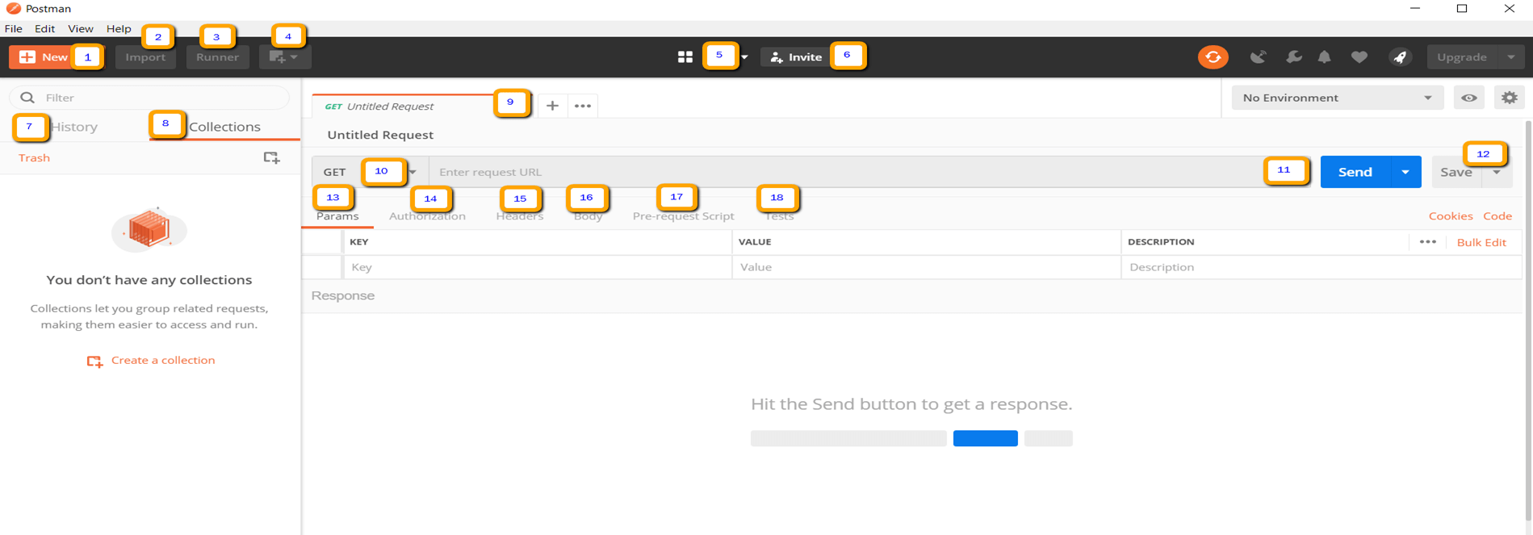

1. New – This is where you will create a new request, collection or environment.
2. Import – This is used to import a collection or environment.
3. Runner – Automation tests can be executed through the Collection Runner.
4. Open New – Open a new tab, Postman Window or Runner Window by clicking this button.
5. My Workspace – You can create a new workspace individually or as a team.
6. Invite – Collaborate on a workspace by inviting team members.
7. History – Past requests that you have sent will be displayed in History. This makes it easy to track actions that you have done.
8. Collections – Organize your test suite by creating collections. Each collection may have subfolders and multiple requests.
9. Request tab – This displays the title of the request you are working on. By default, “Untitled Request” would be displayed for requests without titles.
10. HTTP Request – Clicking this would display a dropdown list of different requests such as GET, POST, COPY, DELETE, etc. In Postman API testing, the most commonly used requests are GET and POST.
11. Request URL – Also known as an endpoint, this is where you will identify the link to where the API will communicate with.
12. Save – If there are changes to a request, clicking save is a must so that new changes will not be lost or overwritten.
13. Params – This is where you will write parameters needed for a request such as key values.
14. Authorization – In order to access APIs, proper authorization is needed. It may be in the form of a username and password, bearer token, etc.
15. Headers – You can set headers such as content type JSON depending on the needs of the organization.
16. Body – This is where one can customize details in a request commonly used in POST request.
17. Pre-request Script – These are scripts that will be executed before the request. Usually, pre-request scripts for the setting environment are used to ensure that tests will be run in the correct environment.
18. Tests – These are scripts executed during the request. It is important to have tests as it sets up checkpoints to verify if response status is ok, retrieved data is as expected and other tests.

**Working with GET Requests**

Get requests are used to retrieve information from the given URL. There will be no changes done to the endpoint.

We will use the following URL for all examples in this Postman tutorial.

<https://jsonplaceholder.typicode.com/users>

In the workspace

1. Set your HTTP request to GET.
2. In the request URL field, input link
3. Click Send
4. You will see 200 OK Message
5. There should be 10 user results in the body which indicates that your test has run successfully.

**Screenshot**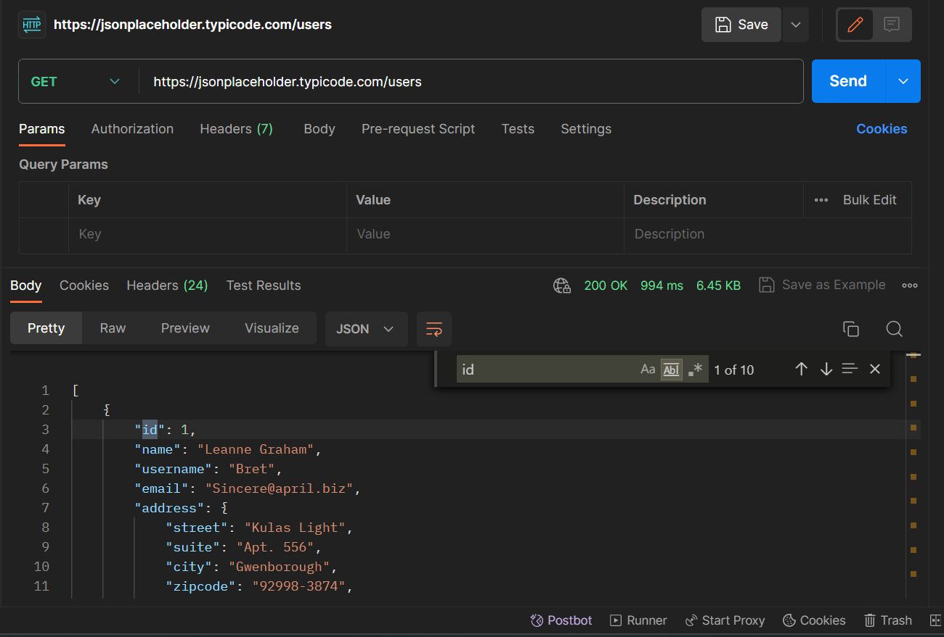

**Working with POST Requests**

Post requests are used to create a new record. There is data manipulation with the user adding data to the endpoint.

**Step 1)** Click a new tab to create a new request. **Step 2)** In the new tab

1. Set your HTTP request to POST.
2. Input the same link in request url: <https://jsonplaceholder.typicode.com/users>
3. switch to the Body tab

**Step 3)** In Body,

1. Click raw.
2. Select JSON

**Step 4)** Copy and paste just one user result from the previous get request like below. Ensure that the code has been copied correctly with paired curly braces and brackets. Change id to 11 and name to any desired name. You can also change other details like the address.

**Step 5)** Next,

1. Click Send.
2. Status: 201 Created should be displayed
3. Posted data are showing up in the body.

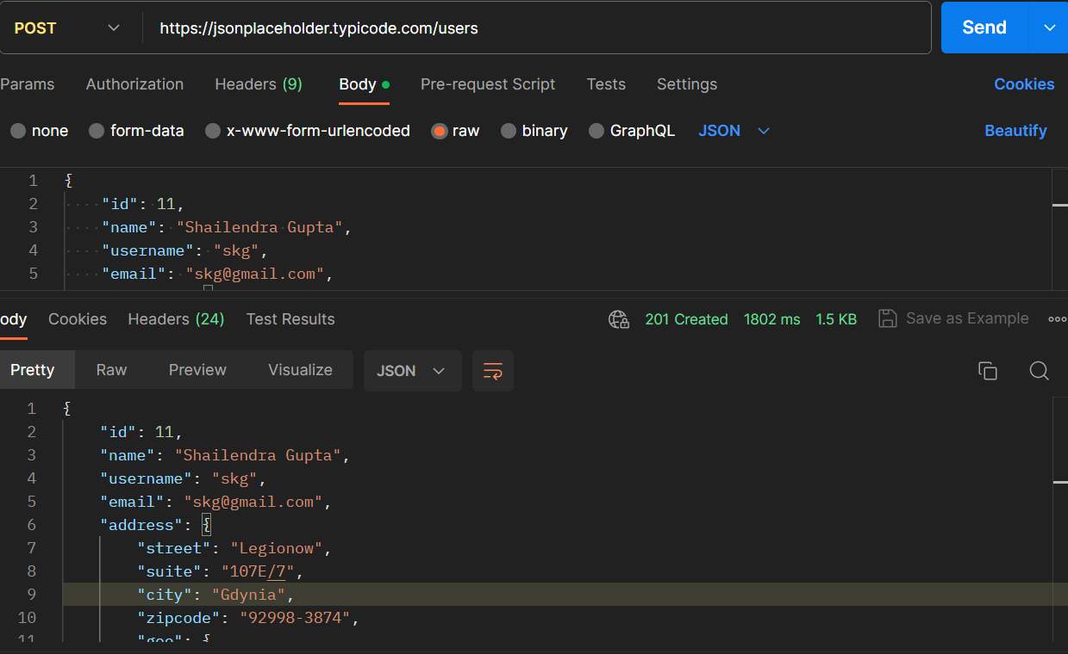

**How to Parameterize Requests**

Task:

1. Set your HTTP request to GET
2. Input this link: <https://jsonplaceholder.typicode.com/users>. Replace the first part of the link with a parameter such as {{url}}. Request url should now be {{url}}/users.
3. Click send.

There should be no response since we have not set the source of our parameter. 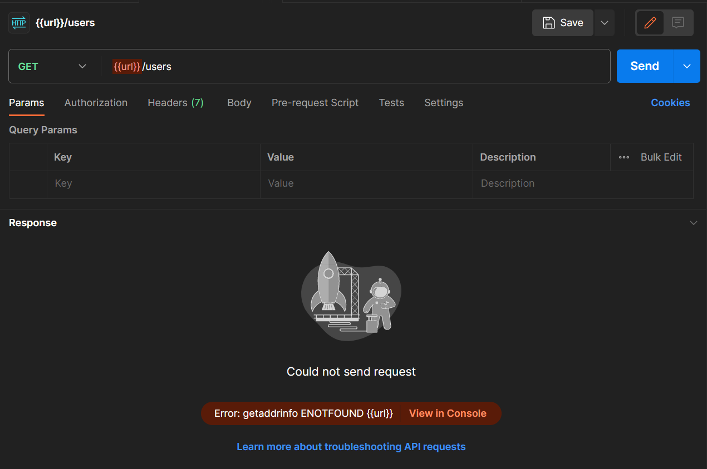

**Step 2)**To use the parameter you need to set the environment

1. Click the eye icon.
2. Click edit to set the variable to a global environment which can be used in all collections.

**Step 3)** In variable,

1. set the name to the url which is https://jsonplaceholder.typicode.com 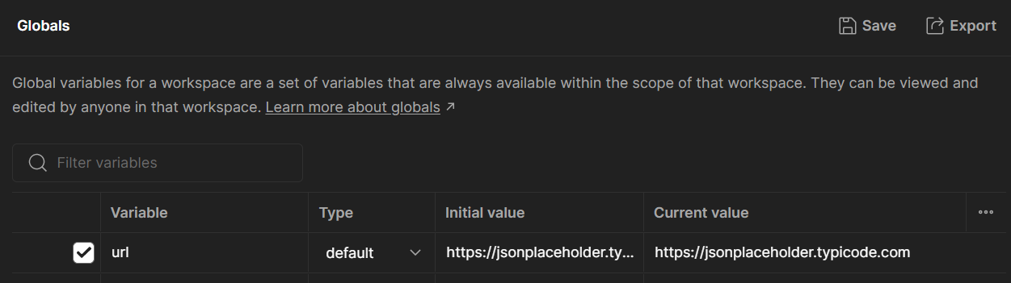
2. click Save.

**Step 4)**Click close if you see the next screen.

**Step 5)**Go back to your Get request then click send. There should now be results for your request. 