Appendix: Documentation of Program

Window Layout
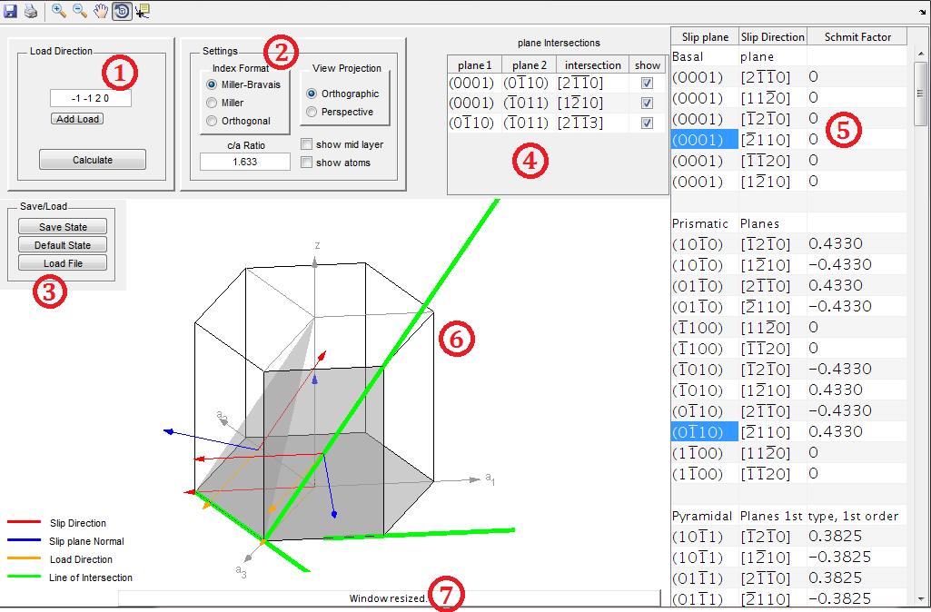
Figure A. Windows Layout
1 load
2 settings
3 save and load
4 plane intersections table
5 system table
6 visualization figure
7 tip text

1, the box at left top allows the user to edit load information. One can edit the load direction using keyboard. Remember to insert a space character, or a comma, between each number entered. Click the ‘Add Load’ button to insert a new load direction, or the ‘x’ button to remove a particular load. One can add up to four load directions. Note that any update to the load directions does not take effect, until the ‘Calculate’ button is pressed. If an input of invalid format is entered, the program produces an error dialog box while the load direction is returned to its last valid value.
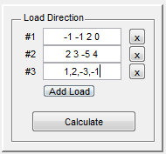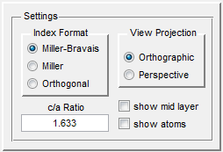
Figure B. The Load Direction box Figure C. The Setting box

2, the box titled ‘setting’ encloses five setting functionalities.
- Index Format options
Choose one of the three options to set the indexing system for planes and directions. The Miller-Bravais and Miller systems affect both the input (to enter load direction) and output of indices. The Orthogonal system works only for the output, with the inputting system staying at the last chosen system. The details of the indexing systems and their inter-conversions are described in section 2.2 of the report.

- View Projection options
“Orthographic projects the viewing volume as a rectangular parallelepiped (i.e., a box whose opposite sides are parallel). Relative distance from the camera does not affect the size of objects. This projection type is useful when it is important to maintain the actual size of objects and the angles between objects.
Perspective projects the viewing volume as the frustum of a pyramid (a pyramid whose apex has been cut off parallel to the base). Distance causes foreshortening; objects further from the camera appear smaller. This projection type is useful when you want to display realistic views of real objects.” (Quoted directly from Matlab 2013b documentation center, at http://www.mathworks.com/help/matlab/visualize/understanding-view-projections.html)
- c/a Ratio setting
Sets the c/a ratio, which is the ratio of the height of the unit cell to the side of the hexagons. Any invalid entry (such as a negative number) will generate an error dialog box while the value of c/a ratio is kept as the last valid entry. Note that any update to the c/a ratio does not take effect, until the ‘Calculate’ button is pressed.

- show/hide mid layer
Right in between the two basal planes (layer A), there are three atoms (layer B). One can choose to show or hide the triangular structure formed by the three atoms.

- Show/hide atoms
By default, the atoms are not shown to enhance better visualization of planes and lines. You can check this box to show the atoms. Layer A and B atoms are colored differently.
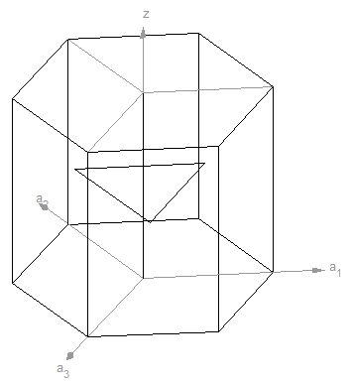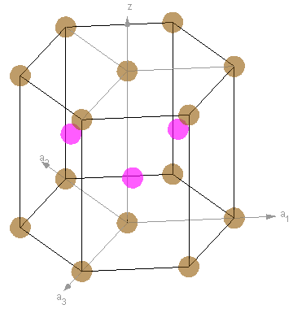
Figure D. Show mid layer Figure E. Show atoms

3, Load and Save
These functions operates with *.fig files, which are able to keep all information of the state of the program. Dialog boxes are generated to navigate the user through the process. Note that the ‘Default State’ option is equivalent to load the file ‘default.fig’.

4, System table
This table is at right side of the window and hosts all possible deformation systems. Each system is represented by a plane and a direction within one row. Use the scroll to access the rows below. The systems are grouped in different types. Click on a cell representing a plane or a system to select it. Once selected, the system will be drawn in the figure. Press and hold Ctrl and click on a plane or a direction to multi-select systems. All selected systems, and the intersections between planes will be drawn; plus the plane intersection table will appear (refer to the next section). The figure is refreshed each time the selection of systems has changed.

5, Plane intersection table
This table appears only when more than one system is selected. It shows all pairing combinations of planes selected in the first two columns. The third column is the calculated intersecting direction of the two planes. If the two planes happen to be parallel, ‘parallel’ is shown in this column. The last column gives the option to show/hide the intersecting lines in the figure.
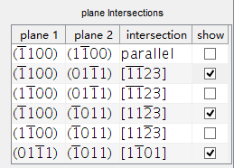
Figure F. The plane intersections table

6, visualization figure
This is where the unit cell is shown and slip/twin systems selected are plotted. The user can zoom in or out using the toolbars at the left top of the window. The hexagonal structure can also be rotated for best visualizing effect.

7, tip text
This text box provides useful information on current status of the program. Place the mouse on a button or another particular place for some time, help text specifically for the particular button will also appear.

