**Part A:**

**Question 1:**

The time complexity is O(n)

**Question 2:**

The time complexity is O(1)

**Question 3:**

The time complexity is O(n)

**Question 4:**

The time complexity is O(n^2)

**Question 5:**

The time complexity is O(n)

**Question 6:**

The left image is the input and the right image is the output

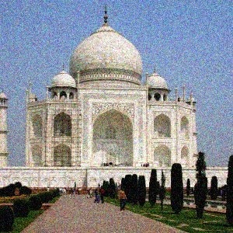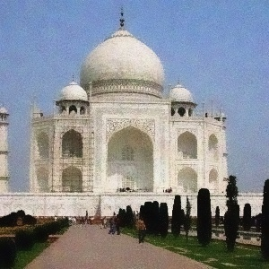

**Question 7:**

The time complexity is O(1)

**Question 8:**

The time complexity is O(1)

**Part B:**

**[a] Star occupancy**

**1)**

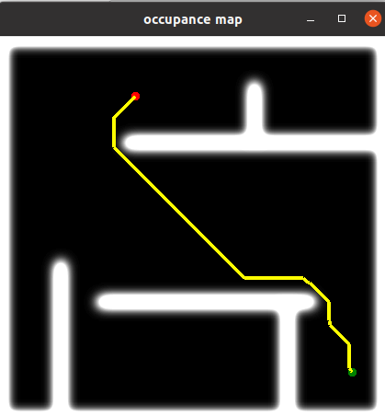

**2)**

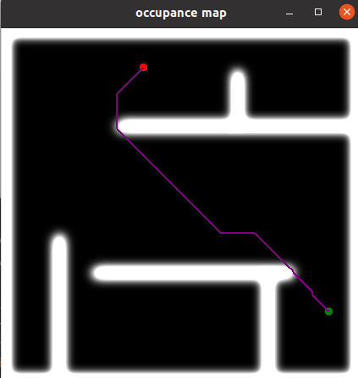

**[b] Quadtree**

**3)**

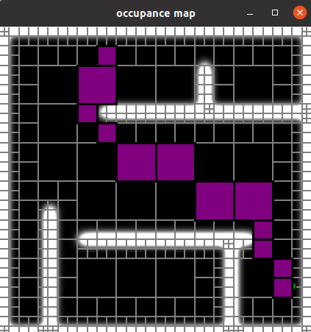

**4)**

