**Input Format (Q1-Q6)**

The **CITY** table is described as follows:

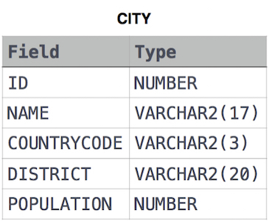

**1. The Count Function**

Query a *count* of the number of cities in **CITY** having a *Population* larger than 100000.

**2. The Sum Function**

Query the total population of all cities in CITY where District is California.

**3.Averages**

Query the average population of all cities in CITY where District is California.

**4. Average Populations**

Query the average population for all cities in CITY, rounded down to the nearest integer.

**5. Japan Population**

Query the sum of the populations for all Japanese cities in CITY. The COUNTRYCODE for Japan is JPN.

**6. Population Density Difference**

Query the difference between the maximum and minimum populations in CITY.

**7. The Blunder**

Samantha was tasked with calculating the average monthly salaries for all employees in the **EMPLOYEES** table but did not realize her keyboard's 0 key was broken until after completing the calculation. She wants your help finding the difference between her miscalculation (using salaries with any zeroes removed), and the actual average salary.

Write a query calculating the amount of error (i.e.: actual – miscalculated average monthly salaries), and round it up to the next integer.

**Input Format**

The **EMPLOYEES** table is described as follows:

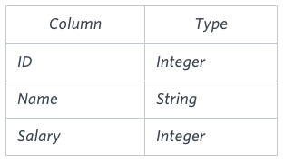

**Note:** *Salary* is measured in dollars per month and its value is 10^5.

**8. Top Earners**

We define an employee's *total earnings* to be their monthly salary * months worked, and the *maximum total earnings* to be the maximum total earnings for any employee in the **Employee** table. Write a query to find the *maximum total earnings* for all employees as well as the total number of employees who have maximum total earnings. Then print these values as 2 space-separated integers.

**Input Format**

The **Employee** table containing employee data for a company is described as follows:

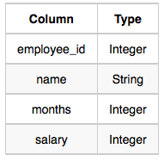

where *employee_id* is an employee's ID number, *name* is their name, *months* is the total number of months they've been working for the company, and *salary* is their monthly salary.

**Input Format(Q9-Q17)**

The **STATION** table is described as follows:

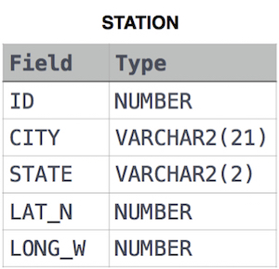

where *LAT_N* is the northern latitude and *LONG_W* is the western longitude.

**9. Weather Observation Station 2**

Query the following two values from the STATION table:

The sum of all values in LAT_N rounded to a scale of 2 decimal places.

The sum of all values in LONG_W rounded to a scale of 2 decimal places

**10. Weather Observation Station 13**

Query the sum of *Northern Latitudes* (*LAT_N*) from **STATION** having values greater than 38.7880 and less than 137.2345. Truncate your answer to 4 decimal places.

**11. Weather Observation Station 14**

Query the greatest value of the *Northern Latitudes* (*LAT_N*) from **STATION** that is less than 137.2345. Truncate your answer to 4 decimal places.

**12. Weather Observation Station 15**

Query the Western Longitude (LONG_W) for the largest Northern Latitude (LAT_N) in STATION that is less than 137.2345. Round your answer to 4 decimal places.

**13. Weather Observation Station 16**

Query the smallest Northern Latitude (LAT_N) from STATION that is greater than 38.7780. Round your answer to 4 decimal places.

**14. Weather Observation Station 17**

Query the Western Longitude (LONG_W) where the smallest Northern Latitude (LAT_N) in STATION is greater than 38.7780. Round your answer to 4 decimal places.

**15. Weather Observation Station 18**

Consider P1(a,b) and P2(c,d) to be two points on a *2D* plane.

* a happens to equal the minimum value in *Northern Latitude* (*LAT_N* in **STATION**).
* b happens to equal the minimum value in *Western Longitude* (*LONG_W* in **STATION**).
* c happens to equal the maximum value in *Northern Latitude* (*LAT_N* in **STATION**).
* d happens to equal the maximum value in *Western Longitude* (*LONG_W* in **STATION**).

Query the [Manhattan Distance](https://xlinux.nist.gov/dads/HTML/manhattanDistance.html) between points P1 and P2 and round it to a scale of 4 decimal places.

**16. Weather Observation Station 19**

Consider P1(a,b) and P2(c,d) to be two points on a 2D plane where (a,b) are the respective minimum and maximum values of Northern Latitude (LAT_N) and (c,d) are the respective minimum and maximum values of Western Longitude (LONG_W) in STATION.

Query the Euclidean Distance between points P1 and P2 and format your answer to display 4 decimal digits.

**17. Weather Observation Station 20**

A median is defined as a number separating the higher half of a data set from the lower half. Query the median of the Northern Latitudes (LAT_N) from STATION and round your answer to 4 decimal places.