## Question 1 to 6 has the below format:

**The CITY table is described as follows:**

## CITY.jpg

## 1. Revising the Select Query I

Query all columns for all American cities in **CITY** with populations larger than 100000. The CountryCode for America is USA.

## 2. Revising the Select Query II

Query the names of all American cities in **CITY** with populations larger than 120000. The CountryCode for America is USA.

## 3. Select All

Query all columns (attributes) for every row in the **CITY** table.

**4. Select By ID**

Query all columns for a city in **CITY** with the ID 1661.

## 5.Japanese Cities' Attributes

Query all attributes of every Japanese city in the **CITY** table. The *COUNTRYCODE* for Japan is JPN.

## 6. Japanese Cities' Names

Query the names of all the Japanese cities in the **CITY** table. The *COUNTRYCODE* for Japan is JPN.

## Question 7 to 17 has the below format:

**Input Format**

The **STATION** table is described as follows:

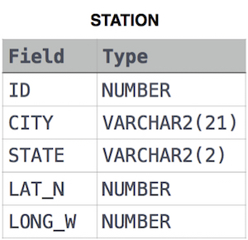

**7. Weather Observation Station 1**

Query a list of CITY and STATE from the STATION table

**8. Weather Observation Station 3**

Query a list of CITY names from STATION with even ID numbers only. You may print the results in any order but must exclude duplicates from your answer.

**9. Weather Observation Station 4**

Let N be the number of CITY entries in STATION and let N’ be the number of distinct CITY names in STATION; query the value of N-N’ from STATION. In other words, find the difference between the total number of CITY entries in the table and the number of distinct CITY entries in the table.

**10. Weather Observation Station 5**

Query the two cities in STATION with the shortest and longest CITY names, as well as their respective lengths (i.e.: number of characters in the name). If there is more than one smallest or largest city, choose the one that comes first when ordered alphabetically.

**11. Weather Observation Station 6**

Query the list of CITY names starting with vowels (i.e., a, e, i, o, or u) from STATION. Your result cannot contain duplicates**.**

**12. Weather Observation Station 7**

Query the list of CITY names ending with vowels (a, e, i, o, u) from STATION. Your result cannot contain duplicates.

**13. Weather Observation Station 8**

Query the list of CITY names from STATION which have vowels (i.e., a, e, i, o, and u) as both their first and last characters. Your result cannot contain duplicates.

**14. Weather Observation Station 9**

**Query the list of CITY names from STATION that do not start with vowels. Your result cannot contain duplicates.**

**15. Weather Observation Station 10**

Query the list of CITY names from STATION that do not end with vowels. Your result cannot contain duplicates.

**16. Weather Observation Station 11**

Query the list of CITY names from STATION that either do not start with vowels or do not end with vowels. Your result cannot contain duplicates.

**17. Weather Observation Station 12**

Query the list of CITY names from STATION that do not start with vowels and do not end with vowels. Your result cannot contain duplicates.

**18. Higher Than 75 Marks**

**Input Format**

The **STUDENTS** table is described as follows:

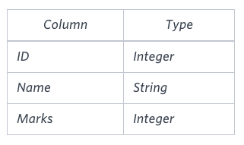

Query the Name of any student in STUDENTS who scored higher than 75 Marks. Order your output by the last three characters of each name. If two or more students both have names ending in the same last three characters (i.e.: Bobby, Robby, etc.), secondary sort them by ascending ID.

## Question 19 and 20 has the below format:

**Input Format**

The **Employee** table containing employee data for a company is described as follows:

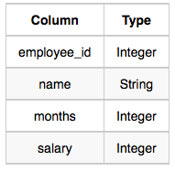

**19. Employee Names**

Write a query that prints a list of employee names (i.e.: the name attribute) from the Employee table in alphabetical order.

**20. Employee Salaries**

Write a query that prints a list of employee names (i.e.: the *name* attribute) for employees in Employee having a salary greater than $2000 per month who have been employees for less than 10 months. Sort your result by ascending *employee_id*.