**Input Format for Q1 to Q3**

The **CITY** and **COUNTRY** tables are described as follows:

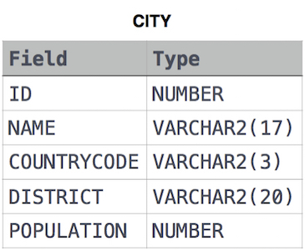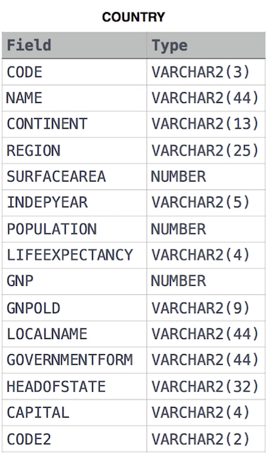

1.

Given the CITY and COUNTRY tables, query the sum of the populations of all cities where the CONTINENT is 'Asia'.

2.

Given the CITY and COUNTRY tables, query the names of all cities where the CONTINENT is 'Africa'.

3.

Given the CITY and COUNTRY tables, query the names of all the continents (COUNTRY.Continent) and their respective average city populations (CITY.Population) rounded down to the nearest integer.

4.

You are given two tables: *Students* and *Grades*. *Students* contains three columns *ID*, *Name* and *Marks*.

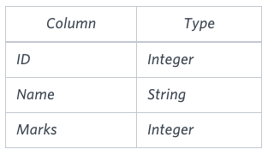

*Grades* contains the following data:

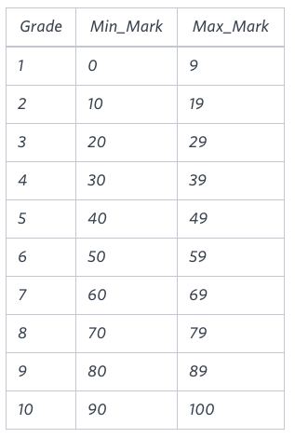

*Ketty* gives *Eve* a task to generate a report containing three columns: *Name*, *Grade* and *Mark*. *Ketty* doesn't want the NAMES of those students who received a grade lower than *8*. The report must be in descending order by grade -- i.e. higher grades are entered first. If there is more than one student with the same grade (8-10) assigned to them, order those particular students by their name alphabetically. Finally, if the grade is lower than 8, use "NULL" as their name and list them by their grades in descending order. If there is more than one student with the same grade (1-7) assigned to them, order those particular students by their marks in ascending order.

Write a query to help Eve.

5.

Julia just finished conducting a coding contest, and she needs your help assembling the leaderboard! Write a query to print the respective *hacker_id* and *name* of hackers who achieved full scores for *more than one* challenge. Order your output in descending order by the total number of challenges in which the hacker earned a full score. If more than one hacker received full scores in same number of challenges, then sort them by ascending *hacker_id*.

**Input Format**

The following tables contain contest data:

* *Hackers:* The *hacker_id* is the id of the hacker, and *name* is the name of the hacker. 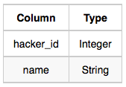
* *Difficulty:* The *difficult_level* is the level of difficulty of the challenge, and *score* is the score of the challenge for the difficulty level. 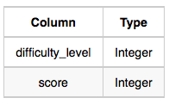
* *Challenges:* The *challenge_id* is the id of the challenge, the *hacker_id* is the id of the hacker who created the challenge, and *difficulty_level* is the level of difficulty of the challenge. 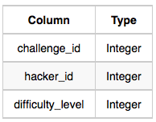
* *Submissions:* The *submission_id* is the id of the submission, *hacker_id* is the id of the hacker who made the submission, *challenge_id* is the id of the challenge that the submission belongs to, and *score* is the score of the submission. 