NLP Pre-processing :-
- converting the text into lowercase or uppercase
- Removing noise(punctuation,common words,html tags)
- tokenization
- stop words removal
- stemming and lemmatization
- text enrichment/augmentation

Must Do:

Noise removal

Lowercasing (can be task dependent in some cases)

Should Do:

Simple normalization – (e.g. standardize near identical words)

Task Dependent:

Advanced normalization (e.g. addressing out-of-vocabulary words)

Stop-word removal

Stemming / lemmatization

Text enrichment / augmentation

Vectorization:-
link :- https://neptune.ai/blog/vectorization-techniques-in-nlp-guide

Bag of Words:

Tokenization

Vocabulary creation

Vector creation

e.g.
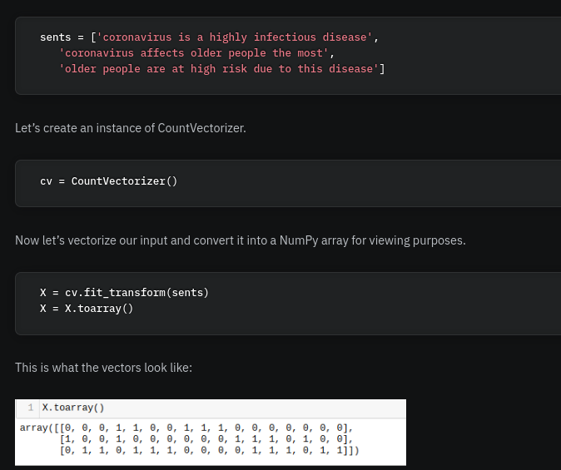

In Bag of Words, we witnessed how vectorization was just concerned with the frequency of vocabulary words in a given document. As a result, articles, prepositions, and conjunctions which don’t contribute a lot to the meaning get as much importance as, say, adjectives.
TF-IDF helps us to overcome this issue. Words that get repeated too often don’t overpower less frequent but important words.

TF-IDF : Term frequency inverse document frequency
    - TF
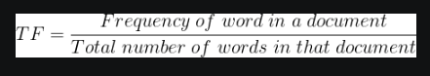

IDF
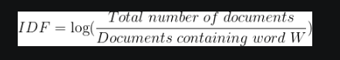

TF-IDF

e.g.
