

No. 1, Kennedy Road, Near RTO Office Sangam wadi, Shivajinagar, Pune - 411001



### SAVITRIBAI PHULE PUNE UNIVERSITY

**A PRELIMINARY PROJECT REPORT ON**

# “Improving Water Resource Management For Agriculture: A Data Driven Approach to Rainfall Forecasting and Irrigation Planning”

SUBMITTED TO THE SAVITRIBAI PHULE PUNE UNIVERSITY, PUNE IN THE PARTIAL FULFILLMENT OF THE REQUIREMENTS FOR THE AWARD OF THE DEGREE

OF

# BACHELOR OF ENGINEERING (COMPUTER ENGINEERING)

BY

### PARTH KADAV 72142681G

### ILIHAS PATEL 72142500D

### ATHARV KULKARNI 72142351F

**SHAILESH JADHAV 72142510M**

*Under the guidance of*

### Prof. M. M. PHADATARE

**1**



# CERTIFICATE

This is to certify that the project report entitled

**“Improving Water Resource Management For Agriculture: A Data Driven Approach to Rainfall Forecasting and Irrigation Planning”**

Submitted by

### PARTH KADAV 72142681G

**ILIHAS PATEL 72142500D**

### ATHARV KULKARNI 72142351F

**SHAILESH JADHAV 72142510M**

is a bonafide work carried out by them under the supervision of Prof. M.M.PHADATARE and it is approved for the partial fulfillment of the requirement of Savitribai Phule Pune University Pune for the award of the degree of Bachelor of Engineering (Computer Engineering). This project work has not been earlier submitted to any other Institute or University for the award of any degree or diploma.

**Prof. M. M. PHADATARE** **Dr. S. V. Athawale Prof. M. M. PHADATARE**

**Prof. D. P. GAIKWAD**

Project Guide H.O.D Computer Engineering Project Coordinator

**Dr. D S Bormane**

Internal Examiner External Examiner Principal,

AISSMSCOE, Pune

2

Date

Place: Pune

PROJECT APPROVAL SHEET A

### Project

on

**“Improving Water Resource Management For Agriculture: A Data Driven Approach to Rainfall Forecasting and Irrigation Planning”**

Is successfully completed by

### PARTH KADAV 72142681G

**ILIHAS PATEL 72142500D**

### ATHARV KULKARNI 72142351F

**SHAILESH JADHAV 72142510M**

at

### Department of Computer Engineering AISSMS College of Engineering, Pune Savitribai Phule Pune University

**2022-2023**

### Prof. M. M. PHADATARE Dr. S V Athawale

Project Guide HOD

Department of Computer Engineering

3

# ACKNOWLEDGEMENT

We would like to extend my sincere gratitude and thanks to my guide Prof. M. M. Phadatare for her invaluable guidance and for giving us useful inputs and encouragement time and again, which inspired us to work harder. Due to her forethought, appreciation of the work involved and continuous imparting of useful tips, this report has been successfully completed.

We are extremely grateful to Dr. S. V. Athawale, Head of the Department of Computer Engineering, for his encouragement during the course of the project work.

We also extend our heartfelt gratitude to the entire staff of the Computer Engineering Department for their cooperation and support.

We are grateful to Dr. D S Bormane, Principal, AISSMS College of Engineering for his encouragement during the course of the project work.

We also take this opportunity to thank all our classmates, friends and all those who have directly or indirectly provided their overwhelming support during our project work and the development of this report.

### PARTH KADAV 72142681G

### ILIHAS PATEL 72142500D

### ATHARV KULKARNI 72142351F

**SHAILESH JADHAV 72142510M**

**4**

# ABSTRACT

Unpredictable rainfall throws a curveball at irrigation planning. Heavy downpours can render irrigation unnecessary, wasting applied water and potentially harming crops. Conversely, droughts or unexpected dry spells can leave crops parched if irrigation isn't adjusted to compensate for the lack of natural rainfall. This uncertainty makes efficient water management a constant challenge for farmers.

This project addresses the critical challenge of water scarcity in agriculture by proposing a data-driven approach to improve water resource management. The project focuses on two key areas: rainfall forecasting and irrigation planning.

By leveraging data analytics, the project aims to:

Enhance the accuracy of rainfall predictions using advanced forecasting models.

Develop data-driven irrigation plans that optimize water use based on forecasted rainfall, crop water needs, and soil moisture conditions.

This integrated approach is expected to achieve significant water savings while maintaining or even improving crop yields. The project will contribute to sustainable agricultural practices and ensure long-term water security for the agricultural sector.

5

# LIST OF FIGURES

|  |  |  |
| --- | --- | --- |
| Sr. No | Title | Page Number |
| 1 | System Architecture | 27 |
| 2 | Data Flow Diagram | 27 |
| 3 | Flowchart | 27 |
| 4 | Use Case Diagram | 24 |
| 5 | Class Diagram | 24 |
| 6 | Activity Diagram | 25 |
| 7 | Sequence Diagram | 25 |
| 8 | State Diagram | 26 |
| 9 | ER Diagram | 26 |
| 10 | Algorithm Graph | 27 |
| 11 | GUI Screen | 41 |
| 12 | Code Editor Screenshot (Frontend) | 42 |
| 13 | Code Editor Screenshot (Backend) | 44 |

**6**

**LIST OF TABLES**

|  |  |  |
| --- | --- | --- |
| No. | Title | Page Number |
|  | Features of Dataset | 12 |
|  | Average Daily Crop Water Needs As Compared To Standard Grass | 35 |
|  | Average Daily Water Need Of Standard Grass | 36 |
|  | Selected Crop water Requirements based on soil , depth and temperature | 13 |
|  | Performance evaluation of the Algorithms | 34 |

7

# CONTENTS

### ACKNOWLEDGEMENT ABSTRACT

**LIST OF FIGURES LIST OF TABLES CHAPTER 1**

INTRODUCTION

**4 5**

6

### 11

### 

* 1. Project Title
  2. Introduction to Project
  3. Machine Learning
  4. Technical Keywords
  5. Domain of Project
  6. Problem Statement
  7. Dataset
  8. Scope
  9. Internal Guide

CHAPTER 2 16

LITERATURE SURVEY

CHAPTER 3 18

* 1. Software Requirement
  2. Hardware Requirement

CHAPTER 4 19

GOALS AND OBJECTIVES

* 1. Goal

8

### CHAPTER 5

### METHODOLOGY 20

* 1. Data Collection
  2. Data Preparation
  3. Model Training
  4. Machine Learning Models
  5. Testing the Model

### CHAPTER 6 24

**UML DIAGRAM**

* 1. Class Diagram
  2. Use Case Diagram
  3. Activity Diagram
  4. Sequence Diagram
  5. State Diagram
  6. ER Diagram

### CHAPTER 7 27

**ALGORITHM & SYSTEM ARCHITECTURE**

* 1. System Architecture
  2. Agriboost Algorithm

7.3 Label Encoder

7.4 Enable iterative imputer

7.5 Minmax Scaler

* 1. Train test split
  2. XGboostRegressor
  3. Fetch Api

7.9 Fast Api

9

### CHAPTER 8 35

**IMPLEMENTATION AND EXECUTION**

* 1. GUI
  2. Input
  3. Output
  4. Risk Management
  5. Project Schedule
  6. Team Organization
     1. Team Structure
     2. Management Reporting and Communication

### CHAPTER 9 41

**RESULTS**

9.1 Screenshots of Output

9.2 Conclusion

9.3 Evaluation Graphs

* 1. Future Scope of the Project
  2. Advantages
  3. Disadvantages
  4. Applications

**CONCLUSION 51**

### REFERENCES 52

**REPORT DOCUMENTATION 53**

**10**

**CHAPTER 1**

# INTRODUCTION

## Project Title

Improving Water Resource Management For Agriculture: A Data Driven Approach to

Rainfall Forecasting and Irrigation Planning

## Introduction

The role of rainfall prediction and water supply management is indispensable. Climate change has made rainfall prediction increasingly important for agriculture. This essay investigates the ways in which controlling water resources and anticipating rains can raise crop production. It highlights how crucial it is to determine the ideal water balance for crops because both too much and too little can be detrimental to them. The authors suggest a method for predicting rainfall for a given location by utilizing information on temperature, humidity, evaporation, wind speed, and rainfall.

This system predicts rainfall and determines when irrigation is necessary using machine learning. The device is able to optimize the amount of water that crops receive for growth by monitoring rainfall data. Both productivity and sustainability in agriculture can be increased with this strategy.

 We have only considered some common crops in this study  as shown in Table 3 . Relevant meteorological data, including temperature, humidity, evaporation, average wind speed, and total rainfall, is collected from sensors of Pune District Maharashtra. This data is stored in a dataset for further analysis[4].

11

Random Forest Regressor,  linear regression, and XGBoost, are employed for rainfall prediction. These models are trained on historical weather data[6]. A new approach analyzes rainfall data, takes geography and crop type into account, and applies machine learning to forecast agricultural water requirements. XGBoost is the most accurate algorithm (predicts rainfall over 90% of the time), enabling customized irrigation suggestions.

When compared to other methods, the XGBoost algorithm proved to be the most accurate (by over 90.414 %) in predicting the amount of rainfall. This is due to XGBoost's ability to manage data with complicated linkages, which is useful for weather forecasting. With the help of these complex patterns, XGBoost builds a more accurate rainfall forecast model. [8]. An approach that forecasts rainfall in Pune District, Maharashtra, India, using XGBoost is discussed. This system's precise rainfall forecasting is intended to assist farmers in managing their water supplies. It is anticipated that the method will raise production and sustainability in agriculture. This high level of accuracy empowers farmers and stakeholders with actionable insights, optimizing irrigation practices and ultimately contributing to enhanced agricultural sustainability and productivity amidst evolving climatic conditions[9,10].

|  |  |  |
| --- | --- | --- |
| **Features** | **Type** | **Scale** |
| Temperature | Numerical | Degree Celsius |
| Maximum Humidity | Numerical | Percentage |
| Minimum Humidity | Numerical | Percentage |
| Evaporation | Numerical | Millimeter/day |
| Average Wind Speed | Numerical | Kilometer per Hour |
| Wind Direction | Numerical | Cardinal Direction |
| Rainfall | Numerical | Millimeters |

Table 1: Features of the Dataset

12

|  |  |  |  |  |  |  |
| --- | --- | --- | --- | --- | --- | --- |
| **Crop** | **Soil Type** | **Water Requirements for Temperature**  **(15-25 °C) in mm/day** | **Water Requirements for Temperature**  **(more than 25 °C) in mm/day** | **Durations(days)** | **Depth (in cm)** | **Depth(feet)** |
| onion | Black | 3 to 4 | 5 to 6 | 70-90 | 10-30 | 0.6 |
| wheat | Clay loam | 6 to 7 | 8 to 9 | 60-150 | 0-20 | 0.3 |
| tomato | red loam soil | 6 to 7 | 8 to 9 | 90-110 | 25-50 | 0.9 |
| maize | sandy loam | 6 to 7 | 8 to 9 | 100-120 | 15-25 | 0.6 |
| Soyabean | Sandy loam | 6 to 7 | 8 to 9 | 90-140 | 15-25 | 0.6 |

Table 2. Selected Crop water Requirements based on soil , depth and temperature

## Machine Learning

Machine learning is a branch of artificial intelligence (AI) and computer science which focuses on the use of data and algorithms to imitate the way that humans learn, gradually improving its accuracy.

Over the last couple of decades, the technological advances in storage and processing power have enabled some innovative products based on machine learning, such as Netflix’s recommendation engine and self-driving cars.

Machine learning is an important component of the growing field of data science. Through the use of statistical methods, algorithms are trained to make classifications or predictions, and to uncover key insights in data mining projects. These insights subsequently drive decision making within applications and businesses, ideally impacting key growth metrics. As big data continues to expand and grow, the market demand for data scientists will increase. They will be required to help identify the most relevant business questions and the data to answer them. Machine learning algorithms are typically created using frameworks that accelerate solution development PyTorch.

13

## Technical Keywords

* + - Water Management
    - Irrigation
    - Smart Agriculture
    - IoT Sensors
    - XGBoost
    - Random Forest
    - Linear Regression
    - Rainfall Prediction

## Domain of the Project

Machine Learning, Web Development and IOT.

14

## Problem Statement:

Design and implement a model for predicting upcoming rainfall using previous observations to calculate the amount of water required to irrigate crops in agriculture.

## Dataset

The project leverages a rich dataset built from historical rainfall recordings meticulously collected by a network of IoT sensors. This data serves as the foundation for our machine learning models. It captures the vital trends and nuances of past precipitation events, providing the crucial insights needed to predict future rainfall patterns. It is formatted as a CSV file and includes various elements for machine learning analysis. These elements encompass not only past rainfall amounts but also temperature factors that influence rainfall patterns. Specifically, the data incorporates wind speed, wind direction, maximum and minimum temperatures, and humidity levels.

## Scope:

This project aims to develop a data-driven system for improved water resource management in agriculture. The scope encompasses building machine learning models to ,forecast rainfall by analyzing historical rainfall data (collected by IoT sensors and stored in CSV format) alongside various weather factors like temperature, wind, and humidity, as well as optimize irrigation plans by using the predicted rainfall, crop water requirements for specific locations and types, and potentially real-time soil moisture data to create data-driven irrigation strategies for maximizing water efficiency and crop yields. Regular maintenance and updates will be required to ensure the system remains effective and compatible with changing requirements.

## Internal Guide:

* + - **Prof. M. M. PHADATARE**

15

# CHAPTER 2 LITERATURE SURVEY

Using a machine learning fusion technique, this research suggests a unique real-time rainfall forecast system for smart cities. Four popular supervised machine learning techniques—decision trees, Naïve Bayes, K-nearest neighbours, and support vector machines—are used in the suggested framework. Fuzzy logic is a technique that is integrated into the framework to integrate the predicted accuracies of machine learning approaches, sometimes referred to as fusion, for effective rainfall prediction. Twelve years of historical weather data for the city of Lahore (from 2005 to 2017) are taken into account for the prediction. The dataset underwent pre-processing operations like cleaning and normalization prior to the classification procedure. 92.48% accuracy was attained. [11].

Floods disturb everyday routines, put lives in peril, and cause economic instability. While statistically predicting river floods is crucial, there are other aspects that contribute to its complexity, including climate, river flow, rainfall, soil, and location. Traditional approaches still have some margin of error, even with the breakthroughs in hydrology [12].

With a case study of the Bijapur district in Karnataka State, India, the paper details the development of a system to offer information on rainfall characteristics and its prediction from historical data sets, as well as the selection of crops based on the forecast on a taluka basis. Rainfall is analyzed on a month-by-month, Nakshatra-by-month, week-by-week, and year-by-year basis. Agro-Meteorologists find great value in the developed method, which was created through the study of rainfall data gathered at the Agricultural Research Station in Bijapur during a 20-year period. The prediction algorithm is performing admirably, with an accuracy rate that ranges from 80% to 90%. [13].

Humidity, temperature, and rainfall are the three main variables that determine the effective rainfall in Paper. Precipitation data is essential for areas and water is an essential natural resource. By establishing links between regional rainfall patterns and local observations, mathematical climate models can significantly enhance rainfall forecasts. [14].

The study assesses the precision and accuracy of rainfall prediction using Logistic Regression (LR) and innovative tree-specific XGBoost (XGB) machine learning methods. An innovative Tree Specific XGBoost classifier is used on a dataset of 145461 records from weather AUS. A system that compares XGBoost and Logistic Regression classifiers for rainfall prediction machine learning algorithms has been developed. Ten people in each group made up the sample size. Clinical analysis was used to determine the sample size, with alpha and beta values of 0.05 and 0.5, 95% confidence, 80%

16

pretest power, and enrollment ratio. For both accuracy and precision, a significant value

(p) of 0.019, or less than 0.05, was found. The classifiers' precision and accuracy were assessed and noted. The accuracy of the Logistic Regression classifier is 79.37%. The same is predicted by the XGboost classifier with an accuracy rate of 94.89%  [15].

Meteorological variable simulation using GCM is generally far superior to rainfall estimate, and meteorological variable observation data are few, if not nonexistent, in many places. By taking advantage of GCM's ability to simulate meteorological variables, the suggested strategy helps demonstrate how well the technique may improve the quality of rainfall forecast. As a result, about 85% of the data become the training set and the remaining 15% become the testing set. To calculate the difference between observed and anticipated values, RMSE is widely employed. It is always positive, and higher model performance is shown by a lower RMSE. During the deep MLP model's training phase, the average RMSE values vary from 5.89 to 19.92, average r values range from 0.4 to 0.72.

The reservoir may flood or become dry due to the unpredictable rains brought on by climate change. Several models and techniques were used in this study to forecast the rainfall data in Terengganu's Tasik Kenyir. The comparative study was carried out with an emphasis on creating and contrasting multiple Machine Learning (ML) models, assessing various scenarios and time horizons, and predicting rainfall with two alternative approaches. The average rainfall from ten stations around the study region was used as the basis for this research, and the station area and anticipated rainfall were weighted using the Thiessen polygon. The findings indicate a coefficient ranging from 0.5 to 0.9, with the daily (0.9739693), weekly (0.989461), 10-days (0.9894429), and monthly (0.99998085) scenarios showing the greatest values .

Based on an analysis of the last 30 years of data (1987-2017) in the Visakhapatnam region, the XG-Boost Model is the best match to forecast the rainfall up to 3 to 5 years with 95% accuracy. According to the current article, the XG-Boost Model offers a reliable and satisfactory rainfall prediction for Vishakhapatnam on a monthly basis. The monthly rainfall of Vishakhapatnam is decreasing between 1987 and 2017. XG-Boost algorithm's performance was assessed using data spanning from 1987 to 2017 by means of a graphical comparison between the observed and predicted data. The rainfall data that was seen and anticipated produced positive results for the XG-Boost algorithm.

We must create a precise rainfall prediction model in response to this circumstance in order to implement prescriptive measures. Previous studies on rainfall prediction have produced subpar results because they rely on models with inherent constraints. The goal of this work is to develop a multivariate rainfall forecast model with Extreme Gradient Boosting, which has proven to be the most effective method to date. The weather station's seven years of historical weather data served as the foundation for this model's construction. The outcome showed that, with a training RMSE of 2.7 mm and a testing MAE of 8.8 mm, the model is capable of generating reliable forecasts for daily rainfall.

17

# CHAPTER 3

# SOFTWARE AND HARDWARE REQUIREMENTS

## Software Requirement

* Programming Language: Python 3.x + , HTML, CSS, Javascript, React JS
  + IDE: VS Code
  + Libraries:
    - sklearn
    - pandas
    - matplotlib
    - XGBoost
    - ReactJS
    - FastAPI

## Hardware Requirement

|  |  |  |  |
| --- | --- | --- | --- |
| Sr. No | Parameter | Minimum Requirement | Justification |
| 1 | CPU Speed | Intel i3 (recommended) 2 GHz | Minimum CPU speed required |
| 2 | RAM | 4 GB | Minimum RAM required |

**Table 3.1:** Hardware Requirements

**18**

# CHAPTER 4

# GOALS AND OBJECTIVES

## Goal :

This project's goal is to develop a machine learning system that optimizes irrigation water use for farms across the country. By analyzing historical rainfall data (collected by IoT sensors) alongside various weather factors (temperature, humidity, wind), the system will predict future precipitation with greater accuracy. This information, combined with data on specific crop water needs and local soil moisture conditions, will generate dynamic irrigation plans. Farmers will be able to use these forecasts to adjust their watering strategies, minimizing water waste and ensuring optimal crop growth, ultimately leading to a more sustainable and water-efficient agricultural industry.

## Objectives:

This project aims to develop a data-driven system that improves water resource management in agriculture by:

* + - Develop a machine learning model that utilizes historical rainfall data along with real-time weather factors to predict future rainfall with high accuracy.
    - Integrate the predicted rainfall data with crop water requirements and location-specific data.
    - Develop a machine learning model that utilizes this combined data with real-time climate data all over India to ensure adequate water availability for crops.
    - By providing farmers with data-driven irrigation plans, the project aims to significantly reduce water waste in agriculture.

19

**CHAPTER 5**

**METHODOLOGY**

Our system, as shown in Fig.1, features a web-based user interface that empowers users to select a specific crop. This selection is pivotal as different crops exhibit varying water requirements and responses to environmental conditions. The system compiles real-time data from Database ,this database consists of the data of the weather climatic conditions of past one year of Pune District which is collected by IOT sensors. Database consists of atmospheric parameters such as temperature, humidity, average wind speed, wind direction, evaporation rates, and total rainfall as shown in Table 1. To facilitate analysis, data pre-processing is done in which null values are replaced by average value of that specific column, categorical variable wind Direction is preprocessed using Label-Encoder. Further, Standardization of dataset is done using Standard Scaler Library. Subsequently, The dataset is split into 80 percent for training and 20 percent for testing, machine learning model, is trained on training data . On the other hand The system extracts the selected crop-specific water requirements from the database itself as shown in Table 3 . It's important to clarify that, in this study, we have focused solely on the general water requirements for specific crops as shown in  Table 2 and Table 3. After training , Current weather conditions like temperature, humidity, average wind speed, wind direction, evaporation rates is given input to model and Rainfall for that specific day is predicted .With this information at hand, the system computes the necessary water quantity in liters that need to supplied to 1 Acre land of selected crop  by using Agriboost algorithm . The result is Displayed to the screen. We have Used Three major algorithms in this research Linear Regression, XGBoost, Random Forest Regressor and afterwards we found the XGBoost have given the highest accuracy of 90.414 percent among all three as shown in Table 4, Fig 3 and Fig 4.

* 1. **Data Collection**

Data is Collected from the following sources:

• Sensor Data: Historical weather data having features like Temperature, Humidity, evaporation, average wind speed, total rainfall of year 2022 is collected from sensor.

• Temperature Sensor: Resistance temperature detectors (RTDs), and thermocouples.

• Humidity Sensor: capacitive humidity sensors, resistive humidity sensors, and

gravimetric humidity sensors.

• Evaporation Sensor: evaporimeters.

• Wind Speed Sensor: Anemometers are commonly used to measure wind speed.

• Rainfall Sensor: Rain gauges, including tipping bucket rain gauges, weighing

precipitation gauges, and optical rain gauges.

• Government Agriculture Site: crop specific data is collected from government sites.

20

## Data Preprocessing

Preprocessing plays a crucial role in preparing data for analysis and modelling in the context of improving water resource management for agriculture through a data-driven approach to rainfall forecasting and irrigation planning.

1. Data Cleaning Methods:

Techniques such as mean imputation, median imputation, or interpolation can be

used to fill in missing values in the dataset. For Data Cleaning we replace the

null value with mean value.

2. Feature Selection Methods:

Identifying highly correlated features and selecting only those that are most

relevant for the analysis to avoid multicollinearity issues.

Feature Importance: Techniques such as random forest feature importance or

gradient boosting feature importance can help rank features based on their

contribution to model performance.

3. Normalization/Standardization Methods:

 Min-Max Scaling: Scaling numerical features to predefined range, typically

between 0 and 1.

Z-score Normalization: Standardizing features by subtracting the mean and

dividing by the standard deviation to center the data around zero with unit

variance.

4. Data Splitting Methods:

Train-Validation-Test Split: Splitting the dataset into training, validation, and

test sets to train models, tune hyperparameters, and evaluate performance

respectively.

## Model Training

After the completion of all the above steps, we have to train the extracted features on the model.

## Machine Learning Algorithms

**1.1 XGBoost**

XGBoost, is a high-performance machine learning algorithm renowned for its effectiveness in both classification and regression tasks. It excels by utilizing ensemble learning, combining the predictions of multiple decision tree models in a boosting framework. XGBoost stands out for its ability to handle large datasets, maintain predictive accuracy, and efficiently manage missing data. It incorporates regularization techniques, such as L1 and L2 regularization, to prevent overfitting and enhance model

21

robustness. With its speed and versatility, XGBoost is a popular choice in data science and machine learning, making it an essential tool for predictive modeling and competitive machine learning challenges.

**1.2 Random Forest**

Random Forest is a versatile ensemble learning technique widely applied in machine learning for tasks such as classification and regression. It consists of multiple decision trees, each created on bootstrapped subsets of the training data with randomly selected features for splitting. This diversity mitigates overfitting. During prediction, the Random Forest combines the results from these trees, yielding robust and accurate predictions, particularly when dealing with complex or noisy datasets. It excels in handling missing data, provides insights into feature importance, and finds practical use in domains requiring both accuracy and interpretability.

**1.3 Linear Regression**

Linear regression is a fundamental statistical and machine learning technique used for modelling the relationship between a dependent variable and one or more independent variables. It assumes a linear, proportional relationship, where changes in the independent variables result in a linear change in the dependent variable. The goal of linear regression is to find the best-fitting line (or hyperplane in multiple dimensions) that minimizes the sum of squared differences between the observed data points and the predicted values. This linear model is characterized by coefficients representing the slope and intercept of the line, allowing for prediction and inference. Linear regression is widely employed for tasks like prediction, trend analysis, and understanding the impact of one variable on another, making it a foundational tool in data analysis and modeling.

## Testing the Model

The System is a web application using React.js for the frontend, FastAPI for the backend, and an XGBoost machine learning model for predicting rainfall and determining daily crop water needs.

The application provides farmers with real-time insights to optimize irrigation scheduling.

**Testing Strategy:**

1. **Unit Testing:**

* Testing that components render correctly with sample props.
* Ensure that UI components respond appropriately to user interactions, such as button clicks or form submissions.
* Used Jest and React Testing Library for unit testing

22

1. **Integration Testing:**

* Test the communication between the React frontend and FastAPI backend.
* Ensure that data is transmitted correctly between the frontend and backend components.
* Validate the integration of the XGBoost model within the FastAPI endpoints

1. **Data Validation Testing:**

* Validate the historical weather dataset used for training and testing the machine learning model.
* Check for missing or erroneous data points in the dataset.
* Implement data preprocessing techniques to handle missing values and outliers effectively

1. **Performance Testing:**

* Assess the computational efficiency of the XGBoost model for making predictions on large datasets.
* Optimize the system for scalability and reliability, especially during peak usage periods.

23

**CHAPTER 6**

**UML DIAGRAM**

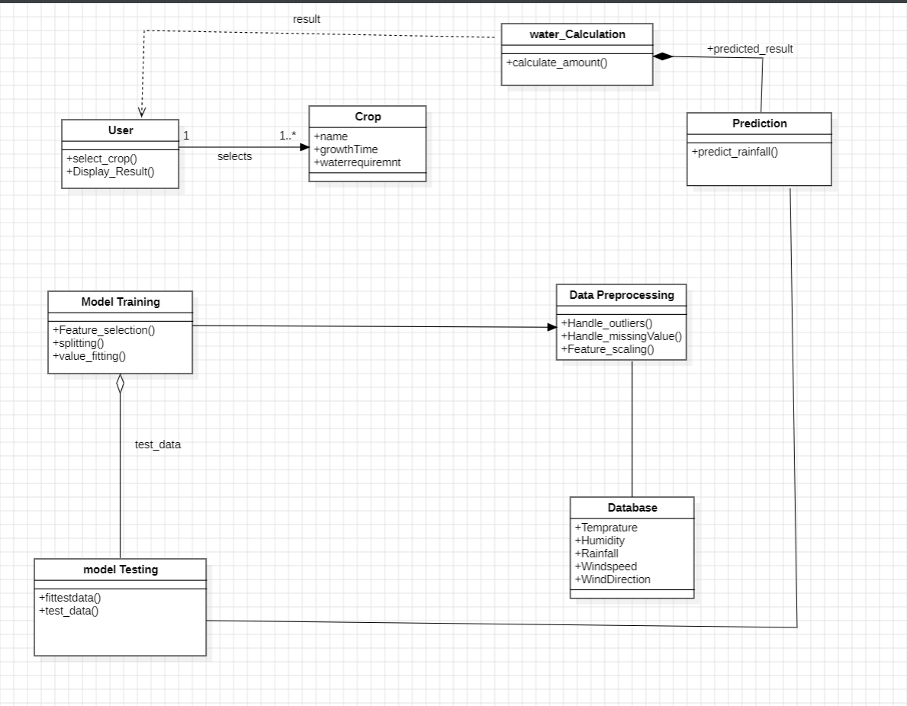**6.1 Class Diagram**

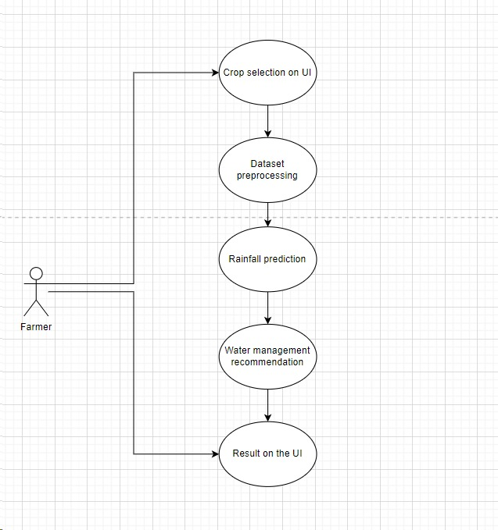**6.2 Use Case Diagram**

24

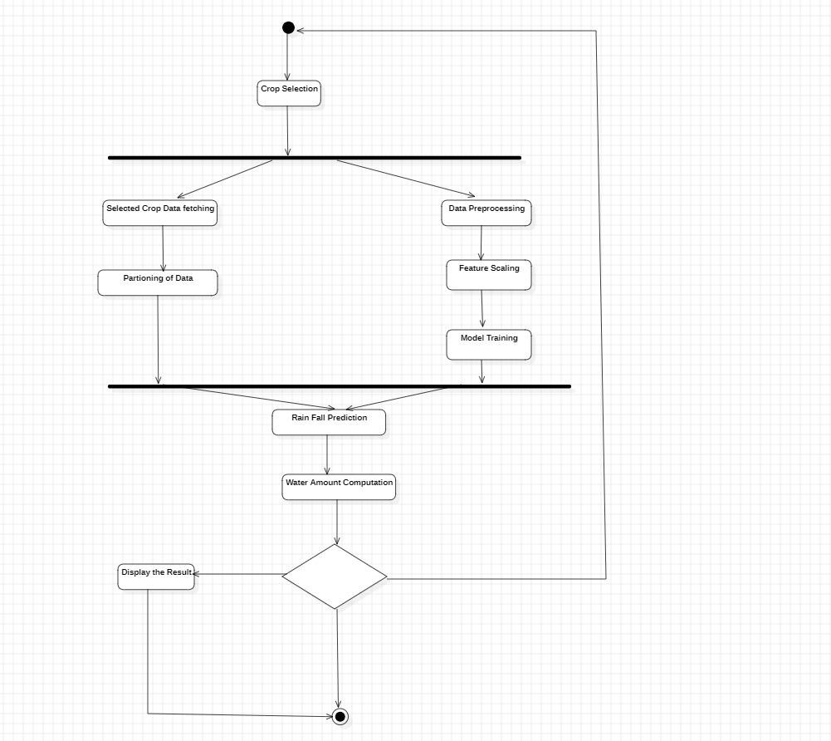**6.3 Activity Diagram**

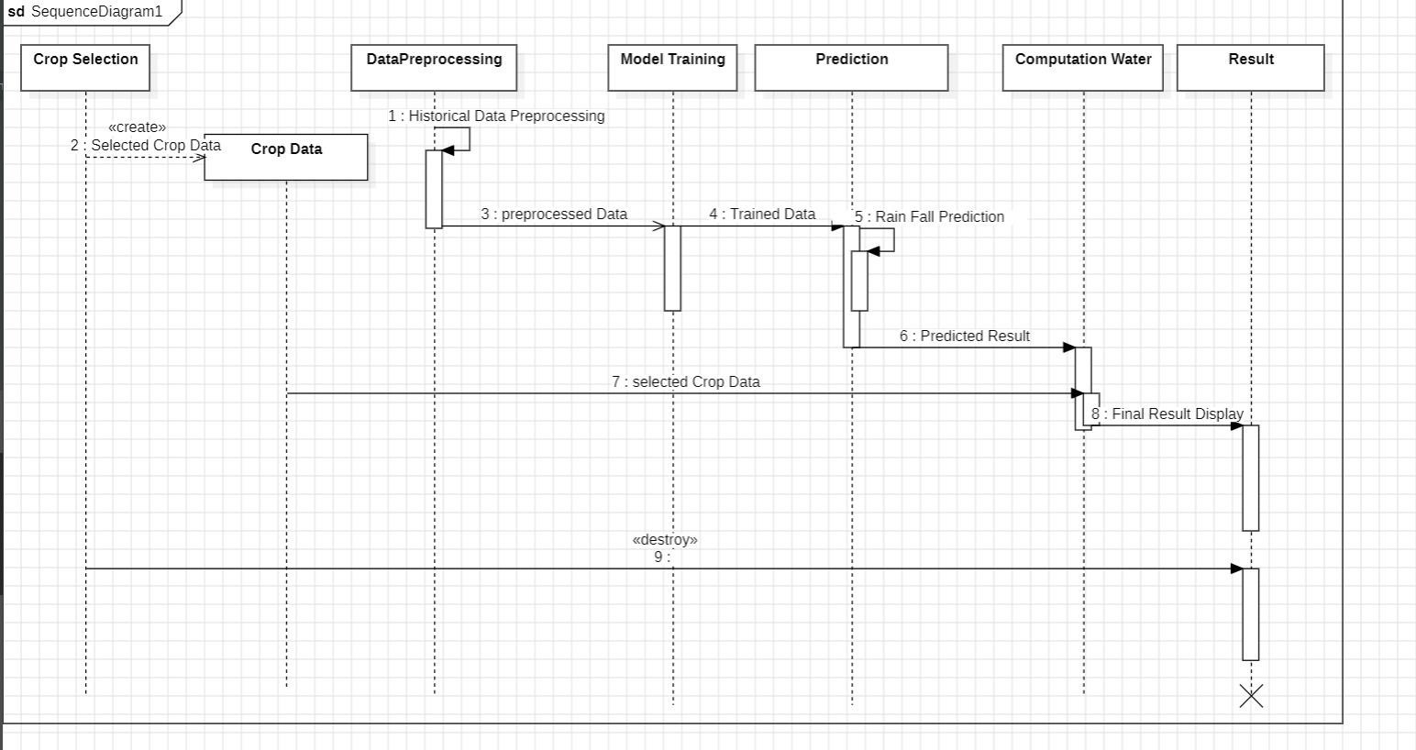**6.4 Sequence Diagram**

25

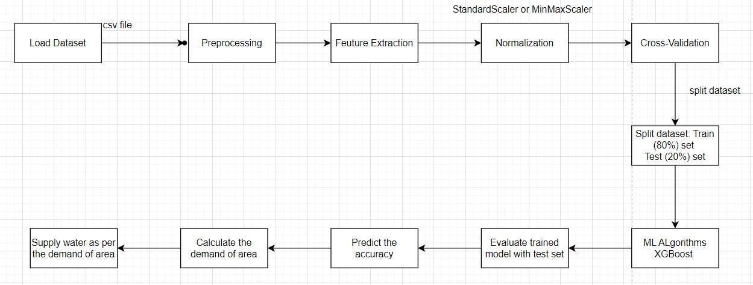**6.5 State Diagram**

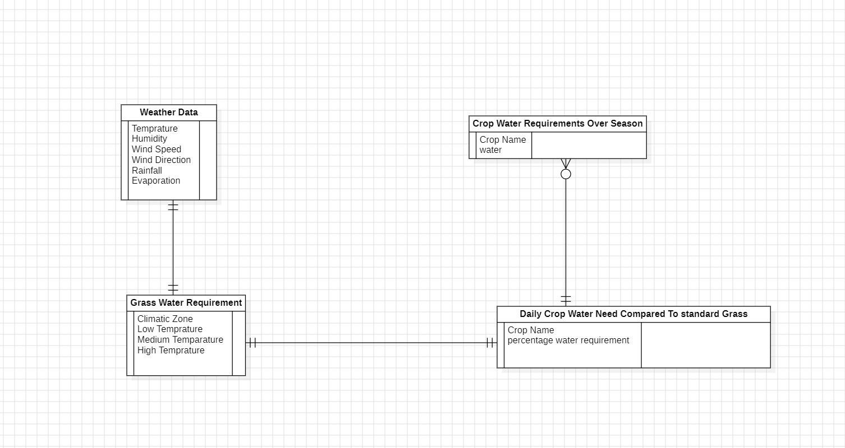**6.6 ER Diagram**

26

**CHAPTER 7**

**ALGORITHM & SYSTEM ARCHITECTURE**

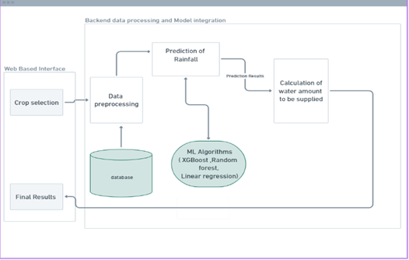

**Fig.1**. Architecture of Water Supply Management System

**7.1 SYSTEM ARCHITECTURE**

Our system, depicted in Fig. 1, has an online user interface that allows users to choose a particular crop. This choice is crucial since different crops have distinct needs for water and how they react to their surroundings. The system gathers real-time data from a database. This database contains information about the weather and climate of Pune District over the previous year, which is gathered via IOT sensors. As indicated in Table 1, the database includes atmospheric factors including temperature, humidity, average wind direction, speed, and evaporation rates in addition to total rainfall.

Data pre-processing is done to make analysis easier. The average value of that particular column, the categorical variable wind, is used to replace null values. Label-Encoder is

27 to preprocess the direction. Additionally, the Standard Scaler Library is used to

standardize the dataset. The machine learning model is then trained using training data after the dataset is divided into 80% for training and 20% for testing. Conversely, as Table 3 demonstrates, the system retrieves the chosen crop-specific water requirements directly from the database.

It's crucial to make clear that, as Tables 2 and 3 demonstrate, we have only looked at the overall water requirements for a given crop in this study. Following training, the model receives current meteorological data, including temperature, humidity, average wind speed, wind direction, and evaporation rates. From this data, the model predicts the amount of rainfall that will fall on a given day.With this data available, the system uses the Agriboost algorithm to calculate the amount of water, in liters, that must be delivered to one acre of specified crop area. The outcome is shown on the screen.

In this study, we employed three primary algorithms: Random Forest Regressor, XGBoost, and Linear Regression. Based on our analysis, we discovered that XGBoost yielded the greatest accuracy of 90.414 percent among the three, as illustrated in Figures 3 and 4 and Table 4.

**7.2 AGRIBOOST ALGORITHM**

The following formula determines how much water is required to irrigate a crop:

Step 1:convert the amount of rainfall that is expected (X) to litres per acre (P).

Step 2: Based on the crop stage, calculate the crop coefficient (kc).

Step 3: Apply the Penman-Monteith algorithm to determine the reference evapotranspiration (Eto) for grass.

Step 4: Multiply Eto by kc to adjust for the crop.

Step 5: Determine how much water the crop (R) will need while taking the current soil water (A) into account.

Step 6: Subtract current soil water from crop water need to determine amount of water to be given (S). Provide S litres of water if S > 0.

By taking into account evapotranspiration, crop attributes, and projected rainfall, this method assures efficient irrigation.

28

Abbreviations :

X : Rainfall (mm) predicted by model

R : Water Required by Crop (mm)

S : Water To Be Supplied ( litres )

Eto : Reference evapotranspiration (mm/day)

P : Predicted Rainfall Over 1 Acre Land (litres)

Input : X

Output : S

Step 1:  Calculate the Amount of Predicted Rainfall in Liters in One acre Land

             P = X*0.001*4046.86*1000

Step 2 : Calculate the kc of selected crop The kc depend on crop stage

Step 3: Calculate the Eto of grass using penman Monteith  algorithm

Step 4: Calculate the Eto of crop = kc * Eto of grass

Step 5 : R = max(0, ETo - P)

Step 6 : S = R- S , if S > 0 then , supply S litres of  water

**Penman Monteith  Algorithm :**

Evapotranspiration, or the total amount of water evaporating from soil and plant surfaces plus transpiration from leaves, is commonly calculated using the Penman-Monteith technique. It offers a reliable and often used technique for calculating evapotranspiration rates, which is essential for many applications like as climate modelling, hydrology, and agriculture.

Input  : Air_temperature ,Wind_speed ,Vapor_pressure ,Relative_humidity ,Net_radiation,Soil_heat_flux ,Albedo

29

Output : ETo_grass

Algo_Eto_grass (Air_temperature, Wind_speed, Vapor_pressure, Net_radiation, Soil_heat_flux, Albedo)

{

    specific_heat = 0.001013 # MJ/kg/°C

    psychometric_constant = 0.067 # kPa/°C

    latent_heat_vaporization = 2.45 # MJ/kg

    Stefan_Boltzmann_constant = 0.000000004903 # MJ/m²/day/K⁴

 delta = (4098 * (0.6108 * np.exp((17.27 * Air_temperature) / (Air_temperature + 237.3)))) / np.power((Air_temperature + 237.3), 2)

    gamma = psychometric_constant

   # Calculate reference evapotranspiration (ETo) using Penman-Monteith equation

    ETo = (0.408 * delta * Net_radiation + gamma * (900 / (Air_temperature + 273)) * Wind_speed * (Vapor_pressure / (Air_temperature + 273))) / (delta + gamma * (1 + 0.34 * Wind_speed))

    return Eto

}

ETo_grass = Algo_Eto_grass (Air_temperature, Wind_speed, Vapor_pressureNet_radiation, Soil_heat_flux, Albedo)

**7.3 LABEL ENCODER**

A Label Encoder is a tool used in machine learning and data preprocessing to convert categorical data into numerical format. In many machine learning algorithms, it's necessary to convert categorical variables into numerical representations, as most algorithms require numerical input.

The Label Encoder assigns a unique numerical value to each category in a categorical feature. For example, if you have a feature "color" with categories like "red," "blue," and "green," a Label Encoder might assign 0 to "red," 1 to "blue," and 2 to "green."

30

Label Encoding is a straightforward way to handle categorical data, but it has some limitations. For example, it implicitly assumes an ordinal relationship between the categories, which may not always be appropriate. In cases where the categorical variable doesn't have any ordinal relationship, other encoding techniques like One-Hot Encoding are preferred.

**7.4 ITERATIVE IMPUTER**

The Iterative Imputer is a method used for imputing missing values in datasets. It's particularly useful when dealing with datasets where missing values are present, and those missing values are correlated with other features in the dataset.

The algorithm iteratively imputes missing values for each feature, taking into account the values of other features. It does this by treating each feature with missing values as a target variable and the other features as predictor variables. Then, it uses a regression model to predict the missing values of the target feature based on the values of the other features.

The algorithm repeats the iteration process until convergence is achieved, meaning that the imputed values stabilize and don't change significantly between iterations.

This method is particularly useful when the missing data are not completely at random and when there are correlations between the variables in the dataset. However, it can be computationally expensive, especially for large datasets or datasets with many missing values.

**7.5 MINMAXSCALER**

The MinMaxScaler is a technique used in data preprocessing to scale numerical features to a specific range. It transforms features by scaling each feature to a given range. Typically, this range is between 0 and 1, but it can be set to any desired range.

Here's how the MinMaxScaler works:

1. Normalization: For each feature, the MinMaxScaler computes the minimum and maximum values present in that feature across the dataset.

2. Scaling: It then scales each feature based on the formula:

3. Output: After scaling, each feature's values are transformed to fall within the specified range, typically between 0 and 1.

The MinMaxScaler is particularly useful when the distribution of the features doesn't follow a normal distribution and when the algorithm you're using for modeling (like neural networks or algorithms based on distance measures) requires features to be on the same scale.

31

In Python, you can use the MinMaxScaler class from the scikit-learn library to apply Min-Max scaling to your dataset. It's applied similarly to other preprocessing techniques in scikit-learn, using the `fit_transform()` method on your dataset.

**7.6 TRAIN TEST SPLIT**

The train-test split is a fundamental technique used in machine learning for evaluating the performance of a model. It involves splitting the dataset into two subsets: one for training the model and the other for testing its performance. The training set is used to train the model, while the testing set is used to evaluate how well the model generalizes to unseen data.

Here's how the train-test split works:

1. Splitting the Dataset: The dataset is divided into two subsets, typically by randomly selecting a certain percentage of the data for training and reserving the remaining data for testing. Common splits include 70-30, 80-20, or 90-10, with the majority of the data allocated to the training set.

2. Training the Model: The model is trained on the training dataset using the features (input data) and their corresponding labels (output data).

3. Evaluating the Model: Once the model is trained, it's evaluated using the testing dataset. The model makes predictions on the testing dataset, and its performance is assessed based on how well these predictions match the actual labels.

4. Performance Metrics: Various performance metrics can be used to evaluate the model, depending on the type of problem. For classification problems, metrics like accuracy, precision, recall, and F1-score are commonly used. For regression problems, metrics like mean squared error (MSE) or R-squared are often used.

5. Generalization Assessment: The goal of the train-test split is to assess how well the model generalizes to unseen data. By evaluating the model on a separate testing set, you can get an estimate of its performance on new, unseen data.

In Python, you can perform the train-test split using libraries like scikit-learn. The `train_test_split` function from scikit-learn's `model_selection` module is commonly used for this purpose. It allows you to specify the size of the testing set and can also handle stratified sampling for classification tasks to ensure that the class distribution is preserved in both the training and testing sets.

**7.7 XGBOOST REGRESSOR**

XGBoost (Extreme Gradient Boosting) is an optimized and efficient implementation of gradient boosting machines, which are a type of ensemble learning method. XGBoost has gained popularity due to its high performance and scalability in various machine learning tasks, particularly in regression and classification problems.

32

The XGBoost Regressor is specifically designed for regression tasks. It's used to build predictive models that can predict continuous numerical values based on input features. Here's how it works:

1. Ensemble Learning: XGBoost employs an ensemble of decision trees to make predictions. It builds multiple decision trees sequentially, where each subsequent tree corrects the errors made by the previous ones.

2. Gradient Boosting: XGBoost uses gradient boosting, which is a gradient descent-based optimization technique. In each iteration, the model fits a new tree to the residuals (the differences between the predicted values and the actual values) of the previous predictions. This process continues iteratively until a stopping criterion is met.

3. Regularization: XGBoost incorporates regularization techniques to prevent overfitting and improve generalization performance. It includes parameters to control the complexity of the trees, such as maximum depth, minimum child weight, and gamma (minimum loss reduction required to make a further partition).

4. Parallelization and Optimization: XGBoost is highly optimized for performance and scalability. It supports parallelization of tree construction, which allows it to efficiently handle large datasets. Additionally, it implements various optimization techniques to speed up the training process.

5. Feature Importance: XGBoost provides feature importance scores, which indicate the relative importance of each feature in making predictions. These scores can be helpful for feature selection and understanding the underlying patterns in the data.

To use the XGBoost Regressor in Python, you can install the `xgboost` library and then instantiate and train the regressor using the appropriate parameters. It's commonly used in conjunction with other libraries like scikit-learn for data preprocessing and evaluation.

**7.8 FETCH API**

The Fetch API is a modern JavaScript interface for fetching resources (such as JSON data, images, scripts, etc.) across the network. It provides a more powerful and flexible alternative to the older XMLHttpRequest (XHR) object.

**7.9 FAST API**

33

FastAPI is a modern, fast (hence the name), web framework for building APIs with Python. It's built on top of Starlette for the web parts and Pydantic for data validation and serialization/deserialization. FastAPI is designed to be easy to use, fast to develop with, and to provide high performance.

Here are some key features and aspects of FastAPI:

1. **Fast**: Asynchronous (async/await) support and performance are core principles of FastAPI. It leverages Starlette's async capabilities to handle high levels of concurrency efficiently.
2. **Type Checking**: FastAPI uses Pydantic models to define request and response schemas. These models are automatically validated and converted from and to JSON. This helps catch errors early and ensures that your data is always in the expected format.
3. **Automatic Documentation**: FastAPI automatically generates interactive API documentation (Swagger UI and ReDoc) based on the defined API endpoints and Pydantic models. This documentation is automatically updated as you modify your code, making it easy to keep it in sync with the actual API implementation.
4. **Dependency Injection**: FastAPI supports dependency injection, allowing you to define dependencies (such as database connections, authentication services, etc.) that are automatically injected into your endpoint functions. This promotes modularity and makes it easier to test and maintain your code.
5. **WebSocket Support**: FastAPI has built-in support for WebSocket connections, allowing you to easily implement real-time communication features in your APIs.
6. **Easy Integration**: FastAPI is designed to be easy to integrate with other Python libraries and frameworks. It works seamlessly with popular tools like SQLAlchemy, Tortoise-ORM, OAuth2, JWT, and more.

**7.10 Algorithm Evaluation**

|  |  |  |  |
| --- | --- | --- | --- |
| Algorithms | MAE | MSE | RMSE |
| Random Forest | 1.58 | 13.77 | 3.71 |
| Linear Regression | 2.23 | 30.86 | 5.55 |
| XGBoost | 2.21 | 16.37 | 4.04 |

**Table 3**. Evaluation Of Algorithms

34

### CHAPTER 8

**IMPLEMENTATION AND EXECUTION**

**8.1 GUI**

Our web-based frontend, developed using ReactJS, offers a user-friendly graphical interface (GUI) presenting detailed real-time weather conditions for Pune. Users can easily access information such as temperature, humidity, wind speed, UV index, date, day, and location. However, the core functionality lies in its integration with the Agriboost algorithm, which operates in the backend. This algorithm harnesses the weather data to provide precise irrigation recommendations tailored to specific crops. The crops currently supported include Wheat, Onion, Maize, Soyabean, and Tomato. These recommendations are crucial for optimizing agricultural practices, ensuring efficient water usage, and maximizing crop yield. Upon selecting a crop from the dropdown menu, users can view the recommended amount of water to be supplied per acre of agricultural land. This output reflects the collective analysis of current weather conditions and the specific requirements of the chosen crop as determined by the Agriboost algorithm.

|  |  |
| --- | --- |
| **Crop Name** | **Percentage Water Requirement as Compared to Standard Grass** |
| Grapes | Less than 30% |
| Maize | More than 10% |
| Tomato | More than 10% |
| Sugarcane | More than 20% |
| Onion | Same as standard grass |

Furthermore, our system offers predictive capabilities, forecasting weather conditions for the upcoming five days. This forecast includes not only the expected weather parameters but also anticipates the corresponding water needs for the selected crop. The water requirement is quantified in liters per acre, providing actionable insights for farmers to plan their irrigation schedules effectively. By amalgamating real-time weather data, advanced algorithms, and predictive analytics, our platform empowers farmers with actionable insights to enhance agricultural productivity while conserving water resources.

**Table 4.** Average Daily Crop Water Needs As Compared To Standard Grass

35

|  |  |  |  |
| --- | --- | --- | --- |
| **Climatic Zone** | **Low(less than 15°C)**  **In millimetres** | **Medium(15-25°C)**  **In millimetres** | **High (more than 25°C)**  **In millimetres** |
| Desert/arid | 4-6 | 7-8 | 9-10 |
| Semi-arid | 4-5 | 6-7 | 8-9 |
| Sub humid | 3-4 | 5-6 | 7-8 |
| Humid | 1-2 | 3-4 | 5-6 |

**Table 5.** Average Daily Water Need Of Standard Grass

**8.2 Input**

The system operates on a dataset stored in CSV format, containing crucial features such as Dates, Maximum Temperature, Minimum Temperature, Maximum Humidity, Minimum Humidity, Evaporation, Average Wind Speed, Wind Direction, and Rainfall. This dataset serves as the foundational input for our predictive model. Moreover, to determine the crop-specific requirements accurately, the Agriboost algorithm receives detailed information about the selected crop. This information includes the crop coefficient (kc), alongside environmental parameters like Air Temperature, Wind Speed, Vapor Pressure, Relative Humidity, Net Radiation, Soil Heat Flux, and Albedo. These specifics are acquired dynamically from the OpenWeather API, specifically for the location of interest, which in our case is Pune. During the model training phase, this dynamic data retrieval ensures the algorithm is fine-tuned to the unique environmental conditions of Pune.Utilizing this comprehensive dataset and crop-specific details, the Agriboost algorithm performs intricate calculations to optimize irrigation strategies. By integrating meteorological data with crop physiology principles, the algorithm accurately predicts the water requirements tailored to the selected crop and prevailing environmental conditions.The resultant output from the Agriboost algorithm is then seamlessly displayed on the frontend GUI, providing farmers with actionable insights regarding the precise amount of water needed for optimal crop growth and yield. This integration of real-time data, advanced algorithms, and user-friendly visualization empowers agricultural stakeholders to make informed decisions, ultimately enhancing productivity and sustainability in farming practices.

**8.3 Output**

The system output comprises two essential components:

36

* 1. **Current Weather Conditions**: Users receive real-time updates on key meteorological factors
  2. ***Temperature***: The prevailing temperature is showcased, providing values in both Celsius

- ***Humidity***: This metric indicates the amount of moisture present in the atmosphere, crucial for assessing growing conditions.

- ***UV Index:*** Reflecting the intensity of ultraviolet radiation from the sun, this index aids in understanding potential impacts on crops and workers.

- ***Wind:*** Details on wind speed and direction are provided, aiding farmers in assessing potential wind-related risks.

- ***Current Date and Day***: Users are informed of the present date and day, facilitating effective scheduling and planning.

- ***Location***: The system displays the current location, ensuring users are aware of the geographical context for the weather data.

**2. Irrigation Recommendation:** Additionally, the system calculates and presents the required irrigation amount for one acre of agricultural land based on the selected crop. This recommendation is tailored to optimize crop growth and yield while conserving water resources. By integrating factors such as crop-specific water needs, soil conditions, and current weather data, the system offers actionable insights to farmers, enabling them to make informed decisions regarding irrigation scheduling and resource allocation.

**8.4 Risk Management**

Managing risks in a system aimed at addressing water scarcity in agriculture through data-driven rainfall forecasting and irrigation planning requires careful consideration of potential challenges. Here are some risk management strategies:

1. Model Accuracy and Reliability: Regularly validate and update the forecasting models to ensure they accurately reflect changing weather patterns and environmental conditions. Incorporate feedback loops and expert insights to improve model performance over time.

3. Uncertainty in Weather Forecasting: Acknowledge the inherent uncertainty in weather forecasting and communicate potential limitations and confidence intervals to stakeholders. Provide contingency plans and adaptive strategies to respond to unexpected weather events or deviations from forecasted conditions.

37

4. Adoption and User Engagement: Facilitate user adoption and engagement by providing intuitive interfaces, actionable insights, and user-friendly tools for interpreting

forecasted data and irrigation recommendations. Offer training and support to farmers to promote effective utilization of the system.

5. Regulatory and Policy Compliance: Ensure compliance with relevant regulations and policies governing water use, agricultural practices, and environmental conservation. Stay informed about changes in legislation and adapt the system accordingly to remain compliant and avoid legal risks.

6. Resource Constraints: Address resource constraints such as limited access to technology, internet connectivity, or financial resources among farming communities. Develop strategies to overcome these barriers and ensure equitable access to the benefits of the system.

7. Crop and Soil Variability: Recognize the variability in crop types, growth stages, and soil characteristics across different agricultural regions. Tailor irrigation plans and recommendations to account for these variations and provide customizable options for farmers to adjust based on their specific circumstances.

8. Long-Term Sustainability: Emphasize the importance of long-term sustainability in water management practices. Promote soil conservation, water recycling, and other sustainable agricultural practices alongside the use of data-driven technologies to ensure the continued health of agricultural ecosystems and water resources.

**8.5 Project Schedule**

Project tasks in Project are:

* 1. Project topic selection
  2. Literature survey and study of papers
  3. Requirement gathering phase
  4. Installing required libraries and softwares in the system.
  5. Coding and implementation
  6. Model training phase
  7. Unit and Integration testing
  8. System testing
  9. Modifications and documentation

38

## 8.6 Team Organization:

**8.6.1 Team Organization**

Various tasks are distributed among four team members.

Distribution of tasks is done based on the skill sets and considering the balanced distribution of the workload among the team members.

|  |  |  |
| --- | --- | --- |
| Sr No. | Member Name | Responsibility |
| 1 | Athrav Kulkarni | Backend + System Design |
| 2 | Ilihas Patel | Frontend + Documentation |
| 3 | Shailesh Jadhav | Frontend + Model Testing |
| 4 | Parth Kadav | Documentation + UI Design |

**Table 6**. Team Organization

### Management Reporting and Communication

* + - To maintain a log book and keep detail of all the information about the meeting with the Internal Project Guide.
    - To complete synopsis and review within the given time
    - Weekly update of the assignments given by the external guide.
    - Team meeting in every week to discuss the progress of the project.
    - Meeting with the internal guide on every Friday and giving the update of work done in

the entire week.

* + - Participating in Monthly review and give update about project and improvement over previous suggestions of external guides.

39

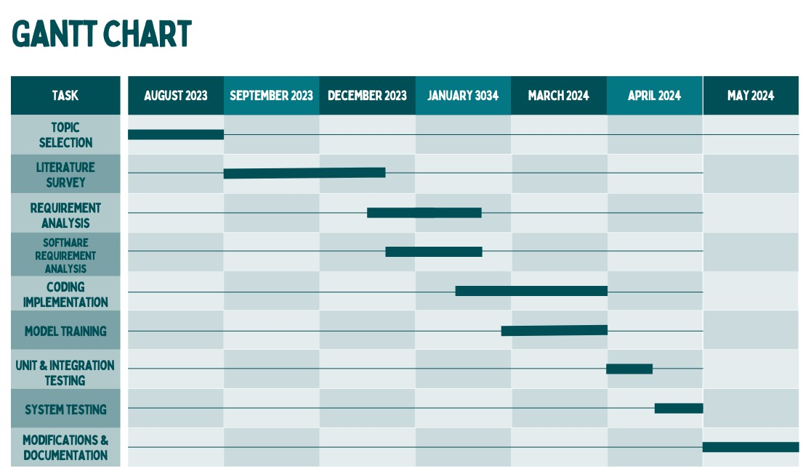**GANTT CHART**

**40**

**CHAPTER 9**

**RESULTS**

**9.1 Screenshots**

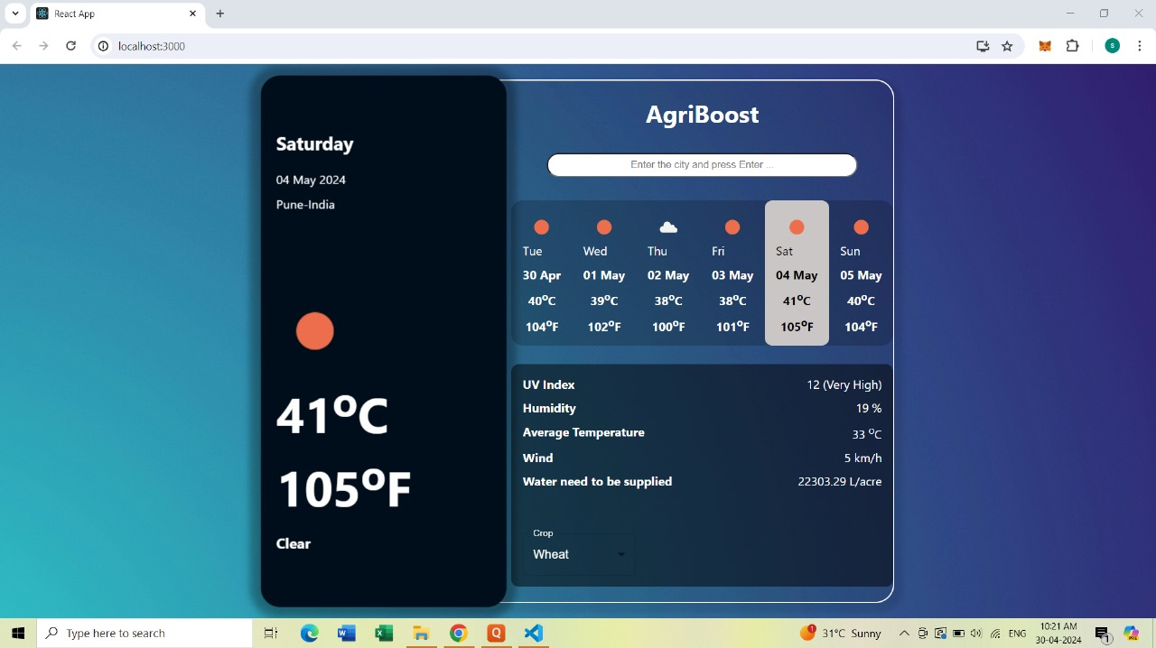

**Output Screen GU**

41

41

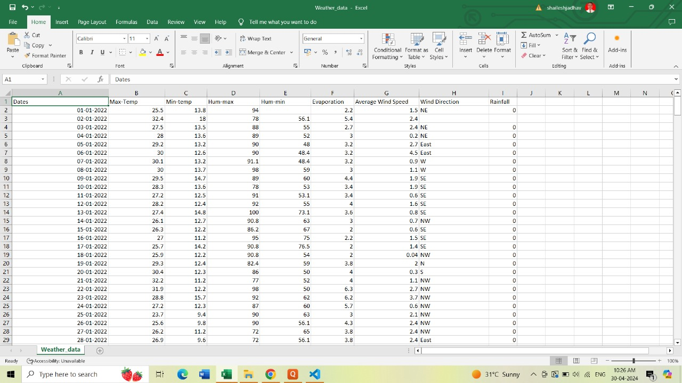

42

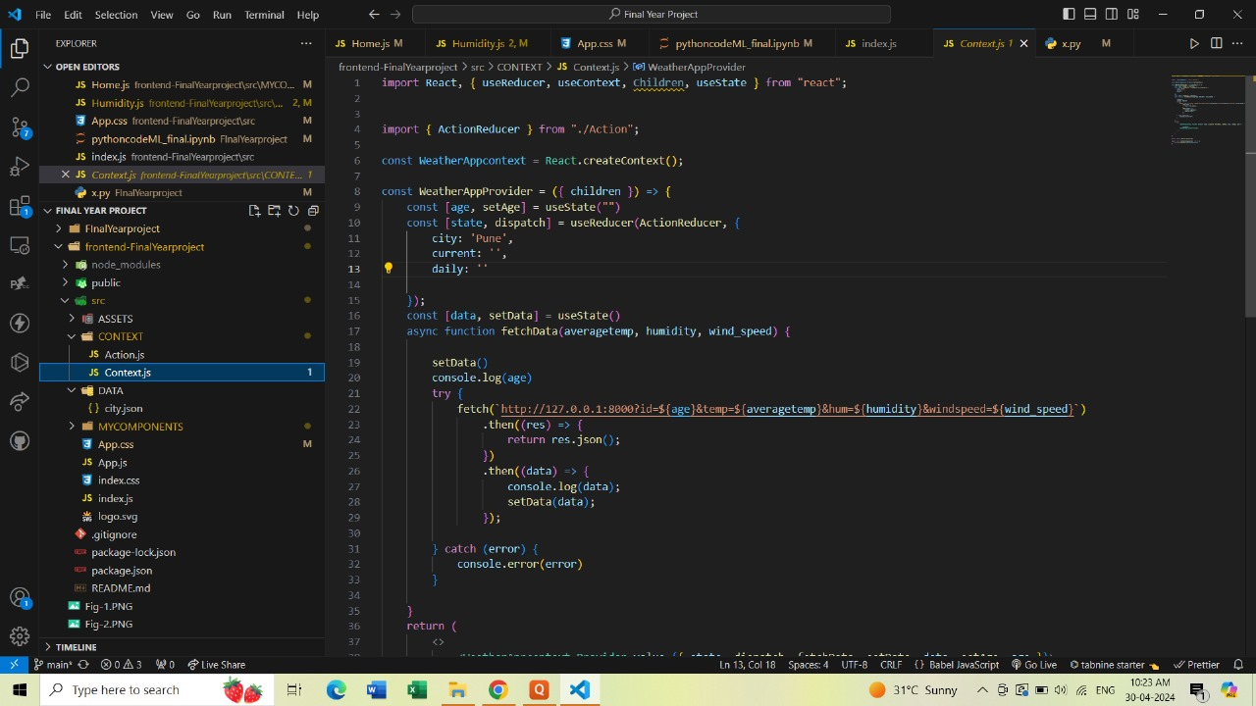**Dataset**

**Frontend Code**

43

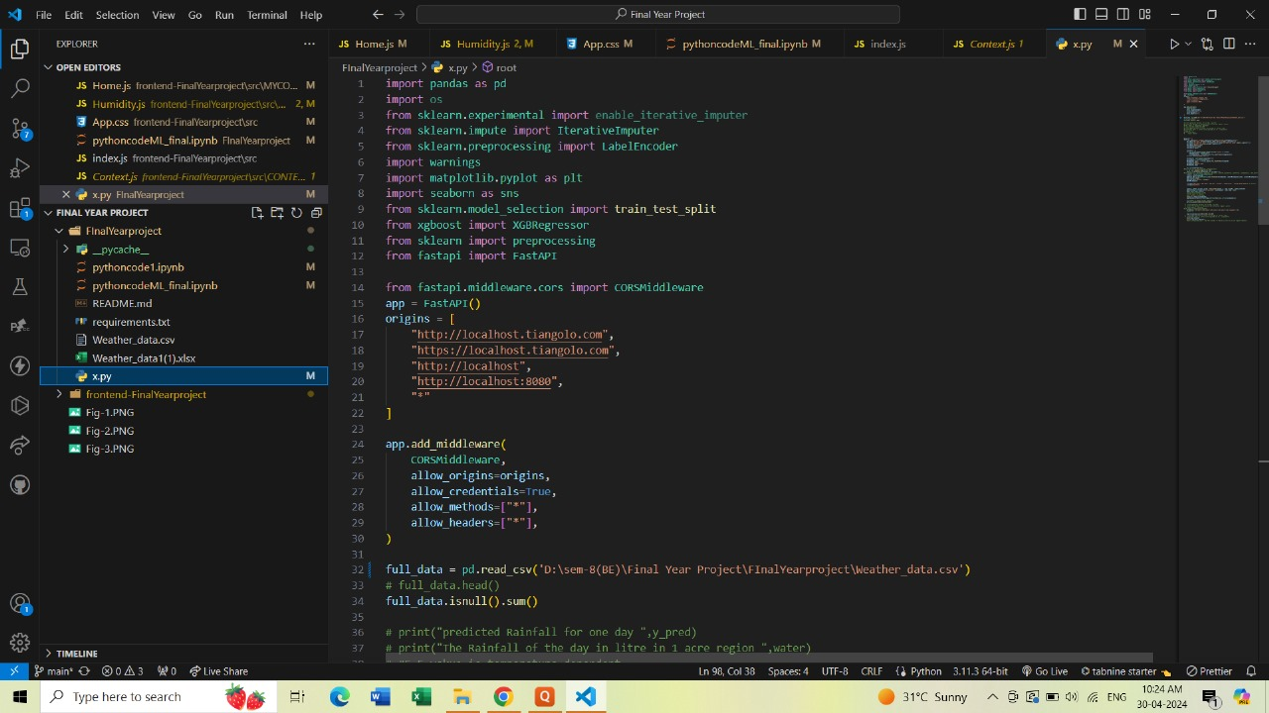

**Backend Code over Fast Api**

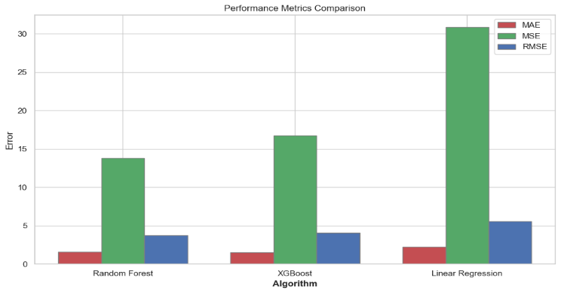**9.2 Evaluation Graphs**

Fig 3 compares the performance of three algorithms on a particular problem. It focuses on the error numbers that each algorithm produced, which were assessed using metrics for performance evaluation.

44

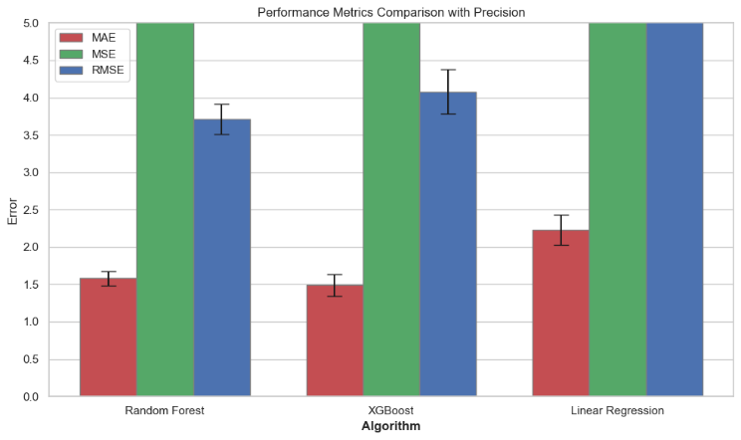

Fig 4 shows a performance comparison of three different algorithms on a particular task. It uses quantitative metrics for error evaluation and visually represents the performance of each method.

45

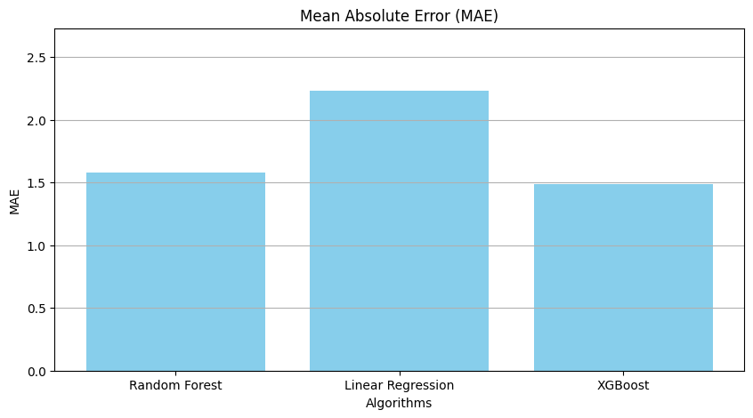

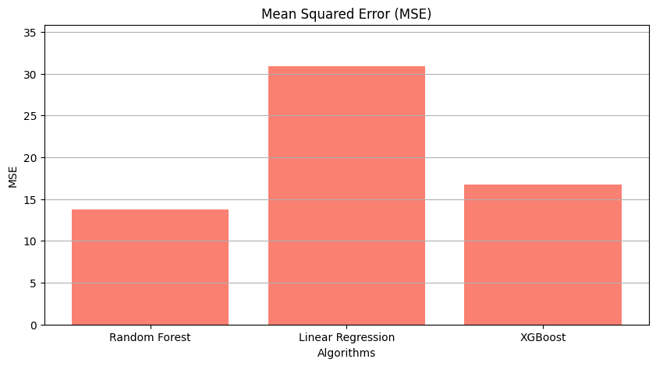

**46**

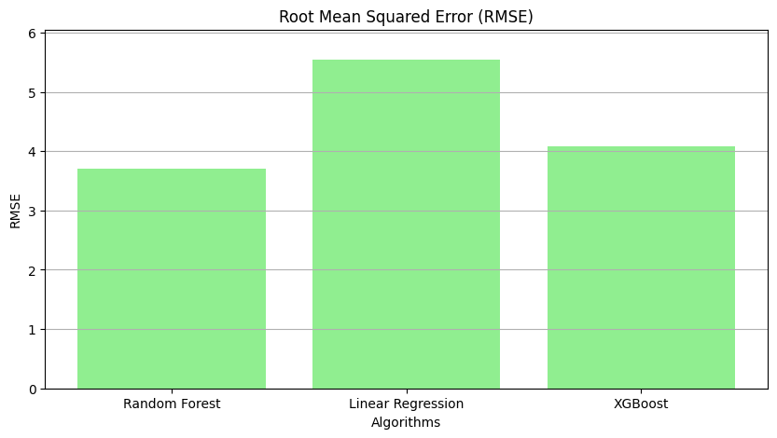

**9.3 Future Scope**

• **Improved Accuracy through AI and Machine Learning**: Utilizing advanced machine learning algorithms and artificial intelligence, future systems can better analyse historical weather data, atmospheric patterns, and other relevant factors to provide more accurate rainfall predictions. These systems could also incorporate real-time data from sensors and satellites to continuously update and refine their predictions.

• **Integration with IoT and Sensors**: Internet of Things (IoT) devices and sensors can be deployed across agricultural fields to collect data on soil moisture levels, crop health, and other relevant parameters. By integrating this data with rainfall prediction systems, farmers can receive more precise recommendations for irrigation scheduling.

• **Customized Crop Water Requirement Models**: Developing sophisticated models that take into account the water requirements of specific crops at different growth stages can help farmers optimize irrigation practices. These models can consider factors such as crop type, soil type, climate conditions, and local water availability to provide personalized recommendations for irrigation scheduling and water usage.

• **Mobile Applications and Decision Support Systems**: User-friendly mobile applications and decision support systems can empower farmers to make informed decisions about irrigation and water management practices based on real-time weather forecasts and crop water requirement models.

47

• **Climate Change Adaptation Strategies**: Given the increasing unpredictability of weather patterns due to climate change, future rainfall prediction systems and water management tools will need to incorporate adaptive strategies to help farmers cope with changing conditions. This may include scenario planning, risk assessment, and the development of resilient agricultural practices that can withstand extreme weather events such as droughts and floods.

• **Policy Support and Stakeholder Collaboration**: Governments, agricultural organizations, and research institutions play a crucial role in supporting the development and adoption of advanced rainfall prediction systems and water management technologies. Collaborative efforts among stakeholders can help ensure that these tools are accessible, affordable, and tailored to the needs of different regions and farming communities.

**9.4 Advantages**

• **Increased Crop Yields**: By accurately predicting rainfall patterns and tailoring irrigation schedules to match crop water requirements, farmers can optimize water usage and ensure that crops receive the right amount of moisture at the right time. This can lead to improved crop yields and quality.

• **Water Conservation**: Precise water management based on real-time data and predictive analytics helps farmers avoid over-irrigation, reducing water wastage and promoting sustainable use of limited water resources. This is particularly crucial in regions facing water scarcity or drought conditions.

• **Cost Savings**: Efficient water management can result in cost savings for farmers by reducing the amount of water, energy, and labour required for irrigation. By minimizing input costs while maximizing yields, farmers can improve their profitability and economic sustainability.

• **Risk Mitigation**: Accurate rainfall predictions enable farmers to anticipate and mitigate the risks associated with extreme weather events such as droughts, floods, and erratic rainfall patterns. By adopting proactive water management strategies, farmers can minimize crop losses and financial instability.

• **Environmental Benefits**: By minimizing water runoff and leaching of nutrients, optimized irrigation practices contribute to improved soil health and reduced environmental pollution. Additionally, sustainable water management practices help conserve ecosystems and preserve biodiversity in agricultural landscapes.

• **Adaptation to Climate Change**: Advanced rainfall prediction systems provide valuable insights for farmers to adapt to changing climate conditions and mitigate the impacts of climate change on agricultural production.

**48**

**9.5 Disadvantages**

• **Reliance on Technology**: Dependence on technology for rainfall predictions and water management recommendations can pose risks, such as system failures, data inaccuracies, or connectivity issues. Farmers may face challenges if they lack access to reliable technology infrastructure or if the systems are not user-friendly.

• **Cost of Implementation**: Adopting advanced rainfall prediction systems and irrigation technologies may require significant upfront investments in equipment, sensors, software, and training. Small-scale farmers or those with limited financial resources may find it difficult to afford these technologies, limiting their adoption and benefits.

• **Data Privacy and Security Concerns**: Collecting and analysing sensitive data related to farm operations, weather patterns, and water usage raises concerns about data privacy and security. Farmers may be reluctant to share their data with third-party providers or government agencies due to privacy concerns or fear of misuse.

• **Complexity and Technical Expertise**: Understanding and interpreting the data generated by rainfall prediction systems and crop water requirement models may require technical expertise and specialized knowledge. Farmers who lack the necessary skills or resources to interpret the information accurately may struggle to derive meaningful insights from the technology.

• **Limited Accessibility**: In rural or remote areas with poor internet connectivity or infrastructure, access to advanced rainfall prediction systems and decision support tools may be limited. This digital divide can exacerbate disparities in agricultural productivity and resilience between regions with different levels of technological access.

• **Environmental Impact**: While optimized irrigation practices can conserve water and reduce environmental impact, improper implementation or overreliance on irrigation may lead to negative consequences such as soil erosion, salinization, and depletion of groundwater resources. Balancing water conservation with environmental sustainability requires careful planning and management.

**9.6 Applications**

* **Precision Irrigation**: Rainfall prediction systems can help farmers optimize their irrigation schedules by providing insights into upcoming weather patterns. By aligning irrigation practices with rainfall forecasts and crop water requirements, farmers can minimize water wastage and maximize crop yields.
* **Crop Planning and Management**: Farmers can use rainfall prediction data to make informed decisions about crop selection, planting times, and cultivation practices. By choosing crops that are well-suited to local climate conditions and adjusting planting schedules based on anticipated rainfall, farmers can improve productivity and reduce risks associated with weather variability.

49

* **Drought Monitoring and Early Warning**: Rainfall prediction systems play a critical role in monitoring drought conditions and issuing early warnings to farmers and policymakers. By detecting patterns of below-average rainfall and anticipating drought events, these systems enable proactive measures to mitigate the impacts on agriculture, water resources, and food security.
* **Flood Forecasting and Risk Management**: In flood-prone areas, rainfall prediction systems can help forecast potential flood events and assess the risk to agricultural lands and infrastructure. By providing timely warnings, farmers can take preventive measures such as adjusting planting schedules, implementing soil conservation practices, or relocating livestock to higher ground.
* **Water Resource Management**: Rainfall prediction data can inform water resource management strategies at the local, regional, and national levels. By understanding future water availability and demand, policymakers can develop sustainable water allocation plans, prioritize water use for agriculture, industry, and domestic purposes, and implement measures to enhance water conservation and efficiency.
* **Insurance and Financial Risk Management**: Rainfall prediction systems can support the development of weather-indexed insurance products tailored to the needs of farmers. By linking insurance payouts to objective rainfall measurements, these products provide financial protection against crop losses due to adverse weather conditions, helping farmers manage risk and improve resilience.
* **Research and Development**: Rainfall prediction systems generate valuable data for scientific research and modelling studies related to climate variability, hydrology, agronomy, and ecosystem dynamics. Researchers can use this data to improve our understanding of the complex interactions between weather, water, and agriculture and develop innovative solutions to address global challenges such as climate change and food security.
* **Community Engagement and Capacity Building**: Rainfall prediction systems can serve as educational tools to raise awareness about climate change, weather patterns, and sustainable agriculture practices among farmers, policymakers, and the general public. By fostering community engagement and capacity building, these systems empower stakeholders to take collective action to build resilience and adapt to changing environmental conditions.

50

**9.7 Conclusion**

The proposed design addresses crucial challenges in modern farming. Firstly, it provides a means to accurately measure and determine the amount of precipitation that is truly beneficial for agricultural crops. This knowledge enables farmers to manage their water resources more efficiently, ensuring that they use water effectively and avoid over-irrigation or under-irrigation. Secondly, by understanding the precise water requirements of different types of crops, this technology allows for tailored irrigation practices. Farmers can provide crops with the right amount of water at the right time, promoting healthier growth and maximizing yield while conserving water resources. Thirdly, the integration of rain sensors into agriculture is expected to revolutionize water supply management for crops in specific regions. By collecting data on local precipitation patterns, these sensors can predict water availability and assist in planning irrigation strategies accordingly. This advancement is likely to expand the areas that can be effectively monitored, reducing water wastage and contributing to sustainable and more productive agriculture. Overall, this innovation promises to bring about significant positive changes in the field of irrigation and crop management.

51

**REFRENCES**

|  |  |
| --- | --- |
| [1] | A.-u. Rahman, "Rainfall Prediction System using Machine Learning Fusion for smart cities," in *MDPI Sensors*, 2022. |
| [2] | D. D. G. Savarkar, "Rainfall Prediction based on Rainfall Stastical Data," in *2016*, International Journal in Recent and Innovation Trends in Computing. |
| [3] | C. Sandy, "Nowcasting extreme rain and extrem wind speed with machine learning techniques applied to different datasets," *Atmospheric Research Volume 282,* 2023. |
| [4] | F. Jawad, "Analysis of Optimum Crop Cultivation Using Fuzzy System," in *IEEE 15th International Conference on computer and Information Science*, 2016. |
| [5] | S. A. Hussain, "Early prediction of rainfall using xgboost and Logistic regression," 2022. |
| [6] | M. I. Khan, "Hybrid Deep Learning Approach for Multi Step Ahead Daily Rainfall Prediction using GSM Simulations," in *IEEE*, 2020. |
| [7] | W. M. Ridwan, "Rainfall Forecasting model using machine learning methods," in *Ain Shams Engineering Journal*, 2021. |
| [8] | D. K. Poola, "Prediction of rainfall by using extreme gradient boost ( XGboost ) in Vishakapattanam," 2020. |
| [9] | M. T. Anwar, "Rainfall prediction using Extreme Gradient Boosting," in *Conference on science and technology 2020 journal of physics* , 2020. |
| [10] | V.P.Tharun, "Prediction of Rainfall Using Data Mining Techniques.," in *Second International Conference on Inventive Communication and Computational Technologies*, 2018. |
| [11] | J.Refonaa, "Prediction using Regression," in *International Journal of Recent Technology and Engineering* , 2019. |
| [12]  52 | Ouma, Dam Water Level Prediction Using Vector AutoRegression, Random Forest Regression, 2022. |
| [13] | Tolani, "Analysis & Estimation of Soil for Crop Prediction using Decision Tree and Random Forest Regression Methods.," in *International Technical Conference on Circutes/Systems, Computers and Communications*, 2022. |
| [14] | Roshani, Analyzing trend and forecast of rainfall and temprature in Valmiki Tiger Reserve., 2022. |
| [15] | Lotfirad, "Drought monitoring and prediction using SPI, SPEI, and random forest model in various climates of Iran," in *Journal of Water and Climate Change* , 2021.  **REPORT DOCUMENTATION** |

53