Online Chinese Character Handwriting Recognition for Linux

Research Proposal

Author: Ran Cheng
Student ID: n5105269
Course: IT29 - Honours of IT
Primary Supervisor: Jim Hogan
Associated Supervisor: Jinhai Cai
Subject: Research Methodology

Table of Content
1. Introduction 2
1.1 Statement of Research Problem 2
1.2 Research Objectives/Questions 3
1.3 Rationale/Background 3
1.4 Significance of Study 4
1.5 Limitations of Study 4
2. Literature Review 5
2.1 Hidden Markov Model (HMM) 5
2.1.1 Introduction 5
2.1.2 Element of an HMM 6
2.1.3 Three classic problems 6
2.1.4 Type of HMMs 7
2.2 Dynamic Programming (DP) 8
2.3 Chinese Character Processing 9
2.3.1 Introduction 9
2.3.2 Character segmentation 10
2.3.3 Pre-processing 10
2.3.4 Pattern Representation 11
2.3.5 Classification 11
2.3.6 Context processing 11
2.4 Smart Common Input Method (SCIM) 12
2.5 GTK+ 14
3. Research Method 15
3.1 Research Approach 15
3.2 Implementation of the Project 17
3.3 Types of Outcomes Anticipated 18
3.4 Reliability/validity of Results 18
3.5 Anticipated Problems and Suggestions for their Solution 19
3.6 Time-line 21
3.7 Budget 23
4. References 23

Introduction
Handwriting is one of the input methods to let user interact with computer. Handwriting recognition has been researched for many years, but until recent years, as new types of pen input devices and interfaces have been developed, some major hardware issues have been resolved, and handwriting started to be used in PC. As a sub-project of “Internationalisation of Software” which is sponsored by Redhat (a leading Linux company), in this project, we’ll try to develop a new algorithm for Chinese Character handwriting recognition under Linux.

Statement of Research Problem
First research problem we need figure out is online handwriting recognition. There are three types of handwriting recognition: online, offline and signature recognition. Online recognition means by using some stylus and touch screen, while user are writing some strokes, the system will try to recognize the character at runtime. Offline recognition means by using a pen and a piece of paper, after users write some sentences, they put the piece of paper in a scanner, and the system will try to recognize all the information on that piece of paper at one time. Signature recognition is kind of offline recognition. Imagine when people sign some paper, most people don’t use print name, they write some symbols which won’t be able to be recognized as any language. For recognition of that kind of character, it’s called signature recognition. In this project, a couple of reasons let us choose online handwriting recognition over the other two. Firstly, online handwriting recognition is the only feasible way to recognize the input character at runtime. Secondly, online handwriting recognition is the most frequently used recognition, so research result can be used more effectively in the future.

Second research problem we need resolve is Chinese character processing. Unlike English, Chinese language has more than 10,000 character categories, and more than 50,000 characters. So recognize Chinese character is much harder than recognize English. Chinese character is composed by strokes, and the order or position of the strokes have significant influence on the recognition. In some cases, two or more characters looks very similar, but they have large difference in terms of semantic meaning. Handwriting recognition for English has been researched for ages, but until recent years, handwriting recognition for Chinese started getting popular. Handwriting recognition is sort of pattern classification, for each character, we need some pattern to match. English language only consists of 26 different characters. Chinese language, however, consists of more than 50,000 different characters, even though the most common used characters are more than 1,000. So the pattern we need to recognize Chinese characters are far more difficult than English characters. There are some technologies and algorithms already exist, but most of them doesn’t do good job, in the other words, the quality of recognition is not good. A couple of reasons convince me focusing on Chinese character. Firstly, China has the potential largest market on the world, so research conducted on
Chinese character can be well pay back. Secondly, recent years our industry sponsor launched a new large program “Internationalisation of Linux”, one of the goal for this program is developing Chinese market.

Last but not the least problem I need deal with is implementing the recognition algorithm under Linux. Linux, as the top one competitor to MS Windows, is trying to spread their advantages to the world. The best thing of Linux is that Linux is open source, which means more secure, more stable, faster development cycle and cheaper price (sometimes even free). The current Linux input framework is SCIM (Smart Common Input Method). By the end of this project, we need find out how to implement and develop a software prototype using SCIM API under Linux.

Research Objectives/Questions
The following are the main objectives to achieve and questions to be answered by the end of this project.
- Review the current online handwriting recognition techniques in general and specifically to those using HMM
- Review the current online handwriting recognition techniques for Chinese character
- Review the current SCIM techniques under Linux
- Review the HMM techniques in speech recognition
- Modify some existing handwriting algorithm and Chinese character processing algorithm to try to create new handwriting algorithm for Chinese character.
- Test modified algorithm
- Modify some exiting speech recognition algorithm (HMM has been widely used for speech recognition) to let these recognition algorithm work for Chinese character recognition.
- Test modified algorithm
- Compare the results of two modified algorithm and find the better one to implement
- Implementation the algorithm under Linux
- A technical report

Rationale/Background
Recently years, computers are playing more and more important role in our daily life. Some people started learning computers at quite late age. It’s hard for some senior citizens or disabled people to learn input using keyboard. One goog choice for them could be handwriting input. Linux is a pretty new Operating System, it give people a lot of advantages over Microsoft, like better look end feel, more secure and so on.

There are quite many existing handwriting techniques, and they are using different way to achieve it. Among these techniques, only a few of them use HMM. Since this project focuses on handwriting recognition for Chinese, we can not use those existing HMM handwriting recognition directly. For example, through reviewing the literature material, I found one research paper which applied HMM techniques systematically to the speech recognition system. Although speech recognition shares a large similarity with handwriting system, the significant change is still needed, because speech recognition use continuous model instead of discrete model which is the one we are going to use.

Another reason drives this research is that handwriting is not new, but SCIM is new. So far Redhat Linux hasn’t officially done any research on implementing handwriting recognition algorithm using SCIM. Through the literature review phase, the only material can be found is about the SCIM API and some related instructions, but no implementation details.

Significance of Study
It’s hoped that that when the work for this project (both research and implementation) is completed that the study will contribute to the field of online Chinese character handwriting recognition for Linux in the following ways:
- A software application prototype which can be further extended into a fully functional software used by Linux
- A systemic handwriting recognition system implementation approach under Linux. (approach here isn’t only for Chinese, it can be used to adopt new languages)
- A new Chinese handwriting recognition algorithm which may be portable to other Operating System.
We hope after this research project, Linux developers only need a few change or extension to create new Chinese character handwriting recognition software, which will increase the chance of occupying larger percentage in the international Operating System market.

Limitations of Study
The work that will be conducted will be limited in the following ways, which could have an effect on the results and the validity achieved by the objectives that this study will endeavour to achieve.
- Database issue. The basic idea of HMM is that we develop a new training model, and train the system. Then the system will try to recognize the character input by the user based on the template conducted during the training phrase. In the order word, the more templates and information is stored in the database, the better. In this project, only I am the main researcher. The database created by me needs far more information to form a real world useful database.
- Time constraint. A Chinese character can be decomposed into a group of strokes. If we try to recognize each stroke and then recompose them back to a character, the accuracy of recognition can be dramatically increased. The decompose and recompose procedures may take years, if doing that, we could end up with every is out of control. So in the project, after balancing the time and accuracy, we decided to recognize a whole character each time.

Literature Review
This project is sponsored by Industry partner, and they expect more on the implementation than the algorithm. Delivering useful software has more weighting than develop a very good algorithm. Furthermore, my supervise team has quite a lot of handwriting system experience before, and they give me a lot of helpful advise to narrow down the literature material topics. So here when I review the related material, I focus on finding out the suitable way to use the material, rather than canvassing each material.

This section contains four main sections: Hidden Markov Model, which describes some fundamental HMM stuff; Dynamic Programming, which gives some explanation of this compute science term; Chinese Character Processing, which discusses the existing research work and techniques have been done by previous researchers; and finally, SCIM, which is new Linux Input framework.

Hidden Markov Model (HMM)

Introduction
HMM was initially introduced and studied in the late 1960s and early 1970s, and it’s kind of statistical methods of Markov Source. HMM is assumed to be a Markov process with unknown parameters, and the challenge is to determine the midden parameters from the observable parameters. The extracted model parameters can be used to perform further analysis, and one example is the pattern recognition application which is category our project belongs to. HMM differs from Markov model, because in Markov model, the state is directly visible to the observer, in the HMM, the state is hidden but the state can influence some variables which are visible. Each state has a probability distribution over the possible output observations, so the sequence of observations generated by an HMM gives some information about the sequence of states.(Wikipedia, 2006b) In our project, for the handwriting part, the stokes can be transformed into a sequence of dots, which can be treated as the observation sequence, and the final shape of the character can be treated as the state. Therefore, by observing the sequence of dots input by user, the system will guess the correct character. This is one of the main reasons we choose HMM, and the other two strong reasons the HMM draw our attention are: firstly, the models are very rich in mathematical structure and hence can from the theoretical basis for use in a wide range of applications; secondly, when the models are applied properly, it works well in practice for several important applications.(Rabiner, 1989)

Element of an HMM
An HMM is characterized by the following:
- N, the number of states in the model. As we mentioned in the introduction, the state is hidden in the models, but for many practical applications, the number of the state are known.
- M, the number of distinct observation symbols per state.
- The state transition probability distribution A = {a_{ij}}, where
The formula means the probability of changing state from S_{i} at time i to S_{j} at time j.
- The observation symbol probability distribution in state j, B={b_{j}(k)}
- The initial state distribution π.

Given appropriate values of N, M, A, B and π, the HMM can be used as a generator to give an observation sequence.

HMM is very large math model, and it can be used in a lot of areas by selecting proper elements and use it in different way. In the other word, not all the elements will be used for every scenario. Generally, when some elements are not used, we sign a default value to them.

Three classic problems
Problem 1: Given the observation sequence and a model, how to efficiently compute the probability of the observation sequence, given the model?
Problem 2: Give the observation sequence and the model, how to choose a corresponding state sequence whch is optimal in some meaningful sense?
Problem 3: How to adjust the model parameters to maximize the probability of the observation sequence.

We don’t want to worry about how to get the solution to those problems; instead of we want to discuss the implication of the problem and how we can use those solutions to resolve problems.

Problem 1 is the evaluation problem. This problem can be treated as one of scoring how well a given model matches a given observation sequence. In other words, problem 1 allows us to choose the model which best matches the observations.

Problem 2 is trying to uncover the hidden part of the model – state. One thing we should pay attention is that we can’t really find the “correct” state sequence. All we can do is to find out the best or optimal state sequence. Normally, there are several reasonable optimality criteria that can be imposed, and hence the choice of criterion is a strong function of the intended use for the uncovered state sequence. For our project, we’ll be using the theory listed in this problem. By observing the observation sequence, the system will try to find out all the possible states (characters) and list the top 10 or whatever number we required.

Problem 3 can be viewed as a “training” problem. The observation sequence used to adjust the model parameter is called a training sequence since it is used to “train” the HMM. The training process will be essential part of our project. For our project, after developing the recognition system, we need train it, and we need let it be able to recognize the template for each character.

Type of HMMs
There are two main types of HMMs and there are many possible variation and combinations possible. The first main type of HMM is called ergodic model, in which every state can be reached from ever other state in a finite number of steps. This kind of HMM is most common used in the practice. The seconde main type of HMM is called left-right model or a Bakis model. In this kind of model, the state sequence has the property that as time increases the state index increases. We use the following two pictures to show the underlying structure of these two models.
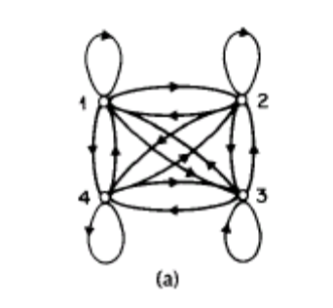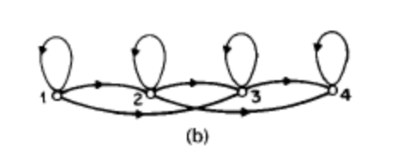
We can see from pic (a), all the states are connected with each other, and the arrows indicate the communication directions are enabled. In pic (b), at any time, the current state can only communicate with the following states and itself, but no previous state can be reached.

Ergodic model seems to be better than left-right model, since every state can be reached from every other state in a finite number of steps. But in the world, left-right model is more useful because it is easier and most of the applications do not need change the state back to previous one.

The left-right model are particular useful for our project, because this kind of model has “the desirable property that it can readily model signals whose properties change over time” (Rabiner, 1989), like speech and handwriting.

Dynamic Programming (DP)
“In computer science, dynamic programming is a method for reducing the runtime of algorithms exhibiting the properties of overlapping subproblems and optimal substructure, described below.”(Wikipedia, 2006a)

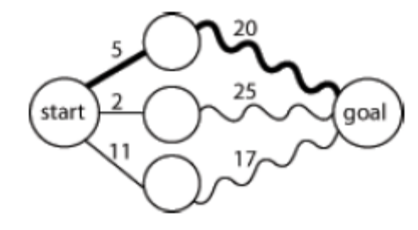
Optimal substructure means that optimal solutions of subproblems can be used to find the optimal solutions of the overall problem. We use the picture shown left to explain the definition. Starting from the leftmost circle, we got three paths to reach the rightmost circle. The number between near the line means the distances. By observing the picture, we can see at the middle of the overall path, the second path from the top has the shortest distance, however, in terms of the total distance, the top path is the shortest. Although the second path was leading the way at some point, the optimal solution is the top path.

Normally, three-step process we should take is:
Firstly, break the problem into smaller subproblems.
Secondly, solve these problems optimally using this three-step process recursively.
Thirdly, use these optimal solutions to construct an optimal solution for the original problem.(Wikipedia, 2006a)

Overlapping subproblems mean that the same subproblems are used to solve many different larger problems. We take Fibonacci sequence as example, F3 = F1 + F2 and F4 = F3 + F2, the consequence calculation also include F2. The calculation of F2 is involved in each following calculations. So we say F2 is the overlapping subproblem in Fibonacci sequence.

The overlapping subproblem introduced a new problem to us. In each calculation of Fibonacci sequence, the calculation may end up computing F2 twice or more. In this approach, it may waste time recomputing optimal solutions to subproblems the system has already solved. To avoid this, the memoization approach was introduced. Memoization means that if the same problem may be need to resolve later, the system will save the solutions to the problem and retrieve and reuse the solutions.

DP usually takes one of two approaches:
Top-down approach: break the problem into subproblems, and after resolve these subproblems, recombine all the subproblems back together.
Bottom-up approach: resolve all the subproblems in advance and then use them to build up solutions to larger problems.

DP can be very useful in the character recognition processing. Picture shown below simulate DP in Chinese Character recognition. As the new strokes are added in, the possibilities of the character change over time, eventually, the system will optimize all the possible solutions and find the best fit one.
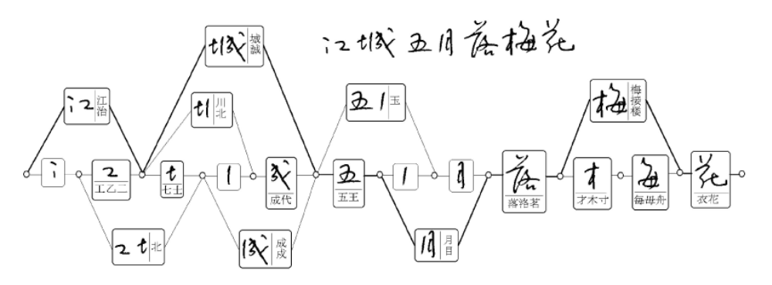

Chinese Character Processing

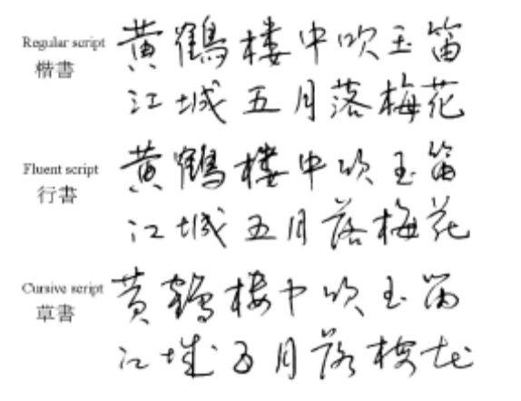
Introduction
More than one quarter of world’s population use Chinese characters in daily communications. There are three main types of Chinese characters: simplified Chinese characters, which are used in mainland China and Singapore; traditional Chinese characters, which are used in Taiwan, Hong Kong and Macao; and Japanese Kanji, which are used in Japan. In both traditional and simplified Chinese, about 5,000 characters are frequently used, In Kanji, 2,965 Kanji characters are included in the JIS level 1 and 3,390 characters in level 2.(C. L. Liu, Jaeger, & Nakagawa, 2004) Although there are a lot of styles of Chinese Characters, normally, the most common used three styles are regular script, fluent script and cursive script. Picture on the right-hand side show the difference between these styles.

Character segmentation
When the handwriting sequence is input into the system, no matter what kind of types of Chinese characters or styles they are, the sequence should be segmented into character patterns according to the temporal and shape information. Frequently, the boundary between characters can’t be determined unambiguously before character recognition, so a set of candidate character patterns are selected in contextual processing at the end of the process chain. After the segmentation, a set of individual Chinese character are output to next stage. Although there is a lot of research work has been done separately, a lot of recognition approaches are available, but for the segmentation part, almost all researchers follow the same pattern.

Pre-processing
Pre-processing consists of noise elimination, data reduction, and shape normalizations. The common used noise reduction techniques are smoothing, filtering, wild point correction, stroke connection, etc.(Tappert, Suen, & Wakahara, 1990) As the quality of input devices is getting mutual and better, trajectory noise becomes less influential and simple smoothing operations will suffice.(C. L. Liu et al., 2004)

Two frequently used approaches for data reduction are equidistance sampling and line approximation. With equidistance sampling, the trajectory points are resampled such that the distance between adjacent points is approximately equal. Line approximation, also called feature point detection, is often used in many online recognition systems.

Normalization of character trajectories to a standard size is adopted in almost every recognition system, so will our project. Three main approaches for normalization are linear, moment and nonlinear normalization. Linear normalization means that the coordinates of stroke points are shifted and scaled such that all points are enclosed in a standard box. Moment normalization means that the centroid of input pattern is shifted to the centre of standard box and the second-order moments are scaled to a standard value.(R.G.Casey, 1970) Nonlinear normalization means that the coordinates of stroke points according to the line density distribution with the aim of equalizing the stroke spacing.(S.-W., Lee, & Park, 1994)

Pattern Representation
The representation schemes of input pattern and model database are of particular importance since the classification method depends largely on them. The representation schema can be divided into three groups: statistical, structural, and hybrid statistical structural. In statistical representation, the input pattern is described by a feature vector, while the model database contains the classification parameters. The statistical-structural scheme is only used for describing he reference models. It takes the same structure as the traditional structural representation, yet the structure elements and/or relationships are measured probabilistically. HMM can be regarded as instances of the statistical-structure representation.

Pattern Representation and the following section – Classification will be the main area we are going to focus on in our project. We’ll be trying to apply HMM to the new algorithm.

Classification
Classification is the core of almost every recognition system. Classification can be further divided into coarse classification and fine classification. Coarse classification can be accomplished by class set partitioning or dynamic candidate selection. In class set partitioning, the groups of classes are determined in the classifier design stage using clustering or prior knowledge. Class grouping can be based on overall character(C. K. Lin & Fan, 1994), basic stroke substructure(R. H. Chen, Lee, & Chen, 1994), stroke sequence(Z. Chen, Lee, & Cheng, 1996), and statistical or neural classification(Matic, Platt, & Wang, 2002). In dynamic candidate selection, a matching score is computed between the input pattern and each class and a subset of classes with high scores is selected for details classification.

In fine classification, three common used approaches are Structural Matching, Probabilistic Matching and Statistical Classification. Structural matching means the input pattern is matched with the structural model of each (candidate) class and the class with the minimum matching distance is taken as the recognition result. Probabilistic matching means that using probabilistic attributes in representing structural models and computing matching distance. Statistical classification means that using various statistical techniques for classification when describing the input pattern as a feature vector.(C. L. Liu et al., 2004)

Context processing
The linguistic context can provide valuable information for selecting the optimal class from this set of candidates. In addition, the geometric features of character patterns are useful to segment a handwriting sequence into single characters. Based on the candidate classes given by the character recognizer, additional candidates can be added according to the statistics of confusion between characters in order to reduce the risk of excluding the true class. The selection of final class from candidate class is based on the linguistic knowledge represented in word dictionaries, character-based n-grams, or word-based n-grams.(M.-Y. Lin & W.-H.Tsai, 1988) Some locale specific dictionary can be used to help to determine the optimal solutions. The ambiguities in segmentation are generally solved by generating candidate character patterns and verifying the candidate patterns using geometric features, recognition results, and linguistic knowledge.

Smart Common Input Method (SCIM)
The recent Redhat Linux distributions use SCIM (Smart Common Input Method) as the input framework. SCIM is a new generation input mechanism under Linux OS. SCIM provides not only a user friendly, full featured input method user interface for POSIX-style OS (including Linux, FreeBSD and other UNIX), but also a development platform to make input method development easier. Currently the SCIM project has a wide range of input methods, covering more than 30 languages including Chinese, Japanese, Korean and many European languages. For Chinese input support, the currently SCIM only cover some shortcut key input methods.

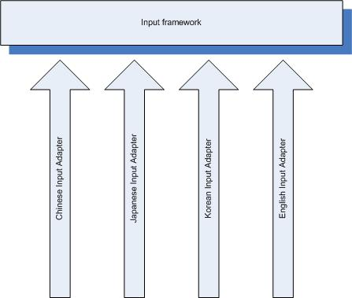
The basic idea of the previous framework can be shown in the right-hand side picture. We can see, for each language package, the developer need develop the new language adapter. To symmetrically develop an input method, such short cut key input way or handwriting input way, the actually work need be done is much more than just an adapter. From software internationalisation perspective, this kind of input framework is not acceptable, since the language and cultural information have to be embedded into the source code.

However, for SCIM the architecture is different. SCIM employ a common language adapter. When new language is needed, all the developers need is create a language package, and plug into the adapter. In this case, language and cultural information are isolated form the original source code, which means internationalisation of the software is possible. Picture below demos the current SCIM input framework.
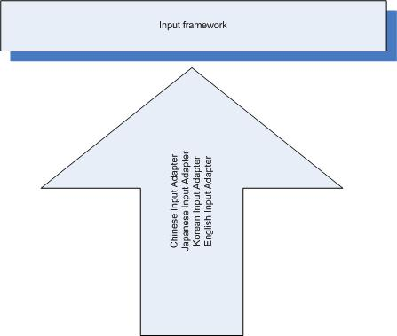

There are several reasons Linux use SCIM to replace previous input framework:
First of all, SCIM is a common IM platform written in C++. It abstracts input method interface into several classes and try to make these classes as simple and independent as possible. With such simple interfaces, developers can write their own input method in a few lines code very easily.

Second, SCIM is highly modularized: most components can be implemented as dynamically loadable modules, thus can be loaded at runtime as you wish. For example, input methods written for SCIM could be IMEngine modules, and users can use such IMEngine modules combined with different interface modules (FrontEnd) in different environment without rewrite/recompile the IMEngine modules.

Third, SCIM is a higher level library comparing with XIM or IIIMF.It has much simpler interface than XIM and IIIMF. And it can work with XIM or even IIIMF (in the future). SCIM can also support client specific input method interface, like gtk2 immodule and qt immodule.

SCIM is designed to support internationalisation. It has the following features:
- Fully Object Oriented structure written in C++.
- Highly modularized.
- Very flexible architecture, can be used as a dynamically loaded library as well as a C/S input method environment.
- Simple programming interface.
- Fully i18n support with UCS-4/UTF-8 encoding.
- Include many handy utility functions to speedup the development.
- GUI Panel with very rich features.
- Unified configuration framework.
SCIM is still under developing, several goals the SCIM is trying to achieve are:
- Act as an unified frontend for current available input method libraries. Currently bindings to uim and m17n library are available.
- Act as a language engine of IIIMF input method framework (TBD).
- Provide as many native IMEngines as possible.
- Support as many input method protocol/interface as possible.
- Support as many operating systems as possible.(C. Liu, 2006)

GTK+
GTK+ is a multi-platform toolkit for creating graphical user interfaces. Offering a complete set of widgets, GTK+ is suitable for projects ranging from small one-off projects to complete application suites.

GTK+ is free software and part of the GNU Project. However, the licensing terms for GTK+, the GNU LGPL, allow it to be used by all developers, including those developing proprietary software, without any license fees or royalties.
GTK+ is based on three libraries developed by the GTK+ team:
- GLib is the low-level core library that forms the basis of GTK+ and GNOME. It provides data structure handling for C, portability wrappers, and interfaces for such runtime functionality as an event loop, threads, dynamic loading, and an object system.
- Pango is a library for layout and rendering of text, with an emphasis on internationalization. It forms the core of text and font handling for GTK+-2.0.
- The ATK library provides a set of interfaces for accessibility. By supporting the ATK interfaces, an application or toolkit can be used with such tools as screen readers, magnifiers, and alternative input devices.
GTK+ has been designed from the ground up to support a range of languages, not only C/C++. Using GTK+ from languages such as Perl and Python (especially in combination with the Glade GUI builder) provides an effective method of rapid application development. (team, 2006)
Basically, GTK+ is like Swing in Java, and just more complicated, since GTK+ can be used to develop the GUI for entire Operating System. In terms of using GTK+ in our project, that’s low level or programming level stuff, it’s not really possible to explain more without showing the code.

Research Method
The purpose of this section is to present and describe details about the proposed research and the course of action that will be taken to complete the project. While every effort will be made to ensure the project follows the details provided in this document, unforeseen circumstances in the future may result in a different direction being taken to complete this project.

Research Approach
There are a bunch of research methodologies available. In this project, I plan to use scientistic methodology.

“Scientific method is a body of techniques for investigating phenomena and acquiring new knowledge, as well as for correcting and integrating previous knowledge. It is based on gathering observable, empirical, measurable evidence, subject to the principles of reasoning.”(Newton, 1999) Normally, the scientific method consists of the following components:
- “Observe: collect evidence and make measurements relating to the phenomenon you intend to study
- Hypothesize: invent a hypothesis explaining the phenomenon that you have observed
- Predict: use the hypothesis to predict the results of new observations or measurements
- Often advanced mathematical and statistical hypothesis testing techniques are used to design experiments that attempt to effectively test the plausibility of hypotheses
- Verify: perform experiments to test those predictions.
- Attempting to experimentally falsify hypotheses is thought to be a better choice of term here
- Evaluate: if the experiment contradicts your hypothesis, reject it and form another. If the results are compatible with predictions, make more predictions and test it further.
- Publish: Tell other people of your ideas and results, and encourage them to verify the claims themselves, in particular by inviting them to challenge your reasoning and check that your experimental results can be repeated. This process is known as ‘peer review’. “(Gable, 2006)

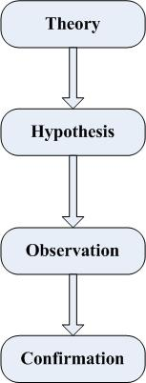
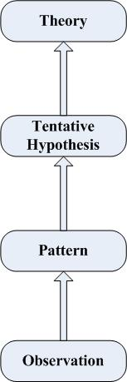
The scientific method is a general concept, which can be used as research method in different areas rather than computer science only. In terms of scientific method, there are two possible ways the researchers can take - Deductive Reasoning and Inductive Reasoning. “Deductive reasoning is generally used to predict the results of the hypothesis. That is, in order to predict what measurements one might find if you conduct an experiment, treat the hypothesis as a premise, and reason deductively from that to some not currently obvious conclusion, then test for that conclusion.”(Gable, 2006) This approach starts from more general then keeps narrow the topic and makes it more specific. Sometimes it’s called ‘top down’ approach. The right-hand side picture shows the procedures of Deductive Reasoning. Inductive reasoning works the reverse way; it starts from the more specific or the bottom to the more general or up. The left-hand side picture shows the procedures of Inductive Reasoning. Two ways of scientific form the cyclical Nature of Research, which is shown below.
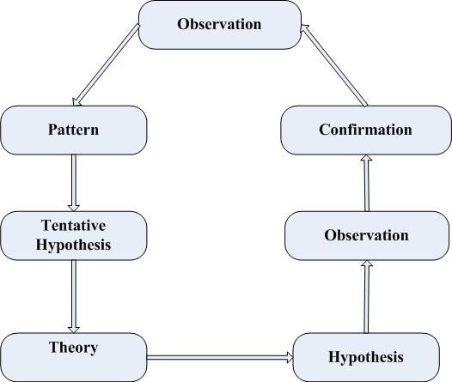

We choose this research methodology because of these following reasons:
- Clear observations and predictions
  - Some successful speech recognition have been conducted based on HMM and the speech recognition shares large similarity with handwriting recognition. So I predict HMM model can be used for handwriting recognition.
  - A lot of successful researches have been conducted with regards to handwriting recognition and the basic idea of HMM is that it treats any strokes as a sequence of dots. So I predict after incorporating the handwriting algorithm and HMM, the new algorithm will be able to recognize Chinese characters, since the characters are just a sequence of dots.
  - Fortunately, I found one Japanese character handwriting recognition software which has been successfully adopted by SCIM under Linux. So I predict SCIM will be able to adopted Chinese character recognition.
- More suitable than others
Before I made decision, I investigated some other research methodologies, such as experiments, case study, and so on. In terms of this project, our sponsor expects some useful software prototype rather than a very good algorithm. In the other words, this project focuses more on the practical work. So the research methods, like case study method, which focus on investigation, will not be suitable. As we mentioned before, we are not going to deal with a large amount of data, experiment method seems not be a good choice.

Implementation of the Project
The primary goal of this project is developing Chinese character handwriting recognition algorithm and create software prototype under Linux. Since this project involved Linux programming, C++ or C is essential implementation language. I got quite a lot of programming experience with Java and .Net languages, but in terms of C++ or C, I’m a novice. The software prototype will involve a lot of Linux GUI programming, GTK+ is the GUI language library under Linux OS. To develop the software prototype, I need learn GTK+ as well. Redhat Linux is developing very fast. Every six month, new distribution of Linux is released. For this project, I’ll be using Fedora Core 5 as the Operating System; the entire library used in this project will be compiled under FC5. To use the software application s developed in this project in future Linux distribution, user can recompile from the source code. During this research project, the following tasks need be done.
    - Learn and familiarize myself with C++
    - Learn and familiarize myself with GTK+
    - Learn HMM and Dynamic Programming
    - Decide the particular HMM type and model to use
    - Implement three classic HMM problems using C++
    - Compare HMM technique with some other existing handwriting techniques to find out if I can steal some approaches and use them to help apply HMM to handwriting
    - Analyse both handwriting and speech techniques (a lot of speech algorithm use HMM), try to find out the common part to reuse.
    - Investigate the Chinese character processing techniques, including segmentation, pre-processing, pattern representation, classification and context processing.
    - Investigate the existing Linux Japanese handwriting recognition software-Tomoe, find out the parts we can reuse
    - Create simple testing Chinese character database
    - Investigate the SCIM API
    - Create writing pad using GTK+ and C++
    - Deal with feature analysis of input character
    - Deal with unit matching system (apply HMM and DP)
    - Deal with Lexical decoding (add in word dictionary)
    - Deal with syntactic analysis (add in grammar checking)
    - Deal with semantic analysis (add in task model)
Some of tasks are at low level or programming level. It’s not easy to explain further details without show the real source code. But anyway, tasks above are what I’m going to finish within my honours project period.

Types of Outcomes Anticipated
It is hoped that upon completion of this research project that the work undertaken will help improve the understanding of handwriting technique under Linux for not only the researcher but also field in general. Especially SCIM is new, and there will be a lot of research work can be done in the future. Good research outcome in this project can give useful suggestion to the future researchers.

The following is a list of the major deliverables for this research project that have been decided upon and that the researcher will aim to produce by the completion of the work.
- A software prototype which show how well the SCIM and adopt Chinese character handwriting technique and how it works under Linux
- An enhanced writing pad which can be reused to input any language character in the future
- An online Chinese character handwriting recognition algorithm which can be portable to other OS
- A detailed instruction and approach of handwriting implementation under Linux which can be used as a guide for any other language handwriting recognition under Linux in the future

Reliability/validity of Results
To verify that the results obtained are correct rigorous testing is needed to ensure that any outcomes achieved can be reproduced. As I mentioned earlier, handwriting for Linux is quite new, any research I conduct in this research might be used in the future. So validation of any results achieved in this project is important before other researchers would accept any of the work done.

Since this project is the beginning of handwriting recognition for Linux, the primary issue is not how well the handwriting system work under Linux but it’s about whether the handwriting works. So the validation of the results is straight ward. As long as the system can recognize the characters, the job is done. In terms of recognition quality, we can try to achieve if the time is enough, or as the future project extension. Although we don’t have other similar project or algorithm to compare with, we don’t have results of two hypothesises to compare with each other. As mentioned in previous section, two possible hypothesises are taken in this project. One is incorporate HMM to existing handwriting technique, the other one is modify speech recognition which already using HMM.

Scientific method is used as the approach to this research, which tests an assumption or hypothesis that has been made through the entire project, testing is naturally part of the process. Experiments will be conducted to test two hypothesises. Experiments may be repeated until expected results come out or the predictions are approved. This will hopefully ensure that the results reported are valid and reliable and can be of benefit to the field of handwriting recognition under Linux.

Anticipated Problems and Suggestions for their Solution
As at this stage in the research proposal there are no obvious problems with the process or desired outcomes, although problems may rise further into the project can not be discounted. There are several aspects of the project that may prove to cause problems later on and are detailed here.

Firstly, Linux distribution version issue. As I mentioned in earlier sections, the distribution I use to develop the software prototype are Fedora Core 5, and Linux kernel is 2.16. The development cycle of Fedora is six month, which means that when new distribution is released, the new distribution may not be able to run the software. Same situation apply to the Linux distribution from other producer, like SuSE. The solution to this problem is recompiling source code. Normally, the source code will be delivered with the software prototype.

Secondly, external library issue. By default, when install Linux, the GTK+ library is not installed. Sometimes, even user use exactly the same distribution of Linux as I use to develop the software, the user may still encounter some issue. The solution to this problem can be easily resolved by installed extra GTK+ library and some related library.

Finally, the testing database may be too small. The testing database will be used during the project is created by myself. Only a few characters are stored in this database. When the recognition system try to recognize the character, it’s not hard for the system to find the correct one. However, when the database getting larger, there could be many characters share large shape similarity. In terms of accuracy, the recognition system may do a bad job. This problem can be easily resolved in the extension of this project. Basically, all we need to do is retrain the system, and give the system as much template as possible.

Time-line
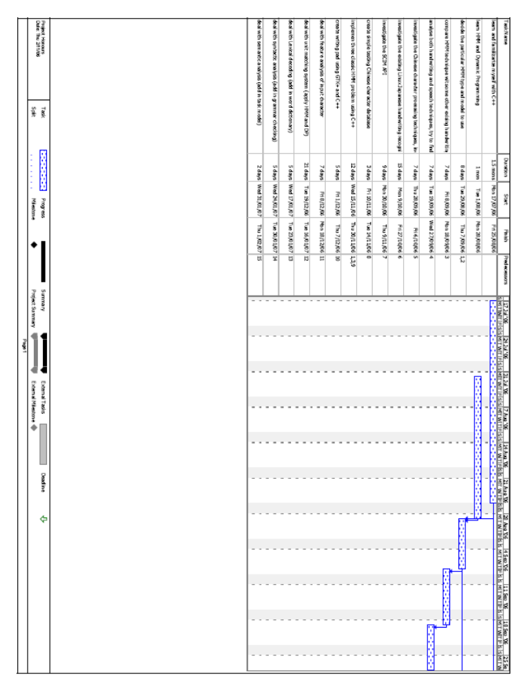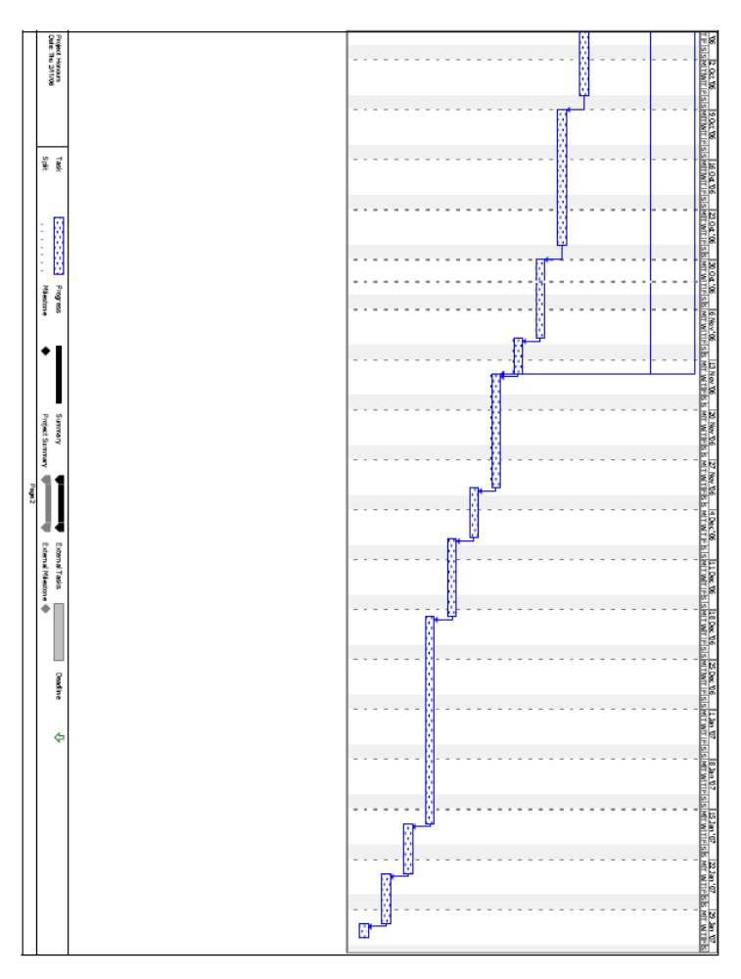

Budget
Most of the related research papers are available in library or library online store. But in case some materials are not available, document delivery may be requested, so sufficient fund should be reserved for that.

A computer with Linux Operating System is required, but software expenses can be eliminated, since I’ll be using open source OS and software to implement the algorithm.

I work at Uni or Redhat at most of the time. Both of these locations have Internet access, so there is no extra cost for setting up new broadband.

I’ll create a small testing database. But if by the end of the project, everything is going well. I may need purchase a larger database to test the software prototype.

Ultimately, it is forecast that the largest cost for the university will be the cost of supervision by the researcher’s supervisor for the course of the research project.

References
Chang, J.-Y., & Wan, M.-H. (1998). Fuzzy stroke type identification for online Chinese character recognition. Paper presented at the Systems, Man, and Cybernetics, 1998. 1998 IEEE International Conference on.

