Week 10 Practical: sorting
This week you should aim to extend the Birthday book with a sorting and selection feature. The DataTable provides a culture sensitive sort operation for columns. Your task is to write some simple code that also exercises skills in culture-dependent string comparison.

New controls
We will begin by adding controls which allow the user to enter a name or string, and to list all the individuals whose name comes after the one specified – at least according to the present default sort order. For simplicity, and to avoid clutter, we will make this another form, accessed from a button which we shall call cmdSearch. The basic layout of the main form is now as follows:
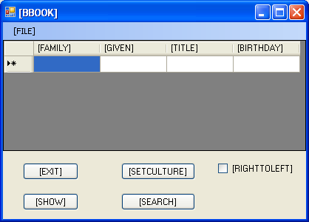

The use of the search button should yield a form which has a textbox in which a particular string can be entered, a ListBox or similar control called cultList to hold the alternative cultures (see below), a button called cmdUpdate which will cause the selection to be made, and a ListBox to contain the resulting data. Some basic idea of this may be gained from the screenshot on the next page. Needless to say, a good deal of the basics will be stolen from the SelectCulture form.
Note that the DataTable is private to the main form, so it is necessary for you to expose it in some way. The easiest way of doing this is to create a read-only public property:
public DataTable BBookTable {
get { return this.m_BBookTable; }
}
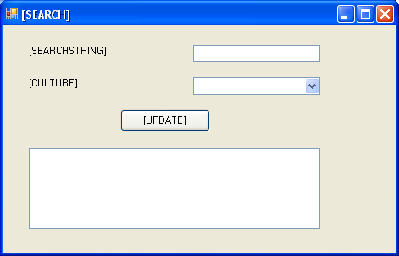

The ListBox control allows you to add text as follows:
ListBox.Items.Add("New Item");
There are also methods to clear the box, and to enforce local sorting. One may write code which, on the press of a button, populates the list box with names of people who come after a given name in the sort order.

Alternative sort orders
Some cultures support alternative methods for sorting strings, approaches geared to particular applications. To access these methods, you can create new CultureInfo objects which include a new alternative sort order. However these must be obtained by a numeric identifier. For example, we can declare a CultureInfo variable which we shall call ci, and assign to it one of the created CultureInfo objects. Below:
new CultureInfo("de-DE"); //German default
new CultureInfo(0x10407); //Phone order German
new CultureInfo("zh-SG"); //Singapore default
new CultureInfo(0x21004); //Sing. stroke count
new CultureInfo("es-ES"); //Spanish Internt'l
new CultureInfo(0x40A); //Spanish Trad.
You can then set the Current culture of the thread, and compare strings using the alternative convention:
Thread.CurrentThread.CurrentCulture = ci
comparison = String.Compare("String1", "String2");
The String.Compare method returns an integer which is negative, zero, or positive, based on whether the first string is less than, equal to, or greater than that the second. You can also use the string compare method with the culture info object directly. The third boolean argument determines whether case is ignored.
compare = String.Compare("Str1","Str2",true,cult);
Your task is to extend the application to let the user select one of these cultures for use in the string comparison used to populate the list box; but to do it without resetting any of the cultures in the thread. The appropriate culture should be passed as an argument to the relevant methods.

Sort keys
It is also possible to use a more efficient method based on sort keys, which one might use in a locale-aware application which requires that we process a more substantial amount of data:
SortKey key1, key2;
CultureInfo ci;
key1 = ci.CompareInfo.GetSortKey("String1");
key2 = ci.CompareInfo.GetSortKey("String2");
int comp = SortKey.Compare(key1, key2);
The keys capture information sufficient to sort a string, and allow that information to be accessed more efficiently. The key point, so to speak, is that we maintain cultural sensitivity by obtaining the SortKey information under the same cultural conditions.
The String.Compare algorithms which work directly on strings are generally easier to use, but in some applications the sort key technique can result in significant performance savings. The above code is simply some examples of the objects and methods which you can apply to this problem. Recode the application to use sort keys. When populating the list box, you should only need to extract the sort key of the user entered comparison string once. But once again, you must ensure that the same culture is used for all SortKey extractions…

