Online Chinese Character Handwriting Recognition for Linux

Author: Ran Cheng
Student ID: n5105269
Course: IT29 - Honours of IT
Primary Supervisor: Jim Hogan
Associated Supervisor: Jinhai Cai

Abstract:
Redhat Linux is one of the leading Linux distributions in the market. Redhat Linux provides user friendly Chinese character input by using a keyboard short cut key combination mechanism, such as the popular “Pin Ying” keyboard input method. As part of the further development of Linux, Redhat plans to add more input methods to the distributions, under Redhat Linux sponsorship, we kicked off this project. In this project, we focus on investigating the proper mechanism and approach for Chinese character recognition under Linux environment, and deliver some software prototype for the purpose of demonstrating the feasibility of our mechanism and approaches.

In this project, we start with investigating Chinese character nature, and try to find out the best suitable way to apply the recognition mechanism. By considering both complexity and time constraint, the approaches we take in this project is considering detail up to Chinese character stroke level, but use the whole character as the basic recognition unit. In terms of the recognition mechanism, we select mathematic Hidden Markov Model, and customise this model according to Chinese character and handwriting nature. During the customising we made a few assumptions, and justified them. These assumptions can be easily removed by add a few features to our recognition system. Finally, to make our recognition system work well under Linux OS, we investigated several GUI library and implementation programming languages, and selected GTK+ as the development GUI environment and C/C++ as implementation languages.

Through we focus on Chinese character and Linux OS, the handwriting mechanism we developed in this project is still portable to other Linux distributions or other OS.

Table of Content
Abstract: 1
Chapter One: Introduction 4
1.1 Statement of Research Problem 4
1.2 Research Aim and Objects 5
1.3 Rationale/Background 6
1.4 Significance of Study 7
1.5 Limitations of Study 7
Chapter two: Background and Related work 8
2.1 Hidden Markov Model (HMM) 8
2.1.1 Introduction 8
2.1.2 Element of HMM 9
2.1.3 Three classic problems 9
2.1.4 Type of HMMs 10
2.2 Dynamic Programming (DP) 11
2.3 Viterbi Algorithm 13
2.3.1 Exhaustive search for a solution 14
2.3.2 Reducing complexity using recursion 14
2.3.3 Back tracking 16
2.4 Chinese Character Processing 17
2.4.1 Introduction 17
2.4.2 Character segmentation 18
2.4.3 Pre-processing 18
2.4.4 Pattern Representation 19
2.4.5 Classification 20
2.4.6 Context processing 20
2.5 GTK+ 21
Chapter Three: Research Method 22
3.1 Research Approach 22
3.2 Implementation of the Project 24
3.3 Types of Outcomes Anticipated 26
3.4 Reliability/validity of Results 26
3.5 Anticipated Problems and Suggestions for their Solution 27
Chapter Four: Handwriting Recognition System 28
4.1 Writing pad 28
4.1.1 Event handling 28
4.1.2 Drawing Area Widget and Drawing 30
4.1.3 GUI 32
4.2 Data collection 32
4.2.1 Data selection criteria 33
4.3 Data organization 35
4.4 Data format 37
4.4.1 Raw data file 37
4.4.2 Feature data file 38
4.4.3 Distribution probability file 39
4.4.4 Transition probability file 41
4.4.5 Result file 41
4.5 Initial raw data collecting and processing 42
4.6 Feature analysis 43
4.6.1 Character decomposition 43
4.6.2 State decomposition 44
4.6.3 Input and output 45
4.7 Training state initialisation 45
4.7.1 Observation segmentation 46
4.7.2 Feature distribution 47
4.7.3 State Transition 49
4.7.4 Input and output 51
4.8 Training state optimisation 51
4.8.1 Customised Viterbi algorithm 51
4.8.2 Observation segmentation 54
4.8.3 Feature distribution 55
4.8.4 State Transition 55
4.8.5 Input and output 55
4.9 Character recognition 56
4.9.1 Feature analysis 56
4.9.2 Recognition 56
4.9.3 Input and output 57
Chapter Four: Experiment and Results 57
4.1 Evaluation Criteria 57
4.2 Scalability (cover the extend data sets) 57
4.3 Result Evaluation 57
Chapter Five: Conclusion 58
5.1 Findings and Analysis 58
Chapter Six: Future work 58
6.1 Writing Pad XInput support 58
References 59

Table of Feature
Figure 1 Types of HMM 11
Figure 2 Dynamic programming path 12
Figure 3 DP in Chinese Character recognition 13
Figure 4 Exhaustive search 14
Figure 5 Forward algorithm 16
Figure 6 Viterbi probability formula 16
Figure 7 Viterbi path formula 17
Figure 8 Three types of Chinese Character 18
Figure 9 Research approach 24
Figure 10 Handwriting Pad 32
Figure 11 Chinse character stroke list (Education) 34
Figure 12 Data collection 35
Figure 13 Data framework 37
Figure 14 Raw data text file 38
Figure 15 Feature data file 39
Figure 16 Distribution data file 40
Figure 17 part of a transition probability file 41
Figure 18 Result file 42
Figure 19 Coordinate segmentation 44
Figure 20 Feature distribution in a state 45
Figure 21 Observation segmentation 47
Figure 22 Probability formula 48
Figure 23 State Transition Architechture 49
Figure 24 Transition Distribution Matrix 50
Figure 25 Customised Viterbi algorithm 51
Figure 26 Customised Viterbi Algorithm demo 54
Figure 27 Optimised Observation Segmentation 55

Chapter One: Introduction
Handwriting is one of the input methods to let user interact with computer. Handwriting recognition has been researched for many years, but until recent years, as new types of pen input devices and interfaces have been developed, some major hardware issues have been resolved, and handwriting started to be used in PC. As a sub-project of “Internationalisation of Software” which is sponsored by Redhat (a leading Linux company), in this project, we’ll try to develop a new algorithm for Chinese Character handwriting recognition under Linux.

Statement of Research Problem
First research problem we need figure out is online handwriting recognition. There are three types of handwriting recognition: online, offline and signature recognition. Online recognition means by using some stylus and touch screen, while user are writing some strokes, the system will try to recognize the character at runtime. Offline recognition means by using a pen and a piece of paper, after users write some sentences, they put the piece of paper in a scanner, and the system will try to recognize all the information on that piece of paper at one time. Signature recognition is kind of offline recognition. Imagine when people sign some paper, most people don’t use print name, they write some symbols which won’t be able to be recognized as any language. For recognition of that kind of character, it’s called signature recognition. In this project, a couple of reasons let us choose online handwriting recognition over the other two. Firstly, online handwriting recognition is the only feasible way to recognize the input character at runtime. Secondly, online handwriting recognition is the most frequently used recognition, so research result can be used more effectively in the future.

Second research problem we need resolve is Chinese character processing. Unlike English, Chinese language has more than 10,000 character categories, and more than 50,000 characters. So recognize Chinese character is much harder than recognize English. Chinese character is composed by strokes, and the order or position of the strokes have significant influence on the recognition. In some cases, two or more characters looks very similar, but they have large difference in terms of semantic meaning. Handwriting recognition for English has been researched for ages, but until recent years, handwriting recognition for Chinese started getting popular. Handwriting recognition is sort of pattern classification, for each character, we need some pattern to match. English language only consists of 26 different characters. Chinese language, however, consists of more than 50,000 different characters, even though the most common used characters are more than 1,000. So the pattern we need to recognize Chinese characters are far more difficult than English characters. There are some technologies and algorithms already exist, but most of them doesn’t do good job, in the other words, the quality of recognition is not good. A couple of reasons convince me focusing on Chinese character. Firstly, China has the potential largest market on the world, so research conducted on
Chinese character can be well pay back. Secondly, recent years our industry sponsor launched a new large program “Internationalisation of Linux”, one of the goal for this program is developing Chinese market.

Last but not the least problem I need deal with is implementing the recognition algorithm under Linux. Linux, as the top one competitor to MS Windows, is trying to spread their advantages to the world. The best thing of Linux is that Linux is open source, which means more secure, more stable, faster development cycle and cheaper price (sometimes even free). The current Linux input framework is SCIM (Smart Common Input Method). By the end of this project, we need find out how to implement and develop a software prototype using SCIM API under Linux.

Research Aim and Objects
The following are the main objectives to achieve and questions to be answered by the end of this project.
- Review the current online handwriting recognition techniques in general and specifically to those using HMM
- Review the current online handwriting recognition techniques for Chinese character
- Review the current SCIM techniques under Linux
- Review the HMM techniques in speech recognition
- Modify some existing handwriting algorithm and Chinese character processing algorithm to try to create new handwriting algorithm for Chinese character.
- Test modified algorithm
- Modify some exiting speech recognition algorithm (HMM has been widely used for speech recognition) to let these recognition algorithm work for Chinese character recognition.
- Test modified algorithm
- Compare the results of two modified algorithm and find the better one to implement
- Implementation the algorithm under Linux
- A technical report

Rationale/Background
Recently years, computers are playing more and more important role in our daily life. Some people started learning computers at quite late age. It’s hard for some senior citizens or disabled people to learn input using keyboard. One goog choice for them could be handwriting input. Linux is a pretty new Operating System, it give people a lot of advantages over Microsoft, like better look end feel, more secure and so on.

There are quite many existing handwriting techniques, and they are using different way to achieve it. Among these techniques, only a few of them use HMM. Since this project focuses on handwriting recognition for Chinese, we can not use those existing HMM handwriting recognition directly. For example, through reviewing the literature material, I found one research paper which applied HMM techniques systematically to the speech recognition system. Although speech recognition shares a large similarity with handwriting system, the significant change is still needed, because speech recognition use continuous model instead of discrete model which is the one we are going to use.

Another reason drives this research is that handwriting is not new, but SCIM is new. So far Redhat Linux hasn’t officially done any research on implementing handwriting recognition algorithm using SCIM. Through the literature review phase, the only material can be found is about the SCIM API and some related instructions, but no implementation details.

Significance of Study
It’s hoped that that when the work for this project (both research and implementation) is completed that the study will contribute to the field of online Chinese character handwriting recognition for Linux in the following ways:
- A software application prototype which can be further extended into a fully functional software used by Linux
- A systemic handwriting recognition system implementation approach under Linux. (approach here isn’t only for Chinese, it can be used to adopt new languages)
- A new Chinese handwriting recognition algorithm which may be portable to other Operating System.
We hope after this research project, Linux developers only need a few change or extension to create new Chinese character handwriting recognition software, which will increase the chance of occupying larger percentage in the international Operating System market.

Limitations of Study
The work that will be conducted will be limited in the following ways, which could have an effect on the results and the validity achieved by the objectives that this study will endeavour to achieve.
- Database issue. The basic idea of HMM is that we develop a new training model, and train the system. Then the system will try to recognize the character input by the user based on the template conducted during the training phrase. In the order word, the more templates and information is stored in the database, the better. In this project, only I am the main researcher. The database created by me needs far more information to form a real world useful database.
- Time constraint. A Chinese character can be decomposed into a group of strokes. If we try to recognize each stroke and then recompose them back to a character, the accuracy of recognition can be dramatically increased. The decompose and recompose procedures may take years, if doing that, we could end up with every is out of control. So in the project, after balancing the time and accuracy, we decided to recognize a whole character each time.

Chapter two: Background and Related work

Hidden Markov Model (HMM)

Introduction
HMM was initially introduced and studied in the late 1960s and early 1970s, and it’s kind of statistical methods of Markov Source. HMM is assumed to be a Markov process with unknown parameters, and the challenge is to determine the midden parameters from the observable parameters. The extracted model parameters can be used to perform further analysis, and one example is the pattern recognition application which is category our project belongs to. HMM differs from Markov model, because in Markov model, the state is directly visible to the observer, in the HMM, the state is hidden but the state can influence some variables which are visible. Each state has a probability distribution over the possible output observations, so the sequence of observations generated by an HMM gives some information about the sequence of states.(Wikipedia, 2006b) In our project, for the handwriting part, the stokes can be transformed into a sequence of dots, which can be treated as the observation sequence, and the final shape of the character can be treated as the state. Therefore, by observing the sequence of dots input by user, the system will guess the correct character. This is one of the main reasons we choose HMM, and the other two strong reasons the HMM draw our attention are: firstly, the models are very rich in mathematical structure and hence can from the theoretical basis for use in a wide range of applications; secondly, when the models are applied properly, it works well in practice for several important applications. (Rabiner, 1989)

Element of HMM
An HMM is characterized by the following:
1) N, the number of states in the model. As we mentioned in the introduction, the state is hidden in the models, but for many practical applications, the number of the state are known.
2) M, the number of distinct observation symbols per state.
3) The state transition probability distribution A = {aij}, where
The formula means the probability of changing state from Si at time i to Sj at time j.
4) The observation symbol probability distribution in state j, B={bj(k)}
5) The initial state distribution π.

Given appropriate values of N, M, A, B and π, the HMM can be used as a generator to give an observation sequence.

HMM is very large math model, and it can be used in a lot of areas by selecting proper elements and use it in different way. In the other word, not all the elements will be used for every scenario. Generally, when some elements are not used, we sign a default value to them.

Three classic problems
Problem 1: Given the observation sequence and a model, how to efficiently compute the probability of the observation sequence, given the model?
Problem 2: Give the observation sequence and the model, how to choose a corresponding state sequence which is optimal in some meaningful sense?
Problem 3: How to adjust the model parameters to maximize the probability of the observation sequence.

We don’t want to worry about how to get the solution to those problems; instead of we want to discuss the implication of the problem and how we can use those solutions to resolve problems.

Problem 1 is the evaluation problem. This problem can be treated as one of scoring how well a given model matches a given observation sequence. In other words, problem 1 allows us to choose the model which best matches the observations.

Problem 2 is trying to uncover the hidden part of the model – state. One thing we should pay attention is that we can’t really find the “correct” state sequence. All we can do is to find out the best or optimal state sequence. Normally, there are several reasonable optimality criteria that can be imposed, and hence the choice of criterion is a strong function of the intended use for the uncovered state sequence. For our project, we’ll be using the theory listed in this problem. By observing the observation sequence, the system will try to find out all the possible states (characters) and list the top 10 or whatever number we required.

Problem 3 can be viewed as a “training” problem. The observation sequence used to adjust the model parameter is called a training sequence since it is used to “train” the HMM. The training process will be essential part of our project. For our project, after developing the recognition system, we need train it, and we need let it be able to recognize the template for each character.

Type of HMMs
There are two main types of HMMs and there are many possible variation and combinations possible. The first main type of HMM is called ergodic model, in which every state can be reached from ever other state in a finite number of steps. This kind of HMM is most common used in the practice. The seconde main type of HMM is called left-right model or a Bakis model. In this kind of model, the state sequence has the property that as time increases the state index increases. We use the following two pictures to show the underlying structure of these two models.
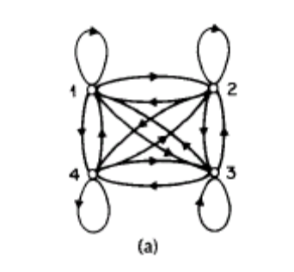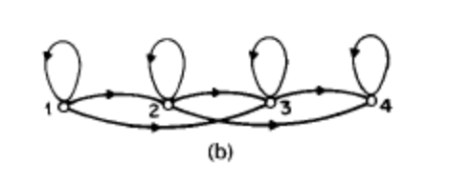
Figure 1 Types of HMM
We can see from pic (a), all the states are connected with each other, and the arrows indicate the communication directions are enabled. In pic (b), at any time, the current state can only communicate with the following states and itself, but no previous state can be reached.

Ergodic model seems to be better than left-right model, since every state can be reached from every other state in a finite number of steps. But in the world, left-right model is more useful because it is easier and most of the applications do not need change the state back to previous one.

The left-right model are particular useful for our project, because this kind of model has “the desirable property that it can readily model signals whose properties change over time”(Rabiner, 1989), like speech and handwriting.

Dynamic Programming (DP)
“In computer science, dynamic programming is a method for reducing the runtime of algorithms exhibiting the properties of overlapping subproblems and optimal substructure, described below.”(Wikipedia, 2006)

Optimal substructure means that optimal solutions of subproblems can be used to find the optimal solutions of the overall problem. We use the picture shown below to explain the definition. Starting from the leftmost circle, we got three paths to reach the rightmost circle. The number between near the line means the distances. By observing the picture, we can see at the middle of the overall path, the second path from the top has the shortest distance, however, in terms of the total distance, the top path is the shortest. Although the second path was leading the way at some point, the optimal solution is the top path.
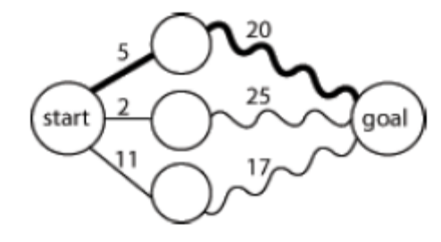
Figure 2 Dynamic programming path
Normally, three-step process we should take is:
Firstly, break the problem into smaller subproblems.
Secondly, solve these problems optimally using this three-step process recursively.
Thirdly, use these optimal solutions to construct an optimal solution for the original problem.(Wikipedia, 2006)

Overlapping subproblems mean that the same subproblems are used to solve many different larger problems. We take Fibonacci sequence as example, F3 = F1 + F2 and F4 = F3 + F2, the consequence calculation also include F2. The calculation of F2 is involved in each following calculations. So we say F2 is the overlapping subproblem in Fibonacci sequence.

The overlapping subproblem introduced a new problem to us. In each calculation of Fibonacci sequence, the calculation may end up computing F2 twice or more. In this approach, it may waste time recomputing optimal solutions to subproblems the system has already solved. To avoid this, the memoization approach was introduced. Memoization means that if the same problem may be need to resolve later, the system will save the solutions to the problem and retrieve and reuse the solutions.

DP usually takes one of two approaches:
Top-down approach: break the problem into subproblems, and after resolve these subproblems, recombine all the subproblems back together.
Bottom-up approach: resolve all the subproblems in advance and then use them to build up solutions to larger problems.

DP can be very useful in the character recognition processing. Picture shown below simulate DP in Chinese Character recognition. As the new strokes are added in, the possibilities of the character change over time, eventually, the system will optimize all the possible solutions and find the best fit one.
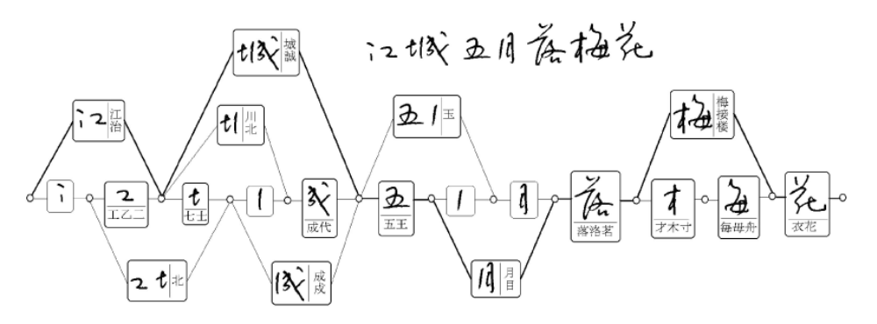(Liu, Jaeger, & Nakagawa, 2004)
Figure 3 DP in Chinese Character recognition

Viterbi Algorithm
We often wish to take a particular HMM, and determine from an observation sequence the most likely sequence of underlying hidden states that might have generated it.

Exhaustive search for a solution
One straight forward solution to this problem is exhaustive search for a solution. We can use a picture of the execution trellis to visualise the relationship between states and observations.
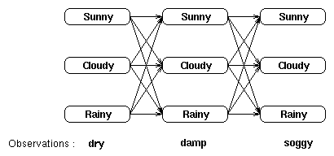(Leeds, 2006b)
Figure 4 Exhaustive search
We can find the most probable sequence of hidden states by listing all possible sequences of hidden states and finding the probability of the observed sequence for each of the combinations. The most probable sequence of hidden states is that combination that maximises. This approach is viable, but to find the most probable sequence by exhaustively calculating each combination is computationally expensive. As with the forward algorithm, we can use the time invariance of the probabilities to reduce the complexity of the calculation.

Reducing complexity using recursion
We will consider recursively finding the most probable sequence of hidden states given an observation sequence and a HMM. We will first define the partial probability , which is the probability of reaching a particular intermediate state in the trellis. We then show how these partial probabilities are calculated at t=1 and at t=n (> 1). These partial probabilities differ from those calculated in the forward algorithm since they represent the probability of the most probable path to a state at time t, and not a total.

Partial probabilities ( 's) and partial best paths
Consider the trellis we used in the “exhaustive search for solution” showing the states and first order transitions for the observation sequence dry, damp, soggy;
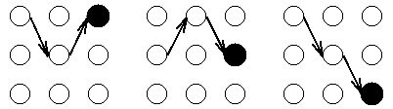(Leeds, 2006b)
We will call these paths partial best paths. Each of these partial best paths has an associated probability, the partial probability or . Unlike the partial probabilities in the forward algorithm, is the probability of the one (most probable) path to the state. Thus (i,t) is the maximum probability of all sequences ending at state i at time t, and the partial best path is the sequence which achieves this maximal probability. Such a probability (and partial path) exists for each possible value of i and t. In particular, each state at time t = T will have a partial probability and a partial best path. We find the overall best path by choosing the state with the maximum partial probability and choosing its partial best path.

Calculating 's at time t = 1
We calculate the partial probabilities as the most probable route to our current position (given particular knowledge such as observation and probabilities of the previous state). When t = 1 the most probable path to a state does not sensibly exist; however we use the probability of being in that state given t = 1 and the observable state k1 ; i.e.
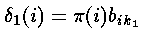
As in the forward algorithm, this quantity is compounded by the appropriate observation probability.

Calculating 's at time t ( > 1 )
We now show that the partial probabilities at time t can be calculated in terms of the 's at time t-1.
Consider the trellis below :
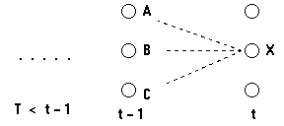(Leeds, 2006b)
Figure 5 Forward algorithm
We consider calculating the most probable path to the state X at time t; this path to X will have to pass through one of the states A, B or C at time (t-1). Therefore the most probable path to X will be one of
(sequence of states), . . ., A, X; (sequence of states), . . ., B, X; Or (sequence of states), . . ., C, X
We want to find the path ending AX, BX or CX which has the maximum probability.

Following this, the most probable path ending AX will be the most probable path to A followed by X. Similarly, the probability of this path will be
Pr (most probable path to A) . Pr (X | A) . Pr (observation | X)
So, the probability of the most probable path to X is :
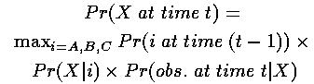(Leeds, 2006b)
Figure 6 Viterbi probability formula
where the first term is given by at t-1, the second by the transition probabilities and the third by the observation probabilities.

Back tracking
Consider the trellis we used in the “exhaustive search for solution” again, At each intermediate and end state we know the partial probability, (i,t). However the aim is to find the most probable sequence of states through the trellis given an observation sequence - therefore we need some way of remembering the partial best paths through the trellis.

Recall that to calculate the partial probability, at time t we only need the 's for time t-1. Having calculated this partial probability, it is thus possible to record which preceding state was the one to generate (i,t) - that is, in what state the system must have been at time t-1 if it is to arrive optimally at state i at time t. This recording (remembering) is done by holding for each state a back pointer which points to the predecessor that optimally provokes the current state.
Formally, we can write
(Leeds, 2006b)
Figure 7 Viterbi path formula
Here, the argmax operator selects the index j which maximises the bracketed expression.

Notice that this expression is calculated from the 's of the preceding time step and the transition probabilities, and does not include the observation probability (unlike the calculation of the 's themselves). This is because we want these 's to answer the question `If I am here, by what route is it most likely I arrived?' - this question relates to the hidden states, and therefore confusing factors due to the observations can be overlooked.(Leeds, 2006a)

Chinese Character Processing

Introduction
More than one quarter of world’s population use Chinese characters in daily communications. There are three main types of Chinese characters: simplified Chinese characters, which are used in mainland China and Singapore; traditional Chinese characters, which are used in Taiwan, Hong Kong and Macao; and Japanese Kanji, which are used in Japan. In both traditional and simplified Chinese, about 5,000 characters are frequently used, In Kanji, 2,965 Kanji characters are included in the JIS level 1 and 3,390 characters in level 2.(Liu et al., 2004) Although there are a lot of styles of Chinese Characters, normally, the most common used three styles are regular script, fluent script and cursive script. Picture on the right-hand side show the difference between these styles.
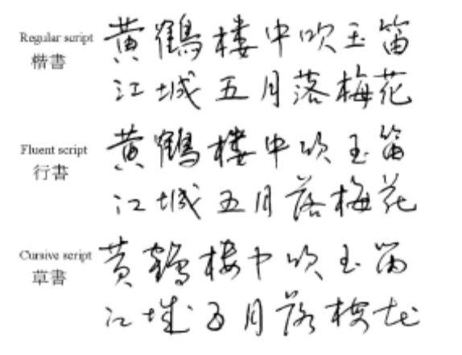(Liu et al., 2004)
Figure 8 Three types of Chinese Character

Character segmentation
When the handwriting sequence is input into the system, no matter what kind of types of Chinese characters or styles they are, the sequence should be segmented into character patterns according to the temporal and shape information. Frequently, the boundary between characters can’t be determined unambiguously before character recognition, so a set of candidate character patterns are selected in contextual processing at the end of the process chain. After the segmentation, a set of individual Chinese character are output to next stage. Although there is a lot of research work has been done separately, a lot of recognition approaches are available, but for the segmentation part, almost all researchers follow the same pattern.

Pre-processing
Pre-processing consists of noise elimination, data reduction, and shape normalizations. The common used noise reduction techniques are smoothing, filtering, wild point correction, stroke connection, etc.(Tappert, Suen, & Wakahara, 1990) As the quality of input devices is getting mutual and better, trajectory noise becomes less influential and simple smoothing operations will suffice.(Liu et al., 2004)

Two frequently used approaches for data reduction are equidistance sampling and line approximation. With equidistance sampling, the trajectory points are resampled such that the distance between adjacent points is approximately equal. Line approximation, also called feature point detection, is often used in many online recognition systems.

Normalization of character trajectories to a standard size is adopted in almost every recognition system, so will our project. Three main approaches for normalization are linear, moment and nonlinear normalization. Linear normalization means that the coordinates of stroke points are shifted and scaled such that all points are enclosed in a standard box. Moment normalization means that the centroid of input pattern is shifted to the centre of standard box and the second-order moments are scaled to a standard value.(R.G.Casey, 1970) Nonlinear normalization means that the coordinates of stroke points according to the line density distribution with the aim of equalizing the stroke spacing.(S.-W., Lee, & Park, 1994)

Pattern Representation
The representation schemes of input pattern and model database are of particular importance since the classification method depends largely on them. The representation schema can be divided into three groups: statistical, structural, and hybrid statistical structural. In statistical representation, the input pattern is described by a feature vector, while the model database contains the classification parameters. The statistical-structural scheme is only used for describing he reference models. It takes the same structure as the traditional structural representation, yet the structure elements and/or relationships are measured probabilistically. HMM can be regarded as instances of the statistical-structure representation.

Pattern Representation and the following section – Classification will be the main area we are going to focus on in our project. We’ll be trying to apply HMM to the new algorithm.

Classification
Classification is the core of almost every recognition system. Classification can be further divided into coarse classification and fine classification. Coarse classification can be accomplished by class set partitioning or dynamic candidate selection. In class set partitioning, the groups of classes are determined in the classifier design stage using clustering or prior knowledge. Class grouping can be based on overall character(C. K. Lin & Fan, 1994), basic stroke substructure(R. H. Chen, Lee, & Chen, 1994), stroke sequence(Z. Chen, Lee, & Cheng, 1996), and statistical or neural classification(Matic, Platt, & Wang, 2002). In dynamic candidate selection, a matching score is computed between the input pattern and each class and a subset of classes with high scores is selected for details classification.

In fine classification, three common used approaches are Structural Matching, Probabilistic Matching and Statistical Classification. Structural matching means the input pattern is matched with the structural model of each (candidate) class and the class with the minimum matching distance is taken as the recognition result. Probabilistic matching means that using probabilistic attributes in representing structural models and computing matching distance. Statistical classification means that using various statistical techniques for classification when describing the input pattern as a feature vector.(Liu et al., 2004)

Context processing
The linguistic context can provide valuable information for selecting the optimal class from this set of candidates. In addition, the geometric features of character patterns are useful to segment a handwriting sequence into single characters. Based on the candidate classes given by the character recognizer, additional candidates can be added according to the statistics of confusion between characters in order to reduce the risk of excluding the true class. The selection of final class from candidate class is based on the linguistic knowledge represented in word dictionaries, character-based n-grams, or word-based n-grams.(M.-Y. Lin & W.-H.Tsai, 1988) .Some locale specific dictionary can be used to help to determine the optimal solutions. The ambiguities in segmentation are generally solved by generating candidate character patterns and verifying the candidate patterns using geometric features, recognition results, and linguistic knowledge.

GTK+
GTK+ is a multi-platform toolkit for creating graphical user interfaces. Offering a complete set of widgets, GTK+ is suitable for projects ranging from small one-off projects to complete application suites.

GTK+ is free software and part of the GNU Project. However, the licensing terms for GTK+, the GNU LGPL, allow it to be used by all developers, including those developing proprietary software, without any license fees or royalties.
GTK+ is based on three libraries developed by the GTK+ team:
GLib is the low-level core library that forms the basis of GTK+ and GNOME. It provides data structure handling for C, portability wrappers, and interfaces for such runtime functionality as an event loop, threads, dynamic loading, and an object system.
Pango is a library for layout and rendering of text, with an emphasis on internationalization. It forms the core of text and font handling for GTK+-2.0.
The ATK library provides a set of interfaces for accessibility. By supporting the ATK interfaces, an application or toolkit can be used with such tools as screen readers, magnifiers, and alternative input devices.
GTK+ has been designed from the ground up to support a range of languages, not only C/C++. Using GTK+ from languages such as Perl and Python (especially in combination with the Glade GUI builder) provides an effective method of rapid application development. (team, 2006)
Basically, GTK+ is like Swing in Java, and just more complicated, since GTK+ can be used to develop the GUI for entire Operating System. In terms of using GTK+ in our project, that’s low level or programming level stuff, it’s not really possible to explain more without showing the code.

Chapter Three: Research Method
The purpose of this section is to present and describe details about the proposed research and the course of action that will be taken to complete the project. While every effort will be made to ensure the project follows the details provided in this document, unforeseen circumstances in the future may result in a different direction being taken to complete this project.

Research Approach
There are a bunch of research methodologies available. In this project, I plan to use scientistic methodology.

“Scientific method is a body of techniques for investigating phenomena and acquiring new knowledge, as well as for correcting and integrating previous knowledge. It is based on gathering observable, empirical, measurable evidence, subject to the principles of reasoning.”(Newton, 1999) Normally, the scientific method consists of the following components:
- “Observe: collect evidence and make measurements relating to the phenomenon you intend to study
- Hypothesize: invent a hypothesis explaining the phenomenon that you have observed
- Predict: use the hypothesis to predict the results of new observations or measurements
- Often advanced mathematical and statistical hypothesis testing techniques are used to design experiments that attempt to effectively test the plausibility of hypotheses
- Verify: perform experiments to test those predictions.
- Attempting to experimentally falsify hypotheses is thought to be a better choice of term here
- Evaluate: if the experiment contradicts your hypothesis, reject it and form another. If the results are compatible with predictions, make more predictions and test it further.
- Publish: Tell other people of your ideas and results, and encourage them to verify the claims themselves, in particular by inviting them to challenge your reasoning and check that your experimental results can be repeated. This process is known as ‘peer review’. “(Gable, 2006)
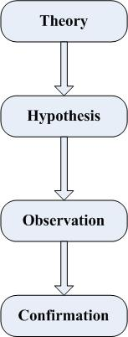
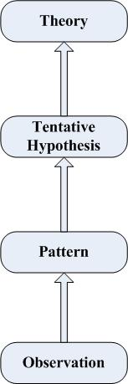
The scientific method is a general concept, which can be used as research method in different areas rather than computer science only. In terms of scientific method, there are two possible ways the researchers can take - Deductive Reasoning and Inductive Reasoning. “Deductive reasoning is generally used to predict the results of the hypothesis. That is, in order to predict what measurements one might find if you conduct an experiment, treat the hypothesis as a premise, and reason deductively from that to some not currently obvious conclusion, then test for that conclusion.”(Gable, 2006) This approach starts from more general then keeps narrow the topic and makes it more specific. Sometimes it’s called ‘top down’ approach. The right-hand side picture shows the procedures of Deductive Reasoning. Inductive reasoning works the reverse way; it starts from the more specific or the bottom to the more general or up. The left-hand side picture shows the procedures of Inductive Reasoning. Two ways of scientific form the cyclical Nature of Research, which is shown below.
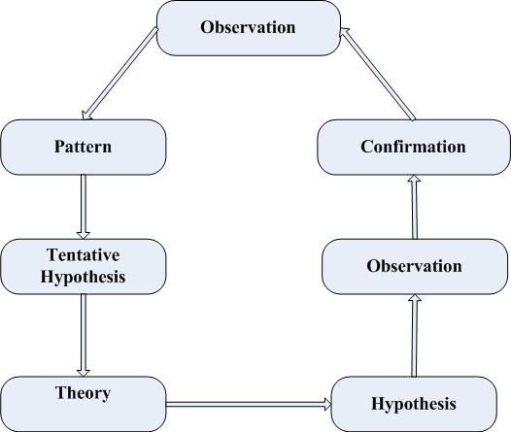
Figure 9 Research approach
We choose this research methodology because of these following reasons:
- Clear observations and predictions
  - Some successful speech recognition have been conducted based on HMM and the speech recognition shares large similarity with handwriting recognition. So I predict HMM model can be used for handwriting recognition.
  - A lot of successful researches have been conducted with regards to handwriting recognition and the basic idea of HMM is that it treats any strokes as a sequence of dots. So I predict after incorporating the handwriting algorithm and HMM, the new algorithm will be able to recognize Chinese characters, since the characters are just a sequence of dots.
  - Fortunately, I found one Japanese character handwriting recognition software which has been successfully adopted by SCIM under Linux. So I predict SCIM will be able to adopted Chinese character recognition.
- More suitable than others
Before I made decision, I investigated some other research methodologies, such as experiments, case study, and so on. In terms of this project, our sponsor expects some useful software prototype rather than a very good algorithm. In the other words, this project focuses more on the practical work. So the research methods, like case study method, which focus on investigation, will not be suitable. As we mentioned before, we are not going to deal with a large amount of data, experiment method seems not be a good choice.

Implementation of the Project
The primary goal of this project is developing Chinese character handwriting recognition algorithm and create software prototype under Linux. Since this project involved Linux programming, C++ or C is essential implementation language. I got quite a lot of programming experience with Java and .Net languages, but in terms of C++ or C, I’m a novice. The software prototype will involve a lot of Linux GUI programming, GTK+ is the GUI language library under Linux OS. To develop the software prototype, I need learn GTK+ as well. Redhat Linux is developing very fast. Every six month, new distribution of Linux is released. For this project, I’ll be using Fedora Core 5 as the Operating System; the entire library used in this project will be compiled under FC5. To use the software application s developed in this project in future Linux distribution, user can recompile from the source code. During this research project, the following tasks need be done.
    - Learn and familiarize myself with C++
    - Learn and familiarize myself with GTK+
    - Learn HMM and Dynamic Programming
    - Decide the particular HMM type and model to use
    - Implement three classic HMM problems using C++
    - Compare HMM technique with some other existing handwriting techniques to find out if I can steal some approaches and use them to help apply HMM to handwriting
    - Analyse both handwriting and speech techniques (a lot of speech algorithm use HMM), try to find out the common part to reuse.
    - Investigate the Chinese character processing techniques, including segmentation, pre-processing, pattern representation, classification and context processing.
    - Investigate the existing Linux Japanese handwriting recognition software-Tomoe, find out the parts we can reuse
    - Create simple testing Chinese character database
    - Investigate the SCIM API
    - Create writing pad using GTK+ and C++
    - Deal with feature analysis of input character
    - Deal with unit matching system (apply HMM and DP)
    - Deal with Lexical decoding (add in word dictionary)
    - Deal with syntactic analysis (add in grammar checking)
    - Deal with semantic analysis (add in task model)
Some of tasks are at low level or programming level. It’s not easy to explain further details without show the real source code. But anyway, tasks above are what I’m going to finish within my honours project period.

Types of Outcomes Anticipated
It is hoped that upon completion of this research project that the work undertaken will help improve the understanding of handwriting technique under Linux for not only the researcher but also field in general. Especially SCIM is new, and there will be a lot of research work can be done in the future. Good research outcome in this project can give useful suggestion to the future researchers.

The following is a list of the major deliverables for this research project that have been decided upon and that the researcher will aim to produce by the completion of the work.
- A software prototype which show how well the SCIM and adopt Chinese character handwriting technique and how it works under Linux
- An enhanced writing pad which can be reused to input any language character in the future
- An online Chinese character handwriting recognition algorithm which can be portable to other OS
- A detailed instruction and approach of handwriting implementation under Linux which can be used as a guide for any other language handwriting recognition under Linux in the future

Reliability/validity of Results
To verify that the results obtained are correct rigorous testing is needed to ensure that any outcomes achieved can be reproduced. As I mentioned earlier, handwriting for Linux is quite new, any research I conduct in this research might be used in the future. So validation of any results achieved in this project is important before other researchers would accept any of the work done.

Since this project is the beginning of handwriting recognition for Linux, the primary issue is not how well the handwriting system work under Linux but it’s about whether the handwriting works. So the validation of the results is straight ward. As long as the system can recognize the characters, the job is done. In terms of recognition quality, we can try to achieve if the time is enough, or as the future project extension. Although we don’t have other similar project or algorithm to compare with, we don’t have results of two hypothesises to compare with each other. As mentioned in previous section, two possible hypothesises are taken in this project. One is incorporate HMM to existing handwriting technique, the other one is modify speech recognition which already using HMM.

Scientific method is used as the approach to this research, which tests an assumption or hypothesis that has been made through the entire project, testing is naturally part of the process. Experiments will be conducted to test two hypothesises. Experiments may be repeated until expected results come out or the predictions are approved. This will hopefully ensure that the results reported are valid and reliable and can be of benefit to the field of handwriting recognition under Linux.

Anticipated Problems and Suggestions for their Solution
As at this stage in the research proposal there are no obvious problems with the process or desired outcomes, although problems may rise further into the project can not be discounted. There are several aspects of the project that may prove to cause problems later on and are detailed here.

Firstly, Linux distribution version issue. As I mentioned in earlier sections, the distribution I use to develop the software prototype are Fedora Core 5, and Linux kernel is 2.16. The development cycle of Fedora is six month, which means that when new distribution is released, the new distribution may not be able to run the software. Same situation apply to the Linux distribution from other producer, like SuSE. The solution to this problem is recompiling source code. Normally, the source code will be delivered with the software prototype.

Secondly, external library issue. By default, when install Linux, the GTK+ library is not installed. Sometimes, even user use exactly the same distribution of Linux as I use to develop the software, the user may still encounter some issue. The solution to this problem can be easily resolved by installed extra GTK+ library and some related library.

Finally, the testing database may be too small. The testing database will be used during the project is created by myself. Only a few characters are stored in this database. When the recognition system try to recognize the character, it’s not hard for the system to find the correct one. However, when the database getting larger, there could be many characters share large shape similarity. In terms of accuracy, the recognition system may do a bad job. This problem can be easily resolved in the extension of this project. Basically, all we need to do is retrain the system, and give the system as much template as possible.

Chapter Four: Handwriting Recognition System

Writing pad
To recognize the Chinese character, we need some mechanism in place to take users’ input. A writing pad is most common used mechanism to make the users’ input happen. Under Linux, GTK+ is handy a multi-platform toolkit for creating graphical user interfaces. Besides creating a handwriting pad, GTK+ can be extended to support for XInput devices, such as drawing tablets. Furthermore, GTK+ provides support routines which make getting extended information, such as pressure and tilt, from such devices quite easy. In this project, we’ll be using GTK+ to create the writing pad only, the further support can be added in the future work. In terms of writing pad, there are three things we need to cope with: Event handling, Drawing Area Widget and Drawing.

Event handling
Before I explain the writing pad event handling, I’ll give a brief explanation about theory of signals and callbacks in GTK+. GTK is an event driven toolkit, which means it will sleep the main controller event until an event occurs and control is passed to the appropriate function. This passing of control is done using the idea of "signals". (Note that these signals are not the same as the Unix system signals, and are not implemented using them, although the terminology is almost identical.) When an event occurs, such as the press of a mouse button, the appropriate signal will be "emitted" by the widget that was pressed. This is how GTK does most of its useful work. There are signals that all widgets inherit, such as "destroy", and there are signals that are widget specific, such as "toggled" on a toggle button. Callback is relative easier theory to understand. Callback is just like method or function in a programming language.

Mouse moving and key pressing are low-level GTK+ events. The corresponding low-level signals and event handlers which have an extra parameter that is a pointer to a structure containing information about the event are required to handle these kinds of events. For example, motion event handlers are passed a pointer to a GdkEventMotion structure which looks (in part) like:
struct _GdkEventMotion
{
GdkEventType type;
GdkWindow *window;
guint32 time;
gdouble x;
gdouble y;
...
guint state;
...
};
Where type will be set to the event type, window is the window in which the event occurred. x and y give the coordinates of the event, state specifies the modifier state when the event occurred (that is, it specifies which modifier keys and mouse buttons were pressed).

In the writing pad program, we are interested in when the mouse button is pressed and when the mouse is moved, so we specify GDK_POINTER_MOTION_MASK and GDK_BUTTON_PRESS_MASK as the GdkEventType. GDK_POINTER_MOTION_MASK introduces a new problem to the writing pad. This will cause the server to add a new motion event to the event queue every time the user moves the mouse. Imagine that it takes us 0.1 seconds to handle a motion event, but the X server queues a new motion event every 0.05 seconds, which means if the user keeping drawing for a several seconds, the server will be far behind to process the signal. The solution we use to resolve this problem is that we use GDK_POINTER_MOTION_HINT_MASK to replace GDK_POINTER_MOTION_MASK. When specifying GDK_POINTER_MOTION_HINT_MASK, the server sends us a motion event the first time the pointer moves after entering our window, or after a button press or release event. Subsequent motion events will be suppressed until we explicitly ask for the position of the pointer using the function gdk_window_get_pointer.(Main & team, 2007)

Drawing Area Widget and Drawing
A drawing area widget is essentially an X window and nothing more. It is a blank canvas in which the users can draw the character. It should be noted that when we create a DrawingArea widget, we are completely responsible for drawing the contents. If our window is obscured then uncovered, we get an exposure event and must redraw what was previously hidden. Having to remember everything that was drawn on the screen so we can properly redraw it can, to say the least, be a nuisance. In addition, it can be visually distracting if portions of the window are cleared, then redrawn step by step. The solution to this problem is to use an offscreen backing pixmap. Instead of drawing directly to the screen, we draw to an image stored in server memory but not displayed, and then when the image changes or new portions of the image are displayed, we copy the relevant portions onto the screen.

To create an offscreen pixmap, we use the following function:
GdkPixmap* gdk_pixmap_new (GdkWindow *window,
gint width,
gint height,
gint depth);
The window parameter specifies a GDK window that this pixmap takes some of its properties from. width and height specify the size of the pixmap. depth specifies the color depth, that is the number of bits per pixel, for the new window. If the depth is specified as -1, it will match the depth of window. For a good look ‘n’ feel, we call gdk_draw_rectangle() to clear the pixmap initially to white. Finally, the exposure event handler then simply copies the relevant portion of the pixmap onto the screen.

After discussing how to keep the screen up to date with our pixmap, now we need to find out how to draw character on our pixmap. There are a large number of calls in GTK's GDK library for drawing on drawables. A drawable is simply something that can be drawn upon. It can be a window, a pixmap, or a bitmap (a black and white image). Here is a list of drawables:
gdk_draw_point ()
gdk_draw_line ()
gdk_draw_rectangle ()
gdk_draw_arc ()
gdk_draw_polygon ()
gdk_draw_pixmap ()
gdk_draw_bitmap ()
gdk_draw_image ()
gdk_draw_points ()
gdk_draw_segments ()
gdk_draw_lines ()
gdk_draw_pixbuf ()
gdk_draw_glyphs ()
gdk_draw_layout_line ()
gdk_draw_layout ()
gdk_draw_layout_line_with_colors ()
gdk_draw_layout_with_colors ()
gdk_draw_glyphs_transformed ()
gdk_draw_glyphs_trapezoids ()
In our writing pad, we retrieve the co-ordinations from GDK_POINTER_MOTION_HINT_MASK which is discussed in previous section, then use gdk_draw_line () to connect all the co-ordinations. It should be noted that the default line side of gdk_draw_line () should be override to a larger value to achieve the better look ‘n’ feel.

GUI
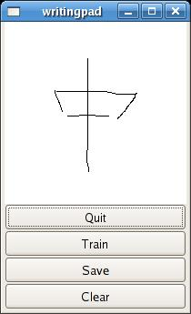
Figure 10 Handwriting Pad
This is a screen shot of the handwriting pad we developed. In the middle, there is a while spare space for user input. Users can use “Quit” button or the cross on the top-right corner to close the application. The button “Clear” is used to erase the unwanted user input. Button “train” and “Save” are used in pair to take user input and store as training example. When users try to input a character example character, before draw anything on the writing pad, they need click button “Train” to inform the system the start of input. When users finish input the whole character, they need click button “Save” to save the input to file system.

Data collection
In this project, we selected a set of characters to be used for training and recognition. There is huge number of Chinese characters, and we can’t try to recognize them all. So what we are trying to do is selecting a set of characters which can delegate the huge number of Chinese characters. In terms of the data selection criteria, please refer to the next section.

For each character in the data collection, we repeatedly write ten times in the writing pad and store them. Eight times of the characters are used for training and two times of them are used for recognition.

Data selection criteria
The objective of this project is to develop a mechanism of Chinese character recognition system, and deliver the software prototype. We do not expect this software prototype can compete with the existing commercial software, but we do expect this prototype can demonstrate the feasibility of the recognition mechanism and can be expended and used as the foundation of real world recognition system. To prove the scalability of the prototype, we will try to make good use of the limited resource. We will try to selected a few number of Chinese characters which can delegate the entire Chinese characters set, and can be easily extended to a larger characters set. Every Chinese character consists of a number of strokes. No matter how complicated the Chinese characters are, they are always can be decomposed into a list of strokes. We can not cover all the Chinese characters, but we can cover all the strokes. We believe if we can recognize those strokes, we can recognize the Chinese characters.
So two selection criteria are:
Firstly, the experiment characters should cover all the Chinese character strokes
Secondly, the experiment characters should be frequently used charaters.
A list of strokes can be found below:
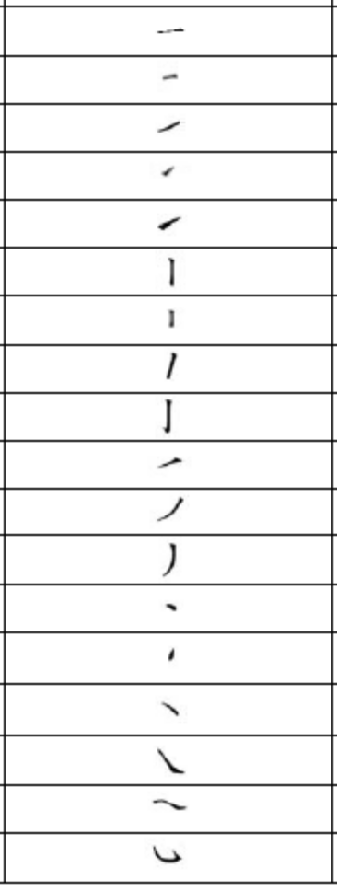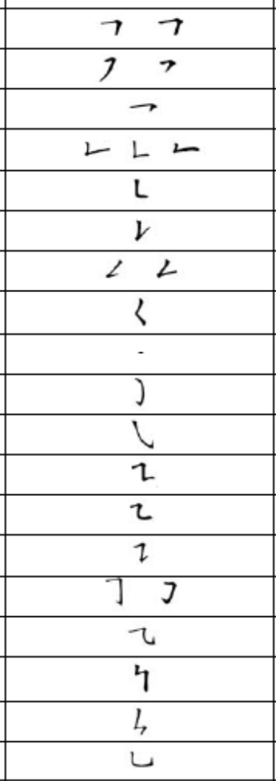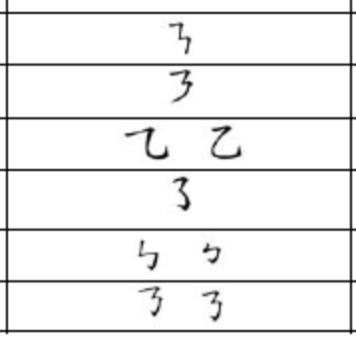
Figure 11 Chinse character stroke list (Education)

What we do in this project is that for each stroke, we select a set of characters which contains that stroke, then we pick up the only one character which is more frequently used than others. Finally, we got the following data set: 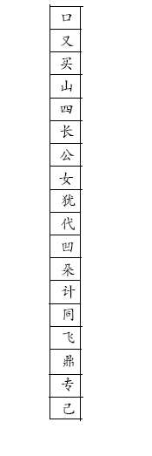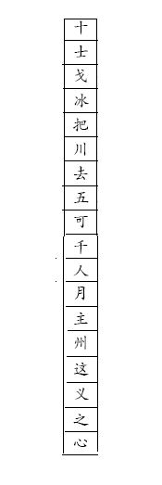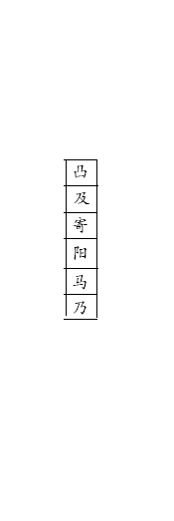
Figure 12 Data collection

Data organization
After getting the data collection, we need work out how to organize the data. In this project, we will create a data framework according to the role of the data play.

At the top of the data framework, all the data will be categorised into two types – training data and recognition data. We need allocate some of the data in the data collection as the training data, and the rest as the recognition data. As mentioned before, for each Chinese character, we let user write ten times in the writing pad and store in the central repository. We use the first eight times as the training data and the rest as the recognition data.

In terms of the training data, it can be further categorised into three types – Raw data, Initial Data and Optimised Data. Raw data is the data we get directly from the writing pad without any process; after pre-processing or initialising the raw data, we get the initial data; after optimising the initial data, we end up with the optimised data. Further details about these three types of data and processing, please refer to the following section. Under Raw Data directory, we classify all the raw data by character, and store the all the raw data file which represent the same Chinese character within one directory. Following the same pattern, all the feature data (initialised data) will be categorised by character as well. There are two text file are associated with each character. One of the text file contains the distribution probability of features in each character. The other text file contains the transition probability of states in each character. With regards to distribution and transition probability, please refer to the following sections. “Optimised Data” folder use exactly same structure with “Initial Data” folder. It contains a sequence of folders categorised by character and text files which are associated with each character. However the only difference between “Initial Data” folder and “Optimised Data” folder is the content within each character folder. In the character folders under “Initial Data”, the text files contain the feature data. But in the character folders under “Optimised Data”, the text files contain the Viterbi sequence data.

In terms of recognition data, it can be further categorised into three types as well – Raw data, Feature data and Result data. The “Raw data” folder shares the exactly same structure with “Raw data” folder under training data. The “Feature data” folder is similar to the “Initial data” folder under training data except that “Feature data” folder doesn’t contain the distribution and transition probability files. The “Result” folder contains all the recognition results.

The picture below shows the data framework.
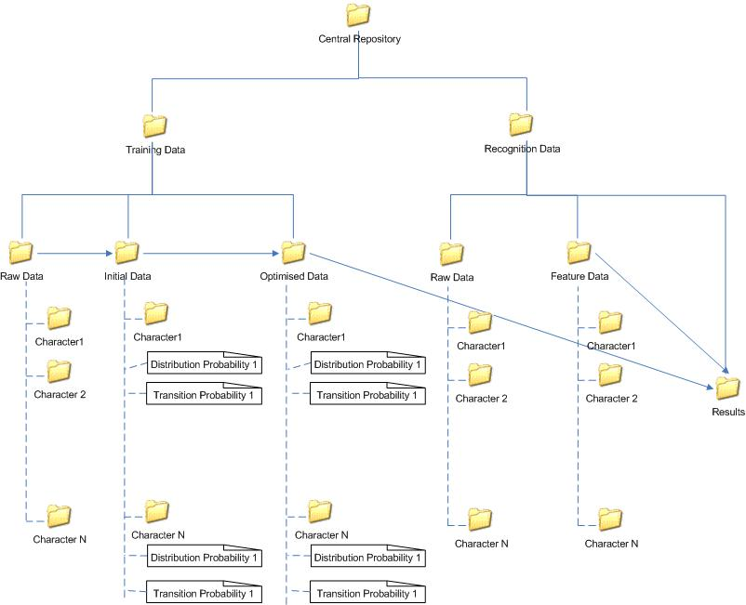
Figure 13 Data framework

Data format
So far we have discussed the overall data framework structure. Now we get into more details about the data files. There are two options for us to store the data files, text and binary. In terms of the efficiency, binary should be a better choice. In this project, however, we focus more on the feasibility and the accuracy of the mathematic model and algorithm, furthermore, for easy diagnostic purpose, we used text format for all the data files. To improve the efficiency of the recognition system, binary format can be used in the future work.

Raw data file
We follow the order we discuss the folders in previous section. We start with “Raw data” folder in the “Training data” folder. In each Character folder, there are a number of files which represent the same character. Those files contain the raw data which means the data directly retrieved from the writing pad without any processing. From the system point of view, the characters which are drawn by the users are just a sequence of dots in the coordinate and nothing more than that. So when we store those dots for a character, we should see a sequence of X, Y coordinates. The separator should be used between X, Y coordinates, and we use “,” in the raw data files. While retrieving the sequence of the dots which represent the characters, we need take some action to clearly identify the border between strokes. We use tag mechanism to do so. All the dots which belong to the same stroke will be stored between tag “<s>” and “</s>”. A screen shot of two-stroke character raw data file can be found below:
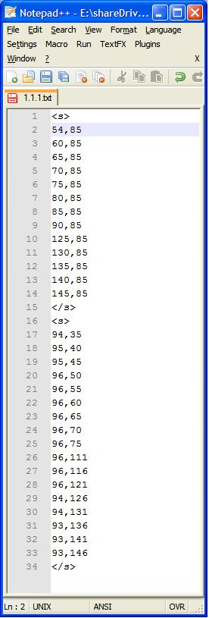
Figure 14 Raw data text file

Feature data file
In essential, Feature data files are the raw data files after feature analysis process. There will be one to one mapping between raw data files and feature files. Furthermore, during the feature analysis process, information loss should never occur, so the feature data file contains the exactly same number of rows as the raw data file. By comparing the two screen shots (one for raw data from previous section and one for feature data below), we can see there 34 rows in raw data file, and 4 of them are tags. So the corresponding feature file contains 30 rows. It should be noted that the feature doesn’t employ the tag mechanism, since the recognition system use different method to handle these types of files. To segment the strokes in the character in the feature file, we use “add/minus” mechanism. We already know the number appear in the feature data files are always between “0” and “15”, so we need find some particular number, and after adding that particular number to the original value, the original value can be significant change and is out of the normal range. The particular number we pick up is “16”. For the first value of each stroke, we add number “16” to it, and for the last value of each stroke, we minus “16” to it. Every time the system meets a number larger than 15 or less than 0, it will notice that is the beginning or end of a stroke.
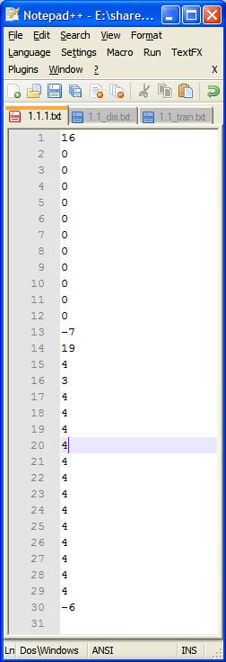
Figure 15 Feature data file

Distribution probability file
We mentioned in the previous section, there can be sixteen different numbers in the feature data files (don’t include the heading and ending process). Actually, those sixteen numbers represent the sixteen possible statuses of features. Every feature is in one of the sixteen statuses in each state, and the percentage of particular status occupy in the state is called the distribution probability of that status. The distribution probability files contains a list of sections, and each section consists of sixteen rows which represent the sixteen different status of a state. Like the raw data and feature data files, we still need locate the border of the states, but no additional mechanism is required to do so. Since each state section always occupy sixteen rows in the file, we can locate the border by counting the number of rows. One thing we should notice is the summary of each state section should always equal one.
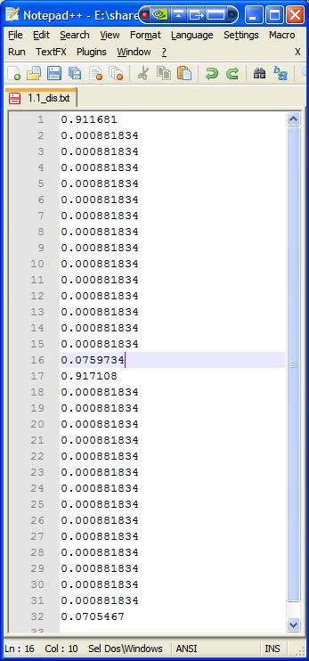
Figure 16 Distribution data file

Transition probability file
Similar to the distribution file, transition probability contains a list of probabilities as well. The transition probability describes the probability of one state jumping to another. Since different characters may contain different number of states, we can not use the “counting row” method to locate the border of states. The probability is always between 0 and 1, so we can use the mechanism used in raw and feature data file. However, in some middle stages of the recognition process, we want to keep the summary of probability equal one. Furthermore, each section in the transition probability files represents one row in a 2D array. So instead of using the “add/minus” mechanism, we manually add some tag between sections. The tag we used is “new row”. The screen shot below shows part of the transition probability file.
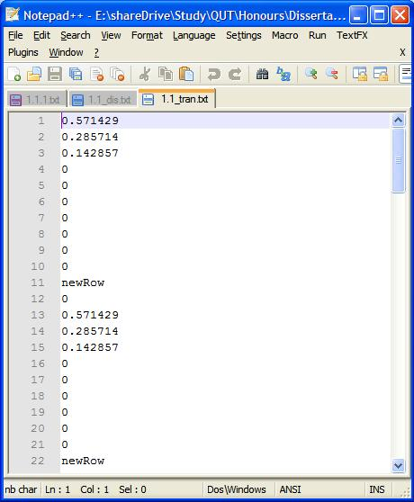
Figure 17 part of a transition probability file

Result file
The result file contains the recognition result of a character. At the top of the file, it shows information about input character for recognition, and a sequence of match patterns are listed below in descending order by the similarity. An assistant ranking number mechanism is used to make the result easier to read. The screen shot below shows the recognition result of character with ID 1.2.
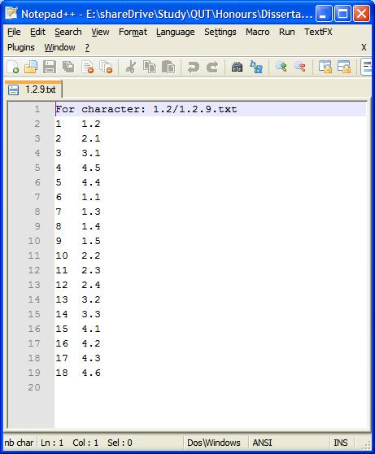
Figure 18 Result file

Initial raw data collecting and processing
As discussed in the writing pad section, every time the GDK_POINTER_MOTION_HINT_MASK is called, it will record the current position of the cursor in the writing pad, and until the user issue a signal to the writing pad to indicate the end of input, the writing pad will output the list of position to a text file. The interval between GDK_POINTER_MOTION_HINT_MASK events is only 0.05 second, as the result, we could end up with a huge number of cursor positions. If we use these data without some necessary processing, the overall efficiency of the recognition system could be significantly decreased. The GDK_POINTER_MOTION_HINT_MASK interval is fixed, and we can not do much about it. But we can do is periodically pick up some cursor positions rather than pick up all. There are two easy implementations solution for this problem. One is setting up some time frame, for example double or triples the GDK_POINTER_MOTION_HINT_MASK interval. Another one is setting up the distance between two cursor positions. The former one may introduce new problem to the data collection. For example, if the user input first half part of the stroke quite slow, and second half part of the stroke quite fast. Most of the data will be representing the first half of the stroke, the first part will become the dominating part and the whole stroke is not balanced. In this project, we take the latter approach, and set the distance interval to 5 pixels. The number of distance interval can be slightly adjusted, but can not be less than 3. The reason for this will be given in “Feature analysis” section.

Feature analysis
HMM is a pure mathematic model, but handwriting is more on the Graphic User Interface side. We need have some mechanism sitting between them, and let them be able to talk to each other. As mentioned in the literature review, HMM need five essential elements. To apply the HMM to the real world research problem, the elements “state” and “observation” should be firstly resolved. We need decided what the states and observation should be in the model correspond to, and then deciding how many states should be in the model.

Character decomposition
In this project, we use the single Chinese character as the training and recognition unit. Each unit consists of several sections which correspond to the strokes in that character. The section is the container of the “states”, and each section contains a fix number of states. In other word, we used a fix number of states to represent a stroke. Now, we go back to section 3.2.1, by observing the Figure “Chinse character stroke list”, we can see the most complicated stroke of Chinese character is “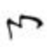”, which consist of five segmentations. What this mean is that we need at least use five states in a stroke to cope with all the possible occurrences. Theoretically, the more segmentations (or states) the strokes have, the more accurate the recognition results should be, but the efficiency of the recognition system will go down as it need process more states in each stroke. In this project, we focus on the feasibility of HMM and reasonable accuracy. So we start with five states in each stroke. To make the definition more clearly, we use a two-stroke character as the example to demonstrate. The character “人” can be represented using the following state sequence: S₀, S₁, S₂, S₃, S₄, S₅, S₆, S₇, S₈, S₉.

State decomposition
Up to this stage, we have decomposed the Chinese character into a sequence of stages, but we haven’t completely finished the mapping between the Chinese character and the raw data. Furthermore, we haven’t decided what the observation of HMM correspond to yet. What we are going to do here is to pick up a pair of cursor position data from a raw data file. By putting these two position data in the coordinate, they can determine an angle. We divide the entire coordinate into sixteen equal parts, and assign each part a number starting from 0 and ending with 15. Then according to the angle, we use the correspond number to replace the position data, and output to a text file which is called feature file. We repeat the procedure to all the raw position data, and finally we will get a collection of feature data which correspond to the original raw data files. The picture below shows the sixteen segmentation of the coordinate.
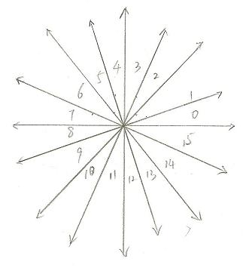
Figure 19 Coordinate segmentation

After getting the feature data, the observation problem has been solved implicitly. Basically, we can use the feature data as the observation in HMM. The last thing we need to do is to create the relation between the states and features. We let the state be the container of features, and store the features by allocating them according to their feature number. From the software engineer point of view, the state contains an array with the size 16. Every item in the array contains the number of same type of features. For example, a state which contains 35 features may have the following structures:
0 | 1 | 2 | 3 | 4 | 5 | 6 | 7 | 8 | 9 | 10 | 11 | 12 | 13 | 14 | 15
0 | 2 | 3 | 1 | 5 | 0 | 4 | 3 | 1 | 1 | 1 | 1 | 2 | 5 | 2 | 4
Figure 20 Feature distribution in a state
This state does not contain feature with number “0” and “5”; contains only one feature for feature with number “3”, “8”, “9”, “10” and “11”; contains two features for feature with number “1”, “12” and “14”; contains three features for feature with number “2” and “7”; contains four features for feature with number “6” and “15”; contains five features with number “4” and “13”.

By now, the entire GUI character has been transformed into a sequence of number which can be coped by HMM.

Input and output
Input: Raw data files getting from the writing pad.
Output: feature data files.

Training state initialisation
In the feature analysis phase, we have already figured out two elements of HMM, the “state” and the “observation”. In order to apply the HMM to our recognition system, we need figure out the rest three elements before we move on. In this project, we will deliver some software prototype rather than a perfect recognition system. So some assumptions need to be made at the very beginning. Firstly, we assume the users know the correct order to write the strokes in Chinese characters. Secondly, we assume the users know the correct way to write the Chinese strokes. Every Chinese character has a standard way to draw, and we made the assumption that all the users are aware of the standard. What it means is that for a character, we always start at the same stroke and use the same way to draw that stroke. In terms of the initial state distribution π, it is certain we always start at state S₀.

Observation segmentation
HMM is always associated with statistic methodology. In our project, we have a number of training examples for each character. Since all the raw data files which represent the same character are grouped together (see Data organization section), we can easily process them group by group. In each raw data or feature file, there is no separator between the states. One of the goal we want to achieve by using Viterbi algorithm (see section “Customized Viterbi Algorithm” is to find out the proper border between the states, but before we do that, we need roughly give a border to the states. The approach we use is to try to equally divide the list of feature observation in each stroke in each feature file into a fix number (the number is 5 in our project). For example, if there are 16 feature observations in a stroke, we will end up with 3, 3, 3, 3 and 4. What this means is that the first three feature observation belong to state one; the second three feature observation belong to state two, and so on.
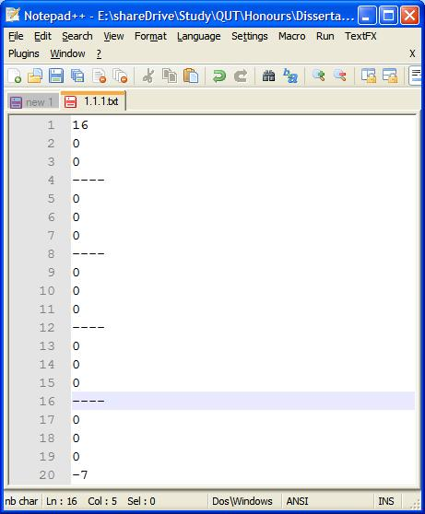
Figure 21 Observation segmentation

Feature distribution
After roughly divide the strokes into five states, now we can do something on states. We go through each file in the group and count the accumulated value of each feature in each stroke. For example, if we have two training example files one and two, for state X, after the process, we will end up with the last table shown below.
State X in file one: (table one)
0 | 1 | 2 | 3 | 4 | 5 | 6 | 7 | 8 | 9 | 10 | 11 | 12 | 13 | 14 | 15
0 | 2 | 3 | 1 | 5 | 0 | 4 | 3 | 2 | 0 | 0 | 2 | 2 | 5 | 2 | 4
State X in file two: (table two)
0 | 1 | 2 | 3 | 4 | 5 | 6 | 7 | 8 | 9 | 10 | 11 | 12 | 13 | 14 | 15
1 | 1 | 4 | 0 | 3 | 2 | 3 | 3 | 2 | 0 | 0 | 3 | 6 | 4 | 2 | 2
Static State X value: (table three)
0 | 1 | 2 | 3 | 4 | 5 | 6 | 7 | 8 | 9 | 10 | 11 | 12 | 13 | 14 | 15
1 | 3 | 7 | 1 | 8 | 2 | 7 | 6 | 4 | 0 | 0 | 5 | 8 | 9 | 4 | 6
After we get the statistic value in the state, we can start calculating the feature distribution probability in each state. Still using the example above, we can see the total number of features in the state is 71, so the distribution probability of feature “0” d₀ is 1/71 = 1.41%, d₁ = 4.23% and so on. One interesting thing is that for feature “8” and “9”, there is no occurrence in table one and table two which lead to the d₈ and d₉ both equal 0. The point I am trying to make here is that due to the time constraint, we only can employ a few training examples, but it is highly possible that those training example didn’t complete cover all the possible feature occurrences. If we only use the training example to make the training model, when another variation emerges, this model will not treat it friendly. The improvement we use to fix this problem is to give an extremely small possibility to those kinds of features. The formula to calculate the small value is:
Probability = 1 / (80*N)
Figure 22 Probability formula
Where N is the number of features which has no occurrence. In the above example, N = 2.
It seems to be trivial improvement at this stage, but it can make huge difference in terms of the recognition results. For instance, if we have two user inputs which represent the same character, one of the inputs has 70% match and all features observations are contained in the character model, another one has 99% match but a few features observations have no probability in the character model. Before the employ the improvement, the latter higher match character will be abandon, since 99% * 0% equal 0%.

By adding extra value to the distribution probability, even the extra values are extreme small, but it still make the overall probability exceed 1. Before the distribution probability can be used, we need normalise it to 1. The approach we take is quite simple, we recalculate the total distribution probability P_{new} (should be larger than 1), and let each probability in the distribution multiple 1/ P_{new..}

State Transition
To understand and calculate the state transition probability, we need figure out the state transition architecture used in our project. As mentioned before, every stroke consists of five states, and every character consists of a list of strokes. So a character can be described by the picture below:
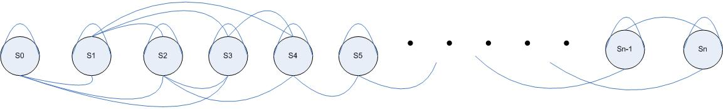
Figure 23 State Transition Architechture
As the time goes, a state can stay at the same place or it can jump to following states. We give set the max jump number. In the picture above, we set the max jump number to 3. In additional, we know use always need finish draw one stroke before start drawing the second one, which means the all the states in one stroke can jump until the last state in one stroke. Lastly, the last state in the stroke can jump the first state in the following stroke and repeat the procedure. So we combine these two rules, and get the following rule: as time goes on, any state can stay at the same place or jump to the following states, the state can jump MAX number times or until reach the last state of the stroke it belong to and the last state can jump to the first state in the following stroke. By observing the picture above, we can see, S0 and S1 can jump 3 times; S2 can only jump twice; S3 can only jump to S4; and S4 only can stay at the same place or jump to S5 which is the first state in the following stroke. Actually, the procedure happened to the first stroke will repeat in the following strokes as well. In every stroke, it always starts at the first state, and end at the last state then jump to the first state in the next stroke.

Now we go further to the inside of the state. The features in the state follow a similar pattern as the state transition architecture does. There is a sequence of features labelled as f0, f1 and so on, and only the last feature can jump to the first feature in the next state. For instance, there are two adjacent states, and both of them contain 6 features. So we used the following feature sequence to present these two states: f0, f1, f2 … f11. The border between these two states sits between f5 and f6. In other words, in the first state only f5 can jump to f6 which is the first feature in the second state. By observing the sequence of the features, we can see that if we randomly pick up one feature, there is only 1/6 chance a state transition could happen, and 5/6 chance the feature transition could happen which happen only within one state. It’s not hard to note that the calculating we just discussed is only suitable for the state transition with max jump number equal one. In our project, however, we set the max jump number equal three. So we need develop another calculating method on top of the existing one. In the new calculating method, we keep the probability of a state stay at the same place, and for all the following transition probabilities, we let the next probability equal half of the current probability. Still using the same example showing in Figure “State Transition Architechture”, we let S0 has N features, so the probability of S0 stay at its self is (N-1)/N, the probability S0 jump to S1 is 0.5*((N-1)/N), and the probability S0 jump to S2 is 0.5*0.5*((N-1)/N). Finally, we normalise the probability using the approach we discussed before, we should get state transition matrix like this:
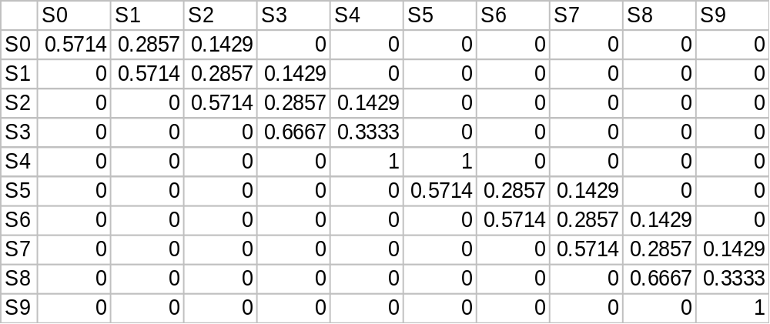
Figure 24 Transition Distribution Matrix
This is transition distribution matrix for a character consists of two strokes. We can see this matrix follows all the rules we defined before. The only thing we didn’t mention but appear in the matrix is the transition probability S4 – S4 and S4 – S5. We can see all the rows except row S4 in the matrix follow the rule: the total probability should equal one. The reason for this is that we the last state must stay at the same place, but after that we need give some instruction to make sure next state must start at the first state in the second stroke.

Input and output
Input: feature data file getting from the feature analysis step
Output: initial distribution probability files and transition probability files.

Training state optimisation
The distribution and transition probability we got from Training state initialization are approximate values, so we can not use them straight way. But all the values we got from previous steps are very good starting point. In this section, we will introduce our customised Viterbi algorithm, and use the existing distribution, transition probability and feature files to find out the best state path with can interpret the observation feature sequence. Then starting from there, we review the feature files, and recalculate the optimised distribution and transition probability for each character. Some of the steps in this section are just repetition in training state initialisation. For consistence, we still list them as parts of this section, but in terms of the actual content, please refer to previous section.

Customised Viterbi algorithm
Step 1: Initialization
α₁ ₌ logb_{i} (O₁)
Φ₁ (i) = 0
Step 2: Recursion. From time t=2 to T.
α_{t} (j) = max[α_{t-1}(i) + loga_{ij} + logb_{j}(O_{t})],
Φ_{t} (j) = argmax[α_{t-1}(i) + loga_{ij}] i < j
Step 3: Termination. (S_{F} is the final state set.)
Β₁(ω) = logρ*(O|λ _{ω}) = max[α_{T}(s)],
s_{T} = argmax[α_{T} (s)]
Step 4: State path backtracking. From time t = T-1 to 1.
s_{t =} Φ_{t+1} (s_{t+1})
Figure 25 Customised Viterbi algorithm
As discussed previously, when drawing the character, we always start at the first state S₀, so in the “initialization” stage, there is no the initial state distribution π required. In the initialization stage, we initialize two values, the probability at first state α_{1,} and the best path to first state Φ_{1.} With regards to Φ₁, one thing I want to make clear is the path indicates the best path between two states, not the best path through the whole sequence of states. The best path through the whole sequence of states will be calculated at the “State path backtracking” stage. Basically, the probability at first state only depends on the feature distribution probability.

In “Recursion” stage, the probability at the current stage depends on three factors: the probability at the previous stage, the transition probability between previous and current states and the feature distribution probability. Ideally, any states at time t-1 can jump to the current state at time t, so there will be a list of probabilities. We pick up the largest value, and store it as the probability of current state. It should be noted that the probability values we get from the formula are always be negative number, so when we try to pick up the bigger, we try to pick up the one closer to 0, not the absolute value of the number. The best path calculation use the similar calculating approach, but one more additional step need to be taken. After we find out the biggest value, we need map the biggest value to its origin. In other word, we need find out which path (connecting the previous state and the current state) can make the biggest probability value occur, and record it as the current Φ.

In “Termination” and “State path backtracking” stages, when we reach the last observation at time T, we will end up with a list of probability values. The state with the largest probability will be the ending state of the overall state sequence, and in this project we should always expect the ending state is the last state in a character. Since in the “Recursion” stage we already the best path for each state, now we just simply trace back.
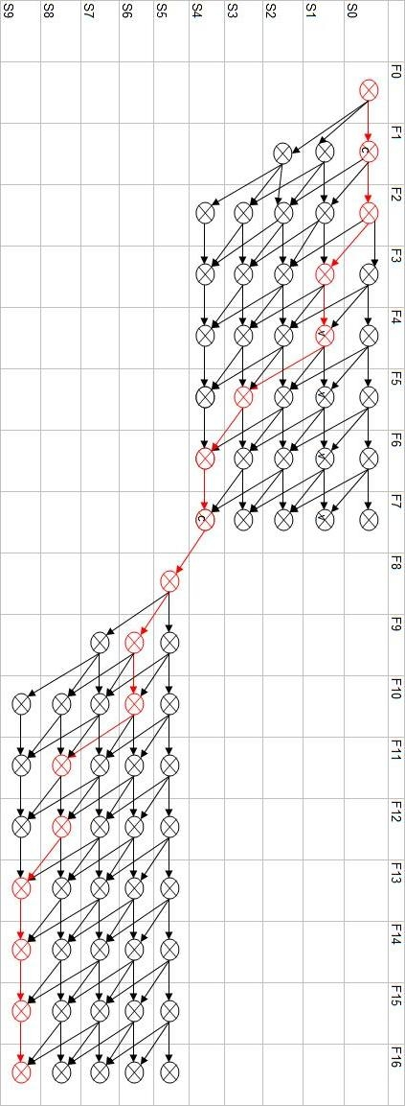
Figure 26 Customised Viterbi Algorithm demo
The picture above is a simple demo for a character with two strokes. We assume one of the feature file contains 17 features (the first 8 feature represent the first stroke and the rest represent the second stroke), so we should form a 10 rows (we set the state number for each stroke equal 5, and the max jump number of state equal 3) and 17 columns matrix. The icons including black ones and red ones show all the possible paths occur and the red ones indicate the final best path. Actually, picture does not show all the actual paths happened in the system, it only shows the paths which has enough weighting to affect the final result. For example, for transition between F7 and F8, this picture shows the jumping between S4 and S5. Actually, the jumping between any two of S0, S1, S2, S3, S4 still happen, but since they are heavily penalized, their probabilities are extremely small to affect the overall result, to make the effective paths more clear, we simply ignore the rest in this picture.

By observing the picture above, we can see the state jump in forward direction. That is because in the transition probability file, we set the backward probability to 0. In additionally, we can see the border between two strokes is very clear. To make this happen, we use penalty mechanism. We give a large penalty to the state transition which we do not expect to make sure that state transition will not be counted in the best path even it does happen. For instance, if a feature is the first feature for a stroke, the state it stays must be the first state of that stroke, like feature F0 must stay at state S0 and F8 must stay at S5.

Observation segmentation
After apply the customised Viterbi to a feature file which is from the state straining initialization, we will get a corresponding state sequence file. We will use the corresponding state sequence as the index original feature file, and redefine the border of the state in the feature files. We use the following files (one is optimised segmentation file, the other one is the corresponding state sequence file) to demonstrate:
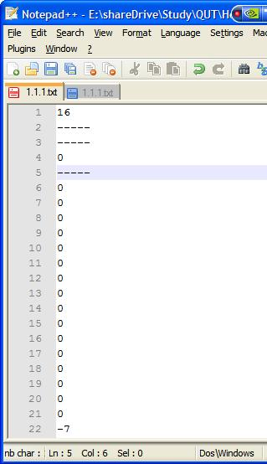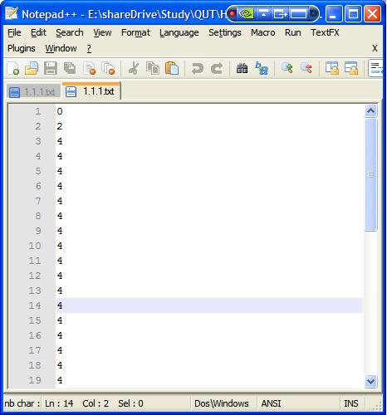
Figure 27 Optimised Observation Segmentation
By using the state sequence as the index, we can tell the first feature in the original feature file belong to S0; there no feature belongs to S1 and S3; the second feature in the original feature file belongs to S2; all the rest belong to S4. By comparing the new Observation segmentation file and the one in initialisation, we can see that these two files which are original from the same feature file now have different borders.

Feature distribution
Please refer to section “Feature distribution” in “Training state initialisation”.

State Transition
Please refer to section “State Transition” in “Training state initialisation”.

Input and output
Input: initial distribution probability and transition probability files
Output: state sequence files, optimised distribution probability and transition probability files.

Character recognition
This is the final stage of the entire recognition system. There is no new mechanism added in this stage, and it just a simple reuse all the algorithm and mechanism we developed before and do a comparison between the runtime inputs with the training model stored in the system.

Feature analysis
Please refer to section “Feature analysis” in previous section.

Recognition
The recognition stage is very similar to the optimisation stage, and we still use our customized Viterbi algorithm. For testing purpose, we use the stored input files (the two files we reserved in the very beginning) as the recognition files, but in the real system, we let use to input the character runtime and store it in some temp file to use as the recognition file. Here is a list of steps we need follow to recognise the input character:
- Create a ranking list.
- Pick up a reserved input file as the observation file in our customised Viterbi algorithm.
- Pick up the distribution probability and transition probability files for a character stored in the database or file system.
- Run the customised Viterbi algorithm and record the overall probability (we only used the overall path in the state transition optimisation, and only use overall probability here).
- According to the probability, insert the character at the proper position into the ranking list.
- Repeat step 2 to 5 until no more character data left in the database or file system.
If everything is all right, we should end up with a list of character names, the top one in the rank is the most possible matching character. In the words, the recognition system thinks the top one in the rank is the character user try to input.

Input and output
Input: feature data file from feature analysis in “Character recognition”
Output: recognition result (in a rank format)

Chapter Four: Experiment and Results
Two examples:
Recognition result for 4.6
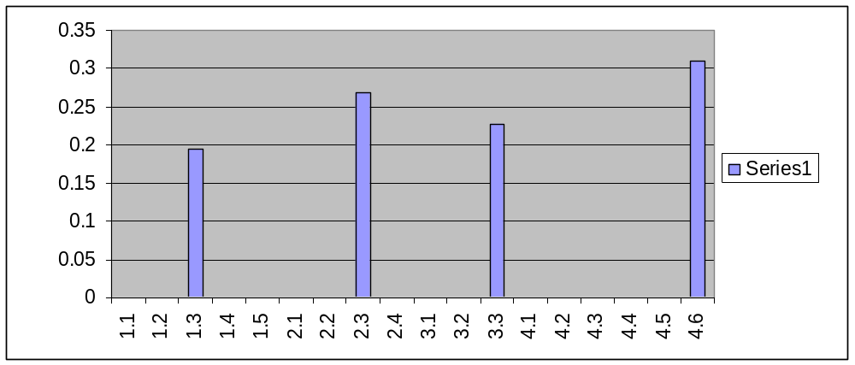

Recognition result for 2.1
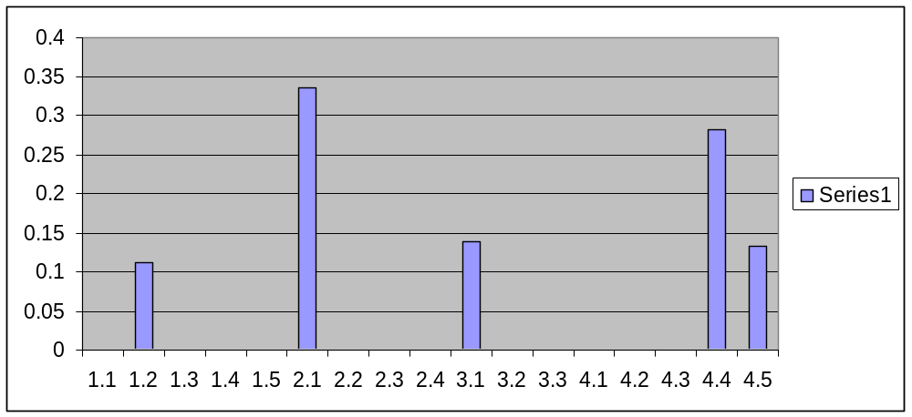

Evaluation Criteria

Scalability (cover the extend data sets)

Result Evaluation

Chapter Five: Conclusion

Findings and Analysis

Chapter Six: Future work
Due to the constraint of time, we only are able to finish as much as we can. Obviously, handwriting recognition system can be extremely complicated and the accuracy and performance vary as more features added in. In this section, we will give some suggestion with regard to the further work.

Writing Pad XInput support
Mouse is quite good wring input device, but it is not as good as dedicated input stylus or pen. It is now possible to buy quite inexpensive input devices such as drawing tablets, which allow drawing with a much greater ease of artistic expression than does a mouse. In GTK environment, the following steps need to be taken to make XInput support happen.
- Enabling extended device information.
To let GTK know about our interest in the extended device information, we merely have to add a single line to the program:
gtk_widget_set_extension_events(drawing_area,GDK_EXTENSION_EVENTS_CURSOR);
This statement will tell the system that we are interested in extension events.
- Using extended device information
Once we've enabled the device, we can just use the extended device information in the extra fields of the event structures. In fact, it is always safe to use this information since these fields will have reasonable default values even when extended events are not enabled. Once change we do have to make is to call gdk_input_window_get_pointer() instead of gdk_window_get_pointer. This is necessary because gdk_window_get_pointer doesn't return the extended device information.(Main & team, 2007)

References

Wikipedia. (2006). Hidden Markov Model, from http://en.wikipedia.org/wiki/Hidden_Markov_model

