OS MINI PROJECT: CLIPBOARD UTILITY USING PYTHON

*##this project is created by Shailesh V Iyer ,Uday Menon and Nandukumar Mudaliar.  
##the librarys used are tkinter for GUI and pyperclip to access the pastebuffer and interact with it.***from** tkinter **import** *  
**import** pyperclip  
  
*##mainlist = []*buttonlist = []  
buttonlist1 = []  
  
*##index=-1  
##copydict is the main dictionary*copydict={}  
root = Tk()  
  
  
**class** staticindex:  
 *##this class here is responsible for maintaining unique indexes for each item* index = 0  
  
  
indexinstance = staticindex()  
  
  
**def** textwindow1(indexer):  
 *##this function is used for looking at the complete text in another window with a scrollbar* print(indexer)  
 win = Toplevel()  
 frame1 = Frame(win)  
 sbar = Scrollbar(frame1)  
 text1 = Text(frame1)  
 text1.insert(INSERT, copydict[indexer])  
 sbar.config(command=text1.yview)  
 text1.config(yscrollcommand=sbar.set)  
 sbar.pack(side=RIGHT, fill=Y, expand=**False**)  
 text1.pack(side=LEFT, fill=BOTH, expand=**True**)  
 frame1.pack()  
  
  
**def** store():  
 *##this function is used to store copy contents into a dictionary and get the respective frame for content* **global** root, indexinstance  
 spam = pyperclip.paste()  
  
 currentindex = indexinstance.index  
  
 copydict[currentindex] = spam  
  
  
 frame_create = Frame(root, height=3, width=10)  
 new_window = Button(frame_create, text=**"Expand"**, command=**lambda**: textwindow1(currentindex))  
 copy_button = Button(frame_create, text=**"Copy"**, command=**lambda**: get(currentindex))  
 remove_button= Button(frame_create,text=**"remove"**,command=**lambda**:remove(currentindex,frame_create))  
 buttonlist.append(new_window)  
 buttonlist1.append(copy_button)  
  
 print(buttonlist)  
 text = Text(frame_create, height=5, width=100)  
 text.insert(INSERT, spam[0:100])  
 text.pack()  
 buttonlist[currentindex].pack()  
 buttonlist1[currentindex].pack()  
 remove_button.pack()  
  
 frame_create.pack()  
 print(spam)  
 indexinstance.index += 1  
  
  
**def** get(index):  
 *##this is used to copy a text into the paste buffer* print (index)  
 item = copydict[index]  
 print (item)  
 pyperclip.copy(item)  
  
**def** remove(index,frame):  
 *##this is used to remove an item and its respective frame* copydict.pop(index)  
 frame.destroy()  
 print(copydict)  
 print (index)  
  
*##this is the main function which runs the GUI main loop and contains the store button*store_button = Button(root, text=**"store"**, command=store)  
store_button.pack()  
  
root.mainloop()

**OUTPUT**

**INITIAL GUI**

C:\Users\Menon\Desktop\College\OS\OS Project\initial.PNG

**COPY ANY TEXT**

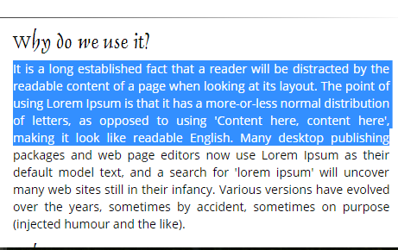

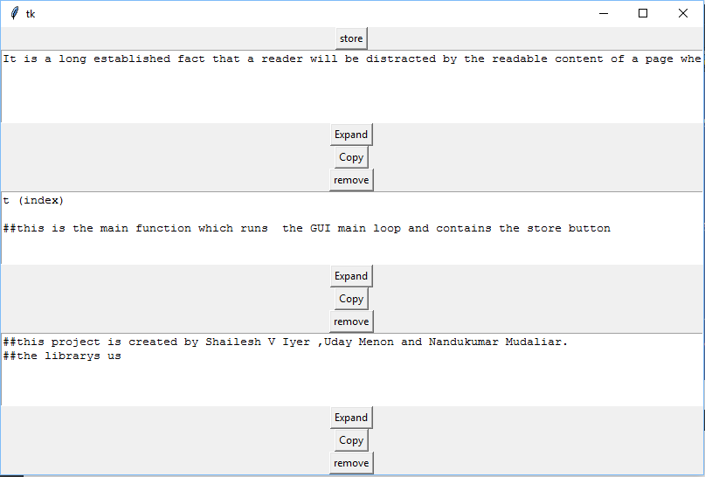COPY AS MANY TEXT AS NEEDED(store each time)

EXPAND DESIRED CONTENT(FROM THE STORED CONTENT)

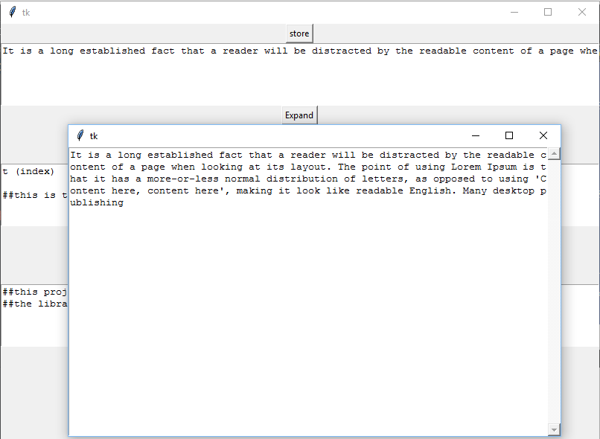

REMOVE COPIED CONTENTS(CLICK ON REMOVE BUTTON OF DESIRED FRAME)

EG: REMOVING THE 2ND FRAME OF CONTENTS

