1. **Write a query that will give you all orders for more than Rs. 1,000.**

=>select * from orders where amt>1000.00;

1. **Write a query that will give you the names and cities of all salespeople in London with a commission above .10.**

**=>**select * from salespeople where comm>0.10;

1. **Write a query on the Customers table whose output will exclude all customers with a rating <= 100, unless they are located in Rome.**

**=>**select * from customers where rating>100 and city!='Rome';

**4) What will be the output from the following query?**

**Select * from Orders where (amt < 1000 OR NOT (odate = ‘1990-10-03’ AND cnum > 2003));**

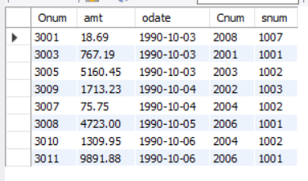

**5) What will be the output of the following query?**

**Select * from Orders where NOT ((odate = ‘1990-10-03’ OR snum >1006) AND amt >= 1500);**

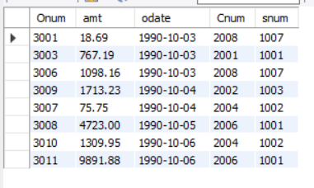

**6) What is a simpler way to write this query?**

**Select snum, sname, city, comm from Salespeople Where (comm > .12 or comm < .14);**

=> select * from salespeople;