**Documentation**

About

Footwear shop

**Year: 2021-2022**



**SUBMITTED TO:**

**SUBMITTED TO: SMT.V.B. NANDOLA COMP.SCI.COLLEGE**

**BKNMU**

**JUNAGADH –GUJARAT**

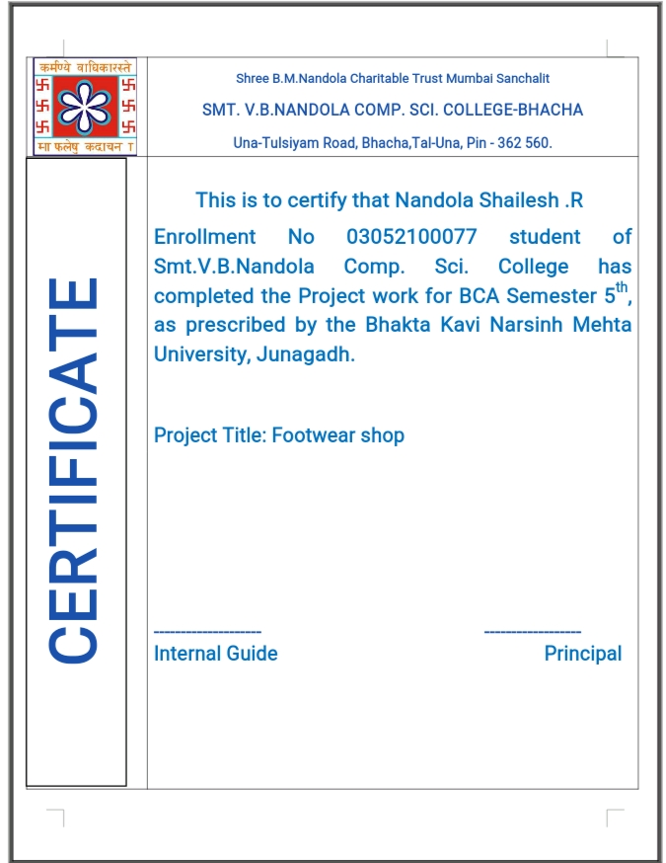

|  |  |  |
| --- | --- | --- |
| Sr.No | Description | Page Number |
| 1 | Introduction :  1.1Acknowledgement  1.2Student Profile  1.3Project Profile  1.4Institute Profile |  |
| 2 | Project Introduction :  2.1Project Definition  2.2 Introduction About Project  2.3 Current System Analysis  2.4 Solution From New Project |  |
| 3 | Introduction About Technology Server  3.1 Introduction About Front-End  3.2 Introduction About Back-End  3.3 Introduction About Document Tools |  |
| 4 | System Requirement :  4.1 Software Requirement  4.2 Hardware Requirement |  |
| 5 | System Analysis :  5.1 Introduction About SDLC |  |
| 6 | System Diagram :  6.1 Data Flow Diagram  6.2 Flowchart |  |
| 7 | Data Dictionary |  |
| 8 | User Interface[Screen Layout] |  |
| 9 | Testing And Implementation |  |
| 10 | Project Limitation |  |
| 11 | Bibliography |  |

ACKNOWLEDGEMENT

* I take occasion to thank God, almighty for blessing us with his grace and taking our endeavor to a successful culmination. I extend our sincere and heartfelt thanks to our esteemed guide, MR.SURAJ CHAVDA , for providing us with the right guidance and advice at the crucial junctures and for showing me right way.
* I also take opportunity to express a deep sense of our other coordinators, MR.SURAJ CHAVDA and other faculties for their cordial support Valuable suggestions and guidance. I extend our thanks to our respected head of the department Mr. Pankaj Zalera, for allowing I use the faculties available. I would like to thank the other faculty member also, at this occasion.
* Last but not the least, I would like to thank our friends and family for the support and encouragement they have given us during the course of our work.

Yours Faithfully.

Nandola Shailes R.

STUDENT PROFILE

|  |  |
| --- | --- |
| Enrollment No. | 03052100077 |
| Full Name | Nandola shaileshkumar |
| Date of Birth | 07-01-2003 |
| Department | B.C.A |
| Semester | 5th |
| E-Mail | [Shaileshnandola123@gmail.com](mailto:Shaileshnandola123@gmail.com) |

PROJECT PROFILE

|  |  |
| --- | --- |
| Name | Description |
| Project title | Footwear shop |
| Organization Name | Smt V.B. Nandola computer Scienc  college-Bhacha |
| Group Size | 1(One) |
| Project Duration | 3 Months |
| Front End | C# |
| Back End | SQL Server(Client Server) |
| Language | English |
| Document Tool | MS Word 2010,MS Power Point 2010 |
| GUI Tool | Visual Studio 2008 |
| Report | Crystal Report |
| Internal guide | MR.SURAJ CHAVDA |
| Submit | SMT V.B. Nandola Computer ScienceCollege –Bhacha (2112002)  (BKNMU -Junagadh) |

INSTITUTE PROFILE



VBNBCA COLLEGEwas established in the year 2008

to take up the challenges of effective education and

training of professionals for careers in management and

computer studies. The institute is approved by with

initial affiliation to the Gujarat Technological University. Now that B.M.NANDOLA trust is becomesa landmark, the institute has become a constituent of it.

• The institute has provided all the required infrastructure and excellent facilities to the students’ right from the inception.

• The institute right from its commencement has been sincerely committed to the cause of professional education in the areas of and hence has spared no efforts to create an academic environment conducive for effective learning. The institute's main attempt was to meet one of its cherished goals of providing the industry with a reservoir of managerial talent with a sound educational foundation enhanced.

• To this end, the institute has taken a concrete and positive initiative to could the student's attitudes towards their work, towards others and most importantly, towards themselves. The attitudes being those which would distinguish them from the others help them to be humble, to be open to change yet be prudent enough to judge when and which change is for better.

PROJECT DEFINITION

Footwear Management System is designed for better interaction between Management, Staff and Customers. Footwear mgmt System handles all the requirements for easy Footwear Management. This software will help the Footwear Business to structuralize the activities and maintain data transparency where needed and properly store data for regular operations and future analysis.

•The user can see different types of reports , which displays all the details of customers , bills ,customer receipts etc..

•So these are the normal process of the organization and how each and every process is done in the company that is shows in the project.

INTRODUCTION ABOUT PROJECT

* The Project is Footwear Management System. It is one type of Desktop Application. It provides reliable and Secure Accessing.

* It is developed using c#.net as front end and SQL server as back end. In this system user Can Store Information of Customer Registration, Customer Bill, Dealer Management etc.
* In addition, report is also included in Footwear Management System. The admin is able to generate different kinds of report like Customer registration, Product master, Customer Bill Report.

CURRENT SYSTEM ANALYSIS

As the current system is totally manual. In manual system there many ltion.

* Everything to be done manually.
* Due to manual process, it require more time for completion of any work.
* Current system is manual. So it increases the change of any mistake.
* Lot of time is consumed for each report generation.
* More man power is required and timely updating is complicated.

1.Current System

* + This current system totally manual complete.
  + In this system occur many limitations.
  + Current system generates change of some mistake.
  + Lots of consumed for each report generation.

2.Purpose of System

Each system is a created with some purpose.

The purpose which completed some requirement of the user.

Some purpose which listed below :

I.Accuracy

II.Security

III.Time Saving

IV.Easy modification

V.Attraction and status

SOLUTION FROM NEW SYSTEM

* This system first is logging security provide.
* This is work give computer bill.
* Admin can see to the daily report.
* Print to the billing report.
* This system in logging security provides.

INTRODUCTION ABOUT FRONT-END

[C#]

1.About c#

* The Front End of this project is c#.
* C# is a language that has design this scratch to work with .NET as well as advantage of all the process in developer environment.
* C# is an object oriented programming language.
* We have use c# as front end of our project.
* We are using c# as front end because it is type safe, simple
* &modern programming language.
* If we look a lot of syntaxes are same as c++ so that person has basic knowledge of c++ can handle c# easily.
* It was develop by Microsoft within .Net initiative and later.

2.History of C#

* Originated by Microsoft as a response to java.
* Language name inspired by musical notes c#.
* Lead designers are Anders Hejlsberg, Scoot Wimtamuth.
* Unified object system.
* Single inheritance.
* Interface.
* Sutras.
* Delegates

3.Why C#

* C# is a created as an Object Oriented Programming Language.
* Many people believed that there was no need for new programming
* language .java ,c#, Perl, visual basic and other existing language were believed to offer all the functionality needed.
* These objectives can be summarized in the claims Microsoft makes about c#.

•C# is simple.

•C# is modern.

•C# is Object Oriented.

In addition of Microsoft’s reason, there are other reasons to use c#.

•C# is powerful and Flexible

•C# is a language of few word

•C# is modular

4.Advantage of C#

* Usually it is much efficient than java and runs faster.
* Automatic garbage collection.
* There are no functions variable , Everything belongs to class

INTRODUCTION ABOUT BACK-ENDSQL SERVER

* SQL Stand for Structure Query Language.
* SQL is the language use to manipulate relational database.
* SQL is a programming standard originally developed in the 1970s that is now used in many database and related technology
* Retrieve data from a database
* Insert/update/delete record in a database
* Set permission
* SQL Server is relational database management system developed by Microsoft Corporation.
* SQL Server is the most widely used database is the word.

•SQL Provide statement for a variety of task including.

•Inserting, updating, deleting, database object.

•Creating, modifying and database object.

* Benefits of using SQL 2005

•Handled large amount of data efficiently.

•First in current infrastructure.

Introduction About Documentation Tool

• Microsoft PowerPoint

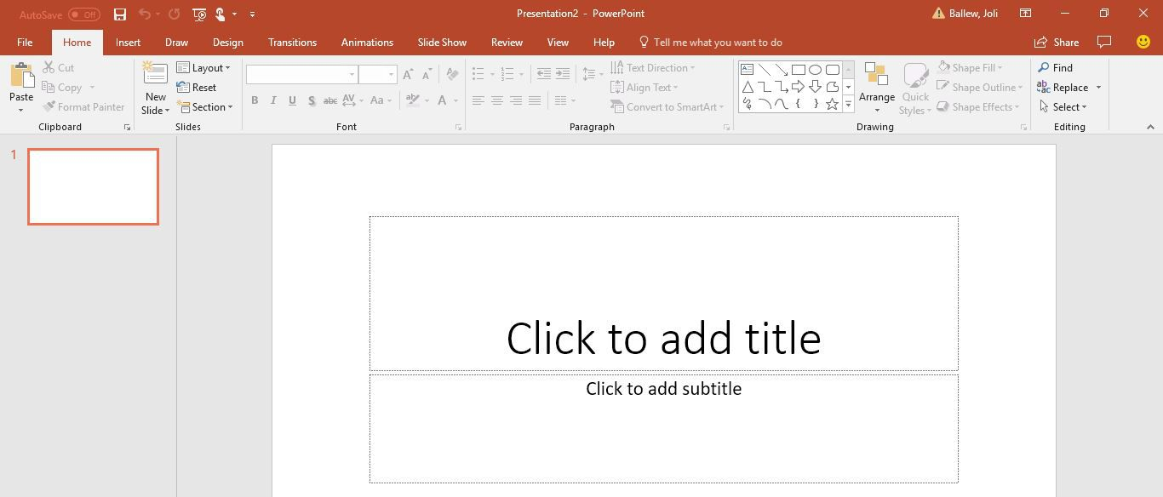

Microsoft PowerPoint 2010 enables user to quickly and easily create high impact, vibrant slide presentation.

PowerPoint 2010 has powerful graphics capabilities and great formatting features that enable even the notice to create professional looking presentation.

The user interface has been redesign with the internet of making the tools you need easier to find and help you give your presentation a professional and consistent look throughout.

This document will provide you will step-by-step instruction on how to use some of the new tools and how to find some of the old tools that you grew to know

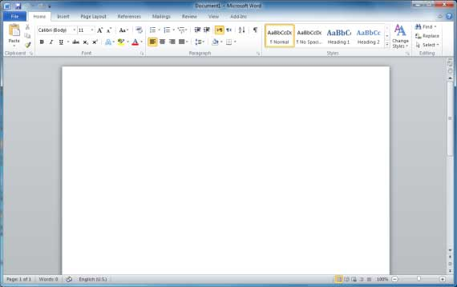

## Microsoft word 2010

1. **Description:**

* + This document will introduce you to Microsoft Word 2016 features and usage.

1. **Prerequisites**

* + You should have a basic knowledge of Microsoft window and some familiarity with tabs and menus.

1. **Goal(s)**

* + User should have understood of the new ribbon, the office button, saving option and how to print.
  + Document using Microsoft Word 2016.

1. **Content** 
   * The Microsoft word 2010 **“fluent user interface”** and the ribbon.
   * The DOCX Format.
   * Create, editing and saving a document.

* + Print a data.

1. **Disclaimer**

* + Basic knowledge of the windows Operating System is necessary in order to maximize understanding of the documents.
  + The image and examples found in the document are the based on the window 10 OS and differ slightly from how it appears.

SYSTEM REQUIREMENT

* Software Requirement

|  |  |
| --- | --- |
| Name | Description |
| Operating System | Windows XP, Windows 10, etc. |
| Front End | Visual Studio 2008 |
| Back End | SQL server |
| Report API | Crystal Report |
| .Net Framework | .Net framework 3.5 |

* Hardware Requirement

|  |  |
| --- | --- |
| Name | Description |
| Hard Disk | 40GB Free space |
| Processor | P4, Dual core, etc. |
| RAM | 1GB minimum |
| Printer | Yes |
| Web camera | No |
| Scanner | No |

SYSTEM DEVELOPMENT LIFE CYCLE

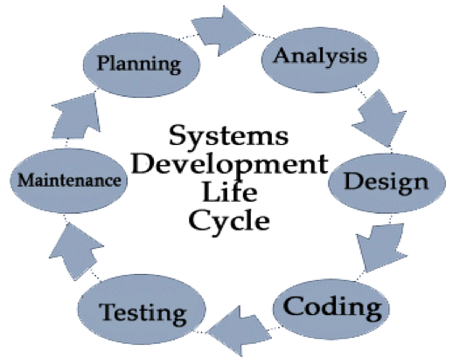

1. Planing

2. Analysis

3. Design

4. Implemetion

5. Testing & Integration

6. Maintenance

1. Planning

•Planning is a first step of SDLC.

•Planning are created and implemente

•It requirement are identify and also problem as well as limitation are discuused

•The purpose of this phase is to find out the scope of the problem solution.

2.Analysis

•After planning, the next step will analysis.

•The second phase is consider the functional requirement of the project or

solution.

•Analysis means to collect information on theavaliable files, decision point and

transaction of the system

3.Design

•The design phase come after a good understanding of customer’s requirement.

•The general design are facilities cost and benefits of the system are listed.

•This phases defines the element of a system, the component, the security level

and type of data that goes through the system.

4. Implementation

•

This phase comes after a complete understanding of system requirement and

specification.

•The purpose of when the majority of the code for the program is written.

•The coders write programs based on design.

5. Testing

•

This phase involves systems integration and system testing of program and

procedures normally carried out by a Quality Assurance(QA) professional to

determineif the prposed design meets the initial set of business goals.

•The system is tested again and again until requirement are fullfield and

system is error free.

6. Maintenance

•The last phase is when end users can final tune the system, if they

wish, to add new capabilities or additional user requirement.

SYSTEM DIAGRAM

Introduction About Data Flow Diagram[DFD]

* DFD stands for Data Flow Diagram.
* A data flow diagram is a logical model used to show the flow of data through system.
* A data flow diagram is a graphical represent.

•Rules Of DFD

* A minimum of one data flow in and one data flow out of a purpose.
* A data store must be connected to a process.
* A single data flow must only flow one way.

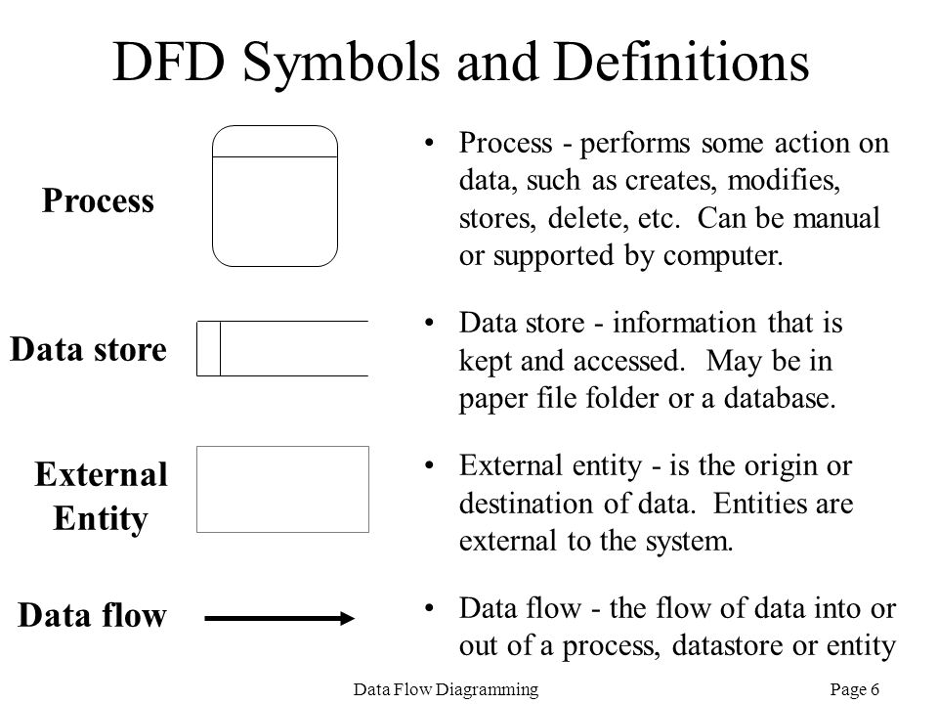

Flow Charts :

1. Login Form



Enter Username And

Password

Read

Data

Show Main

Form

If Match With Users

Incorrect Username or

Password

**Yes**

**No**

Start

Stop



2.User Registration

Data successfully save



**Enter all detail**

]

Read Data

IF Data Valid

Stop

**No**

**Yes**

Invalid Data



Start



3. Customer Registration Form

Data successfully save



**Enter all detail**

]

Read Data

IF Data Valid

Stop

**No**

**Yes**

Invalid Data



Start



4.company registration form

Data successfully save



**Enter all detail**

]

Read Data

IF Data Valid

Stop

**No**

**Yes**

Invalid Data



Start



5. Supplier Registration Form

Data successfully save



**Enter all detail**

]

Read Data

IF Data Valid

Stop

**No**

**Yes**

Invalid Data



Start



6. Product Registration Form

Data successfully save



**Enter all detail**

]

Read Data

IF Data Valid

Stop

**No**

**Yes**

Invalid Data



Start



7. Bill

Data successfully save



**Enter all detail**

]

Read Data

IF Data Valid

Stop

**No**

**Yes**

Invalid Data



Start



Data Flow Diagram

Context [0] Level DFD

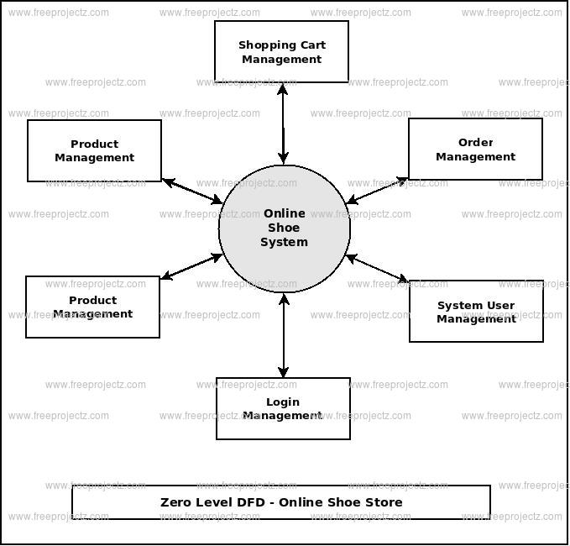

Context [1] Level DFD

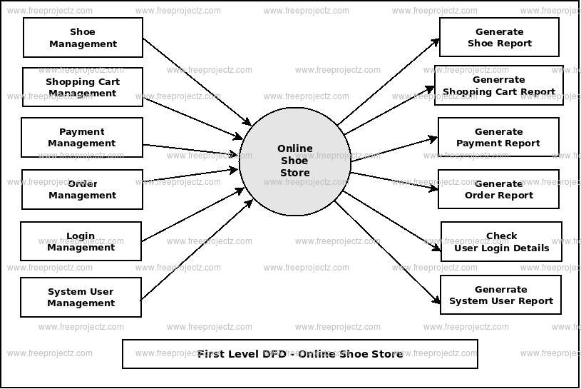

•Data Dictionary

User Registration

|  |  |  |  |  |
| --- | --- | --- | --- | --- |
| Sr.No. | Filled Name | Data type | Constrain | Description |
| 1. | userid | Varchar(20) | Primary key | User Id |
| 2. | username | Varchar(20) | - | User Name |
| 3. | fullname | Varchar(20) | - | Full Nam |
| 4. | gender | Varchar(20) | - | Gender |
| 5. | City | Varchar(20) | - | City |
| 6. | Mobilen | Numeric(10) | - | Mobile Number |
| 7. | emai | Varchar(20) | - | Email Id |
| 8. | Dob | Varchar(20) | - | Date of Birth |
| 9. | password | Varchar(10) | - | Password |

•Compony

|  |  |  |  |  |
| --- | --- | --- | --- | --- |
| Sr.No. | Filled Name | Data type | Constrain | Description |
| 1. | com_id | Varchar(30) | - | Compony id |
| 2. | Com_name | Varchar(30) | - | Compony name |
| 3. | Emai | Varchar(30) | - | Email id |
| 4. | Com_phno | Numeric(10) | - | Phone Number |
| 5. | Com_address | Varchar(10) | - | Adress |
| 6. | City | Varchar(30) | - | City |

•Customer Registration

|  |  |  |  |  |
| --- | --- | --- | --- | --- |
| Sr.No | Filled Name | Data type | Constrain | Description |
| 1. | cust_id | int | Primary Key | Customer Id |
| 2. | Name | Varchar (50) | - | Customer name |
| 3. | Address | Varchar (100) | - | Address |
| 4. | Gender | Varchar (6) | - | Gender |
| 5. | mo_no | Numeric (10) | - | Mobile |

Product Registration

|  |  |  |  |  |
| --- | --- | --- | --- | --- |
| Sr.No | Filled Name | Data type | Constrain | Description |
| 1. | Pid | int (10) | Primary key | Product id |
| 2. | Pname | Varchar (30) | Foreign Key | Product Name |
| 3. | comp_id | Varchar (20) | - | Compony Id |
| 4. | cat_id | Varchar (20) | - | Category Id |
| 5. | Pdetail | Varchar max | - | Product detail |
| 6. | Pprice | Varchar (20) | - | Product Price |
| 7. | Pqty | Varchar (30) | - | Product Quantity |
| 8. | P_size | Varchar (30) | - | Product Size |
| 9. | Colour | Varchar (30) |  | Product color |

•Category

|  |  |  |  |  |
| --- | --- | --- | --- | --- |
| Sr.No | Filled Name | Data type | Constrain | Description |
| 1. | cat_id | Varchar(30) | Primary Key | Id of the  Category |
| 2. | cat_nm | Varchar(50) | - | Name of  Category |

Supplier

|  |  |  |  |  |
| --- | --- | --- | --- | --- |
| Sr.No | Filled Name | Data type | Constrain | Description |
| 1. | com_id | Varchar(30) | Foreingn Key | Compony id |
| 2. | Snm | Varchar(50) | - | Supplier Nam |
| 3. | City | Varchar(50) | - | City |
| 4. | Mobileno | numeric(10) | - | Mobile no |
| 5. | Email | Varchar(30) | - | Email |
| 6. | Date | Varchar(50) | - | Date |

•Bill

|  |  |  |  |  |
| --- | --- | --- | --- | --- |
| Sr.No | Filled Name | Data type | Constrain | Description |
| 1. | bill. no. | nchar (10) | Primary key | Sr.No. |
| 2. | cust_id | int | Foreingn Key | Customer id |
| 3. | Name | Varchar(50) | - | Customer Name |
| 4. | Pid | Varchar(50) | - | Product id |
| 5. | pnm | Varchar(50) | - | Product Name |
| 6. | Com_name | Varchar(50) | Foreingn Key | Company Name |
| 7. | Discount | Varchar(50) |  | discount |
| 8. | Price | Varchar(50) | - | Price |
| 9. | Gst | Integer (5) | - | GST |
| 10. | Total | Varchar(50) |  | Total |
| 11. | Date | Varchar(50) | - | Date |

* Login form

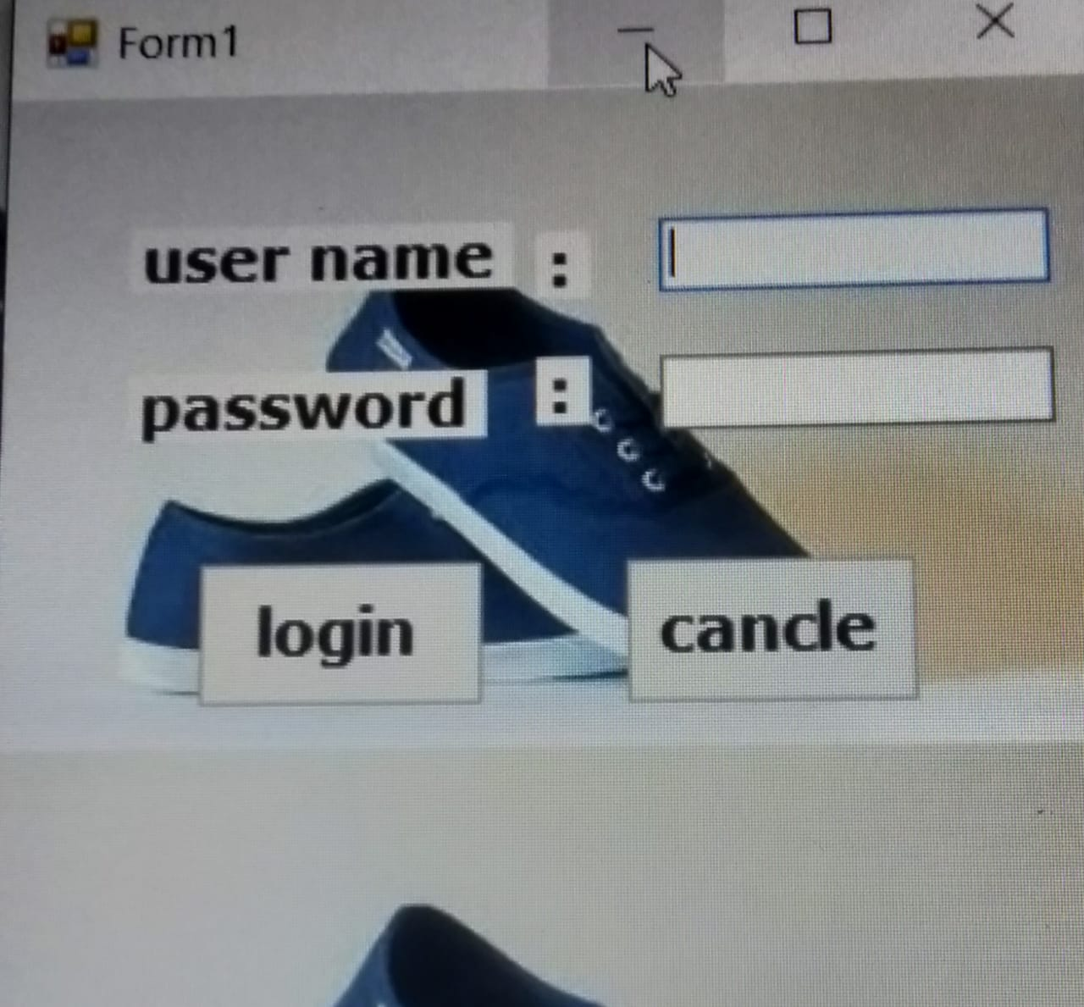

* Progress bar

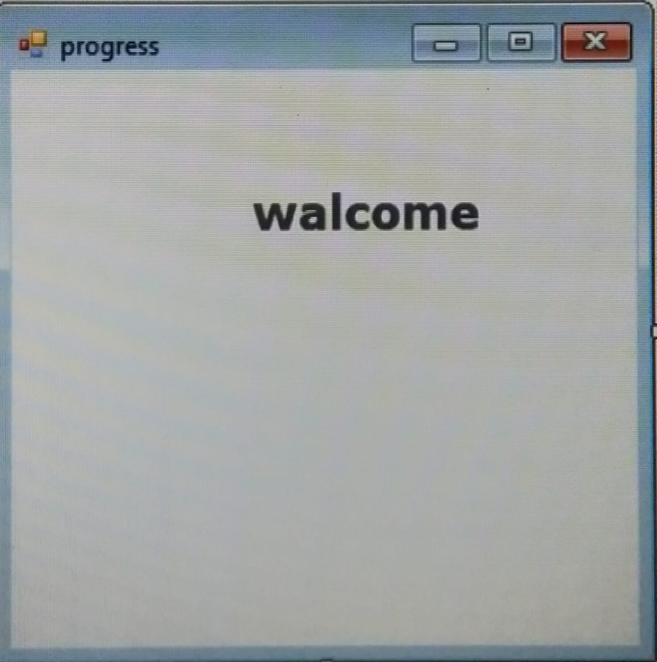

* Home page

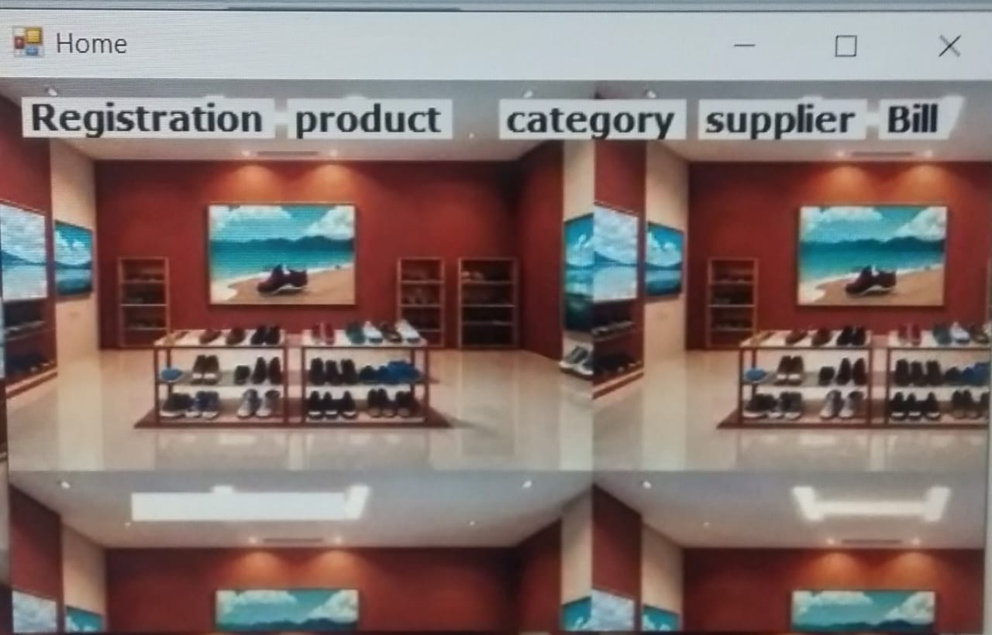

* User Resgistration

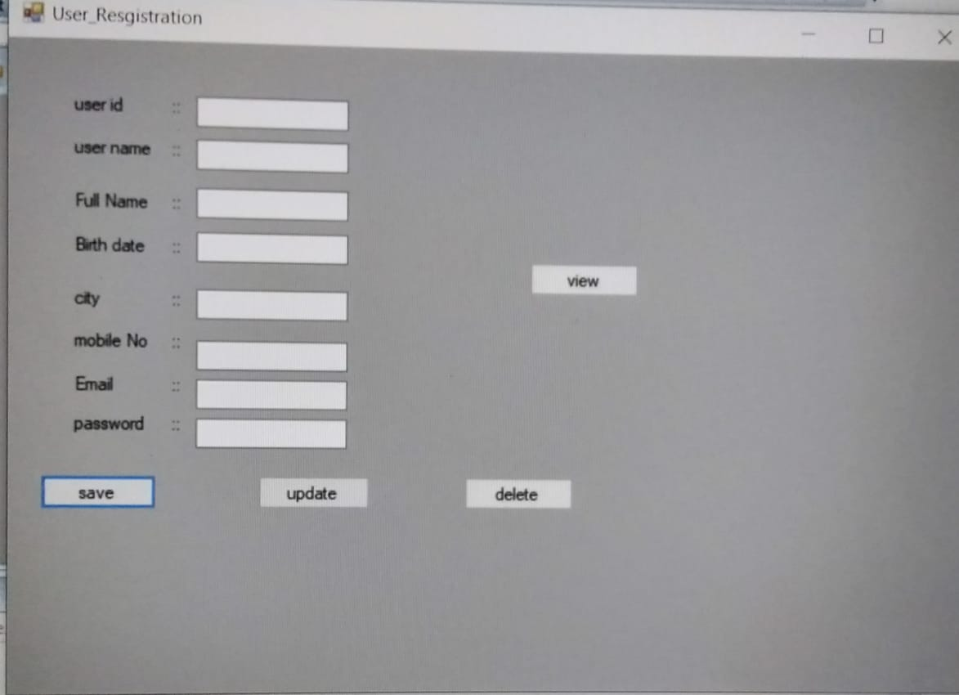

* Customer Resgistration

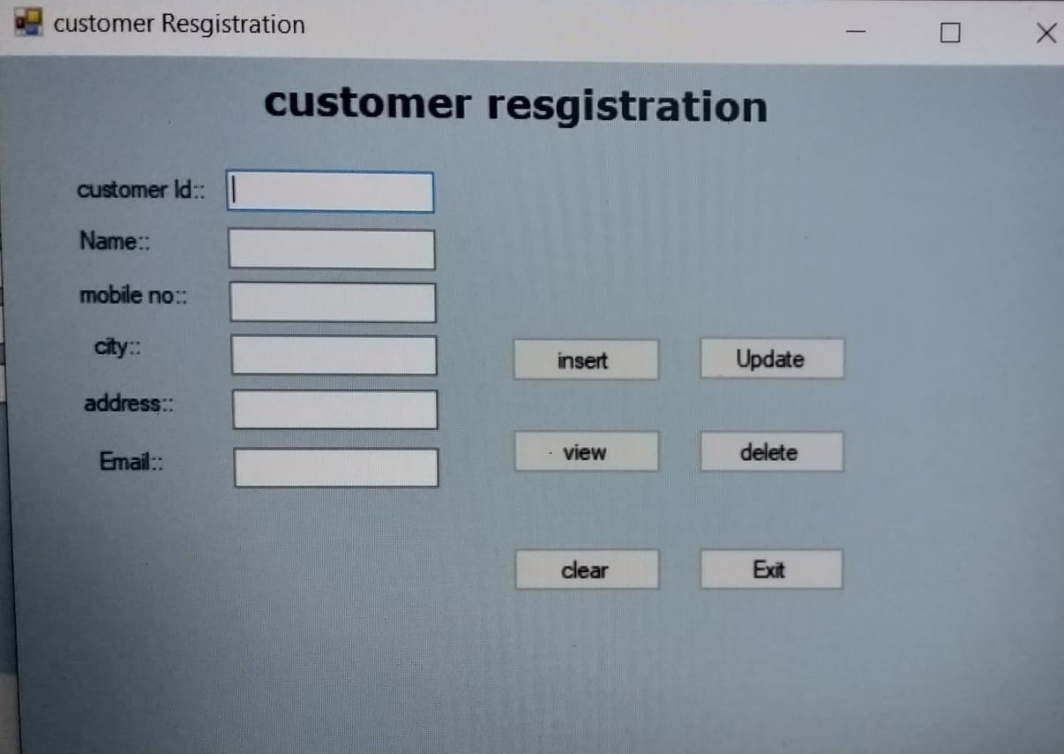

* Company Resgistration

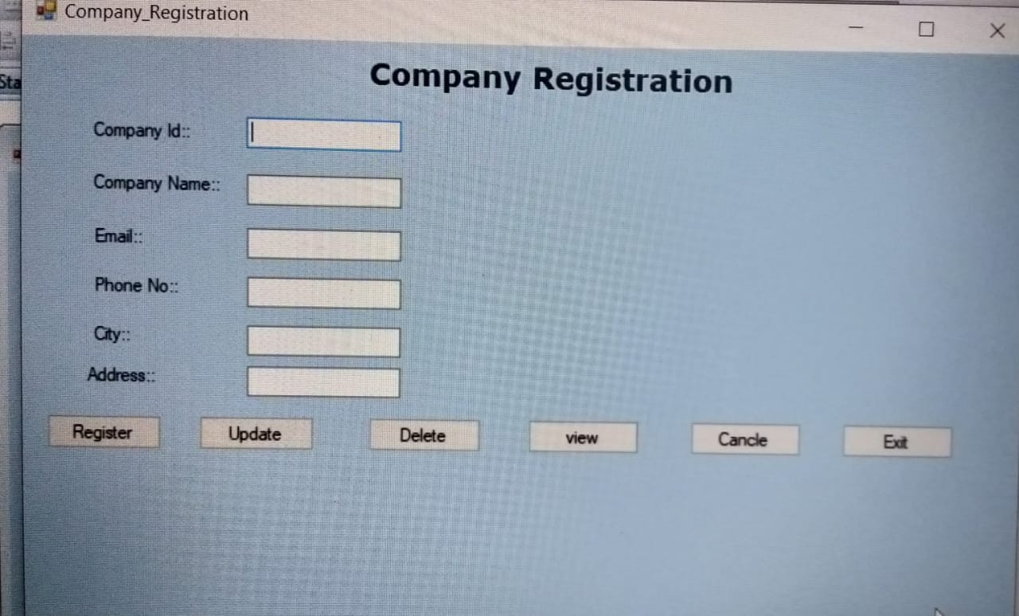

* Category

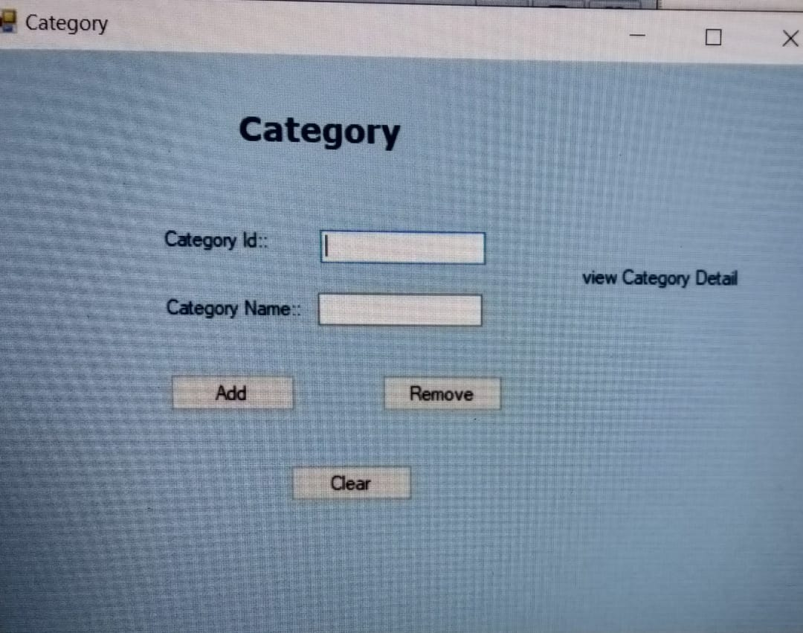

Testing & Implementation

Testing is a process of collection and error from system.

The main aim of the software testing process to determine all defect in our project.

The program was subjected to a set of test input and various observation were made and based on these observations it will be decided whether the program behaves as an expected or not.

Our project went through two levels of testing.

* Black-box testing
* White-box testing

Black-box test is used to demonstrate that software function are operational that input is properly accepted and output is currently produced and the integrity of external information is maintained.

White-box tests are used to examine the procedural detail. It checks the logical path by test case. It can also check the condition, loops used in software coding. It checks that loops are working correctly on defined boundary value.

##### Black-box Testing

Black-box testing focuses on the functional requirement of the software. That is black-box testing enable the software engineer to drive sets of input condition that will fully exercise all functional.

Requirement for the program black-box testing is not an alternative to white-box testing techniques.

Rather, it is a complimentary approach that likely to uncover different class of errors then whit-box methods.

We use in our coding to find errors in the following categories.

* Incorrect or missing functions
* Interface errors
* Errors in database
* Initialization and termination errors
* Performance errors

###### Feasibility Study

A feasibility study evaluates the project’s potential for success; therefore, perceived objectivity is an important factor in the credibility of the study for potential investors and lending institutions. There are five types of feasibility study—separate areas that a feasibility study examines, described below.

**1.Technical Feasibility -** this assessment focuses on the technical resources available to the organization. It helps organizations determine whether the technical resources meet capacity and whether the technical team is capable of converting the ideas into working systems. Technical feasibility also involves evaluation of the hardware, software, and other technology requirements of the proposed system. As an exaggerated example, an organization wouldn’t want to try to put Star Trek’s transporters in their building—currently, this project is not technically feasible.

1. **Economic Feasibility -** this assessment typically involves a cost/ benefits analysis of the project, helping organizations determine the viability, cost, and benefits associated with a project before financial resources are allocated. It also serves as an independent project assessment and enhances project credibility—helping decision makers determine the positive economic benefits to the organization that the proposed project will provide

**Operational Feasibility** - this assessment involves undertaking a study to analyse and determine whether—and how well—the organization’s needs can be met by completing the project. Operational feasibility studies also analyse how a project plan satisfies the requirements identified in the requirements analysis phase of system development.

##### White-box Testing

White-box testing is one of the major processes of system testing and it is a part of Black-box testing.

White-box testing check that code of system is depending on design or not if code is depending on design than system is correct otherwise there will be error.

White-box testing sometimes called glass-box testing. Always we are thinking that there is no necessary to execute or check that the loops and conditions, and so large number of error is uncovered.

White-box testing method, we have checked that.

* All independent paths within a function have been executed at least once.
* All logical decision on their true or false side.
* All loops working correctly at their boundary values and within their specified condition.

Project Limitations

* Online backup is not possible because it’s offline application
* Online data can’t be fetch when you want • Data only stored in single computer • Not work at more than one computer.

Future Update Description

* In future version of this application, it will follow iterative SDLC Model for better improvements.

Next Version will be V1.1.0 that will have complete Organization work performance.

##### Bibliography

|  |  |
| --- | --- |
| **Name** | **Description** |
| Book reference | Professional c#.net  C# complete Reference |
| Web Site Reference | [www.google.com](http://www.google.com/)  [www.Youtube.com](http://www.youtube.com/) |