**AIM: Investigate the Mobile Device.**

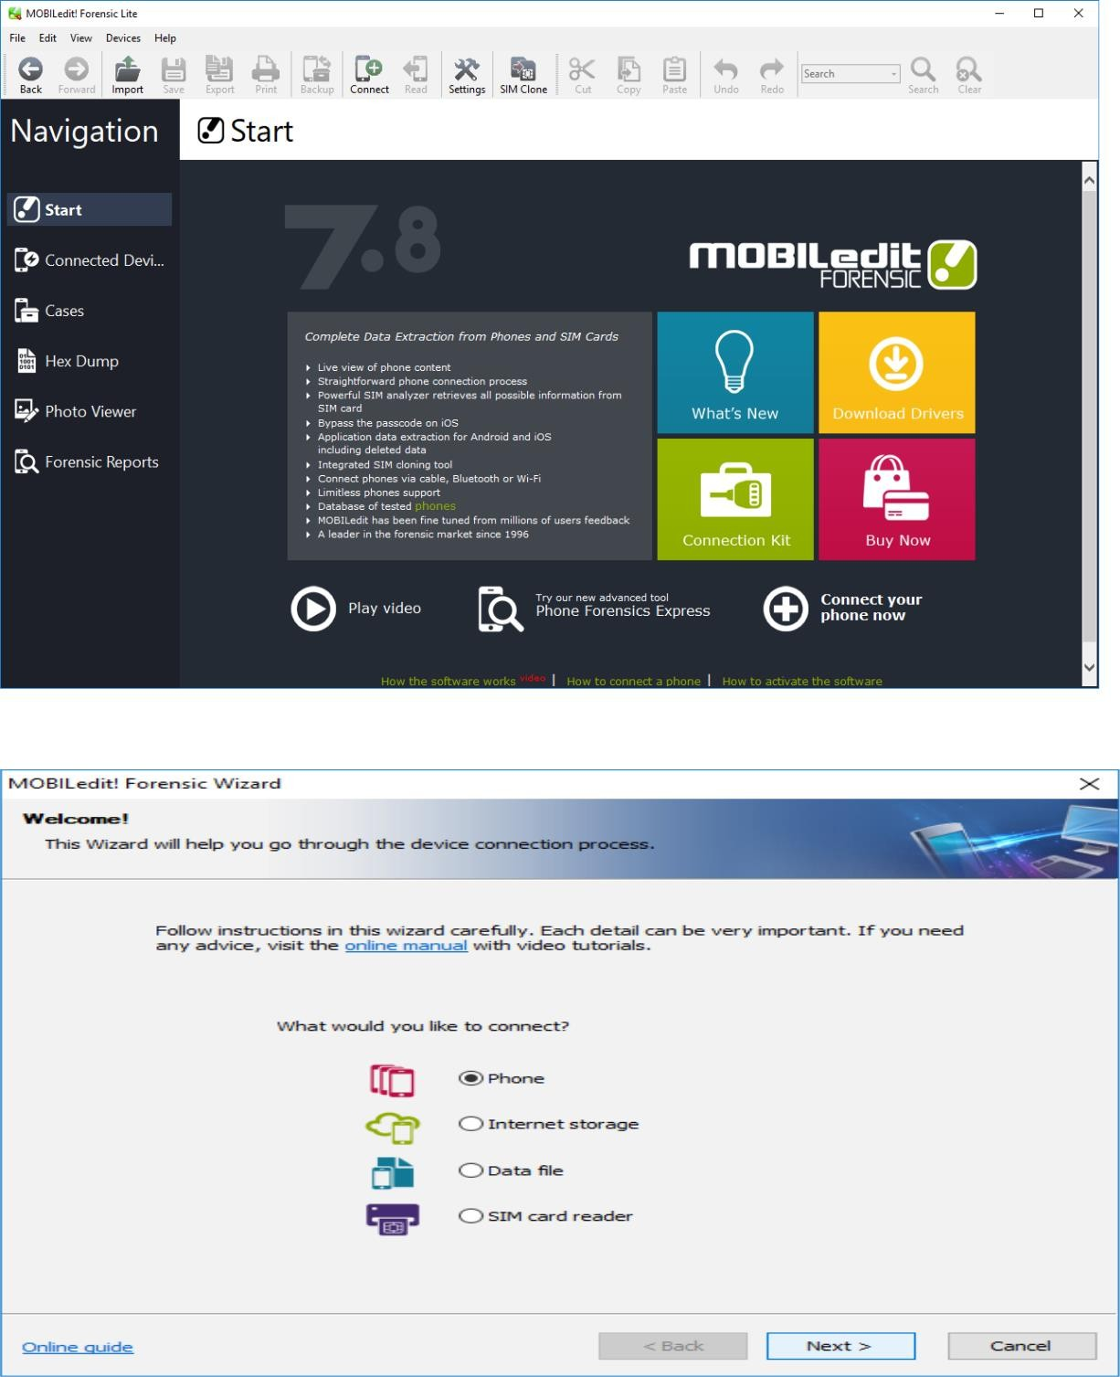

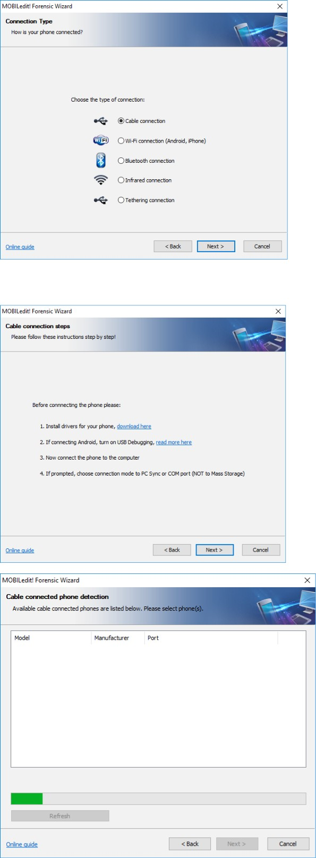

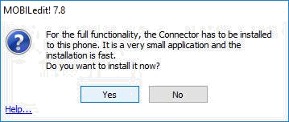

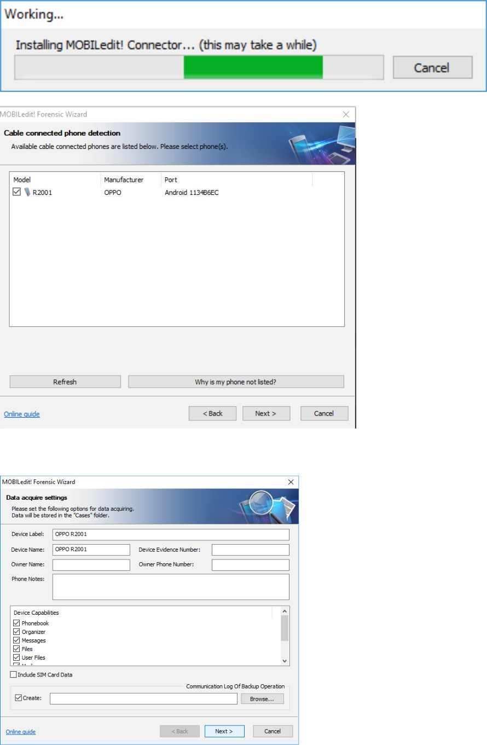

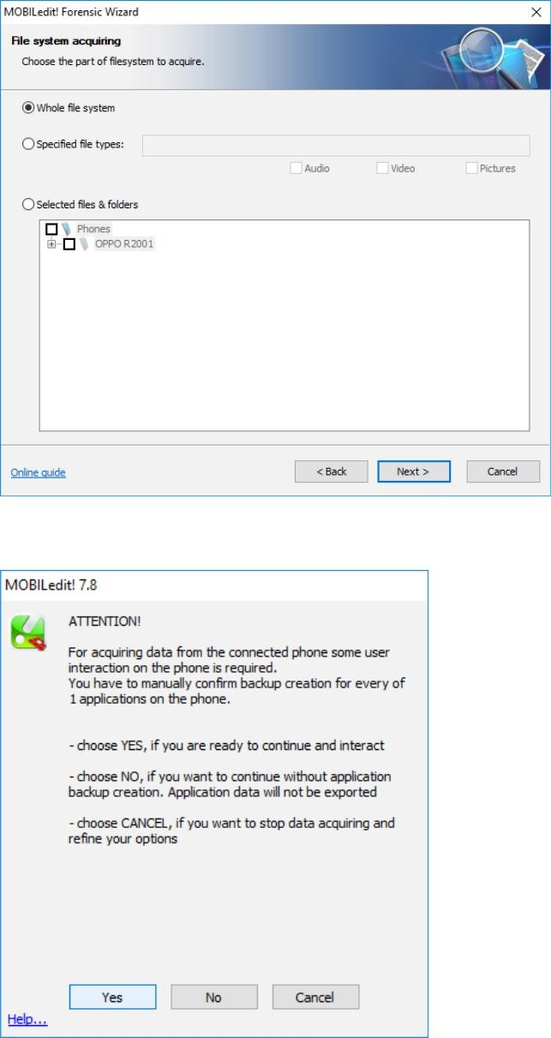

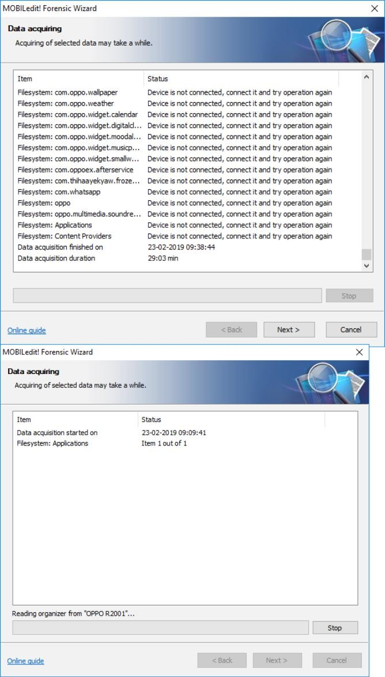

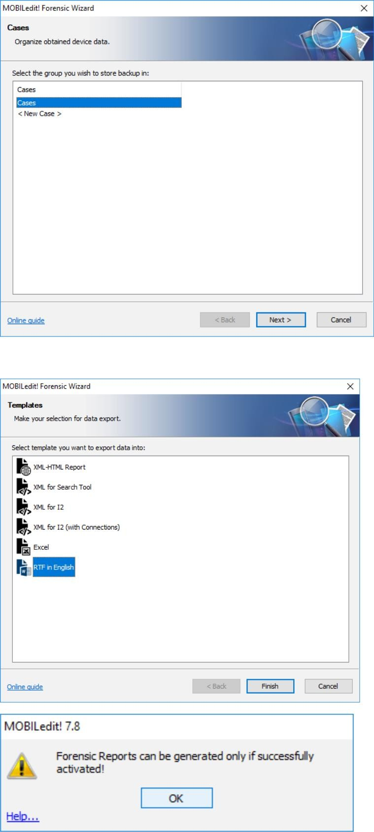

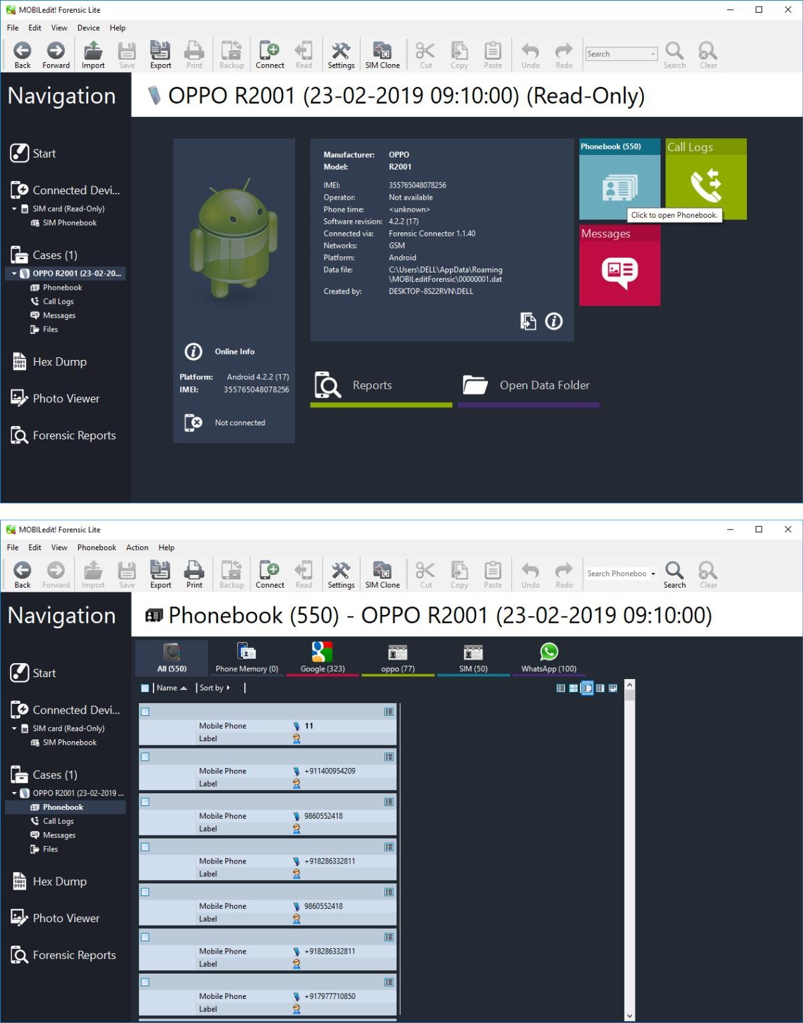

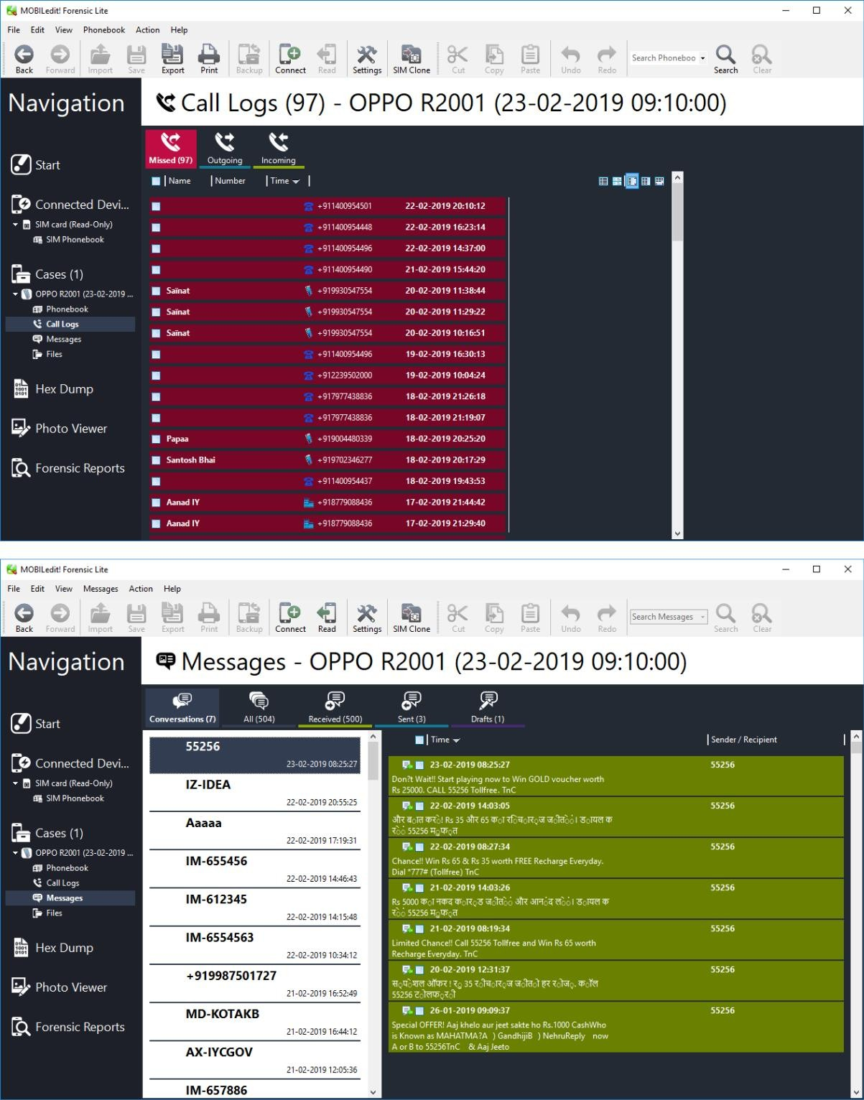

Aim: Using Data Acquisition Tools [ProDiscover Pro]

Solution:

Step 1: open the ProDiscover and add the case number and name.

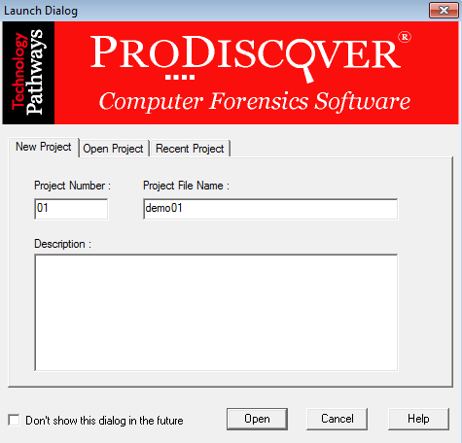

Step 2:open the project and click on Add then select the capture&Add image.fil all the detail as shown in the snap.

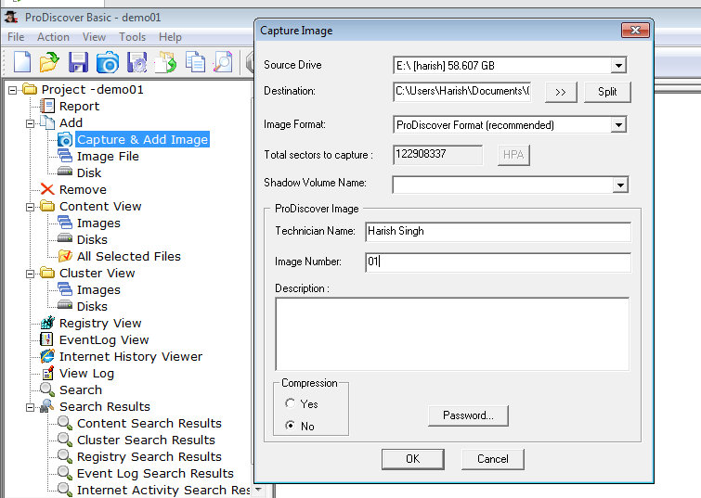

Step 3: After clicking ok image should be created.

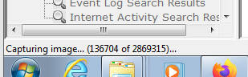

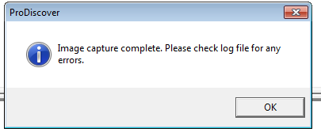

Step 4: After complete of image creation. please check the log file for any error. For that go to content view and click image.

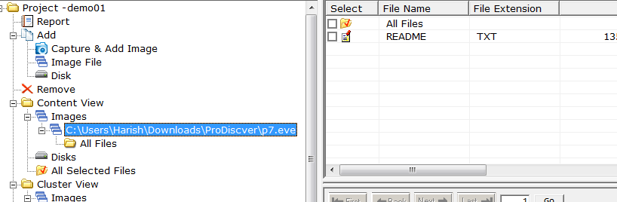

Step 5: you can also see the cluster view file has been created.

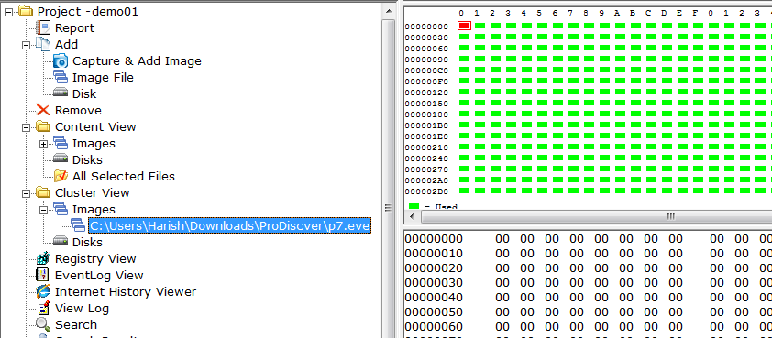

Step 6: we can view the file of PanDrive as we created he image.

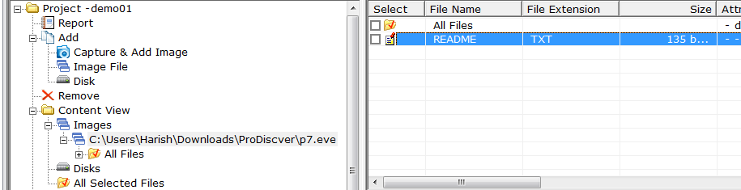

Step 7: At last we need to save the CaseFile.

