ERP PROCUREMENT MODULE
Development Strategy & Blueprint

Business Requirements | Process Maps | Data Structure | Rules Engine | Wireframes

Document Type | Strategy & Blueprint
Version | 1.0
Date | April 2026
Classification | Internal — Confidential

Table of Contents
Table of Contents 1
1. Business Requirements Document 1
1.1 Executive Summary 1
1.2 Stakeholders 1
1.3 Functional Requirements 1
1.4 Non-Functional Requirements 1
2. Process Maps & Workflows 1
2.1 Procure-to-Pay Master Process Flow 1
2.2 Approval Workflow Matrix 1
2.3 RFQ Lifecycle 1
2.4 Three-Way Match Logic 1
3. Data Structure 1
3.1 Entity Relationship Diagram 1
3.2 Core Table Definitions 1
vendors 1
purchase_requisitions 1
purchase_orders 1
audit_log 1
3.3 Numbering Convention 1
4. Rules Engine 1
4.1 Rule Categories 1
4.2 Rule Definitions 1
4.3 Rules Engine Architecture 1
5. UI Wireframes 1
5.1 Procurement Dashboard 1
5.2 Purchase Requisition List 1
5.3 Purchase Requisition Creation Form 1
5.4 Vendor Management 1
6. Delivery Roadmap 1
6.1 Implementation Phases 1
6.2 Technology Stack 1
6.3 Team Composition 1

1. Business Requirements Document
This BRD defines the scope, stakeholders, functional and non-functional requirements for the Procurement Module within the broader ERP ecosystem. The module automates and governs the complete procure-to-pay lifecycle — from purchase requisition through goods receipt and vendor payment.

1.1 Executive Summary
The Procurement Module automates and governs the complete procure-to-pay lifecycle — from purchase requisition through goods receipt and vendor payment. It enforces organizational policies (approval hierarchies, budget controls, preferred vendor rules) while providing real-time visibility into spend analytics and supplier performance. The module integrates with Finance (GL posting, AP), Inventory (stock updates), Budget Control (soft reservations), and Tax Engine (GST/VAT computation).

1.2 Stakeholders
Stakeholder | Role | Key Interest
Procurement Team | Primary User | Streamlined requisition-to-PO cycle, vendor management
Department Heads | Requisition Approver | Budget adherence, approval visibility
Finance / Accounts Payable | Invoice & Payment | 3-way matching, payment terms compliance
Warehouse / Stores | Goods Receipt | Accurate GRN, quality inspection workflows
Vendors / Suppliers | External Portal User | Bid submission, PO acknowledgment, invoice status
Internal Audit | Compliance Monitor | Complete audit trail, policy enforcement proof
IT / System Admin | Configuration Owner | Master data governance, role-based access control

1.3 Functional Requirements
ID | Requirement | Description
FR-01 | Purchase Requisition | Create, edit, clone PRs with multi-line items. Support catalog-based and free-text requisitions. Auto-route to approval workflow based on value, category, and department.
FR-02 | Vendor Management | Vendor registration portal, compliance document upload (GST, PAN, bank details), vendor scoring, blacklisting, approved vendor list (AVL) by category.
FR-03 | RFQ / Tender Management | Create RFQ from approved PR lines. Invite vendors, collect sealed bids, comparative statement generation, negotiation tracking, technical + commercial evaluation.
FR-04 | Purchase Order | Auto-generate PO from awarded bid or direct PR conversion. Amendment management with version control. PO acknowledgment by vendor. Delivery schedule tracking.
FR-05 | Goods Receipt Note | GRN creation against PO. Partial receipts with running balance. Quality inspection hold and release. Integration with inventory module for stock update.
FR-06 | Invoice & 3-Way Match | Vendor invoice registration. Automated matching: PO vs. GRN vs. Invoice. Tolerance-based auto-approval. Exception routing for mismatches beyond threshold.
FR-07 | Contract Management | Rate contracts, blanket POs, annual maintenance contracts. Auto-release against contracts. Expiry alerts and renewal workflows.
FR-08 | Spend Analytics | Real-time dashboards for spend by category, vendor, department. Budget vs. actual tracking. Savings reports from negotiations. Maverick spend detection.
FR-09 | Vendor Portal | Self-service portal for vendors to respond to RFQs, view POs, upload invoices, check payment status, and update compliance documents.
FR-10 | Audit & Compliance | Immutable audit trail on every transaction. Digital signatures on approvals. Document versioning. Compliance reports for regulatory needs.

1.4 Non-Functional Requirements
ID | Category | Requirement | Target
NFR-01 | Performance | Page load for PR listing | < 2 seconds (1000+ records)
NFR-02 | Scalability | Concurrent users | 500+ simultaneous, no degradation
NFR-03 | Availability | System uptime | 99.5% (excl. planned maintenance)
NFR-04 | Security | Role-based access control | Field-level permissions, SSO, MFA
NFR-05 | Audit | Change history | Every field change logged with user & timestamp
NFR-06 | Integration | ERP module sync | Real-time sync with Finance, Inventory, Assets
NFR-07 | Localization | Multi-currency, tax regimes | GST, VAT, withholding tax support

2. Process Maps & Workflows
End-to-end procurement lifecycle broken into discrete process stages with decision points, approval gates, and system integration touchpoints.

2.1 Procure-to-Pay Master Process Flow
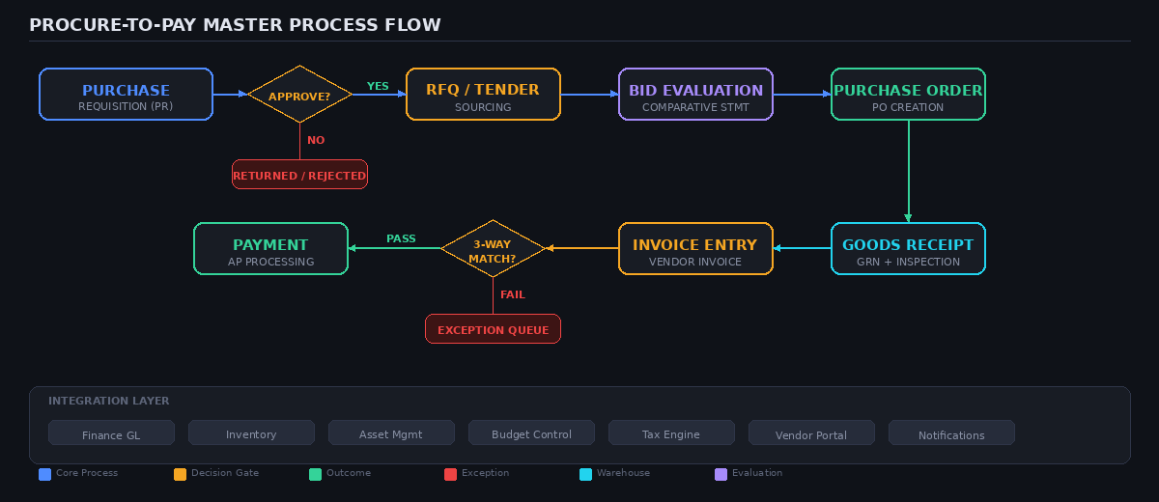

2.2 Approval Workflow Matrix
The approval chain is determined by the estimated PR value. Higher-value requisitions require progressively senior approvers. Critical-priority PRs activate parallel approval across all levels simultaneously.
PR Value Range | Level 1 | Level 2 | Level 3 | SLA
₹0 – ₹50,000 | Dept Head | — | — | 24 hrs
₹50,001 – ₹5,00,000 | Dept Head | Procurement Mgr | — | 48 hrs
₹5,00,001 – ₹25,00,000 | Dept Head | Procurement Mgr | Finance Head | 72 hrs
₹25,00,001+ | Dept Head | Procurement Mgr | Finance Head + MD | 5 days

2.3 RFQ Lifecycle
Step | Description
Step 1 | Approved PR lines grouped by category are pushed to the sourcing queue.
Step 2 | Procurement officer creates RFQ, selects vendors from AVL, sets bid deadline.
Step 3 | Vendors receive notification via portal/email; submit sealed bids online.
Step 4 | Post deadline, system generates comparative statement (price, delivery, terms).
Step 5 | Evaluation committee scores technical + commercial parameters.
Step 6 | Winning bid selected; PO auto-generated with negotiated terms.
Step 7 | Unsuccessful vendors notified; bid data archived for analytics.

2.4 Three-Way Match Logic
The 3-way match validates: PO quantity & rate vs. GRN received quantity vs. Invoice billed quantity & amount.
Outcome | Logic
Auto-Approve | All three documents within ±2% tolerance → invoice cleared for payment automatically.
Partial Match | Quantity within tolerance but rate differs → route to Procurement for manual review.
Full Mismatch | Exceeds tolerance on multiple parameters → hold invoice, notify vendor, escalate to AP manager.

3. Data Structure
Entity-relationship model, core table definitions, and field specifications for the procurement module database layer.

3.1 Entity Relationship Diagram
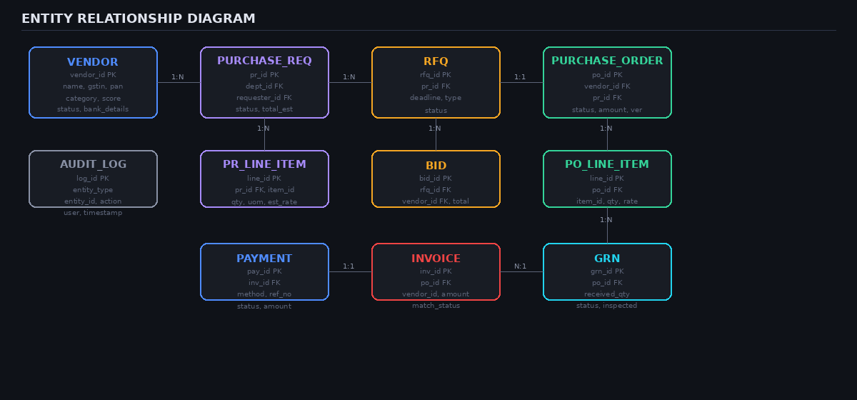

3.2 Core Table Definitions

vendors
Column | Data Type | Constraint | Description
vendor_id | UUID | PK | Auto-generated primary key
vendor_code | VARCHAR(20) | UNIQUE, NOT NULL | Human-readable vendor code (VND-00xxx)
name | VARCHAR(255) | NOT NULL | Registered business name
gstin | VARCHAR(15) |  | GST Identification Number
pan | VARCHAR(10) |  | Permanent Account Number
category_id | UUID | FK | Reference to vendor_categories table
vendor_score | DECIMAL(3,2) | DEFAULT 0.00 | Weighted performance score (0.00–5.00)
status | VARCHAR(20) | DEFAULT PENDING | PENDING | ACTIVE | SUSPENDED | BLACKLISTED
payment_terms | INTEGER | DEFAULT 30 | Payment terms in days
bank_details | JSONB |  | Bank account, IFSC, UPI details
created_at | TIMESTAMPTZ | DEFAULT now() | Record creation timestamp
updated_at | TIMESTAMPTZ | DEFAULT now() | Last modification timestamp

purchase_requisitions
Column | Data Type | Constraint | Description
pr_id | UUID | PK | Auto-generated primary key
pr_number | VARCHAR(20) | UNIQUE, NOT NULL | Formatted PR number (PR-2026-00001)
department_id | UUID | FK | Reference to departments table
requester_id | UUID | FK | Reference to users table
pr_type | VARCHAR(20) |  | STANDARD | URGENT | BLANKET
priority | VARCHAR(10) | DEFAULT NORMAL | LOW | NORMAL | HIGH | CRITICAL
status | VARCHAR(20) | DEFAULT DRAFT | DRAFT | SUBMITTED | APPROVED | REJECTED
total_estimated | DECIMAL(15,2) |  | Sum of all line item estimated totals
justification | TEXT |  | Business justification for the requisition
required_date | DATE |  | Date by which items are needed
budget_code | VARCHAR(30) |  | Associated budget allocation code
current_approver_id | UUID | FK | Current approver in the workflow chain
created_at | TIMESTAMPTZ | DEFAULT now() | Record creation timestamp

purchase_orders
Column | Data Type | Constraint | Description
po_id | UUID | PK | Auto-generated primary key
po_number | VARCHAR(20) | UNIQUE, NOT NULL | Formatted PO number (PO-2026-00xxx)
pr_id | UUID | FK | Reference to purchase_requisitions
vendor_id | UUID | FK | Reference to vendors table
po_type | VARCHAR(20) |  | STANDARD | BLANKET | CONTRACT
status | VARCHAR(20) | DEFAULT DRAFT | DRAFT | ISSUED | ACKNOWLEDGED | CLOSED
net_amount | DECIMAL(15,2) |  | Total before tax
tax_amount | DECIMAL(15,2) |  | Computed tax amount (GST/VAT)
total_amount | DECIMAL(15,2) |  | Net + Tax = Total payable
currency | VARCHAR(3) | DEFAULT INR | ISO 4217 currency code
delivery_date | DATE |  | Expected delivery date
payment_terms | INTEGER |  | Payment terms in days
version | INTEGER | DEFAULT 1 | Amendment version counter
created_at | TIMESTAMPTZ | DEFAULT now() | Record creation timestamp

audit_log
Column | Data Type | Constraint | Description
log_id | BIGSERIAL | PK | Auto-incrementing primary key
entity_type | VARCHAR(50) | NOT NULL | PR | PO | GRN | INVOICE | VENDOR
entity_id | UUID | NOT NULL | ID of the affected entity
action | VARCHAR(30) |  | CREATE | UPDATE | APPROVE | REJECT | DELETE
field_changed | VARCHAR(100) |  | Name of the modified field
old_value | TEXT |  | Previous value (JSON for complex types)
new_value | TEXT |  | New value after change
performed_by | UUID | FK | Reference to users table
performed_at | TIMESTAMPTZ | DEFAULT now() | Timestamp of the action
ip_address | INET |  | IP address of the user session

3.3 Numbering Convention
Document | Format | Example
Purchase Requisition | PR-{YYYY}-{SEQ:5} | PR-2026-00142
RFQ | RFQ-{YYYY}-{SEQ:4} | RFQ-2026-0038
Purchase Order | PO-{YYYY}-{SEQ:5} | PO-2026-00567
Goods Receipt Note | GRN-{YYYY}-{SEQ:5} | GRN-2026-00891
Invoice | INV-{YYYY}-{SEQ:5} | INV-2026-01234
Vendor | VND-{SEQ:5} | VND-00412

4. Rules Engine
Configurable business rules that govern approvals, validations, routing, escalations, and compliance enforcement across the procurement lifecycle. Rules are stored as configurable JSON in a rules_config table, not hardcoded.

4.1 Rule Categories
Category | Purpose
ROUTING | Approval path determination based on value, category, urgency
VALIDATION | Field-level and business-logic checks before state transitions
ESCALATION | SLA breach detection and auto-escalation to next level
COMPLIANCE | Regulatory and policy enforcement (vendor eligibility, budget caps)
AUTOMATION | Auto-PO generation, auto-match, auto-notifications
SCORING | Vendor performance scoring and dynamic AVL management

4.2 Rule Definitions
RUL-001 | ROUTING | PR Approval Routing
Trigger | PR submitted for approval
Condition | Evaluate pr.total_estimated against approval matrix
Action | Route to appropriate approval chain based on value slab, department, and PR type. If pr.priority = CRITICAL, enable parallel approval (all levels simultaneously).
Fallback | If approver is on leave, route to designated delegate within delegation_master.

RUL-002 | VALIDATION | Budget Availability Check
Trigger | PR submission
Condition | budget.available_amount >= pr.total_estimated
Action | Pass: Proceed to approval workflow, soft-reserve the budget amount. Fail: Block submission with insufficient budget message.
Fallback | Finance Head can override with justification (logged in audit trail).

RUL-003 | ESCALATION | Approval SLA Breach
Trigger | Cron job every 4 hours
Condition | now() - approval_request.created_at > sla_matrix[pr.value_slab].max_hours
Action | Level 1: Send reminder at 75% SLA. Level 2: At 100%, escalate to manager + notify requester. Level 3: At 150%, auto-approve if below threshold, else escalate to Procurement Head.
Fallback | All escalation events logged with timestamps for SLA reporting.

RUL-004 | COMPLIANCE | Vendor Eligibility Gate
Trigger | PO creation / RFQ vendor invitation
Condition | vendor.status = ACTIVE AND gstin_valid = true AND compliance_docs_expiry > today AND vendor NOT IN blacklist
Action | All conditions must pass. Failure on any condition blocks the transaction and notifies Procurement team with the specific failed check.
Fallback | Procurement Head can grant temporary waiver with documented justification.

RUL-005 | AUTOMATION | 3-Way Match Auto-Clear
Trigger | Invoice registered against PO with existing GRN
Condition | Quantity deviation ≤2%, Rate deviation ≤2%, Total within tolerance amount
Action | Pass: Auto-approve invoice and schedule payment per vendor payment terms. Fail: Route to exception queue, generate mismatch report.
Fallback | Exception reports include line-level deviation breakdown for AP team.

RUL-006 | SCORING | Vendor Score Recalculation
Trigger | On each GRN completion, Invoice clearance, or Complaint resolution
Condition | score = (delivery_on_time × 0.30) + (quality_pass_rate × 0.30) + (price_competitiveness × 0.20) + (compliance_record × 0.20)
Action | Score below 3.0/5.0: auto-flag for review. Below 2.0: suspend from new RFQs pending review committee decision.
Fallback | Score history retained for trend analysis. Committee review must be completed within 15 days.

4.3 Rules Engine Architecture
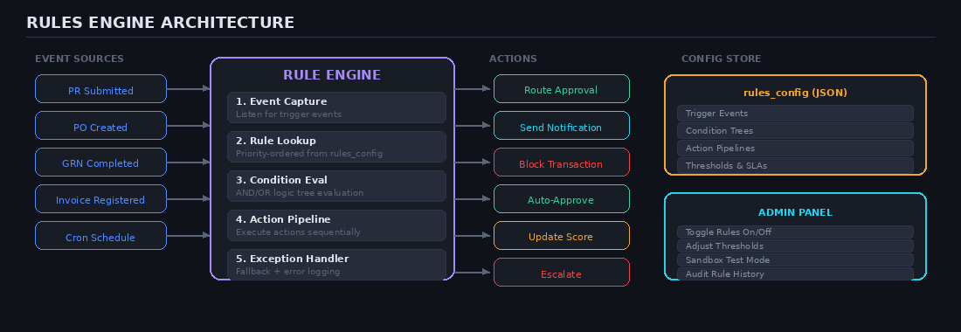
The engine evaluates rules in priority order and supports rule chaining (output of one rule becomes input to next). Admin users can toggle rules on/off, adjust thresholds, and test in sandbox mode before production activation. All rule evaluations are logged for audit purposes.

5. UI Wireframes
Low-fidelity wireframes for key procurement module screens. These wireframes establish the information architecture, navigation patterns, and data density expectations for each screen.

5.1 Procurement Dashboard
The main dashboard provides at-a-glance KPIs (pending PRs, active PO value, overdue GRNs, match exceptions), spend analytics charts, and a recent requisitions summary table.
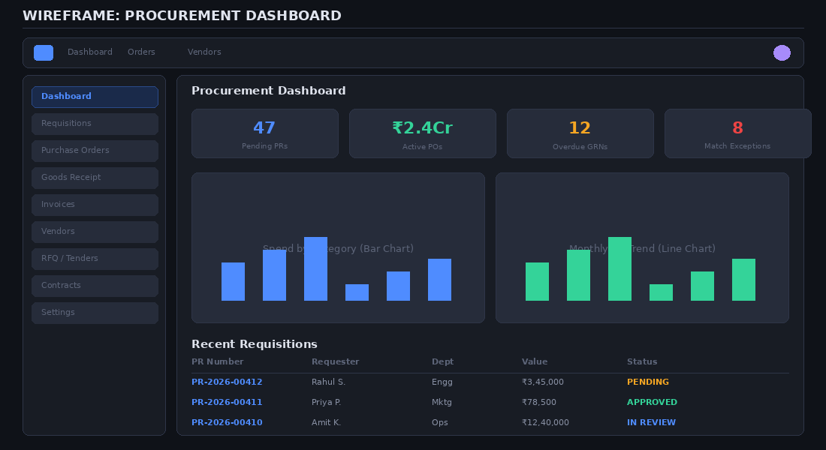

5.2 Purchase Requisition List
The PR list view supports search, multi-filter (status, department, date range), and quick actions. Each row displays the PR number, requester, department, item count, estimated value, and current status with color-coded badges.
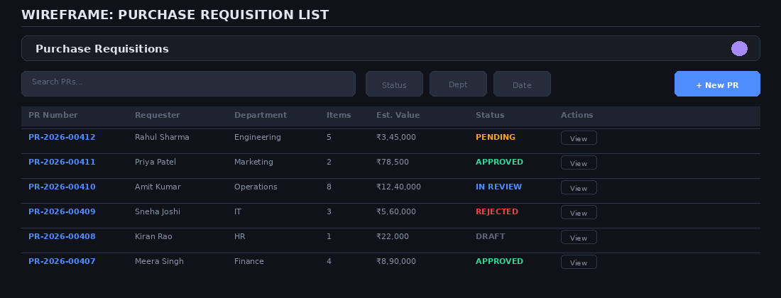

5.3 Purchase Requisition Creation Form
The PR creation form captures header information (department, type, priority, dates, budget code) and supports multi-line item entry with catalog lookup. Running totals update in real-time. The form supports Save as Draft and Submit for Approval actions.
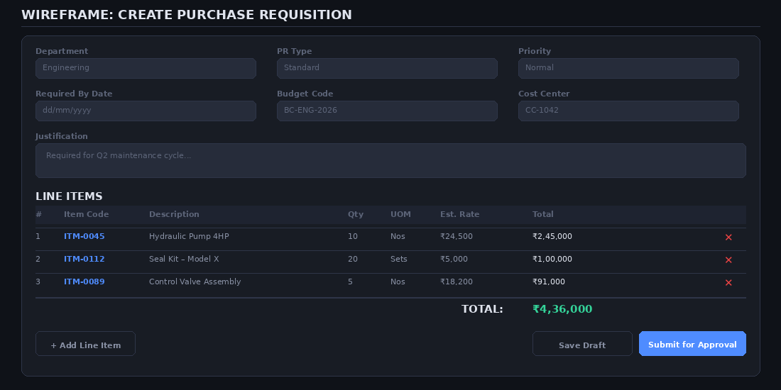

5.4 Vendor Management
The vendor management screen lists all registered vendors with search and category/status filters. Each row shows the vendor code, name, procurement category, GSTIN, performance score with color indicators, and current status. The Manage action opens the vendor detail/edit view.
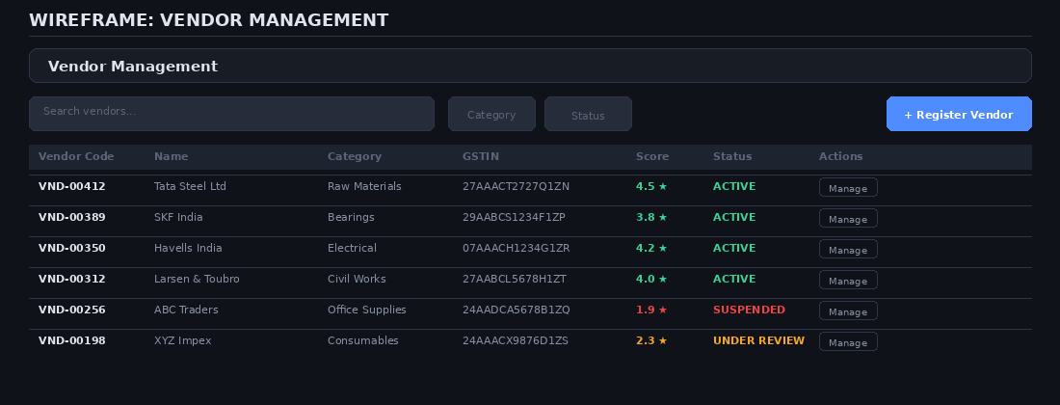

6. Delivery Roadmap
Phased implementation strategy designed for iterative delivery with tangible business value at each milestone.

6.1 Implementation Phases
Phase | Focus Area | Deliverables
Phase 1 | Foundation & Core (Weeks 1–6) | Master data setup (Vendors, Items, Departments, Users). Purchase Requisition module (CRUD + approval workflow). Basic role-based access control. Audit trail framework. Core database schema deployment.
Phase 2 | Sourcing & POs (Weeks 7–12) | RFQ creation and vendor bidding workflow. Comparative statement and bid evaluation. PO generation (manual + auto from awarded bids). PO amendment and version control. Budget integration and soft-reservation.
Phase 3 | Fulfillment & Finance (Weeks 13–18) | Goods Receipt Note with quality inspection hold. 3-way matching engine (PO vs. GRN vs. Invoice). Exception handling and resolution workflows. Payment processing integration. Tax computation engine (GST/VAT).
Phase 4 | Analytics & Portal (Weeks 19–24) | Vendor self-service portal. Spend analytics dashboards. Contract and rate contract management. Vendor scoring engine. Configurable rules engine admin UI. Mobile-responsive optimization.

6.2 Technology Stack
Layer | Recommendation
Frontend | React / Next.js with TypeScript. Tailwind CSS for styling. Recharts for dashboards. Formik + Yup for form validation.
Backend | Node.js (NestJS) or Python (FastAPI). RESTful + GraphQL hybrid API. JWT + OAuth2 for authentication. Redis for session caching.
Database | PostgreSQL (primary RDBMS). Redis (sessions/cache). Elasticsearch (search and analytics). S3-compatible storage for documents.
Integration | Event-driven via RabbitMQ or Kafka. Webhooks for vendor portal. REST APIs for ERP module sync. SFTP for bank file exchange.

6.3 Team Composition
Role | Count | Allocation
Product Manager | 1 | Full-time
Business Analyst | 1 | Full-time (Phase 1–2), Part-time (Phase 3–4)
UI/UX Designer | 1 | Full-time (Phase 1), Part-time thereafter
Backend Engineers | 3 | Full-time
Frontend Engineers | 2 | Full-time
QA Engineer | 1 | Full-time from Phase 2
DevOps / Infra | 1 | Part-time

