INFO659 Final
5/26/2020
Data Loading
## Row.ID
orderID orderDate shipDate shipMode customerID
## 1 32298 CA-2012-124891 7/31/12 7/31/12 Same Day RH-19495 ## 2 26341 IN-2013-77878 2/5/13 2/7/13 Second Class JR-16210 ## 3 25330 IN-2013-71249 10/17/13 10/18/13 First Class CR-12730 ## 4 13524 ES-2013-1579342 1/28/13 1/30/13 First Class KM-16375 ## 5 47221 SG-2013-4320 11/5/13 11/6/13 Same Day RH-9495 ## 6 22732 IN-2013-42360 6/28/13 7/1/13 Second Class JM-15655
## customerName segment city
## 1 Rick Hansen Consumer New York City
state country New York United States
## 2 Justin Ritter Corporate Wollongong New South Wales
## 3 Craig Reiter Consumer ## 4 Katherine Murray Home Office ## 5 Rick Hansen Consumer ## 6 Jim Mitchum Corporate ## postalCode market region
Brisbane Berlin Dakar
Queensland Berlin Dakar
Sydney New South Wales
Australia Australia Germany Senegal Australia
productID category subCategory
## 1
## 2
## 3
## 4
## 5
## 6 ##
10024 US East TEC-AC-10003033 Technology Accessories
NA APAC Oceania FUR-CH-10003950 Furniture NA APAC Oceania TEC-PH-10004664 Technology NA EU Central TEC-PH-10004583 Technology NA Africa Africa TEC-SHA-10000501 Technology NA APAC Oceania TEC-PH-10000030 Technology
Chairs Phones Phones Copiers Phones
productName sales
## 1 Plantronics CS510 - Over-the-Head monaural Wireless Headset System 2309.650 ## 2 Novimex Executive Leather Armchair, Black 3709.395
## 3 Nokia Smart Phone, with Caller ID 5175.171
## 4 Motorola Smart Phone, Cordless 2892.510
## 5 Sharp Wireless Fax, High-Speed 2832.960
## 6 Samsung Smart Phone, with Caller ID 2862.675 ## quantity discount profit shippingCost orderPriority

cc <- read.csv("Global Superstore.csv") head(cc)

## 1 | 7 | 0.0 762.1845 | 933.57 | Critical
## 2 | 9 | 0.1 -288.7650 | 923.63 | Critical
## 3 | 9 | 0.1 919.9710 | 915.49 | Medium
## 4 | 5 | 0.1 -96.5400 | 910.16 | Medium
## 5 | 8 | 0.0 311.5200 | 903.04 | Critical
## 6 | 5 | 0.1 763.2750 | 897.35 | Critical

Filter out only USA data
## Row.ID
orderID orderDate shipDate shipMode customerID
## 1 32298 CA-2012-124891 7/31/12 7/31/12 Same Day RH-19495 ## 9 40155 CA-2014-135909 10/14/14 10/21/14 Standard Class JW-15220 ## 10 40936 CA-2012-116638 1/28/12 1/31/12 Second Class JH-15985 ## 11 34577 CA-2011-102988 4/5/11 4/9/11 Second Class GM-14695 ## 17 36178 CA-2014-143567 11/3/14 11/6/14 Second Class TB-21175 ## 22 31784 CA-2011-154627 10/29/11 10/31/11 First Class SA-20830
## customerName segment city
## 1 Rick Hansen Consumer New York City ## 9 Jane Waco Corporate Sacramento
state country New York United States California United States
## 10 Joseph Holt Consumer Concord North Carolina United States ## 11 Greg Maxwell Corporate Alexandria
## 17 Thomas Boland Corporate Henderson ## 22 Sue Ann Reed Consumer Chicago
## postalCode market region productID
## 1 10024 US East TEC-AC-10003033
Virginia United States Kentucky United States Illinois United States
category subCategory Technology Accessories
## ## 1
productName Plantronics CS510 - Over-the-Head monaural Wireless Headset System
## 9 Fellowes PB500 Electric Punch Plastic Comb Binding Machine with Manual Bind ## 10 Chromcraft Bull-Nose Wood Oval Conference Tables & Bases
## 11 Martin Yale Chadless Opener Electric Letter Opener
## 17 Logitech diNovo Edge Keyboard
## 22 Apple iPhone 5S
## sales quantity discount profit shippingCost orderPriority

usa <- subset(cc,country == "United States") head(usa)

## 9 | 95823 | US West OFF-BI-10003527 Office Supplies Binders
## 10 | 28027 | US South FUR-TA-10000198 Furniture Tables
## 11 | 22304 | US South OFF-SU-10002881 Office Supplies Supplies
## 17 | 42420 | US South TEC-AC-10004145 Technology Accessories
## 22 | 60610 | US Central TEC-PH-10001363 Technology Phones

## 1 2309.650 | 7 | 0.0 762.1845 | 933.57 | Critical
## 9 5083.960 | 5 | 0.2 1906.4850 | 867.69 | Low
## 10 4297.644 | 13 | 0.4 -1862.3124 | 865.74 | Critical
## 11 4164.050 | 5 | 0.0 83.2810 | 846.54 | High
## 17 2249.910 | 9 | 0.0 517.4793 | 780.70 | Critical
## 22 2735.952 | 6 | 0.2 341.9940 | 752.51 | High

Create a Days to Ship variable
## Row.ID
orderID orderDate shipDate shipMode customerID
## 1 32298 CA-2012-124891 2012-07-31 2012-07-31 Same Day RH-19495
## 9 40155 CA-2014-135909 2014-10-14 2014-10-21 Standard Class JW-15220
## 10 40936 CA-2012-116638 2012-01-28 2012-01-31 Second Class JH-15985
## 11 34577 CA-2011-102988 2011-04-05 2011-04-09 Second Class GM-14695
## 17 36178 CA-2014-143567 2014-11-03 2014-11-06 Second Class TB-21175
## 22 31784 CA-2011-154627 2011-10-29 2011-10-31 First Class SA-20830
## customerName segment city
## 1 Rick Hansen Consumer New York City ## 9 Jane Waco Corporate Sacramento
state country New York United States California United States
## 10 Joseph Holt Consumer Concord North Carolina United States ## 11 Greg Maxwell Corporate Alexandria
## 17 Thomas Boland Corporate Henderson ## 22 Sue Ann Reed Consumer Chicago
## postalCode market region productID
## 1 10024 US East TEC-AC-10003033
Virginia United States Kentucky United States Illinois United States
category subCategory Technology Accessories
## ## 1
productName Plantronics CS510 - Over-the-Head monaural Wireless Headset System
## 9 Fellowes PB500 Electric Punch Plastic Comb Binding Machine with Manual Bind ## 10 Chromcraft Bull-Nose Wood Oval Conference Tables & Bases
## 11 Martin Yale Chadless Opener Electric Letter Opener
## 17 Logitech diNovo Edge Keyboard
## 22 Apple iPhone 5S
## sales quantity discount profit shippingCost orderPriority daysToShip

usa$orderDate <- as.Date(usa$orderDate, format = "%m/%d/%y") usa$shipDate <- as.Date(usa$shipDate, format = "%m/%d/%y") usa$daysToShip <- usa$shipDate - usa$orderDate
head(usa)

## 9 | 95823 | US West OFF-BI-10003527 Office Supplies Binders
## 10 | 28027 | US South FUR-TA-10000198 Furniture Tables
## 11 | 22304 | US South OFF-SU-10002881 Office Supplies Supplies
## 17 | 42420 | US South TEC-AC-10004145 Technology Accessories
## 22 | 60610 | US Central TEC-PH-10001363 Technology Phones

## 1 2309.650 | 7 | 0.0 762.1845 | 933.57 | Critical | 0 days
## 9 5083.960 | 5 | 0.2 1906.4850 | 867.69 | Low | 7 days
## 10 4297.644 | 13 | 0.4 -1862.3124 | 865.74 | Critical | 3 days
## 11 4164.050 | 5 | 0.0 83.2810 | 846.54 | High | 4 days
## 17 2249.910 | 9 | 0.0 517.4793 | 780.70 | Critical | 3 days
## 22 2735.952 | 6 | 0.2 341.9940 | 752.51 | High | 2 days

Transform quantity from nominal value to factor
## [1] "factor"

usa$quantity <- factor(usa$quantity,levels=c(1,2,3,4,5,6,7,8,9,10,11,12,13,14),labels= c("1","2","3","4","5","6", "7","8","9","10","11","12","13","14"))
class(usa$quantity)
Split Train and Test data (80% train, 20% test)

ind <- sample(2, nrow(usa), replace=T, prob= c(0.8,0.2)) train <- usa[ind==1,]
test <- usa[ind==2,]
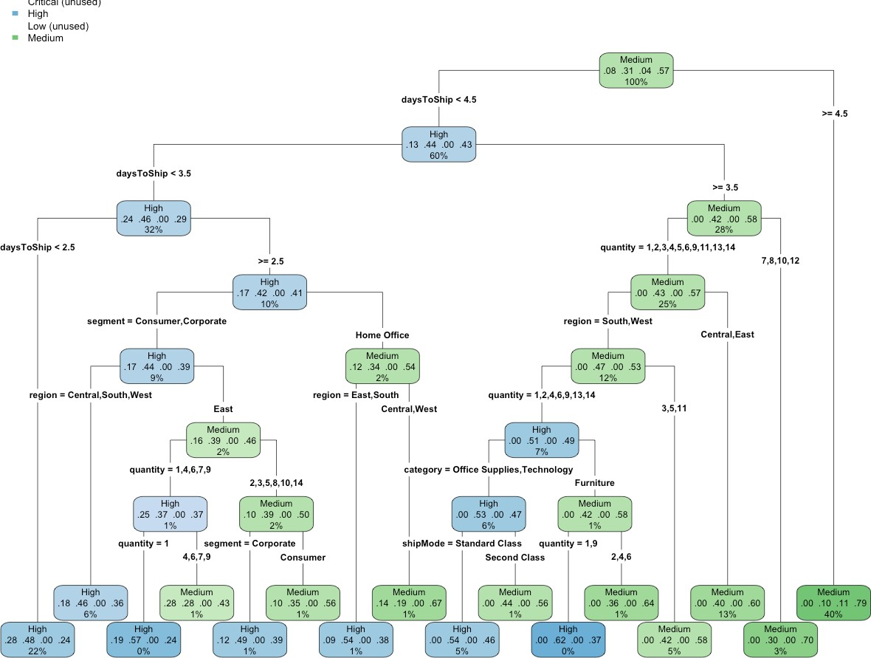Use Decision Tree to predict Order Priority

library("rpart") library("rpart.plot")
dtPriority <- rpart(orderPriority ~ shipMode + daysToShip + category + segment + region + quantity, train, method
="class", parms=list(split='information'), minsplit=10, cp=0.001) rpart.plot(dtPriority, type=4)

## Critical | 0 0 0 | 0
## High | 152 333 0 | 224
## Low | 0 0 0 | 0
## Medium | 8 287 82 | 907
##

## Sensitivity | 0.00000 | 0.5371 | 0.00000 | 0.8019
## Specificity | 1.00000 | 0.7261 | 1.00000 | 0.5626
## Pos Pred Value | NaN | 0.4697 | NaN | 0.7064
## Neg Pred Value | 0.91972 | 0.7765 | 0.95886 | 0.6841
## Prevalence | 0.08028 | 0.3111 | 0.04114 | 0.5675
## Detection Rate | 0.00000 | 0.1671 | 0.00000 | 0.4551
## Detection Prevalence | 0.00000 | 0.3557 | 0.00000 | 0.6443
## Balanced Accuracy | 0.50000 | 0.6316 | 0.50000 | 0.6823

Use Naive Bayes to predict Order Priority
## Loading required package: lattice
## Loading required package: ggplot2
## Confusion Matrix and Statistics ##
## Reference
## Prediction Critical High Low Medium
## Overall Statistics ##
## ## ## ## ## ## ##
Accuracy : 0.6222
95% CI : (0.6005, 0.6435)
No Information Rate : 0.5675
P-Value [Acc > NIR] : 4.021e-07

Kappa : 0.2786
## Mcnemar's Test P-Value : NA ##
## Statistics by Class: ##
##
Class: Critical Class: High Class: Low Class: Medium

confusionMatrix(dtPredict,test$orderPriority)

dtPredict<- predict(dtPriority, test, type="class")
library(caret)
##
## Naive Bayes Classifier for Discrete Predictors ##
## Call:
## naiveBayes.default(x = X, y = Y, laplace = laplace) ##
## A-priori probabilities:
## Y
## Critical High Low Medium ## 0.07786527 0.30608674 0.04374453 0.57230346 ##
## Conditional probabilities:
## shipMode
## Y First Class Same Day Second Class Standard Class ## Critical 0.44301766 0.19582665 0.36115570 0.00000000
## High 0.23233973 0.08697428 0.24173132 0.43895468
## Low 0.00000000 0.00000000 0.00000000 1.00000000
## Medium 0.08517143 0.02118366 0.15986023 0.73378467
##
## daysToShip
## Y 0 1 2 3 4
5
## Critical 0.19261637 0.11556982 0.47672552 0.21508828 0.00000000 0.00000000
## High 0.08248265 0.05675786 0.20783993 0.14005717 0.38423846 0.12862393
## Low 0.00000000 0.00000000 0.00000000 0.00000000 0.00000000 0.00000000
## Medium 0.01943656 0.01768945 0.05459707 0.07228653 0.28193929 0.31011138
## daysToShip
## Y 6 7
## Critical 0.00000000 0.00000000
## High 0.00000000 0.00000000
## Low 0.46571429 0.53428571
## Medium 0.17820485 0.06573488 ##
## segment
## Y Consumer Corporate Home Office ## Critical 0.5313002 0.2841091 0.1845907
## High 0.5263373 0.2964475 0.1772152
## Low 0.4942857 0.3371429 0.1685714
## Medium 0.5136493 0.3053068 0.1810439
##
## category
## Y Furniture Office Supplies Technology ## Critical 0.2070626 0.6051364 0.1878010
## High 0.2078399 0.5998367 0.1923234
## Low 0.1742857 0.6485714 0.1771429
## Medium 0.2186067 0.6029701 0.1784232
##
## region
## Y Africa Canada Caribbean Central Central Asia East ## Critical 0.0000000 0.0000000 0.0000000 0.2215088 0.0000000 0.2921348
## High 0.0000000 0.0000000 0.0000000 0.2200898 0.0000000 0.2825643
## Low 0.0000000 0.0000000 0.0000000 0.2485714 0.0000000 0.2371429
## Medium 0.0000000 0.0000000 0.0000000 0.2439397 0.0000000 0.2856519
## region
## Y EMEA North North Asia Oceania South Southeast Asia ## Critical 0.0000000 0.0000000 0.0000000 0.0000000 0.1621188 0.0000000
## High 0.0000000 0.0000000 0.0000000 0.0000000 0.1584320 0.0000000
## Low 0.0000000 0.0000000 0.0000000 0.0000000 0.1457143 0.0000000
## Medium 0.0000000 0.0000000 0.0000000 0.0000000 0.1611706 0.0000000
## region
## Y West
## Critical 0.3242376
## High 0.3389138
## Low 0.3685714
## Medium 0.3092378
##
## quantity
## Y 1 2 3 4 5
## Critical 0.101123596 0.260032103 0.247191011 0.109149278 0.113964687
## High 0.088199265 0.251122907 0.244997958 0.122498979 0.109432421
## Low 0.080000000 0.262857143 0.214285714 0.102857143 0.151428571
## Medium 0.089757589 0.233457087 0.243939725 0.119895174 0.125573269
## quantity
## Y 6 7 8 9 10
## Critical 0.041733547 0.065810594 0.025682183 0.022471910 0.006420546
## High 0.060432830 0.053899551 0.022866476 0.027766435 0.006124949
## Low 0.048571429 0.071428571 0.022857143 0.037142857 0.000000000
## Medium 0.055907403 0.063550994 0.028608867 0.022712383 0.006114872
## quantity
## Y 11 12 13 14
## Critical 0.001605136 0.001605136 0.001605136 0.001605136
## High 0.004083299 0.002858310 0.002041650 0.003674969
## Low 0.005714286 0.000000000 0.000000000 0.002857143
## Medium 0.003494213 0.002620660 0.002620660 0.001747106
## Confusion Matrix and Statistics ##
## Reference
## Prediction Critical High Low Medium
## Overall Statistics ##
## ## ## ## ## ## ##
Accuracy : 0.5855
95% CI : (0.5636, 0.6073)
No Information Rate : 0.5675 P-Value [Acc > NIR] : 0.05405

Kappa : 0.2665
## Mcnemar's Test P-Value : NA ##
## Statistics by Class: ##
##
Class: Critical Class: High Class: Low Class: Medium

nbPredict <- predict(nbPriority, test, type = "class") confusionMatrix(nbPredict,test$orderPriority)

library(e1071)
nbPriority <- naiveBayes(orderPriority ~ shipMode + daysToShip + segment + category + region + quantity, train) nbPriority

## Critical | 75 127 0 | 57
## High | 85 202 0 | 171
## Low | 0 0 13 | 26
## Medium | 0 291 69 | 877
##

## Sensitivity | 0.46875 | 0.3258 0.158537 | 0.7754
## Specificity | 0.89962 | 0.8135 0.986395 | 0.5824
## Pos Pred Value | 0.28958 | 0.4410 0.333333 | 0.7090
## Neg Pred Value | 0.95098 | 0.7277 0.964688 | 0.6640
## Prevalence | 0.08028 | 0.3111 0.041144 | 0.5675
## Detection Rate | 0.03763 | 0.1014 0.006523 | 0.4400
## Detection Prevalence | 0.12995 | 0.2298 0.019568 | 0.6207
## Balanced Accuracy  ##Create ROC Curve | 0.68418 | 0.5697 0.572466 | 0.6789

library(ROCR) library(ggplot2)
nbPredict2 <- predict(nbPriority, test, type = "raw") score<- nbPredict2[,c("Critical")]
actual_class<-test$orderPriority =="Critical" pred<-prediction(score,actual_class)
perf<- performance(pred,"tpr", "fpr")
plot(perf, lwd=2, xlab="False Positive Rate (FPR) ",ylab="True Positive Rate (TPR) ")
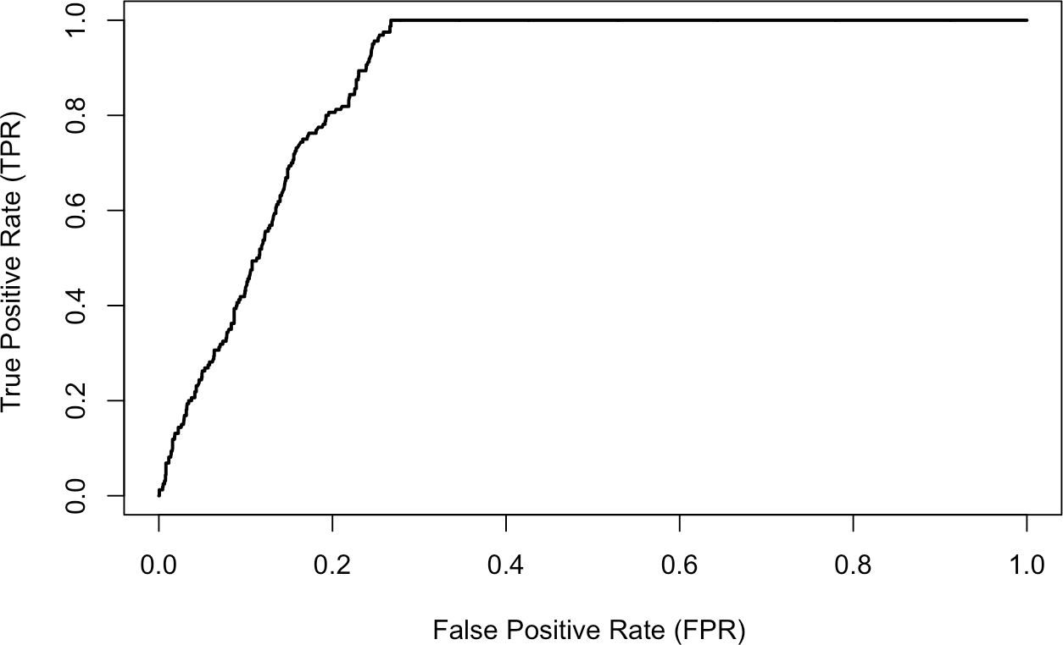
## [1] 0.8821757

auc <- performance (pred, "auc")
auc <- unlist (slot(auc, "y.values")) auc

