**Ques 1**

**“grep” command is used for searching the pattern in any file.**

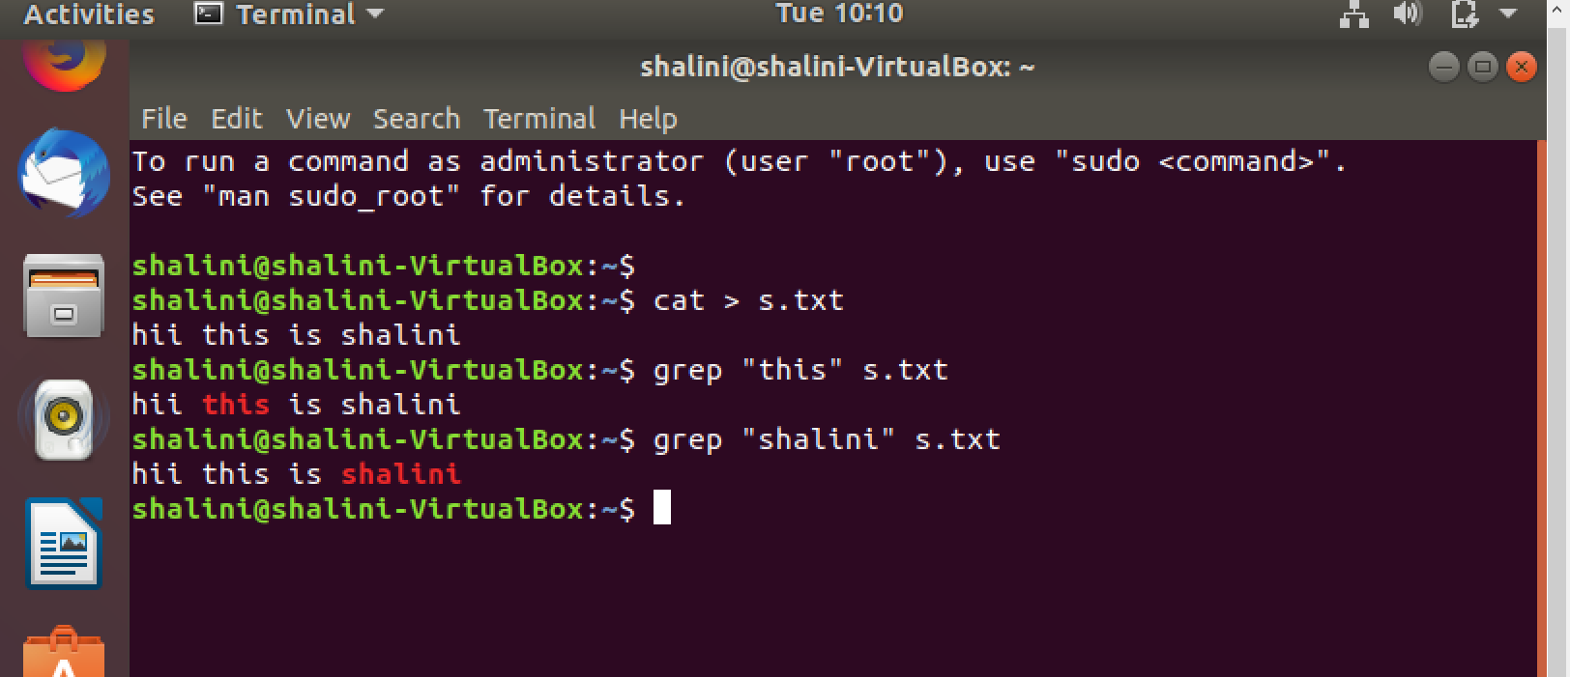

Ques 2

“chmod” command is used for changing the permissions of the file.

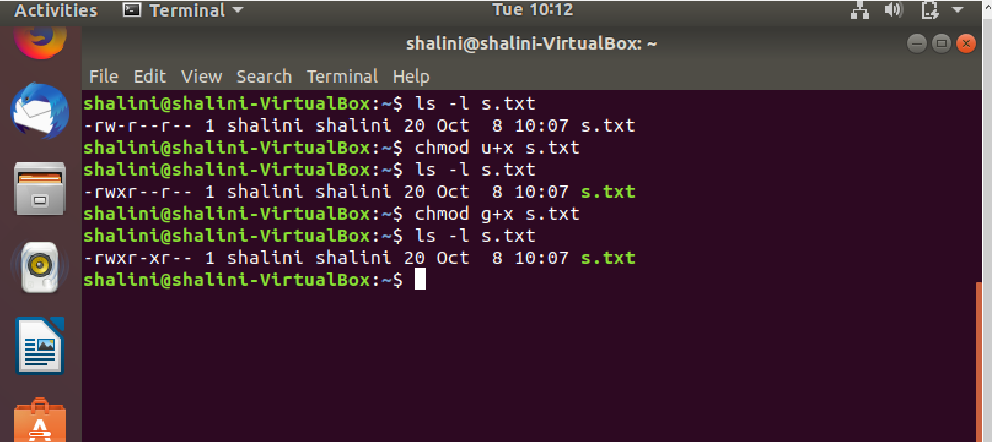

Ques 3

“cp” command is used for copy the file from one directory to another directory.

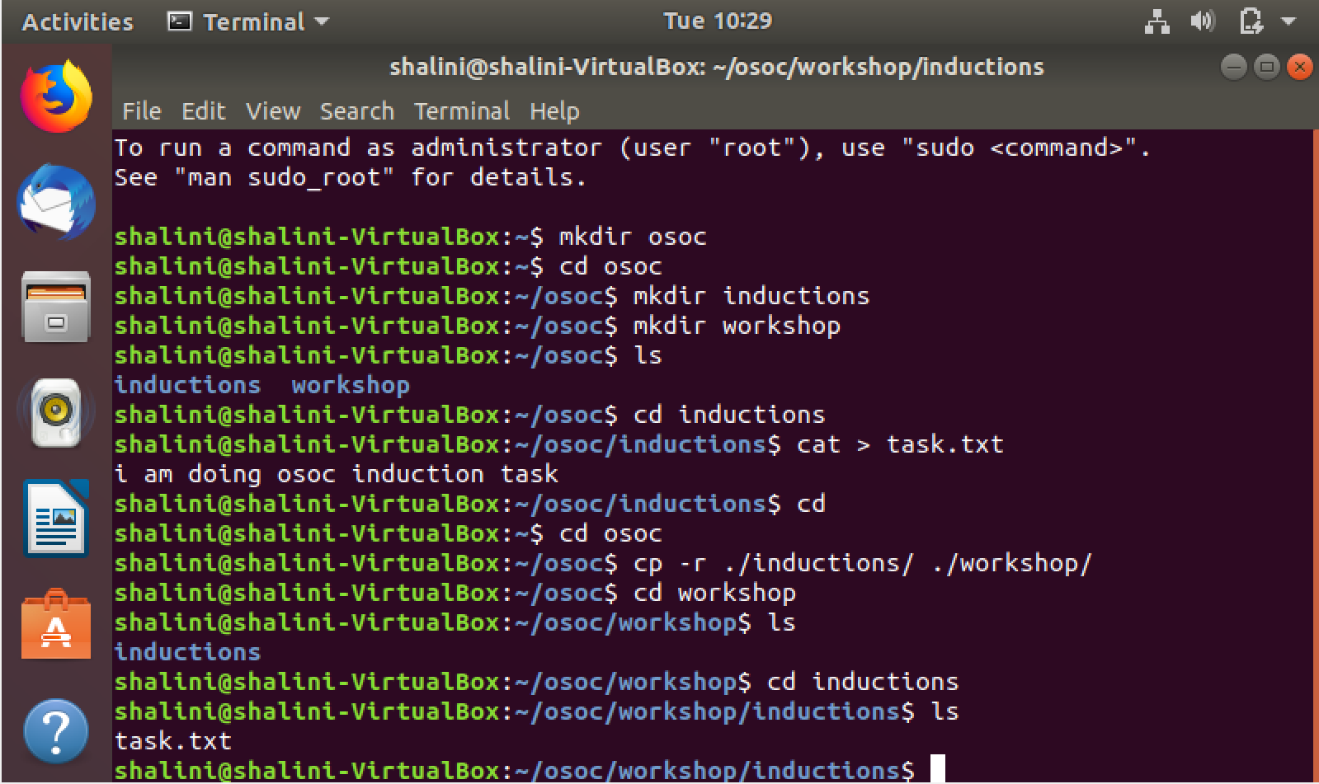

Ques 4

“ping” is used for checking the internet connection.

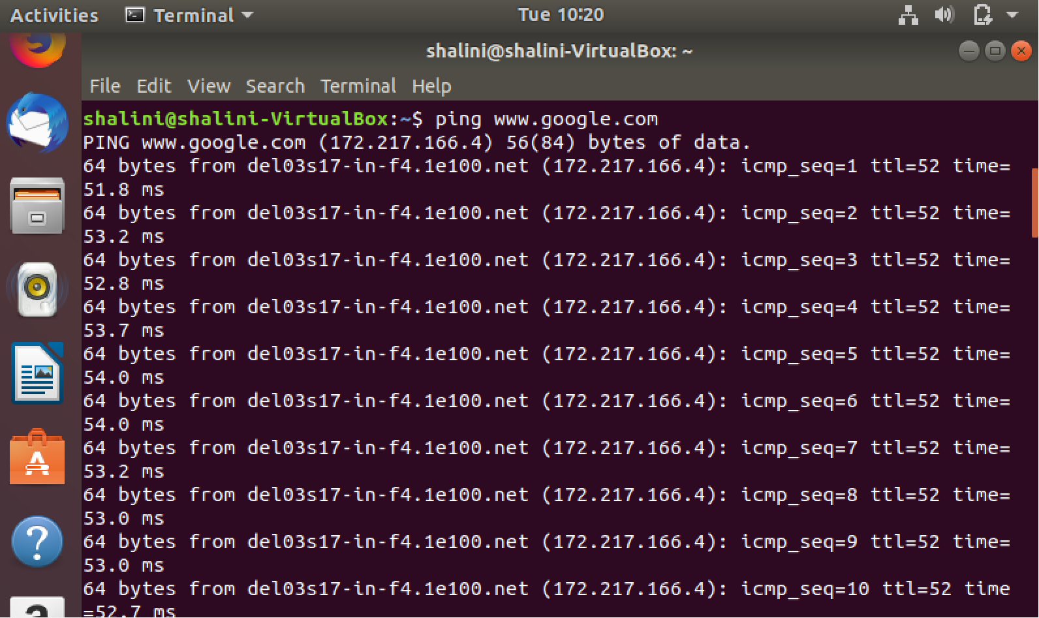

Ques 5

“passwd” command is used for changing the password.

