Contents

AWS Server Setup/Instance Creation 1

AWS instance backup and user management 6

Modifying the Size of EBS Volume on Linux 9

AWS support and raising a request 10

Costing of AWS instance 11

User Creation for VPN 12

Application Server details 13

PS Cartridge Server Details 14

Scheduling server start/stop from ACP Portal 20

# AWS Server Setup/Instance Creation

1. Login to the AWS console using the default admin id and password provided or by the user who has admin access to the console.

The default url and user credentials are:

|  |  |  |
| --- | --- | --- |
| **AWS Login Page** | <https://ps-innovation.signin.aws.amazon.com/console> | |
| **AWS Account Login** | **PS_Innovation_Admin**  (Password will be communicated through a separate e-mail due to security reasons) | |
| **WsH4jHskxtNuf66n** | |

1. After logging into amazon account, click on services dropdown in the top left corner and select EC2.

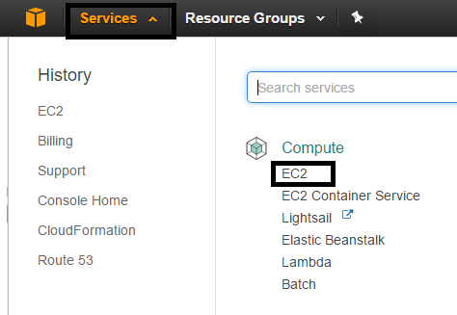

1. Launch a new instance from the instances section.

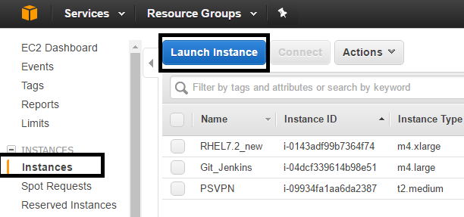

1. Select a pre-built AMI provided by AWS.

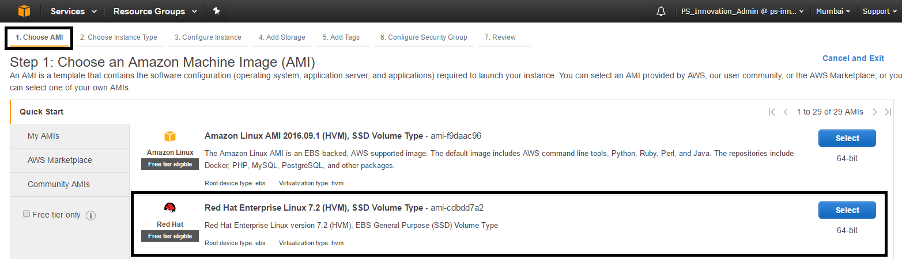

1. Choose instance type based on cpu’s and memory(RAM) required and click on next to go to next section.

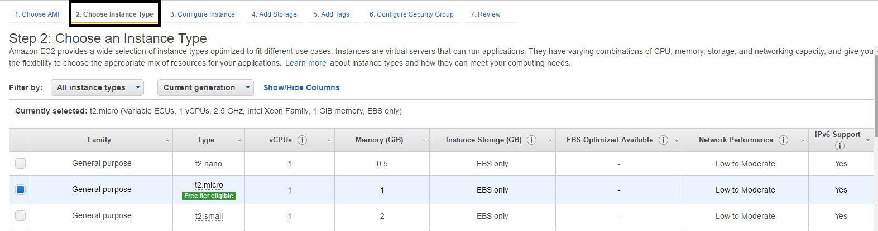

1. In the next section configure instance select network and subnet as ap-south-1a and keep other things default. Select the checkbox to enable termination protection. After the selection click on next to go to next section.

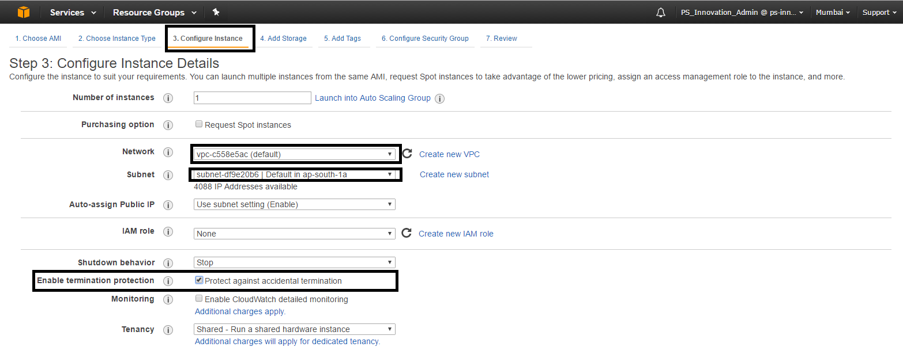

1. Under add storage section create a new volume with the size in GB required apart from the root volume.

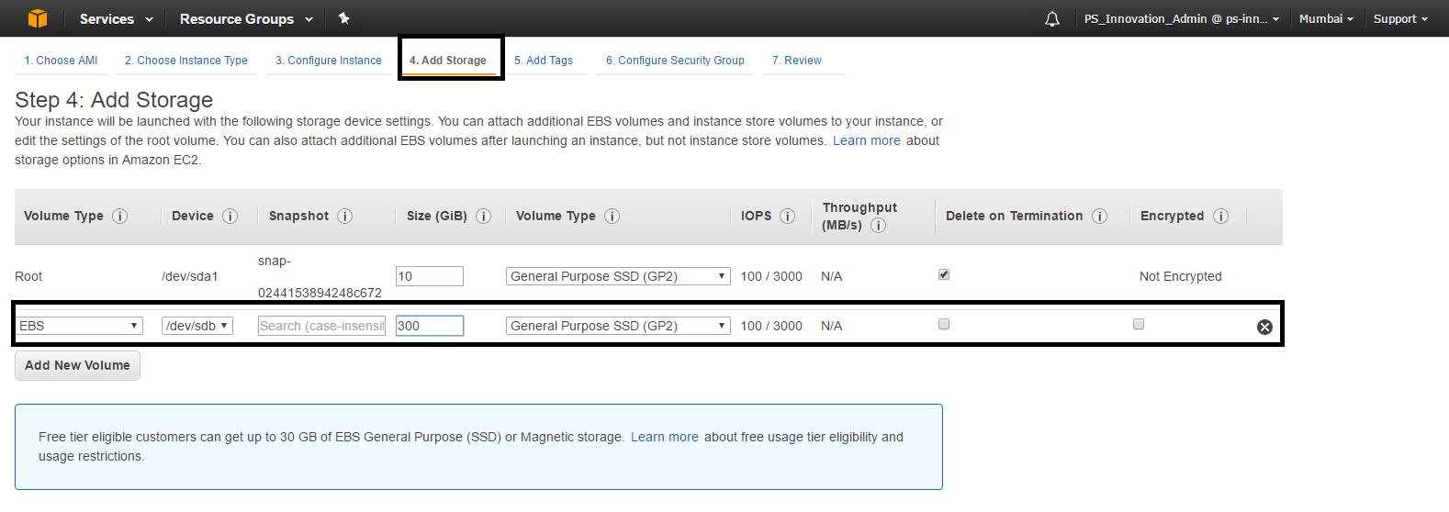

1. Add tag name to the instance(optional).

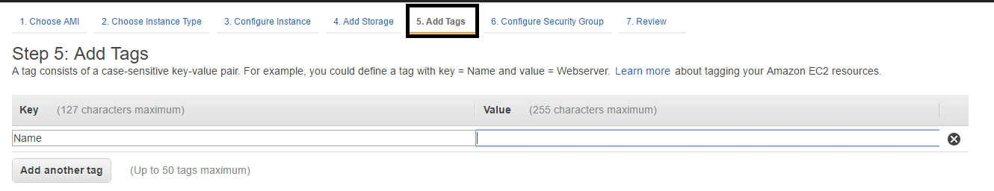

1. Select the existing security group or create a new group.

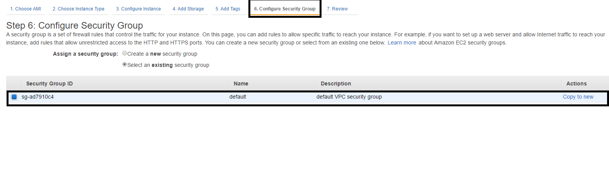

1. Review and launch. After reviewing click on launch to create new instance.



1. Once the instance is created we need to use the keypair.pem file provided for authentication.The steps are:
2. open git bash
3. cd to directory where .pem file is located
4. ssh -i keyfilename.pem [ec2-user(or centos or ubuntu)@<Instance ip>](ec2-user@172.32.31.13)
5. sudo -i
6. cd /etc/ssh
7. chmod 777 sshd_config
8. vi /etc/ssh/sshd_config
9. enable password authentication yes

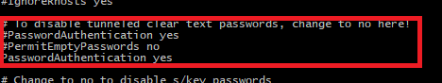

1. sudo service sshd restart
2. useradd username
3. passwd username
4. To add the user as admin/sudo in the environment type in **visudo** which will open up an editor and scroll to the end of the file.
5. There would be an entry for ec2-user so below it add the user to be added as admin.

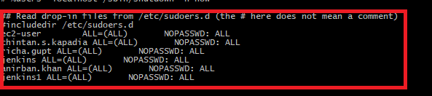

1. Save the file.
2. Now the user can login to the server using putty.

# AWS instance backup and user management

For taking a backup of an aws instance you will have to create an AMI(Amazon machine image) for the same which will create a backup of the instance and create a snapshot of volume associated to that instance.Follow below steps to create an AMI:

1. Go to EC2 Dashboard under services and click on the instances section.
2. Right click on the instance you want to create a backup of and select Image->Create Image.

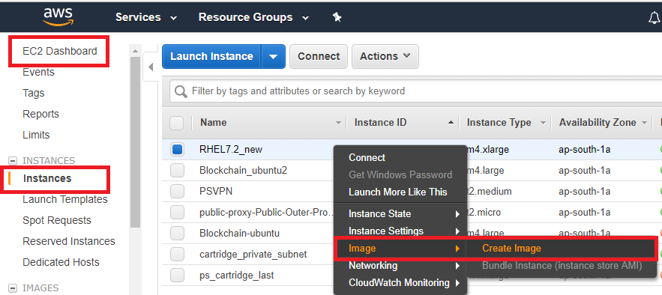

1. On the create image page give a logical name to the image and check the no reboot checkbox.Click on create image.

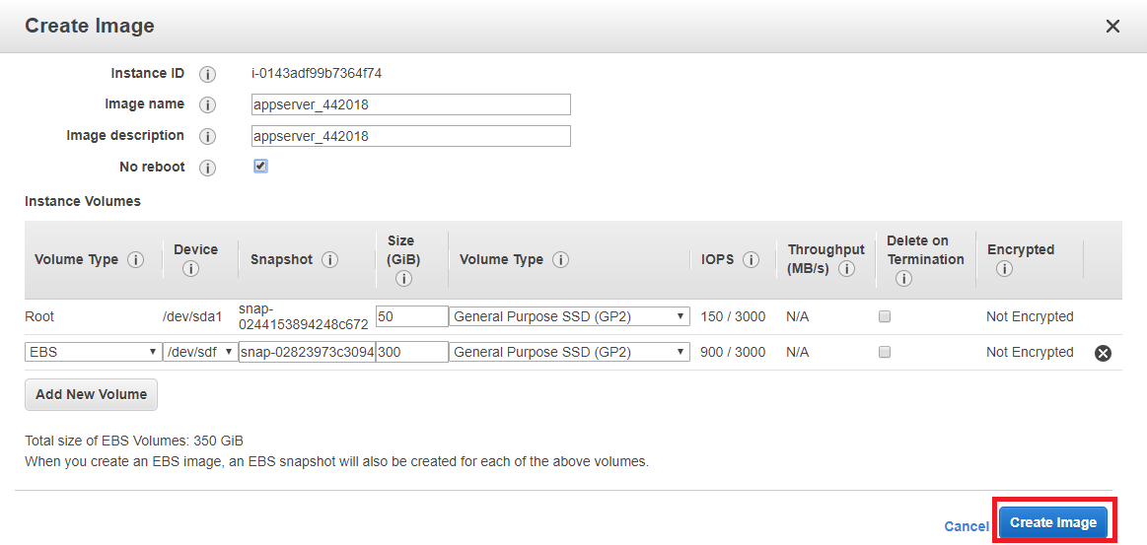

1. Once the image is created you will be able to see the same under AMI section.
2. Go to snapshot section and name the recently backed up volumes similar to image name created previously.

For **User management**, to add/remove users having access on the AWS console follow the below steps:

1. Go to services on top left of the console and search for IAM.

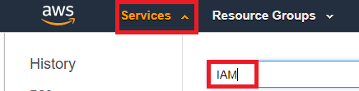

1. Under Users section, click on add user and provide the details of the user as below,

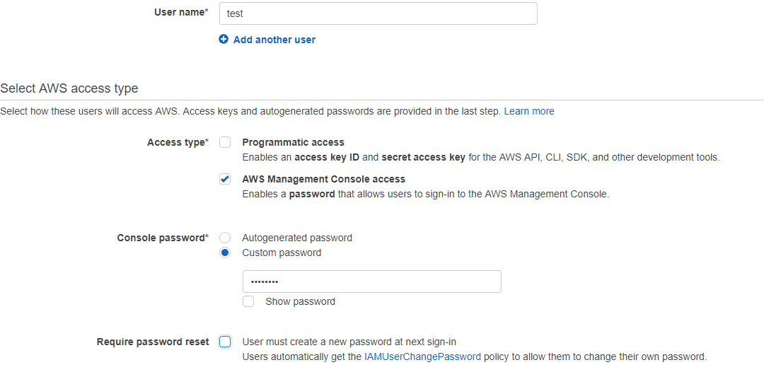

1. Click on Next:Permissions to add a user to group.Select ACP_Admin_Access as the group and click on Next:Review.

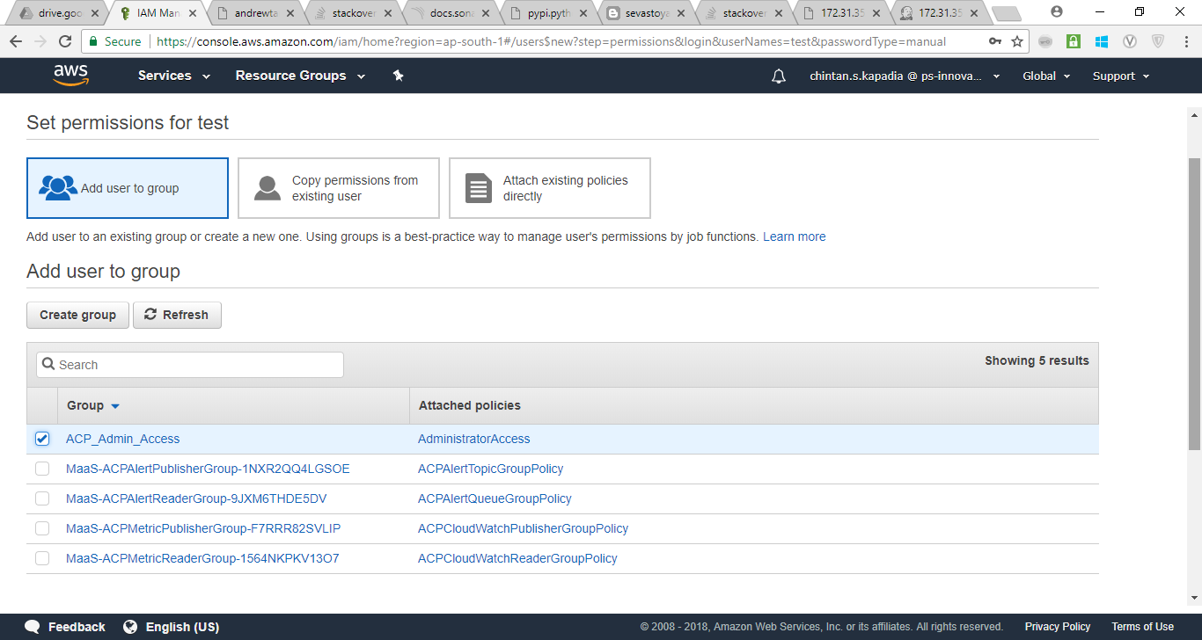

1. Review the details and click on create user to provide new user access to the AWS console.
2. To delete the user, one can select the user checkbox and click on delete user.

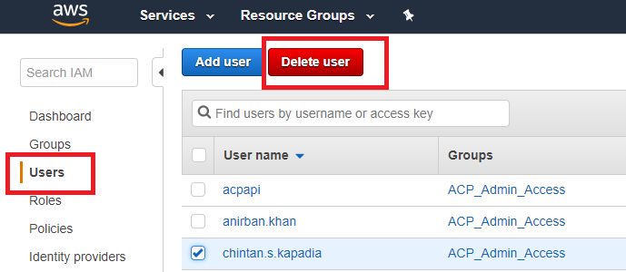

# Modifying the Size of EBS Volume on Linux

If your Amazon EBS volume is attached to a current generation EC2 instance type, you can increase its size, change its volume type, or (for an io1 volume) adjust its IOPS performance, all without detaching it. You can apply these changes to detached volumes as well.

**Modifying an EBS Volume from the Console**

The following procedure shows how to apply available volume modifications from the Amazon EC2 console.

1. Open the Amazon EC2 console at <https://console.aws.amazon.com/ec2/>.
2. Choose **Volumes**, select the volume to modify and then choose **Actions**, **Modify Volume**.
3. The **Modify Volume** window displays the volume ID and the volume's current configuration, including type, size, and IOPS. You can change any or all of these settings in a single action. Set new configuration values as follows:
   * To modify the type, choose a value for **Volume Type**.
   * To modify the size, enter an allowed integer value for **Size**.
   * If you chose **Provisioned IOPS (IO1)** as your volume type, enter an allowed integer value for **IOPS**.
4. After you have specified all of the modifications to apply, choose **Modify**, **Yes**.

An EBS volume being modified goes through a sequence of states. After you issue a ModifyVolume directive, whether from the console, CLI, API, or SDK, the volume enters first the Modifying state, then the Optimizing state, and finally the Complete state. At this point, the volume is ready to be further modified.

To check which type of file system is used the command is :

**Sudo file -s <block name e.g /dev/xvdg>**

To check the block devices attached to the instance use:

**Lsblk**

If the file system is ext1,2,3,4 use the below command to expand the volume size:

**Sudo resize2fs <block name>**

If the filesystem is xfs then use:

sudo yum install xfsprogs

**sudo xfs_growfs -d */mnt***

# AWS support and raising a request

To get help from the AWS team a request will have to be raised from the AWS console.Based on the support plan the appropriate request could be possible to raise.

**Note**: To raise technical support request we need to have developer support plan which will have to be activated by dropping a mail to [acp.support@accenture.com](mailto:acp.support@accenture.com). It is a monthly chargeable plan.

The requests can be raised as below,

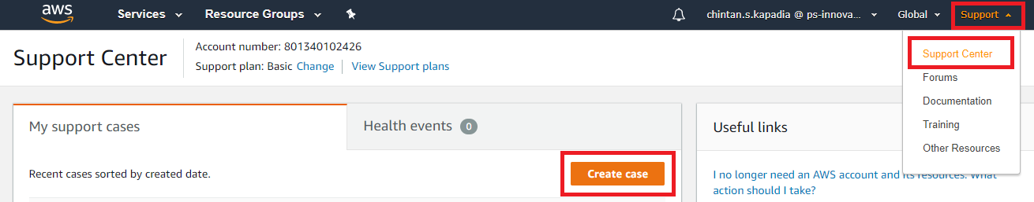

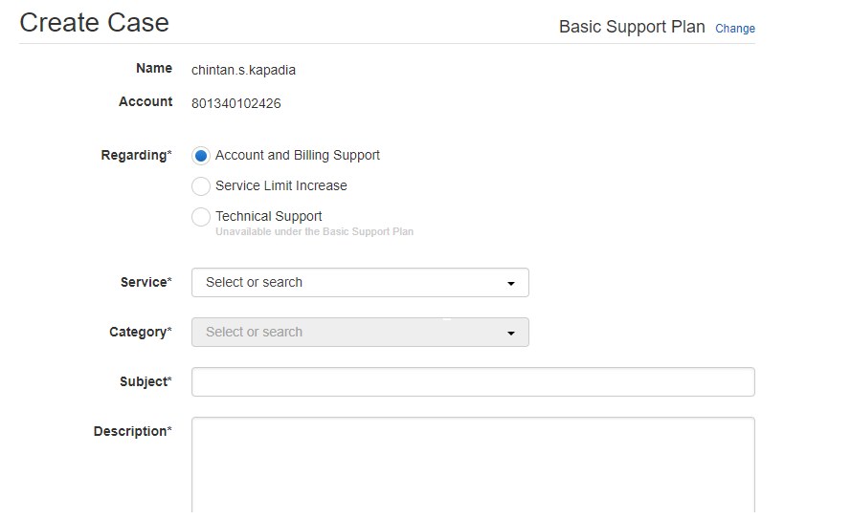

After all details are duly filled click on Submit. The responses can be checked on the support page itself.

# Costing of AWS instance

Costing of any instance can be approximately calculated by going to the url <https://calculator.s3.amazonaws.com/index.html>

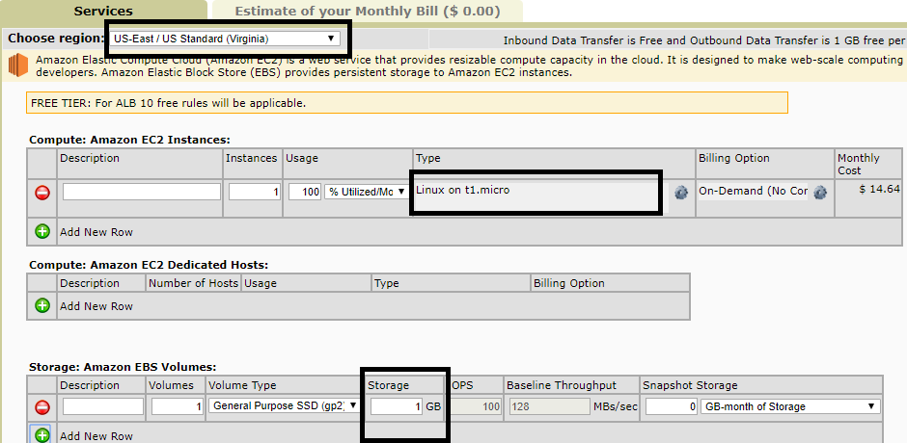

As per the image above, select the required regions, OS type of the instance and volume(disk space) to calculate approx. costing of the server.

To check the bills from the AWS Console click on your username dropdown on right corner of the console and select **My Billing Dashboard**.

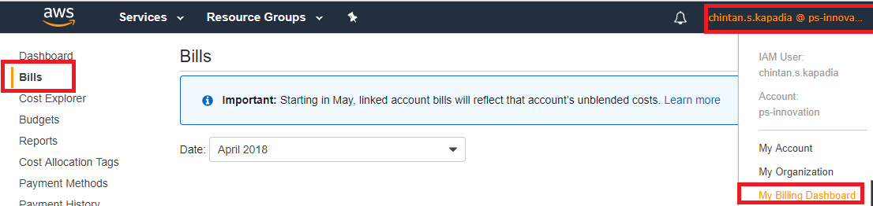

# User Creation for VPN

1. Login into the url <https://35.154.119.42/admin/> and provide the credentials.

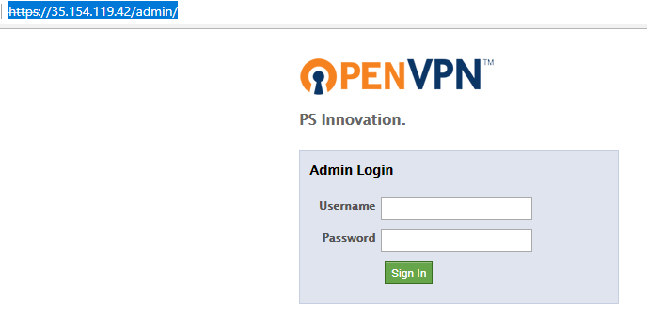

1. After login under user permission add the new username and provide the password.

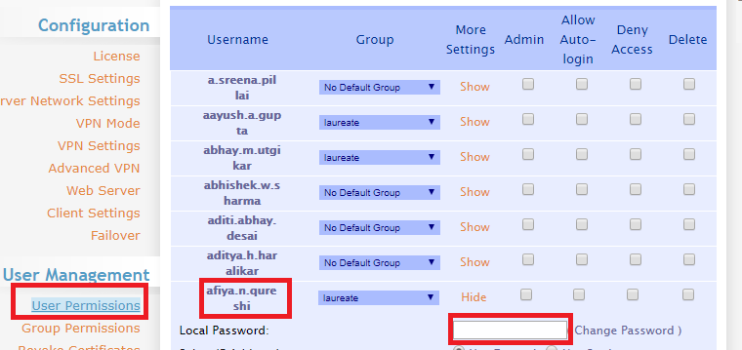

1. Click on save settings. Once done it will prompt to update the running server, so click on the same to get the changes reflected.
2. To delete the user, select the checkbox against the user and save settings.Update the running server.

# Application Server details

**Application Server Details: RHEL 7**

**Private IP: 172.31.24.242**

All the applications hosted on the server are under /opt directory. So after login with your username switch to sudo user and cd to /opt directory.

The startup scripts can be found by typing in **crontab -l** . The directories where startup script should be placed is **/etc/init.d/.**

**For all the applications except Blockchain the script is at /etc/init.d/startup_app.sh.**

**For blockchain the script is /etc/init.d/Blockchain_startup.sh.**

# PS Cartridge Server Details

**Cartridge Server Details: Ubuntu**

**Private IP: 172.31.35.12**



**ADOP LDAP Password:** d70f708f4f051673

Steps to add users in ldap to enable them to perform git related actions and also access the dashboard are as below:

1. Login to the url <http://172.31.35.12> to get the PS Cartridge dashboard.
2. Click on the Ldap icon to take you to the login screen.

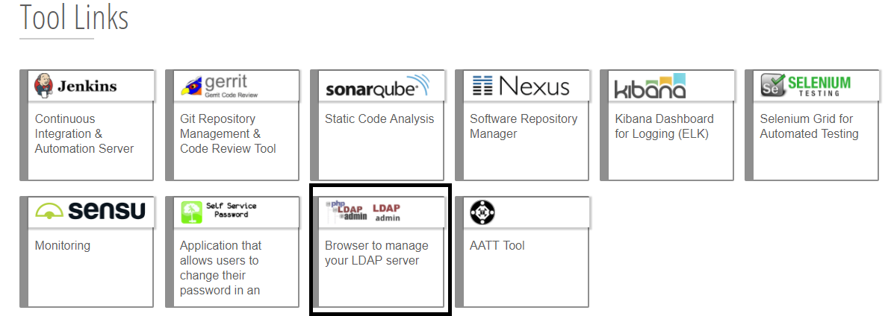

1. Click on login and provide the ldap password **d70f708f4f051673.** Click on Authenticate.

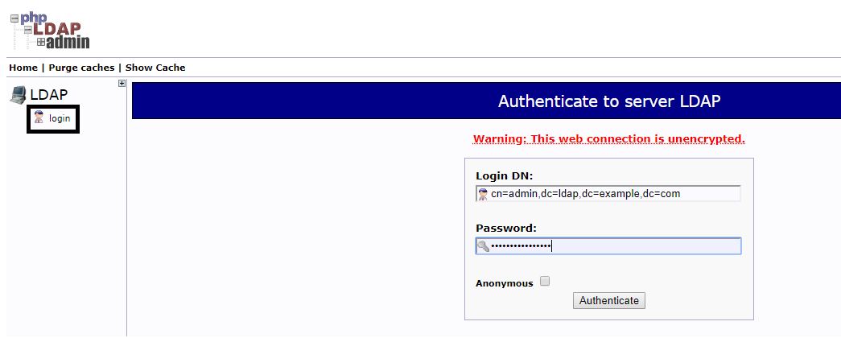

1. Expand the people section to add/remove user. Select any user to copy the entry for new user. Once the selected user page opens then click on **copy or move this entry.**

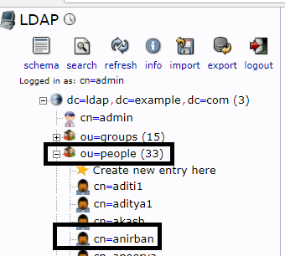

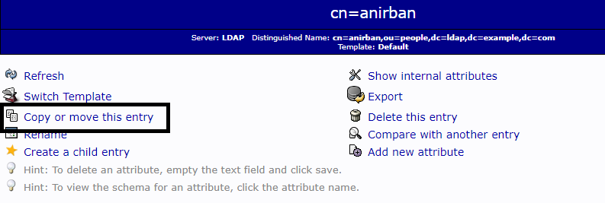

1. Once you chose to **copy or move this entry** you will be provided with the screen to create a new user.Just replace the existing user with the new one and click on copy.

For eg: in the below screenshot replace anirban with the required username.

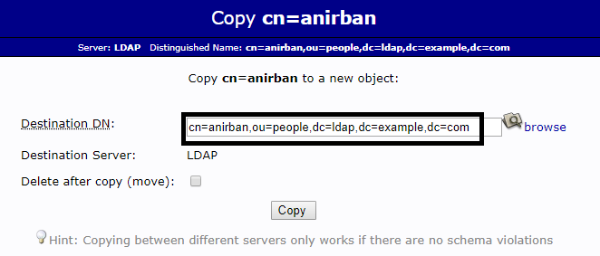

1. Once you click on copy a create object page comes up wherein we need to provide the details of the user as per the screenshot below.

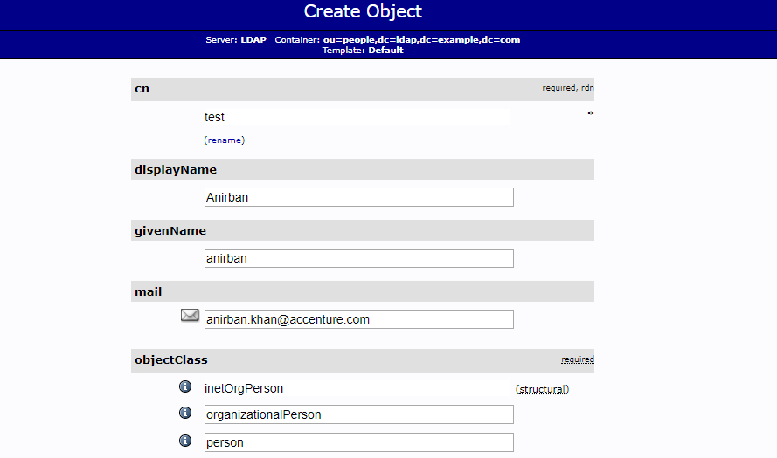

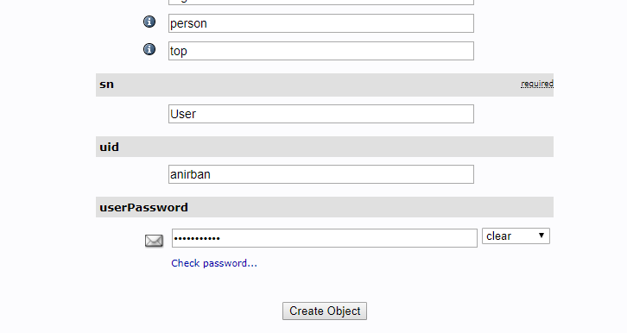

1. After clicking on create object you would be presented with review screen to verify the details and commit.

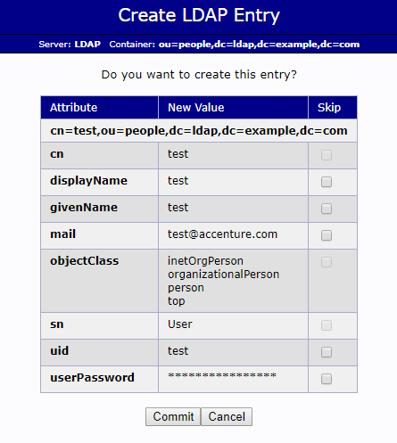

1. After committing you should get a success message of entry creation.

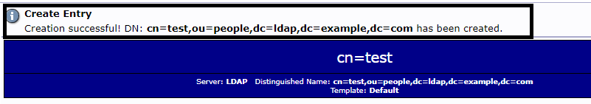

1. If the user should be given only the access to dashboard then the above steps would suffice, but to have user perform git operations continue to follow the remaining steps.
2. Expand the groups section and select **gerrit-developer** group.

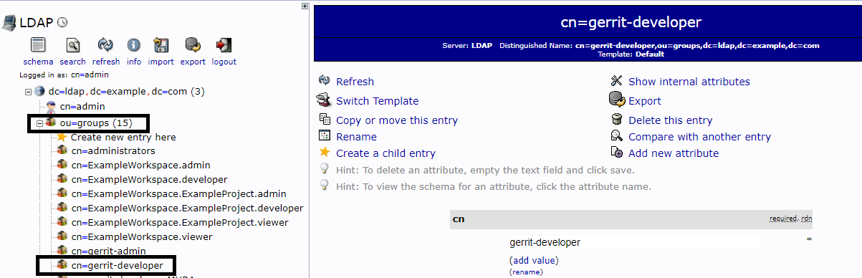

1. Now add the entry of the user created by selecting add value option in the below shown format and click on update object.

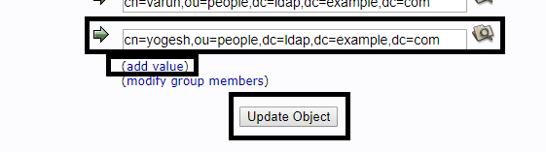

1. A new screen asking the conformation of changes would come up. Review and select update object to add the user’s entry into the group. The newly added user would now be able to perform all git operations.

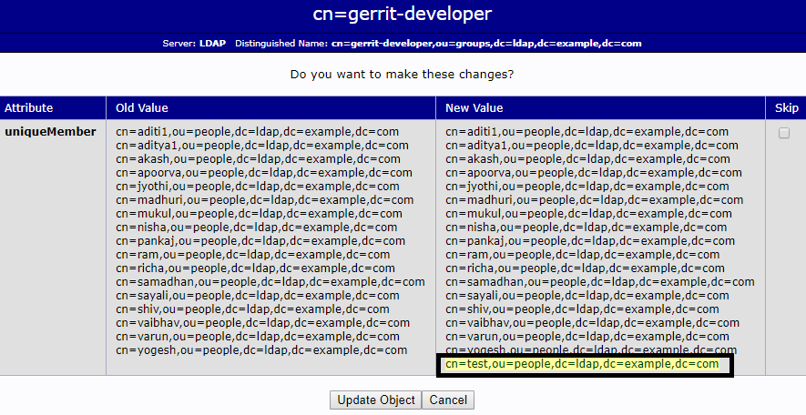

1. To add the user as administrator, follow steps 10 to 12 by selecting the group as administrators.

# Scheduling server start/stop from ACP Portal

1. Open the url: <https://cloudportal.accenture.com/dashboard/> and provide the Accenture credentials.

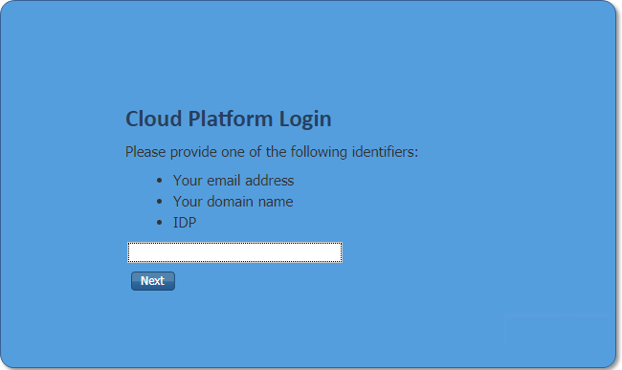

1. On the landing page click on Resources->Inventory. It will show up the server/istance inventory of our AWS account.

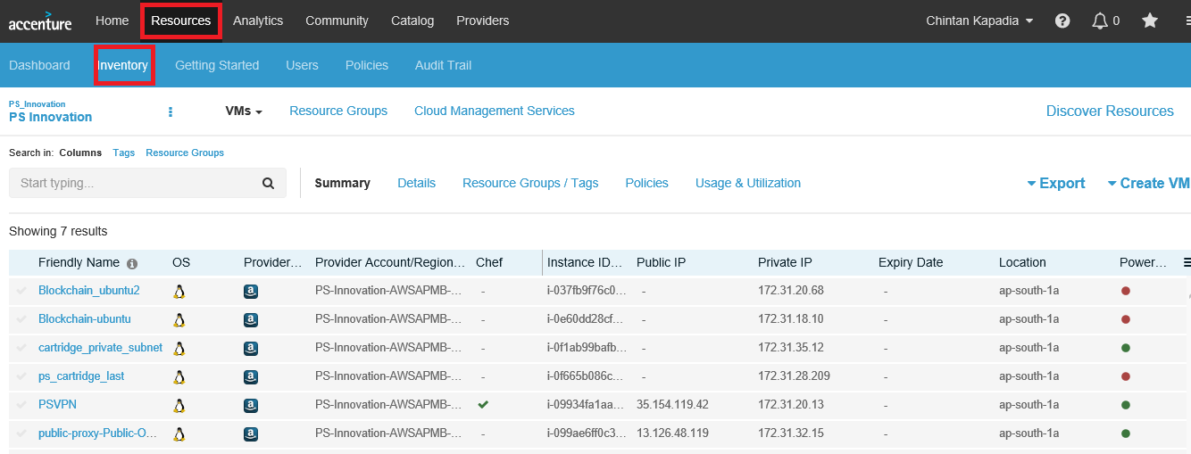

1. Now click on **Resource Groups** from within the Inventory page.

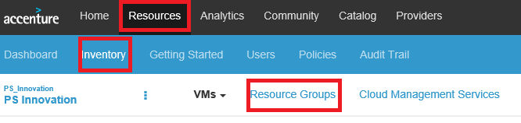

1. To schedule timing of a particular instance hosted on AWS click on the required resource group name.

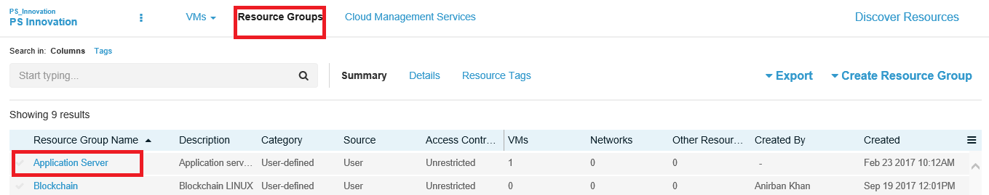

1. On the instance landing page click on the calendar icon and schedule the timing as per the requirement.

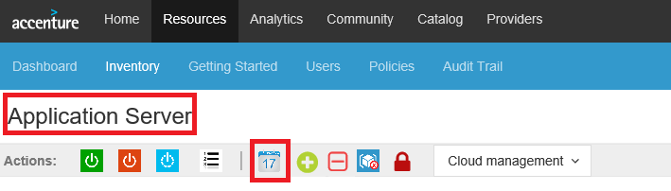

It will open up a page as below:

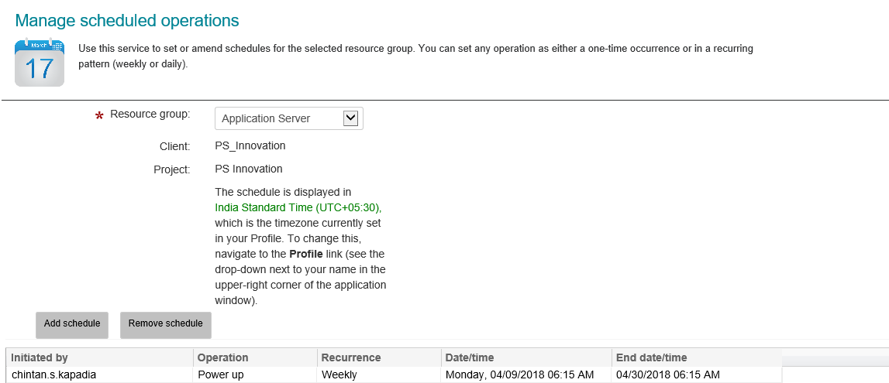

1. Click on add/remove schedule as per the requirement.

