## Using Ansible facts to make decisions in playbooks:

Ansible playbooks can be powerful way to perform a series of tasks



But sometimes you needs somethings a little more complex, like ability for a playbook to **make a decision** and act upon it.

Write a play book that can install a package on hosts with different linux distributions.

We will install apache and the package name is different in these linux distributions.

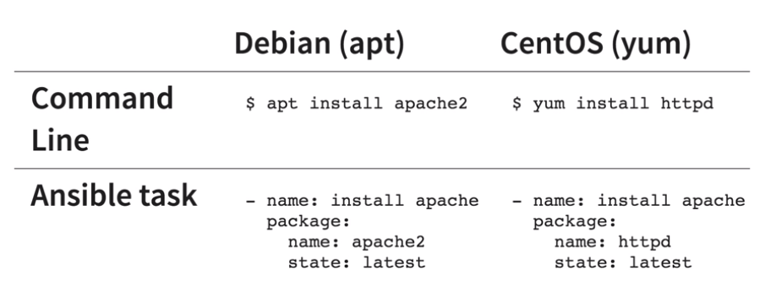

As we are using ansible package module with will use the appropriate package manger so that we have to not worry about it how ever we have to take care of the the package name as it will be different depending on whether I am installing on Debian where the package is name apache2 or Centos where the appropriate package name httpd.

Ansible facts – Information about a hosts which ansible automatically gathers. Facts can be referenced as variables within ansible.

To print values of ansible facts we can use the following adhoc commad:

Ansible all -m setup -i inventoryfile name

Launching docker containers using ANSIBLE:

We will do the following 4 task and create 4 playbooks for the below each steps:

1. Pull a centos image
2. Create a custom image
3. Create a container
4. Validate deployment.

We will be running these jobs as pipline.