Movie Recommendation System
Felix (Guohan) Gao, Calvin (Kim-Pang) Lei
University of California, Los Angeles
{gaogu, clei}@cs.ucla.edu

Abstract
Recommendation systems in e-commerce become increasingly important due to the large number of choices consumers face. In general, recommendation systems first take a set of input which could be user profiles, a set of item ratings, etc, identify similarities among the input, and pass the similar pairs for prediction calculation. Among the techniques used in building recommendation systems, collaborative filtering is one of the most promising approaches. LikeMinds, a commercially available recommendation system makes use of collaborative filtering, and our approach is inspired by that system. In this paper, we mainly address the challenges of building an efficient and useful recommendation system given a large data set, and discuss our approach on identifying neighbors as well as our prediction heuristics. We also present the results of our experiment where we evaluate the accuracy of our algorithm based on the predictions calculated by trivial algorithms, and the result shows that our algorithm can give accurate ratings.

1. Introduction
The amount of information in Internet is growing so fast that it overwhelms web users. This is also a major problem for e-commerce because online shoppers cannot simply explore and compare every possible product. To alleviate the problem, recommendation systems are introduced to e-commerce. Among all the existing techniques, Collaborative Filtering is one of the most promising approaches to build recommendation systems. Collaborative Filtering collects user's preferences for items, looks for a set of neighbors sharing similar preferences, and infers rating on a particular item based on the information collected from neighbors. With the predicted rating, the system will recommend products which have high predicted ratings to users.
Recommendation system is particularly useful when online merchants are selling large number of products that are in similar domains such as Music CDs, Movies, etc. The recommendation is based on the ratings on products that users have previously rated. A useful recommendation system is efficient since in practice the system handles millions of ratings and prediction is calculated in real times. A useful recommendation system also generates accurate prediction. We will explain these challenges in more details in section 1.1.
Recently, Netflix, an online DVD rental company, developed an algorithm of predicting users' movie ratings. In order to further improve their algorithm, Netflix provides a data set of 480,195 users, 17,770 movies, and 100 million ratings to the public and claim to give out 1 million dollars as reward for anyone who beats their algorithm by 10 percent. In this paper, we will focus on the problem of handling that huge data set efficiently while generating accurate predictions. We will make use that data set to test our algorithm and use the results from trivial algorithms to evaluate our algorithm.

1.1 Challenges
The first challenge is to identify neighbors efficiently. Given a large number of users (480,195 users), a huge items profile (100 million ratings), and a large number of movies (17,770), the system must compute the recommendations within seconds if predictions are to be generated in real time. The process of computing recommendation takes two phases. The first phase is to identify neighbors of the users we are trying to recommend items to. In this phase, the system needs to search through thousands of users and compute the similarities between the candidate neighbors and the targeted user. The second phase is to collect the similarities between the target users and the neighbors and to compute the prediction. Once the prediction is computed, the system will recommend items which achieve a certain threshold of rating to the target user. Given the tasks in these two phases, it is obvious that we need efficient algorithms.
The second challenge is to accurately compute the rating. Before we can compute the prediction, we need information from neighbors. However, how do we identify neighbors in the first place? User ratings are very subjective, so is it possible to extract similarities between users given the ratings of movies? Even if we can somehow identify neighbors, what is the best way to compute the prediction accurately?
In this paper, we present an algorithm and address the challenge of calculating accurate prediction. We evaluate the accuracy of our algorithms using the predictions computed by trivial algorithms.

2. Related Work
Collaborative filtering recommender system is a well studied topic. Such systems try to predict the ratings of certain items for a target user based on the items previously rated by other users [1]. Using collaborative filtering technique, a recommendation system tries to identify neighbors who have the least rating disagreement to the target users' ratings. The neighbors can be interpreted as having similar taste to the target users', so the recommendation is computed based on information from those neighbors only. LikeMinds [2] is one of the most famous applications using collaborative filtering. LikeMinds essentially try to identify neighbors based on the rating difference of each rating pairs between the target users and the candidates. LikeMinds take a target user and a set of candidate users as input, and computes the closeness based on the rating differences between the target user and the candidate users. The candidate with highest closeness score are considered as a mentor to the target user. The target user's prediction is then computed based on the mentor's rating.

3. Neighbor Identification
According to LikeMinds, we can predict movie ratings based on the concept of Mentoring. Therefore, we need to identify the closet neighbors to the target user first. Intuitively, to identify the closet neighbor, we need to find the candidates having the least disagreement on movie ratings to the target user. In Figure 1, we are trying to predict the ratings of movie E for Bob. Obviously Felix is a better neighbor because Calvin disagrees with Bob on some movies.

 | A | B | C | D | E
Bob | 5 | 3 |  | 4 | ?
Calvin | 4 | 3 |  | 3 | 3
Felix | 4 | 3 | 4 | 4 | 4
Figure (1) Shows Felix is a better neighbor to Bob since they generally agree with each other on ratings
Formally, Let U_{a} and U_{b} be the target user and the candidate neighbor respectively. Let R_{a} be the set of movie ratings rated by U_{a}, R_{b} be the set of movie ratings rated by U_{b}, and P_{a,m} be the prediction for the target user on movie M. We summarize the notations we use in this paper in Figure 2.

U_{a} | Target user whom we are computing predication for
U_{b} | Candidate neighbor to U_{a}
R(a) | A set of ratings rated by U_{a}
R(b) | A set of ratings rated by U_{b}
pcc(U_{a,} U_{b)} | Pearson Coefficient Correlation of U_{a} and U_{b}
Figure (2) Notations we will use throughout this paper

To evaluate how similar U_{a} and U_{b}, we always compute the disagreement of both users on ratings. In other words, a perfect neighbor’s ratings would completely agree with U_{a}‘s ratings. The first scheme we use is to look for the best neighbor from the set of candidate neighbors. To look for the best neighbor, our system search for candidates who have given the same rating as U_{a} for the movies they both rented, and have the highest number of such occurrence. However, using this scheme would not yield good predictions because we cannot guarantee that the candidates found by using this scheme have the least disagreement to U_{a.} In figure 3, assuming U_{a} is Bob while Calvin and Felix is two different U_{b.} In our straightforward scheme, they system would return Felix as the best neighbor since Felix completely agree with Bob on two movie ratings while Calvin only has one movie rating that is completely agree with Bob. However, it is obvious that the sum of disagreement between Felix and Bob is three while the sum of disagreement between Calvin and Bob is two. Therefore, our first scheme is not a good one in identifying the best neighbor. In addition, using the ratings from only one neighbor is subject to have inaccurate prediction since we are not taking the user’s subject behavior on movie ratings into account.

 | A | B | C | D | E | Sum of disagreement to Bob
Bob | 5 | 3 |  | 5 |  | -
Calvin | 4 | 2 |  | 5 | 3 | 2
Felix | 5 | 3 | 4 | 2 | 4 | 3
Figure (3) Showing that highest number of agreements on movie ratings is not necessarily imply the least disagreement.

In order to address these two problems, we use Pearson Correlation Coefficient as our neighbor identification function. Formally, Pearson Correlation Coefficient is defined as,
pcc(U_{a,} U_{b)} = 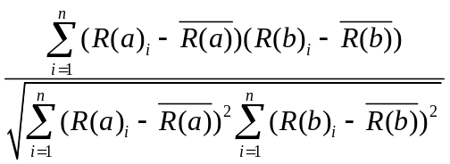

The value of pcc(U_{a,} U_{b)} falls in the range of -1 to 1, where pcc(U_{a,} U_{b)} = -1 means the user pair has negative correlation while pcc = 1 means the user pair has positive correlation. Therefore, if pcc(U_{a,} U_{b)} = 1, we can interpret that those two users have the same taste, and we can consider U_{b} as a good neighbor to U_{a}. However, there are two issues in calculating Pearson Correlation Coefficient directly. The first issue is the computational overhead. For each user pair, the system needs to find out the intersection of R(a) and R(b), compute the means, and calculate Pearson Correlation Coefficient. To reduce the overhead, we simplify the equation above to avoid computing the means for each user pair as followed,

pcc(U_{a,} U_{b)} = 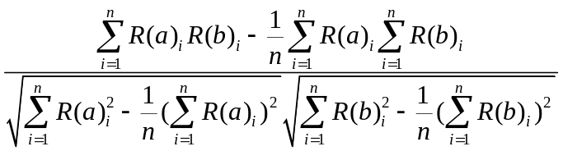

Another issue is related to the fact that two users are considered as similar purely based on statistical reasons. For example, even if U_{b} positively correlated to U_{a,} we need to make sure that it is not because of the fact that one of them has rented many movies while the other user has only rent a small number of movies. To solve this problem, we select candidates who have rent a certain number of movies based on number of movies U_{a} has rented. Formally, we only select candidates who satisfy the following condition,

(|U_{a}| * tp2) |U_{b}| (|U_{a}| * tp) where tp and tp2 are tuning parameters

4. Prediction Generation
Once we have identified the possible candidate neighbors, the ratings from all the neighbors are combined to compute a predicted rating for our target user. The basic way to combine the entire candidates’ rating in our algorithm is to put them into different bins based on two factors, size of the intersection and the value of pcc(U_{a,} U_{b)}, and assign a weight based on each of the relevant factor. The weight we decide to use is 0.05 for PCC and intersection ratio between 0 and 0.249; 0.15 for PCC and intersection ratio between 0.25 and 0.49; 0.3 for PCC and intersection ratio between 0.5 to 0.749; and 0.5 for PCC and intersection ratio between 0.75 and 1. In summary, if the PCC value and the intersection size are moderate, then this group of candidates will have more influence on the final rating than the candidates only satisfy one of the conditions. To illustrate, if the PCC value between two users is 0.1, which means they do not agree much on the ratings, the intersection ratio is 0.5, and the candidate gives the movie we want to predict a 4, then the final contribution to the predicted rating is 0.05*0.3*4 which is 0.06. The contribution is low because those two users are not highly correlated candidate, so his rating will not have major impact on the final rating. On the other hand, if the PCC value is 1, the intersection ratio is 0.7, and the rating is a 4, then the contribution of this user to the final rating is 1 which is more than 16 times stronger.
The prediction of the movie is broken up into two parts, the first part is categorizing the candidate user into selective bins and the second part is to assign a weight to each bin and sum the value of the bins together. In our algorithm, we use 16 bins totally - four bins to hold the ratio of the intersection size over candidate user size and within each bin there are four bins to classify the PCC value. For example, if target user rated 100 movies and candidate user N rated 50 movies in common, then the ratio is 50% and hence it is put into the bin that holds ratio from 50% to 75%. Within the ratio bin, we also have four bins that categorize the PCC value from 0 to 100. If the target user with user N's PCC is 89%, then we will put the user N's rating into the correct PCC bin within the ratio bin. After we have identified all the possible candidates to generate the prediction rating we simply take the average of each bin's rating normalize to the size of the bin and multiply a weight factor that is normalized to 1.
Formally, let be the rating for each candidate neighbor for the movie and user in interest, 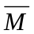 be the average rating by all the users for the given movie, and R be the prediction of the movie, then
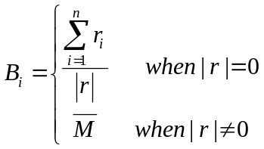
In this implementation we are currently experimenting with only four bins, and let 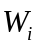 denote to the weight we assign to each of the bin and the final rating is given by the following formula,
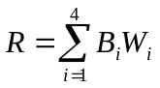
The current weight placed on each bin is 0.05, 0.15, 0.3 and 0.5. We are planning to incorporate the very high negative correlation into this calculation to see if we have a better result.

5. Experiments on Netflix Dataset

In our experiment, we run our algorithm against five random sets of movies in which there are 50,000 predictions to be calculated. To obtain the random sets, we first prune out popular movies that have been rented for more than 40,000 times because we find that using the movie average is a very good measure for those movies. After the first pruning, we prune out 50% of predictions needed to be calculated in the original set, and then we randomly select 50,000 predictions for each run. In addition, we also prune out users whose average rating is either higher than 4.5 or lower than 1.5. The intuition is that if users have such high or low average ratings, it means that those users always rate movies either very high or very low. We can expect those users will continue this rating behavior.

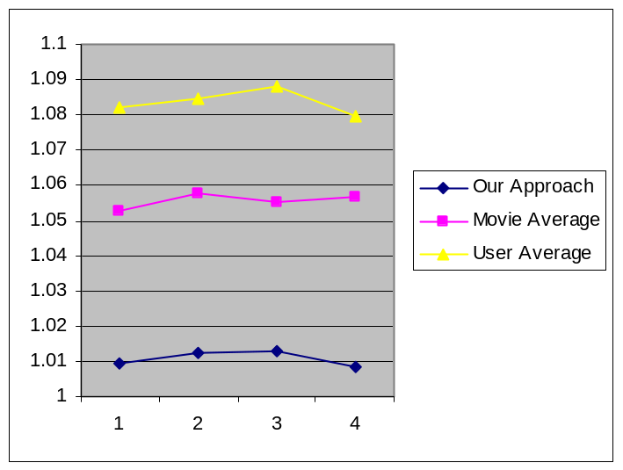
Run #
RMSE

Figure(4) RMSE comparison

To evaluate the accuracy of our algorithm, we compare the RMSE to the RMSEs obtained by using the average of the movie we are trying to predict, and the user’s average rating. We select tp2 = 0.6 and tp = 4 because we find that using those values yield the best RMSE. In Figure (4), the x-axis show the number of run, and the y-axis show the RMSE. it is obvious that our approach is around 4% better than using the average of the movie we are trying to predict as prediction heuristic, and it is 7% better than using the user’s average rating as prediction heuristic. The movie average prediction heuristic performs better than the user average prediction heuristic because even we only consider movies that are rented less than 40,000 times, most of the movies are rented more than 1,000 times. Therefore it is still possible for us to use the average rating for those movies, but those predictions are less accurate compared to those movies that are rented for more than 40,000 times. We also want to compare the our algorithm to the RMSE obtained from using a wild guess approach, meaning that we give a rating 3 for all of the predictions we are trying to calculated. Figure (5) shows the result. In Figure (5), x-axis shows the number of run, and the y-axis shows the RMSE. The graph shows that our algorithm is almost 30% better than the result obtained from wild guess prediction heuristics. Moreover, it is very surprising to see that the averaging prediction heuristics are not very inaccurate. One of the reasons could be the size of our data set. In our data set, each user has rented 209 movies on average, and each movie is rented 5,655 times on average. Given such a huge data set, using averaging schemes should not be very inaccurate.

Even though our approach is able to achieve a RMSE that is at least 4% better than the averaging scheme, we expect our approach to perform much better. The algorithm does not perform as expected because in the data set, we encounter the major drawback of collaborative filtering technique, which is the new user and new item problems. In our data set, there are over 8,000 movies that are rented less than 500 times, and there are over 244,072 users who have rented less than 100 movies. Whenever we are trying to predict the ratings of those new movies for those new/inactive users, our Pearson Correlation Coefficient would not give much meaning info, and our weighted averaging scheme is error-prone.

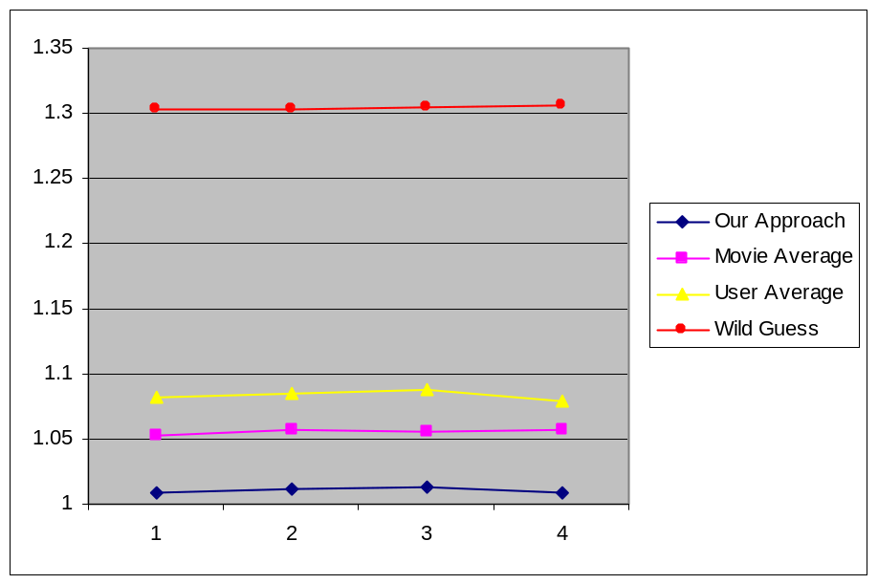
Run #
RMSE

Figure(10) RMSE Comparison with the Wild Guess Approach

6. Conclusion

In this paper, we present our approach on building a movie recommendation system. We address the challenge of computing accurate rating by first using a straightforward scheme. It turns out that scheme does not work very well since the scheme used the information from only one neighbor to calculate predictions, and the algorithm of determining a neighbor was incorrect. Therefore, we decide to use Pearson Correlation Coefficient and weighted averaging as our prediction heuristic. We run the algorithm on 5 randomly generated sets and evaluate the result. The result is better than just using averaging scheme by at least 4%. In the data set, we are able to identify characteristics of the users and the movies, which help us to prune out some of the prediction calculation. Moreover, we encounter the new user and new item problem in our data set, so our algorithm did not perform as expected.

7. Discussion and Future Work

In the future, we expect to address the challenge of efficiency as well. One obvious way to tackle this problem is to parallelize our algorithm. Since our algorithm spends most of the time on computing Pearson Correlation Coefficient which deals with data that is independent to each other, we can partition the data into pieces, distribute it to different computers, and collect the result from those computers when we calculate the Pearson Correlation Coefficient. Moreover, we can partition the set of predictions we need to compute, and distribute the computations to different computers too. With the distributed workload, we can expect a huge speed up on calculating the prediction.

Another extension is to define a better prediction heuristics. As we have mentioned, our algorithm is very sensitive to the new user and new item problem. One possible extension is to first identify the categories that the target user falls into, and then use a specific heuristic or algorithm which works best for that category and compute the prediction for that user.

Reference
[1] Gediminas Adomavicius and Alexander Tuzhilin "Toward the Next Generation of Recommender Systems: A Survey of the State-of-the-Art and Possible Extensions" IEEE Transactions on Knowledge and Data Engineering, Vol 17, No 6, June 2005
[2] Dan R. Greening "Building Consumer Trust with Accurate Product Recommendations", A White Paper on LikeMinds Personalization Server
[3] Jonathan L. Herlocker, Joseph Konstan, Al Borchers, and John Riedl "An Algorithmic Framework for Performing Collaborative Filtering"

