**How to create windows (Worker) service in asp.net core**

**Please follow below points**

1. Create Project using Visual Studio 2019=><https://github.com/shailsoft/ShailWorWinService/>

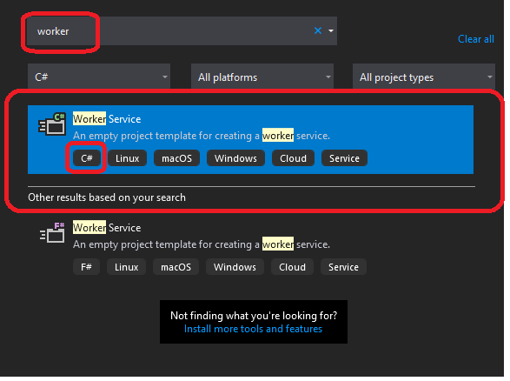

1. Default

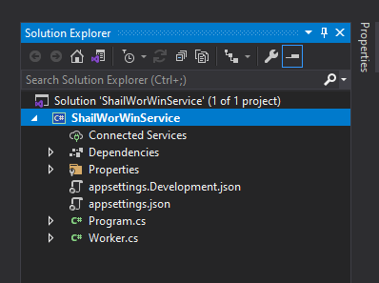

1. Installed Packages

* Microsoft.Extensions.Hosting
* Microsoft.Extensions.Hosting.WindowsServices
* Serilog.AspNetCore
* Serilog.Sinks.File

1. Modified Program.cs

public static void Main(string[] args)

{

Log.Logger = new LoggerConfiguration().MinimumLevel.Debug()

.MinimumLevel.Override("Microsoft", Serilog.Events.LogEventLevel.Warning)

.Enrich.FromLogContext()

.WriteTo.File(@"D:\Shailendra\SelfProject\Windows\ShailWorWinService\ShailWorWinService\bin\Debug\LogFile.txt")

.CreateLogger();

try

{

Log.Information("Starting up the service ");

CreateHostBuilder(args).Build().Run();

}

catch (Exception ex)

{

Log.Fatal(ex, "There was a problem starting the service");

return;

}

finally

{

Log.CloseAndFlush();

}

}

public static IHostBuilder CreateHostBuilder(string[] args) =>

Host.CreateDefaultBuilder(args).UseWindowsService()

.ConfigureServices((hostContext, services) =>

{

services.AddHostedService<Worker>();

}).UseSerilog();

1. **Modified in Worker.cs**

public class Worker : BackgroundService

{

private readonly ILogger<Worker> _logger;

private HttpClient client;

public Worker(ILogger<Worker> logger)

{

_logger = logger;

}

/// <summary>

/// create by shailendra

/// created date 3 may 2022

/// </summary>

/// <param name="cancellationToken"></param>

/// <returns></returns>

public override Task StartAsync(CancellationToken cancellationToken)

{

client = new HttpClient();

return base.StartAsync(cancellationToken);

}

public override Task StopAsync(CancellationToken cancellationToken)

{

client.Dispose();

return base.StopAsync(cancellationToken);

}

protected override async Task ExecuteAsync(CancellationToken stoppingToken)

{

while (!stoppingToken.IsCancellationRequested)

{

var result = await client.GetAsync("https://www.iamtimcorey.com");

if (result.IsSuccessStatusCode)

{

_logger.LogInformation("Worker running at(The website is up): {StatusCode}", result.StatusCode);

}

else

{

_logger.LogInformation("Worker running at(The website is down): {StatusCode}", result.StatusCode);

}

await Task.Delay(5000, stoppingToken);

}

}

}

1. **How to install**

PS C:\Windows\system32> sc.exe create ShailWorWinService binpath=D:\Shailendra\SelfProject\Windows\ShailWorWinService\ShailWorWinService\bin\Debug\net5.0\ShailWorWinService.exe start=auto

1. **How to un-install**

S C:\Windows\system32> sc.exe delete ShailWorWinService