PYTHON ASSIGNMENT BOOK

MAKE A MOVE TO PYTHON

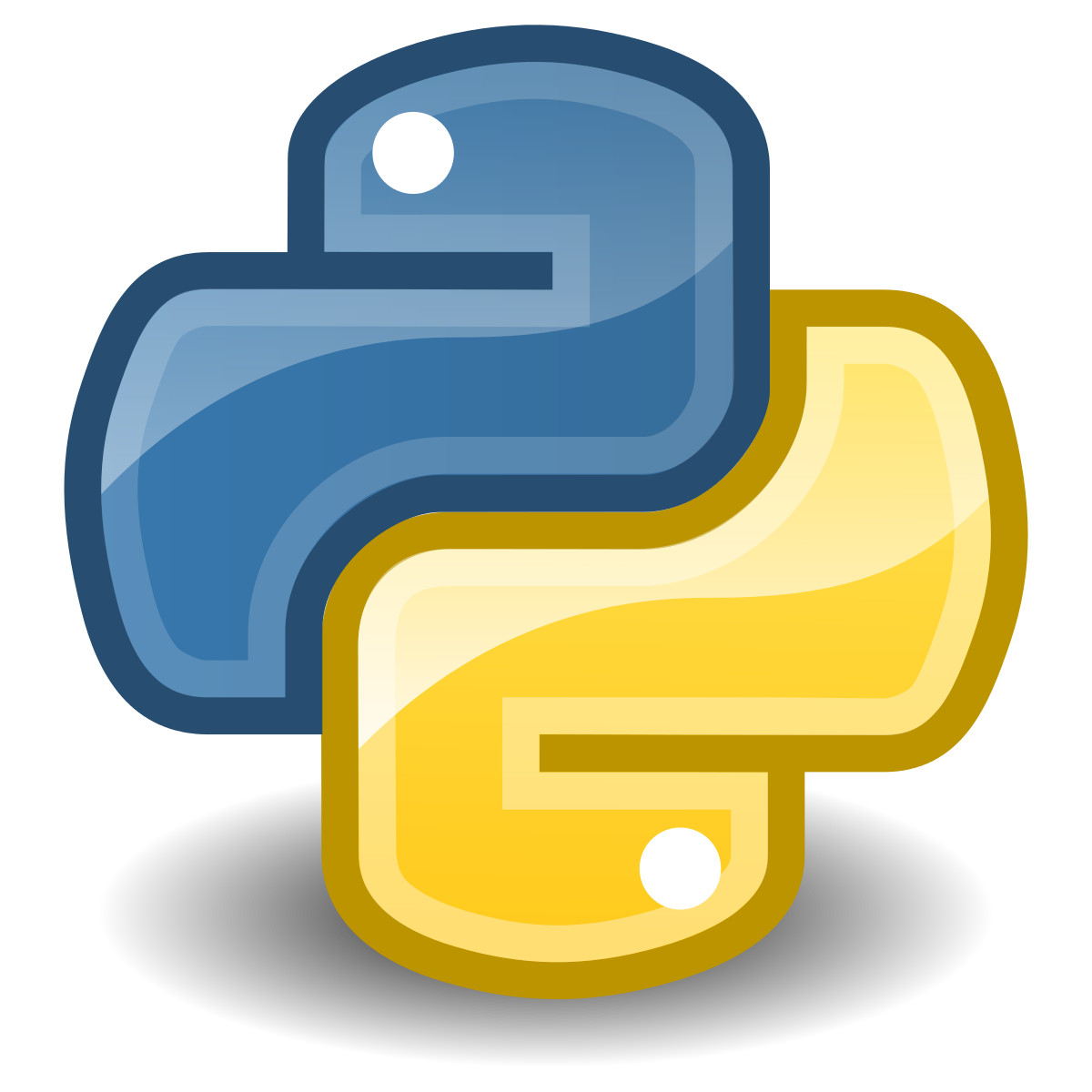

**ASSIGNMENTS**