**Project: Cheap-o-Flights (cheapoflights.com)**

|  |  |
| --- | --- |
| **Developer** | **JJ** |
| **Purpose** | **Project Screenshot** |
| **Date** | **Aug 9, 2021** |
| **Version** | **1.0** |

Table of Contents

**Git Repository2**

Git Repository details.

**Screenshots of an Application 11**

1. **Git Repository details.**

[**https://github.com/shailyjeet/fsd/tree/main/Cheap_o_flights**](https://github.com/shailyjeet/fsd/tree/main/Cheap_o_flights)

1. **Screenshots of output.**
   1. **Homepage.jsp after running the .bat file.**

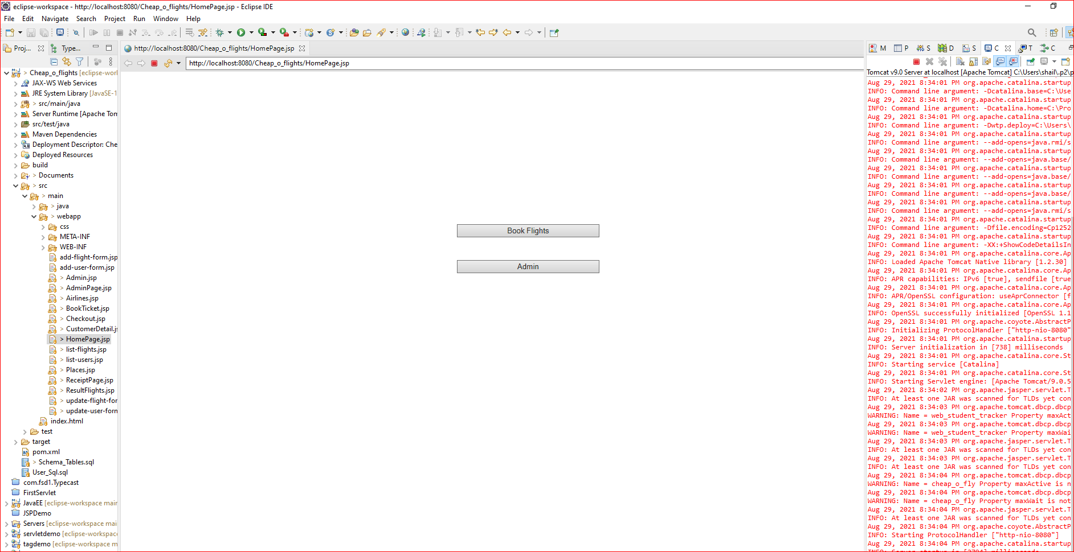

* 1. **Choose Admin button to authenticate as an admin. Please user username: cheap_o_user and password: cheap_o_pass and Click on Login button.**

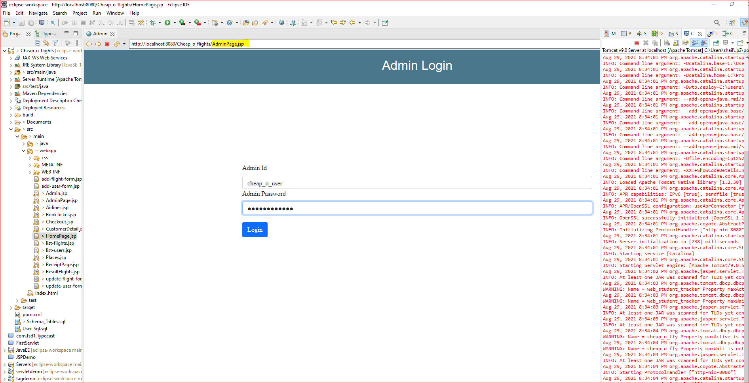

* 1. **After User is logged in as an admin user. User can view list of flights scheduled. The admin user has an option to manager users ( i.e. Add/ Update/Delete), manage flights i.e. (Add / Update/ Delete ) flights details, View list of Places, View list of Airlines and Logout Button to Log off of Admin module and go back to HomePage.jsp.**

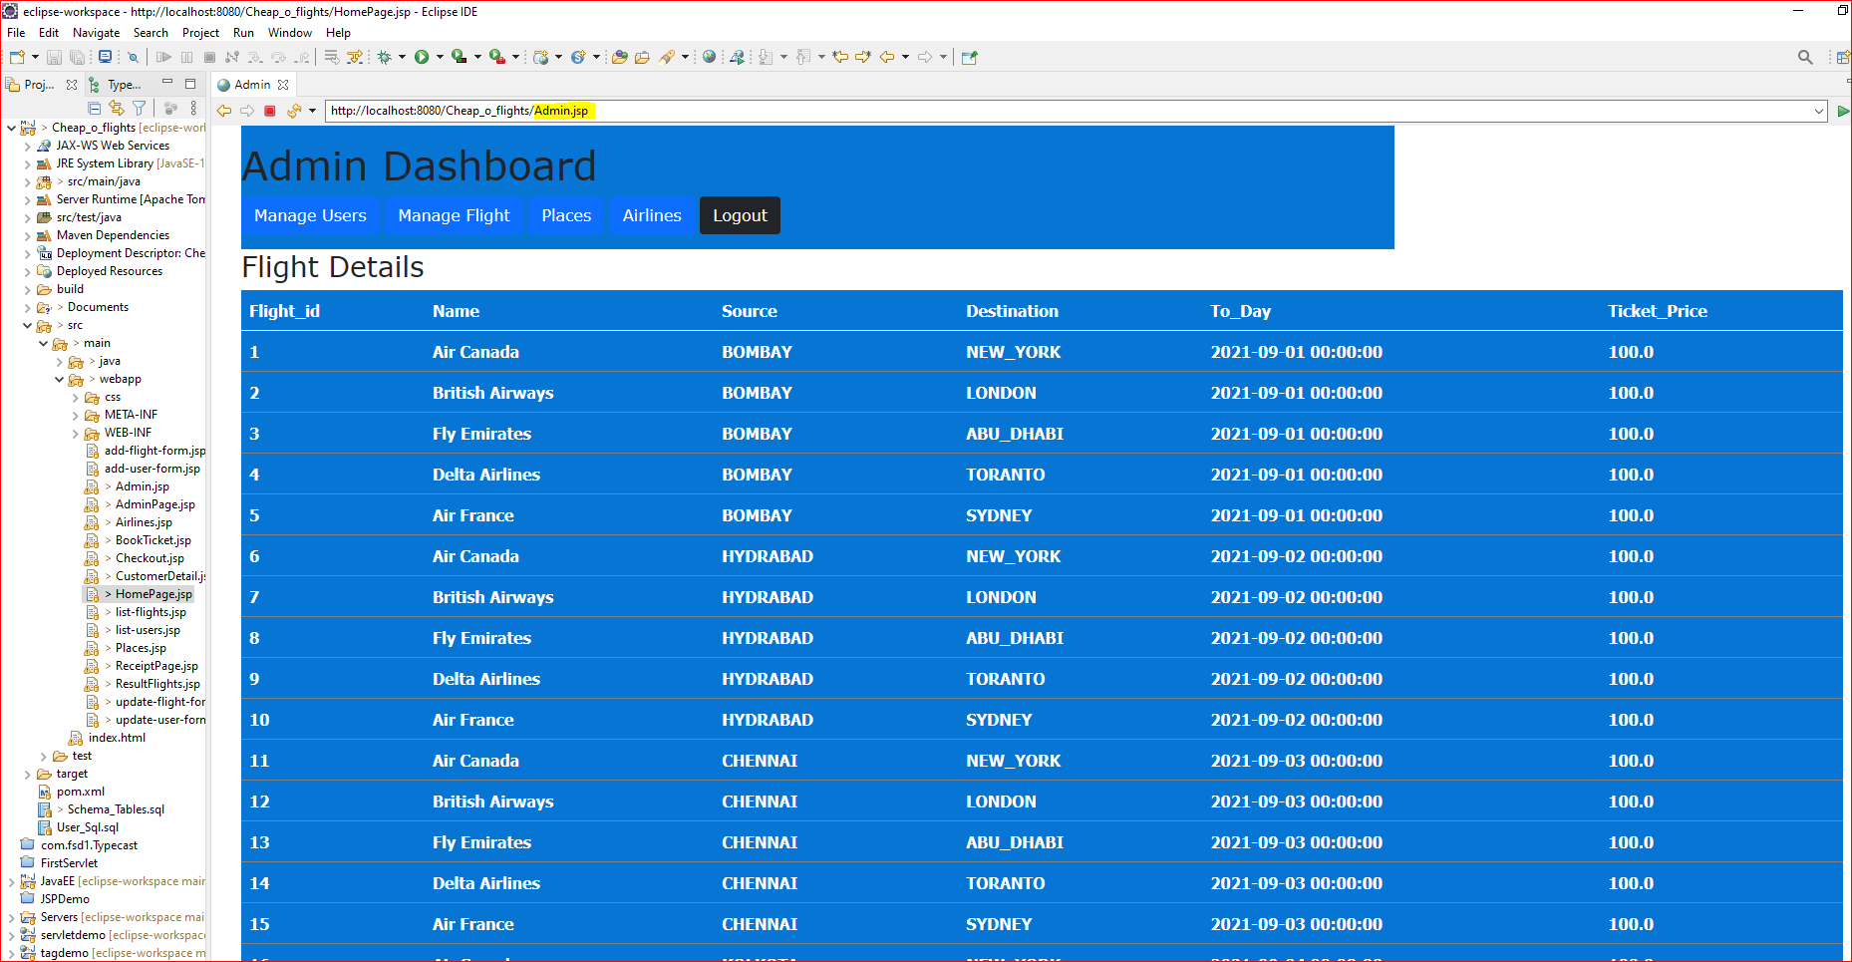

* 1. **Admin user can click on “Manage Users” to Manager Users. i.e.**

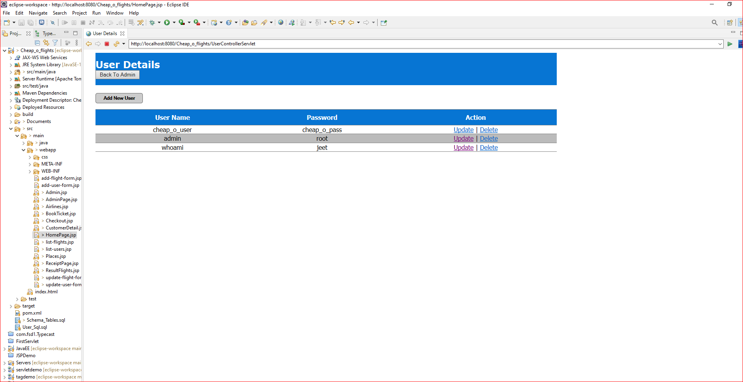

* 1. **Admin user can click on Update Action and Update the details for Admin users. Here in this case User wants to change Username from “admin” to “Admin”. So user clicked on Update action.**

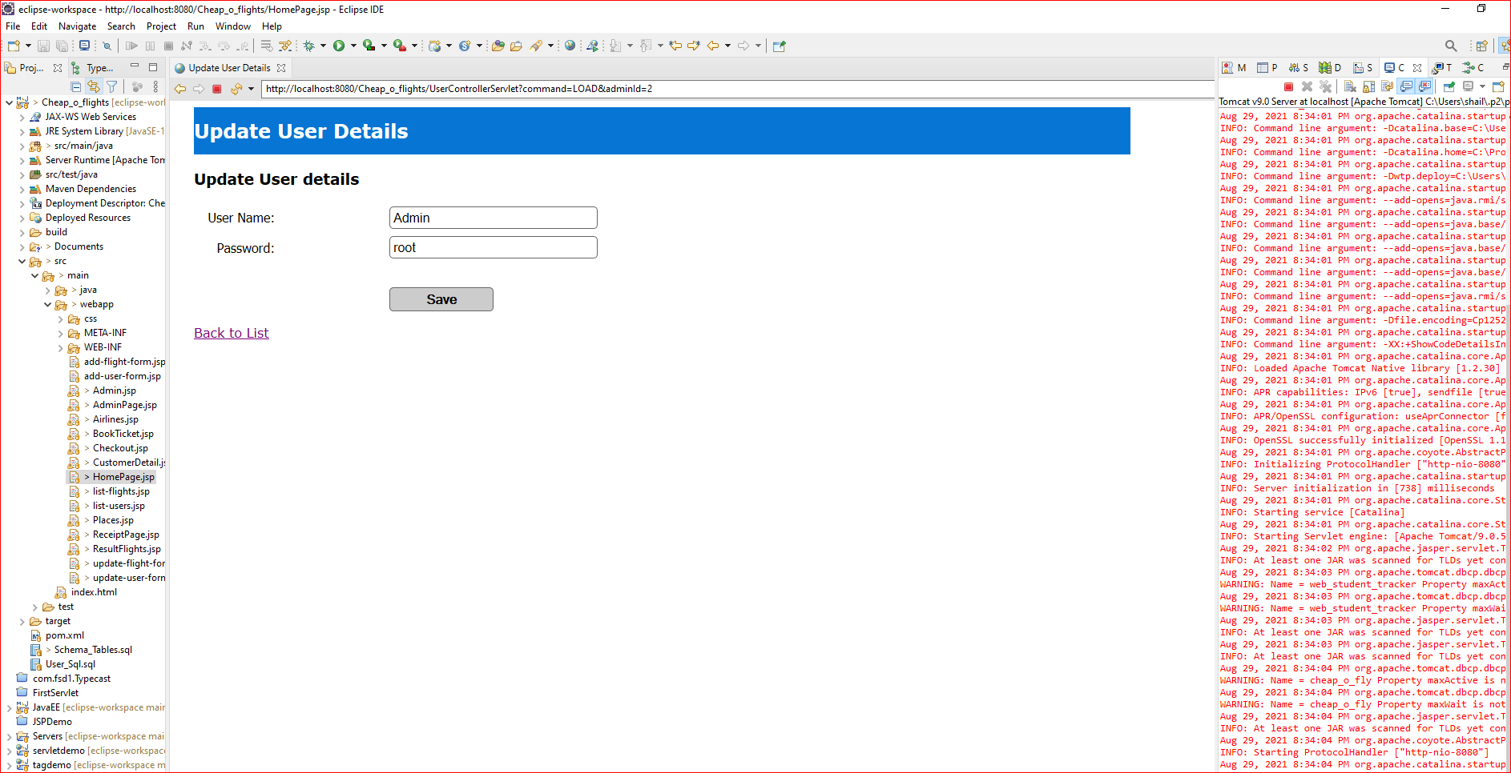

* 1. **User clicked on Save button and Username successfully changed from “admin” to “Admin”.**

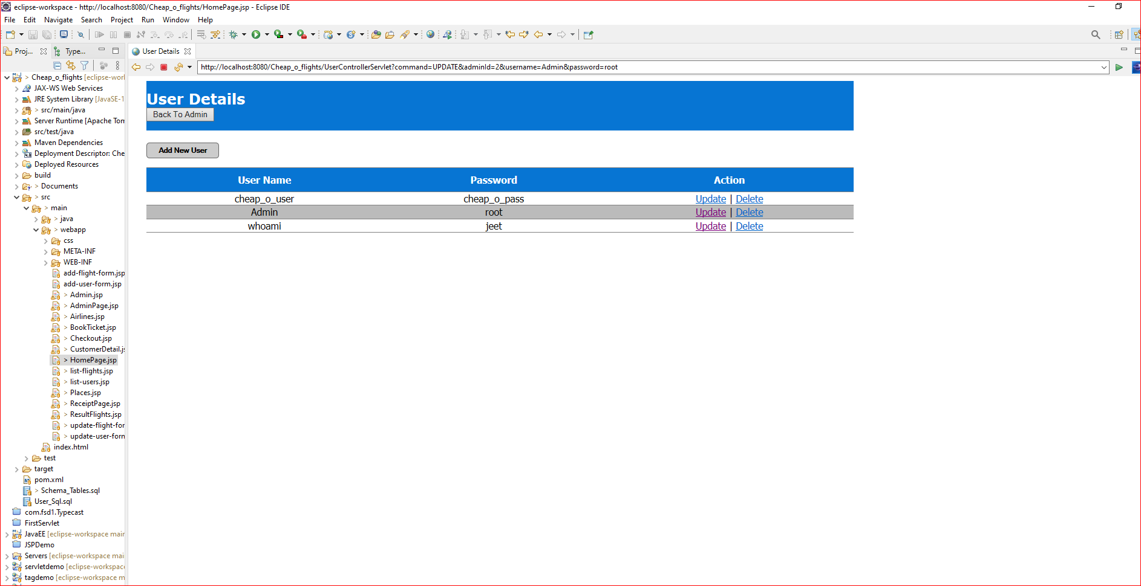

* 1. **Next, User wanted to update the flight details and update the price from Rs.100 to Rs. 90. So, from Admin.jsp page user clicked on “Manage flights” button and User is displayed following page.**

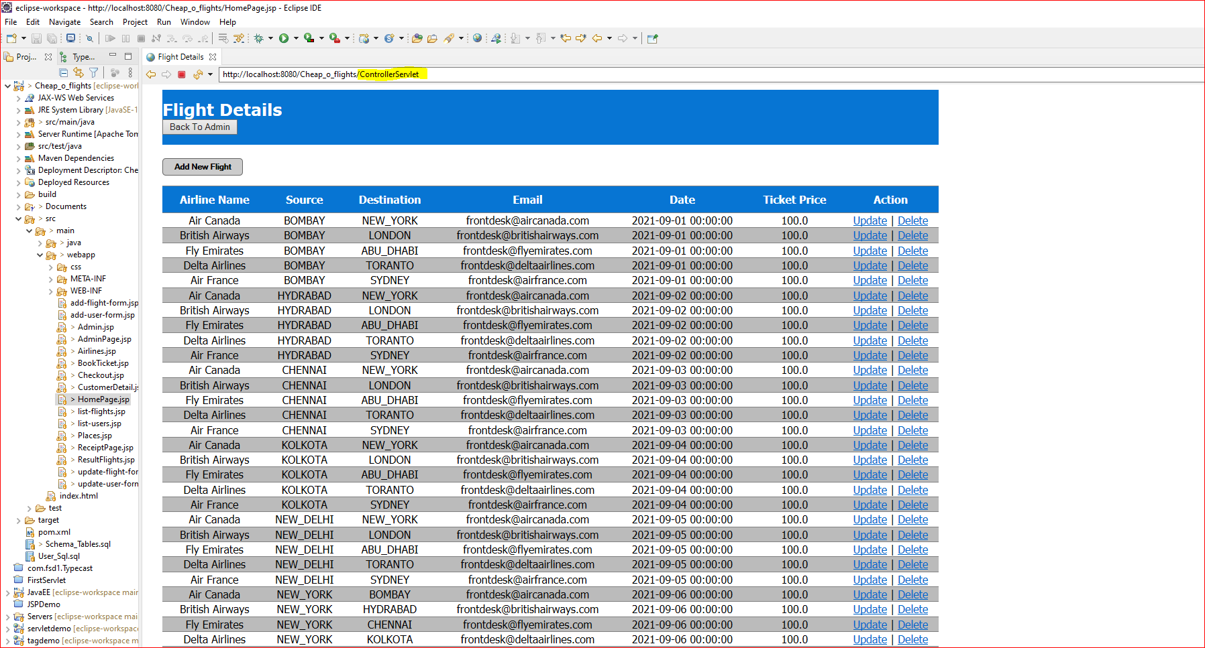

* 1. **Here User clicked on Update action and make amendments to flight details. ( Here in this case change price value )**

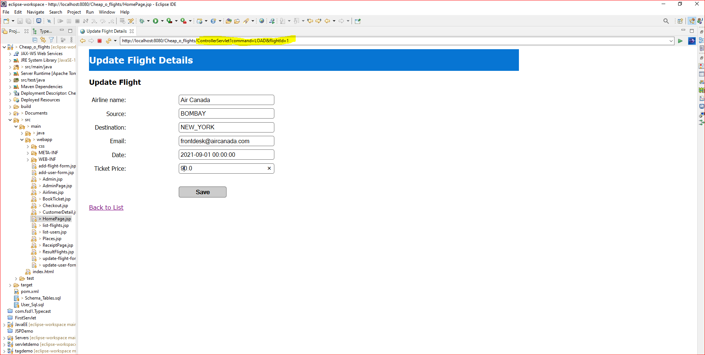

* 1. **The user clicked on save button after making the required changes. The changes are successfully saved and User can see the changes in the screen.**

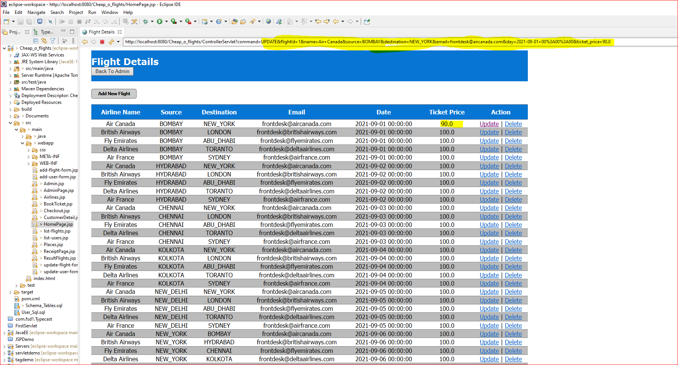

* 1. **Next, User wanted to perform Delete action on unwanted Dummy record created for Dummy flight. Here, user is prompted with a dialog box before deleting the record from database.**

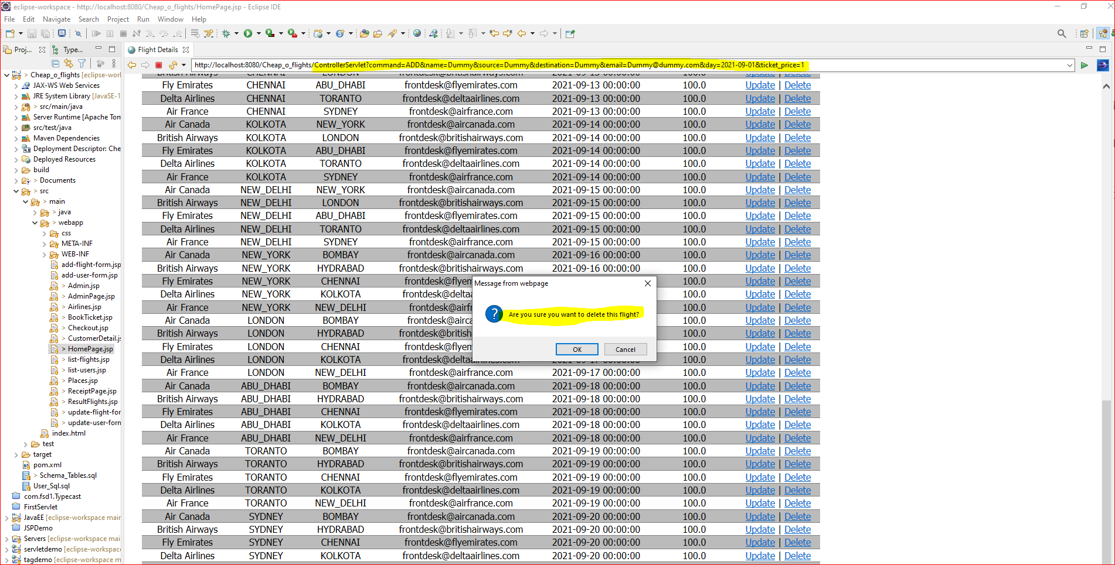

* 1. **Next, User wanted to see the list of Places the flights are scheduled. The user clicked on “Places” Button from “Admin.JSP” i.e. main page for Admin module. Please each page has an option to go back to Admin page i.e. “Back To Admin” button.**

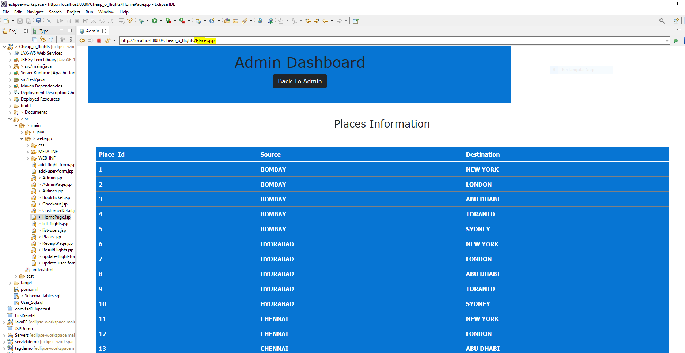

* 1. **Next, User wanted to see the List of Airlines companies.**

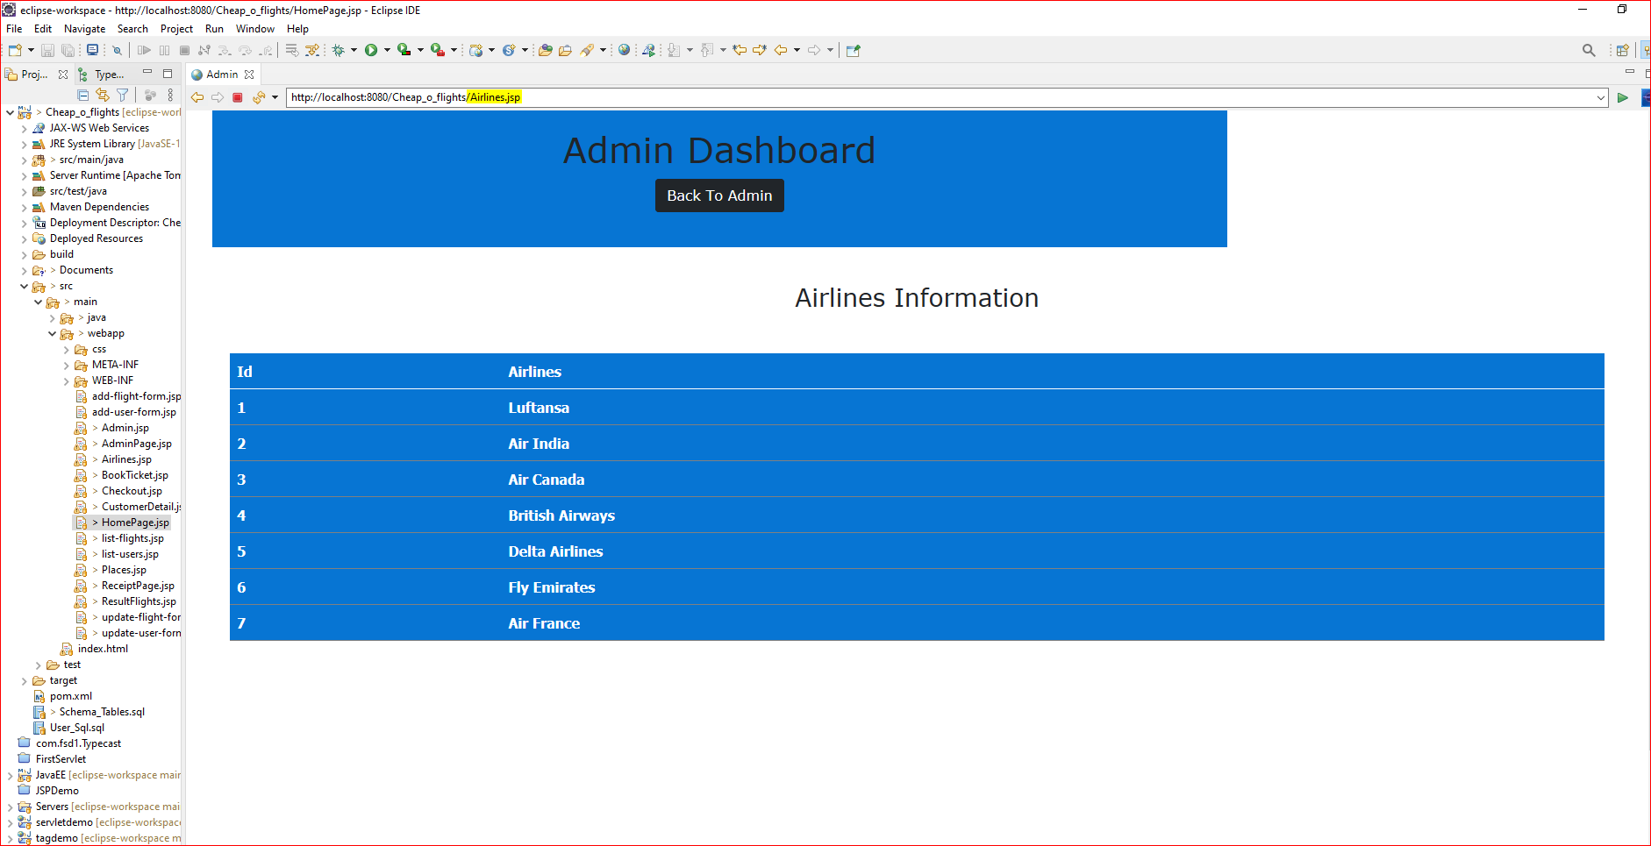

* 1. **Finally after exploring all the options in Admin module, User decided to Log Off the module. The button name “Logout” is created to log off from Admin module and go back to Homepage.jsp**



**Next, User wants to Book the Tickets for Flights.**

1. **User clicks on “Book Flights” button from HomePage.jsp**

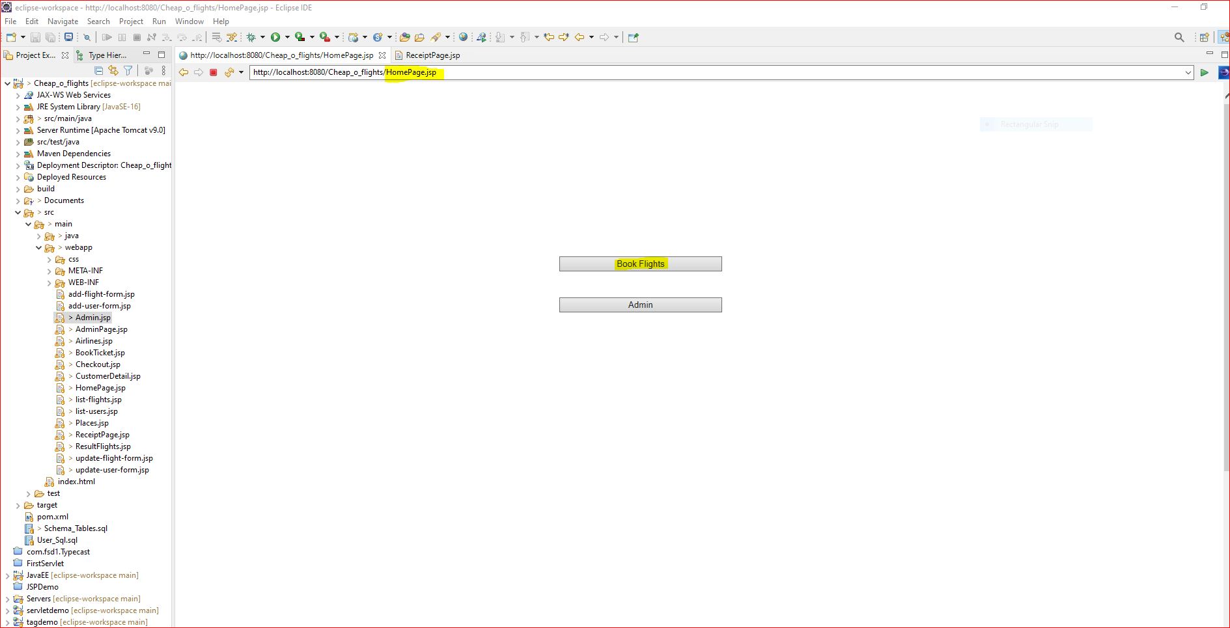

1. **User is prompted with option to provide Source, Destination, No of Persons and Date on which Users wants to book the flight. Please choose the Date in the form of YYYY-MM-DD.**

**Here user selected source location as “Bombay” Destination as “New York”, Number of Person as “3” and Date on which users would like to travel as “2021-09-01” and then click on “SearchFlight” button.**

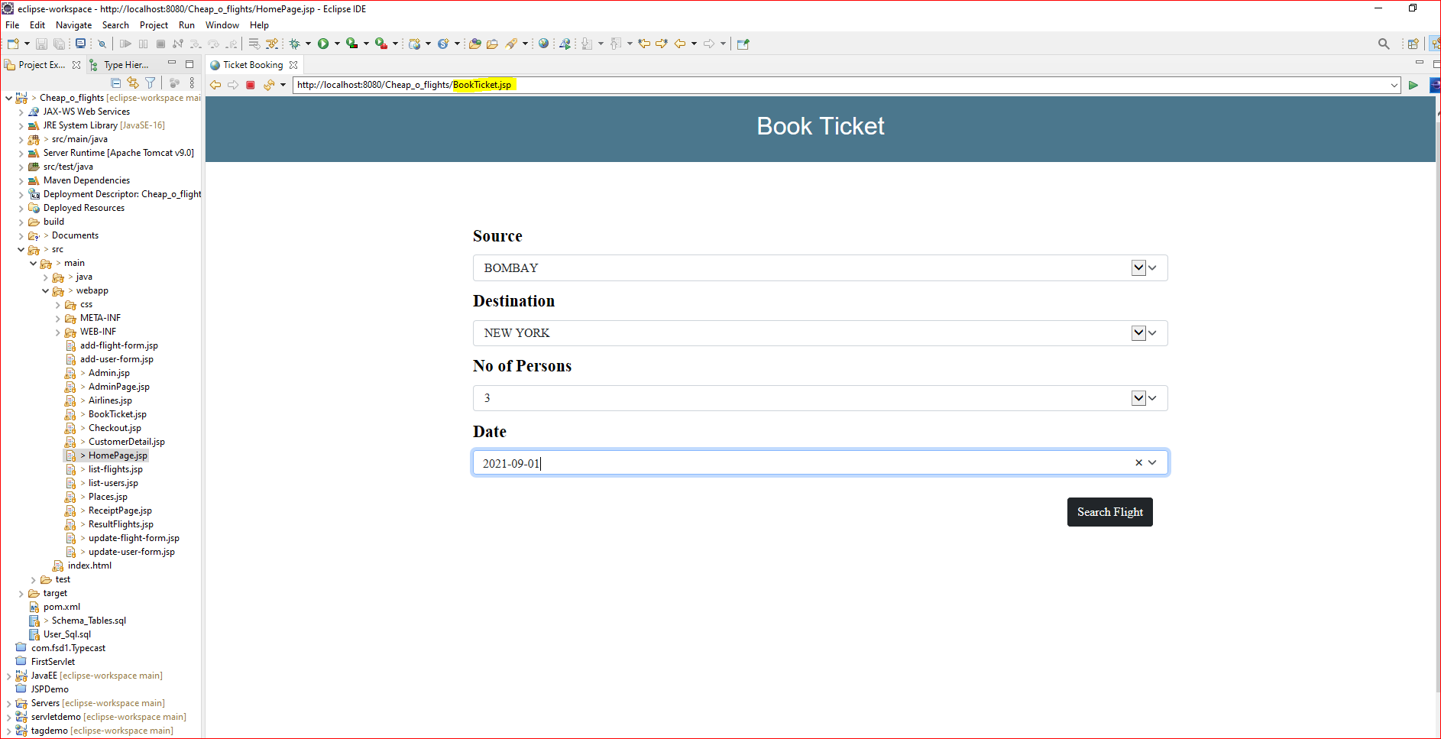

1. **Next, User is provided with list of available flights. User can choose among the flights and Click on Book the Flight button.**

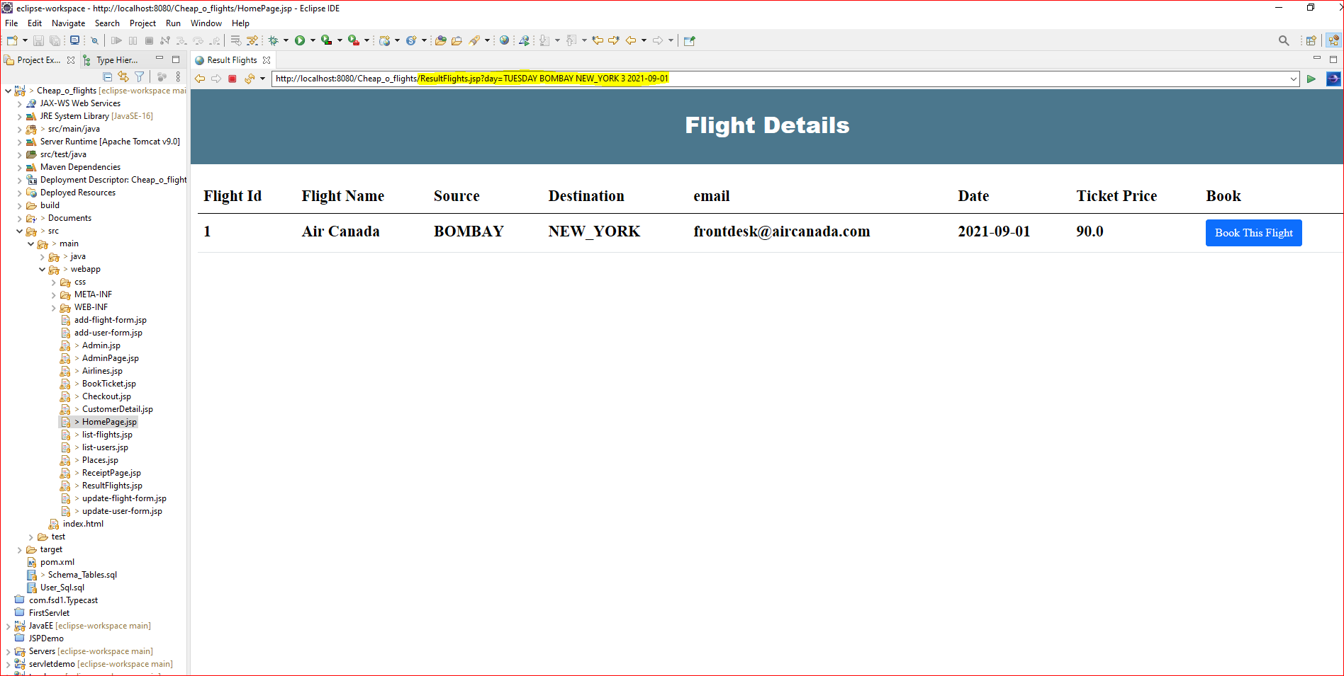

1. **Once user clicks on “Book This Flight” button, User is prompted to provide Customer Details. i.e. Customer Name, Email id and Mobile Number to verification purpose. Please provide same Customer Name as that is mentioned in Passport.**

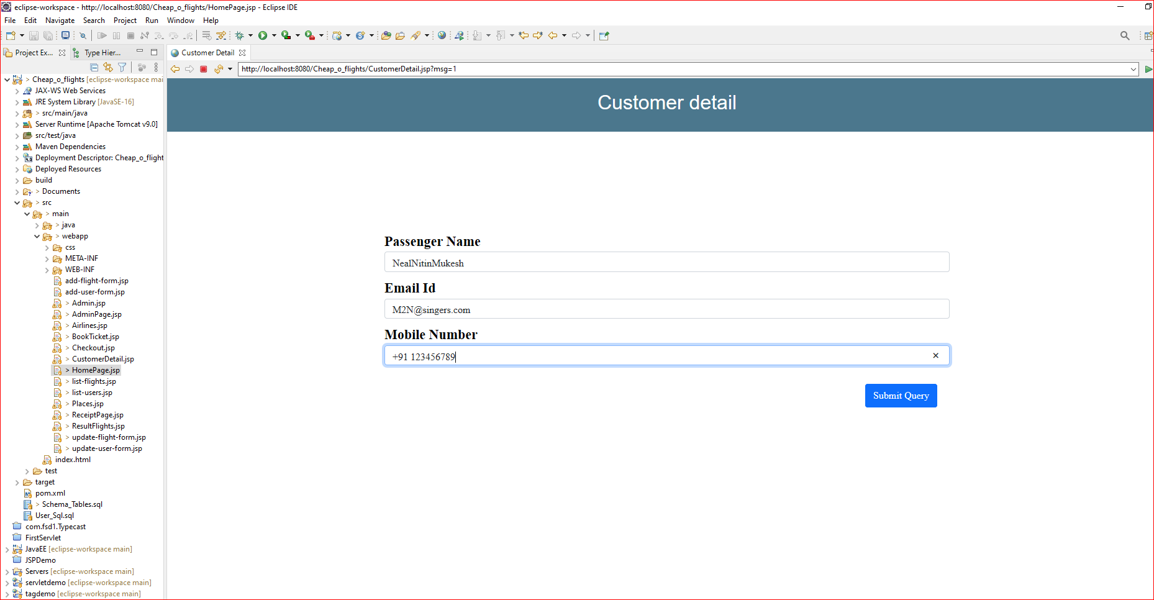

1. **After User clicks on “Submit Query” button, The user is prompted with Payment options for Credit/Debit card to Pay the Air ticket fair. Unable to Prepay the airfare will result in Cancellation of Ticket and User can not print the boarding pass.**

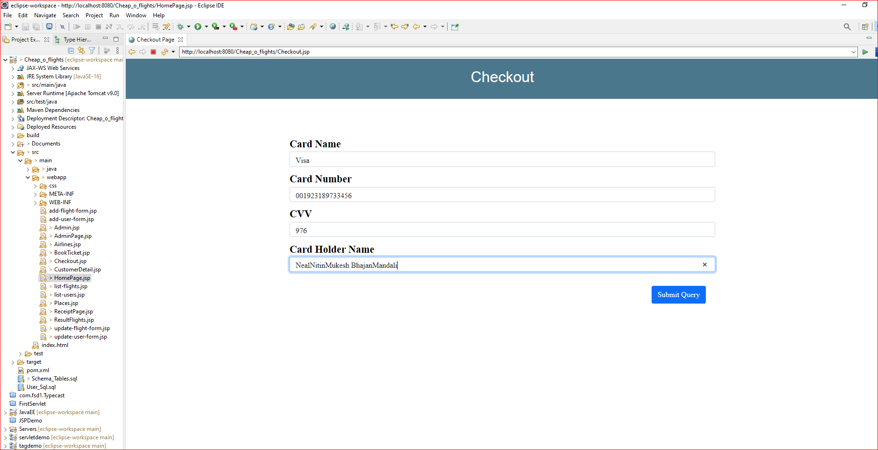

1. **Once, Payment details are provided and User clicks on Submit Query, the ticket may not be Cancelled and User is taken to printing the boarding pass for the flight.**

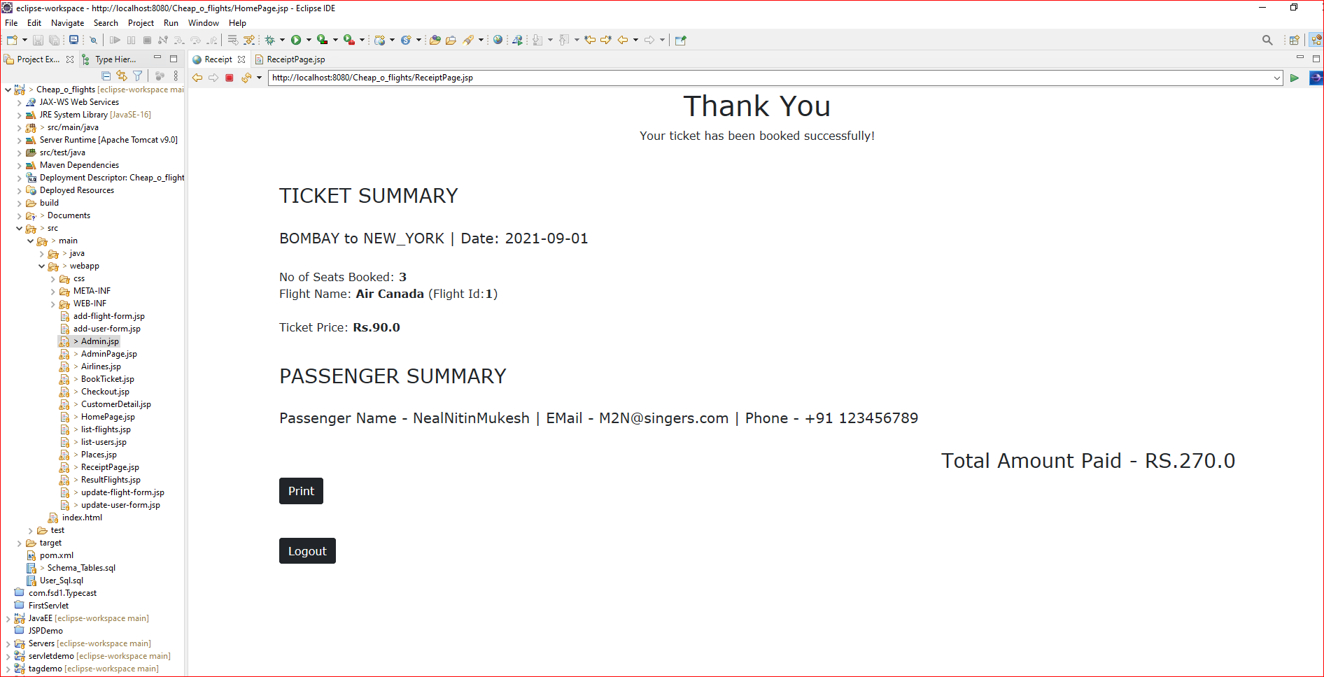

1. **Once User click on “Print” button, User can print the Boarding details, Once Ticket is printed, User can click on Logout button to go back to HomePage.jsp**

