**Project: Lockers Private Limited (LockedMe.com)**

|  |  |
| --- | --- |
| **Developer** | **JJ** |
| **Version** | **1.0** |

**Screenshots of output.**

1. **Main Menu after running the .bat file.**

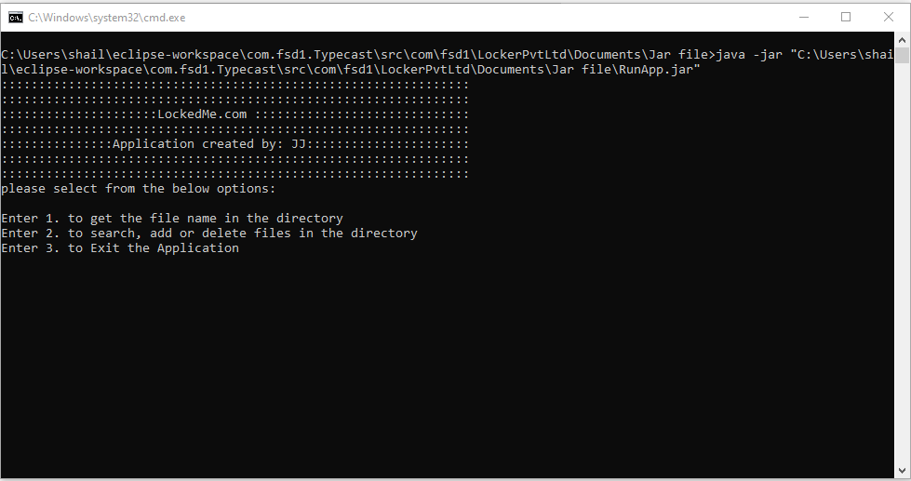

1. **Choose 1 to show list of files.**

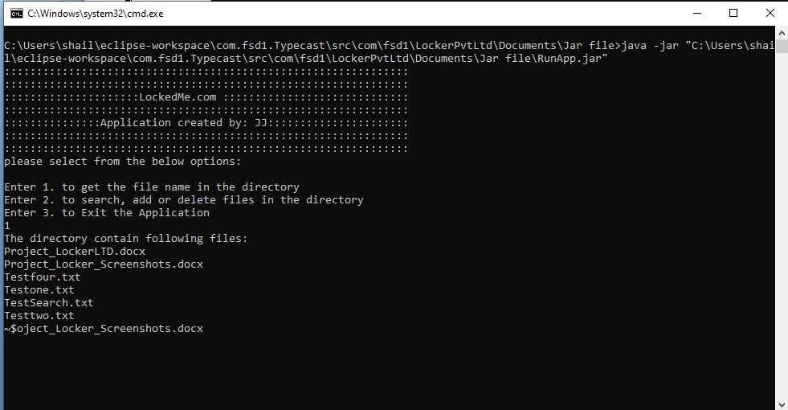

1. **Choose 2 to Search for, Add new file OR Delete existing file. ( SubMenu opens up )**

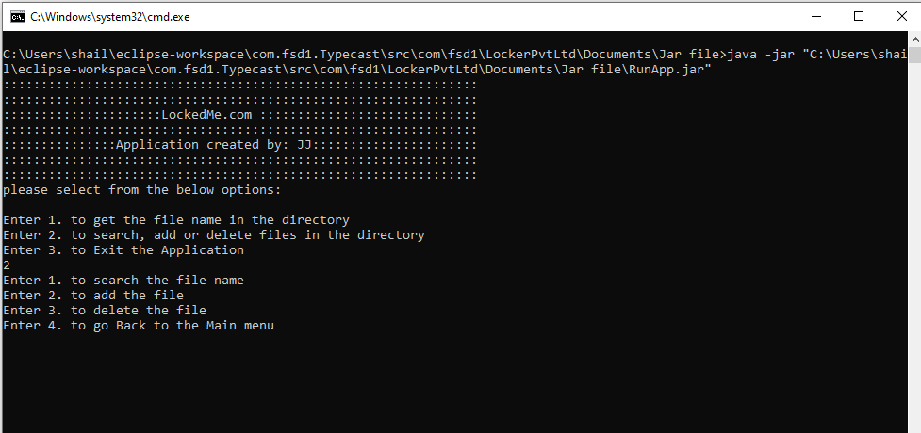

1. **Choice 1 to Search for file name TestSearch.txt ( Result Success )**

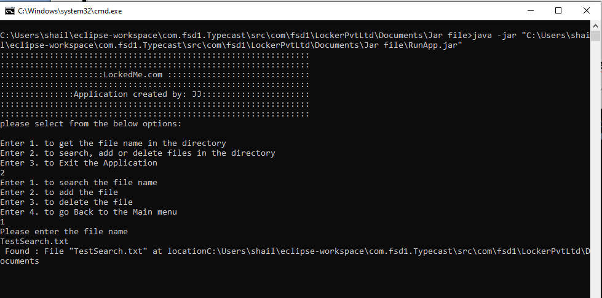

1. **Choice 2 to Add new file in the directory.**

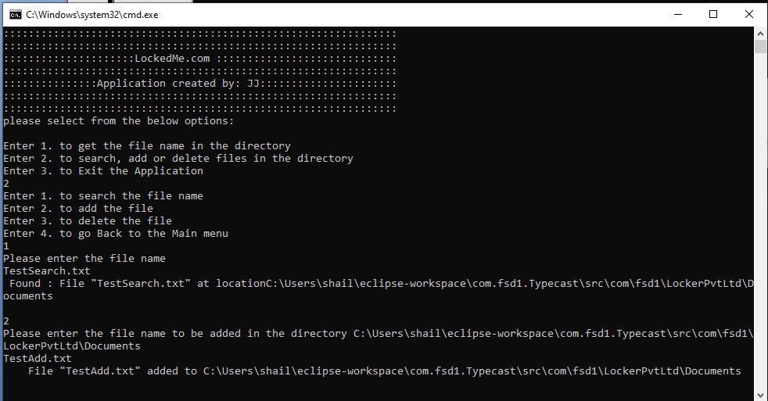

1. **Choice 3 to delete the file in the directory.**

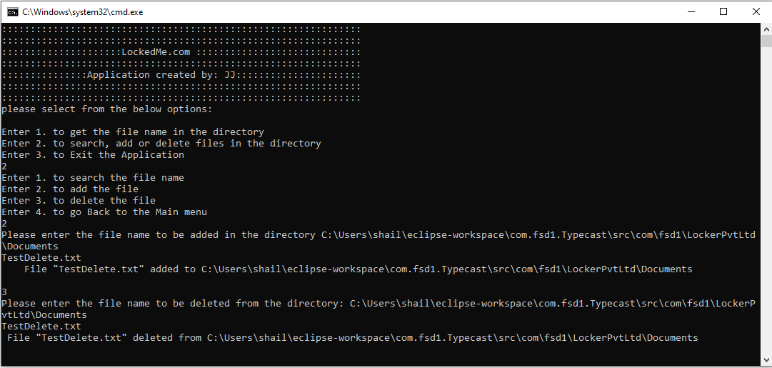

1. **Choice 4 to go back to main page.**

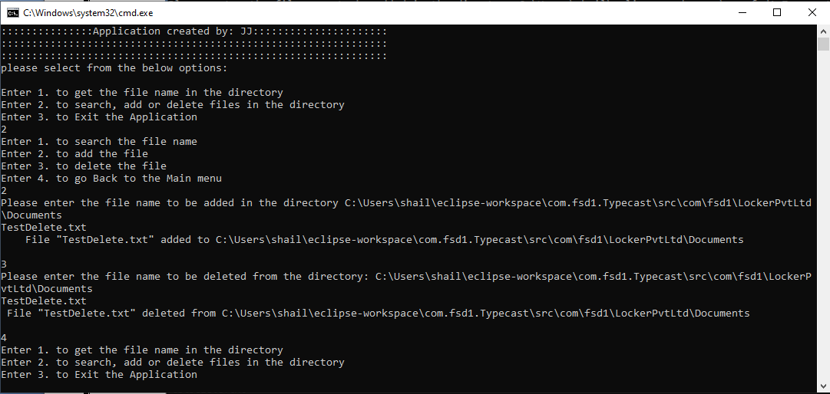

1. **Once in Main menu, we can opt for option 3 to exit an application. The user will be prompt weather user is sure if he want to exit an application. Y/y will proceed and exit an application.**

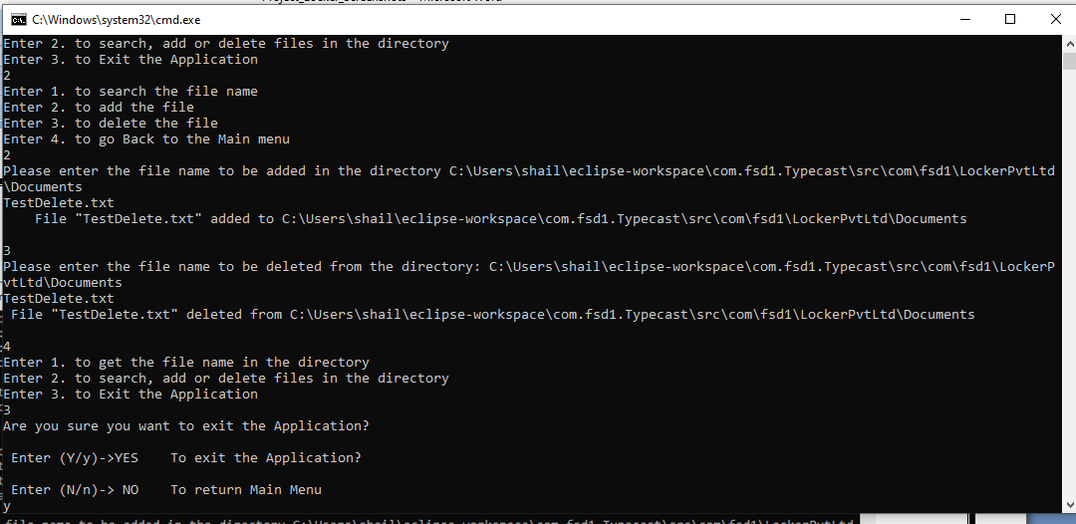

**Rahiman Dhaga Prem ka, Mat Todo Chatakay**

**Tuta Se Phir Na Jude, Jude Ganth Pad Jaaye.**