**Project: Lockers Private Limited (LockedMe.com)**

|  |  |
| --- | --- |
| **Developer** | **JJ** |
| **Purpose** | **Project Screenshot** |
| **Date** | **Aug 9, 2021** |
| **Version** | **1.0** |

Table of Contents

**Git Repository2**

Git Repository details.

**Code Walkthrough 4**

RunApp.java4

MainMenu.java5

MainMenuImpl.java6

Submenu.java7

SubMenuImpl.java9

**Screenshots of an Application 11**

1. **Git Repository details.**

[**https://github.com/shailyjeet/fsd/tree/main/com.fsd1.Typecast/src/com/fsd1/LockerPvtLtd**](https://github.com/shailyjeet/fsd/tree/main/com.fsd1.Typecast/src/com/fsd1/LockerPvtLtd)

1. **Code Walkthrough** 
   1. RunApp.java

|  |
| --- |
| /**  *  */  **package** com.fsd1.LockerPvtLtd;  /**  * **@author** JJ  *  */  **public** **class** RunApp {  /**  * runApp is the first Java program that is called.  * It calls mainMenu.java  */  **static** mainMenu *obj* = **new** mainMenu();  **public** **static** **void** main(String[] args) {  // **TODO** Auto-generated method stub  System.***out***.println(":::::::::::::::::::::::::::::::::::::::::::::::::::::::::::::::");  System.***out***.println(":::::::::::::::::::::::::::::::::::::::::::::::::::::::::::::::");  System.***out***.println(":::::::::::::::::::::LockedMe.com :::::::::::::::::::::::::::::");  System.***out***.println(":::::::::::::::::::::::::::::::::::::::::::::::::::::::::::::::");  System.***out***.println(":::::::::::::::Application created by: JJ::::::::::::::::::::::");  System.***out***.println(":::::::::::::::::::::::::::::::::::::::::::::::::::::::::::::::");  System.***out***.println(":::::::::::::::::::::::::::::::::::::::::::::::::::::::::::::::");  System.***out***.println("please select from the below options: ");  System.***out***.println(" ");  System.***out***.println("Enter 1. to get the file name in the directory ");  System.***out***.println("Enter 2. to search, add or delete files in the directory");  System.***out***.println("Enter 3. to Exit the Application");  **do** {    *obj*.mainMenuimplementation();    } **while** (**true**);  }  } |

* 1. **MainMenu.java**

|  |
| --- |
| **package** com.fsd1.LockerPvtLtd;  /**  * **@author** JJ  *  */  **import** java.util.Scanner;  **public** **class** MainMenu {  /**  * mainMenu Java application program provides menu options  * 1 to get the files in directory  * 2 to search, add file in the directory  * 3 Exit maain Application.  */  **static** Scanner *sc* = **new** Scanner(System.***in***);  **static** mainMenuImpl *mmi* = **new** mainMenuImpl();  **static** subMenu *sm* = **new** subMenu();    **public** **void** mainMenuimplementation()  {  **do**  {  String user_input = *sc*.next();    **switch**(user_input)  {  // case to Retrieve file name in the directory  **case** "1":  *mmi*.getFileNames();  **break**;    // case to manage the directory files  **case** "2":  *sm*.subMenuImplementation();  **break**;    // case to exit application  **case** "3":  *mmi*.exitApplication();  **break**;    **default**:  System.***out***.println("Invalid input: Please Eenter from the following options:");  System.***out***.println("Enter 1. to get the file name in the directory ");  System.***out***.println("Enter 2. to search, add or add files in the directory");  System.***out***.println("Enter 3. to Exit the Application");    }    }  **while** (**true**);  }  } |

* 1. **MainMenuImpl.java**

|  |
| --- |
| **package** com.fsd1.LockerPvtLtd;  /**  * **@author** JJ  *  */  **import** java.io.File;  **import** java.util.Scanner;  **public** **class** MainMenuImpl  {    **static** String *path* = "C:\\Users\\shail\\eclipse-workspace\\com.fsd1.Typecast\\src\\com\\fsd1\\LockerPvtLtd\\Documents";  **static** mainMenu *obj* = **new** mainMenu();    /**  * Method to Retrieve file names in the directory (ASC order)  * The method does not return anything.  * The method displays list of files in the current Documents directory.  */  **public** **void** getFileNames()  {    System.***out***.println("The directory contain following files:");  File dir = **new** File(*path*);  File[] listofFiles = dir.listFiles();  String[]flist = dir.list();    **if** (flist == **null**)  {  System.***out***.println("The directory is empty");    }    **for**(File file : listofFiles)  {  **if** (file.isFile())  {  System.***out***.println(file.getName());    }    }  }    /**  * Method to exit an application. Before exit, It will prompt a question  * Y/Y is Yes and it exit an application  * N/n is NO and it will take to Main Menu.  */    **public** **void** exitApplication()  {  Scanner sc = **new** Scanner(System.***in***);  System.***out***.println("Are you sure you want to exit the Application?");  System.***out***.println("\n Enter (Y/y)->YES To exit the Application?");  System.***out***.println("\n Enter (N/n)-> NO To return Main Menu ");  String exit = sc.next();    **if**(exit.equals("y") || exit.equals("Y"))  {  System.***out***.println("thank you for using the Application");  System.*exit*(0);  }  **else** **if** (exit.equals("n") || exit.equals("N"))  {  System.***out***.println("1. to search the file name");  System.***out***.println("1. to get the file name in the directory ");  System.***out***.println("2. to search, add or add files in the directory");  System.***out***.println("3. to Exit the Application");  *obj*.mainMenuimplementation();    }  **else** **if**(!(((exit.equals("n")||exit.equals("N"))||(exit.equals("y")||exit.equals("Y")))))  {  System.***out***.println("Please enter valid input");  }    sc.close();  }    } |

* 1. **Submenu.java**

|  |
| --- |
| **package** com.fsd1.LockerPvtLtd;  /**  * **@author** JJ  *  */  **import** java.util.Scanner;  **public** **class** SubMenu {  **static** mainMenu *mm* = **new** mainMenu();  **static** mainMenuImpl *mmi* = **new** mainMenuImpl();  **static** subMenu *sm* = **new** subMenu();  **static** subMenuImpl *smi* = **new** subMenuImpl();  **static** Scanner *sc* = **new** Scanner(System.***in***);    /**  * The method subMenuImplementation provides menu options to Add file, delete file,  * search file or Go back to main menu. It also prints default options is any  * parameter other than 1,2 or 3 is entered.  */  **public** **void** subMenuImplementation() {  System.***out***.println("Enter 1. to search the file name");  System.***out***.println("Enter 2. to add the file ");  System.***out***.println("Enter 3. to delete the file");  System.***out***.println("Enter 4. to go Back to the Main menu");  **do** {  String user_input = *sc*.next();  **switch** (user_input) {  **case** "1":  *smi*.searchFile();  **break**;  **case** "2":  *smi*.addFile();  **break**;  **case** "3":  *smi*.deleteFile();  **break**;  **case** "4":  System.***out***.println("Enter 1. to get the file name in the directory ");  System.***out***.println("Enter 2. to search, add or delete files in the directory");  System.***out***.println("Enter 3. to Exit the Application");  *mm*.mainMenuimplementation();  **break**;  **default**:  System.***out***.println(" Invalid input, please Enter: ");  System.***out***.println("Enter 1. to search the file name");  System.***out***.println("Enter 2. to add the file ");  System.***out***.println("Enter 3. to delete the file");  System.***out***.println("Enter 4. to go Back to the Main menu");  **break**;  }  } **while** (**true**);  }  **}** |

* 1. **SubMenuImpl.java**

|  |
| --- |
| **package** com.fsd1.LockerPvtLtd;  **import** java.io.File;  **import** java.io.FileWriter;  **import** java.io.IOException;  **import** java.util.ArrayList;  **import** java.util.List;  **import** java.util.Scanner;  /**  * **@author** JJ  *  */  **public** **class** SubMenuImpl {  **static** String *path* = MainMenuImpl.*path*;  **static** Scanner *sc1* = **new** Scanner(System.***in***);  **static** Scanner *sc2* = **new** Scanner(System.***in***);  **static** Scanner *sc3* = **new** Scanner(System.***in***);  /**  * The Method searchfile() does not return anything. The method just prints  * Found if the specified filename exists in the directory.  */  **public** **void** searchFile() {  System.***out***.println("Please enter the file name");  String filename = *sc1*.next();  File searchfile = **new** File(*path* + "/" + filename);  **if** (searchfile.exists()) {  System.***out***.println(" Found : File \"" + filename + "\" at location" + *path* + "\n");  System.***out***.println("Enter 1. to search the file name");  System.***out***.println("Enter 2. to add the file ");  System.***out***.println("Enter 3. to delete the file");  System.***out***.println("Enter 4. to go Back to the Main menu");  } **else** {  System.***out***.println("File not found \n");  }  }  /**  * The Method addfile() does not return anything The addfile() simply creates  * the filename of extenstion provided. The method also checks if mentioned file  * already exists in the directory. If filename specified is not created it  * prints out error message.  */  **public** **void** addFile() {  System.***out***.println("Please enter the file name to be added in the directory" + " " + *path*);  // variable declaration  **int** linescount;  List<String> content = **new** ArrayList<String>();  String filename = *sc2*.nextLine();  // File addfile = new File(path + "/" + filename);  System.***out***.println(" Enter how many lines in the file");  linescount = Integer.*parseInt*(*sc2*.nextLine());  **for** (**int** i = 1; i <= linescount; i++) {  System.***out***.println("Enter line" + i + " :");  content.add(*sc2*.nextLine());  }  **try** {  File f1 = **new** File(*path*, filename);  FileWriter fw = **new** FileWriter(f1);  **for** (String s : content) {  fw.write(s + "\n");  }  fw.close();  System.***out***.println("File and data saved");  System.***out***.println("Enter 1. to search the file name");  System.***out***.println("Enter 2. to add the file ");  System.***out***.println("Enter 3. to delete the file");  System.***out***.println("Enter 4. to go Back to the Main menu");  } **catch** (Exception e) {  // **TODO** Auto-generated catch block  e.printStackTrace();  System.***out***.println("Some error occured");  }  **if** (*sc1*.equals("2") || *sc1*.equals("3") || *sc1*.equals("4")) {  **return**;  }  }  /**  * The method deletefile() does not return anything. The method simply deletes  * the filename specified. Error message is printed if spcified filename is not  * deleted.  */  **public** **void** deleteFile() {  System.***out***.println("Please enter the file name to be deleted from the directory:" + " " + *path*);  String filename = *sc3*.next();  File file = **new** File(*path* + "/" + filename);  **if** (file.delete()) {  System.***out***.println(" File \"" + filename + "\" deleted from " + *path* + "\n");  System.***out***.println("Enter 1. to search the file name");  System.***out***.println("Enter 2. to add the file ");  System.***out***.println("Enter 3. to delete the file");  System.***out***.println("Enter 4. to go Back to the Main menu");  } **else** {  System.***out***.println(" Delete operation failed. File count not be found \n");  }  }  } |

1. **Screenshots of output.**
   1. **Main Menu after running the .bat file.**

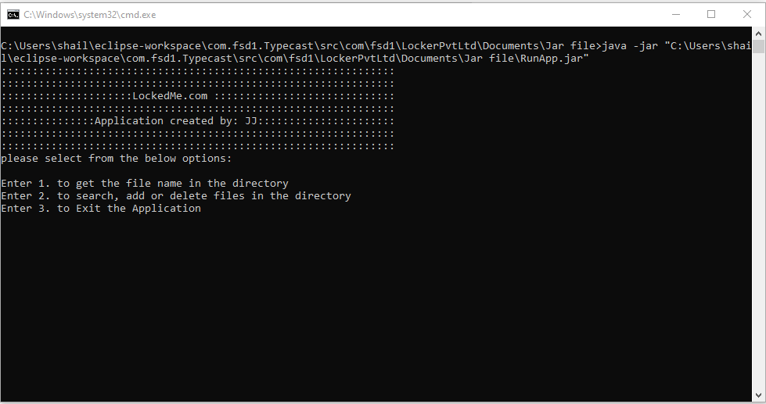

* 1. **Choose 1 to show list of files.**

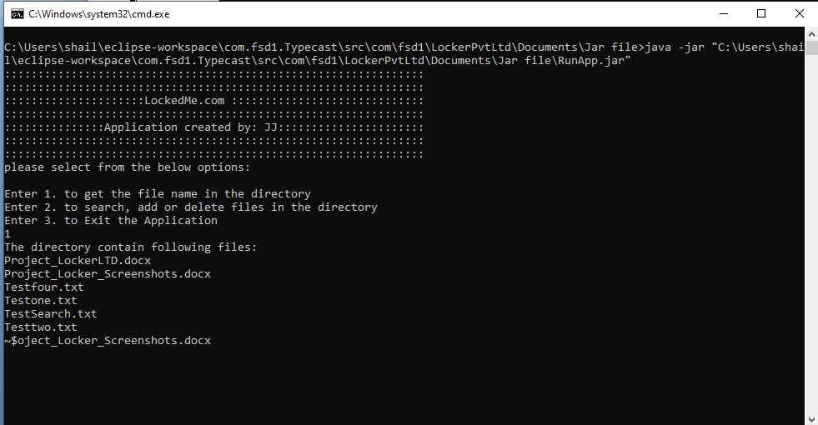

* 1. **Choose 2 to Search for, Add new file OR Delete existing file. ( SubMenu opens up )**

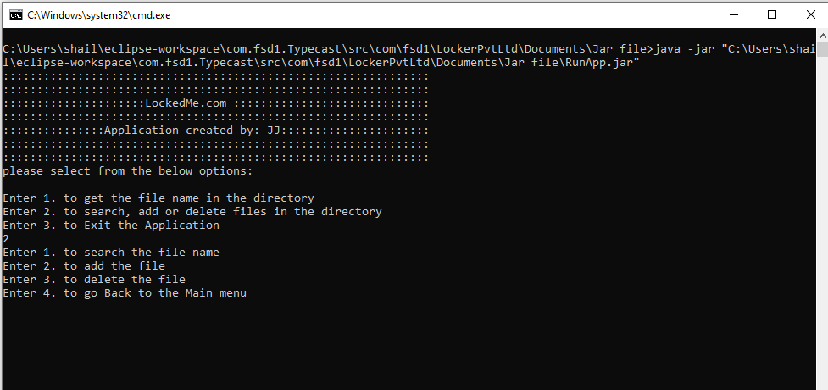

* 1. **Choice 1 to Search for file name TestSearch.txt ( Result Success )**

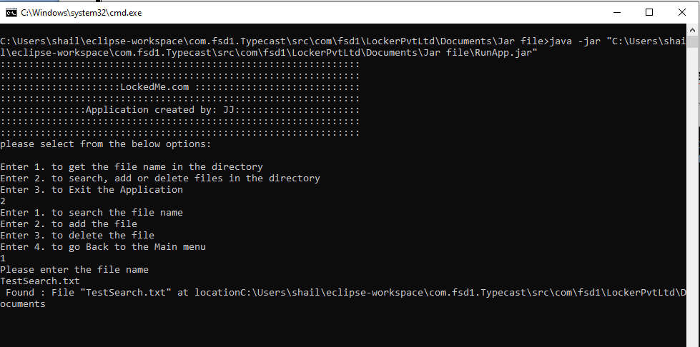

* 1. **Choice 2 to Add new file in the directory.**

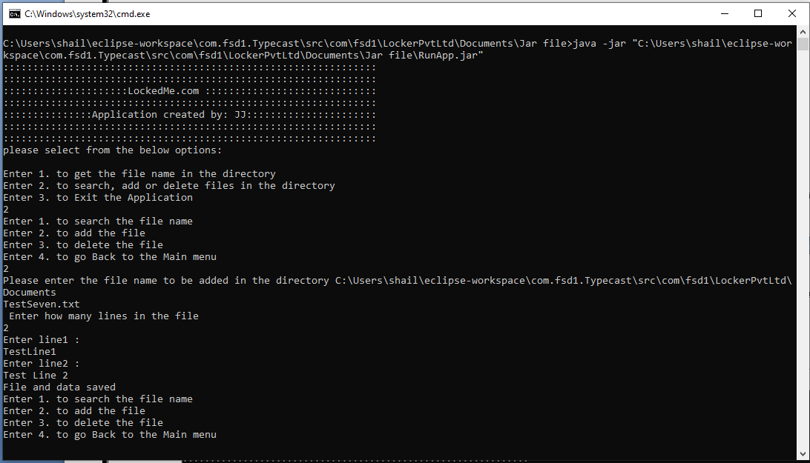

* 1. **Choice 3 to delete the file in the directory.**

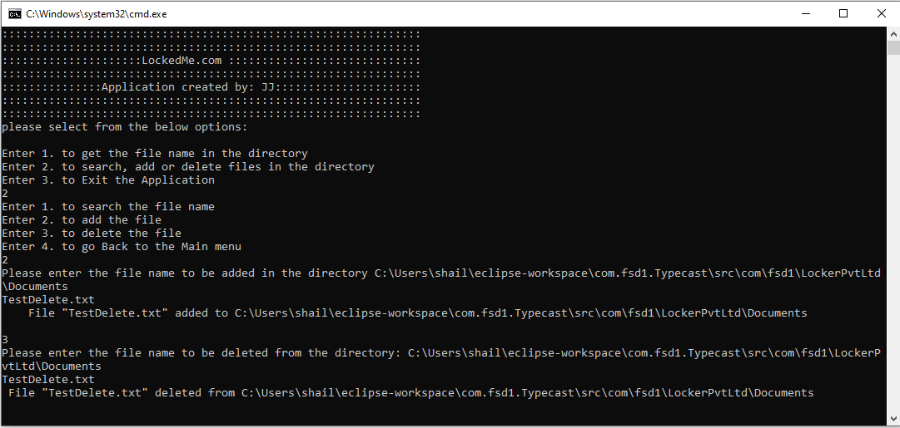

* 1. **Choice 4 to go back to main page.**

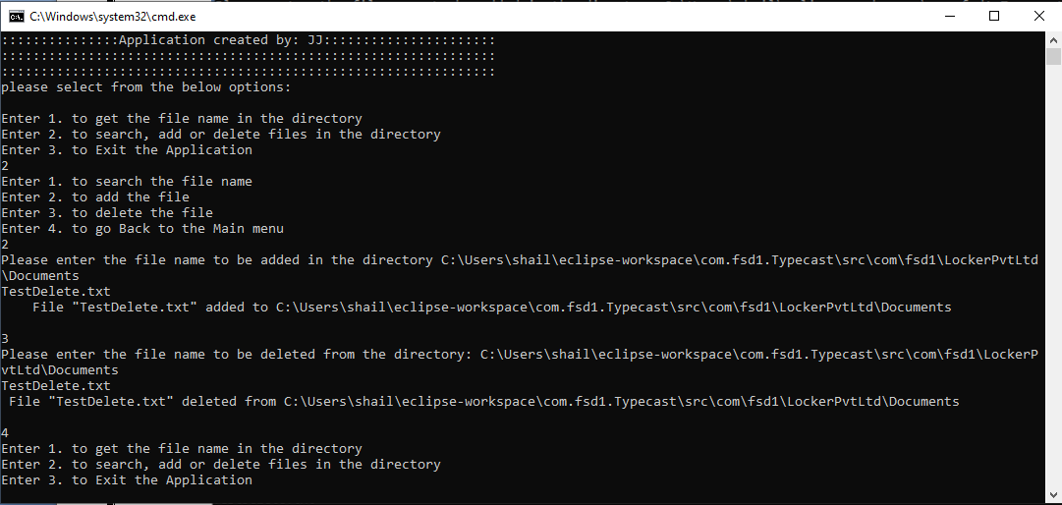

* 1. **Once in Main menu, we can opt for option 3 to exit an application. The user will be prompt weather user is sure if he want to exit an application. Y/y will proceed and exit an application.**

