

Introduction

Problem Statement
ABC is an online content sharing platform that enables users to create, upload and share the content in the form of videos. It includes videos from different genres like entertainment, education, sports, technology and so on. The maximum duration of video is 10 minutes.
Users can like, comment and share the videos on the platform.
Based on the user’s interaction with the videos, engagement score is assigned to the video with respect to each user. Engagement score defines how engaging the content of the video is.
Understanding the engagement score of the video improves the user’s interaction with the platform. It defines the type of content that is appealing to the user and engages the larger audience.

Objective
The main objective of the problem is to develop the machine learning approach to predict the engagement score of the video on the user level. It can be considered as a regression problem where we have to use the features to predict the continuous variable i.e. engagement score.



Overview
This is a detailed data analysis and problem-solving approach report gained from the study of the dataset provided . This report also includes the method that has been used to solve the problem to obtain maximum accuracy score in predicting the target variable ( engagement score )

Libraries used:
- NumPy
- Pandas
- Scikit-learn
- Matplotlib
- Seaborn

Dataset
There are two datasets and both are csv (comma separate values) files
- train.csv contains the user and video information along with the engagement score
- test.csv contains the user and video information, and we have to predict the engagement score

There are 89197 rows and 10 columns(features) in Train dataset and
11121 Rows and 10 columns In Test dataset.

Data Preprocessing
Before jumping straight into model training and prediction it is very important to pre-process the dataset. Pre-processing includes choosing the appropriate features for training and handling missing values and outliers.
It also includes encoding the categorical features into numeric features

Missing Values
Luckily there is no missing data in both the training and testing dataset.

- Duplicate Rows
There are no duplicate rows in both the training and testing dataset.

Outlier Detection
The outliers are handled using the IQR method
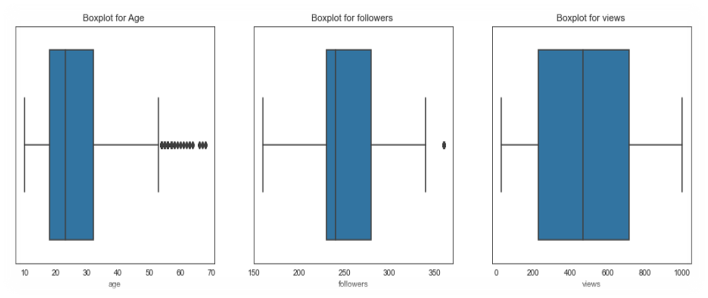

We can see from Boxplot that there are outliers and we need to remove them in order to make our predictions more accurate.

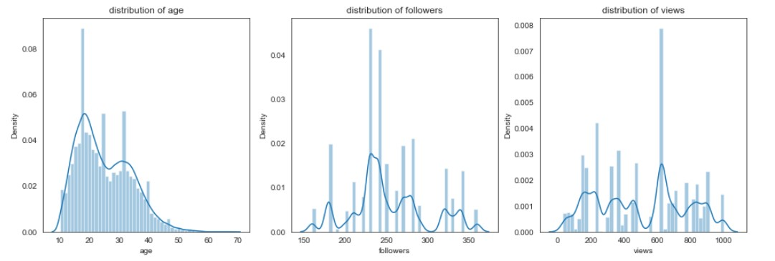

Since the distribution is not normal so we can not use z score or standard deviation to remove the outliers

IQR method is used to remove the outliers

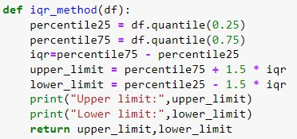

Age, Gender and Profession are the most important features.
(engagement score is more by the student)
(engagement score is more by the males)

Distribution for Engagement Score(Target Variable)

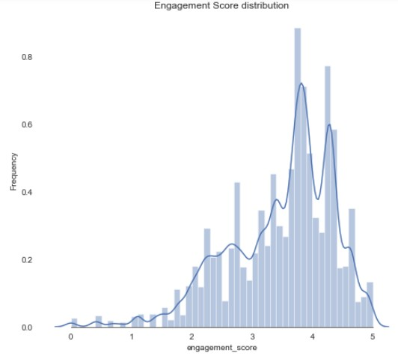

Final Model
Best Model : LGBM
