
Employee Task and Performance Tracking

أسماء الطالبات:
ايلاف عبدالعزيز المهداوي
شيماء عبدالرحمن المهداوي
شادن عبدالرحمن المهداوي

Introduction
The Employee Task & Performance Tracker project is a full-fledged software solution that aims to make the management of the employee-related activities less complicated and more efficient within an organization. Along with the system's tools for task creation, assignment, progress tracking, and performance evaluation, transparency and accountability are guaranteed at all organizational levels.

In the current scenario of fast-paced digital environment, proper task management and constant monitoring of employee performance are the key factors for keeping productivity at a good level and reaching the organization's objectives. The traditional manual tracking systems are usually very inefficient, slow, and inconsistent in terms of data. This project takes on these challenges by creating an automated software solution that is cloud-ready and comes with real-time tracking, structured reporting, and safe data handling as its major features.

1. Software Product Management

1.1 Product Vision
The Employee Task and Performance Tracking (ETPT) system offers the capability to operate in multiple, distinct instances and manage employee tasks through a cloud-based enterprise solution. This is crucial for enhancing performance metrics monitoring and boosting workplace productivity.
Building an intelligent platform streamlines administrative workflows, provides a user-friendly view, encourages employee accountability, and ensures transparency through real-time tracking and data analysis.

1.2 Product Goals
The system has clear objectives that align with the project vision and the organization's needs:
- User satisfaction: Using an easy-to-use interface that achieves a 90% user satisfaction rate.
- Security and Reliability: Using a role-based access control system ensures that data confidentiality and system readiness are maintained at 95%.
- Improve performance: Use effective monitoring tools that help reduce project delays by 25%.
- Scalability: Support multiple concurrent users by designing a cloud system.
- Automation: Task assignment, tracking, and reporting activities are approximately 80% automated.

1.3 Success Metrics
Success of the software product will be evaluated using both technical and non-technical indicators:

Metric Type | Success Indicator | Target Value
System Uptime | Continuous system availability | 95% minimum uptime
Response Time | Dashboard load speed | Less than 2 seconds
Data Accuracy | Task and performance records | 100% validated entries
User Satisfaction | Feedback rating | ≥ 90% satisfaction
Deployment Reliability | Successful CI/CD integrations | 100% without failure
Security Compliance | Privacy and access control | Full GDPR compliance

1.5 Product Backlog
The product backlog is a dynamic, prioritized list of user stories and features that represent the project’s functional and non-functional requirements. It will evolve as the team gathers feedback and adjusts to stakeholder needs.
Priority | Feature | User Story | Acceptance Criteria
High | User Authentication | As an admin, I want to securely log in so that I can manage employees. | Login is secured with JWT authentication and verified in real time.
High | Task Management | As a manager, I want to assign and track employee tasks easily. | Tasks can be created, updated, and viewed by authorized users.
Medium | Performance Tracking | As an admin, I want to monitor employee productivity using KPIs. | Dashboard displays daily, weekly, and monthly performance summaries.
Medium | Notifications | As a user, I want to receive alerts for new tasks or approaching deadlines. | Email and in-app notifications trigger automatically.
Low | Reports & Analytics | As a manager, I want to generate detailed performance reports. | Reports can be exported in PDF or Excel format with date filters.

1.6 Stakeholder and Requirement Management
Effective stakeholder communication and requirement management are critical for ensuring that the project aligns with user expectations and business objectives. The following table identifies key stakeholders and outlines their roles and engagement plans.
Stakeholder | Role | Interest Level | Communication Method
Product Owner | Defines vision, prioritizes backlog, and approves deliverables | High | Weekly sprint reviews and backlog grooming
Developers | Implement features and integrate cloud services | High | Daily stand-ups and version control updates
Quality Assurance Team | Validate features through testing and feedback | Medium | Testing reports after each sprint
End Users (Managers & Employees) | Use the system for task tracking and evaluation | High | User acceptance testing and feedback sessions
DevOps Engineer | Oversees deployment and CI/CD pipelines | High | Continuous integration reports and pipeline logs

2. Agile Software Engineering

2.1 Sprint Planning
Sprint planning consists of selecting high priority features from the product backlog that will be completed in a single sprint. This project specifies that each sprint is two weeks long and the team holds planning meetings at the initiation of each sprint.
Sprint | Duration | Main Deliverable
Sprint 1 | Week 1–2 | User Authentication & Database Setup
Sprint 2 | Week 3–4 | Task Management Module
Sprint 3 | Week 5–6 | Performance Tracking & Dashboard
Sprint 4 | Week 7–8 | Notification System & Reports
Sprint 5 | Week 9–10 | System Testing, Cloud Deployment, and Final Review

At the start of each sprint, we have a Sprint Planning Meeting during which the team:
- Defines the Sprint Goal (the purpose of the sprint and our objective).
- Selects User Stories from the backlog.
- Breaks those User Stories into Tasks estimated in story points (a measure of level of effort).
- All tasks are agreed to as user stories to complete during the sprint.

2.2 User Stories
The following user stories were developed and prioritized for early iterations of the project. Each story represents a functional requirement aligned with the project vision.
Sprint | User Story | Acceptance Criteria
Sprint 1 | As an admin, I want to securely log in so I can manage employee data. | User credentials are verified through secure JWT authentication. Invalid logins are rejected with proper messages.
Sprint 1 | As a developer, I want to connect the system to a database so that data can be stored securely. | Database connection must be reliable, encrypted, and tested with CRUD operations.
Sprint 2 | As a manager, I want to assign tasks to employees easily. | The system allows managers to add, edit, and delete tasks with assigned priorities.
Sprint 3 | As an admin, I want to monitor employee performance through a dashboard. | Dashboard displays accurate data for completed, pending, and overdue tasks.
Sprint 4 | As a user, I want to receive notifications about upcoming deadlines. | Email and in-app alerts trigger when tasks are updated or deadlines approach.
Sprint 5 | As a manager, I want to generate reports for productivity analysis. | Reports can be downloaded in PDF or Excel format and filtered by department or date.

All stories are reviewed and updated after each sprint review to reflect feedback from stakeholders and end users.

2.3 Agile Ceremonies
Agile ceremonies guarantee continual communication, collaboration, and process improvement. The team holds the following Scrum ceremonies throughout the project:

2.3.1 Daily Stand-Up Meetings
Short, 15-minute meetings held in the morning every day of the grace time.
In these meetings, each team member answers 3 questions:
- What did I accomplished yesterday?
- What will I do today?
- Are there any impediments blocking my productivity?
This facilitates product visibility of our work and issues without waiting until the end of the sprint to troubleshoot.

2.3.2 Sprint Reviews
At the end of each sprint, we will hold a sprint review to display the delivered product increment to stakeholders.
The purposes of the sprint review includes the following:
- To demo a new features/enhancement/functionalities.
- To get stakeholders feedback.
- To reprioritize the product backlog.

2.3.3 Sprint Retrospective
After each sprint review, the team will hold a retrospective session to reflect on:
- What went well during the sprint
- Where issues can improved.
- What actions are we going to take into the next sprint.
This cycle of continuous improvement in the team will create productivity, improve quality and collaborative team engagement overtime.

2.4 Incremental Product Delivery
The Agile process emphasizes delivering working software in small, valuable increments. After each sprint, a new version of the Employee Task & Performance Tracker is produced, tested, and validated.
Incremental Delivery Plan
Sprint | Increment/Feature Delivered | Outcome
Sprint 1 | User Authentication and Database Integration | Secure login and data persistence implemented.
Sprint 2 | Task Management System | Managers can assign and monitor tasks.
Sprint 3 | Performance Dashboard | KPI-based performance tracking live.
Sprint 4 | Notification and Reporting Modules | Alerts and reports operational.
Sprint 5 | Final Integration, Testing, and Cloud Deployment | Full system deployed to cloud with CI/CD.

3. Features, Scenarios & Stories

3.1 User Stories with acceptance criteria
This story reflects what has become the standard format of a user story:
As a <role>, I <want | need> to <do something>
Story ID | User Story | Acceptance Criteria
US1 | As an employee, I want to log in securely so that I can access my assigned tasks. | - The system must verify credentials. - Invalid credentials should trigger an error message.
US2 | As a manager, I want to assign tasks to employees so that I can track their progress. | - Managers can create, edit, and delete tasks. - Each task must have a deadline and priority.
US3 | As an employee, I want to update the status of my tasks so that my manager can see my progress. | - Employees can mark tasks as "In Progress," "Completed," or "Pending." - Updates should be reflected in the manager dashboard in real-time.
US4 | As a manager, I want to evaluate employees’ performance so that I can generate performance reports. | - Evaluation includes rating, comments, and feedback. - Reports should be automatically stored and retrievable.
US5 | As an administrator, I want to manage user roles and access so that the system remains secure and organized. | - Admins can add, remove, and update user roles. - Access control rules must be enforced.

3.2 Feature Scenarios
Each function was elaborated into function scenarios that describe how the user will interact with the system differently. The scenarios will describe the edge case and the test case paths.
Scenario 1: Successful Login
Precondition: The user has a valid login.
Steps:
- User enters their login id and password.
- System checks the request.
- System sends the user to their dashboard.
Expected Outcome: User dashboard displays successfully with user viewable content.
Scenario 2: Task Creation
Precondition: Manager is logged in.
Steps:
- Manager navigates to the Task Management module.
- Manager creates a task assignment with a deadline for an employee.
- System sends a notification to the employee.
Expected Outcome: The employee receives a task notification on the dashboard with content and due date
Scenario 3: Performance Review
Precondition: Employee completed tasks.
Steps:
- Manager opens the Performance Review form.
- Manager rates the employee's performance and adds comments.
- System saves the performance review in the database.
Expected Outcome: Performance review is saved and accessible in the employee's performance record.

3.3 Linking Scenarios to Implementation
All scenarios pertain to a functional module within the implementation phase:
- Scenario 1 → Authentication Module
Enables user authentication and redirects based on user role.
- Scenario 2 → Task Management Module
Enables task creation and assignment; includes service to notify users of task assignments.
- Scenario 3 → Performance Module
Enables storing ratings, reporting, and analytics.
The development was done as an incremental release, where each sprint provided a working and testable implementation of these modules.

3.4 Validate scenarios with testing artifacts.
Artifacts for testing were created to verify user stories and their associated scenarios:
- Unit Tests – verified core tasks, for example, login, data updates, and calculations.
- Integration Tests – ensured the task module had the same data as the performance module
- UAT Tests – confirmed the final outputs matched user expectations.
The status of each user story was "done" only after all relevant test cases were cleared, indicating they met quality standards and conformed to the acceptance criteria.

DevOps and Code Management

Version Control and Repository Management
The project uses Git as the source control system and GitHub as the online hosting platform for the repository. Source control allows the team to collaborate, while keeping an organized, auditable record of project development history.

4.1.1 Repository Set up
A centralized repository was created on GitHub to store each of the project files-- source code, documentation, and configuration scripts. The repository file structure was organized by modularity:
/employee-tracker/
│
├── src/ # Application source code
├── tests/ # Unit tests
├── IntegrationTest/ # Integration tests
├── docs/ # Project documentation
├── configs/ # Configuration and environment files
├── .github/workflows/ # CI/CD workflow definitions
└── README.md # Project overview and instructions

4.1.2 Branching Model
To support a stable, and scalable workflow, the GitFlow branching model was used:
Branch Name | Purpose
main | Contains the production-ready code.
develop | Serves as the integration branch for new features before merging into main.
feature/* | Used for developing new features or user stories.
bugfix/* | Used to fix issues identified during testing.
release/* | Prepared for staging and pre-production testing.

Using this branching model reduces the potential for merge conflicts as parallel activity occurs for each feature, while keeping the repo branches in a stable state.

4.1.3 Merges and Pull Requests
Each new feature, or fix is worked on as a new branch, and submitted back to the develop branch as a Pull Request( PR). The PR process has:
Code Review - Team members reviewing code for quality and standard (our coding standards)
Testing: The CI pipeline runs an automated test for stability.
Post testing and review, we add our approval and the new code is merged.
This workflow allows for collaboration, and only tested code makes it to the trunk or main project branch.

Continuous Integration (CI)
Continuous Integration (CI) guarantees that all each code alteration is built and verified automatically to the main branch prior to being merged into the main repository for this briefing CI was created using GitHub Actions with a .NET 8.0.
Workflow file named .github/workflows/ci.yml, it automatically runs when code is pushed to the develop branch or pulled request is submitted.
Pipeline stages include:
- Checkout – get the repository code;
- Set Up .NET Environment – install .NET SDK;
- Restore Dependencies – download NuGet packages;
- Build – build C# project;
- Test – run all unit and integration tests using xUnit;
- Report – report test results to GitHub actions.

Continuous Delivery and Deployment (CD)
Continuous Delivery (CD) builds upon CI by automatically deploying validated builds to the staging, or production, environment. This is accomplished through the CD workflow (deploy.yml) which automates the packaging and deployment to Azure App Service (or any equivalent cloud host such as AWS Elastic Beanstalk or Render).
- Any build triggered from the main branch will automatically deploy to production.
- Any build from the develop branch will deploy to the staging environment for testing.

4.4 Automate builds, tests, and deployments.
The employee task & performance tracker project also integrates DevOps automation, to speed up the management of the software release. By using a version control system (GitHub) and continuous integration tools, whenever new code is pushed into a repository, the build process will automatically start itself.
An automated build script compiles the C# console application and checks dependencies. When that succeeds the code is tested automatically The automaticity instruments used for these checks are dependent on experience, common sense and knowledge of the problem domain.
After completion of the testing phase, the system even deploys to a designated environment (either local or cloud-based). This ensures consistent releases, reducing manual errors and shortening delivery cycles. The automated CI/CD pipeline maintains reliability throughout the whole development lifecycle: it's quite simply a tidy but efficient business.

Software Architecture

5.1 Design Overall Architecture of the System
The Employee Task & Performance Tracker uses a modular layered architecture, allowing us to separate the system into specific components for presentation, application logic, and data storage.
- Presentation Layer - provides user interfaces (web or mobile) for employees, managers, and administrators
- Application Layer - applies business logic through task assignment, performance tracking, and reporting.
- Data Layer - responsible for persistent storage using a relational database for transactional operations or cloud storage to save reports or logs.
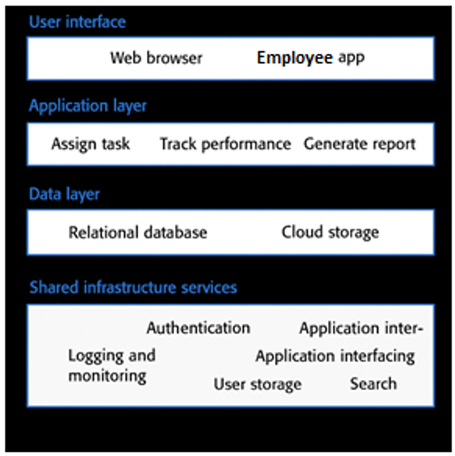
Figure 1: A layered architectural model

With this layered design, not only does it allow for fine grain maintainability and simplicity for testing, it establishes a separation of concerns across the different components of the business system.

5.2 Integrate Cloud-Based and Microservice Software Architecture
The system is designed as a cloud-friendly platform that can be deployed to cloud-based services such as Microsoft Azure or AWS. Each important module (Authentication, Task, Performance Evaluation and Reporting, Notification) can live as a microservice and communicate with each other using RESTful APIs or communicating through message queues.
- Cloud friendly means auto-scaling vertically and horizontally, load balancing, continuous deployment pipelines (GitHub Actions).
- Microservices work well in the cloud as a container, thus allow flexibility in deploying the application, supports the portability across cloud deployments, and allows for more simple maintenance.
This will also support DevOps methodologies, which is the current best practices for reliability, the cloud, and easy development.

5.3 Ensure Scalability, Reliability, and Modularity
Scalability is accomplished by designing stateless services that can scale out as workloads change. Caching (Redis) and message queues (Service Bus/RabbitMQ) also improve performance when concurrent users are involved.
Reliability is achieved through off the shelf redundancy deployments, health checks, and recovery features built into the cloud infrastructure.
Modularity is enforced through clear service boundaries, so that you can develop, test, and deploy each module: Tasks, Performance. Without causing impacts to the overall product.

Reliable Programming & Quality Assurance

Fault Avoidance
We minimize faults by adhering to well-defined design principles and programming standards in C#.
Techniques Used
- Single Responsibility Principle (SRP):
Every class in Program.cs (User, TaskItem, and PerformanceEvaluation) limits its responsibility to its designated obligation, which simplifies testing.
- Consistent Naming and Formatting:
Commands are given self-explanatory identifiers (AddEvaluation(), ListTasks()) that enhance readability and maintainability.
- Avoid Deep Inheritance:
The system is implemented using simple composition, rather than complex hierarchies, which reduces dependencies and faults.
- Avoid Deep Nesting:
Decisional statements are flattened using early return codes, which reduces deep nesting of code and the possibility of logic faults, by eliminating excessive indentation.
- Code Reviews & Standards:
The program adheres to known C# standards (PascalCase for methods/classes, camelCase for local variables) and are suitable for peer review for clarity and functionality flow.

Input Validation
All user inputs are validated for safety to avoid runtime errors and data inconsistencies.
Here is an example of implementation in Program.cs:
Console.Write("Enter rating (1-5): ");
if (!int.TryParse(Console.ReadLine(), out int rating) || rating < 1 || rating > 5)
{
Console.WriteLine("Invalid rating. Please enter a number between 1 and 5.");
return;
}
This makes sure that:
- Provides assurance that a user cannot enter non-numeric and/or out of range values.
- Prevents the application from crashing due to an invalid input type.
In addition to this, the IDs for tasks and users are validated before it is assigned to ensure that valid object references exist to avoid null errors in the process.

Failure Management
The application is intended to make failure less impactful to users.
For example:
- Graceful Error Messages:
Rather than simply terminating, the application will display descriptive messages like "Invalid Task ID!" or "User not found!" This enables users to understand what happened and how to recover.
- Try-Catch for Important Operations:
For file I/O or external dependencies (if later added), any exceptions will be caught and logged to avoid causing the application to fail.
- Recovery and Continue:
In the case of input errors, the program will continue running, and allow the user to re-attempt to perform an action, rather than needing to restart.

6.4 Automated and Manual Quality Assurance
Automated QA
- Static Code Analysis:
Automated tools like SonarLint or Visual Studio Analyzer can automatically report unused variables, issues with complexity, and other potential exceptions.
- Continuous Integration (CI):
The CI pipeline on GitHub Actions automatically builds and tests the code, making it easier to have confidence in the code before you merge it.
Manual QA
- Code Reviews:
The team reviews the logic for clarity, the code for naming conventions, and any code that meets standards.
- Test Scenarios:
Manual functional tests are run for various typical tasks (task creation, assigning a task, task evaluation, submission, invalid test scenarios, etc.).
- Usability Checks:
Interface feedback is tested for clarity, this is an important part to verify that the users will be able to understand the errors and results without clarity issues.

Fault Tolerance and Maintainability
- Error Management: The software anticipates errors in user behavior, and can respond to them gracefully.
- Modularity: Each functionality (for example, task creation, task assignment, task evaluation) is handled in separate methods, making it easier to debug and add features in the future.
- Extensibility: New features (for example, persistence to a file, synchronization with the cloud) can be added without making significant changes to core software logic.
- Documentation: Inline comments describe the purpose of methods and provide ease of readability for maintenance.

Risk Analysis & Testing

Risk Identification
Category | Potential Risk | Description / Impact
Technical | Runtime errors due to invalid user inputs | Can cause unexpected exceptions or incorrect data entries.
Technical | Data loss if the application crashes | Unsaved data in memory could be lost during abnormal termination.
Technical | Limited scalability in console environment | Console apps are single-user; scaling for multiple users requires migration to a web/cloud platform.
Organizational | Lack of version control or backups | Code or data loss may occur if changes aren’t tracked.
Organizational | Insufficient testing coverage | Hidden bugs may remain undiscovered before submission.
Security | Unauthorized data access | Without authentication enforcement, sensitive data may be exposed.
Security | Weak data validation | May allow malicious inputs or inconsistent records.
Security | Hard-coded credentials (future extensions) | Could expose security vulnerabilities if used in cloud deployment.

7.2 Risk Mitigation Strategies
Risk Type | Mitigation Strategy
Runtime & Validation Errors | Implement strong input validation using int.TryParse() and range checks for all numeric inputs.
Data Loss | Introduce simple file persistence (save/load data to JSON or text) and use exception handling (try-catch) to protect critical operations.
Scalability Limitations | Design the application modularly to support future migration to a web API or cloud service without rewriting core logic.
Versioning | Use GitHub for source-code management with regular commits and backup.
Testing Coverage | Apply systematic unit and integration testing with frameworks such as xUnit.
Unauthorized Access | Define roles (Admin, Manager, Employee) and validate actions based on role permissions.
Security Vulnerabilities | Sanitize user inputs and avoid direct system calls or unvalidated file access.
Operational Failure | Use detailed error messages and logging to help identify the cause of failure quickly.

7.3 Unit Testing
Test Cases Implemented
Test Name | Description | Expected Outcome
CreateTask  ShouldIncreaseTaskCount() | Validates that adding a new TaskItem increases the total task count. | Task list count + 1
AssignTask  ShouldAssignEmployeeSuccessfully() | Ensures a task is correctly assigned to a valid employee. | AssigneeId matches employee ID
UpdateTaskStatus  ShouldChangeToCompleted() | Confirms that the task status changes to Completed. | Status == TaskStatus.Completed
AddEvaluation  ShouldStoreEvaluationDataCorrectly() | Verifies that performance evaluation data are saved accurately. | Correct rating and comments stored

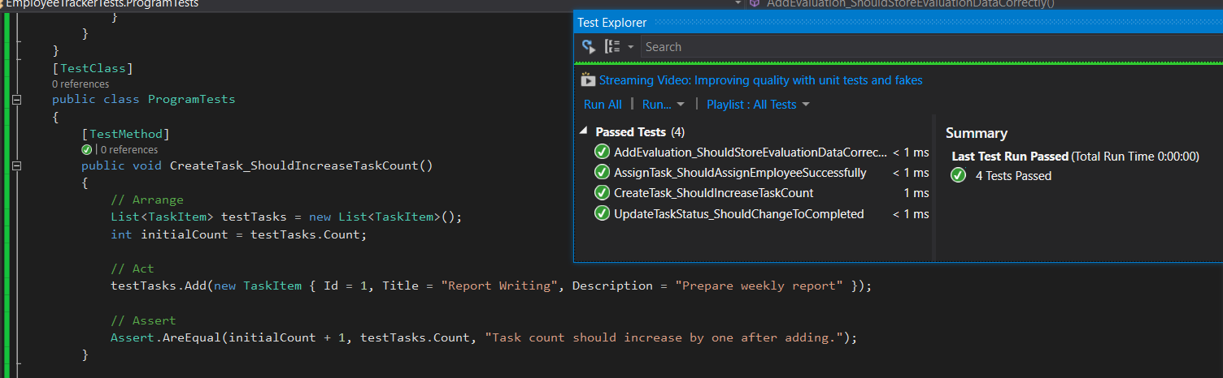
Figure 2: Unit Test#1

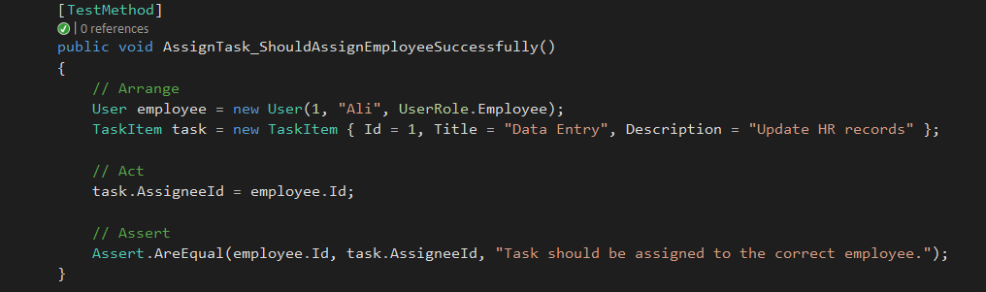
Figure 3: Unit Test#2

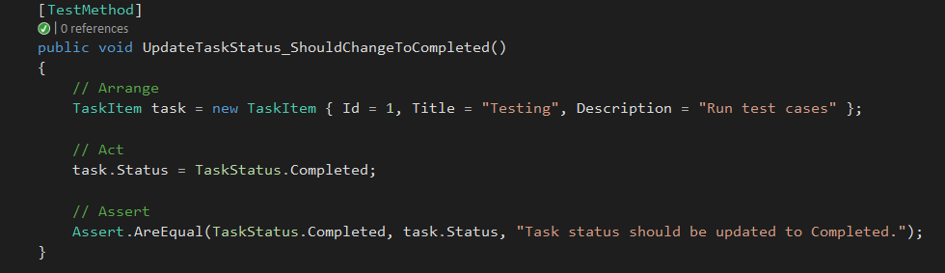
Figure 4: Unit Test#3

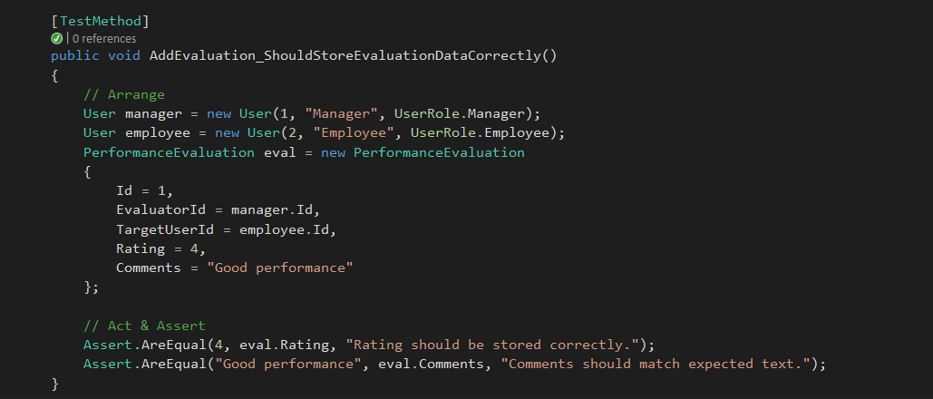
Figure 5: Unit Test#4

In Test Explorer, all testing methods executed successfully, where return green check marks ✅.
Where under normal conditions functionality working as expected for creating tasks, assigning employees, updating statuses, and storing evaluations performs.

7.4 Integration Testing
Integration testing in the Employee Task & Performance Tracker system aims to validate the correct interaction between different software modules, including user management, task management, and performance evaluation.
Work testing together aims to support the real-world workflow of assigning, completing, and evaluating employee tasks.

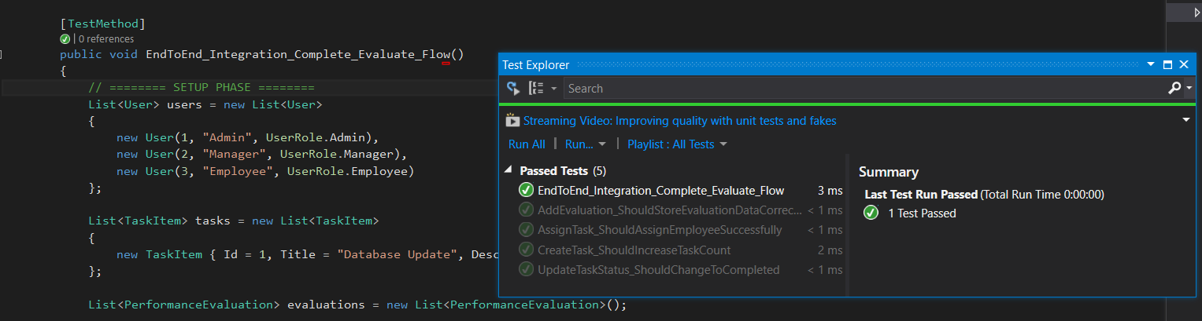
Figure 6: Integration test#1.1
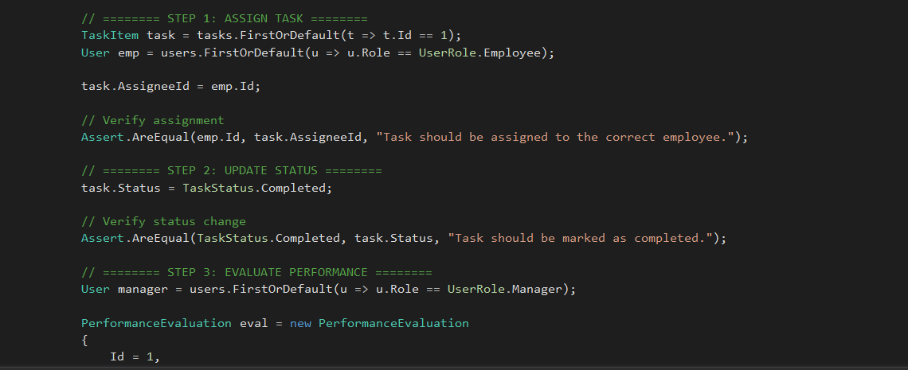
Figure 7: Integration test#1.2

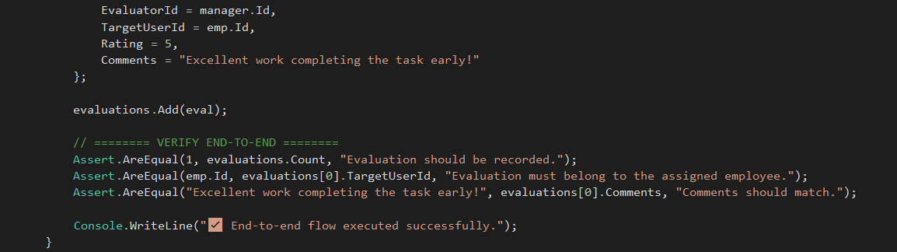
Figure 8: Integration test#1.3

- Classes (User, TaskItem, PerformanceEvaluation) work together correctly.
- Scenario:
  - Create User
  - Create a task.
  - Assign it to an existing user (employee, Admin, Manager).
  - Update the status to Completed.
  - Verify that the output reflects correct task ownership and completion.
- Integration tests are executed automatically in the CI pipeline after each build.

7.5 System Testing
System testing covers the end-to-end behavior of the console-based application, including:
- User login and role behavior (Admin, Manager, Employee)
- Task creation, assignment, and tracking
- Performance evaluation entry and display
- Data consistency across modules
- Handling of invalid or missing input
- System stability and recovery during unexpected actions

Test Scenarios and Results
Test ID | Scenario Description | Expected Result | Actual Result | Status
ST-01 | Create a new task and verify list count | New task appears in the task list | Task displayed correctly | ✅ Pass
ST-02 | Assign an existing task to an employee | Task assigned to the correct employee | Assignment successful | ✅ Pass
ST-03 | Update task status to “Completed” | Task status changes to Completed | Status updated properly | ✅ Pass
ST-04 | Add new performance evaluation | Evaluation saved and linked to user | Evaluation stored accurately | ✅ Pass
ST-05 | Enter invalid input (e.g., text instead of number) | Application prompts error and recovers | Handled with try–catch safely | ✅ Pass
ST-06 | View list of users, tasks, and evaluations | All lists displayed without error | Data output correct | ✅ Pass
ST-07 | Exit application | Application terminates gracefully | No crash or data loss | ✅ Pass

7.6 Acceptance Testing
- End users (Admin/Manager/Employee) taking their respective roles did the final validation through simulation.
- It Verifies that:
  - Creation and assignment of tasks are possible.
  - Successful addition of evaluations.
  - Graceful rejection of invalid IDs or ratings.
- The results of acceptance will be the significant factor in making the decision regarding the project's readiness for either deployment or demonstration.

Conclusion
The Employee Task & Performance Tracker is a perfect example of a dependable, skilfully created software solution that combines agile management with DevOps automation and principles of good software architecture. It shows the capacity to create, produce, and even make a fully functioning software product that is ready for further expansion and real-life deployment.

