* Open the .sln or the .csproj extension files.
* Ensure the below packages/Libraries are installed from the NuGet Packages.
* 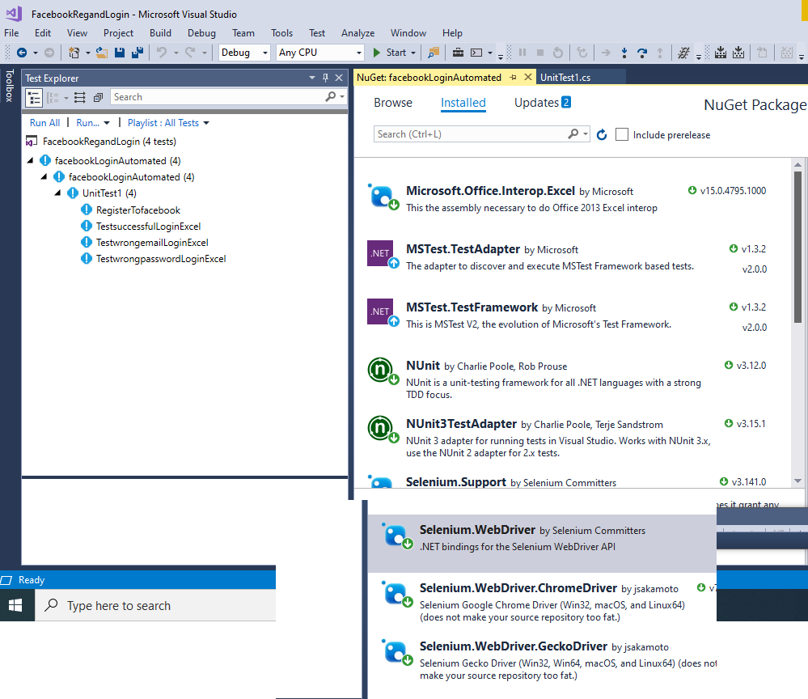
* The framework used is the selenium webdriver
* And the Microsoft office Interop Excel library to support the data-driven automation framework by which the code fetches the data from the parameters defined within he excel sheet
* QA shall Change the test data or add new rows and the system will loop over each row

To validate the test data with the parameter fetched from the excel sheet.

* To summarize the process it loops over the rows by getting the usedrows count and then internally it loops over the column and fetches the data within each cell