

**Birzeit University - Faculty of Engineering & Technology**

**Electrical & Computer Engineering Department - ENCS313**

**Linux laboratory**

**Prepared by:**

**Roa makhtoob 1221636**

**Instructor: Aziz Qaroush**

**Teacher Assistant: Eng. Ahed Mafarjeh**

**Section: 2**

**Shaimaa dar taha 1222440**

**Instructor: Mohammad Jubran**

**Teacher Assistant:** **Eng. Ahed Mafarjeh**

**Section:1**

**Date: 7/8/2024**

Introduction

In the modern healthcare landscape, managing medical test records efficiently is crucial for ensuring accurate diagnosis, treatment, and patient care. This project presents a text-based system designed to streamline the management of medical test records. The system provides a comprehensive menu-driven interface that facilitates the addition, retrieval, and updating of test data, addressing key needs in medical record management.

The core functionalities of the system include:

Adding New Medical Test Records: Users can input and store details of new medical tests, with built-in validation to ensure data accuracy and consistency. This feature supports the maintenance of comprehensive and reliable medical records.

Searching for Test Records: The system offers flexible search options to retrieve test records based on various criteria:

By Patient ID: Users can view all tests for a specific patient, filter by test status, or search for tests within a specific period.

By Test Status: Users can retrieve records based on the status of the test results, aiding in tracking and managing test outcomes.

By Medical Test: Allows for searching abnormal tests across patients, facilitating targeted follow-up actions.

Average Test Values: The system calculates and displays the average values of medical tests, which can assist in identifying trends and assessing overall health conditions.

Updating Existing Test Results: Users can modify existing records to reflect updated test results, ensuring that the data remains accurate and current.

Error Handling and Data Validation: The system incorporates robust error handling to manage invalid inputs, such as incorrect file names or non-existent test records. It also includes data validation mechanisms to ensure that all user inputs are properly formatted and valid, thereby reducing the risk of errors and maintaining data integrity.

Overall, this project aims to enhance the efficiency and accuracy of medical record management, providing healthcare professionals with a reliable tool to manage test data effectively. By integrating features for data entry, retrieval, updating, and validation, the system addresses critical needs in medical record-keeping and supports improved patient care outcomes.

 

**Test cases:**

**The midecalRecord file contain:**

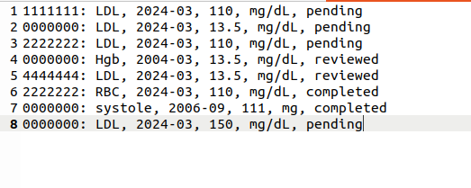

**The medicalTest file contain:**

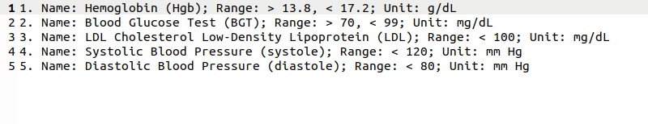

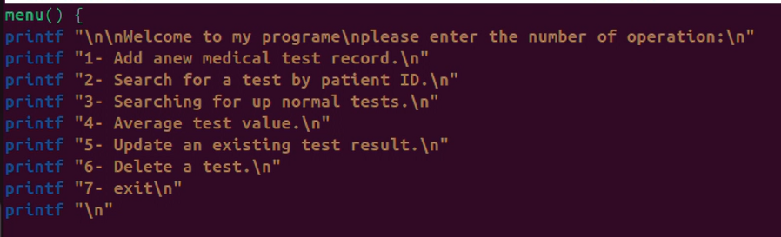**The menu:**

* **Option 1:**

**For handle error not 7 digit or non- number**

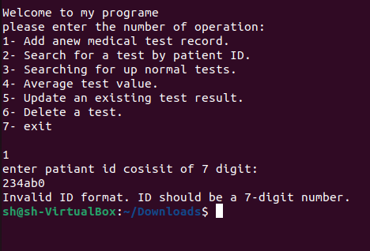

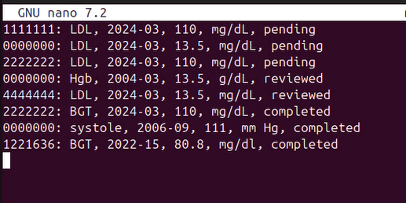**The midecalRecord file after execution:**

* **Option 2:**

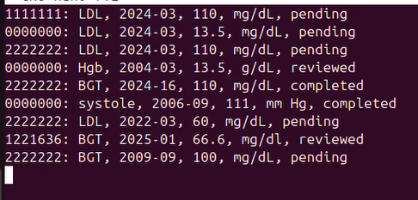**The midecalRecord file contain:**

* 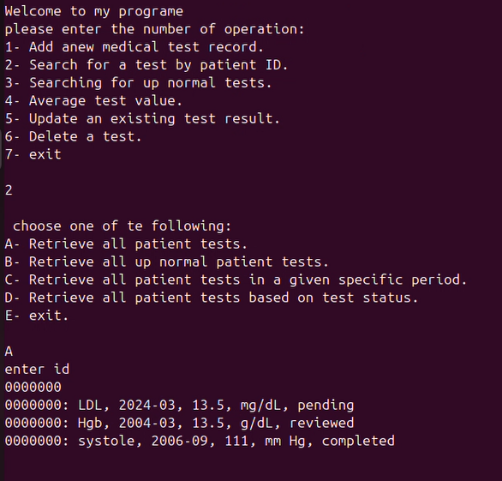**Case A:**
* **Case B:**

**For the value in midecalRecord.txt**



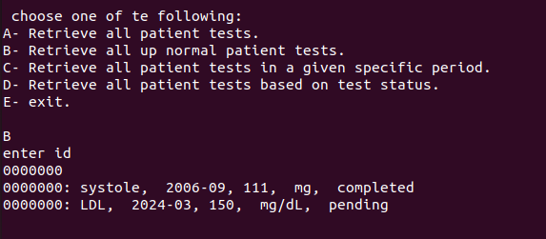

* 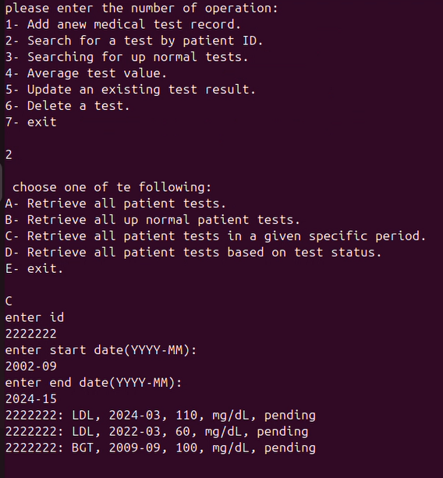**Case C:**
* 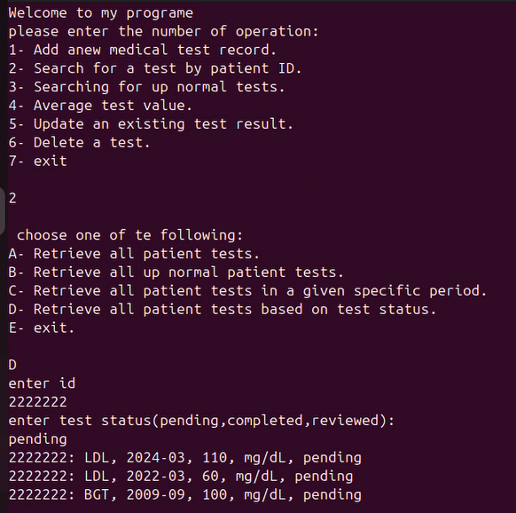**Case D:**
* **Case E:**

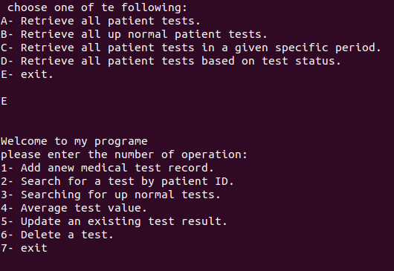

* **Option 3:**

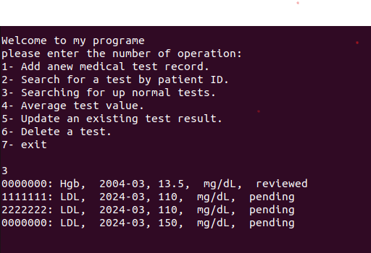

* **Option 4:**

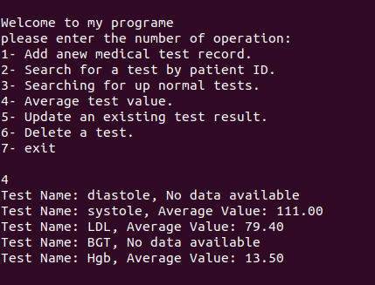

* 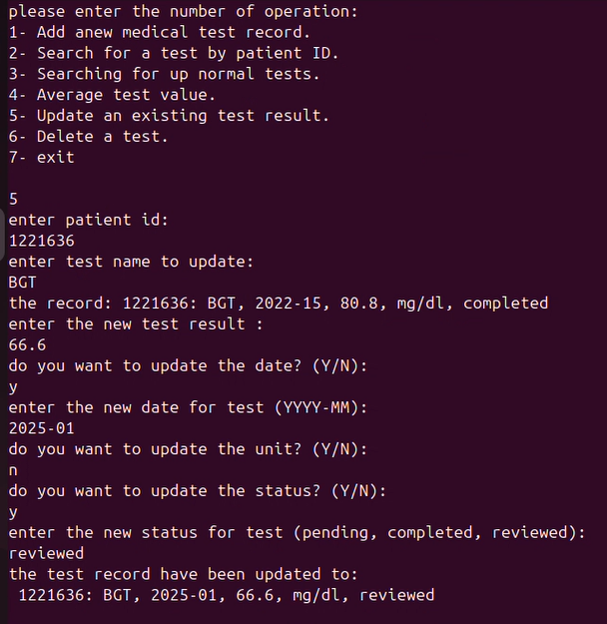**Option 5:**

**The midecalRecord file after execution:**

* 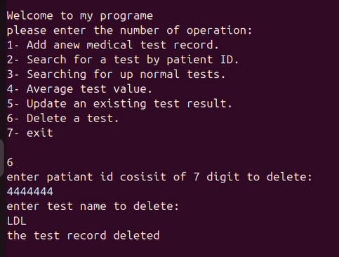**Option 6:**

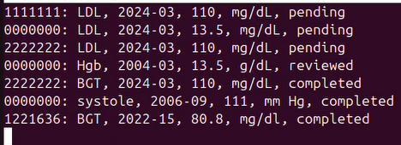**The midecalRecord file after execution:**

* **Option 7:**

