Episode one (∞)

Complex plane uses vectors to represent a specific transformation for natural numbers to convert them into vectors (if we simplify the complex plane, we can say it is a try to add another way to visualize the directions on the number line but in different directions as well instead of having only the positive direction and negative direction on the line number).

In the positive direction in the line number, we can do all arithmetic operations like exponent operations for any two natural number without any issue of finding values that can not be represented on the line number.

The issues starts when X is negative natural number, we could not find a value for a negative number for example we cannot find a value for . Why?

Simply because the negative numbers are not an actual number, they are only a representation for directions. The negative sign only means the number is moving in the other direction that all.

So, to sum up we already have one set of numbers which is positive natural numbers, and the negative sign is only a direction for these numbers of movements.

This is when the scientist starts to think how we are going to get a specific value for things that we measure but moves in the other directions (i.e., the measured value will be negative) for example how we are going to have values for

They start to say let us Imagine that this [-ev] sign we call it [i] (and therefore it is called [i] because they Imagine 😊)

So, they called because simple . So, [i] is a direction

To go into the point faster they built the complex plane, which is based on

So any number that is a result of any arithmetic operations and we cannot represent it on the line number will be represented using some direction [i] in the complex plane. And its magnitude will be how fare this number from the natural value [Zero].

This is concept of angle and magnitude in the complex plane.

Now we agree that complex plane is to representation for natural numbers, and it is moving directions.

Let us now dive into more details on the complex plane canvas to understand it more.

We all know that to move on the line number towards the positive direction of infinity we do multiplications or exponent i.e., uses X \* X \* X \* X…. makes you move in the positive line number away from the origin point (0,0).

number because we can represent it on the line number 😊

So and 1 will be

So in order to move with value X = -1 we need to raise it to some power

And we know that

*Ok, what if raised (-1) to the power of [i] i.e.,*

*We are going to have the same value -1 and now directions.*

*Oh, wait what, is this means the multiplications and power will not going to make us move the in complex plane as it do on the regular line number?*

*No wait 😊 let us see what about -2, -3, -4, …. If we raised them to the power of [i] also, are they going to move around in the complex plane or not remember complex plane is a 2-D plane.*

*Ok how about we draw 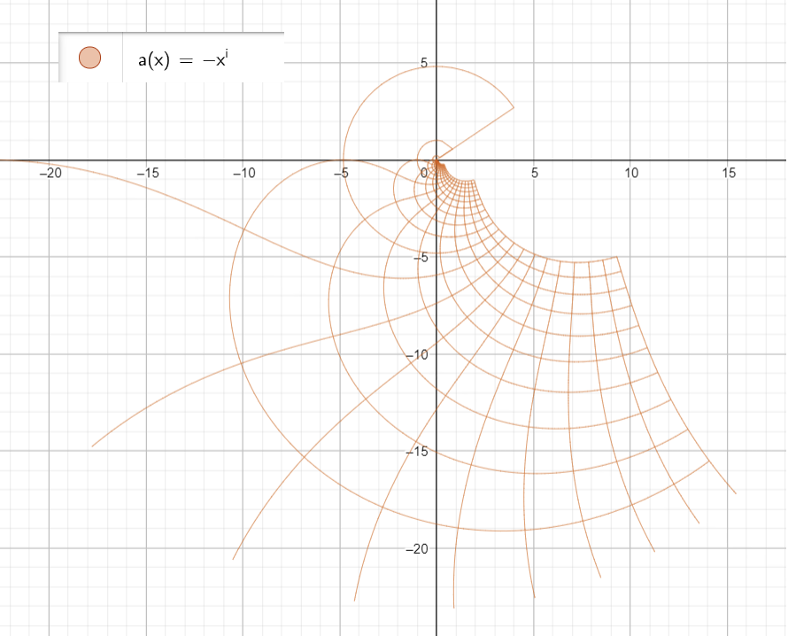*

*ok what is this shape it is a base-10 number system operation represented on the complex plane if we look at the shape it is just a distortion transformation for a square of 40x40 square*

*and it is 40 because we have 4 directions in the complex plane and we 10 because we are using a base 10 number system.*

*The line that is making the uncomplete circle in the middle is the line in the middle line number 11 or line number 9 from the other side.*

*This is how X moves in this line if we choose to use any value for X natural or real all will be on this line that is on the shape of semi-circle like this.*

*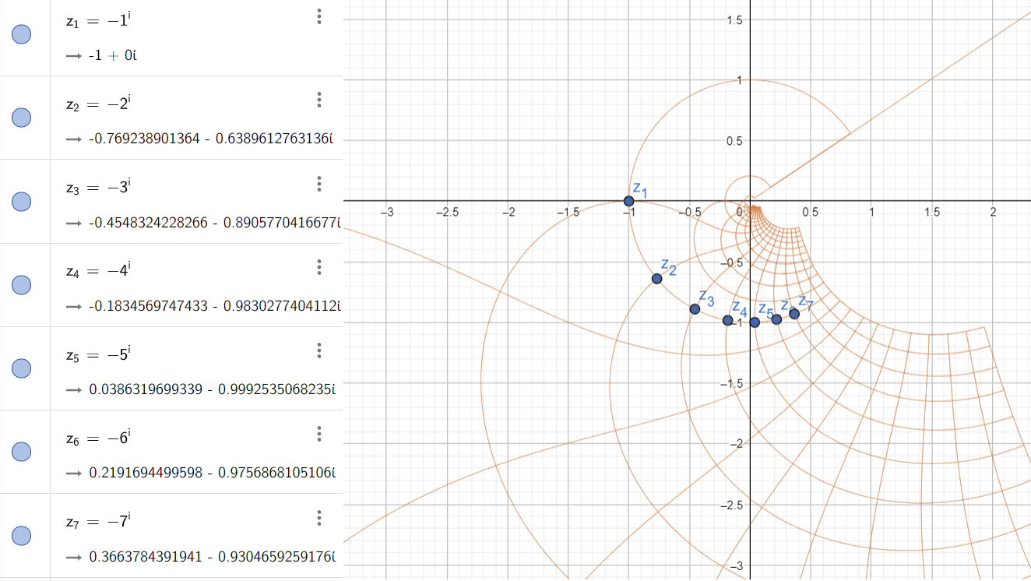*

*This means that using base-10 number system makes us move on this line with is the line as the center line in complex plane [vertical axis] but with the transformation (exponent) applied to it.*

*And as you see each line intersect with the other line that complete it to the whole integer number*

*For example, Z1 point at the intersection of line number 1 and line number 9 counted from the other side the same for Z7 for example is at the intersection of line number 3 if counted from the other side.*

*Ok this is good so we can move on the complex plane using multiplication 😊 ok what about if we checked*

*First let us see*

*it is better transformation with less distortion for the square 40x40. Ok let us see if we still could move on the complex plane using multiplication as well 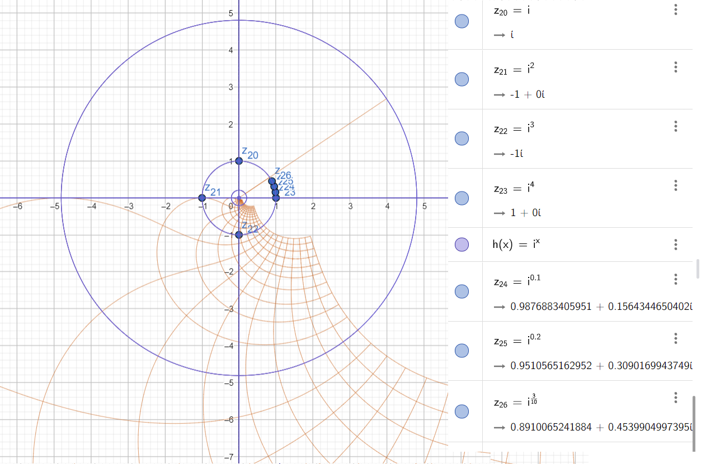*

*great we can still move around the complex plane just by using the multiplication and even on complete unit circle using base-10 number system.*

*Ok so we can move on the complex plane using only a transformation this may be travail nothing new for now, but we will see that this is the concept of a spooky alignment but in a simpler visualization*

*Ok pair with me here let us go on in this transformation concept on the complex plane and explore another transformation we are going to do transformation and its inverse at the same time*

*We all know that this means that if*

*And this should be the same as blue circle in previous graph because*

*But this will not be the case because the order of operations in the transformation is very important*

*If we first calculate a function called*

This is the only way to get back to the X value

So, it is not only a direction but also the order of the operations that will be used in the transformation, by order I do not mean the degree of the transformation, but I mean the order of applying the operations in the transformation is very important point.

Let us see this point in visual here this is to visualize the difference that can be done due to order of transformation operation.

Ok we know that

So let us try transformation that we could reverse if we raised e to the power of ln and still can get this nice approximate value for

We are going to use a transformation and we going to do the transformation on one time and the second time on two steps (order of operations)

This is the visualization if we do it on two steps 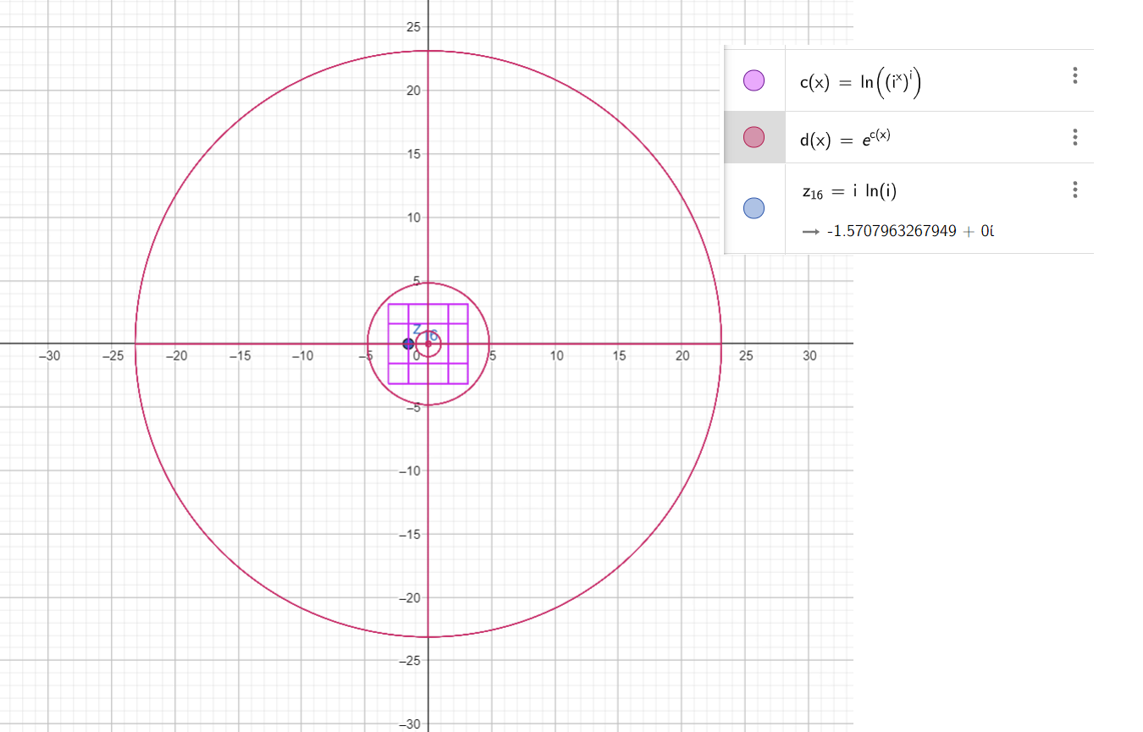

And this is the difference in visualization if we do it in one step

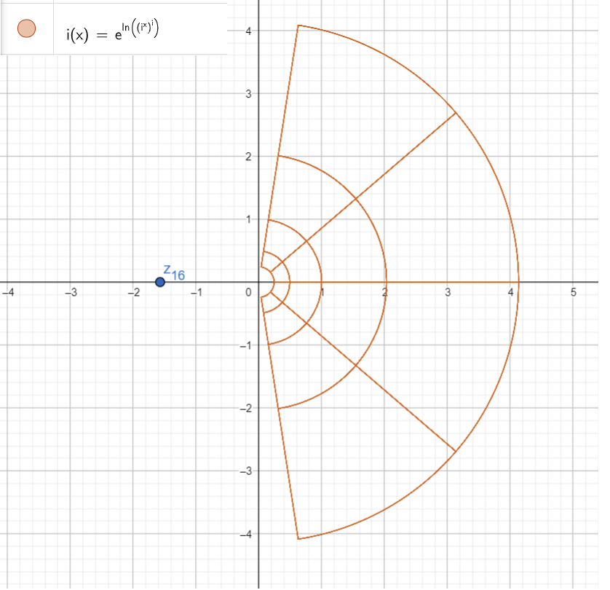

Logically we should get the same visualization for these two-function d(x) and i(x) but because the order of operation we got two different visualizations for the transformation if we applied the ln on X first in one step as a separate function then applied the exponential operation next vs. if we applied both at the same time.

Order of operations in any transformation that includes irrational numbers is very important

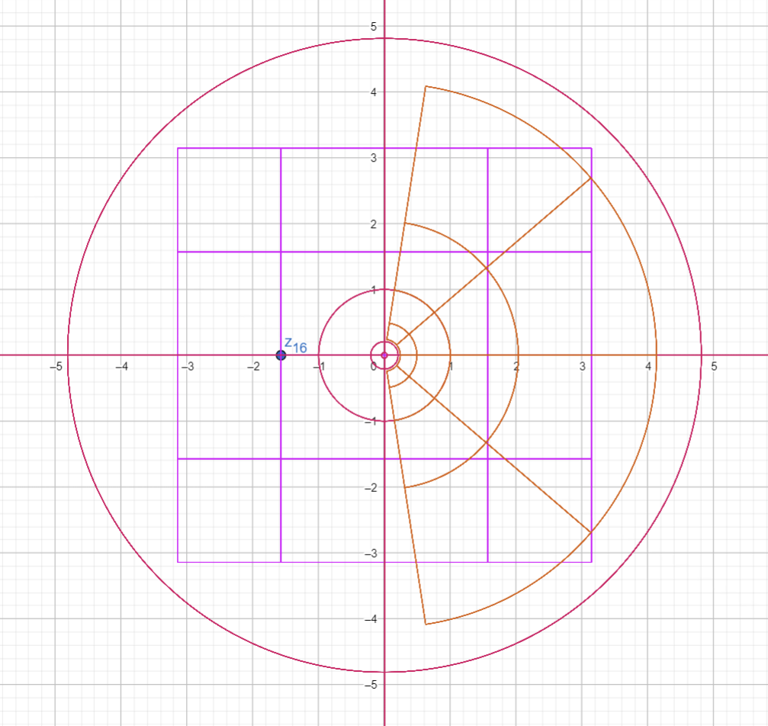

As we are using these transformations to explore the complex plane more, I will take you through this nice one here 😊

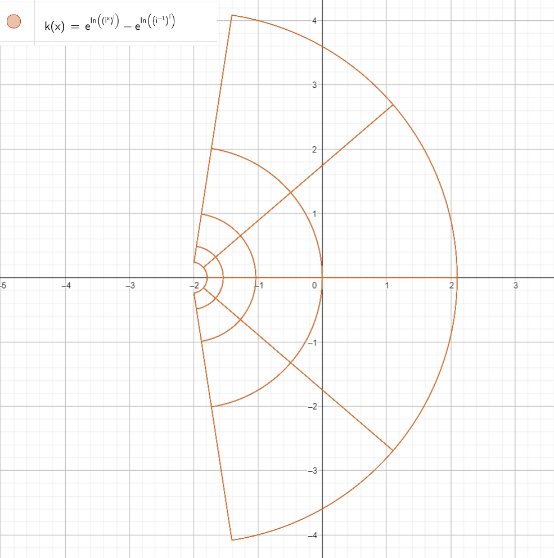

Ok in this transformation most of odd values for x this transformation k(x) = 0 + i0 and the rest of odd numbers of values will be values approximate 0.0301046027444 + 0i if we added pi/2 or if we added e

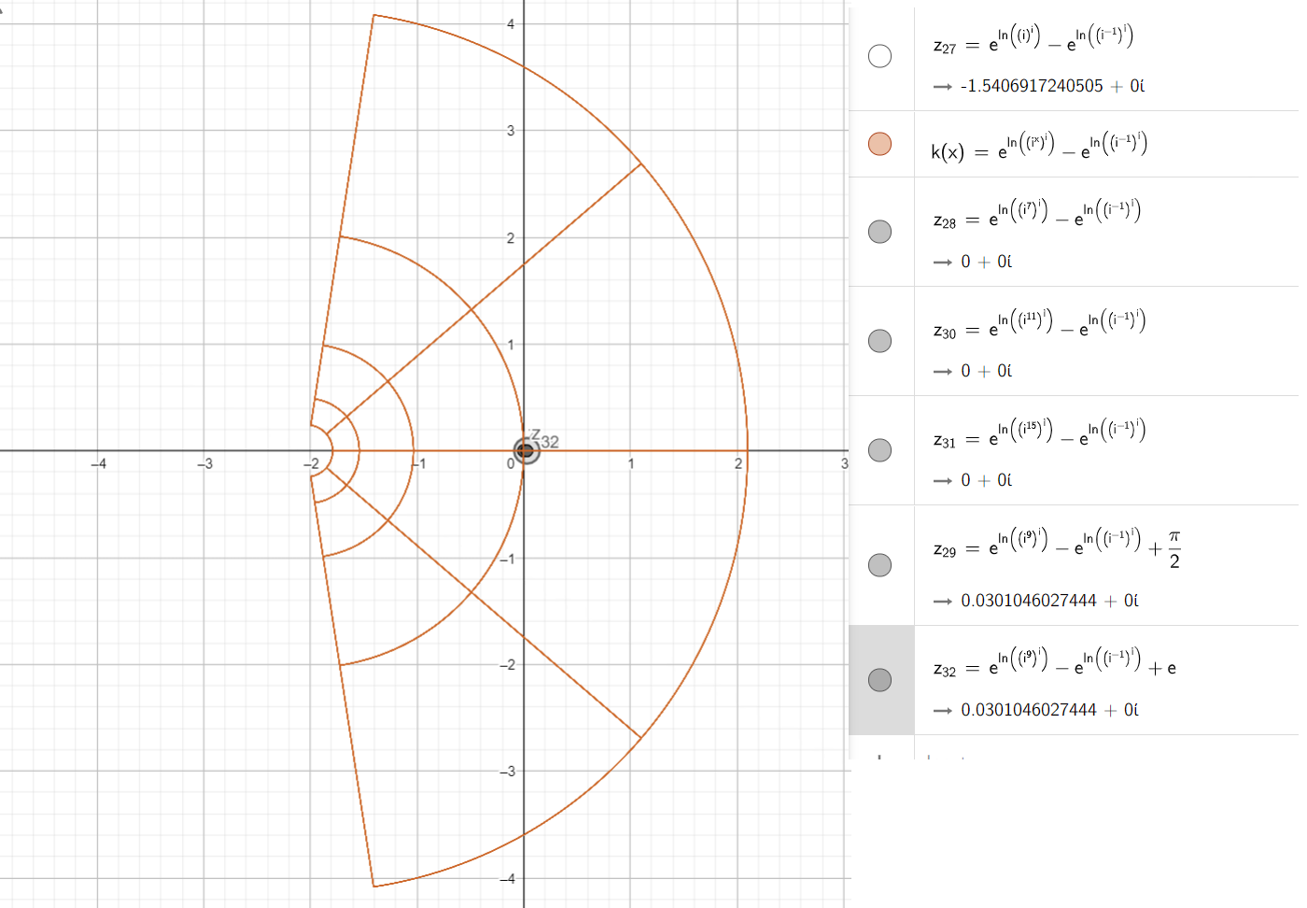

This is a nice transformation as you see.

And this is how value aligns on the square visualization transformation for this transformation

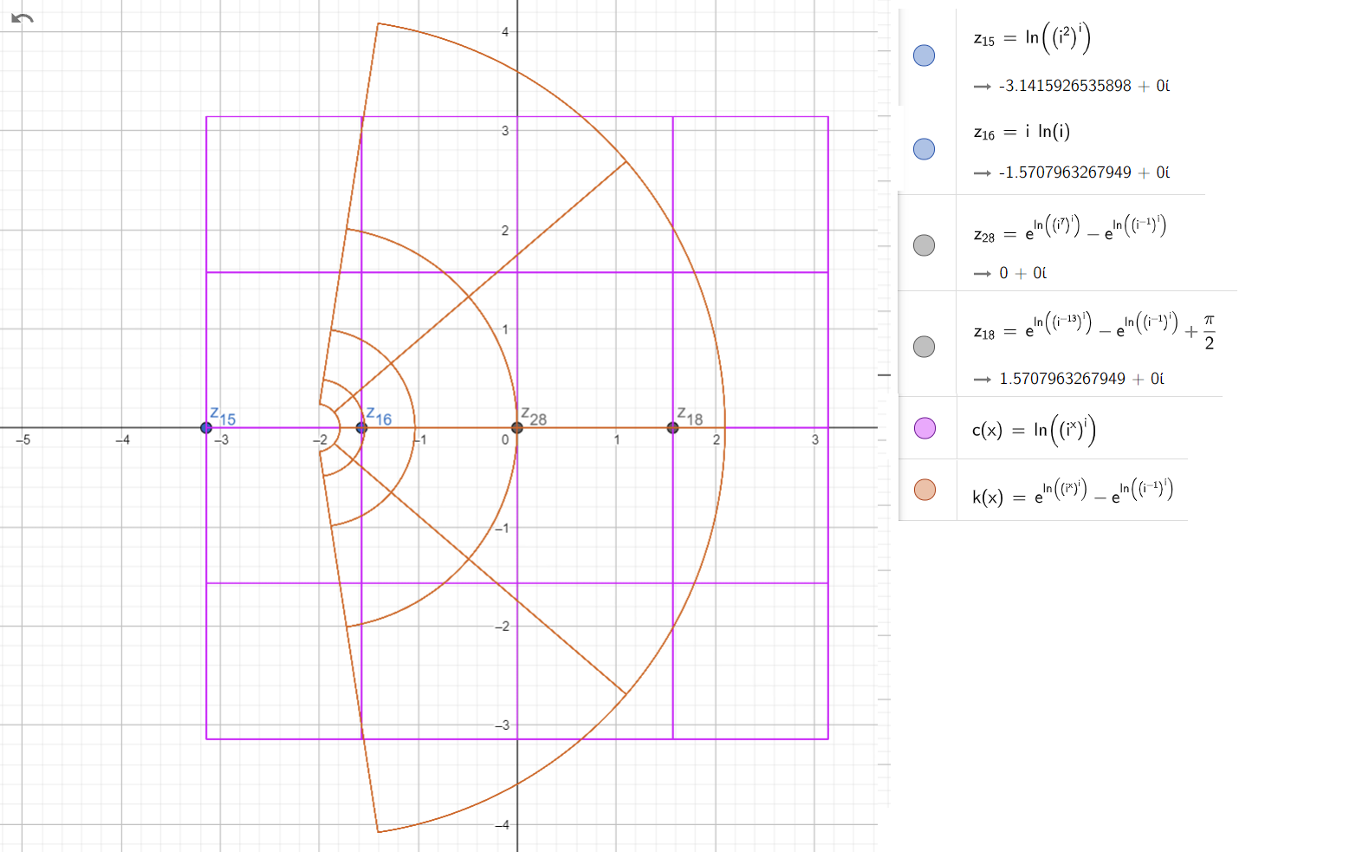

Untill the next episode 😊