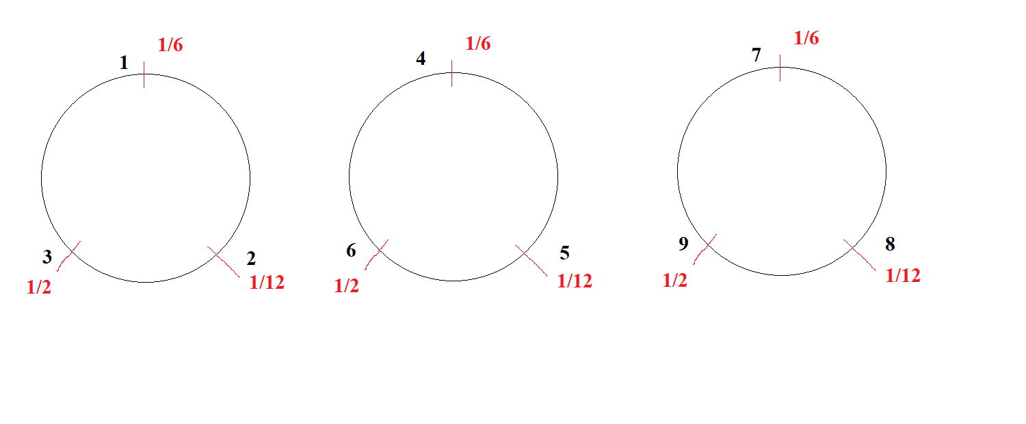

Convert all numbers to some number C + 1/2

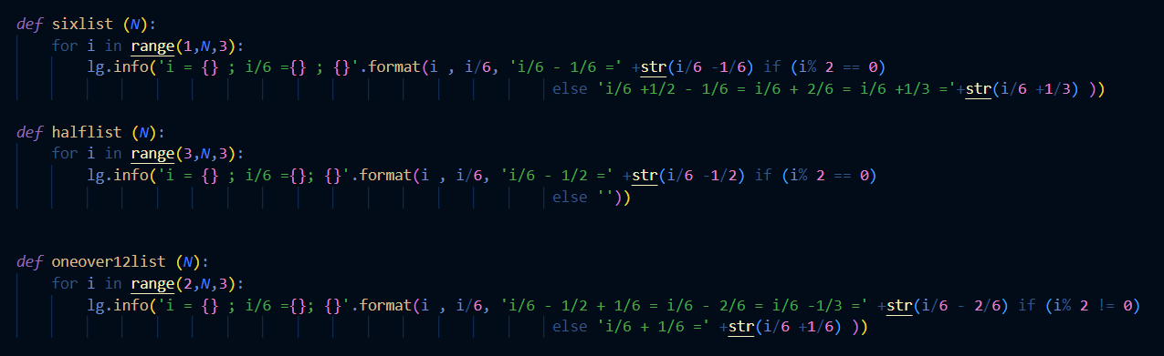

Branch Starts by 1

Odd +1/3 and even -1/6

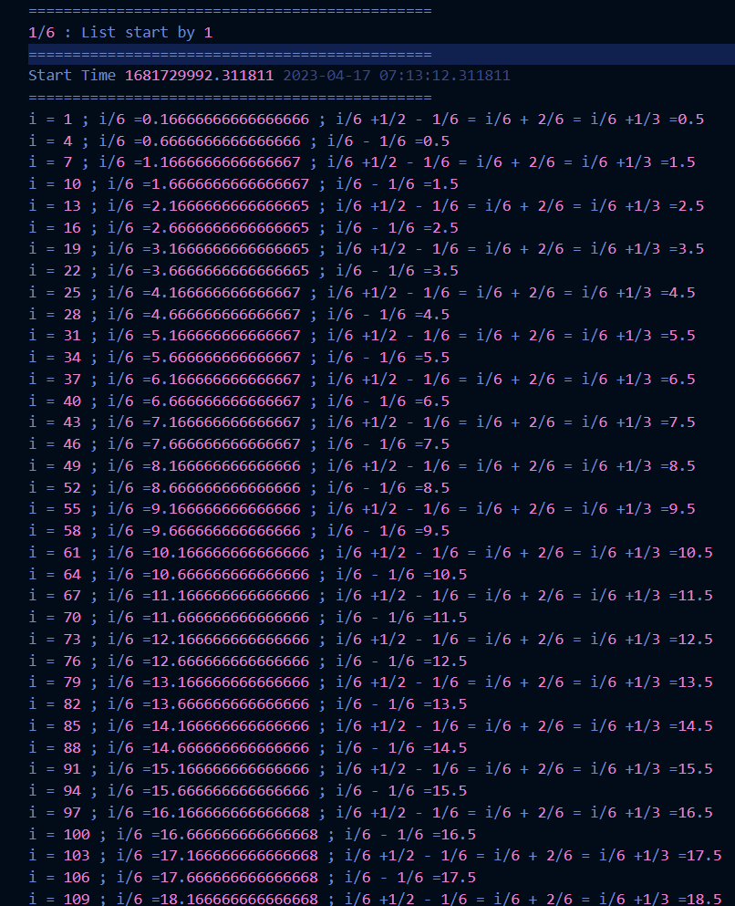

Branch Starts By 2

Even +1/6 and odd -1/3

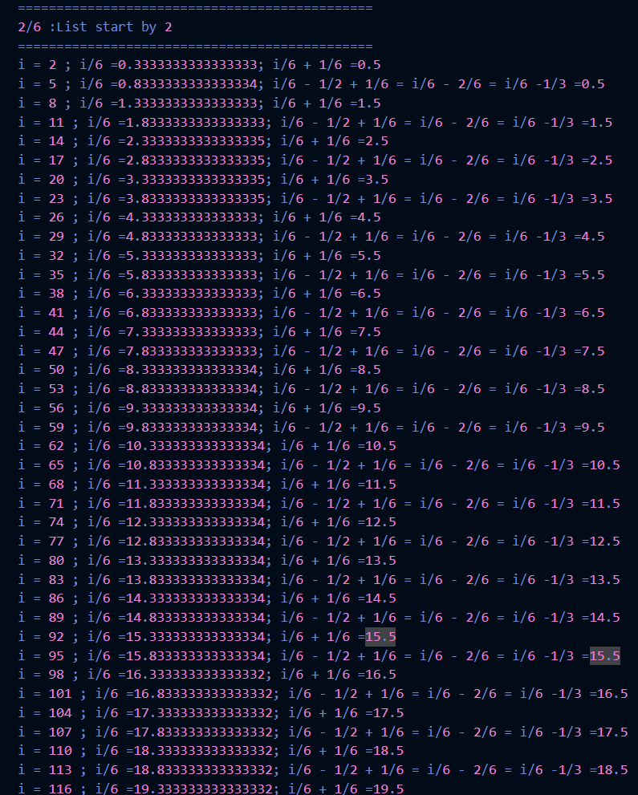

Branch Starts By 3

Even -1/2 and Odd +0

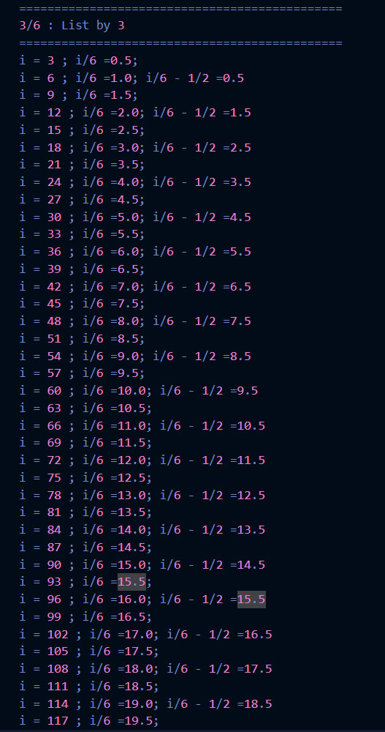

1 +4 + 7 + 10 +13 +16+19+…

+2+5+8+11+14+17+20+23+….

+3+6+9+12+15+18+21+22+…. = Z

1/6 \*( 1 +4 + 7 + 10 +13 +16+19+…)

+ 1/6 \* (2+5+8+11+14+17+20+23+….)

+ 1/6 \*(3+6+9+12+15+18+21+22+….) = Z/6

1/6 \*( 1 +4 + 7 + 10 +13 +16+19+…)

+ 1/6 \* (2+5+8+11+14+17+20+23+….)

+1/2 +1 +3/2 +2+5/2 +3+7/2+4+9/2+…. = Z/6

1/6 \*( 1 +4 + 7 + 10 +13 +16+19+…)

+ 1/6 \* (2+5+8+11+14+17+20+23+….)

½ ( 1+2+3+4+5+6+7+8+9+……) = Z/6

1/6 \*( 1 +4 + 7 + 10 +13 +16+19+…)

+ 1/6 \* (2+5+8+11+14+17+20+23+….)

+1/2 ( Z/3) = Z/6

1/6 \*( 1 +4 + 7 + 10 +13 +16+19+…)

+ 1/6 \* (2+5+8+11+14+17+20+23+….) = 0

(½ + ½ + 3/2 +3/2 + 5/2 +5/2 +7/2 +7/2 + 9/2 + 9/2 +….)

+1/2 +1/2 +3/2 +3/2 +5/2 +5/2 +7/2 +7/2 +9/2 +9/2 +…) = 0

4 ( ½ + 3/2 + 5/2 + 7/2 +9/2 +11/2 +…..) = 0

4 ( ½ + 3/2 + 5/2 + 7/2 +9/2 +11/2 +…..) = 0

½ +1/2+ 3/2 +3/2 +5/2+5/2 +7/2+7/2 +…

+1/2 +1/2 +3/2+3/2+5/2+5/2 +7/2+7/2+….

+1/2 +1 +3/2 +2+5/2 +3+7/2+4+9/2+…. = Z/6

Replace 1 = ½ +1/2

2 = 3/2 +1/2

3 = 5/2 +1/2

4 = 7/2 +1/2

…

(½ +1/2 + ½ +1/2 +1/2 + ½ ) + ½ + (3/2 +3/2 +3/2 +3/2 +3/2 +3/2) + ½ +(5/2+5/2+5/2+5/2+5/2+5/2) + ½ + (7/2+7/2+7/2+7/2+7/2+7/2) + ½ +….. = z/6

(3 + 9 + 15 + 21 + 27 +…..) + ½ +1/2 +1/2 +1/2 +1/2 +1/2 +… = z/6

Note 1:

*For Example: -*

*135 = 1+2+3+4+5+6+7+8+9+10+11+12+13+14+15+16 -1*

*135 = 3 \* (3 +6+9+12+15)*

*153 =1+2+3+4+5+6+7+8+9+10+11+12+13+14+15+16+17*

*153 = 3 \* (1+4+7+10+13+16)*

*C = 0*

*3/6 +9/6 +15/6 + … + 3/6 + 6/6 +9/6 + 12/ 6 + … = 1/6 (1+2+3+4+…)*

Branch 1 : Odd +1/3 and even -1/6

Branch 2: Even +1/6 and odd -1/3

Branch 3: Even -1/2 and Odd +0

1. Branch 1

For each Odd number/6 we are going to add 1/3

For each even number/6 we are going to subtract -1/6

1. Branch 2

For each Even number / 6 we are going to add +1/6

For each odd number /6 we are going to subtract -1/3

1. Branch 3

For each even number /6 we are going to subtract -1/2

For each Odd number /6 we are going to add zero

Add Branch 1 - Branch 2 + Branch 3

If Z(-1) = 0 if each odd number have its term ½

1. Full series Z (-1)
2. Odd terms in Z(-1)
3. Even Terms in the series Z(-1)