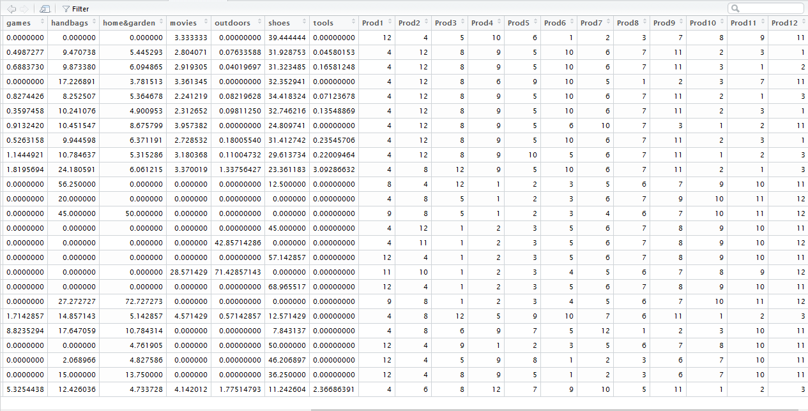
> dt <- CalculateScore(df_Normal_Full)
> dt_discount <- discountMatrix(dt)
> df_score <- ScoreMatrix(dt)
> ProductList('173.255.176.213')
[1] "Welcome To our website You are a GEUST USER "
[1] "Product List"
[1] "--------------------"
[1] "clothing --> 0% Discount"
[1] "shoes --> 0% Discount"
[1] "handbags --> 0% Discount"
[1] "home&garden --> 30% Discount"
[1] "movies --> 2% Discount"
[1] "computers --> 1% Discount"
[1] "electronics --> 0% Discount"
[1] "games --> 11% Discount"
[1] "tools --> 4% Discount"
[1] "outdoors --> 2% Discount"
[1] "accessories --> 0% Discount"
[1] "automotive --> 30% Discount"
[1] "books --> 0% Discount"
> ProductList('67.224.130.63')
[1] "Welcome To our website You are a NOrmaL USER "
[1] "Product List"
[1] "--------------------"
[1] "clothing --> 0% Discount"
[1] "electronics --> 0% Discount"
[1] "handbags --> 0% Discount"
[1] "shoes --> 20% Discount"
[1] "games --> 12% Discount"
[1] "home&garden --> 9% Discount"
[1] "movies --> 3% Discount"
[1] "computers --> 19% Discount"
[1] "tools --> 16% Discount"
[1] "outdoors --> 5% Discount"
[1] "accessories --> 0% Discount"
[1] "automotive --> 12% Discount"
[1] "books --> 0% Discount"

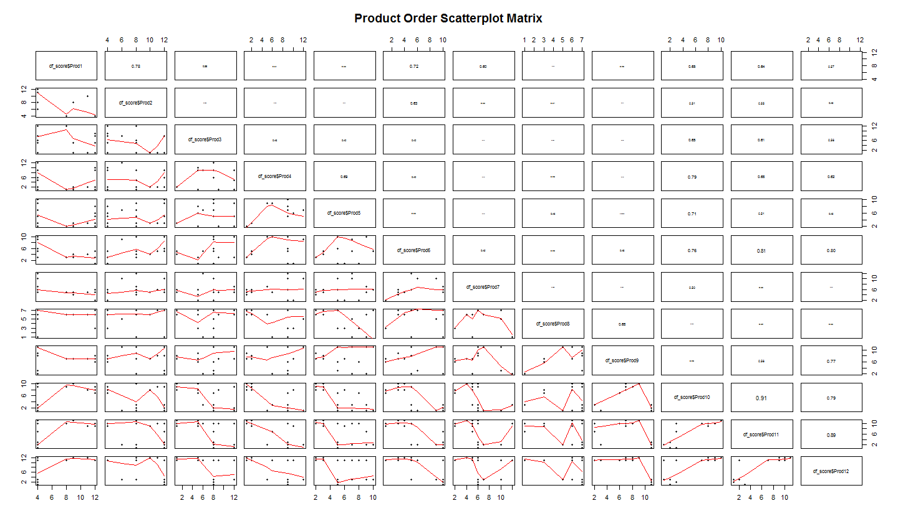

Classification

#-------------------------------------------------------------------
# Module 1) - Apply Cross-validation on combined DataSet on Weka KNN
#-------------------------------------------------------------------
> library("RWeka")
> library("kknn")
> Classifier <- IBk(as.factor(dt_evaluate$Prod1) ~ dt_evaluate$IP_NUMBER + dt_evaluate$AGE + dt_evaluate$Score + dt_evaluate$GENDER , data=dt_evaluate, control= Weka_control(K = 3))
> evaluate_Weka_classifier(Classifier,numFolds =20,data = dt_evaluate)
=== 20 Fold Cross Validation ===

=== Summary ===

Correctly Classified Instances 123681 99.9984 %
Incorrectly Classified Instances 2 0.0016 %
Kappa statistic 0.9982
Mean absolute error 0
Root mean squared error 0.0024
Relative absolute error 0.2048 %
Root relative squared error 5.6167 %
Coverage of cases (0.95 level) 100 %
Mean rel. region size (0.95 level) 20.0003 %
Total Number of Instances 123683

=== Confusion Matrix ===

a b c d e <-- classified as
123110 0 0 0 0 | a = 4
0 16 0 0 0 | b = 8
0 0 31 0 0 | c = 9
0 0 0 7 0 | d = 11
2 0 0 0 517 | e = 12

#-----------------------------------------------
# Module 2) SVM algorthim
#-----------------------------------------------

> summary(svm_model)

Call:
svm(formula = Y ~ DF$IP_NUMBER + DF$AGE + DF$Score + DF$GENDER, data = DF, method = "C-classification",
kernel = "radial", cost = 10, gamma = 0.1)

Parameters:
SVM-Type: C-classification
SVM-Kernel: radial
cost: 10
gamma: 0.1

Number of Support Vectors: 263

( 107 136 2 16 2 )

Number of Classes: 5

Levels:
4 8 9 11 12
-------------------
> conf_Matrix

Y 4 8 9 11 12
4 86168 0 0 0 0
8 0 12 0 0 0
9 0 0 12 0 6
11 0 0 0 7 0
12 38 0 0 0 335
> Correct_Predict
[1] 86534
> False_pred
[1] 44
> Accuracy_Perc
[1] 99.94918
>
--------------------------------------------------------------------------------------------------
> summary(svm_model)

Call:
svm(formula = Y ~ DF$IP_NUMBER + DF$AGE + DF$Score + DF$GENDER, data = DF, method = "C-classification",
kernel = "radial", cost = 25, gamma = 0.1)

Parameters:
SVM-Type: C-classification
SVM-Kernel: radial
cost: 25
gamma: 0.1

Number of Support Vectors: 217

( 89 114 2 10 2 )

Number of Classes: 5

Levels:
4 8 9 11 12

> conf_Matrix

Y 4 8 9 11 12
4 86168 0 0 0 0
8 0 12 0 0 0
9 0 0 18 0 0
11 0 0 0 7 0
12 0 0 0 0 373
> Correct_Predict
[1] 86578
> False_pred
[1] 0
> Accuracy_Perc
[1] 100
---------------------------------------------
> # ON TEST DATA
> conf_Matrix

Y 4 8 9 11 12
4 36930 0 0 0 0
8 0 6 0 0 0
9 0 0 10 0 0
11 0 0 0 3 0
12 0 0 0 0 155
> Correct_Predict
[1] 37104
> False_pred
[1] 0
> Accuracy_Perc
[1] 100
>

