ANALYZE WEBSITE CLICKSTREAM DATA Ryerson Capeston Project
ShaimaaSoltan
October 31, 2015

Step 2: Malicious Click Filtering & IP Analysis
First Do Some featuer Engineering on the Data to Convert some Featuers into numeric Form.
- MAP IP Into numbers
- Classify IPs Into Public And Private
- Get IP Visits Ratio
- Get Day Visits Ratio
- Label IPs into 4 Classes According to Count of unique Visits
- Perform the Principal Component Analysis (PCA)
- Create An ANOVA Table
- Conduct a Tukey's Multiple Comparison Procedure
ALTER VIEW [dbo].[V_Visists]
As
with vististCount As
(
SELECT IP , visit_Count = Count(visittimestamp)
from dbo.Visits
group by IP
), VisitDayCount AS
(
SELECT VisitDay = DAY(visitDate) , Day_visit_Count = Count(visittimestamp)
from dbo.Visits
group by DAY(visitDate)
)
select IP_NUMBER = DENSE_RANK() OVER( order by v.IP), Octet1 ,Octet2,Octet3,Octet4 , v.*, c.visit_Count, u.BIRTH_DT,u.GENDER_CD ,
GENDER= CASE WHEN u.GENDER_CD = 'M' THEN 1
WHEN u.GENDER_CD = 'F' THEN 2
WHEN u.GENDER_CD = 'U' THEN 3
ELSE 4 END , url.category,
IP_Class = CASE WHEN c.visit_Count between 1 and 100 then 'A'
WHEN c.visit_Count between 101 and 200 then 'B'
WHEN c.visit_Count between 201 and 300 then 'C'
WHEN c.visit_Count between 301 and 400 then 'D'
WHEN c.visit_Count between 401 and 550 then 'E'
ELSE 'F' END,
IP_Public_Private = CASE WHEN Octet1 = 10
AND Octet2 between 0 and 255
AND Octet3 between 0 and 255
AND Octet4 between 0 and 255 then 'Private'
WHEN Octet1 = 172
AND Octet2 between 16 and 31
AND Octet3 between 0 and 255
AND Octet4 between 0 and 255 then 'Private'
WHEN Octet1 = 192
AND Octet2 = 168
AND Octet3 between 0 and 255
AND Octet4 between 0 and 255 then 'Private'
ELSE 'Public' END,
ProductType = CASE WHEN url.category = 'clothing' THEN 1
WHEN url.category = 'accessories' THEN 2
WHEN url.category = 'automotive' THEN 3
WHEN url.category = 'books' THEN 4
WHEN url.category = 'clothing' THEN 5
WHEN url.category = 'computers' THEN 6
WHEN url.category = 'electronics' THEN 7
WHEN url.category = 'games' THEN 8
WHEN url.category = 'grocery' THEN 9
WHEN url.category = 'handbags' THEN 10
WHEN url.category = 'home&garden' THEN 11
WHEN url.category = 'movies' THEN 12
WHEN url.category = 'outdoors' THEN 13
WHEN url.category = 'shoes' THEN 14
WHEN url.category = 'tools' THEN 15
ELSE 16 END,
Visis_Day = Day(VisitDate), dc.Day_visit_Count
from ClearVisits v
CROSS APPLY dbo.fn_ParseText2Table(v.IP,'.') AS octet
JOIN vististCount c on c.IP = v.IP
JOIN VisitDayCount dc ON dc.VisitDay = Day(VisitDate)
left JOIN Users u ON u.SWID = v.UserID
Left JOIN [dbo].[URLMap] url ON url.url = v.URL
GO

Unique Visits Count Group By IPs
df_data = read.csv(file='Visits.csv',header = T , sep = ',')
attach(df_data)
boxplot(visit_Count~IP_Class, col=c('Green','RED','BLUE','GRAY','YELLOW'))
legend('topleft','GROUP',c('A (1-100)','B (101-200)','C (201-300)','D (301-400)','E (401-550)') , col=c('Green','RED','BLUE','GRAY','YELLOW'), lty = 1)
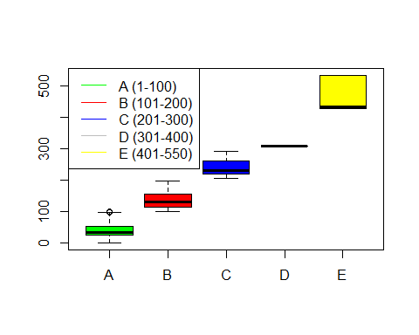

Create An ANOVA Table
dat_aov <- aov(visit_Count~IP_Class)
summary(dat_aov)
## Df Sum Sq Mean Sq F value Pr(>F)
## IP_Class 4 820644294 205161074 412252 <2e-16 ***
## Residuals 427806 212901748 498
## ---
## Signif. codes: 0 '***' 0.001 '**' 0.01 '*' 0.05 '.' 0.1 ' ' 1
# Conduct a Tukey's Multiple Comparison Procedure
TukeyHSD(dat_aov)
## Tukey multiple comparisons of means
## 95% family-wise confidence level
##
## Fit: aov(formula = visit_Count ~ IP_Class)
##
## $IP_Class
## diff lwr upr p adj
## B-A 97.06549 96.74637 97.38461 0
## C-A 200.72352 199.92835 201.51869 0
## D-A 267.31330 263.83889 270.78771 0
## E-A 430.29824 428.66601 431.93048 0
## C-B 103.65803 102.81266 104.50340 0
## D-B 170.24781 166.76157 173.73404 0
## E-B 333.23275 331.57548 334.89002 0
## D-C 66.58978 63.02827 70.15128 0
## E-C 229.57472 227.76447 231.38498 0
## E-D 162.98495 159.14877 166.82112 0

Perform the Principal Component Analysis (PCA)
df_PCA <- cbind(IP,IP_Class,IP_NUMBER,visit_Count,Octet1,Octet2,Octet3,Octet4,GENDER,ProductType,Day_visit_Count,DayVisitRatio,Visis_Day,VisitTimeStamp,URL,TVShow,TV_Station,Domain)
#pairs(df_PCA)
result_PCA <- princomp(df_PCA,scores = TRUE,cor = TRUE)
summary(result_PCA)
## Importance of components:
## Comp.1 Comp.2 Comp.3 Comp.4 Comp.5
## Standard deviation 1.5786895 1.5145426 1.4294162 1.3620662 1.08178393
## Proportion of Variance 0.1384589 0.1274355 0.1135128 0.1030680 0.06501425
## Cumulative Proportion 0.1384589 0.2658944 0.3794072 0.4824753 0.54748950
## Comp.6 Comp.7 Comp.8 Comp.9
## Standard deviation 1.02258492 1.02129875 1.00491733 0.99526843
## Proportion of Variance 0.05809333 0.05794729 0.05610327 0.05503107
## Cumulative Proportion 0.60558283 0.66353012 0.71963339 0.77466445
## Comp.10 Comp.11 Comp.12 Comp.13
## Standard deviation 0.97417313 0.96532705 0.86892500 0.84823948
## Proportion of Variance 0.05272296 0.05176979 0.04194615 0.03997279
## Cumulative Proportion 0.82738741 0.87915721 0.92110336 0.96107615
## Comp.14 Comp.15 Comp.16 Comp.17
## Standard deviation 0.77177029 0.321654901 3.921862e-02 9.946734e-07
## Proportion of Variance 0.03309052 0.005747882 8.544999e-05 5.496529e-14
## Cumulative Proportion 0.99416667 0.999914550 1.000000e+00 1.000000e+00
## Comp.18
## Standard deviation 0
## Proportion of Variance 0
## Cumulative Proportion 1
#Print the Scree Plot
plot(result_PCA)
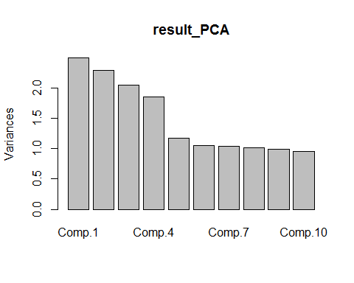

create train data & test data
comp_df_data <- df_data[complete.cases(df_data),]
df_train <- comp_df_data[sample(1:nrow(comp_df_data),nrow(comp_df_data) * .7),]
df_test <-comp_df_data[sample(1:nrow(comp_df_data),nrow(comp_df_data) * .3),]
train_Classes <- df_train['User_Class']
dt_test_class <- df_test['User_Class']

Classify Users To Four Diffrent Categories (Loyal , Active , Normal , Geust )
#----------------------------------------------------------
#Module 2) - Apply knn from Class package
#==========================================================
#load calss
library(class)
#Apply knn

Users Classes Click frequency Analysis
plot(User_Class,visit_Count,type="p", lwd=1.5,lty=2, col= c('red'), pch=4 )
