Assignment 3
Step 0: Formal Definition for the problem
Predict the wine quality where each wine type preference is modeled
In a continuous scale, from 0 (very bad) and 10 (excellent).
Step 1: Data Preparation
- Read Data from csv files
- number of observations
- number of features ( attributes)
- type of attributes
2) Exploratory Data Analysis (EDA)
- Descriptive Statistics
  - Unitarian Exploration
> summary(df_data)
fixed.acidity volatile.acidity citric.acid residual.sugar chlorides free.sulfur.dioxide
Min. : 4.60 Min. :0.1200 Min. :0.000 Min. : 0.900 Min. :0.01200 Min. : 1.00
1st Qu.: 7.10 1st Qu.:0.3900 1st Qu.:0.090 1st Qu.: 1.900 1st Qu.:0.07000 1st Qu.: 7.00
Median : 7.90 Median :0.5200 Median :0.260 Median : 2.200 Median :0.07900 Median :14.00
Mean : 8.32 Mean :0.5278 Mean :0.271 Mean : 2.539 Mean :0.08747 Mean :15.87
3rd Qu.: 9.20 3rd Qu.:0.6400 3rd Qu.:0.420 3rd Qu.: 2.600 3rd Qu.:0.09000 3rd Qu.:21.00
Max. :15.90 Max. :1.5800 Max. :1.000 Max. :15.500 Max. :0.61100 Max. :72.00
total.sulfur.dioxide density pH sulphates alcohol quality
Min. : 6.00 Min. :0.9901 Min. :2.740 Min. :0.3300 Min. : 8.40 Min. :3.000
1st Qu.: 22.00 1st Qu.:0.9956 1st Qu.:3.210 1st Qu.:0.5500 1st Qu.: 9.50 1st Qu.:5.000
Median : 38.00 Median :0.9968 Median :3.310 Median :0.6200 Median :10.20 Median :6.000
Mean : 46.47 Mean :0.9967 Mean :3.311 Mean :0.6581 Mean :10.42 Mean :5.636
3rd Qu.: 62.00 3rd Qu.:0.9978 3rd Qu.:3.400 3rd Qu.:0.7300 3rd Qu.:11.10 3rd Qu.:6.000
Max. :289.00 Max. :1.0037 Max. :4.010 Max. :2.0000 Max. :14.90 Max. :8.000
- We will need to do normalization because feature values are not measured with the same unit.

        - Multivariate Exploration
Plot scatter plot, correlation plot, and density plot
- from density plot for quality: we see that we do not have samples with quality 0,1,2,9,10, and most of data is with quality value = 5 (the sample not representative to all types).
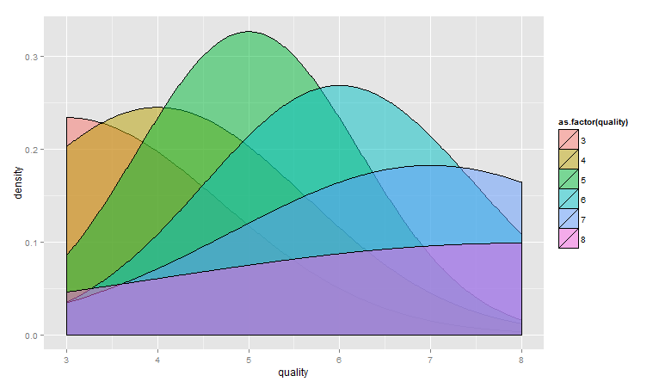
- What is the most influenced feature on the predicted value?
Try to plot data and correlation (try to find the most affected feature on the predicted Value)
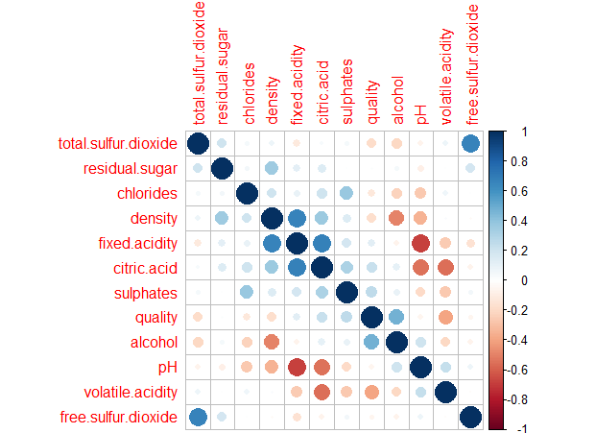
Note: - there is a very height correlation between Quality & alcohol, Quality & volatile. Acidity then those features are important in the wine quality.
- Create scatter plot between the most correlated features with the predicted feature. (It is not linearly separable) then it is not good idea to apply linear regression.
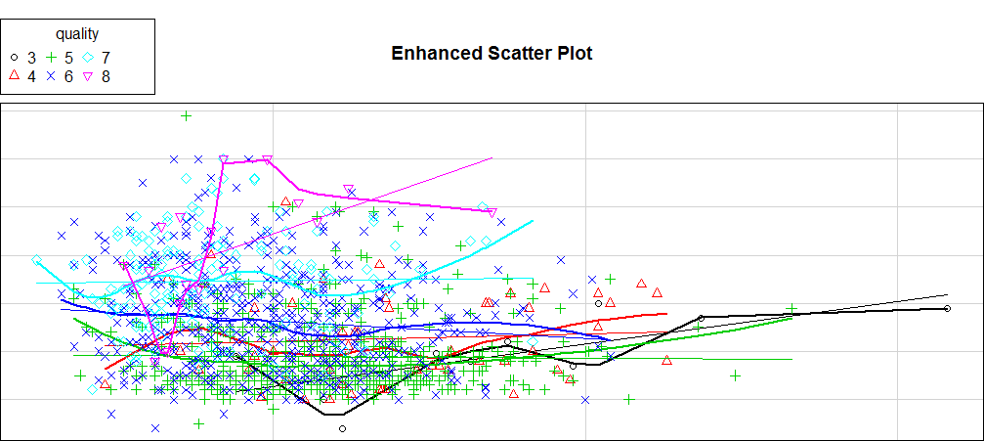
- Draw Scatter plot between quality and alcohol
So relation in positive correlation between quality and alcohol, most of quality sample data between 4 & 7

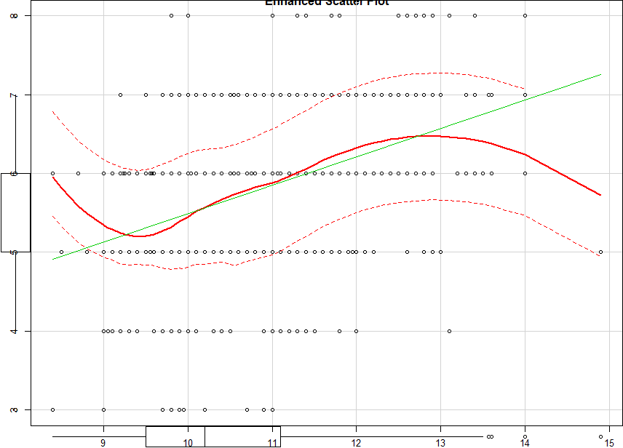

- Draw Scatter plot between quality and volatile.acidity
So relation is negative correlation between quality and volatile.acidity, most of quality sample data between 4 & 7
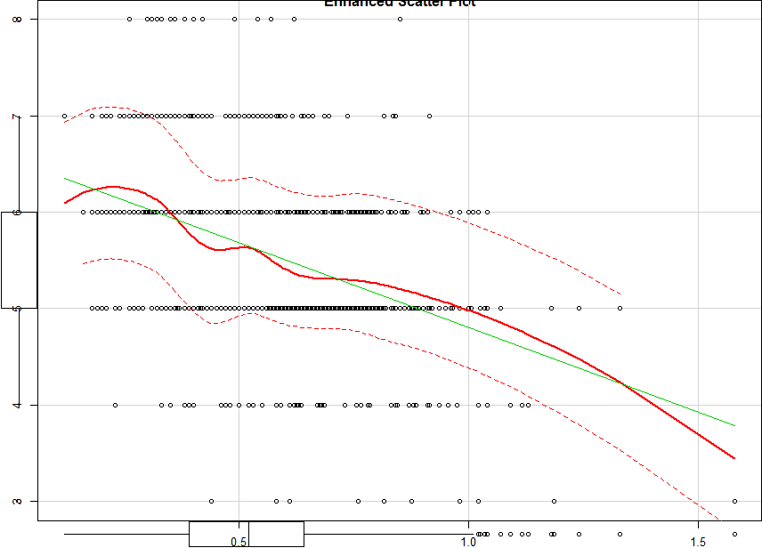

-----------------------------------------------------------------------------------------------
1) Map the quality feature values to (very bad, bad, good, very good, Excellent)
2) Normalize the Data in all features
-----------------------------------------------------------------------------------------------

- What is the best value for K in KNN Algorithm?
K = Sqrt(N) = where N: number if Classes & K should be odd to avoid tie when finding the class for the nearest K
I tried to verify this by creating function to get IBk algorithm Prediction Accuracy
For each K (1:80) and plot the vales.
Note: the Accuracy decreases by increasing the value of K.
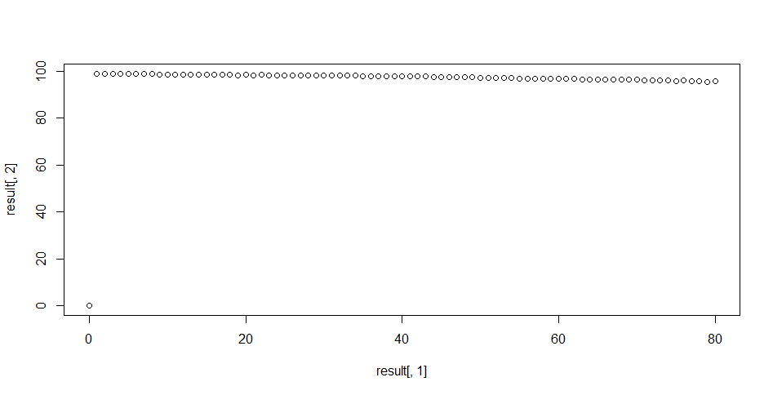
Try different Modules and compare the results.
- Dose normalizing data in each feature will affects the prediction?

Module 1) - apply normalization before apply Weka Classifier
$`Classifier best K Value `
IB1 instance-based classifier
using 3 nearest neighbour(s) for classification

$`Confusion Matrix`
Predicted_Classes
Actual_test_Classes 0 1 2 3 4 5 6 7 8 9
0 357 2 2 0 0 0 2 0 0 0
1 0 355 8 0 1 0 0 0 0 0
2 0 2 362 0 0 0 0 0 0 0
3 0 1 0 334 0 0 0 0 0 1
4 0 0 0 0 355 9 0 0 0 0
5 0 0 0 4 0 331 0 0 0 0
6 0 0 0 0 0 0 336 0 0 0
7 0 0 0 0 0 0 1 362 1 0
8 0 0 0 0 0 1 0 0 335 0
9 0 0 0 0 0 0 0 4 1 331

$`Correctly Classified %`
[1] 98.85649

$`Worng Classified %`
[1] 1.143511

Module 2) - Apply Weka classifier without any normalization
$`Classifier best K Value `
IB1 instance-based classifier
using 3 nearest neighbour(s) for classification

$`Confusion Matrix`
Predicted_Classes
Actual_test_Classes 0 1 2 3 4 5 6 7 8 9
0 357 2 2 0 0 0 2 0 0 0
1 0 355 8 0 1 0 0 0 0 0
2 0 2 362 0 0 0 0 0 0 0
3 0 1 0 334 0 0 0 0 0 1
4 0 0 0 0 355 9 0 0 0 0
5 0 0 0 4 0 331 0 0 0 0
6 0 0 0 0 0 0 336 0 0 0
7 0 0 0 0 0 0 1 362 1 0
8 0 0 0 0 0 1 0 0 335 0
9 0 0 0 0 0 0 0 4 1 331

$`Correctly Classified %`
[1] 98.85649

$`Worng Classified %`
[1] 1.143511

Module 3) - Apply Cross-validation on combined Dataset
=== 20 Fold Cross Validation ===

=== Summary ===

Correctly Classified Instances 10959 99.6998 %
Incorrectly Classified Instances 33 0.3002 %
Kappa statistic 0.9967
Mean absolute error 0.0008
Root mean squared error 0.0215
Relative absolute error 0.4193 %
Root relative squared error 7.1567 %
Coverage of cases (0.95 level) 99.8908 %
Mean rel. region size (0.95 level) 10.0546 %
Total Number of Instances 10992

=== Confusion Matrix ===

a b c d e f g h i j <-- classified as
1141 1 0 0 1 0 0 0 0 0 | a = 0
0 1134 8 0 1 0 0 0 0 0 | b = 1
0 1 1143 0 0 0 0 0 0 0 | c = 2
0 2 3 1049 0 0 0 0 0 1 | d = 3
0 0 0 0 1143 1 0 0 0 0 | e = 4
0 0 0 3 0 1052 0 0 0 0 | f = 5
0 0 0 0 0 1 1054 1 0 0 | g = 6
0 0 0 0 0 0 0 1142 0 0 | h = 7
0 0 0 0 0 1 0 2 1052 0 | i = 8
0 0 0 0 0 0 0 5 1 1049 | j = 9

Module 4) - Apply kNN from “Class” package
>conf_Matrix
ml
0 1 2 3 4 5 6 7 8 9
0 354 0 0 0 0 0 5 0 3 1
1 0 350 11 0 1 0 0 2 0 0
2 0 2 362 0 0 0 0 0 0 0
3 0 1 0 333 0 0 0 0 0 2
4 0 0 0 0 354 10 0 0 0 0
5 0 0 0 4 0 327 0 1 0 3
6 0 0 0 0 0 0 336 0 0 0
7 0 10 1 0 0 0 0 352 1 0
8 1 0 0 0 0 1 0 0 334 0
9 0 1 0 6 1 2 0 5 1 320
>Accuracy_Perc
[1] 97.82733
>Error_Perc
[1] 2.17267

Module 5) weighted KNN

(fit.train1 <- train.kknn(as.factor(df_train[,17]) ~ ., df_train, kmax = 15,
kernel = c("triangular", "rectangular", "epanechnikov", "optimal"), distance = 2))
table(predict(fit.train1, df_test), df_test[,17])
0 1 2 3 4 5 6 7 8 9
0 355 0 0 0 0 0 0 0 0 0
1 2 355 2 1 0 0 0 0 0 0
2 3 8 362 0 0 0 0 0 0 0
3 0 0 0 334 0 4 0 0 0 0
4 0 1 0 0 357 0 0 0 0 0
5 0 0 0 0 6 330 0 0 1 0
6 3 0 0 0 1 0 336 0 0 0
7 0 0 0 0 0 1 0 363 0 3
8 0 0 0 0 0 0 0 1 335 1
9 0 0 0 1 0 0 0 0 0 332

>Accuracy_Perc
[1] 98.88508
>Error_Perc
[1] 1.114923

Algorithm | K Value | Accuracy
IBk | 3 | 98.85
IBk Normalized | 3 | 98.58
Cross- Validation IBK | 3 | 99.69
kNN | 3 | 97.83
Weighted kNN | 3 | 98.88

Then the best classification algorithm for Cross-Validation IBK 99.69
Then Weighted KNN = 98.88

