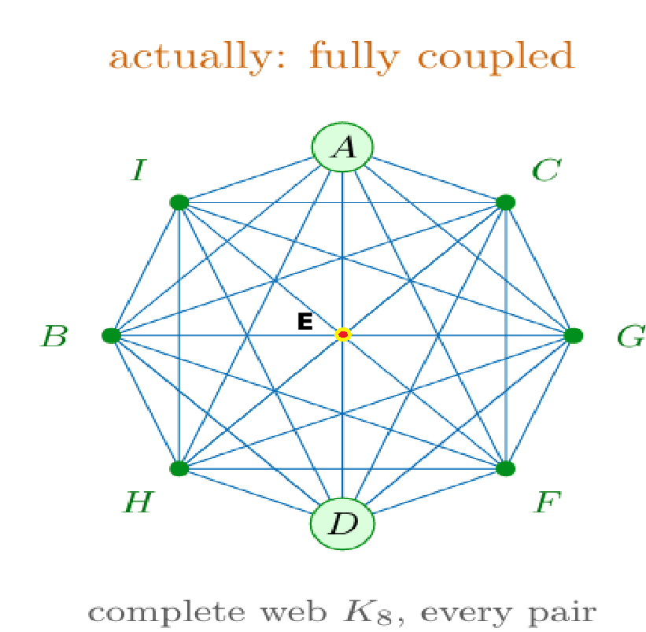
A+E+B = 3k
A+E+C=3k
A+E+D = 3k
A+E+F=3k
A+E+G=3k
A+E+H=3k
A+E+I = 3k
B+E+A=3k
B+E+C=3k
B+E+D=3k
B+E+F=3k
B+E+G=3k
B+E+H=3k
B+E+I=3k

C+E+A=3k
C+E+B=3k
C+E+D=3k
C+E+F=3k
C+E+G=3k
C+E+H=3k
C+E+I=3k

D+E+A=3k
D+E+B=3k
D+E+C=3k
D+E+F=3k
D+E+G=3k
D+E+H=3k
D+E+I=3k

F+E+A=3k
F+E+B=3k
F+E+C=3k
F+E+D=3k
F+E+G=3k
F+E+H=3k
F+E+I=3k

G+E+A=3k
G+E+B=3k
G+E+C=3k
G+E+D=3k
G+E+F=3k
G+E+H=3k
G+E+I=3k

H+E+A=3k
H+E+B=3k
H+E+C=3k
H+E+D=3k
H+E+F=3k
H+E+G=3k
H+E+I=3k

I+E+A=3k
I+E+B=3k
I+E+C=3k
I+E+D=3k
I+E+F=3k
I+E+G=3k
I+E+H=3k

A+D+G=3k
C+F+I=3k
A+B+C=3k
G+H+I=3k

$$B^{2}+F^{2}=2X$$
$$\frac{B^{2}+F^{2}}{2}=X$$
$$B^{2}-D^{2}=X-C^{2}$$
$$B^{2}-D^{2}+C^{2}=X$$
$$2(B^{2}-D^{2}+C^{2})=B^{2}+F^{2}$$
$$2\left(B^{2}-D^{2}+C^{2}\right)=2X$$
$$\left(B^{2}-{2D}^{2}+{2C}^{2}\right)=F^{2}$$
$$F^{2}=A^{2}+X-E^{2}$$
$$\left(B^{2}-{2D}^{2}+{2C}^{2}\right)=A^{2}+X-E^{2}$$

$$B^{2}-2\left(3E^{2}-A^{2}-X\right)+2\left(2E^{2}-X\right)=A^{2}+X-E^{2}$$
$$B^{2}+\left(-6E^{2}+2A^{2}+2X\right)+\left(4E^{2}-2X\right)=A^{2}+X-E^{2}$$
$$B^{2}+\left(-6E^{2}+2A^{2}+2X\right)+\left(4E^{2}-2X\right)=A^{2}+X-E^{2}$$

$$B^{2}+D^{2}=E^{2}-A^{2}+X+3E^{2}-A^{2}-X$$
$$B^{2}+D^{2}=4E^{2}-2A^{2}-→\left(BDP\right)$$
$$B^{2}-D^{2}=E^{2}-A^{2}+X-3E^{2}+A^{2}+X$$
$$B^{2}-D^{2}=E^{2}-A^{2}+X-3E^{2}+A^{2}+X$$
$$B^{2}-D^{2}=-2E^{2}+2X-→\left(BDM\right)$$
$$B^{2}+F^{2}=2X-→(BFP)$$
$$B^{2}-F^{2}=2E^{2}-2A^{2}-→(BFM)$$
$$B^{2}+I^{2}=E^{2}-A^{2}+X+2E^{2}-A^{2}$$
$$B^{2}+I^{2}=3E^{2}-{2A}^{2}+X-→\left(BIP\right)$$
$$B^{2}-I^{2}=E^{2}-A^{2}+X-2E^{2}+A^{2}$$
$$B^{2}-I^{2}=X-E^{2}-→(BIM)$$
$$B^{2}+H^{2}=E^{2}-A^{2}+X+3E^{2}-X-I^{2}$$
$$B^{2}+H^{2}=4E^{2}-A^{2}-I^{2}-→(BHP)$$
$$B^{2}-H^{2}=E^{2}-A^{2}+X-3E^{2}+X+I^{2}$$
$$B^{2}-H^{2}=2X-A^{2}-2E^{2}+I^{2}-→\left(BHM\right)$$
$$B^{2}+C^{2}=E^{2}-A^{2}+X+2E^{2}-X$$
$$B^{2}+C^{2}={3E}^{2}-A^{2}-→\left(BCP\right)$$
$$B^{2}-C^{2}=E^{2}-A^{2}+X-2E^{2}+X$$
$$B^{2}-C^{2}=2X-A^{2}-E^{2}-→(BCM)$$

BDM+BFM+BIM+BNM+BCM =
$$B^{2}-D^{2}+B^{2}-F^{2}+B^{2}-I^{2}+B^{2}-H^{2}+B^{2}-C^{2}=5B^{2}-\left(D^{2}+F^{2}+I^{2}+H^{2}+C^{2}\right)=$$
$$=-2E^{2}+2X+2E^{2}-2A^{2}+X-E^{2}+2X-A^{2}-2E^{2}+I^{2}+2X-A^{2}-E^{2}=$$
$$=-4E^{2}+7X-4A^{2}+I^{2}$$
$$5B^{2}-\left(D^{2}+F^{2}+I^{2}+H^{2}+C^{2}\right)=-4E^{2}+7X-4A^{2}+I^{2}$$
$$5B^{2}=\left(D^{2}+F^{2}+I^{2}+H^{2}+C^{2}\right)-4E^{2}+7X-4A^{2}+I^{2}$$
$$5B^{2}=\left(D^{2}+F^{2}+H^{2}+C^{2}\right)-4E^{2}+7X-4A^{2}+2I^{2}$$
$$B^{2}=\left(\frac{D^{2}}{5}+\frac{F^{2}}{5}+\frac{H^{2}}{5}+\frac{C^{2}}{5}\right)-{\frac{4}{5}E}^{2}+\frac{7}{5}X-\frac{4}{5}A^{2}+\frac{2}{5}I^{2}-→\left(BS1\right)$$
$$7X= 4E^{2}+4A^{2}+5B^{2}-\left(D^{2}+F^{2}+H^{2}+C^{2}\right)-2I^{2}$$
$$X=\frac{4}{7}E^{2}+\frac{4}{7}A^{2}+\frac{5}{7}B^{2}-\left(\frac{D^{2}}{7}+\frac{F^{2}}{7}+\frac{H^{2}}{7}+\frac{C^{2}}{7}\right)-\frac{2}{7}I^{2}-→(X1)$$
$$B^{2}=E^{2}-A^{2}+X-→from equation \left(6\right)$$
$$X=\left(\frac{D^{2}}{5}+\frac{F^{2}}{5}+\frac{H^{2}}{5}+\frac{C^{2}}{5}\right)-{\frac{4}{5}E}^{2}+\frac{7}{5}X-\frac{4}{5}A^{2}+\frac{2}{5}I^{2}-E^{2}+A^{2}$$
$$X=\left(\frac{D^{2}}{5}+\frac{F^{2}}{5}+\frac{H^{2}}{5}+\frac{C^{2}}{5}\right)-{\frac{9}{5}E}^{2}+\frac{7}{5}X+\frac{1}{5}A^{2}+\frac{2}{5}I^{2}-→\left(X2\right)$$
$$5B^{2}-5X=\left(D^{2}+F^{2}+I^{2}+H^{2}+C^{2}\right)-4E^{2}+2X-4A^{2}+I^{2}$$
$$5B^{2}-5X={5E}^{2}-{5A}^{2}-→from equation \left(6\right)$$
$${5E}^{2}-{5A}^{2}= \left(D^{2}+F^{2}+I^{2}+H^{2}+C^{2}\right)-4E^{2}+2X-4A^{2}+I^{2}$$
$${A^{2}= 5E}^{2}-\left(D^{2}+F^{2}+I^{2}+H^{2}+C^{2}\right)+4E^{2}-2X-I^{2}-→\left(A1\right)$$
Add A1 and BS1
$$A^{2}+B^{2}=-\left(\frac{4D^{2}}{5}+\frac{{4F}^{2}}{5}+\frac{4H^{2}}{5}+\frac{4C^{2}}{5}\right)+{\frac{41}{5}E}^{2}-\frac{3}{5}X-\frac{4}{5}A^{2}-\frac{8}{5}I^{2}-→\left(BAP\right)$$
From BS1 and X1
$$B^{2}+X=\left(\frac{{2D}^{2}}{35}+\frac{2F^{2}}{35}+\frac{{2H}^{2}}{35}+\frac{{2C}^{2}}{35}\right)-{\frac{8}{35}E}^{2}+\frac{7}{5}X-\frac{8}{35}A^{2}+\frac{4}{35}I^{2}+\frac{5}{7}B^{2}$$
$$B^{2}+X=\left(\frac{{2D}^{2}}{35}+\frac{2F^{2}}{35}+\frac{{2H}^{2}}{35}+\frac{{2C}^{2}}{35}\right)-{\frac{8}{35}E}^{2}+\frac{49}{35}X-\frac{8}{35}A^{2}+\frac{4}{35}I^{2}+\frac{25}{35}B^{2}-→(BXP)$$
$$\frac{2}{7}B^{2}-\frac{2}{5}X=\left(\frac{{2D}^{2}}{35}+\frac{2F^{2}}{35}+\frac{{2H}^{2}}{35}+\frac{{2C}^{2}}{35}\right)-{\frac{8}{35}E}^{2}-\frac{8}{35}A^{2}+\frac{4}{35}I^{2}$$
$$E^{2}-A^{2}=\left(\frac{{2D}^{2}}{35}+\frac{2F^{2}}{35}+\frac{{2H}^{2}}{35}+\frac{{2C}^{2}}{35}\right)-{\frac{8}{35}E}^{2}+\frac{7}{5}X-\frac{8}{35}A^{2}+\frac{4}{35}I^{2}+\frac{5}{7}B^{2}$$
$$A^{2}=-\left(\frac{{2D}^{2}}{35}+\frac{2F^{2}}{35}+\frac{{2H}^{2}}{35}+\frac{{2C}^{2}}{35}\right)+{\frac{8}{35}E}^{2}-\frac{7}{5}X+\frac{8}{35}A^{2}-\frac{4}{35}I^{2}-\frac{5}{7}B^{2}+E^{2}$$
$${\frac{27}{35}A}^{2}=-\left(\frac{{2D}^{2}}{35}+\frac{2F^{2}}{35}+\frac{{2H}^{2}}{35}+\frac{{2C}^{2}}{35}\right)+{\frac{43}{35}E}^{2}-\frac{7}{5}X-\frac{4}{35}I^{2}-\frac{5}{7}B^{2}$$
$$A^{2}=-\frac{35}{27}\left(\frac{{2D}^{2}}{35}+\frac{2F^{2}}{35}+\frac{{2H}^{2}}{35}+\frac{{2C}^{2}}{35}\right)+\frac{35}{27}{\frac{43}{35}E}^{2}-\frac{35}{27}\frac{7}{5}X-\frac{35}{27}\frac{4}{35}I^{2}-\frac{35}{27}\frac{5}{7}B^{2}$$
$$A^{2}=-\left(\frac{{2D}^{2}}{27}+\frac{2F^{2}}{27}+\frac{{2H}^{2}}{27}+\frac{{2C}^{2}}{27}\right)+{\frac{43}{27}E}^{2}-\frac{49}{27}X-\frac{4}{27}I^{2}-\frac{25}{27}B^{2}-→\left(A2\right)$$
$35 {(B}^{2}+X)+27 A^{2}=35 E^{2}-8A^{2}$
$$A^{2}+B^{2}=-\left(\frac{4D^{2}}{5}+\frac{{4F}^{2}}{5}+\frac{4H^{2}}{5}+\frac{4C^{2}}{5}\right)+{\frac{41}{5}E}^{2}-\frac{3}{5}X-\frac{4}{5}A^{2}-\frac{8}{5}I^{2}-→\left(BAP\right)$$
$$C^{2}=3E^{2}-A^{2}-B^{2}=3E^{2}+\left(\frac{4D^{2}}{5}+\frac{{4F}^{2}}{5}+\frac{4H^{2}}{5}+\frac{4C^{2}}{5}\right)-{\frac{41}{5}E}^{2}+\frac{3}{5}X+\frac{4}{5}A^{2}+\frac{8}{5}I^{2}$$
$$\frac{1}{5}C^{2}={\frac{-26}{5}E}^{2}+\frac{3}{5}X+\frac{4}{5}A^{2}+\frac{8}{5}I^{2}\frac{4D^{2}}{5}+\frac{{4F}^{2}}{5}+\frac{4H^{2}}{5}$$
$$C^{2}=-26E^{2}+3X+8I^{2}+4 \left({A^{2}+D}^{2}+F^{2}+H^{2}\right)-→\left(C1\right)$$
$$C^{2}=2E^{2}-X=-26E^{2}+3X+8I^{2}+4 \left({A^{2}+D}^{2}+F^{2}+H^{2}\right)-→\left(C1\right)$$
$$-28E^{2}+4X+8I^{2}+4 \left({A^{2}+D}^{2}+F^{2}+H^{2}\right)=0-→\left(III\right)$$
$$X=7E^{2}-2I^{2}- \left({A^{2}+D}^{2}+F^{2}+H^{2}\right)-→\left(II\right)$$
$$X=\frac{4}{7}E^{2}+\frac{4}{7}A^{2}+\frac{5}{7}B^{2}-\left(\frac{D^{2}}{7}+\frac{F^{2}}{7}+\frac{H^{2}}{7}+\frac{C^{2}}{7}\right)-\frac{2}{7}I^{2}-→(X1)$$
$$X=\left(\frac{D^{2}}{5}+\frac{F^{2}}{5}+\frac{H^{2}}{5}+\frac{C^{2}}{5}\right)-{\frac{9}{5}E}^{2}+\frac{7}{5}X+\frac{1}{5}A^{2}+\frac{2}{5}I^{2}-→\left(X2\right)$$
$$7X=4\left(E^{2}+A^{2}\right)+5B^{2}-2I^{2}-\left(D^{2}+F^{2}+H^{2}+C^{2}\right)-→\left(IIV\right)$$
$$X=11E^{2}-X-D^{2}-2H^{2}-2I^{2}- \left(A^{2}+B^{2}+F^{2}+C^{2}\right)-→\left(II1\right)$$
$$X=9E^{2}-2H^{2}-2I^{2}- \left({A^{2}+D}^{2}+F^{2}+B^{2}\right)-→\left(II2\right)$$
$$X=7E^{2}-2I^{2}- \left({A^{2}+D}^{2}+F^{2}+H^{2}\right)-→\left(II3\right)$$
$$X=5E^{2}- \left({I^{2}+D}^{2}+F^{2}+H^{2}\right)-→\left(II4\right)$$
$$X=3E^{2}- \left(I^{2}+H^{2}\right)-→\left(II5***\right)$$
$$X=E^{2}+B^{2}+H^{2}- \left(I^{2}+H^{2}\right)-→\left(II6\right)$$
$$X=E^{2}+B^{2}-I^{2}-→\left(II7\right)$$
$$F^{2}=E^{2}+X-I^{2}-→\left(II8\right)$$
$$X=A^{2}+D^{2}+X- \left(I^{2}+H^{2}\right)-→\left(II\right)$$
$$A^{2}+D^{2}= \left(I^{2}+H^{2}\right)-→\left(II9\right)$$
$$X=A^{2}+B^{2}+C^{2}- \left(I^{2}+H^{2}\right)-→\left(II10\right)$$
We have
$$A^{2}+B^{2}=F^{2}+I^{2}$$
$$X=F^{2}+C^{2}- \left(H^{2}\right)-→\left(II11\right)$$
$$5X=-9E^{2}+A^{2}+7X+2I^{2}+\left(D^{2}+F^{2}+H^{2}+C^{2}\right)-→(VIII)$$
$$7X=4\left(E^{2}+A^{2}\right)+5B^{2}-2I^{2}-\left(D^{2}+F^{2}+H^{2}+C^{2}\right)-→\left(IIV\right)$$
$$-2X=-9E^{2}+A^{2}+2I^{2}+\left(D^{2}+F^{2}+H^{2}+C^{2}\right)$$
$$5X=-5E^{2}+5A^{2}+5B^{2}$$
BDP+BFP+BIP+BNP+BCP =
$B^{2}+D^{2}+B^{2}+F^{2}{+B}^{2}+I^{2}+B^{2}+H^{2}+B^{2}+C^{2}=5B^{2}+\left(D^{2}+F^{2}+I^{2}+H^{2}+C^{2}\right)=$
$$4E^{2}-2A^{2}+2X+3E^{2}-{2A}^{2}+X+4E^{2}-A^{2}-I^{2}{+3E}^{2}-A^{2}$$
$$5B^{2}+\left(D^{2}+F^{2}+I^{2}+H^{2}+C^{2}\right)=14E^{2}-6A^{2}+3X-I^{2}$$
$$5B^{2}=-\left(D^{2}+F^{2}+I^{2}+H^{2}+C^{2}\right)+14E^{2}-6A^{2}+3X-I^{2}$$
$$5B^{2}=14E^{2}-6A^{2}+3X-D^{2}-F^{2}-{2I}^{2}-H^{2}-C^{2}$$
$$B^{2}=\frac{14}{5}E^{2}-\frac{6}{5}A^{2}+\frac{3}{5}X-\left(\frac{D^{2}}{5}+\frac{F^{2}}{5}+\frac{H^{2}}{5}+\frac{C^{2}}{5}\right)-{\frac{2}{5}I}^{2}-→(3)$$
$$3X=5B^{2}+6A^{2}-14E^{2}+D^{2}+F^{2}+{2I}^{2}+H^{2}+C^{2}$$
$$X={\frac{5}{3}B}^{2}+\frac{6}{3}A^{2}-\frac{14}{3}E^{2}+\frac{D^{2}}{3}+\frac{F^{2}}{3}+{\frac{2}{3}I}^{2}+\frac{H^{2}}{3}+\frac{C^{2}}{3}-→(4)$$

$$X=11E^{2}-X-D^{2}-2H^{2}-2I^{2}- \left(A^{2}+B^{2}+F^{2}+C^{2}\right)-→\left(II1\right)$$
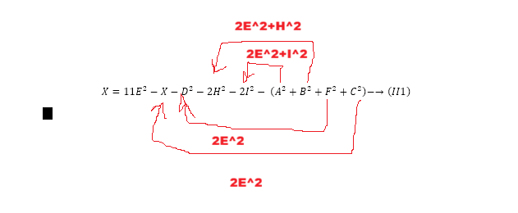
$$2X=11E^{2}-D^{2}-2H^{2}-2I^{2}- \left(A^{2}+B^{2}+F^{2}+C^{2}\right)-→\left(II1\right)$$
$$X={\frac{11}{2}E}^{2}-\frac{D^{2}}{2}-H^{2}-I^{2}- \left(\frac{A^{2}}{2}+\frac{B^{2}}{2}+\frac{F^{2}}{2}+\frac{C^{2}}{2}\right)-→\left(II1\right)$$
$$3E^{2}-{\frac{11}{2}E}^{2}=-\frac{D^{2}}{2}- \left(\frac{A^{2}}{2}+\frac{B^{2}}{2}+\frac{F^{2}}{2}+\frac{C^{2}}{2}\right)-→\left(II1\right)$$
$$-{\frac{5}{2}E}^{2}=- \left(\frac{A^{2}}{2}+\frac{B^{2}}{2}+\frac{F^{2}}{2}+\frac{C^{2}}{2}+\frac{D^{2}}{2}\right)-→\left(II1\right)$$
$${5E}^{2}= \left(A^{2}+B^{2}+C^{2}+D^{2}+F^{2}\right)-→\left(II1\right)$$

