|  |  |  |  |  |
| --- | --- | --- | --- | --- |
| X |  |  |  |  |
| 0 | 1 | 1 | 1 | -∞ |
| 1 |  |  |  |  |
| 2 |  |  |  |  |
| 3 |  |  |  |  |
| 4 |  |  |  |  |
| 5 |  |  |  |  |
| 6 |  |  |  |  |
| … | … | … | … | … |
| … |  |  |  |  |

**The Complex plane frame of reference is an Even function.**

**Shaimaa Soltan**

AT X = -X

|  |  |  |  |  |
| --- | --- | --- | --- | --- |
| -X |  |  |  |  |
| -1 |  |  |  |  |
| -2 |  |  |  |  |
| -3 |  |  |  |  |
| -4 |  |  |  |  |
| -5 |  |  |  |  |
| -6 |  |  |  |  |
| -7 |  |  |  |  |
| … | … | … | … | … |
| … |  |  |  |  |

Therefore.

Taking the exponent with base = [e]

|  |  |  |
| --- | --- | --- |
| X |  |  |
| …. | … | …. |
| -4 |  |  |
| -3 |  |  |
| -2 |  |  |
| -1 |  |  |
| 0 | 0 | 0 |
| 1 |  |  |
| 2 |  |  |
| 3 |  |  |
| 4 |  |  |
| 5 |  |  |
| 6 |  |  |
| … | … | … |
| … |  |  |

Therefore

And if

This is function is an even function and all its Zeros are Even numbers for any natural number X.

And it is 2 * complex plane frame of reference.

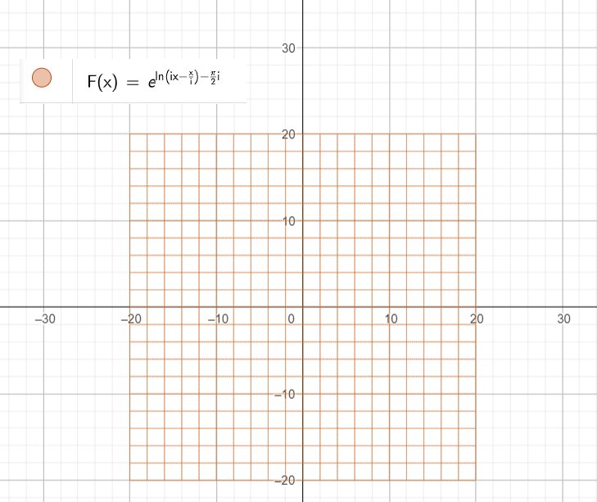

Even Function all its Zero are even numbers only.

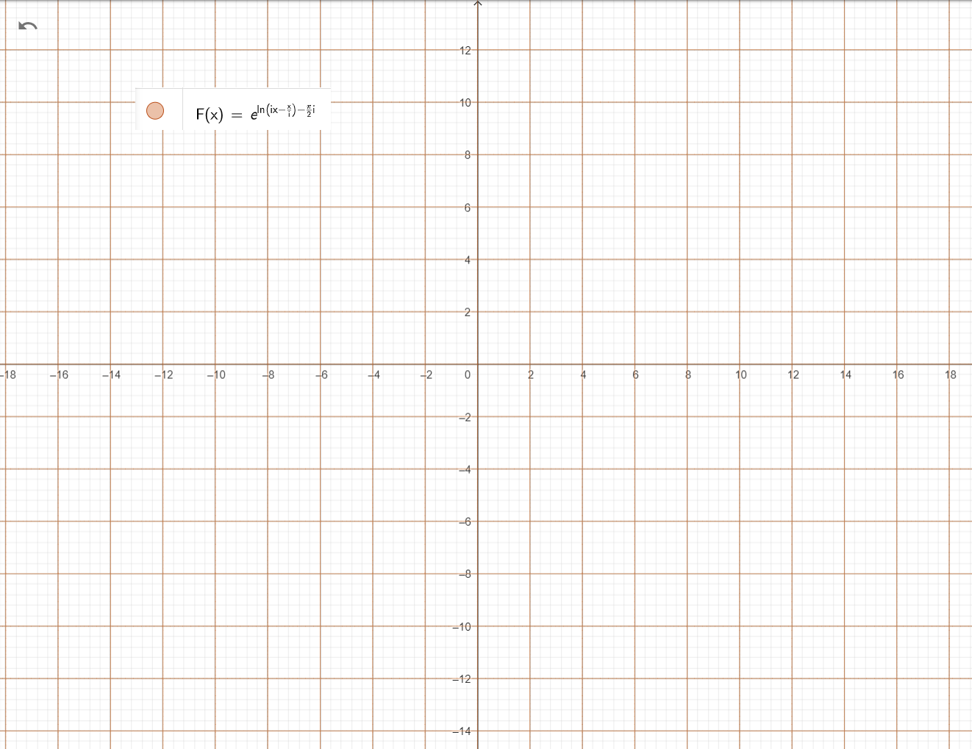

In F(X) let X =X/2 we get the exact complex plane frame of reference, and we get Odd Zeros from an Even function

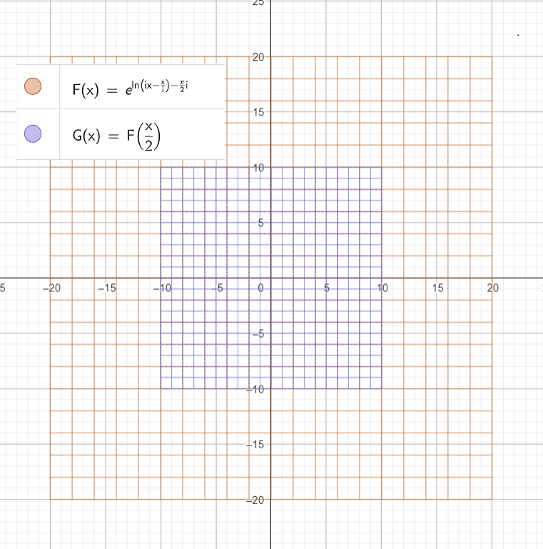

Replace X by X/2 we get the original complex plane frame of reference (i * X) and even and odd Zeros.

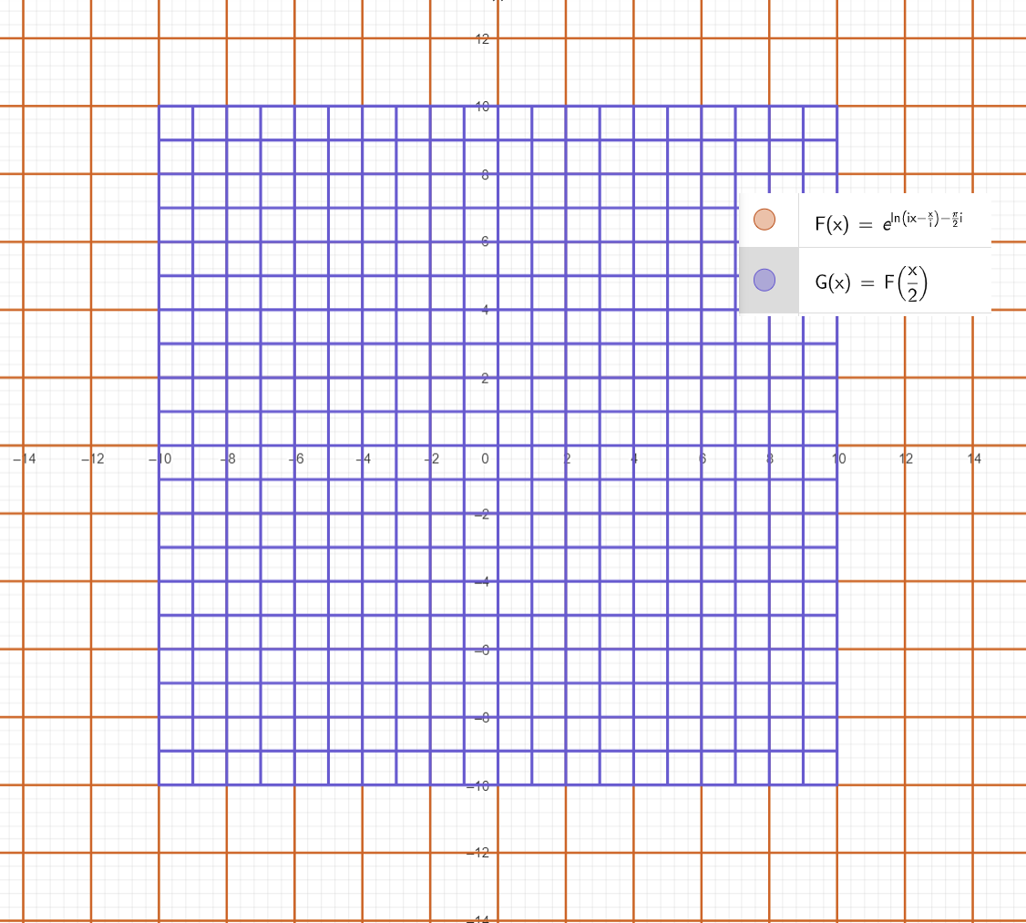

And this what the analytical continuity did by multiplying by ½ ; that converted the complex plane even function into and odd function (i * X) and showed all odd numbers zeros as well!

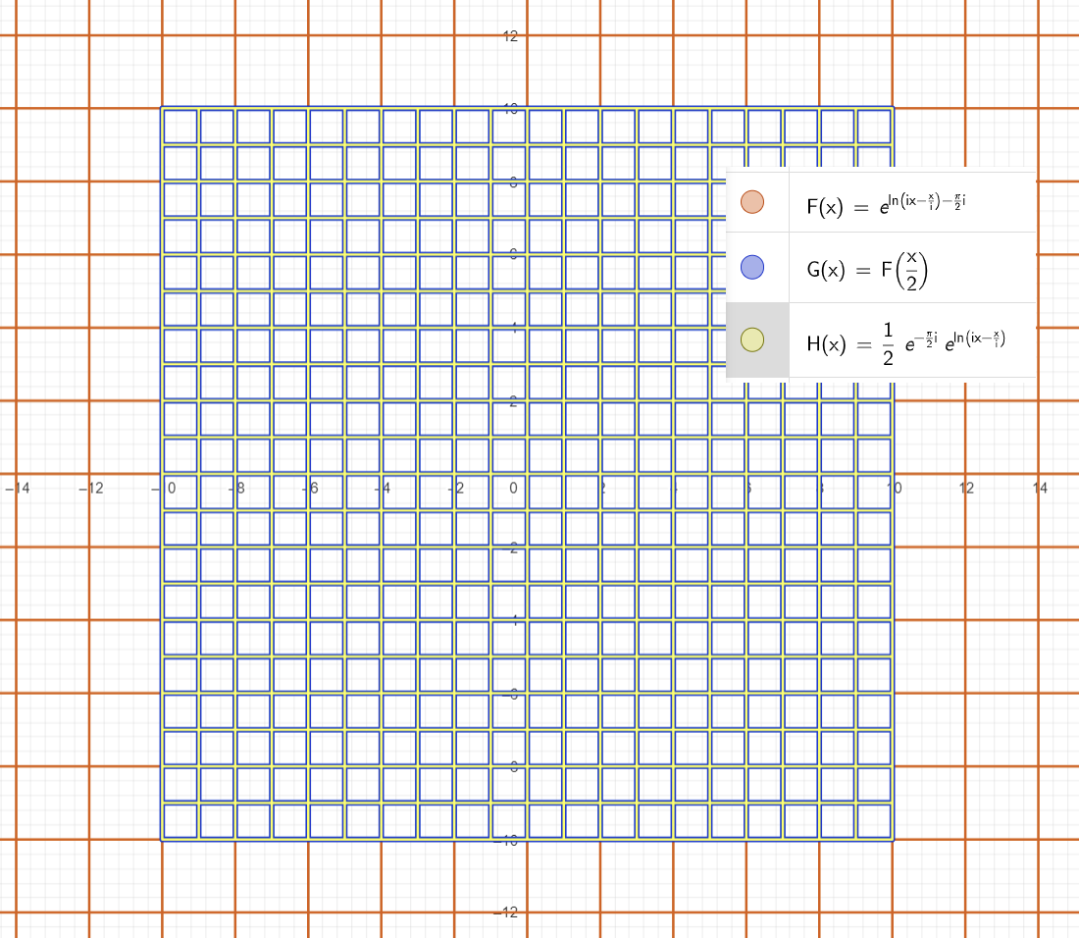

As these even function F(X) is the frame of reference for the complex plane which = (i * X)

Then in Euler’s Identity we can write it with F(X) instead of use (i * X)

Therefore!

Taking exponent with base [e] for both sides

Therefore, we can re write Euler’s Identity as

In this Equation G

Let X = 2 * X we did not change any thing in the numbers nature the even number will remain even, and the odd numbers will remain odd.

If we consider eft hand side one function of X called E(X) and the right-hand side another function called G(X)

Then we can say that the relation between these two functions is

And this is the calculation for some values of the functional relation between these equation and Euler’s Identity

Therefore, this new functional representation for Euler’s Identity will reach Exact natural number at each value of

Therefore, this form of Euler’s Identity works on Cycle.

=

Therefore, this form of Euler’s Identity works on Cycle.

=

Therefore, this form of Euler’s Identity works on Cycle.

=

And this observation says that with our even functional new representation for Euler’s function, we will reach Zeros only when X is complex number Cycle of PI

And these two forms sync together AT.

Going back to Euler’s Equation if we replace X with our functional form.

At X =

At each X = multiplier of 60 degrees Cos term will Equal ±0.5

For any positive natural number N that is multiplier of 3 the Cos term will equal -1 and Sin imaginary Term = 0

For each even value Cos term = 1 and imaginary term = 0 (sin = 0)

For each odd number Cos term = -1 and Sin term = 0 (Sin= 0)

Odd numbers Cos term (real part of the complex number) will = 0.5 and if we divide each S by 3

Only if S is multiplier of 3 we get value = -1 (i.e. not primes) = -1 otherwise = 0.5

For each odd number S it reach pi at π/3 only when S = S/2 to get the for pi/6.

Even numbers Cos term (real part of the complex number) will = 0.5 and if we divide each S by 3

Only if S is multiplier of 3 we get value = -1 (i.e. not primes) = -1 otherwise = 0.5

And because it is even number S then our pi value will be

For Cases of S = S/2; complex number imaginary part will be = 0.5 and real part of complex number = cos(60)

For case S = 5/2 = 2.5

In case S = 19/2

In Case S is multiplier of 3; Like S = {3,6,9,12,15, ….}

Imaginary part of the complex number = i and Real part number of the complex number = 0.

One degree can be represented by this formula.

And these cases if we move by cycle of pi



