Critical Line and Zeta Function

If

$$t\left(X\right)= X^{2}-\frac{1}{2}$$

$$w\left(X\right) is the differnce between t\left(X-1\right) and t\left(X\right)$$

$$w\left(X\right)=t\left(X-1\right)-t\left(X\right)$$

THEN

$$w\left(X\right)={\left(X-1\right)}^{2}-\frac{1}{2}-\left(X^{2}-\frac{1}{2}\right)=-2X+1$$

THEN

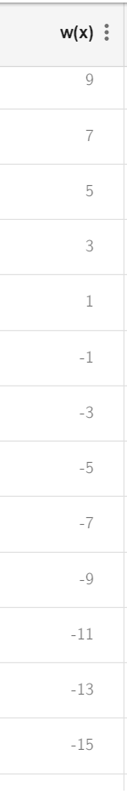W(X) for any X will be odd number set including all prime numbers.

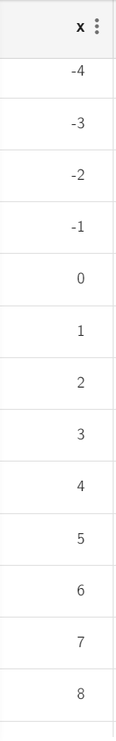

WHEN

$$w\left(X\right)=t\left(X-2\right)-t\left(X+1\right)$$

*THEN $$w\left(X\right)=t\left(X-2\right)-t\left(X+1\right)={\left(X-2\right)}^{2}-\frac{1}{2}-\left({(X+1)}^{2}-\frac{1}{2}\right)=-6X+3$$*

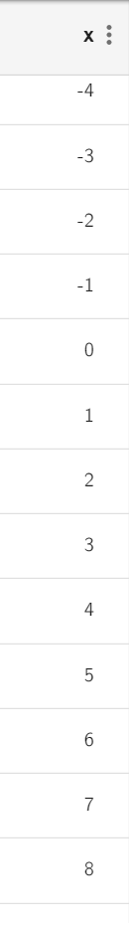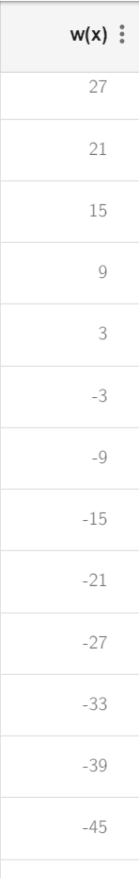

WHEN

$$w\left(X\right)=t\left(X-3\right)-t\left(X+2\right)$$

THEN

$$w\left(X\right)=t\left(X-3\right)-t\left(X+2\right)={\left(X-3\right)}^{2}-\frac{1}{2}-\left({(X+2)}^{2}-\frac{1}{2}\right)=-10X+5$$

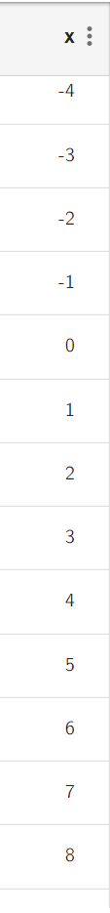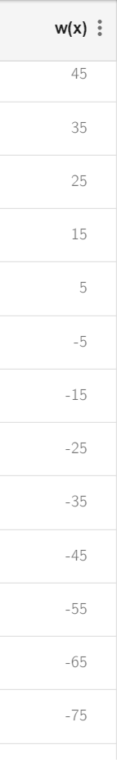

IF

$$t\left(X\right)= X^{2}-\frac{1}{2}$$

AND

$$w\left(X\right)=t\left(X-1\right)-t\left(X\right)=\left(-2*X+1\right)$$

AND IN general K(X) is a difference between any consequence terms.

$$K\left(X\right)=t\left(X-a\right)-t\left(X+\left(a-1\right)\right)=(2a-1)*(2*X+1)$$

$$P\left(X\right)=\frac{K(X)}{W(X)}= \frac{t\left(X-a\right)-t\left(X+\left(a-1\right)\right)}{t\left(X-1\right)-t\left(X\right)}$$

$$P\left(X\right)= \frac{K(X)}{W(X)}= \frac{(2a-1)*(2*X+1)}{(-2*X+1)}=(2a-1)$$

$$P\left(X\right)= \frac{t\left(X-a\right)-t\left(X+\left(a-1\right)\right)}{-2*X+1}=(2a-1)$$

$$FOR ANY Value \left[a\right] NATURAL NUMBER P\left(X\right) IS AN ODD NUMBER (PRIME NUMBER)$$

$$THEN P\left(X\right)=0 Only AT a= \frac{1}{2} FOR ANY NATURAL NUMBER X$$

Example: -1

If a=2; a-1 = 1; $t\left(X\right)= X^{2}-\frac{1}{2}$

$$P\left(X\right)= \frac{t\left(X-2\right)-t\left(X+1\right)}{-2*X+1}=\frac{K(X)}{-2*X+1}=3$$

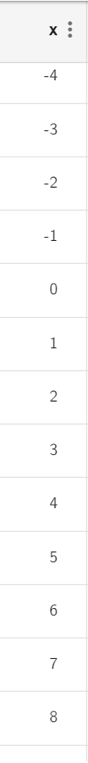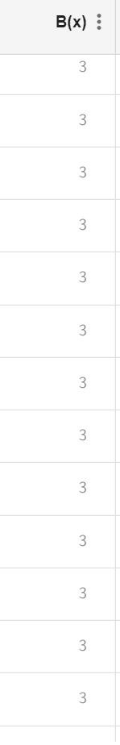

Example: - 2

If a=3; a-1 = 2;

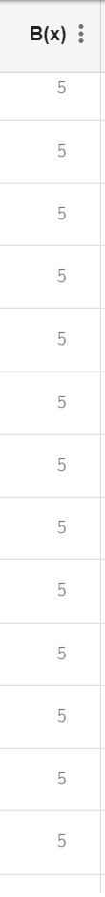

Example: - 3

If a=4; a-1 = 3; $t\left(X\right)= X^{2}-\frac{1}{2}$

$$P\left(X\right)= \frac{t\left(X-4\right)-t\left(X+3\right)}{-2*X+1}=7$$

