**A SUMMER TRAINING REPORT**

**On**

**BANK MANAGEMENT SYSTEM**

**COURSE:**

**APPLICATION DEVELOPMENT USING PYTHON**

**Under the Guidance of**

**Mr. Ravi Verma**

**Done By**

**SHAINA RAJPUT**

**BTECH (IT)**

**ROLL NO. 1803860**

**At**



Computer Hardware Company

**SUBMITTED TO**

**[](https://www.google.com/url?sa=i&rct=j&q=&esrc=s&source=images&cd=&ved=2ahUKEwi14p660uXiAhVKT30KHbPZAxQQjRx6BAgBEAU&url=http://www.davietjal.org/logo-b/&psig=AOvVaw2L13tXNHlYNDilgNl70Nki&ust=1560487319602655)**

**Department of Computer Science**

**D.A.V. INTITUTE**

**OF**

**ENGINEERING & TECHNOLOGY**

**KABIR NAGAR, JALANDHAR**

**TABLE OF CONTENTS**

**1. Introduction**

* GUI Based application development

**2. Technologies Learned**

* **Overview**
* Python
* History and features of python
* GUI (Tkinter module)
* XAMPP
* MySql
* **Demonstration of Project**
* Introduction
* Synopsis
* Aim of the project
* Modules used
* Screenshots
* **Conclusion**

**INTRODUCTION**

The bank management system is an application for maintaining a person's account in a bank. In this project I tried to show the working of banking account system and cover the basic functionality of a bank management system. To develop a project for solving financial applications of a customer in banking environment in order to nurture the needs of an end banking user by providing various ways to perform banking tasks.

The main aim of this project is to develop software for Bank Account Management System. This project has been developed to carry out the processes easily and quickly, which is not possible with the manuals systems, which are overcome by this software. This project is developed using PYTHON language and MYSQL use for database connection. Creating and managing requirements is a challenge of IT, systems and product development projects or indeed for any activity where you have to manage a contractual relationship.

The project analyzes the system requirements and then comes up with the requirements specifications. It studies other related systems and then come up with system specifications. The system is then designed in accordance with specifications to satisfy the requirements. The system design is then implemented with MYSQL and PYTHON . The system is designed as an interactive and content management system. The content management system deals with data entry, validation confirm and updating whiles the interactive system deals with system interaction with the administration and users. Thus, above features of this project will save transaction time and therefore increase the efficiency of the system.

**PYTHON**

**Python Language Introduction**

[Python](https://www.geeksforgeeks.org/python-programming-language/) is a widely used general-purpose, high level programming language. It was initially designed by Guido van Rossum in 1991 and developed by Python Software Foundation. It was mainly developed for emphasis on code readability, and its syntax allows programmers to express concepts in fewer lines of code.

Python is a programming language that lets you work quickly and integrate systems more efficiently.

Python is a high-level, interpreted, interactive and object-oriented scripting language. Python is designed to be highly readable. It uses English keywords frequently where as other languages use punctuation, and it has fewer syntactical constructions than other languages.

* **Python is Interpreted** − Python is processed at runtime by the interpreter. You do not need to compile your program before executing it. This is similar to PERL and PHP.
* **Python is Interactive** − you can actually sit at a Python prompt and interact with the interpreter directly to write your programs.
* **Python is Object-Oriented** − Python supports Object-Oriented style or technique of programming that encapsulates code within objects.
* **Python is a Beginner's Language** − Python is a great language for the beginner-level programmers and supports the development of a wide range of applications from simple text processing to WWW browsers to games.

**History of Python**

Python was developed by Guido van Rossum in the late eighties and early nineties at the National Research Institute for Mathematics and Computer Science in the Netherlands.

Python is derived from many other languages, including ABC, Modula-3, C, C++, Algol-68, SmallTalk, and UNIX shell and other scripting languages.

Python is copyrighted. Like Perl, Python source code is now available under the GNU General Public License (GPL).

Python is now maintained by a core development team at the institute, although Guido van Rossum still holds a vital role in directing its progress.

**Python Features**

Python's features include −

* **Easy-to-learn** − Python has few keywords, simple structure, and a clearly defined syntax. This allows the student to pick up the language quickly.
* **Easy-to-read** − Python code is more clearly defined and visible to the eyes.
* **Easy-to-maintain** − Python's source code is fairly easy-to-maintain.
* **A broad standard library** − Python's bulk of the library is very portable and cross-platform compatible on UNIX, Windows, and Macintosh.
* **Interactive Mode** − Python has support for an interactive mode which allows interactive testing and debugging of snippets of code.
* **Portable** − Python can run on a wide variety of hardware platforms and has the same interface on all platforms.
* **Extendable** − you can add low-level modules to the Python interpreter. These modules enable programmers to add to or customize their tools to be more efficient.
* **Databases** − Python provides interfaces to all major commercial databases.
* **GUI Programming** − Python supports GUI applications that can be created and ported to many system calls, libraries and windows systems, such as Windows MFC, Macintosh, and the X Window system of Unix.
* **Scalable** − Python provides a better structure and support for large programs than shell scripting.

Apart from the above-mentioned features, Python has a big list of good features, few are listed below −

* It supports functional and structured programming methods as well as OOP.
* It can be used as a scripting language or can be compiled to byte-code for building large applications.
* It provides very high-level dynamic data types and supports dynamic type checking.
* IT supports automatic garbage collection.
* It can be easily integrated with C, C++, COM, ActiveX, CORBA, and Java.

**Python graphical user interfaces (GUIs)**

* **Tkinter** − Tkinter is the Python interface to the Tk GUI toolkit shipped with Python. We would look this option in this chapter.
* **WxPython** − this is an open-source Python interface for wxWindows [http://wxpython.org](http://wxpython.org/).
* **JPython** − JPython is a Python port for Java which gives Python scripts seamless access to Java class libraries on the local machine [http://www.jython.org](http://www.jython.org/)

**PYTHON TKINTER GUI**

Tkinter is the standard GUI library for Python. Python when combined with Tkinter provides a fast and easy way to create GUI applications. Tkinter provides a powerful object-oriented interface to the Tk GUI toolkit.

Creating a GUI application using Tkinter is an easy task. All you need to do is perform the following steps −

* Import the *Tkinter* module.
* Create the GUI application main window.
* Add one or more of the above-mentioned widgets to the GUI application.
* Enter the main event loop to take action against each event triggered by the user.

Example

#! /usr/bin/python

import tkinter

top = tkinter.Tk()

# Code to add widgets will go here...

top.mainloop()

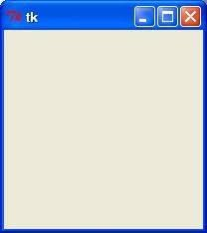

**Tkinter Widgets**

Tkinter provides various controls, such as buttons, labels and text boxes used in a GUI application. These controls are commonly called widgets.

There are currently 15 types of widgets in Tkinter. Some of them are Button, Canvas, CheckButton, Entry, Frame, Label, Listbox , Menu , MenuButton,Message etc.

**Geometry Management**

All Tkinter widgets have access to specific geometry management methods, which have the purpose of organizing widgets throughout the parent widget area. Tkinter exposes the following geometry manager classes: pack, grid, and place.

* [The *pack()* Method](https://www.tutorialspoint.com/python/tk_pack.htm) − This geometry manager organizes widgets in blocks before placing them in the parent widget.
* [The *grid()* Method](https://www.tutorialspoint.com/python/tk_grid.htm) − This geometry manager organizes widgets in a table-like structure in the parent widget.
* [The *place()* Method](https://www.tutorialspoint.com/python/tk_place.htm) − This geometry manager organizes widgets by placing them in a specific position in the parent widget.

**XAMPP**

XAMPP is an open-source software developed by Apache Friends. XAMPP software package contains Apache distributions for Apache server, MariaDB, PHP, and Perl. And it is basically localhost or a local server. This local server works on your own desktop or laptop computer. The use of XAMPP is to test the clients or your website before uploading it to the remote web server. This XAMPP server software gives you the suitable environment for testing MYSQL, PHP, Apache, and Perl projects on the local computer.

The full form of XAMPP is X stands for Cross-platform, (A) Apache server, (M) MariaDB, (P) PHP and (P) Perl. The Cross-platform usually means that it can run on any computer with any operating system. Next MariaDB is the most famous database server and it is developed by the MYSQL team. PHP usually provides a space for web development. PHP is a server-side scripting language. And the last Perl is a programming language and is used to develop a web application.

The XAMPP installation process is very simple and fast. Once XAMPP is installed on your local computer it acts as a local server or localhost. You can test the websites before uploading them to the remote web server. This XAMPP server software gives you a suitable environment for testing MYSQL, PHP, Apache, and Perl applications on a local computer.

**MYSQL**

MYSQL is open-source software. It is actually a relational database management system (RDBMS). This SQL stands for Structured Query Language. It is the most popular and best RDBMS used for developing a variety of web-based software applications. With the help of MYSQL, it is possible to organize the information, manage, retrieve, and update the data whenever you wish to do it.

**React:**

ReactJS tutorial provides basic and advanced concepts of ReactJS. Currently, ReactJS is one of the most popular JavaScript front-end libraries which has a strong foundation and a large community.

ReactJS is a declarative, efficient, and flexible JavaScript library for building reusable UI components. It is an open-source, component-based front end library which is responsible only for the view layer of the application. It was initially developed and maintained by Facebook and later used in its products like WhatsApp & Instagram.

Our ReactJS tutorial includes all the topics which help to learn ReactJS. These are ReactJS Introduction, ReactJS Features, ReactJS Installation, Pros and Cons of ReactJS, ReactJS JSX, ReactJS Components, ReactJS State, ReactJS Props, ReactJS Forms, ReactJS Events, ReactJS Animation and many more.

## 12.1 Why we use ReactJS?

The main objective of ReactJS is to develop User Interfaces (UI) that improves the speed of the apps. It uses virtual DOM (JavaScript object), which improves the performance of the app. The JavaScript virtual DOM is faster than the regular DOM. We can use ReactJS on the client and server-side as well as with other frameworks. It uses component and data patterns that improve readability and helps to maintain larger apps.

**12.2 Introduction**

A ReactJS application is made up of multiple components, each component responsible for outputting a small, reusable piece of HTML code. The components are the heart of all React applications. These Components can be nested with other components to allow complex applications to be built of simple building blocks. ReactJS uses virtual DOM based mechanism to fill data in HTML DOM. The virtual DOM works fast as it only changes individual DOM elements instead of reloading complete DOM every time.

To create React app, we write React components that correspond to various elements. We organize these components inside higher level components which define the application structure. For example, we take a form that consists of many elements like input fields, labels, or buttons. We can write each element of the form as React components, and then we combine it into a higher-level component, i.e., the form component itself. The form components would specify the structure of the form along with elements inside of it.

## 12.3Why learn ReactJS?

Today, many JavaScript frameworks are available in the market (like angular, node), but still, react came into the market and gained popularity amongst them. The previous frameworks follow the traditional data flow structure, which uses the DOM (Document Object Model). DOM is an object which is created by the browser each time a web page is loaded. It dynamically adds or removes the data at the back end and when any modifications were done, then each time a new DOM is created for the same page. This repeated creation of DOM makes unnecessary memory wastage and reduces the performance of the application.

Therefore, a new technology ReactJS framework invented which remove this drawback. ReactJS allows you to divide your entire application into various components. ReactJS still used the same traditional data flow, but it is not directly operating on the browser's Document Object Model (DOM) immediately; instead, it operates on a virtual DOM. It means rather than manipulating the document in a browser after changes to our data, it resolves changes on a DOM built and run entirely in memory. After the virtual DOM has been updated, react determines what changes made to the actual browser's DOM. The React Virtual DOM exists entirely in memory and is a representation of the web browser's DOM. Due to this, when we write a React component, we did not write directly to the DOM; instead, we are writing virtual components that react will turn into the DOM.

**Demonstration of the Project**

**Introduction**

The system provides the access to the customer to create an account, deposit/withdraw the cash from his account, also to view reports of all accounts and perform the transactions on account as per their requirements.

The primary aim of this “**Bank Management System**” is to provide an improved design methodology, which envisages the future expansion, and modification, which is necessary for a core sector like banking. This necessitates the design to be expandable and modifiable and so a modular approach is used in developing the application software.

Bank is the place where customers feel the sense of safety for their property. In the bank, customers deposit and withdraw their money. Transaction of money also is a part where customer takes shelter of the bank. Now to keep the belief and trust of customers, there is the positive need for management of the bank, which can handle all this with comfort and ease. Smooth and efficient management affects the satisfaction of the customers and staff members, indirectly. And of course, it encourages management committee in taking some needed decision for future enhancement of the bank.

Now a day’s, managing a bank is tedious job up to certain limit. So software that reduces the

work is essential. Also today’s world is a genuine computer world and is getting faster and

faster day-by-day. Thus, considering above necessities, the software for bank management has became necessary which would be useful in managing the bank more efficiently. All transactions are carried out online by transferring from accounts in the same Bank or international bank. The software is meant to overcome the drawbacks of the manual system.

The software has been developed using the most powerful and secure backend MYSQL

database and the most widely accepted web oriented as well as application oriented.

**Hardware Requirements Specification**

Processor : Intel Pentium III or later

Main Memory(RAM) : 256 MB

Cache Memory : 512 KB

Monitor : 14 inch Color Monitor

Keyboard : 108 Keys

Mouse : Optical Mouse

Hard Disk : 160 GB

**Software Requirements Specification**

Front End/Language : PYHTON

Back End/Database : MYSQL

Additional Tools : XAPM Server

Operating System : Windows 7, 8, 9, 10, XP

**Synopsis**

Bank Account Management System keeps the day by day tally record as a complete banking system. It can keep the information of account opening form, Deposit fund, Withdrawal, and Searching the transaction, Individual account opening form, Group Account.

**Aim of the Project**

The main aim of designing and developing this **Bank Management System** PYTHON primarily based Engineering project is to provide secure and efficient net banking facilities to the banking customers. MYSQL database used to develop this bank application where all banking customers details are provided.

**Modules Used**

The Modules description of Bank Management System project. These modules will be developed in PYTHON source code and MYSQL database.

* Admin Login Page
* Create New Account
* Account Details Of Customer
* Cashbook Of Customer
* Delete Customer Account
* Update Of Account
* Email To The Customer After Every Update

**Modules of python Used in Project**

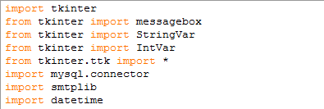

**MYSQL DATABASE USING PYTHON**

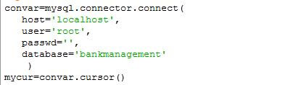

**TKINTER FUNCTION USED**

* Label
* Button
* combobox
* messagebox
* PhotoImage
* Entry
* Iconbitmap
* RadioButton
* Sendmail
* TreeView
* Datetime
* Bind
* Place
* Grid

**SCREENSHOTS:**

Mysql Database Table:

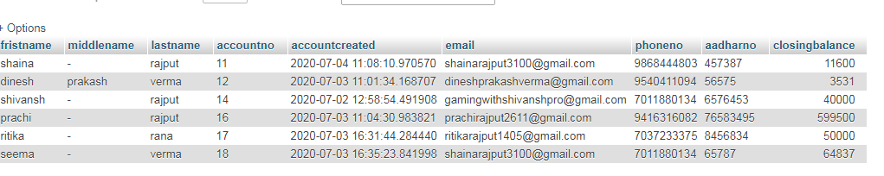

This the first window user will see.

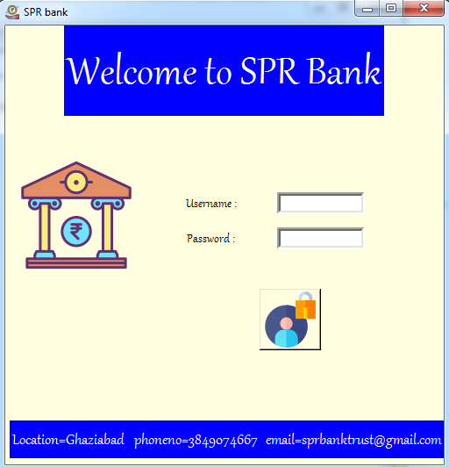

fig 1 login Page

This window provides the functionality to the user to Log in to Account to use the application.

After filling all the fields, on the click of “LOG IN” button the user-data will be compared to the credentials already stored in Database, if a match is found this window closes and home Window will open. Else wise, an error will be displayed.

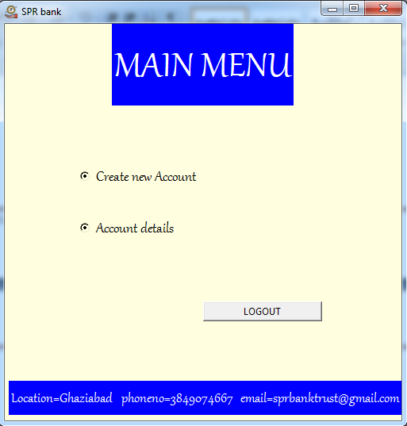

fig 2 MAIN MENU

The user can choose either to create a new account in the bank or to update the existing one.

For creating the new account user will need to fill the form with the proper details otherwise an error window will appear. I have the date and time module for filling the form. After pressing the submit button the account will be created and the information will be entered in the database.

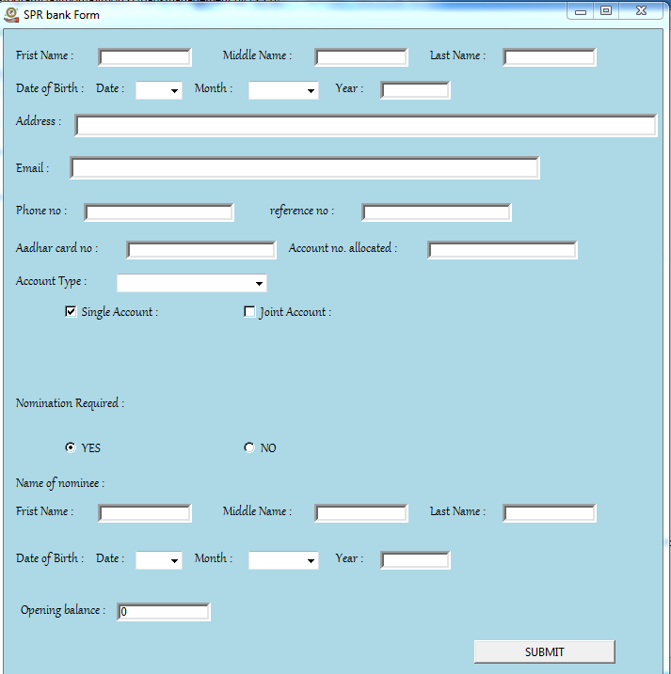

fig3.1 FORM

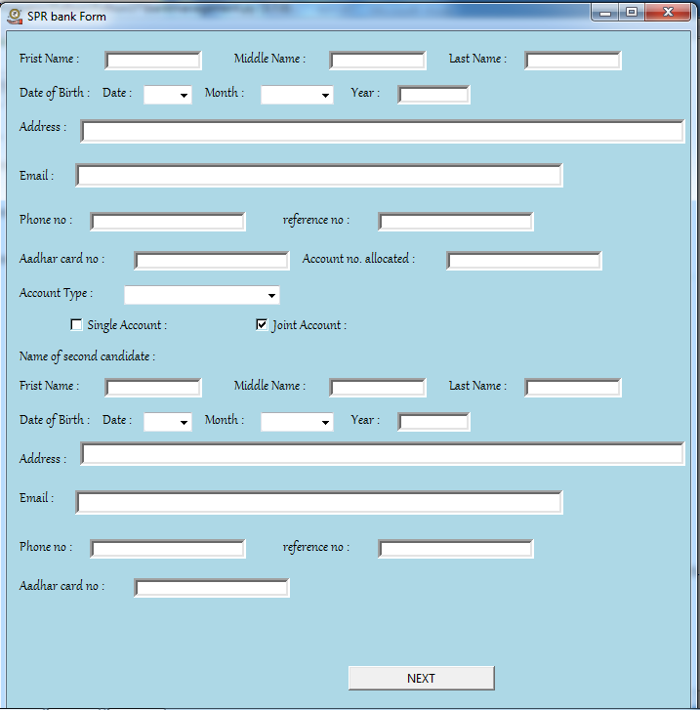

fig 3.2 FORM

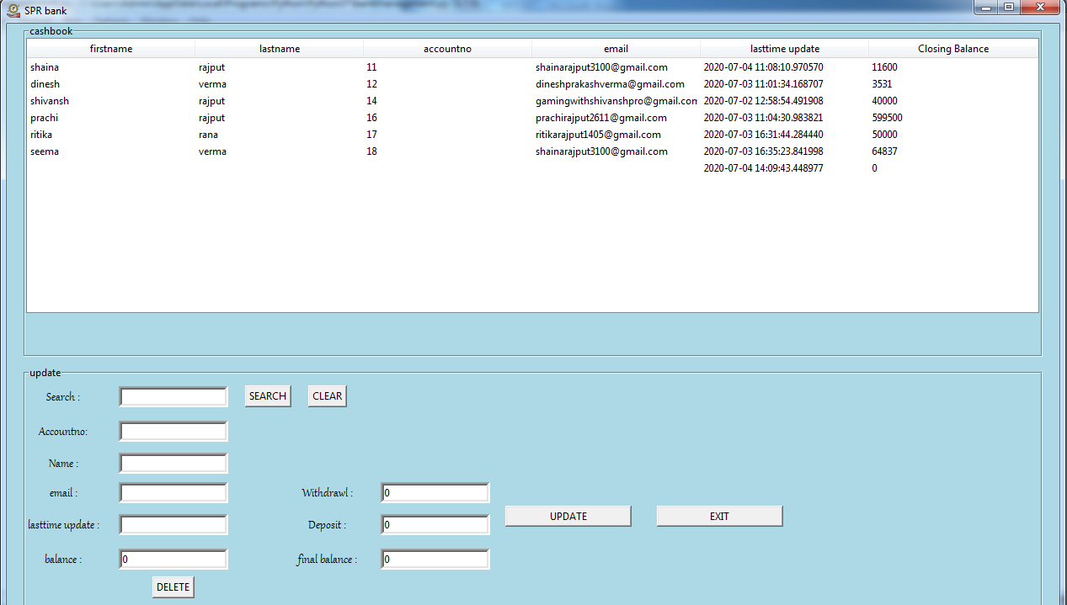

fig 4 CASHBOOK

This cashbook will appear when the user has to update the account. Or needs to deposit or withdraw the money from his account. This will provide following options:

Buttons performing task specific to their label.

SEARCH : searches database for current selection of the account no., name and email. If match is found the details are displayed below else error message is displayed.

DELETE: If account exists then it will be deleted else error message will be displayed.

UPDATE: If account exists then account editor will open for user to modify the contents elsewise error message will be displayed.

EXIT: It will take the user to the main window.

LOGOUT: It will logout from the page and take the user to the login window.

**MESSAGE BOX**

Python Tkinter – MessageBox Widget is used to display the message boxes in the python applications. This module is used to display a message using provides a number of functions.

**Syntax:**

messagebox.Function_Name(title, message [, options])

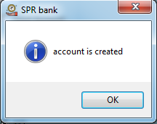 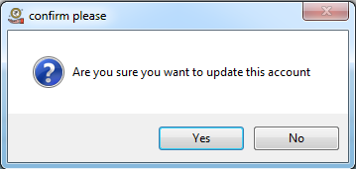

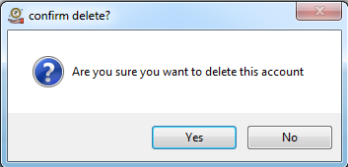 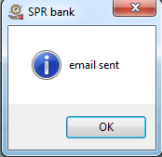

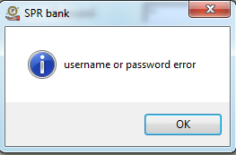

**CONCLUSION**

Bank management system is a virtualization of transactions in banking system. The banking system are used manual working but when we used online banking system it is totally virtualization process which avoid manual process and converts it in automatic process. If user can make a transaction in bank management system it is available in anywhere also user can link aadhar with account, change branch location easily. Bank management system is saving the time with accuracy than bank manual system.