EduCheck
Automated Black-Box UI Test Results

1. Purpose and approach
This report records an automated black-box test of the EduCheck web application. The tests use the same test case IDs as the UAT workbook (EduCheck_UAT_Test_Cases.xlsx), so each result can be traced to its test case. The Status column of that workbook is filled in by the human testers and is not changed by this report; the results of the test cases run by hand are copied from it into Section 6.
Black-box means the tests know nothing about the code. A script opens the real web app in Google Chrome and does what a tester would do: it signs in, clicks the sidebar, fills in forms, uploads the e-Class Record files in 03-Testing/UAT-files, downloads the SF10, and checks what the screen shows against the Expected Result of the test case. The tool is Playwright.
Every run starts from an empty, separate database (educheck_e2e). It is built from the project schema and seeded with test accounts, one school year (2025-2026) and two sections (Grade 6 Rizal, Grade 3 Mabini). The development database and the deployed site are never touched. Emails are written to a file instead of being sent.

2. Test run
Item | Value
Date and time | October 23, 2026, 09:29 AM
Application version | Git commit f4eed5b (main)
Browser | Google Chrome 156.0.8078.47 (headless), 1440 x 900 window
Server | Local backend and built web app on this computer
Total duration | 3.1 minutes
How to repeat | cd e2e, then npm test, then npm run report

3. Summary
Result | Automated (Section 4) | Manual (Section 6) | All test cases
Pass | 63 | 13 | 76
Fail | 0 | 0 | 0
Not run | 0 | 0 | 0
Total | 63 | 13 | 76

63 of 76 test cases (83%) are automated; the other 13 were run by hand. 76 of 76 test cases passed (100%).

4. Results by test case
TC ID | Module | Test case | Result | Time | Remarks
TC-001 | Authentication | Log in with valid credentials | Pass | 3.3 s
TC-002 | Authentication | Log in with a wrong password | Pass | 3.6 s
TC-003 | Authentication | Log in with empty fields | Pass | 2.7 s
TC-004 | Authentication | Inactive account cannot log in | Pass | 1.6 s
TC-005 | Authentication | Repeated failed logins are locked out | Pass | 3.0 s
TC-006 | Authentication | Log out ends the session | Pass | 2.0 s
TC-007 | Authentication | A role cannot open another role's page by URL | Pass | 2.9 s
TC-008 | Account | Change own password | Pass | 4.9 s
TC-009 | Account | Settings shows own profile and assignments | Pass | 7.7 s
TC-010 | Account | Account without a teacher profile | Pass | 3.0 s
TC-011 | Account | Weak new password is rejected | Pass | 2.1 s
TC-012 | Accounts | Create an account (waits for the Principal) | Pass | 2.0 s
TC-013 | Accounts | Edit an account and deactivate it | Pass | 1.6 s
TC-014 | Accounts | Admin resets a user's password | Pass | 4.1 s
TC-015 | Accounts | Search accounts | Pass | 1.5 s
TC-016 | Accounts | Teacher details are kept with the account | Pass | 2.0 s
TC-017 | Section & Assignments | Assign a teacher to several subjects of a section in one save | Pass | 3.5 s
TC-018 | Section & Assignments | Only the section's own grade-level subjects are offered | Pass | 2.0 s
TC-019 | Section & Assignments | Subject Teacher account cannot be Class Adviser | Pass | 1.8 s
TC-020 | Section & Assignments | Set section staffing mode | Pass | 5.5 s
TC-021 | Audit Log | Actions are recorded in the audit log | Pass | 1.5 s
TC-022 | Upload | Upload a valid e-class record | Pass | 2.5 s
TC-023 | Upload | Only assigned subjects and sections are offered | Pass | 1.4 s
TC-024 | Upload | Non-Excel file is rejected | Pass | 1.7 s
TC-025 | Upload | File over 10 MB is rejected | Pass | 2.0 s
TC-026 | Upload | Wrong-section roster is rejected | Pass | 2.0 s
TC-027 | Validation | Validation errors are listed per learner | Pass | 2.5 s
TC-028 | Validation | Correct by re-upload | Pass | 2.4 s
TC-029 | Validation | Validation rules are read-only | Pass | 1.4 s
TC-030 | Upload | Adviser uploads their own assigned subject | Pass | 1.9 s
TC-031 | Consolidation | View own section's consolidated records | Pass | 1.4 s
TC-032 | Consolidation | Adviser cannot see another section | Pass | 1.6 s
TC-033 | Consolidation | Return a subject to its teacher | Pass | 4.2 s
TC-034 | Consolidation | Returning without a reason is refused | Pass | 1.6 s
TC-035 | Submission | Submit a complete record for approval | Pass | 2.6 s
TC-036 | Submission | Incomplete record cannot be submitted | Pass | 1.5 s
TC-037 | Submission | Submit all eligible records at once | Pass | 3.4 s
TC-038 | Section Progress | Section progress shows per-subject status | Pass | 1.4 s
TC-039 | Submission Review | Approve a submitted record | Pass | 3.1 s
TC-040 | Submission Review | Reject a submitted record with a reason | Pass | 2.7 s
TC-041 | Submission Review | Approved learner is locked against re-upload | Pass | 3.0 s
TC-042 | Submission Review | Request an amendment on an approved record | Pass | 3.6 s
TC-043 | Principal | Principal can view school-wide data | Pass | 2.2 s
TC-044 | Principal | Principal cannot change records | Pass | 2.1 s
TC-045 | Repository | Search the repository | Pass | 1.7 s
TC-046 | SF10 | Download an SF10 | Pass | 2.1 s
TC-047 | SF10 | SF10 with no printable year shows a clear message | Pass | 1.5 s
TC-048 | SF10 | Enter historical (pre-EduCheck) grades | Pass | 8.2 s
TC-049 | SF10 | Invalid historical grades are refused | Pass | 5.4 s
TC-050 | Analytics | View academic analytics | Pass | 1.7 s
TC-051 | Notifications | Notifications appear and can be marked read | Pass | 1.9 s | Observation: The sidebar notification badge keeps the old count after Mark all read until the next refresh or page load.
TC-061 | Performance | Upload and validation time | Pass | 2.3 s | Measured: Upload and validation took 1.0 s (local server)
TC-062 | Performance | Page load time | Pass | 2.0 s | Measured: Submission Review: 0.2 s; Academic Analytics: 0.1 s; Records & SF10: 0.1 s; Dashboard: 0.2 s (local server)
TC-067 | Security | Session expires | Pass | 5.9 s
TC-068 | Upload | A file for another subject is refused | Pass | 2.5 s
TC-069 | SF10 | A 3-term year prints as Terms 1-3 | Pass | 3.4 s
TC-070 | SF10 | Import earlier years from an existing SF10 file | Pass | 2.0 s
TC-071 | SF10 | Import refuses another learner's SF10 | Pass | 1.5 s
TC-072 | Accounts | Only DepEd email addresses are accepted | Pass | 2.2 s
TC-073 | Account Approvals | Principal approves a new account | Pass | 3.5 s
TC-074 | Account Approvals | Principal rejects an account with a reason | Pass | 3.9 s
TC-075 | Accounts | Admin finishes the setup of an approved account | Pass | 2.0 s
TC-076 | Authentication | Temporary password must be replaced at first sign-in | Pass | 4.2 s

5. Observations
No test case failed. The points below were seen while writing and running the tests. They do not stop a test case from passing, but the team may want to review them.
Ref | Observation
TC-002 | The wrong-password message reads "Username or password is incorrect. Check both and try again.", not "Invalid username or password." as written in the test case. It still does not say which field was wrong, so the intent is met; the test case wording can be updated.
TC-051 | The sidebar notification badge keeps the old count after Mark all read until its next timed refresh or a page load.
TC-035 | A record waiting for approval shows the badge "Submitted", while its tab is named "Pending approval". The two words mean the same state.
TC-042 | A revision request covers the subject's whole upload, so the section's other records waiting for approval are sent back too (by design: the Administrator should not approve grades the Adviser has flagged). They show the status "Amendment Requested" even though they were never approved, which users may misread.
Audit Log | The Entity filter dropdown has no visible label, so screen readers announce it only as a list box.

6. Manual test cases
These test cases are not automated. They were run by hand, and their results are taken from the Status, Tester and Date columns of the UAT workbook.
TC ID | Module | Test case | Why manual | Result | Tester | Date
TC-052 | Mobile | Install and log in on an Android phone | Runs in the Android app; the automated tests drive the web app only. | Pass | Project team | 2026-10-16
TC-053 | Mobile | View my uploads and validation results | Runs in the Android app; the automated tests drive the web app only. | Pass | Project team | 2026-10-16
TC-054 | Mobile | Submit a record for approval on mobile | Runs in the Android app; the automated tests drive the web app only. | Pass | Project team | 2026-10-16
TC-055 | Mobile | Return a subject to its teacher on mobile | Runs in the Android app; the automated tests drive the web app only. | Pass | Project team | 2026-10-16
TC-056 | Mobile | Approve and return records on mobile | Runs in the Android app; the automated tests drive the web app only. | Pass | Project team | 2026-10-16
TC-057 | Mobile | Principal is read-only on mobile | Runs in the Android app; the automated tests drive the web app only. | Pass | Project team | 2026-10-16
TC-058 | Mobile | Offline: cached data is shown | Runs in the Android app; the automated tests drive the web app only. | Pass | Project team | 2026-10-16
TC-059 | Mobile | New notification arrives while the app is open | Runs in the Android app; the automated tests drive the web app only. | Pass | Project team | 2026-10-16
TC-060 | Mobile | Log out clears the session | Runs in the Android app; the automated tests drive the web app only. | Pass | Project team | 2026-10-16
TC-063 | Compatibility | Works on Chrome, Edge and Firefox | Needs other browsers, devices or screen sizes. | Pass | Project team | 2026-10-16
TC-064 | Compatibility | Layout at laptop and tablet widths | Needs other browsers, devices or screen sizes. | Pass | Project team | 2026-10-16
TC-065 | Usability | First-time task completion | Needs a person's judgement (observation, SUS questionnaire). | Pass | Project team | 2026-10-16
TC-066 | Usability | Light and dark theme are readable | Needs a person's judgement (observation, SUS questionnaire). | Pass | Project team | 2026-10-16

Appendix A. Screenshot evidence
Each screenshot was taken by the test at the end of the test case, showing the screen the last check was made on.

TC-001 Log in with valid credentials
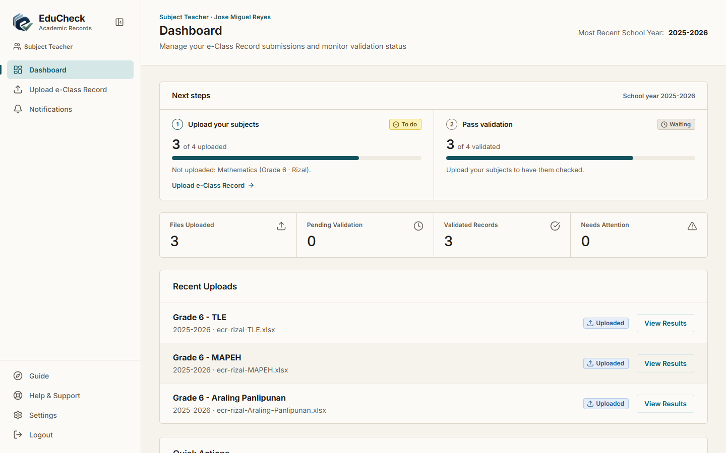
Result: Pass | 10/23/2026, 9:29:59 AM

TC-002 Log in with a wrong password
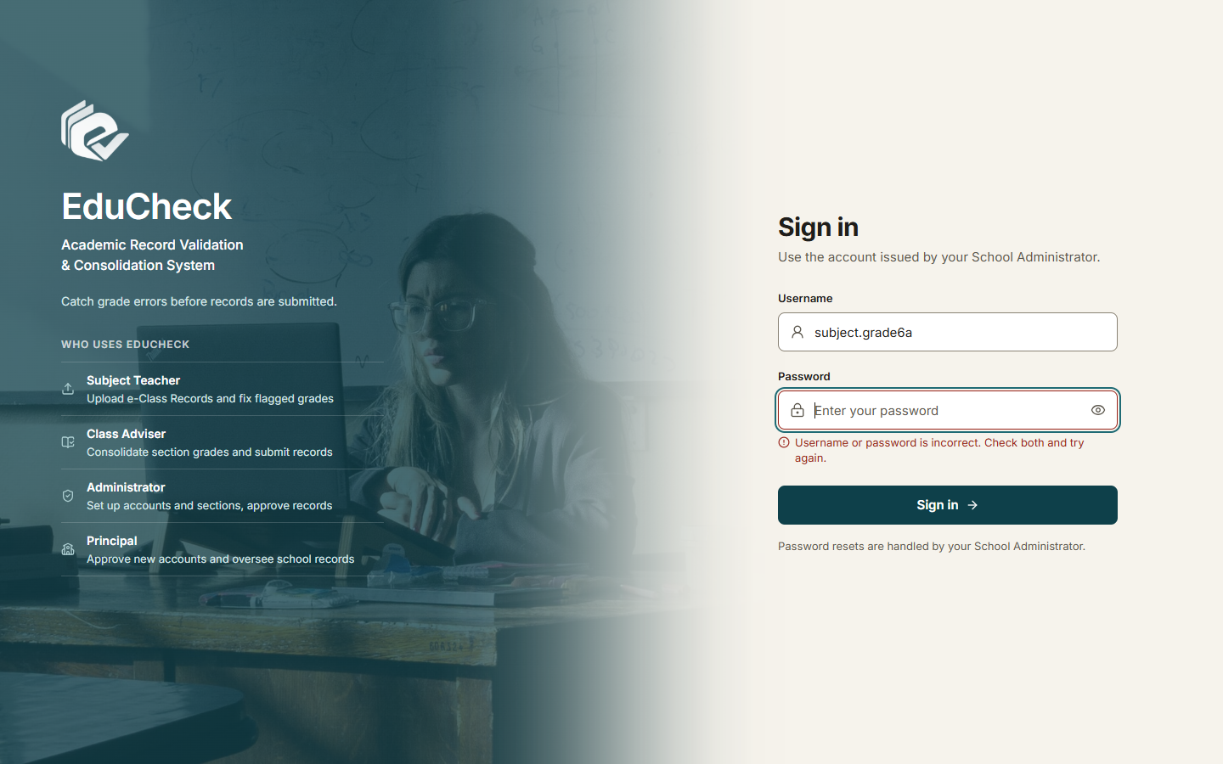
Result: Pass | 10/23/2026, 9:30:03 AM

TC-003 Log in with empty fields
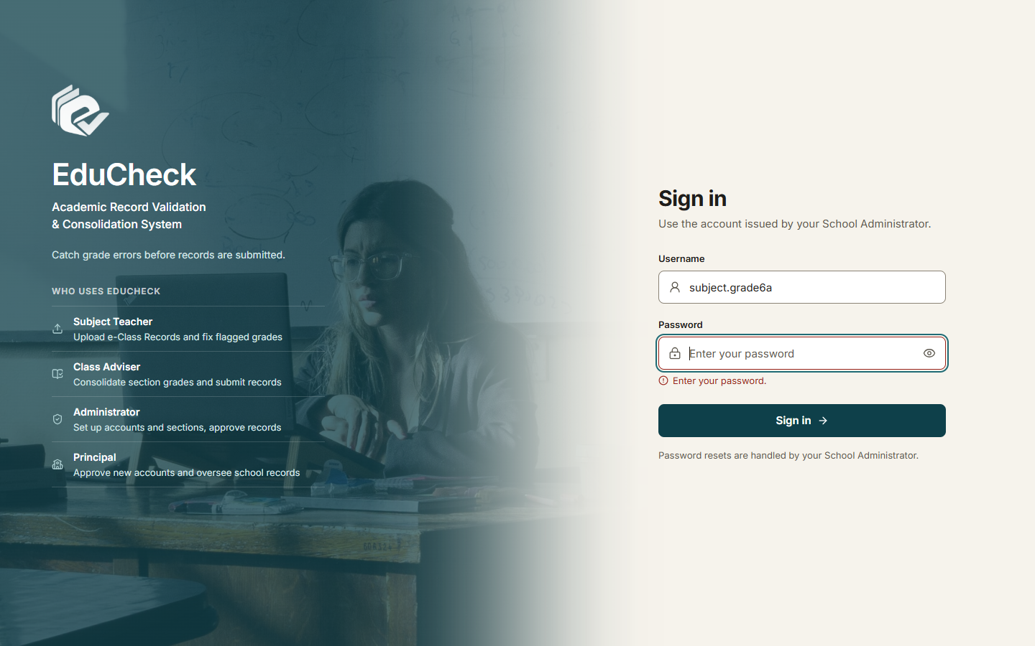
Result: Pass | 10/23/2026, 9:30:07 AM

TC-004 Inactive account cannot log in
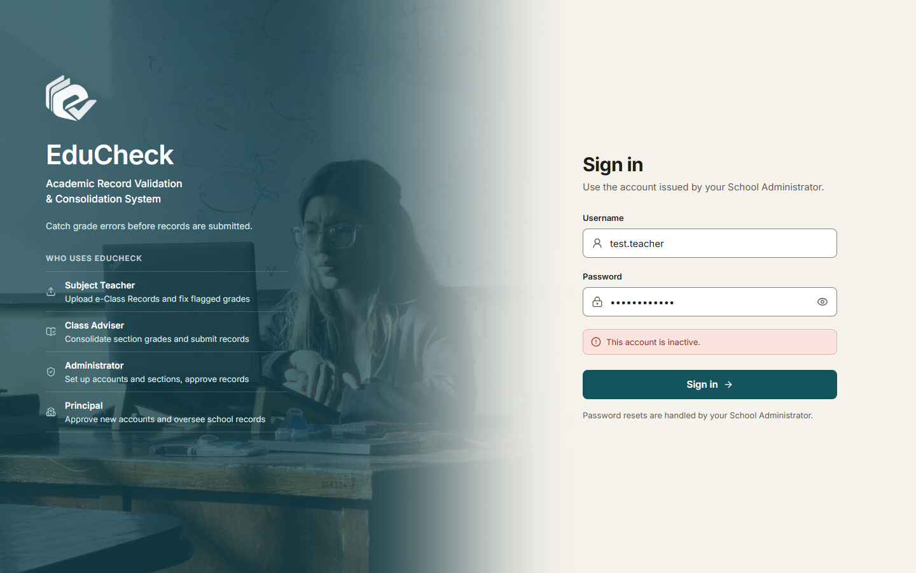
Result: Pass | 10/23/2026, 9:31:06 AM

TC-005 Repeated failed logins are locked out
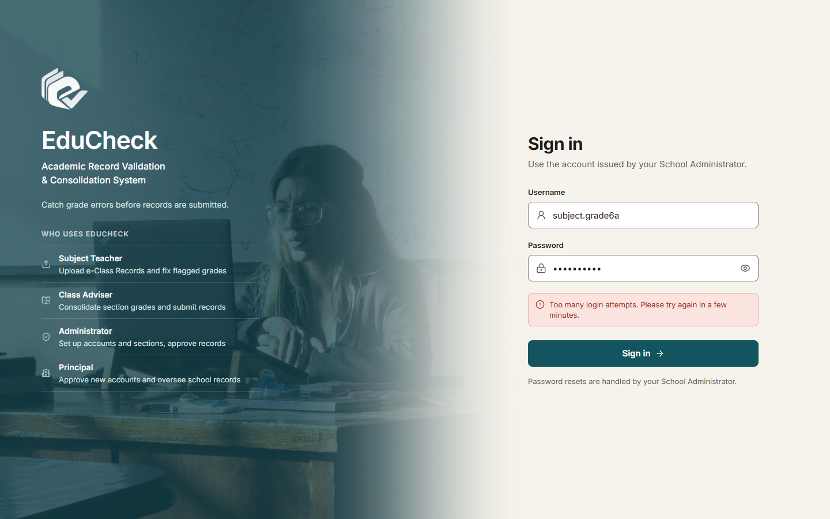
Result: Pass | 10/23/2026, 9:32:51 AM

TC-006 Log out ends the session

Result: Pass | 10/23/2026, 9:30:10 AM

TC-007 A role cannot open another role's page by URL
Result: Pass | 10/23/2026, 9:30:12 AM

TC-008 Change own password
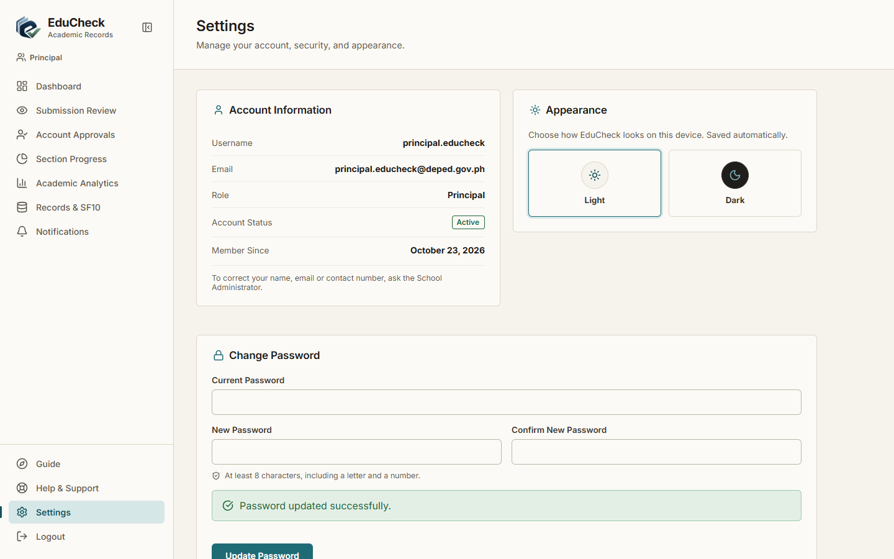
Result: Pass | 10/23/2026, 9:30:34 AM

TC-009 Settings shows own profile and assignments
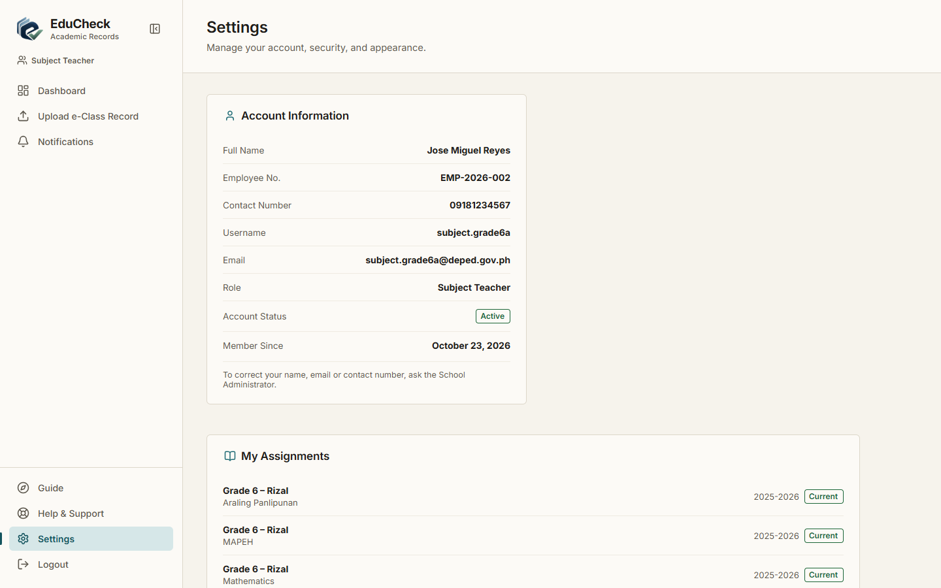
Result: Pass | 10/23/2026, 9:30:21 AM

TC-010 Account without a teacher profile
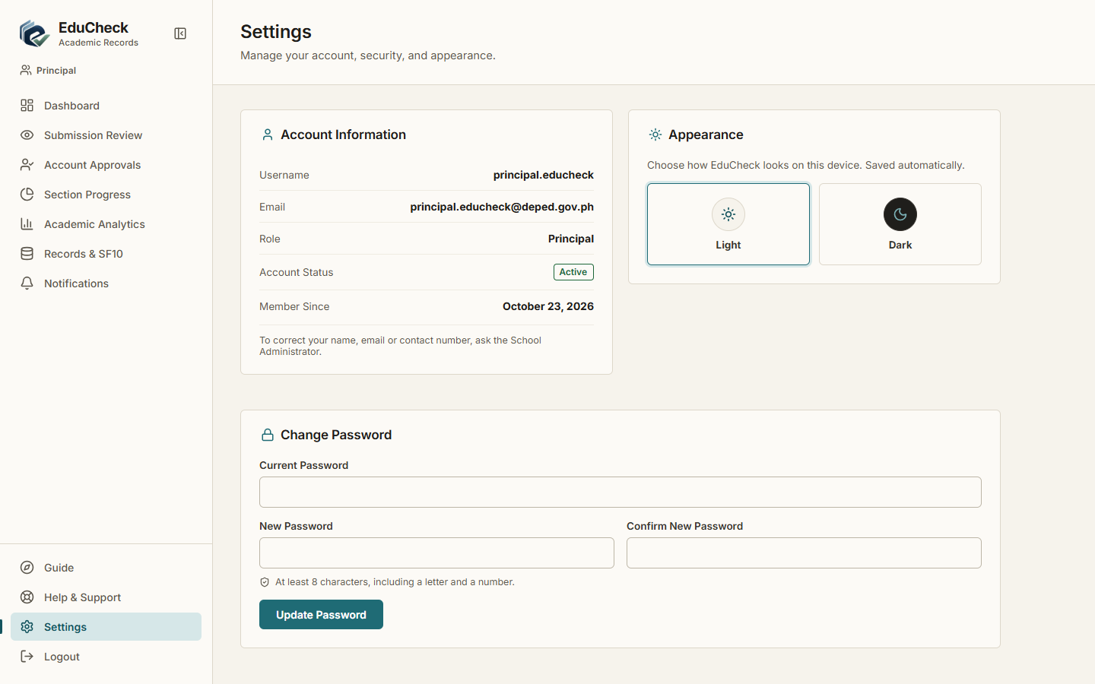
Result: Pass | 10/23/2026, 9:30:28 AM

TC-011 Weak new password is rejected
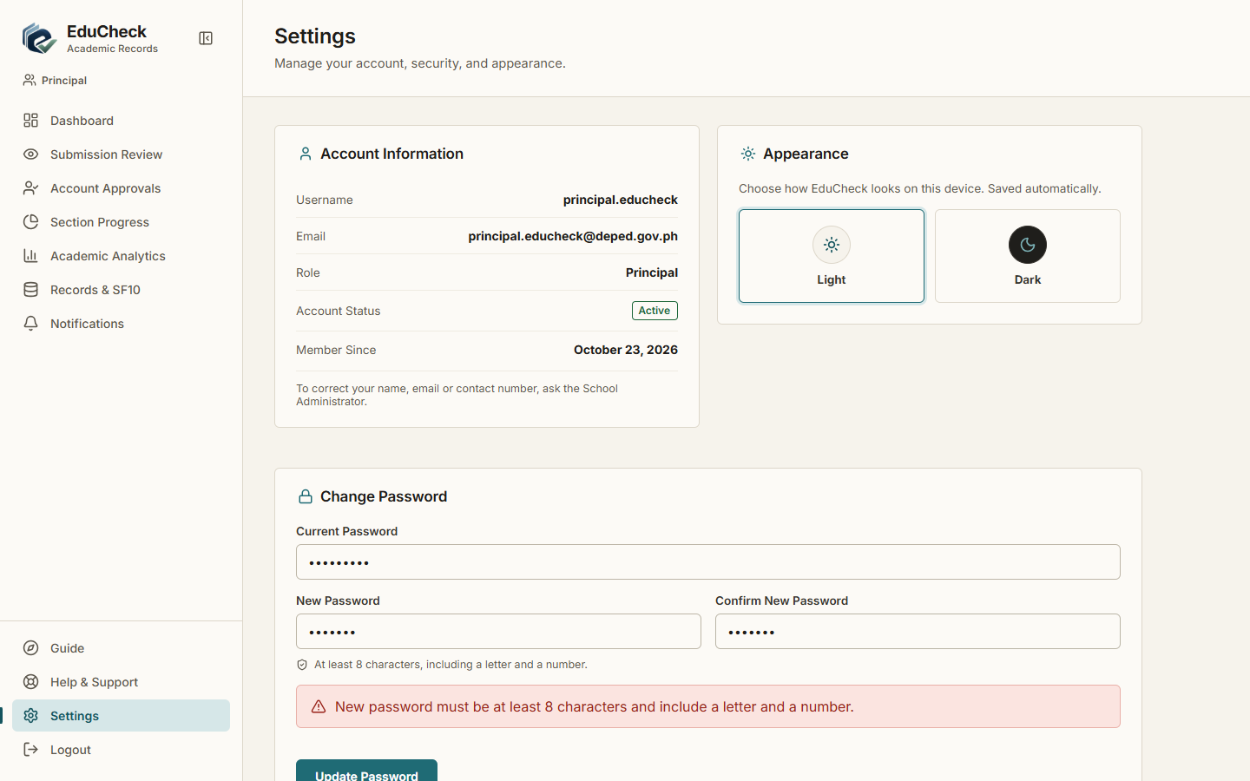
Result: Pass | 10/23/2026, 9:30:31 AM

TC-012 Create an account (waits for the Principal)
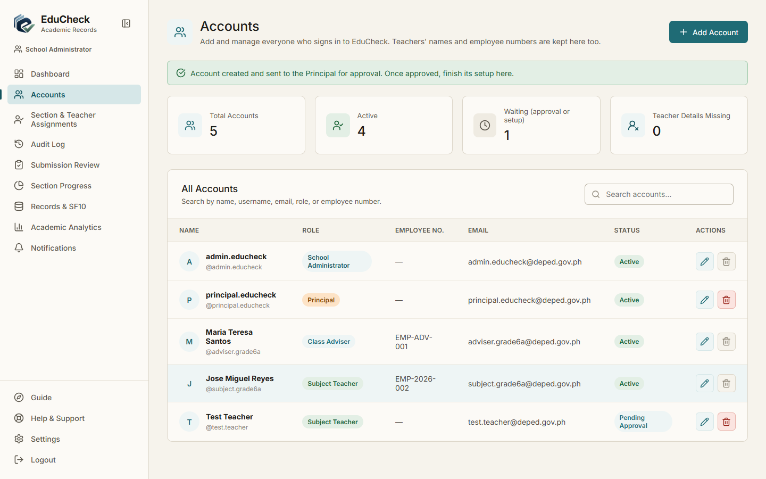
Result: Pass | 10/23/2026, 9:30:41 AM

TC-013 Edit an account and deactivate it
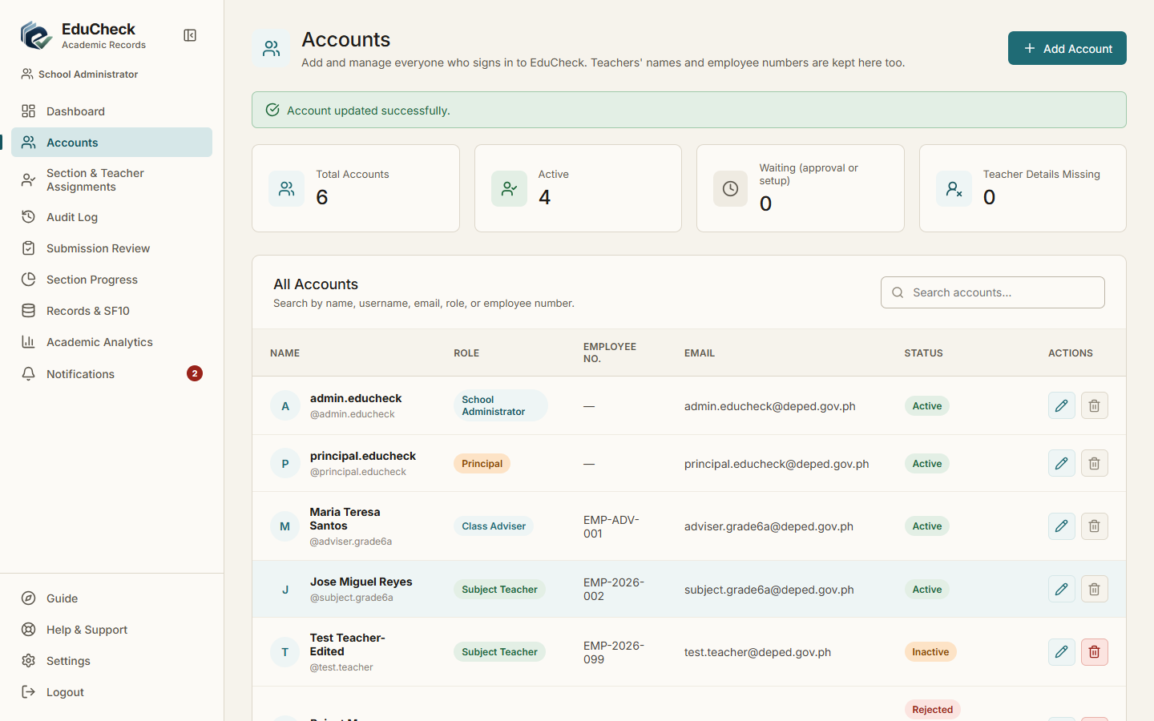
Result: Pass | 10/23/2026, 9:31:04 AM

TC-014 Admin resets a user's password
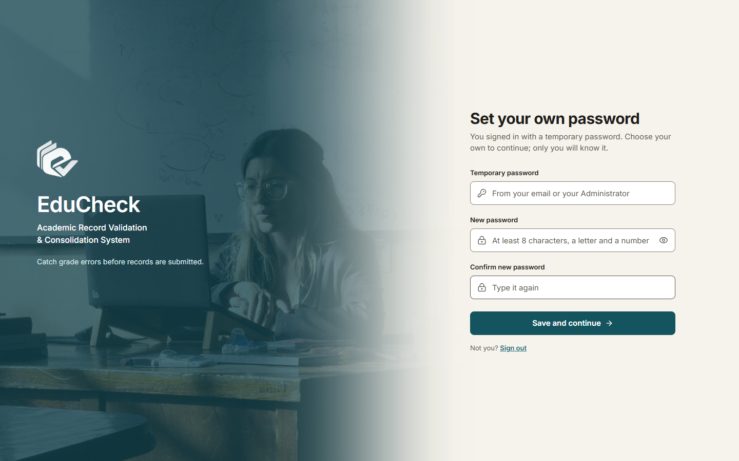
Result: Pass | 10/23/2026, 9:31:00 AM

TC-015 Search accounts
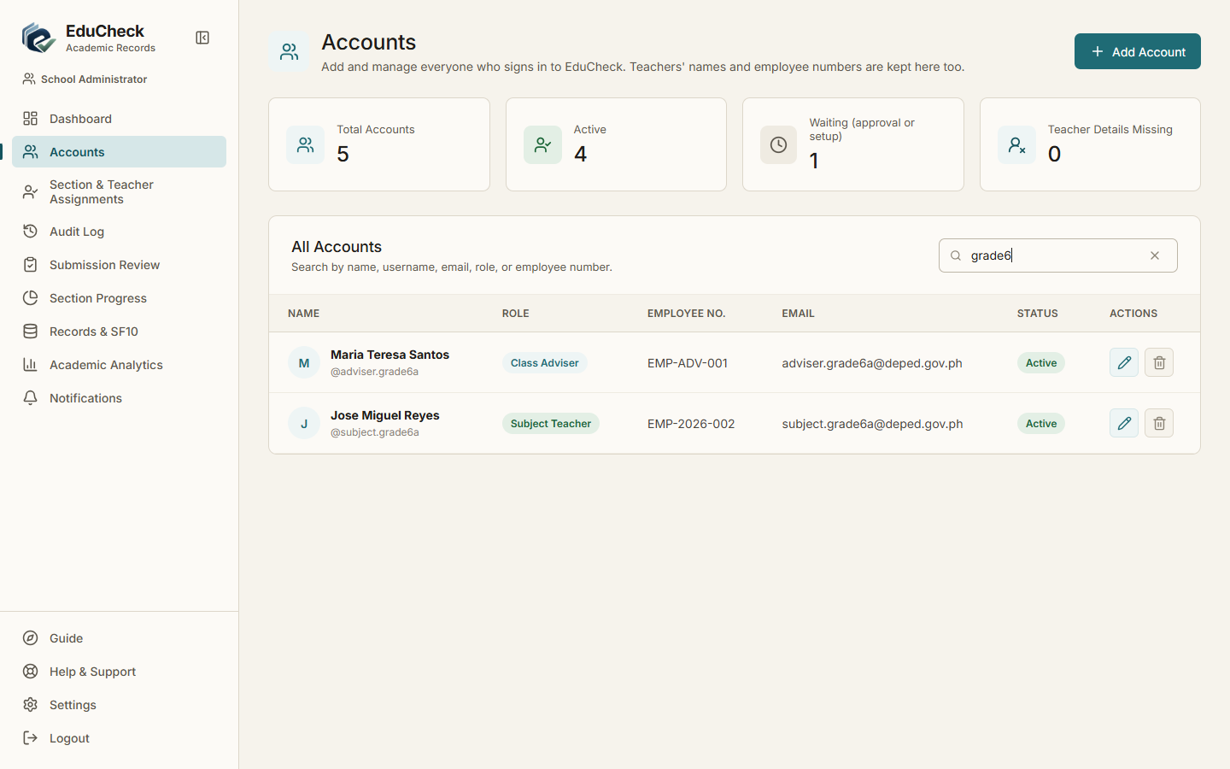
Result: Pass | 10/23/2026, 9:30:43 AM

TC-016 Teacher details are kept with the account
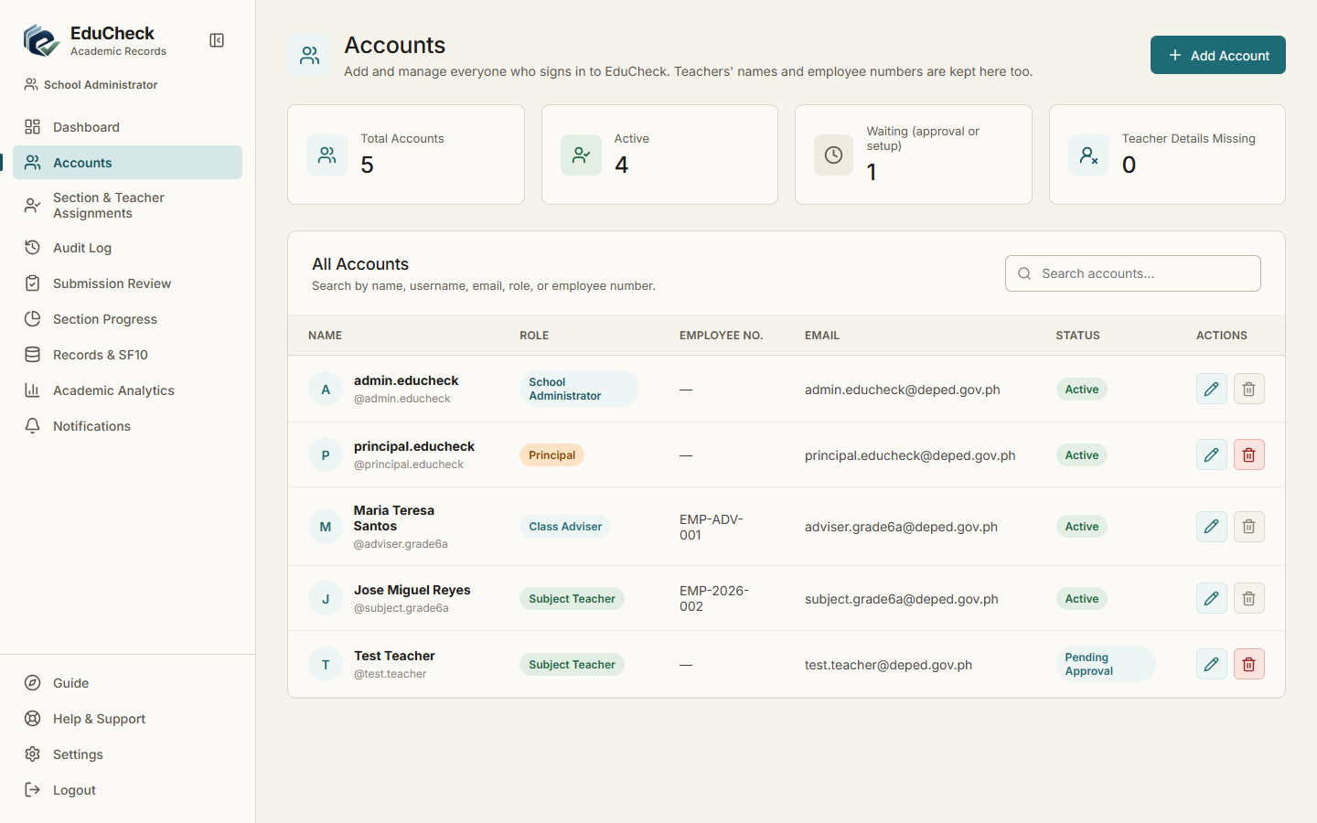
Result: Pass | 10/23/2026, 9:30:44 AM

TC-017 Assign a teacher to several subjects of a section in one save
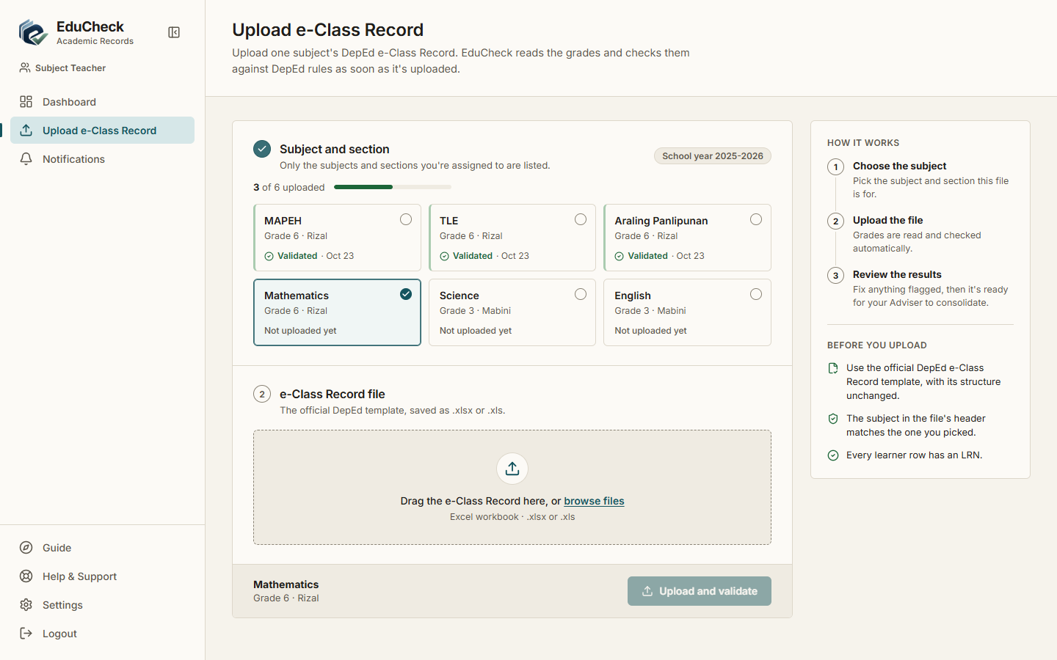
Result: Pass | 10/23/2026, 9:31:09 AM

TC-018 Only the section's own grade-level subjects are offered
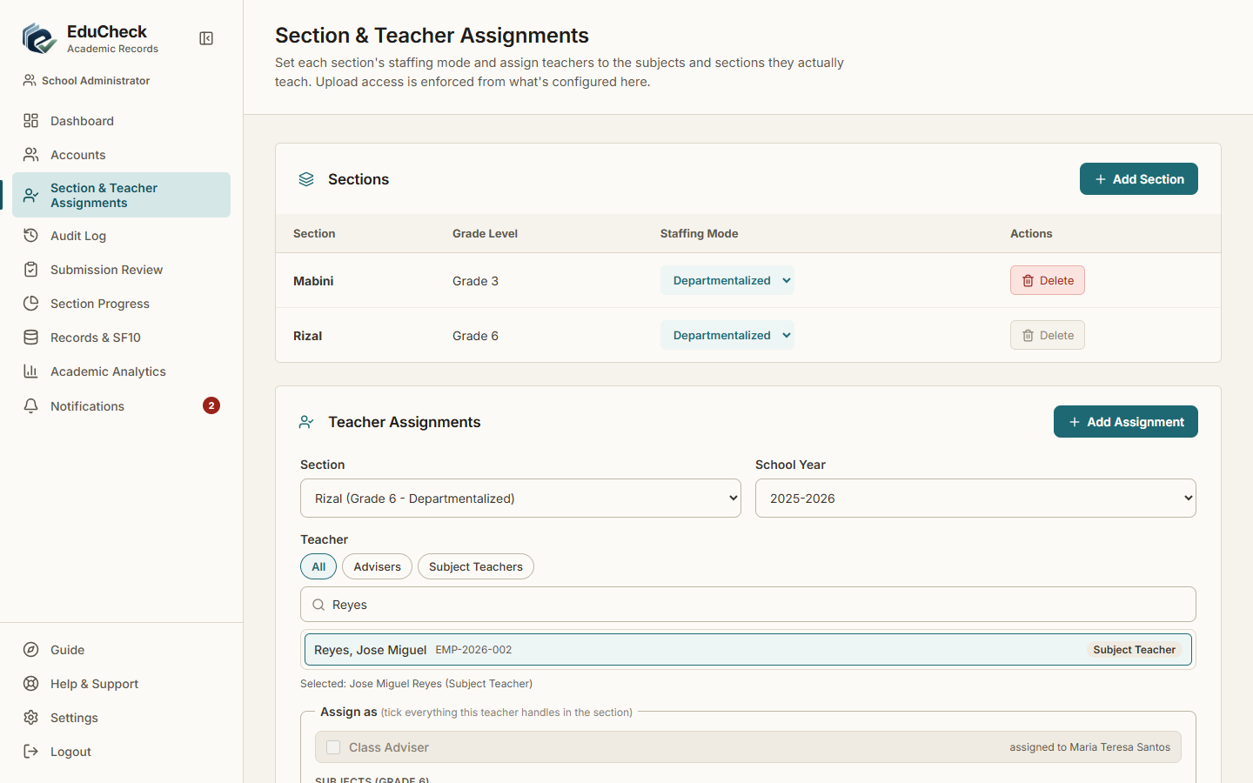
Result: Pass | 10/23/2026, 9:31:07 AM

TC-019 Subject Teacher account cannot be Class Adviser
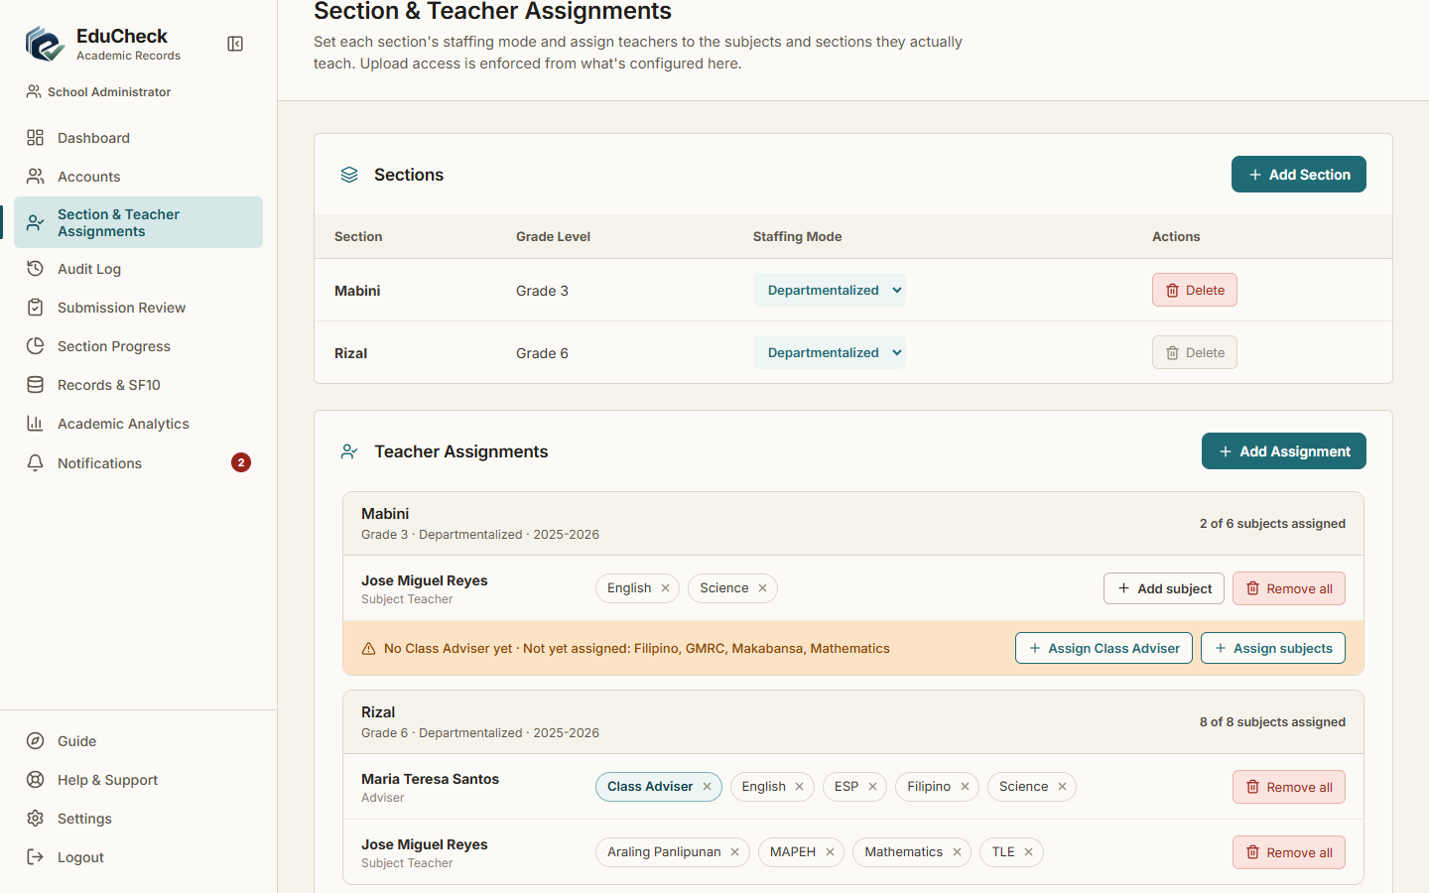
Result: Pass | 10/23/2026, 9:31:13 AM

TC-020 Set section staffing mode
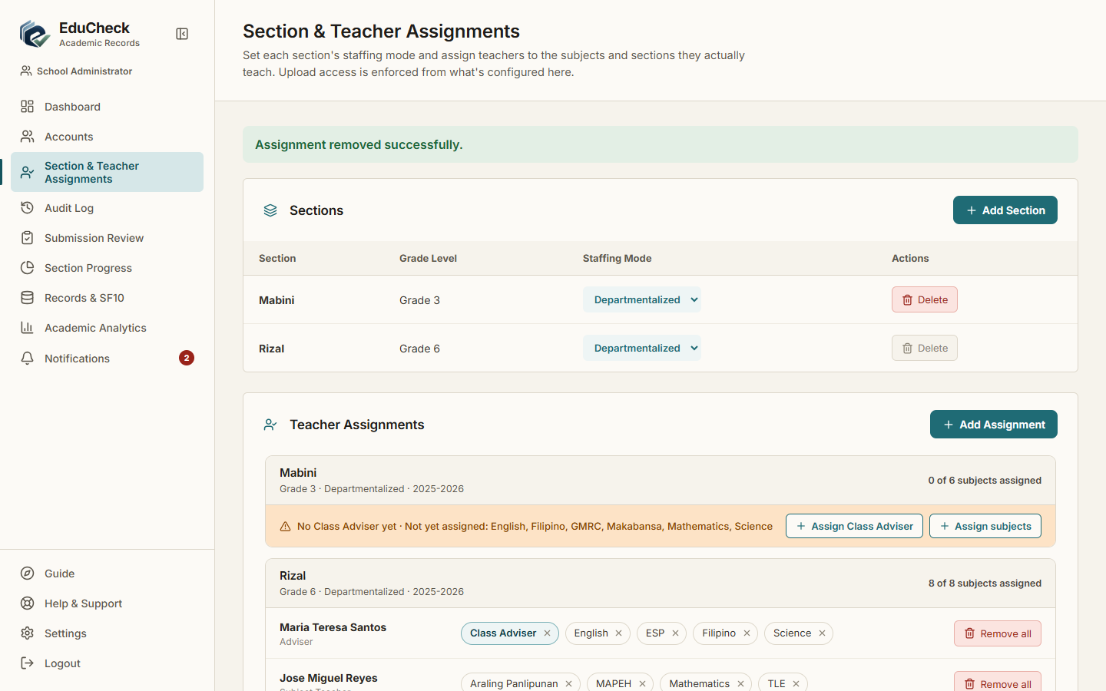
Result: Pass | 10/23/2026, 9:31:15 AM

TC-021 Actions are recorded in the audit log
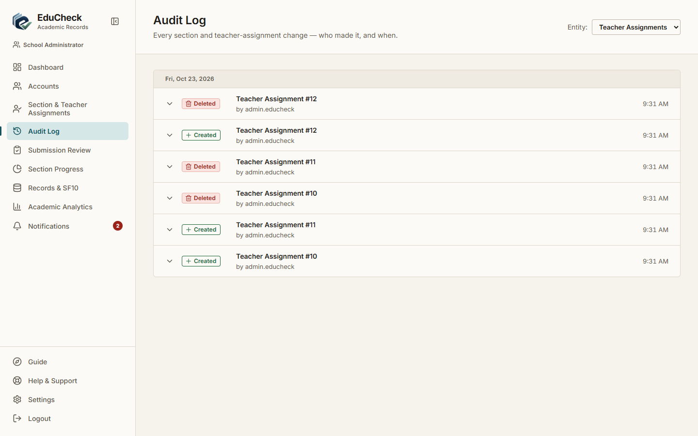
Result: Pass | 10/23/2026, 9:31:20 AM

TC-022 Upload a valid e-class record
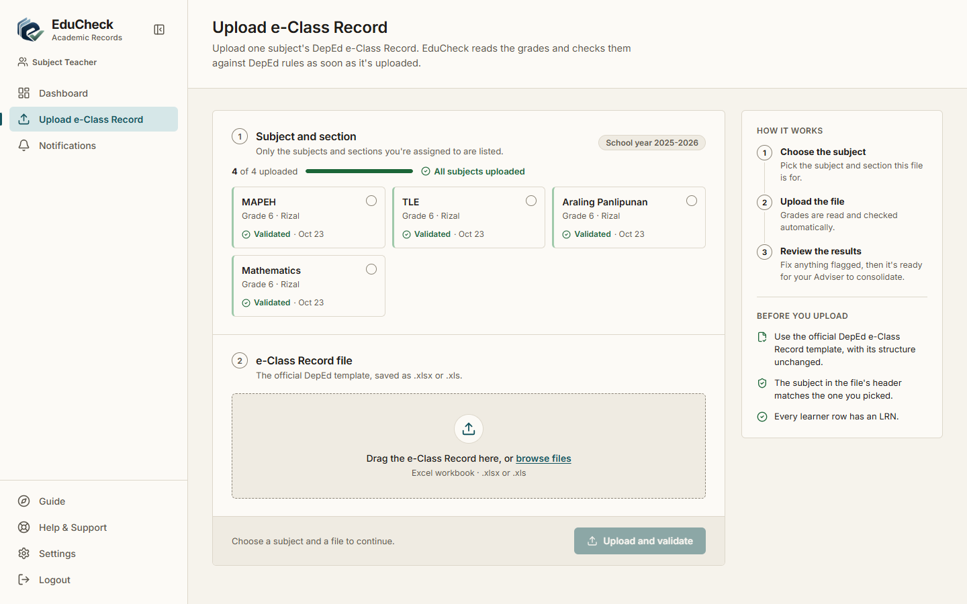
Result: Pass | 10/23/2026, 9:31:32 AM

TC-023 Only assigned subjects and sections are offered
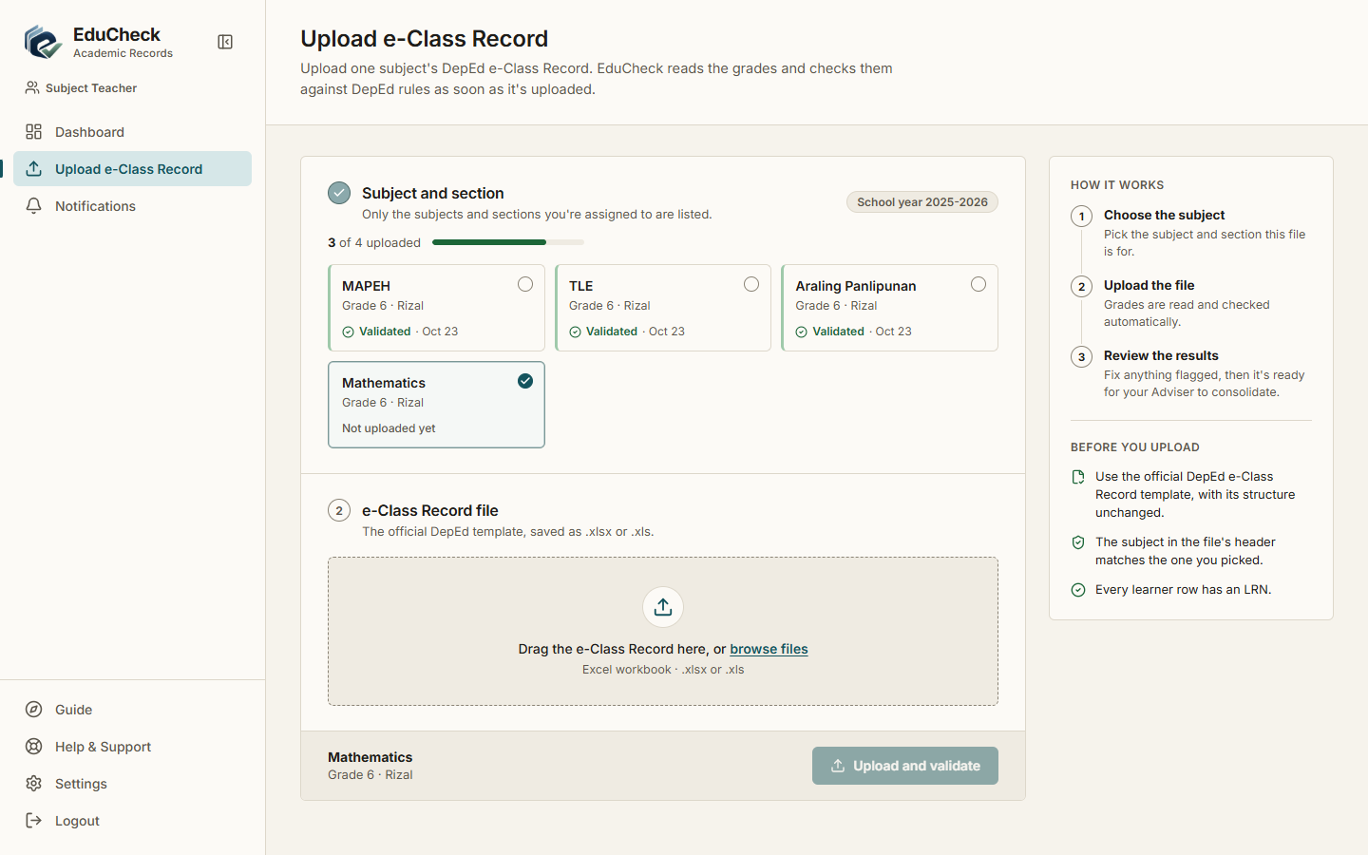
Result: Pass | 10/23/2026, 9:31:22 AM

TC-024 Non-Excel file is rejected
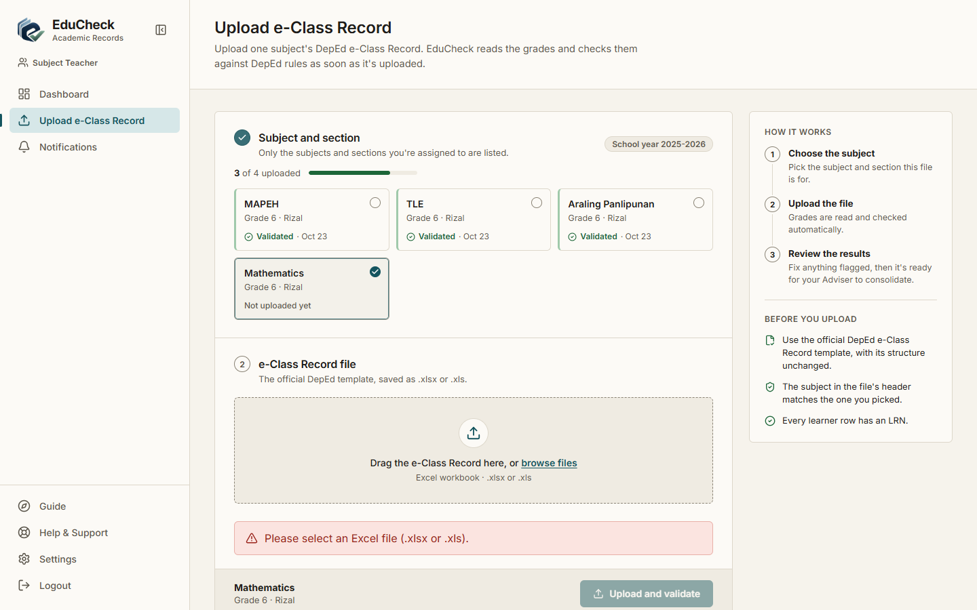
Result: Pass | 10/23/2026, 9:31:23 AM

TC-025 File over 10 MB is rejected
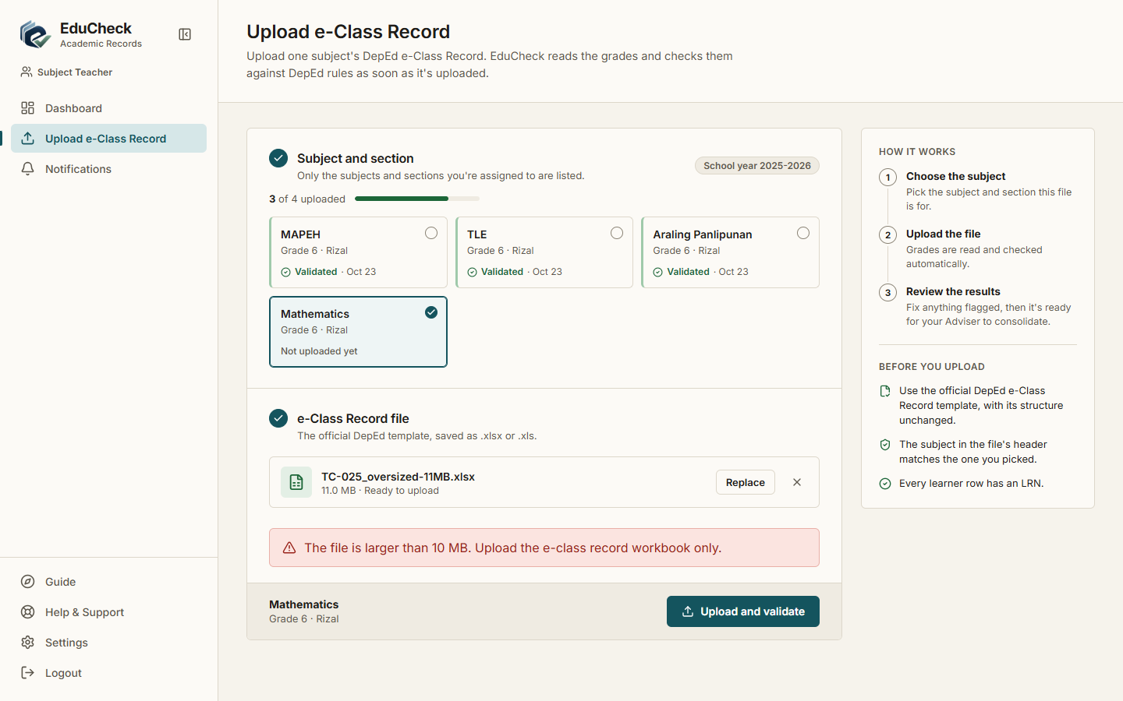
Result: Pass | 10/23/2026, 9:31:25 AM

TC-026 Wrong-section roster is rejected
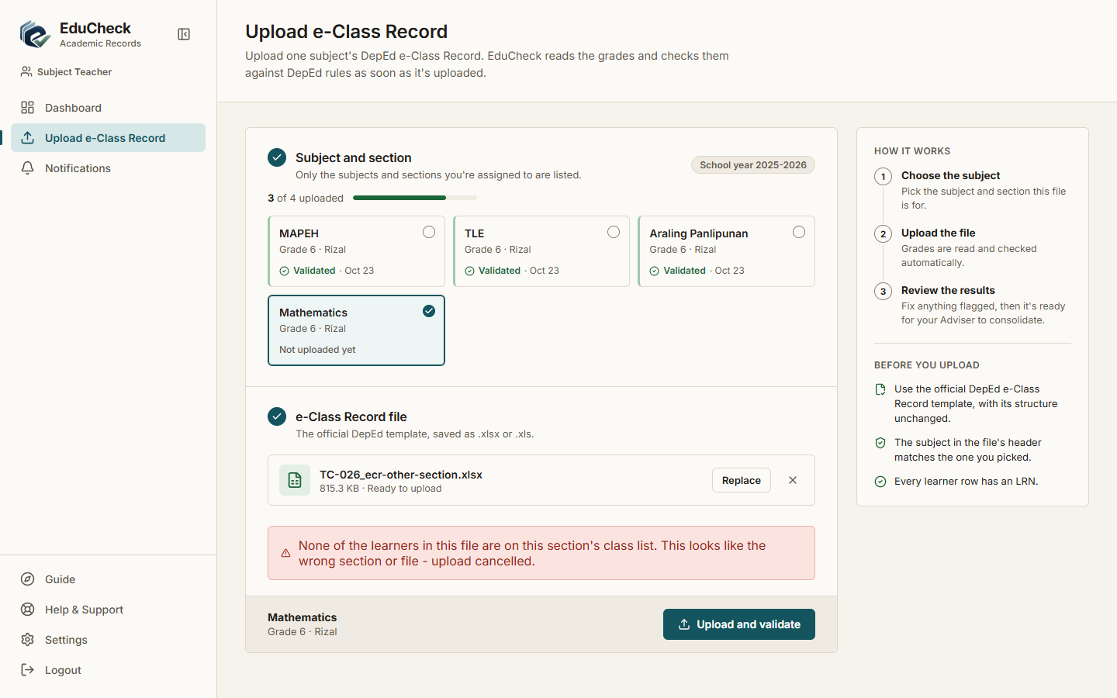
Result: Pass | 10/23/2026, 9:31:27 AM

TC-027 Validation errors are listed per learner
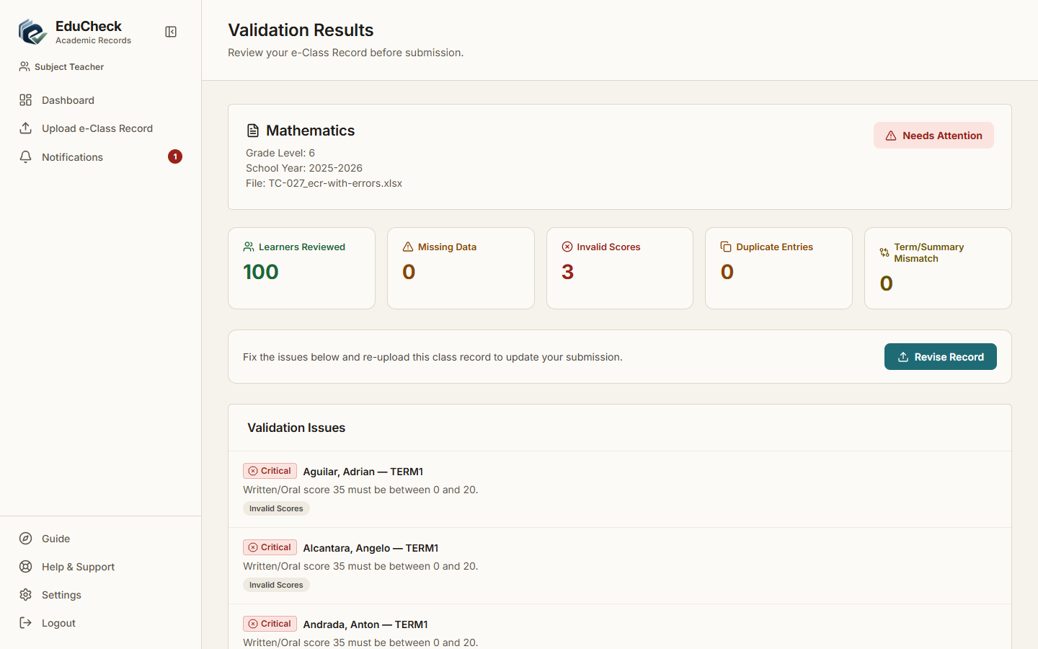
Result: Pass | 10/23/2026, 9:31:34 AM

TC-028 Correct by re-upload
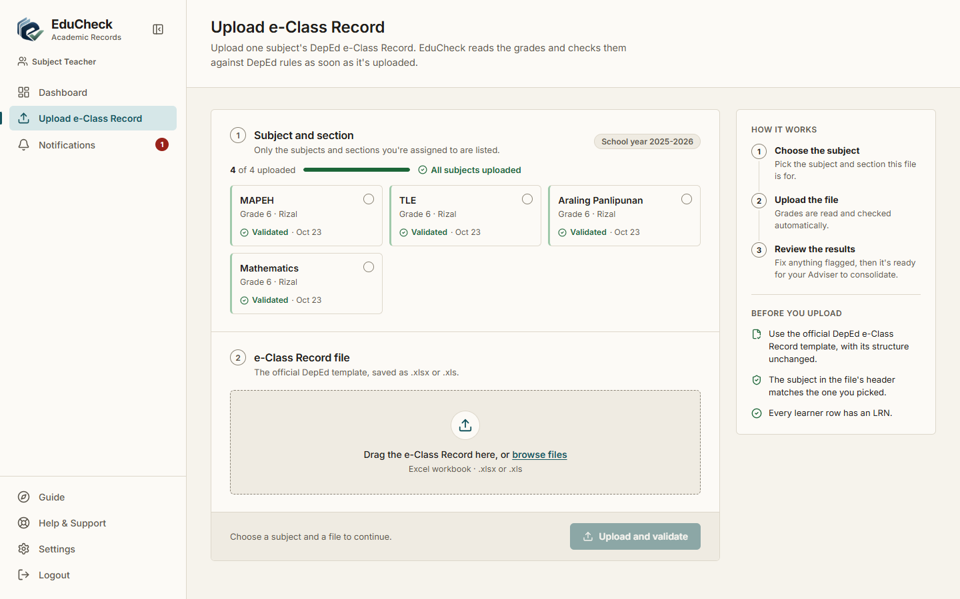
Result: Pass | 10/23/2026, 9:31:37 AM

TC-029 Validation rules are read-only
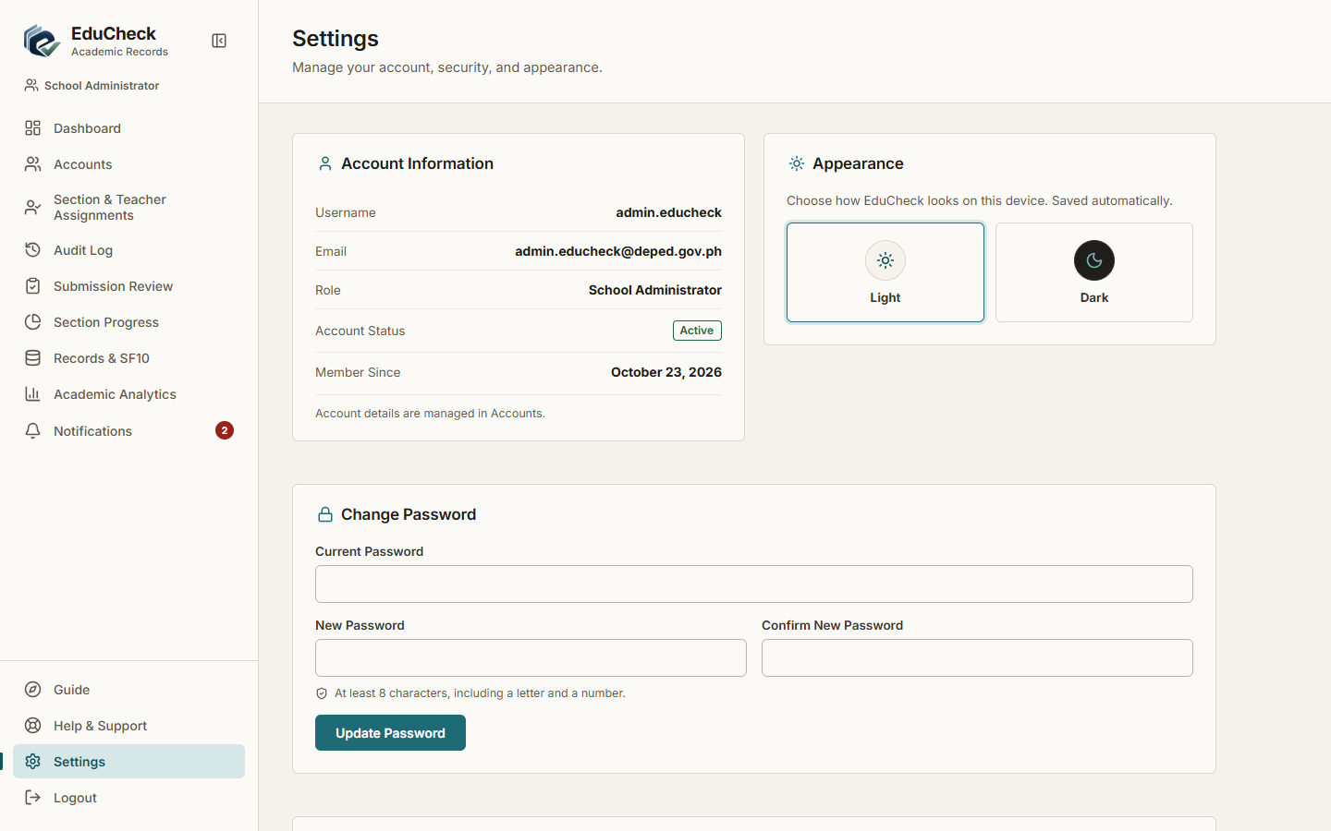
Result: Pass | 10/23/2026, 9:31:41 AM

TC-030 Adviser uploads their own assigned subject
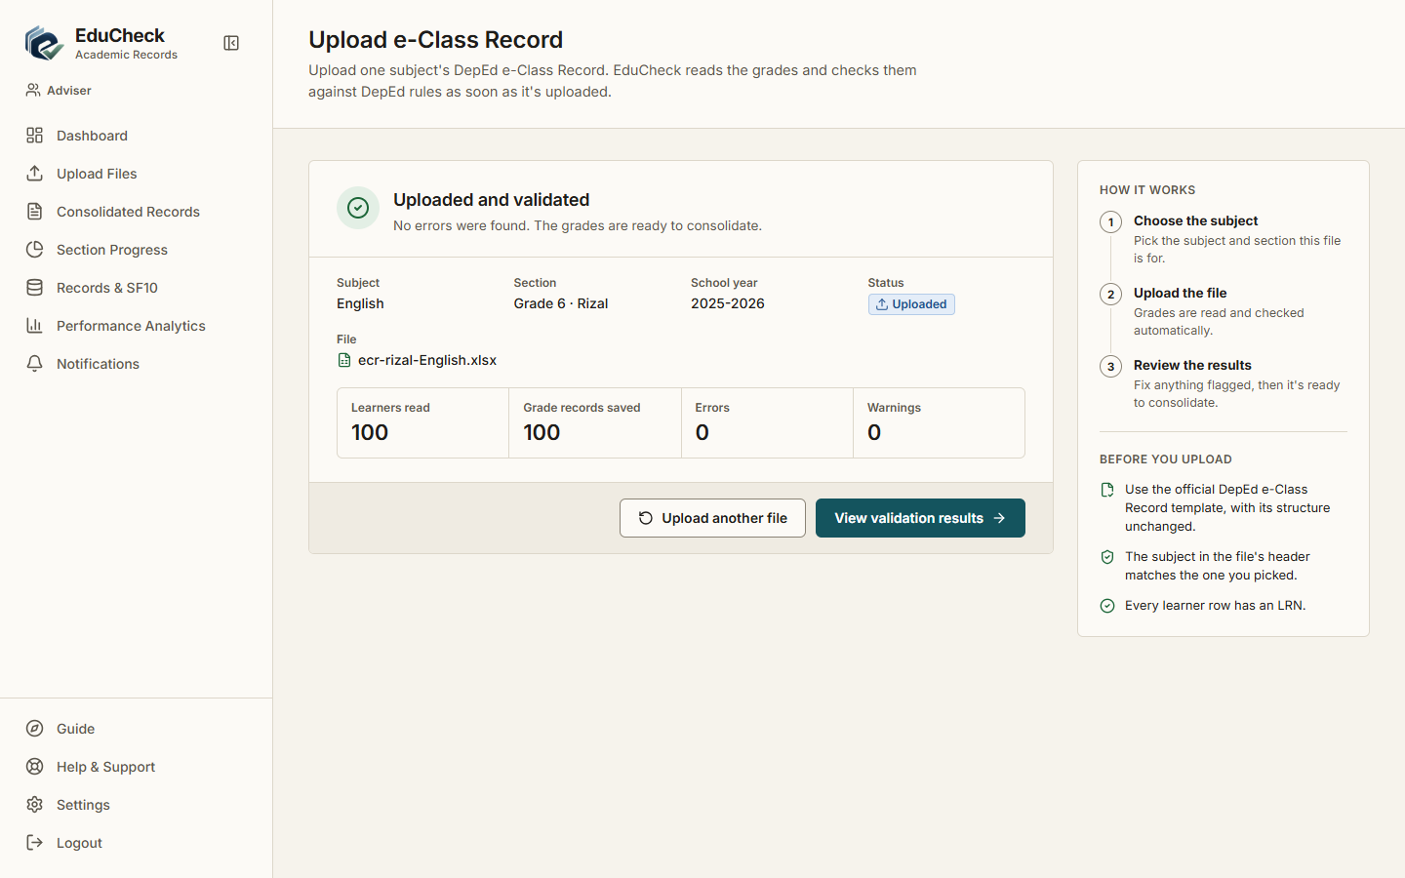
Result: Pass | 10/23/2026, 9:31:43 AM

TC-031 View own section's consolidated records
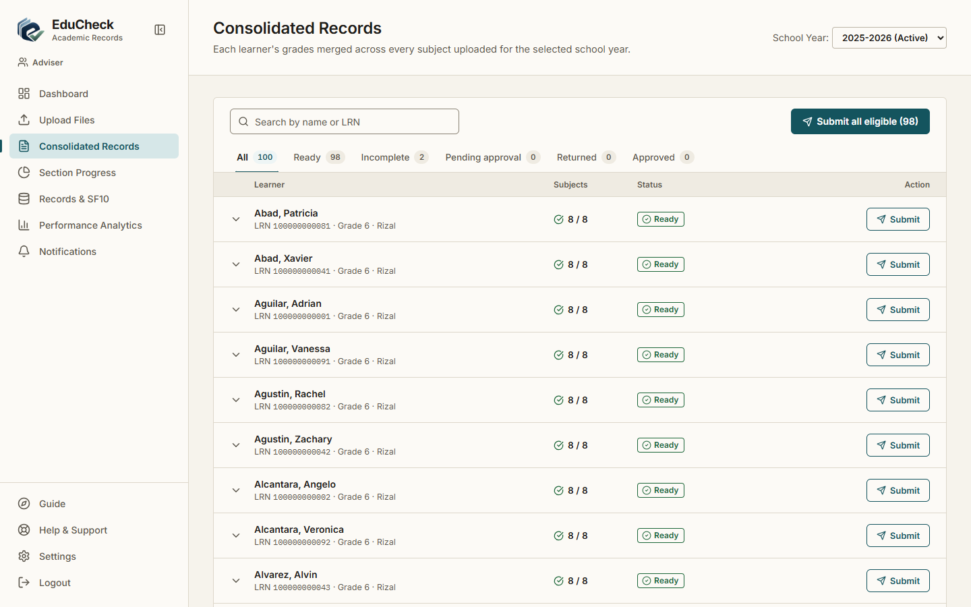
Result: Pass | 10/23/2026, 9:31:45 AM

TC-032 Adviser cannot see another section
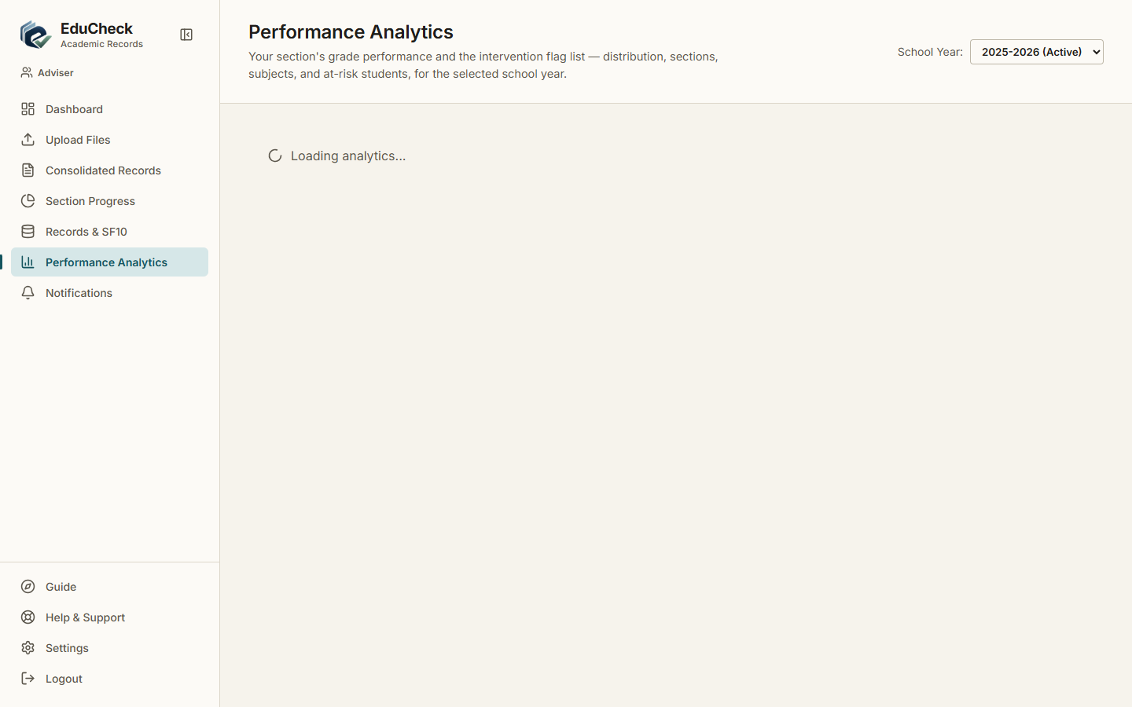
Result: Pass | 10/23/2026, 9:31:46 AM

TC-033 Return a subject to its teacher
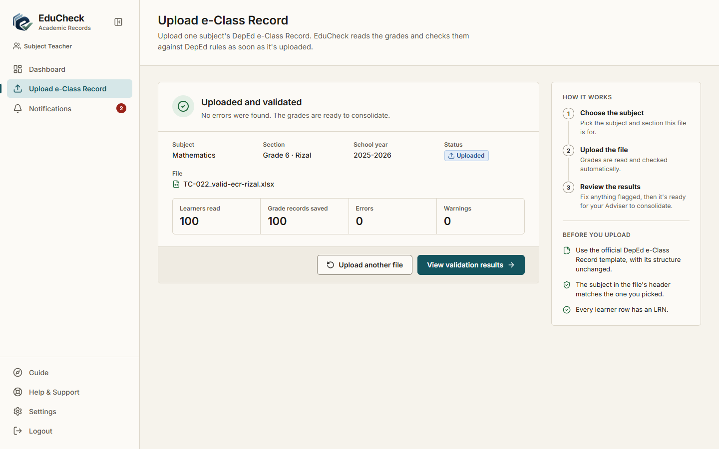
Result: Pass | 10/23/2026, 9:31:51 AM

TC-034 Returning without a reason is refused
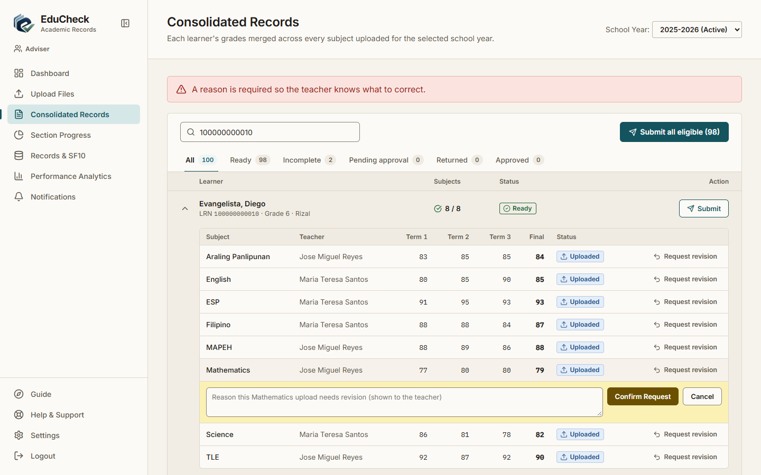
Result: Pass | 10/23/2026, 9:31:49 AM

TC-035 Submit a complete record for approval
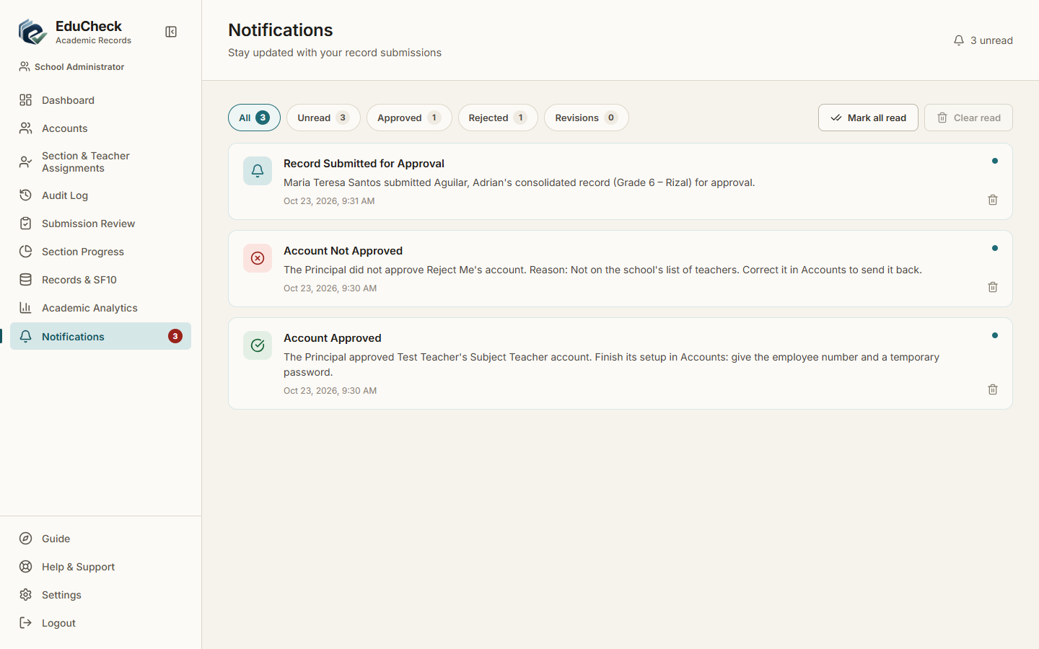
Result: Pass | 10/23/2026, 9:31:57 AM

TC-036 Incomplete record cannot be submitted
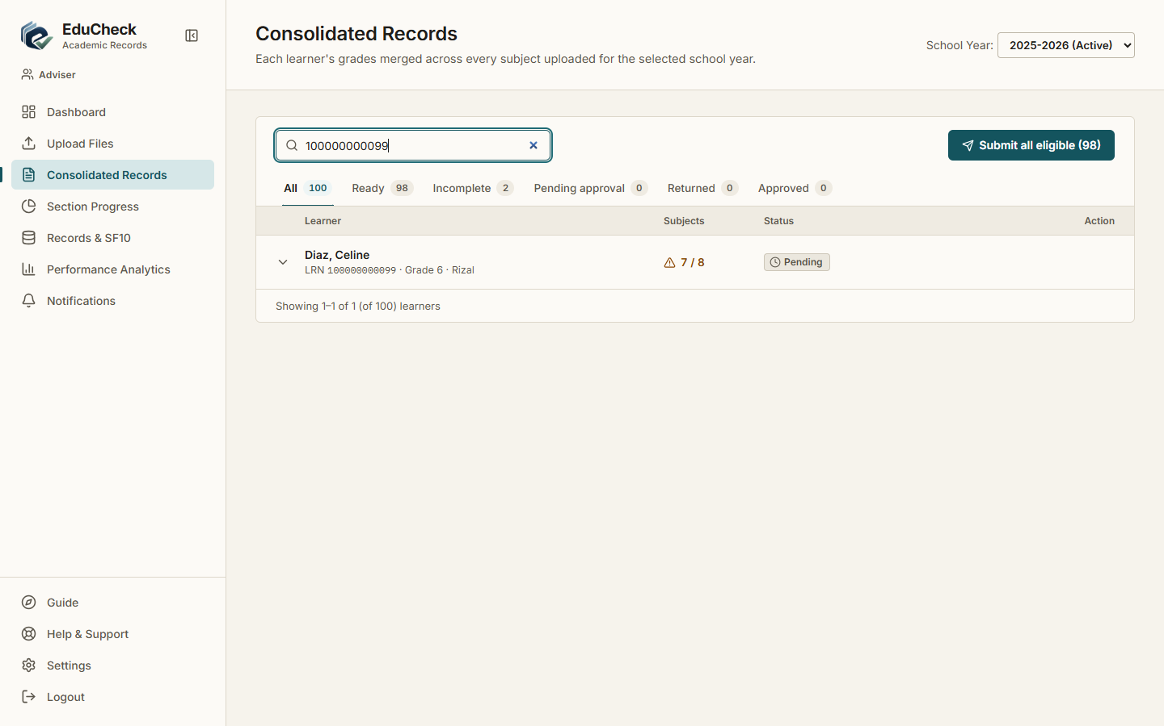
Result: Pass | 10/23/2026, 9:31:55 AM

TC-037 Submit all eligible records at once
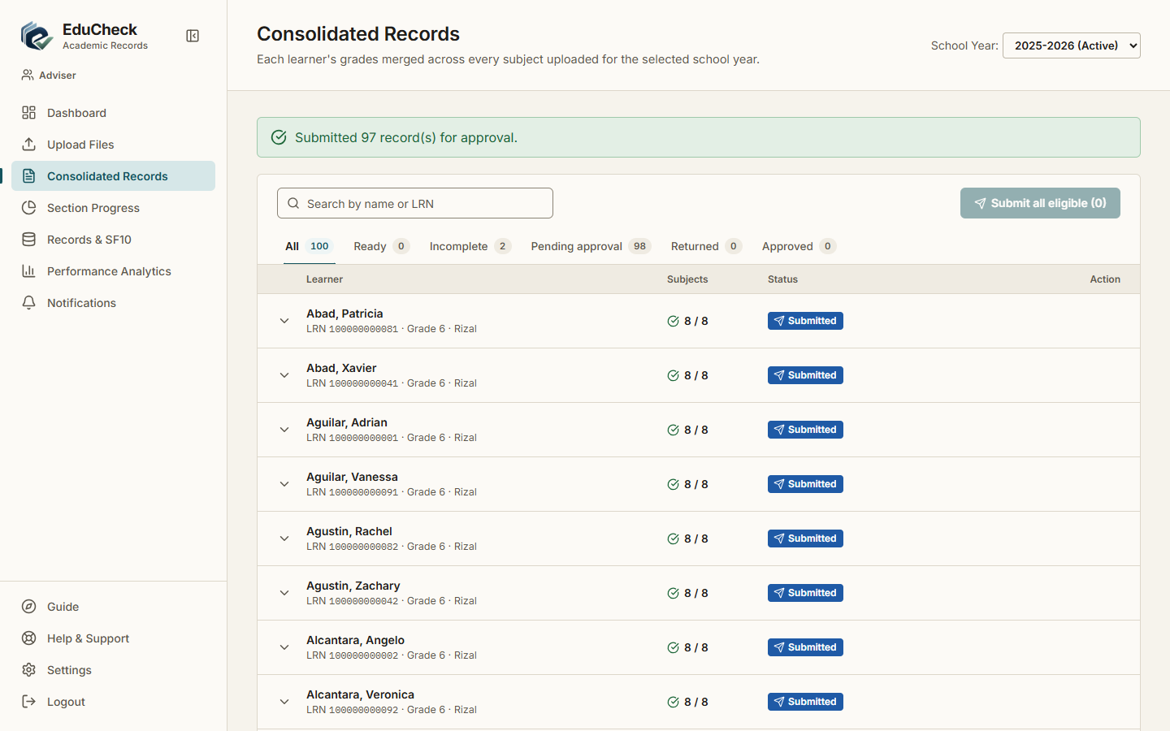
Result: Pass | 10/23/2026, 9:31:59 AM

TC-038 Section progress shows per-subject status
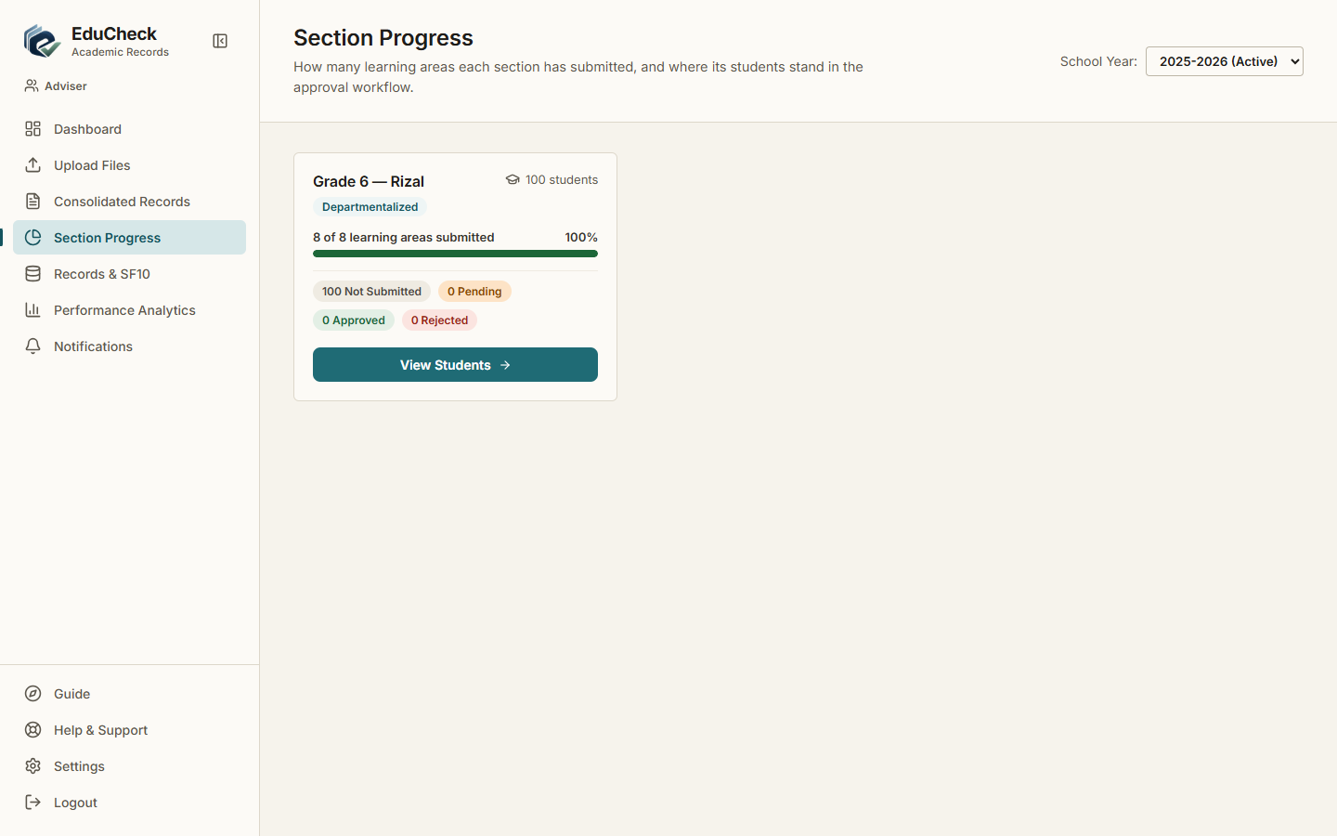
Result: Pass | 10/23/2026, 9:31:48 AM

TC-039 Approve a submitted record
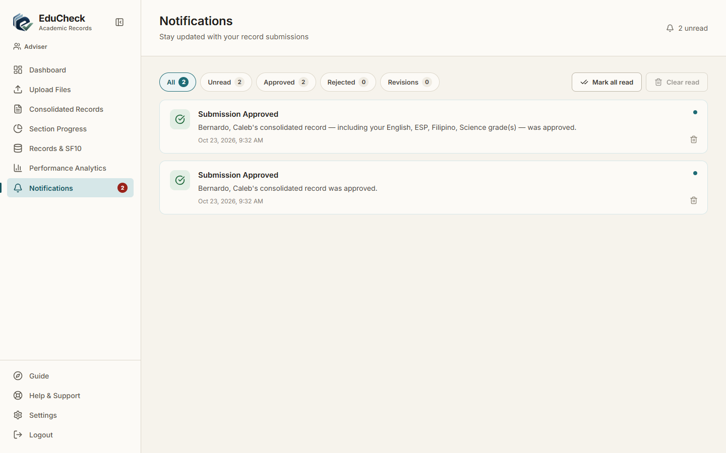
Result: Pass | 10/23/2026, 9:32:03 AM

TC-040 Reject a submitted record with a reason
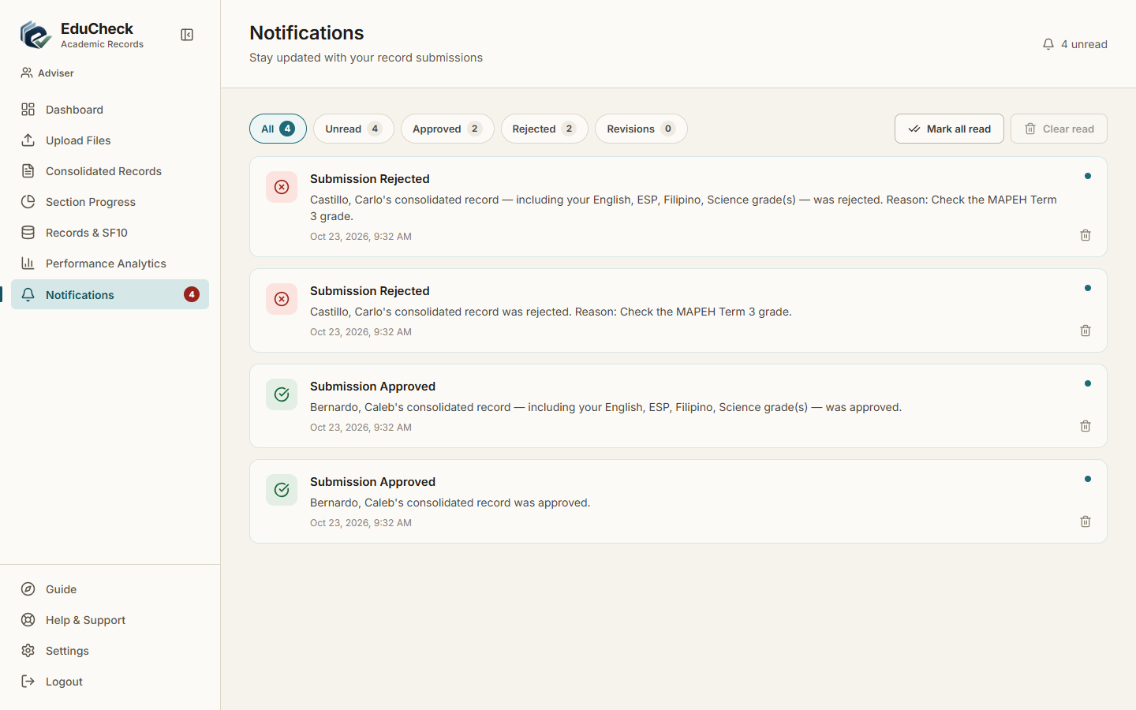
Result: Pass | 10/23/2026, 9:32:06 AM

TC-041 Approved learner is locked against re-upload
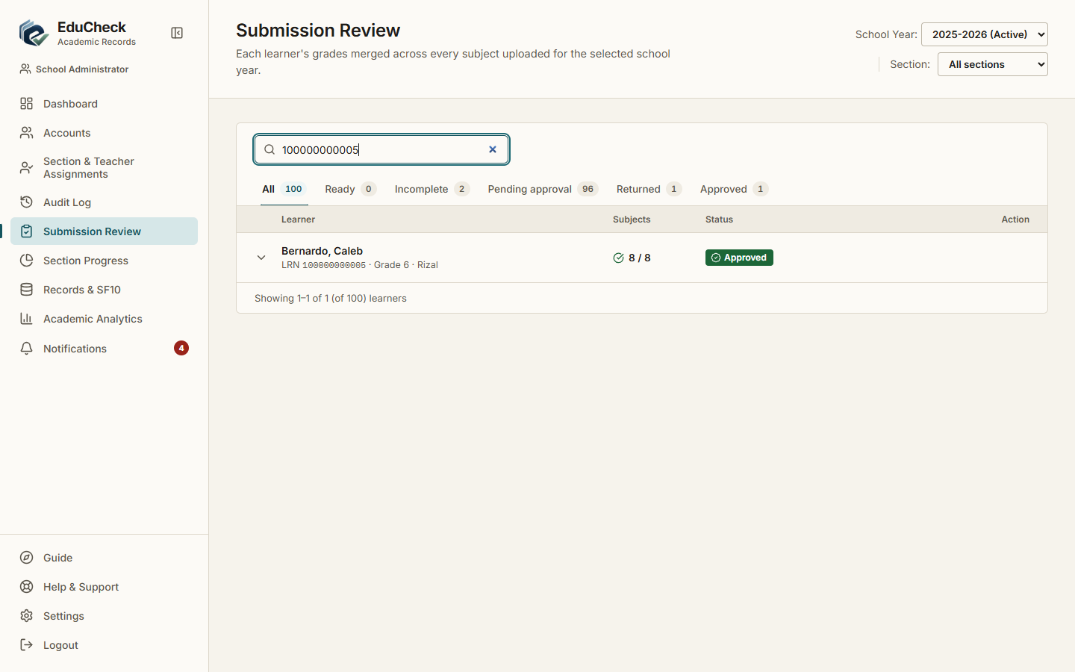
Result: Pass | 10/23/2026, 9:32:09 AM

TC-042 Request an amendment on an approved record
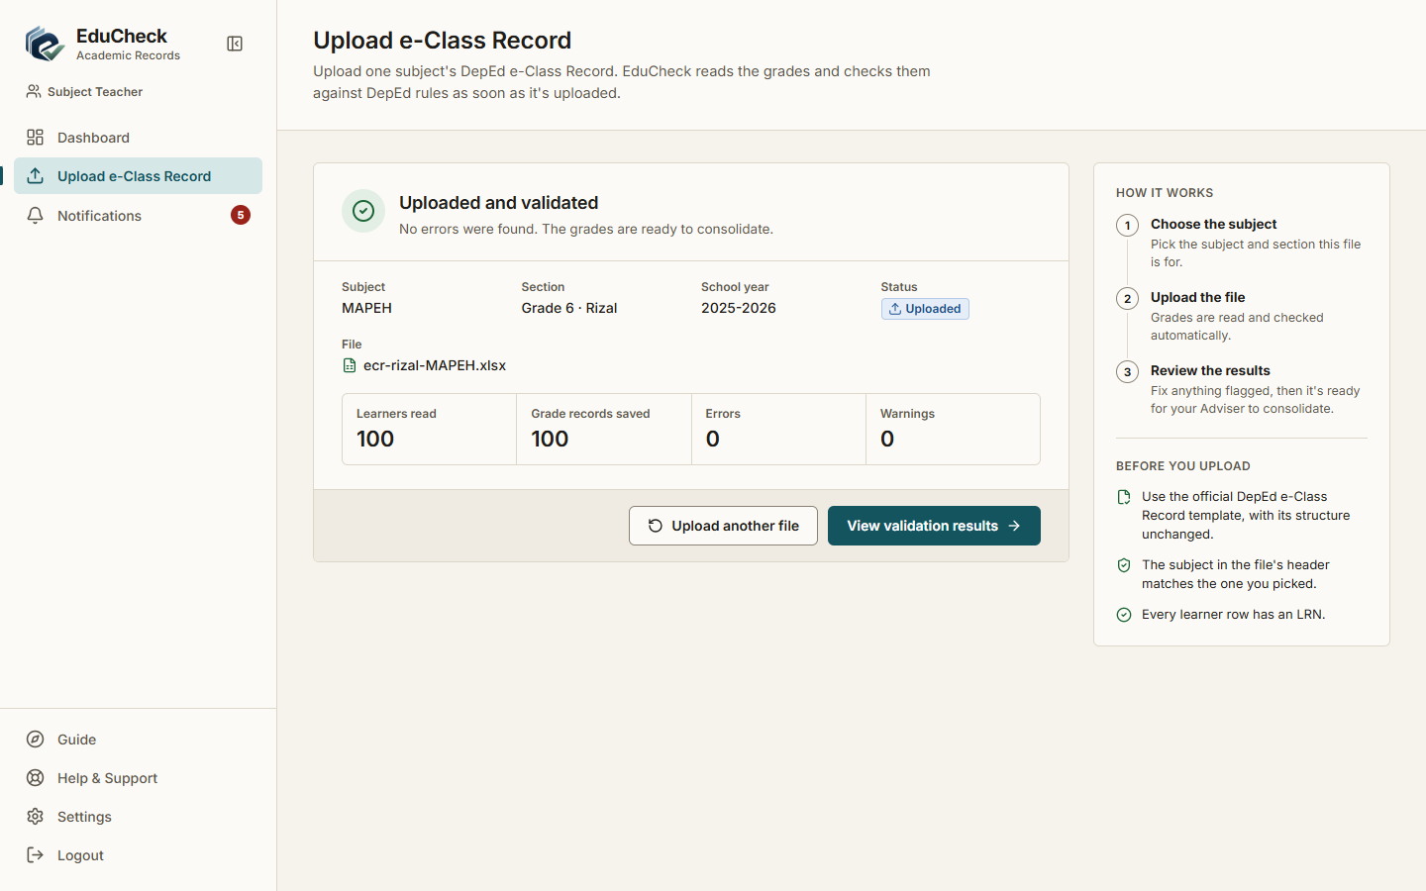
Result: Pass | 10/23/2026, 9:32:12 AM

TC-043 Principal can view school-wide data
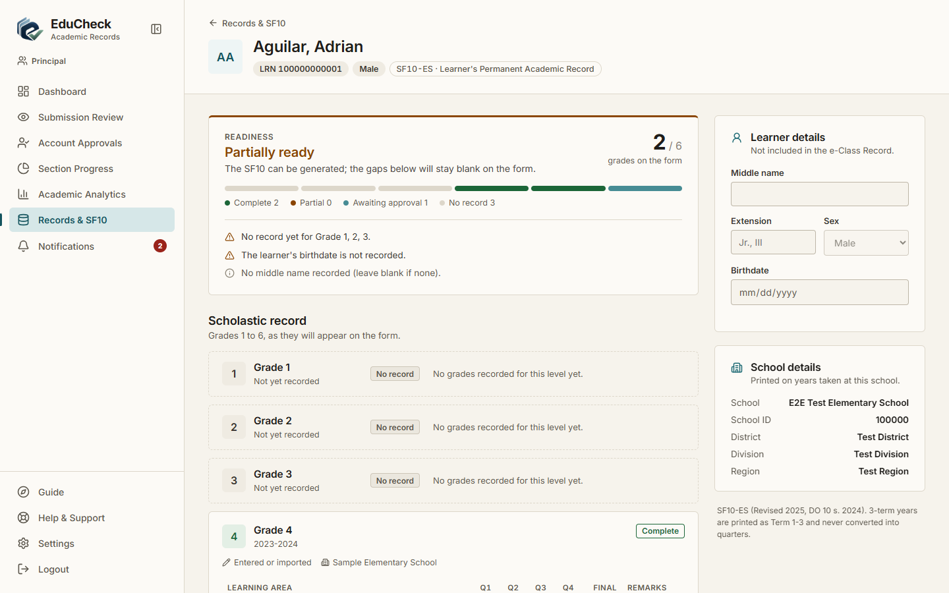
Result: Pass | 10/23/2026, 9:32:41 AM

TC-044 Principal cannot change records
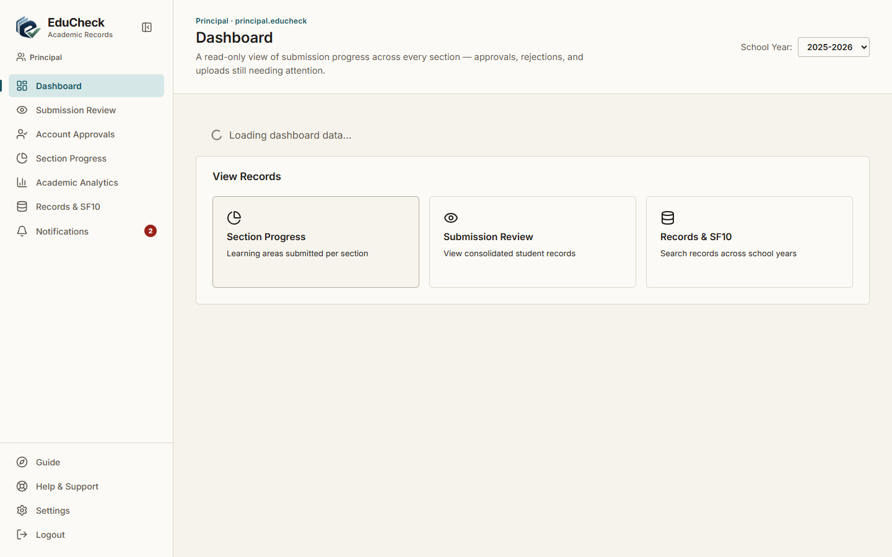
Result: Pass | 10/23/2026, 9:32:44 AM

TC-045 Search the repository
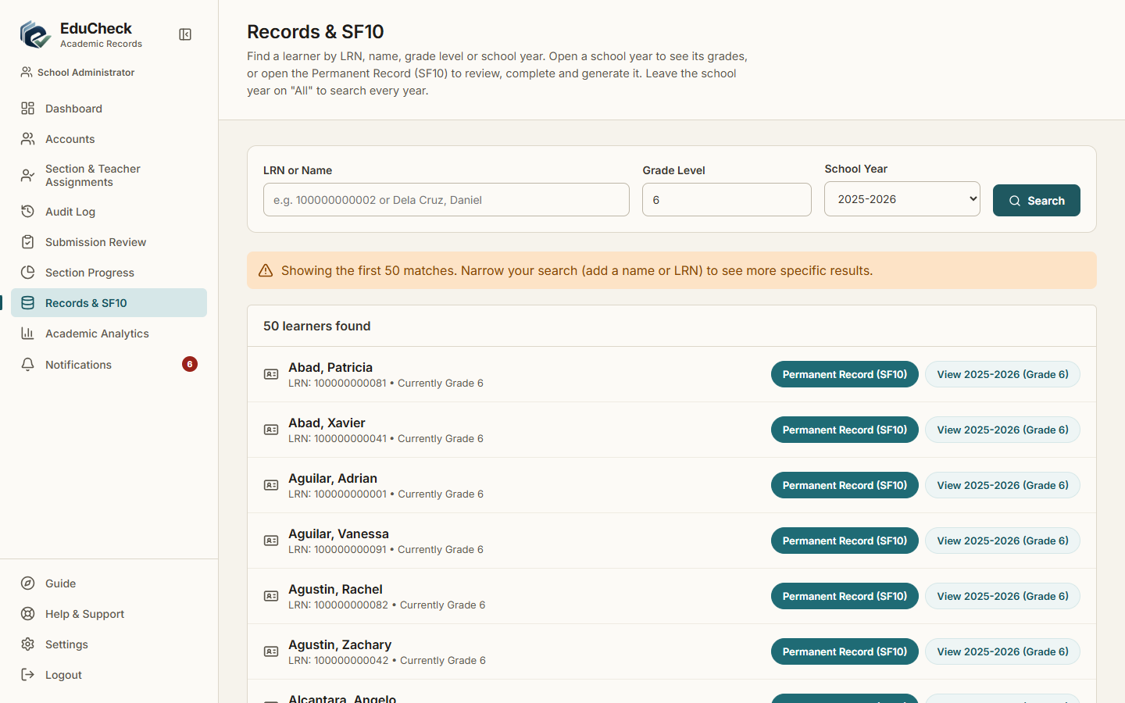
Result: Pass | 10/23/2026, 9:32:15 AM

TC-046 Download an SF10
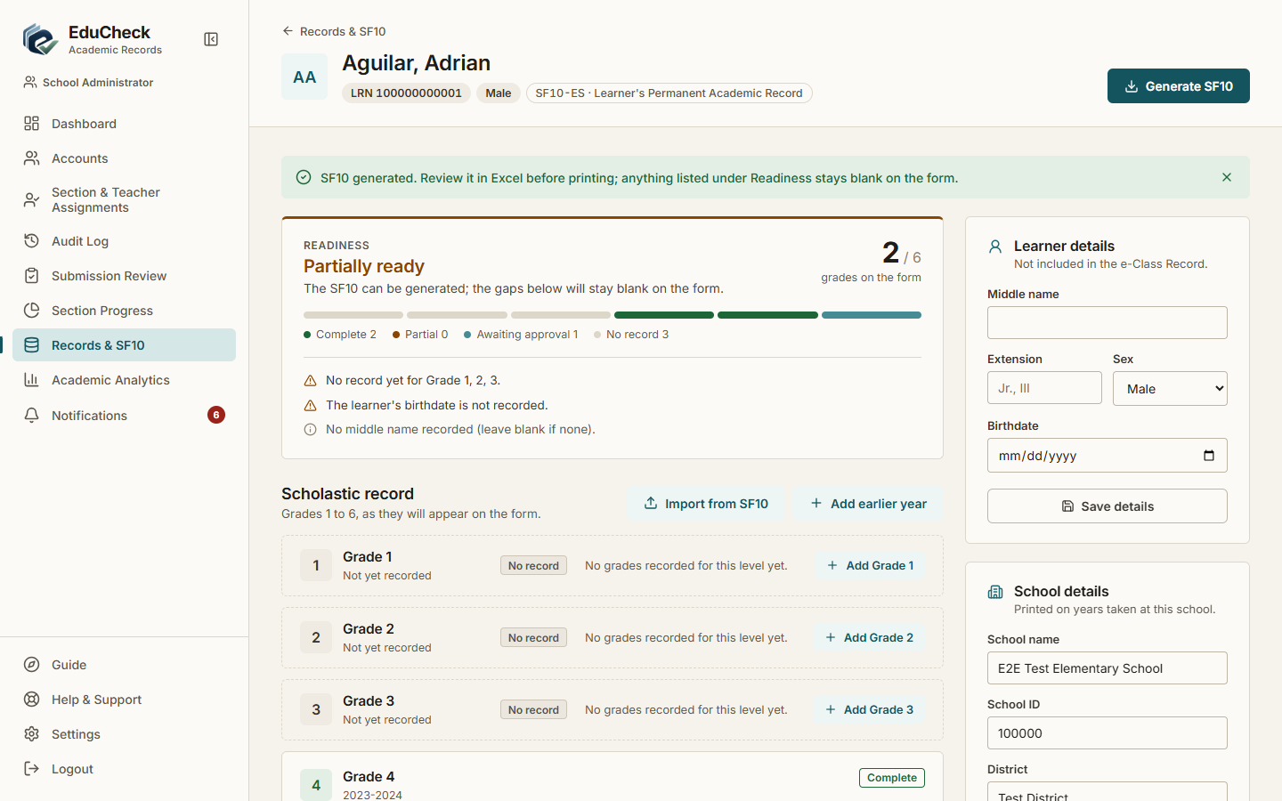
Result: Pass | 10/23/2026, 9:32:31 AM

TC-047 SF10 with no printable year shows a clear message
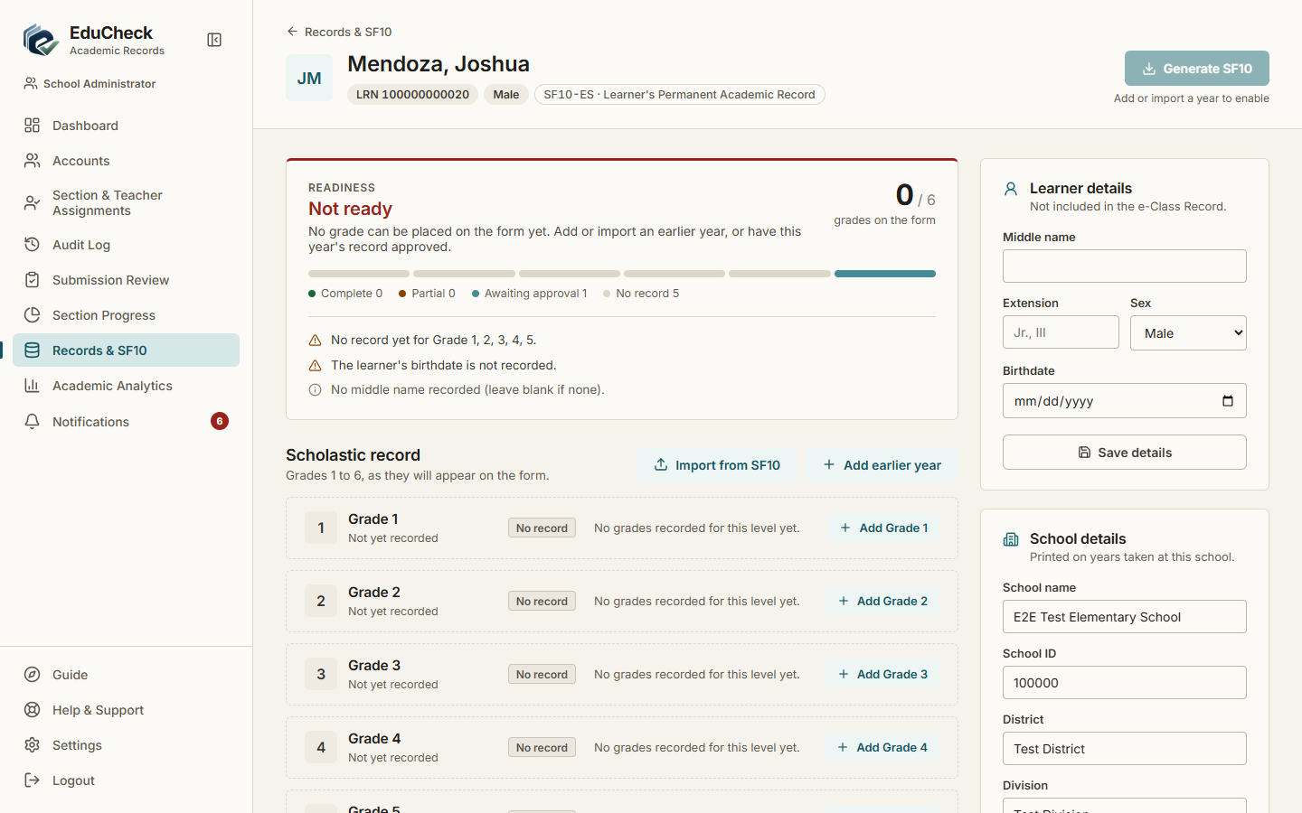
Result: Pass | 10/23/2026, 9:32:33 AM

TC-048 Enter historical (pre-EduCheck) grades
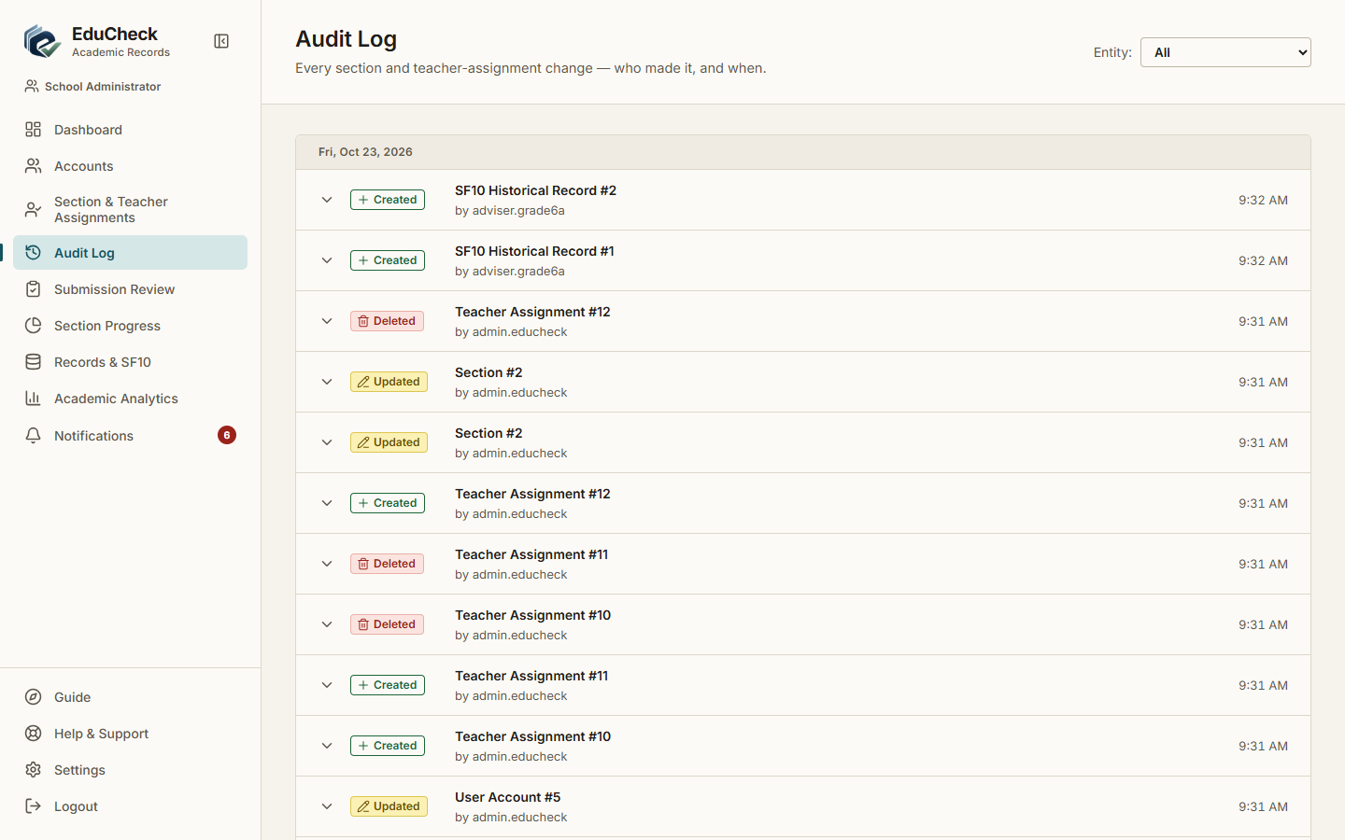
Result: Pass | 10/23/2026, 9:32:17 AM

TC-049 Invalid historical grades are refused
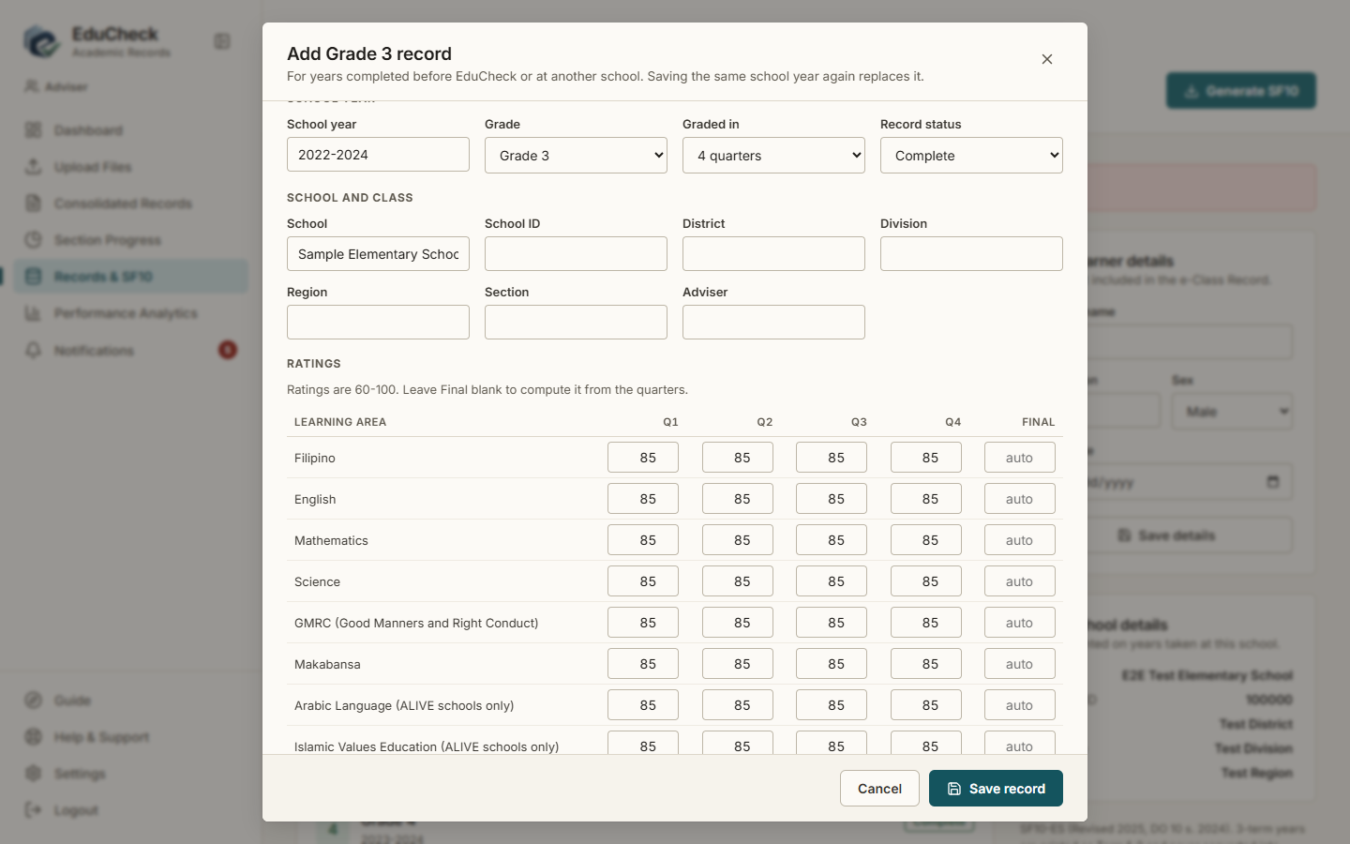
Result: Pass | 10/23/2026, 9:32:25 AM

TC-050 View academic analytics
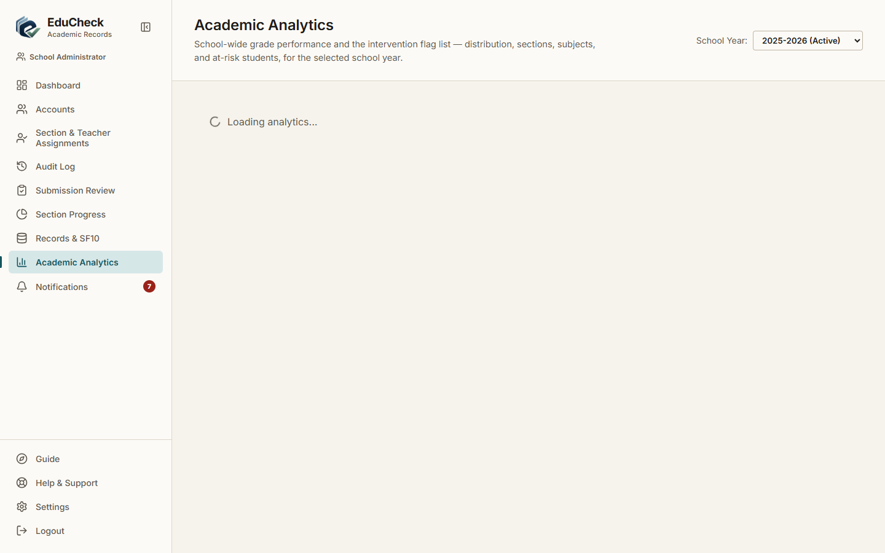
Result: Pass | 10/23/2026, 9:32:46 AM

TC-051 Notifications appear and can be marked read
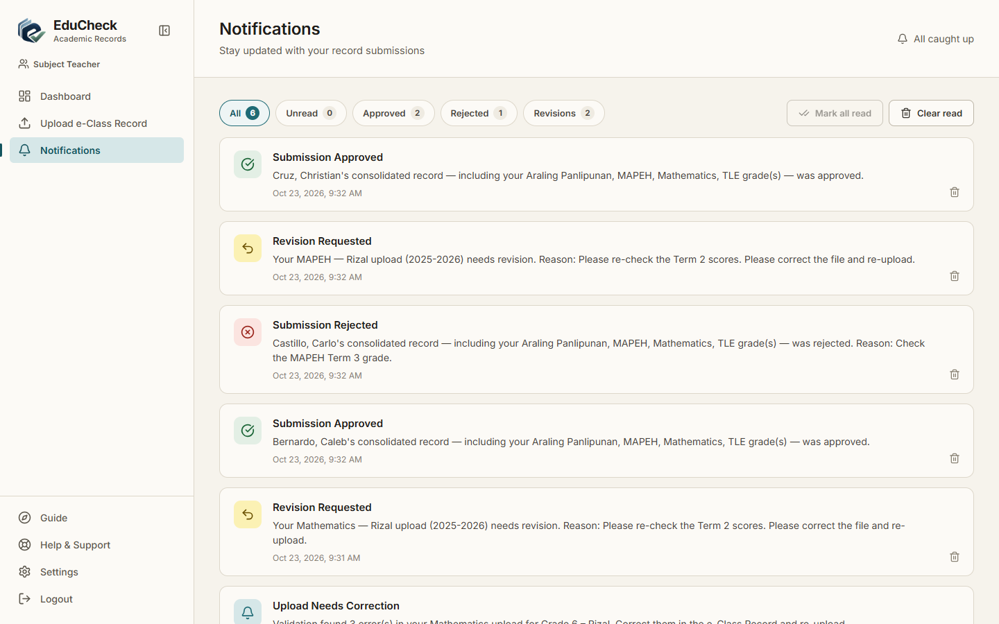
Result: Pass | 10/23/2026, 9:32:47 AM

TC-061 Upload and validation time
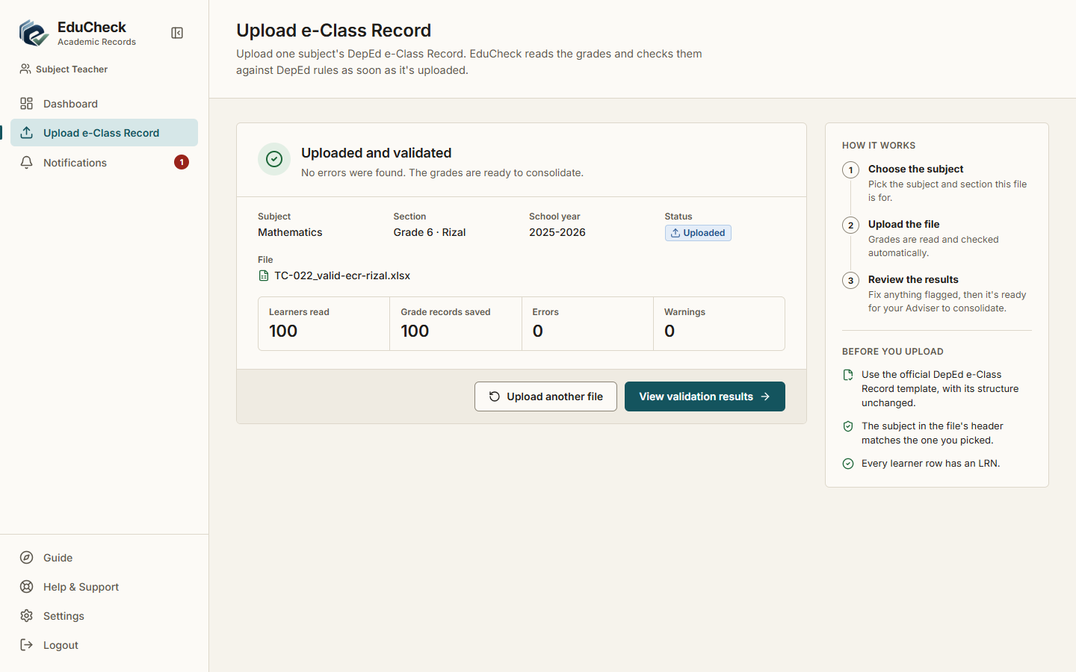
Result: Pass | 10/23/2026, 9:31:39 AM

TC-062 Page load time
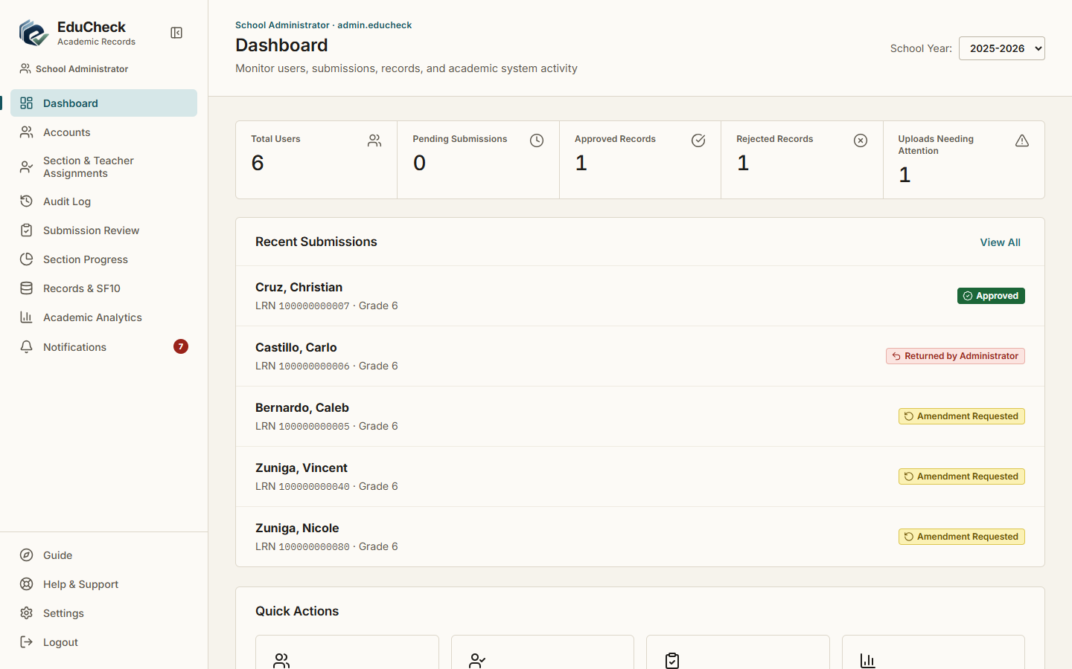
Result: Pass | 10/23/2026, 9:32:49 AM

TC-067 Session expires

Result: Pass | 10/23/2026, 9:30:15 AM

TC-068 A file for another subject is refused
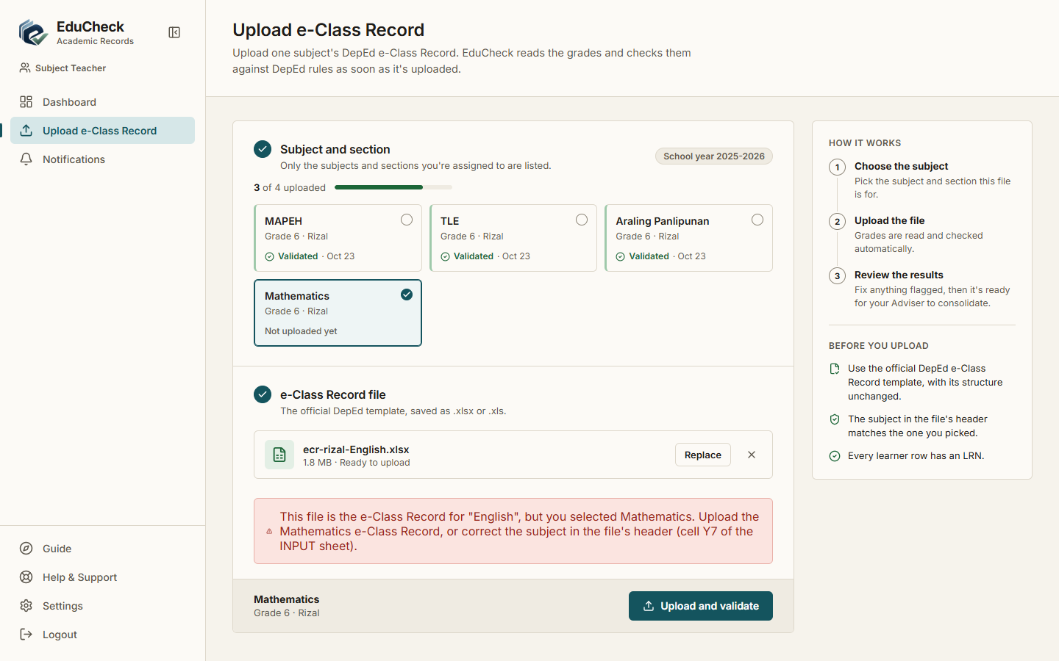
Result: Pass | 10/23/2026, 9:31:29 AM

TC-069 A 3-term year prints as Terms 1-3
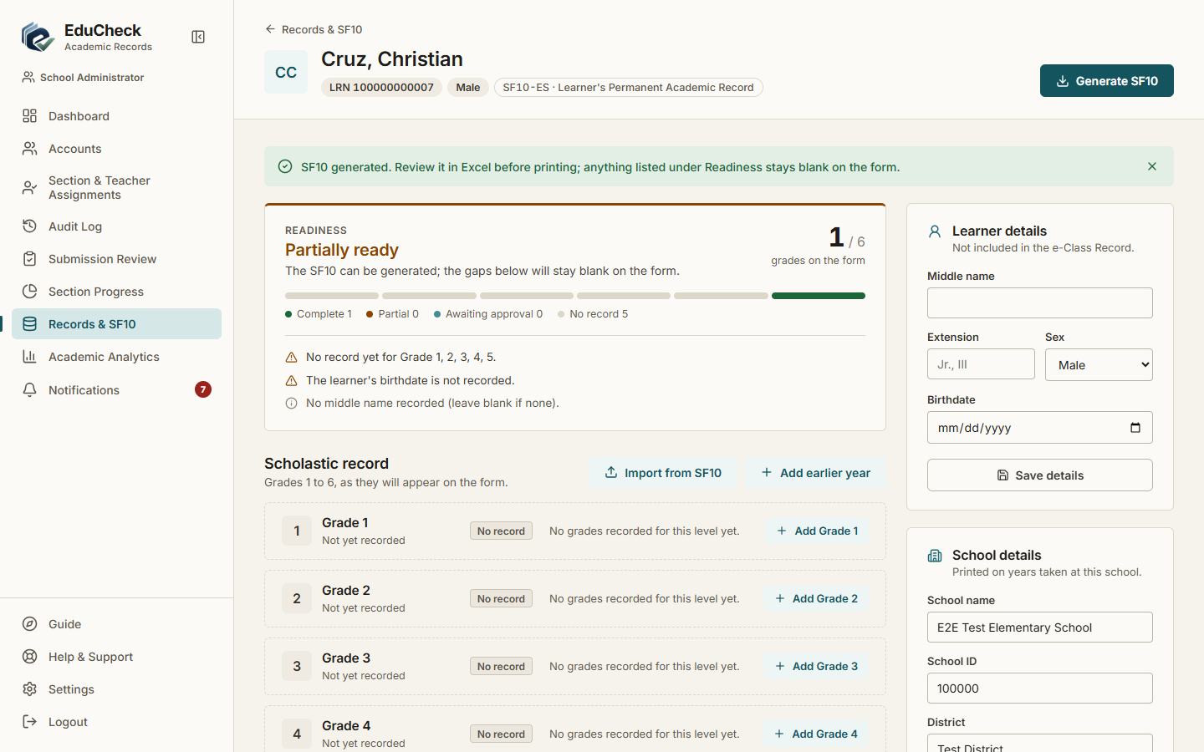
Result: Pass | 10/23/2026, 9:32:34 AM

TC-070 Import earlier years from an existing SF10 file
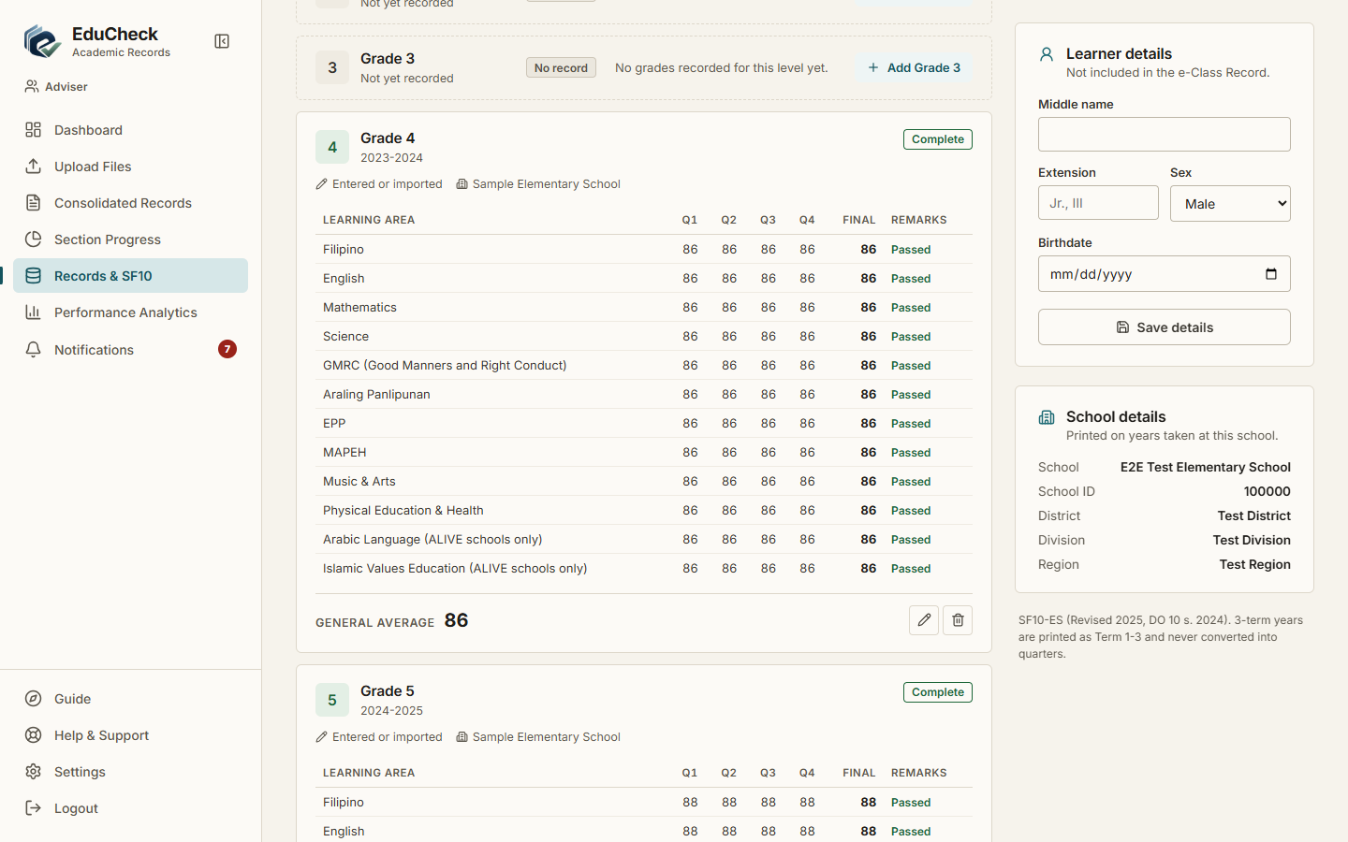
Result: Pass | 10/23/2026, 9:32:39 AM

TC-071 Import refuses another learner's SF10
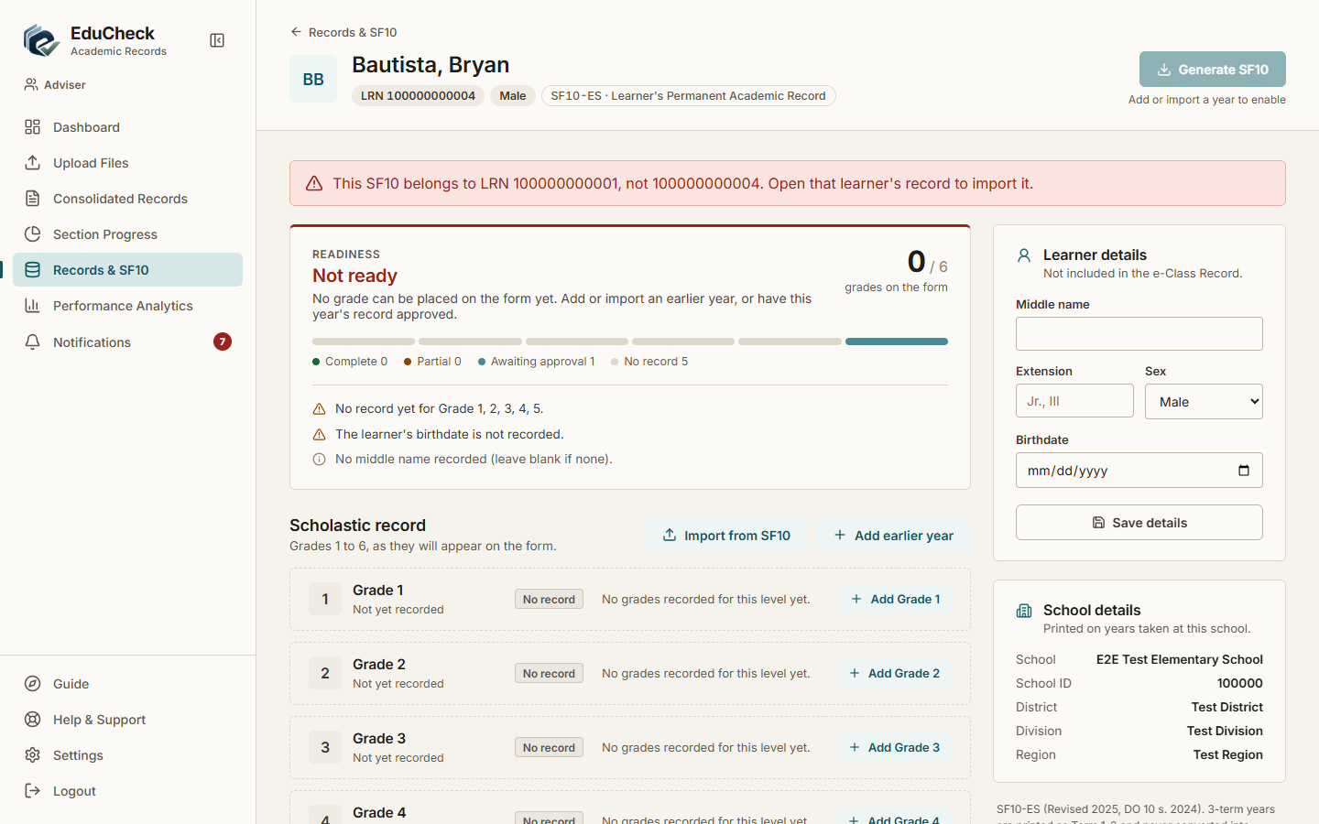
Result: Pass | 10/23/2026, 9:32:38 AM

TC-072 Only DepEd email addresses are accepted
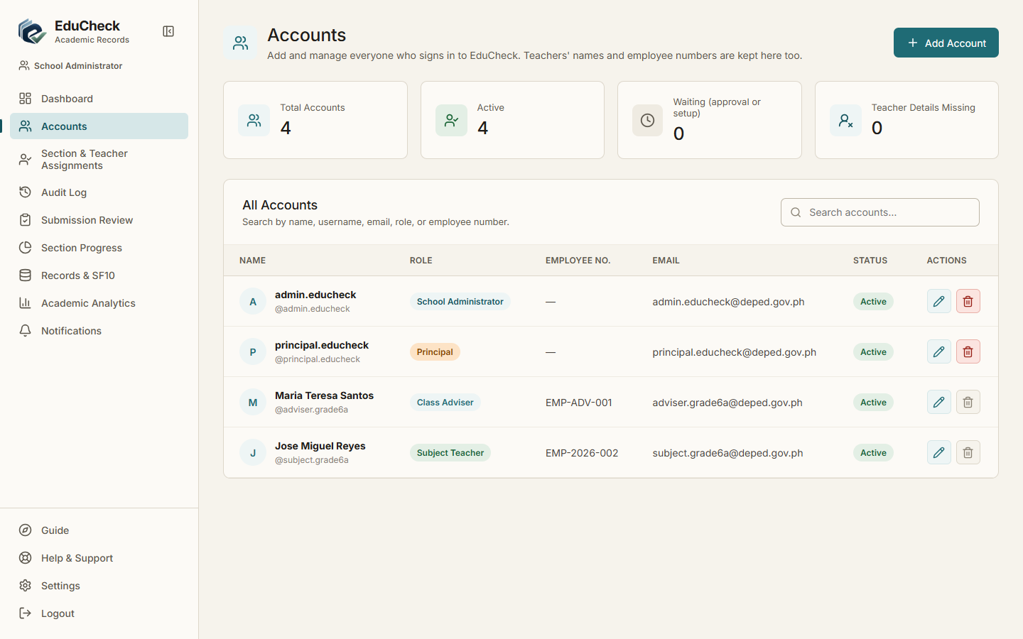
Result: Pass | 10/23/2026, 9:30:38 AM

TC-073 Principal approves a new account
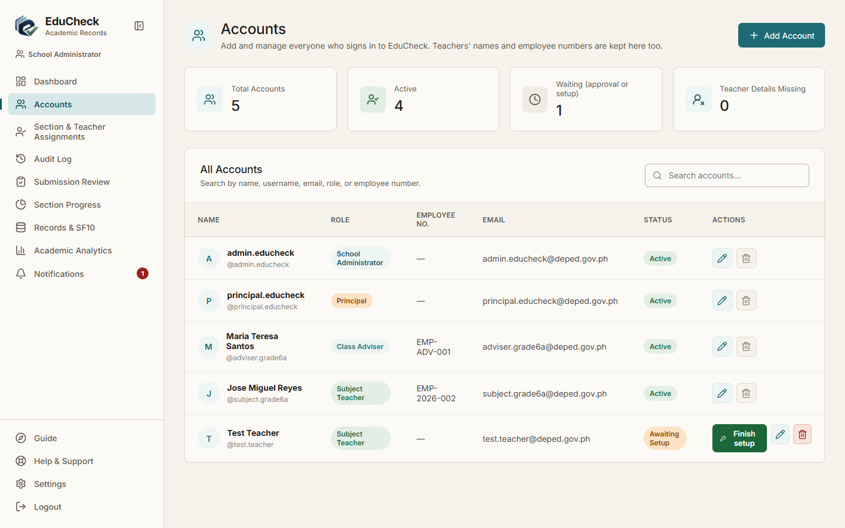
Result: Pass | 10/23/2026, 9:30:46 AM

TC-074 Principal rejects an account with a reason
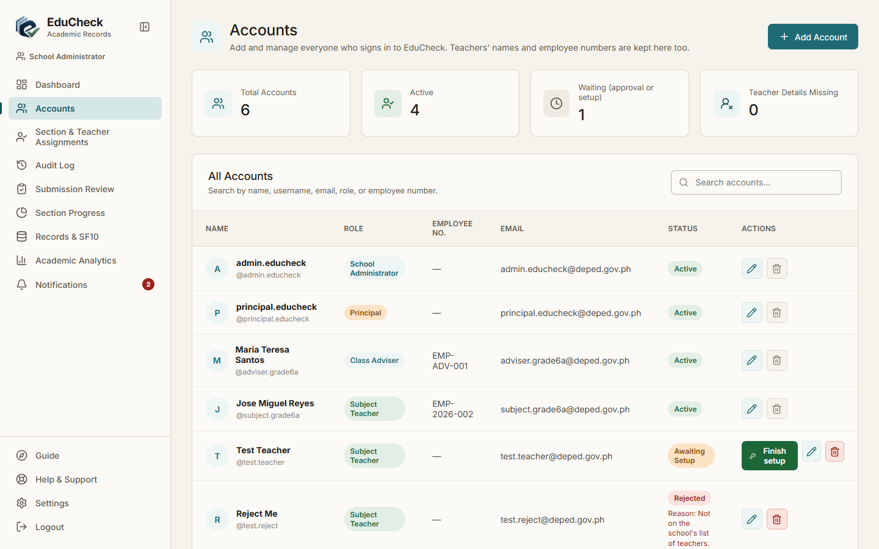
Result: Pass | 10/23/2026, 9:30:50 AM

TC-075 Admin finishes the setup of an approved account
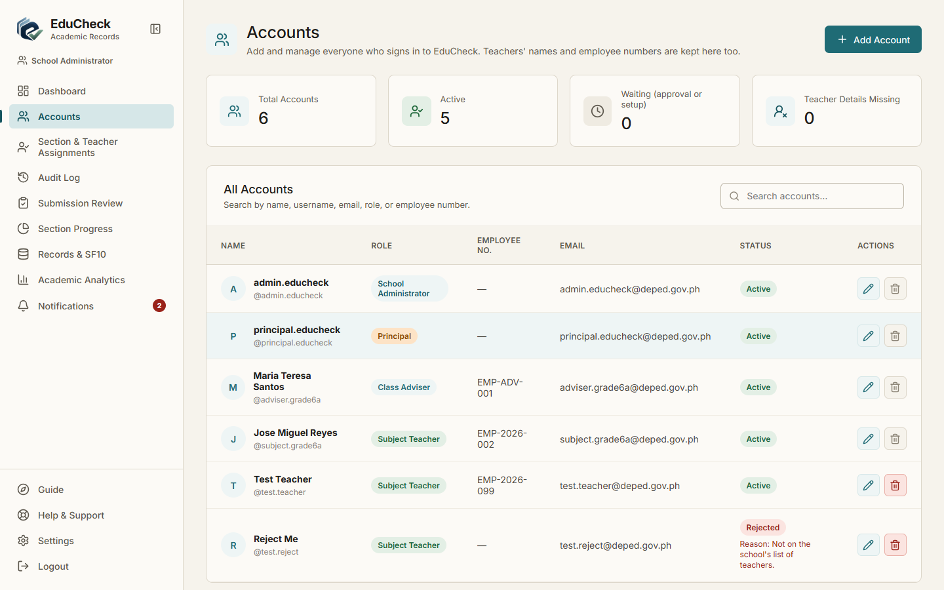
Result: Pass | 10/23/2026, 9:30:54 AM

TC-076 Temporary password must be replaced at first sign-in
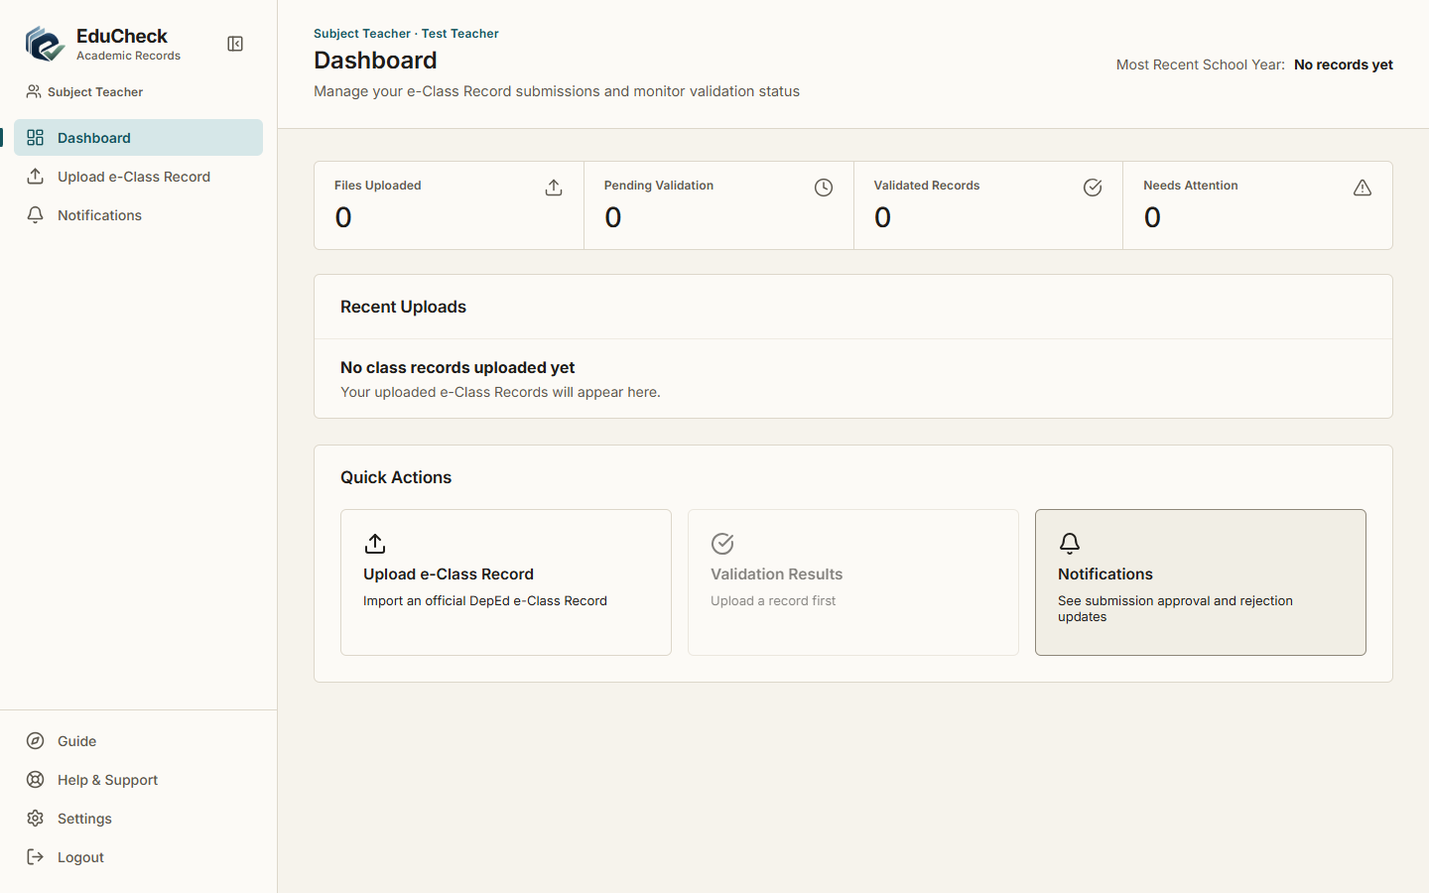
Result: Pass | 10/23/2026, 9:30:56 AM

