Nordic/Baltic Region 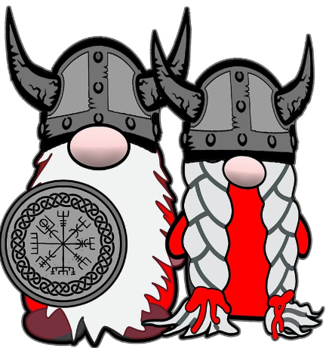 Scandinavia – 2026
updated 5/21/26
June 9 – June 25

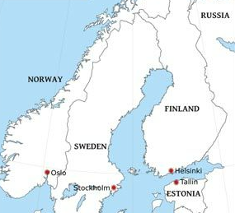

Tue 6/9 IAD/FRA/HEL
United #989 –Tue 6/9 IAD 5:20p – Wed 6/10 FRA 7:20a Seats22K/L connect UA/LUF #8735 FRA 9:40a - HEL 1:10p 6/10 Seats 6 B/C

UA Conf # J952S3 Travel Duration: 12h 50m - 8hrs IAD/FRA - 2h 20m layover - 2h 30m FRA/HEL

Priority Pass Lounges = Concourse B Lufthansa or Turkish Capital One Lounge main terminal
Itinerary locations in BOLD are saved on Google maps.

------------------------------------  Helsinki, Finland -------------------------------------
“Cool Architecture, Saunas and Happy People”

HEL = Helsinki Airport | Finavia - https://www.youtube.com/watch?v=DCIsFoVjhpA
Express Train 30 min, runs every 10min 24 miles to Helsinki Central Station. Need Zone A,B,C ticket. HSL app
Airport to Helsinki Central Station. €5 buy ticket down on platform. Take “P”32min or “I”28min train.
Helsinki Travel Guide - Finland https://www.myhelsinki.fi/
Helsinki-
3 ½ days/ 4 nights Wed 6/10 – Sun 6/14
Temp – 70ish day / 55 night sunrise 3:59a- 10:42p = 18 ½ hrs sunshine 7 hours ahead of DC

Wed 6/10 – arrive HEL at 1:10p

Hotel –

Lapland Hotels Bulevardi – Mystique Deluxe rooms #715 and #815

King/French Balcony/Sauna, Breakfast , early check in 2p , Nathalie Huber GM Nathalie.huber@laplandhotels.com
LAPLAND HOTELS BULEVARDI - KULTÅ KITCHEN & BAR - Mystique DeLuxe French Balcony Room (4K)
------------------------------------------------------------------------
- Amos Rex Museum – very cool modern experimental art underground museum 22€ 11a -8p
- Kamppi Chapel – Chapel of Silence next to Amos Rex. Atypical modern design church/very unique
- Hakaniemi (Old Market) Market Hall- Central Market near Market Square & Harbor
- Souomenlinna Island Sea Fortress Unesco Site The official website of Suomenlinna –15 min ferry from the Market Square. €3 one way HSL ferry (need AB ticket) leaves from Market Sq docks. Runs 24 hrs. Market Square, Helsinki | Stromma Departure Point

Thu 6/11-
Helsinki Synagogue Tour – 10a-11a 10€ pp donation Malminkatu 26 - srk@jchelsinki.fi. significant symbol of Jewish culture and community in the Finnish capital. it's one of just two synagogues in Finland, Helsinki's 1,200-member Jewish community. Built in 1906…Kosher Reindeer?

Helsinki – Private Highlights and Hidden Gems – 3 hr WithLocals - Anna +358 44 3553304
11:15 – 1:15- lunch 1:15-2:15- 2:15 – 3:15
Meeting point –Stockmann Department Store main entrance, under large clock
Highlights & Hidden Gems of Helsinki - Withlocals video - Helsinki, Finland Walking Tour 4k – With Captions

- Design District/Design Museum – immersive experience into the world of Finnish Design. Compact area of nearly 200 design forward establishments. Sustainable and vintage design
- Dinner in Design District- Design museum, shops/cafes. Yes,Yes,Yes-Vegetarian

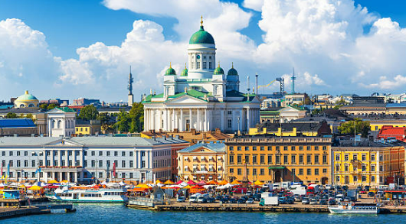

Fri 6/12
Helsinki Day Celebration - Helsinki Day – the City of Helsinki's birthday | City of Helsinki
Helsinki Day has been celebrated every year on June 12 since 1959. It is the birthday of the City of Helsinki, and when King Gustav Vaasa authorized the settlement of Helsinki in 1550.
Main event at Kamppi Narinkkatori and Lasipalatsi Squares featuring live music, film screenings, sports activities and participatory art. Around 250 free events including City Life photo exhibit

- Buleevardi –-Restaurants, cafes, boutiques, galleries. Stop in at Café Eckberg
- Esplanadi (Espa) Park Center of activity/concerts. Market Sq and Harbor at end
- Kotiharjun Sauna – Oldest public sauna 1928
- Temppeliaukio Church/ The Rock Church- carved directly into solid rock, one-of-a-kind architecture
- Allas Pool – Finn sauna culture. combines urban culture, relaxing by the water and live music. surrounded by the sea, saunas and sea water pools.
- Marimekko designer – Flagship Store on Esplanadi
- Tavastia – legendary music venue, one Europe’s oldest rock clubs (near Amos Rex)

Paja Workshop – Design and make your own your own leather, silver jewelry or ring from 1 to 3 hrs in authentic Finnish workshop https://www.pajadesign.com/ Located in Kamppi neighborhood, Eerikinkatu 18

Finnish Food
- Salted liquorice, or salmiakki, popular in Finland. It can be found in practically every variety bag of sweets sold in Finland and is an ingredient in chocolate, ice cream, and liquor among other thing
- Leipäjuusto, often referred to as squeaky cheese, is one of Finland’s most intriguing traditional foods. Its name literally means “bread cheese”. Typically served warm and paired with honey or cloudberry jam, it is a delicacy that surprises and delights in equal measure. Cheese has a mild flavor, a springy texture, and that unmistakable squeak against your teeth as you chew. It holds a special place in Finnish culture
- Karjalanpiirakka - savory Karelian pies. rice porridge surrounded by a rye flour crust, baked until slightly browned. these pastries are often eaten at breakfast or lunch. Delicious topped with ham, cheese, or just (real!) butter.
- Mustikkapiirakka, blueberry pie, is more of a cross between a pie, a tart, and a cheesecake than a traditional pie.

Restaurants/Coffee/Dessert/Bars
- Café Ekberg - the oldest coffee shop in Helsinki
- Johan & Nystrom - Coffee shop/Hot chocolate Rosemary and dark chocolate,
- Café Regatta- cinnamon rolls and kayaks/canoes
- Cheri Chou- exciting pastries St George Bakery - Pastries, sandwiches, smoothies -with terrace view
- YesYesYes -Design District - vegetarian restaurant with vibrant atmosphere and seasonally changing menu. kitchen makes all from scratch, ingredients from local farms.
- Daddy Greens Pizza Bar - Funky top rated/Brick oven - in Design District,
- Ristorante Argegno- highly rated Italian
- Bar Mate –loft style bar/Design district
- Solo Sokus or Torni (Ateljee Rooftop highest in city) Hotel rooftop bar – very high view city
- Tipping – Not expected. But some restaurants are starting to offer option.

Transportation
Helsinki-Vantaa Airport
- HSL App – Transportation App Public Transport in Finland - Step-by-Step Guide for Tickets & Routes!
- Helsinki Transport Card - Helsinki Card – Sightseeing & Excursions | Stromma.com
Helsinki zone is A. Airport is zone C. So going from airport it would be a ABC ticket. Valid for 80 minutes
- Can buy a day pass that works on all city transport.
- App details options/shows map when using “Route” search
- Tram #2 – great sightseeing. Passes Old Market Hall, Market Sq, Senate Sq, Amos Rex museum and Kamppi
- Uber and Bolt
Weather: Summers are mild but it can rain—best dressed is layers and a waterproof jacket.
Currency: €uro Hello = Hei “hay”, Thank You= Kiitos “Kee-toss”, “uhn-teehk-si”

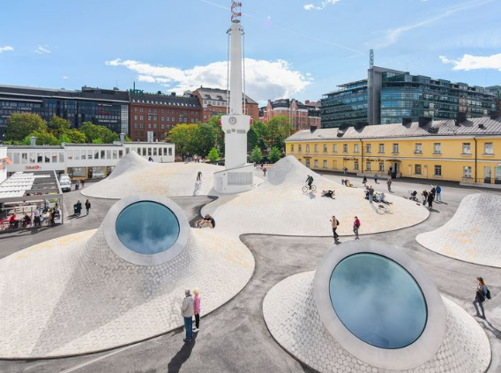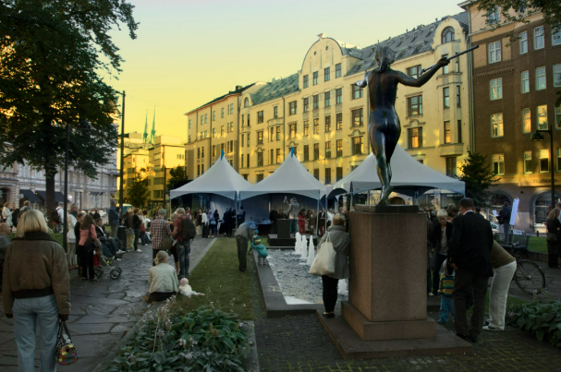

--------------------------------  Tallinn, Estonia  ---------------------------
“Baltic/Scandinavian/Eastern European Culture & Hanseatic Heritage”
Sat 6/13- Day trip from Helsinki (7:30a- 6:30p) - 2 hour ferry each direction https://visittallinn.ee/
From Helsinki, Finland to Tallinn, Estonia by ferry across the Baltic sea - Tallink Mystar

Ferry Megastar– Large ferry/10 decks/ very nice like cruise ship-pub/coffee shop/restaurant
Waiting lounge very modern nice/big has food/coffee. Viewing deck to sit out and see view ferry activity. Luggage lockers on ship €3 small, €5 large, in/out privilege

Tallink Megastar 43.80€ x 2 = 87.60€ / $103.14
Depart 7:30a -9:30a Return 4:30p -6:30p
Helsinki to Tallinn ferry - one-way & return trips
Helsinki→Tallinn Megastar →Check-in latest 07:00 West terminal 2
Tallinn→Helsinki Megastar →Check-in latest 16:00 D-Terminal
Online check-in can be completed online or through the Tallink Silja Line app from 24 hours up to 30 minutes before departure. At the terminal, we recommend using the self check-in kiosks. Please note that the service desk at the terminal charges a fee of 5 €. The gate closes 20 minutes before departure, so make sure to arrive at the terminal with enough time.

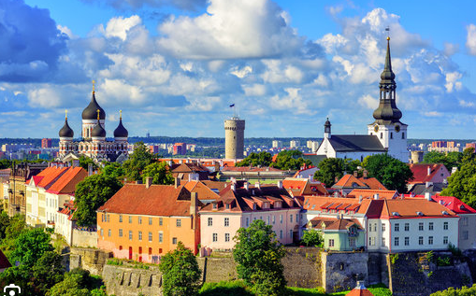

Tallinn– Private Highlights and Hidden Gems – 3 hr WithLocals- Anna +37255612877
10:00a-1:00p Meeting point – Freedom Square in front of the Jaani Kirik church
Highlights & Hidden Gems of Tallinn - Withlocals video - Tallinn, Estonia Walking Tour 4k - With Captions

- *Old Town Sq- Town Hall 700 years old
- *Seaplane Harbor Museum - very unique/Lennusadam Museum- Giant old Seaplane hangar. Full size 1930 submarine you can walk through. Interactive. Boats display drydock at the harbor are free to go on.
- Old Town Defense Tower 14th century – climb Fat Margaret Tower/maritime museum
- Raeapteek - one of Oldest continually open pharmacy 600 years next to Town Hall. Has small free museum- medieval medicines. Picture inside at face cutout board.
- St. Catherines Passage/Monks Alley
- Fortification (Kiek in de Kok) – Museum Climb Maiden Tower and walk city wall/Kicking the Cat Cannon Tower/Bastion Passages- go down underground 13-14th century passages engraved stone slabs and tombs
- Street Art City– cool art.
- Calamaya Area (slightly north of old town)– trendy area / KGB Prison Cells
- Lucky Chimney Sweep Bronze Statue- rub all his buttons for good luck and the Black Angus outside Goodwin Steakhouse
- Soviet era antique stores transport to 1950’s

Estonian Food –
- Estonian Dark Rye/Beetroot Soup/Marzipan/Estonian version of cheesecake
- Olde Hansa Restaurant – 15th century Purely Medieval no electricity, all candles, everyone dressed in medieval clothing. Three floors. Big menu-Herb,Honey or cinnamon beer/sweet almonds/Mushroom Soup w/bread loaf. Troubadors playing. Peppersack another restaurantDefinitely stop in and check out.
- Pulla Bakery – next to Old Town Square- Bun shop

---------------------------------------  Helsinki, Finland -----------------------------------
Sun 6/14-
Flight to Sweden - Helsinki (HEL) 10:10a to Stockholm (ARN) 10:10a
Finnair AY807 (OneWorld Alliance) $246.40 = $92 flight + $23 taxes + $8.20 seats x 2

Priority Pass - Helsinki
OP Lounge gate 22 and 27 or Aspire Lounge gate 13
Helsinki Vantaa, 05:00 - 9:00 daily
Airside - Schengen Area. Lounges access is for Schengen and Non-Schengen passengers. relaxing atmosphere with high-quality service, food, and drinks. premium amenities.

------------------------------------ Stockholm, Sweden -------------------------------
“Capital of Scandinavia/Design & Creativity/ ABBA”

Stockholm Arlanda Airport - From airport 24 miles north of (20 min to downtown $35 one way) take Arlanda Express train. Buy tickets at yellow kiosks. Cheapest Way to Travel to Stockholm City from Arlanda Airport | 42 SEK to T-Central Uber 65-75 € /$75-$87

Stockholm- Ostermalm, Norrmalm, Gamla Stan, Sodermalm, Djurgarden
4 ½ days/ 5 nights Sun 6/14 – Fri 6/19 Stockholm is one hour behind Helsinki
Temp – 70ish day / 55ish night / low chance rain / sunrise 3:33a-9:04p = 18 hrs sunshine Civil Twilight – light all nightlong Stockholm Vacation Travel Guide | Expedia https://www.visitstockholm.com/ Stockholm, Sweden Walking Tour 4k - With Captions

Hotel –
Sparrow Hotel – Superior “Double” King, City view, Top Floor, Boutique
King, Breakfast, Early Check in Mohamad / GM Christian Herslow
Elegant Hotel in Stockholm | The Sparrow Boutique Hotel

-----------------------------------------------------------------

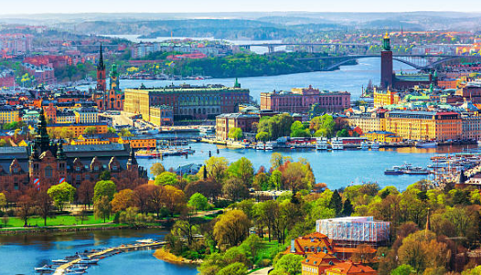

Sun 6/14 – Sodermalm Island
Stockholm – Private City Tour /Gamla Stan 3 hr WithLocals - Zenid +46701768735
12p-3p Meeting point – In front of Stockholms Gästabud restaurant Österlånggatan 7,
Withlocals Your Way! - Stockholm City Tour - Withlocals
Gamla Stan/Norrmalm/Ostermalm quarters, Nobel prizes (concert house), Murder of Olof Palme, Queen Street/ Drottihngham, Parliament, Swedish Welfare System, Royal Family, Stockholm Syndrome, Ruestones, Stortorget Sq 1420, Prastgatan Alley

- Judiska Museet/Jewish Museum- 1hr Stockholm Pass- Gamla Stan located in oldest synagogue 1700’s the first Jewish-Swedish immigrants to the country and how they adjusted to life in Sweden from the 18th Century onwards. Learn how the law decreed how the community lived and behaved and why it stated that Jewish peoples were a nation of their own. 11-5 Sun cl-Mon 11-7 Tue/Wed 11a-8p Thu
- Swedish Viking History Museum – Stockholm Pass/Go City Interactive, worlds largest, 2,500 items
- Sodermalm district (island) trendy galleries and boutiques, eclectic cafes
- Drottninggatan(Queen Street)- Main street of Stockholm
- Monteliusvagen – great sunset views overlooking the water and city backdrop. Green grass like Porto. Bring picnic. scenic walkway located along the Södermalm district. It offers amazing panoramic views of the city skyline, the waterfront, and historic landmarks. trees and benches, strolls and photography.
- Kings Garden – restaurants and walking promenade/fountains, Spotify – Regeringsgatan 17

Mon 6/15- Stadsholem Island
Stockholm Full City Multi Islands - 2 hr 9a-11a Viator
Meeting point - Skeppsbron 25, Gamla Stan Stockholm Full City Multi Island
- Gamla Stan cobblestone streets, medieval buildings, and historic sites. 1252 .
- FIKA in Gamla Stan– Swedish tradition of taking a break to enjoy coffee w/pastry or sweet treat. Traditional Swedish Fika at Systrarna Andersson - The Swedish art of Fika, pronounced "fee-kuh", is one of the country's most cherished customs Pause for a fika; drink coffee, eat cake and relax
- Nobel Prize Museum – 1hr Stockholm Pass Gamla Stan Square. The prestigious Nobel Prize is a world event and, since 1901, has been awarded to more than 950 people (and organizations) for their achievements in medicine, literature, physics, chemistry, economics and peace. Learn about the Nobel Laureates and the founder, Alfred Nobel, self-guided tour , interactive exhibits with audio commentary
- Storkyrkan /Stokholm Cathedral - Stockholm Pass – unique Scandinavian architechture. Located in medieval Old Town, Storkyrkan Stockholm Cathedral is the mother church in Stockholm and dates back to the 1300s. The Cathedral has been at the heart of religious and political life in Sweden. Royal weddings and the opening ceremony of the parliament every autumn.
- The Great Synagogue – Kings Garden- Wahrendorffsgatan 3A– menorah donated by King Gustav 1792
- IceBar- Stockholm Pass - In Hotel C next to Central Station – 30-60 minutes duration entry- includes drink in ice glass. Complete room is ice kept at 23 degrees. 11a-11p. 11-2 less crowd, 5-7 lively /pre-dinner. Capes and gloves provided. Buy through Hellotickets or Tickadoo apps

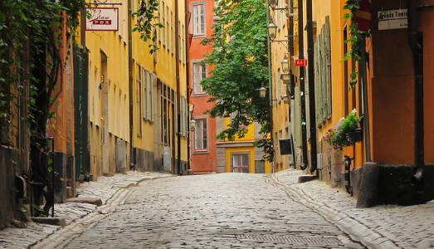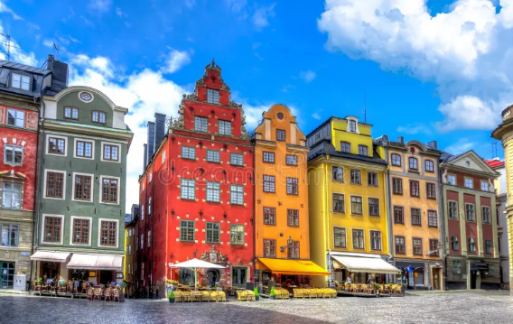

Tue 6/16- Djurgarden Island
- Vasa Exhibit/Museum – 10a – 12:30p Viator – Worlds only fully intact 17th century ship- sank in Stockholm harbor for 333 years. one of the biggest cultural treasures in Sweden – the warship Vasa that sank in 1628 on its maiden voyage from Stockholm. fascinating exhibitions
Stockholm Old Town and Vasa Museum Small-Group Tour 2025 - BOOK NOW
- Skansen – 1-3 unique gardens, cafes, culturally significant buildings. Five centuries Swedish life. Oldest open air museum in world.
- Abba Museum 3 to 3:30p entry-5p - ABBA The Museum | Welcome to ABBA The Museum Timed tickets, Dance with ABBA! QR Audio Guided tour, ABBA Karaoke. Very interactive museum. Reservation needed
- Brad Paisley concert 8-9:30p at Grona Lund

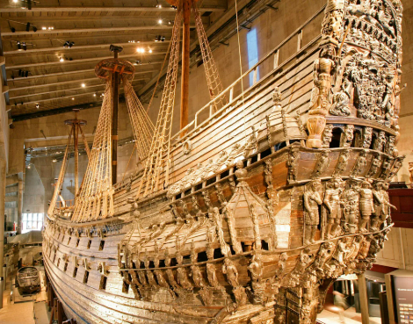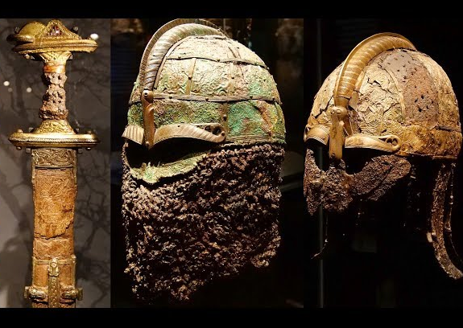

Wed 6/17-
Stockholm Archipelago Speedboat – 2 hrs 9:30 – 11:30 Viator
Meeting Point: Pier 19 (Kajplats 19) Strandvägen 20-28 114 56 Stockholm Stockholm Speed Boat 2 Hour Archipelago Tour
Exploring the traditional summer getaway of locals on the Stockholm Peninsula, view historic sites and summer houses dating to 17th centruy…on the way passing by city sights such as the Old Town and Gröna Lund, explore the Djurgarden Canal then speeding by the island of Fjäderholmarna and visiting Vaxhol the Capital of the Archipelago

Viking History– 2 ½ hrs 1p-3:30p Alex the Viking +46701768735 Free Viking Walking Tour | Stockholm
Meeting point: in Stortorget in front Nobel Museum. Arrive 10m before

Thur 6/18
- Royal Palace - 90 min Stockholm Pass guided tour of Royal Palace - opulent Royal Apartments, Treasury, and Royal Chapel. Changing of guard outer courtyard parade/band at 12:15p takes 40m. Band/guards march through center Stockholm to palace starting at 11:45 view from Skeppsbron water side palace

- Tour Metro Stations – “The World’s Longest Art Gallery” very artsy and cool…the stations are the art.
Subway Order – *Tcentralen (roman) red line #14 to Morby Centrum one stop Ostermamstorg (environment/women’s rights simple sketches). Continue one stop*Stadion (colors/rainbow). Continue one stop to *Tekniska Hogskolan (cosmic). Return to Tcentralen and switch to green #19 toward Hasselby Strand one stop Hotorget (‘50s) then five stops to Thorildsplan (pacman/mario bro), then back to Fridhemsplan (nautical), go through connecting tunnel to blue line #11 to Akalla two stops *Solna Centrum (hell), continue two stops to Hallonbergen (whimsical), return six stops to *Radhuset (cavern/geological),continue two stops to *Kungstradgarden (archeological artifacts), return to Tcentralen.

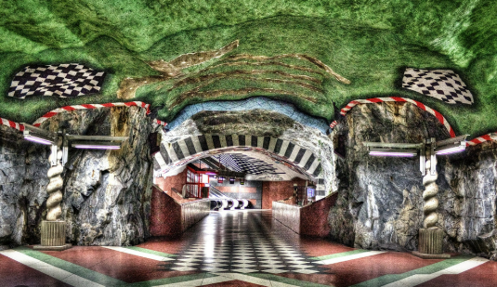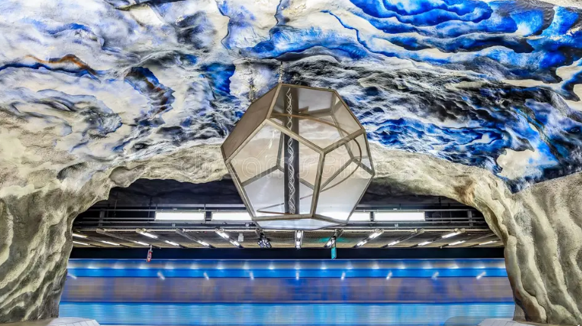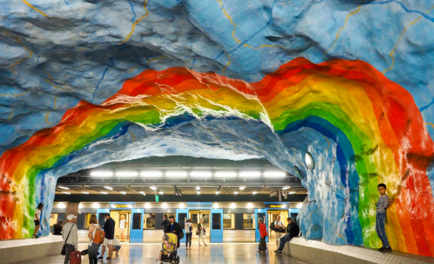

Add-On Options
- Drottingham Palace – Official residence of the royal family. “Sweden’s Versailles” Take ferry
- Golden Hits – Pop Hits and karaoke/disco atmosphere. pulsating dinner shows 6pm doors open. Close to hotel DINNERSHOW 2025-2026 - Golden Hits or Stampen in Gamla Stan – very local/ Jazz music
- SoFo/Sodermalm- hip district filled with vintage stores, design boutiques, galleries, trendy cafes.
- Mariatorget – square in Sodermalm surrounded by cafes, relaxing location to experience local neighborhood vibes
- Nobis Hotel – Former bank where the present locker room vault area where 1970 robbery hostages sympathetic with robbers became known as the “Stockholm Syndrome”
- Morton trotzig Grand – Smallest alley Gstan – Graffiti Art walls
- Stradvagen – Premier address waterfront boulevard, grand 19th century architecture
- Royal Armory – 90 min Stockholm pass - Royal Wardrobe, Royal Arsenal and private collections of a selection of monarchs.
- Riddarholmen Church 30 min - within the grounds of the Royal Palace in the Old Town, Riddarholmen Church is famously the necropolis where many Swedish kings and queens are buried. famous royals buried in the grounds.
- City Hall - Great 360 view of Stockholm from tower. Nobel Banquet - and 1hr tour. Very unique building.
- Fotografika – rotating exhibit famous and emerging photographers, also restaurant with great view Gamla Stan

Restaurants/Coffee/Dessert/Bars
- Stockholm has a growing vegetarian and vegan culture. Swedes eat dinner very early. Make a reservation.
- *Ostermalms Saluhall – 1880’s food hall- MUST visit. Close to hotel
- K25 Food Hall – Many cuisines, Close to hotel About us and our restaurant hall – K25
- *Aifur Krog & Bar - Viking restaurant – down in cave-interior, food, music and atmosphere are reminiscent how Vikings would have enjoyed feasts. https://aifur.se/meny/ or Sjatte Tunnan for meads /dessert only
- Hermitage- a vegetarian buffet restaurant with a stunning city view. International fare. In Gamla Stan
- Chutney - Indian vegetarian and vegan dishes. Veganbar and Veggie by Paul’s.
- La Neta – Mex cantina style. Normalm and Sodermalm
- Hermans – Veg all can eat buffet, in Soddermalm great views Gamla Stan, next to Fotografika
- Vete-Katten – city institution 1920’s style café. Snacks and pastries all from scratch.
- Johan & Nystrom - Coffee shop - Rosemary and dark hot chocolate
- Flickorna Helin – baked goods and coffee. Tree setting near vasa and ABBA museums
- Café Fafangan – great views next to Fotografika
- Socker Sucker – Pastry works of art. Award winning pastry. Drottninggatan 93 and Skeppsbro Bakery Gstan sandwch
- Stora Bageriet (near hotel) great pastry/coffee w/patio outside or Svedjan Bageri
- Lucys Flower Shop –speakeasy. Top 50 bar in World
- Capital Skybar – Outside 8th floor rooftop views GStan and Sodermalm- at Scandic Continental
- *Sodra Teatern – oldest theatre rooftop terrace bar with amazing views.
- Mosebacketerrassen -laid-back open-air terrace in Södermalm, famed for casual vibe and panoramic vistas of the city and water. Ideal for beer, snacks, and watching the sunset—arrive early on sunny days for the best seats.

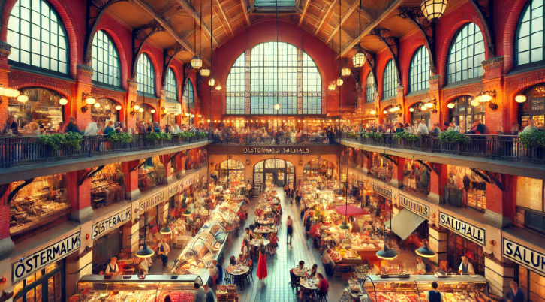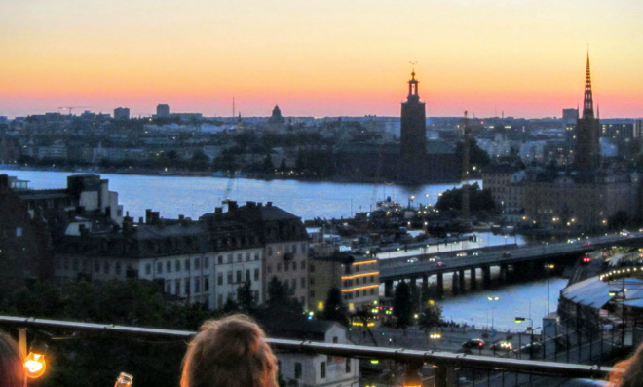

Swedish Food-
- Raggmunk - it’s a type of potato pancake, a comforting food that combines grated potatoes with a mixture of flour, milk, and sometimes eggs. This blend is then fried to create pancakes that strike the perfect balance between crispy and tender. and lingonberry jam, a combination that offers a satisfying mix of savory and sweet flavors.
- Knackebrod – Swedish Crisp Bread- is a flat and dry type of bread containing mostly rye flour. Crispbreads are lightweight and keep fresh for a very long time due to lack of water. Crispbread staple food Sweden
- Lingonberries
- FIKA - Kanelbullar – Swedish cinnamon buns Kardemummabullar – Swedish cardamom buns. Semla – Traditional Swedish pastry cream and almond paste

General Info
Stockholm (Essentials?) Pass – over 70 attractions 1-4 days €89 to €192 https://www.stockholmpass.net/en/
- Currency: Swedish Krona (SEK)
- Tour Guide tipping – $15-$30 pp. No tipping in restaurants expected.
- Uber and Bolt… Don’t take a taxi-many scams. Price should be clear

Transportation- app “Nobina” or Google Maps
Mastering Stockholm's Public Transport: Your Sweden Guide by 2025! #stockholm #stockholmtravel

SL Ticket - Download App – Valid on all public transport - Buy 24 / $17 or 72/$23 hour pass SL Access smart Card reloadable (good for all transport) then tap and go. Buy at booth in metro or convenience stores with SL blue flag flying. Or can use your phone (credit card) to tap and go at turnstile. https://www.youtube.com/watch?v=vtubbZAy8h8
- Metro/Subway is very easy and very large. Three lines-Red/Green/Blue. Very extensive lots of stations.
- SL main transport company. www.SL.se . check SL App for real time info
- Single fare ticket is valid for 75 minutes.
- You must activate ride at blue scanner at metro entrance and on bus. For Tram and ferry there are poles at station with blue scanner before you get on.
Scooters – a day pass on a Voy/Lime/Tier/Bolt scooter is $7.36
Buses- enter through front door to scan ticket. Exit back
Trams- Modern and Heritage trams run every 10-15 min. The Djurgarden and Line 7 the most popular with tourists. Both run from T-Centralen to Djurgarden. They pass Grona Lund, ABBA museum and Skansen
------------------------------------------------------------------------------------------------------
Fri 6/19
Flight to Norway - Stockholm (ARN) Term#5 9:10a to Oslo (OSL) 10:10a
Norwegian Air DY805 $158.40 = $126 flight + $32.40 taxes x 2

Priority Pass Lounge Stockholm Arlanda,
Pearl Lounge - Terminal 2 (after security) or Terminal 4/Gate 37
Airside - after Security Screening, turn left & pass the Tax Free Shop. Proceed to the first (green) staircase. The entrance is at the top of the stairs. Access only for Schengen and Non-Schengen Departures.

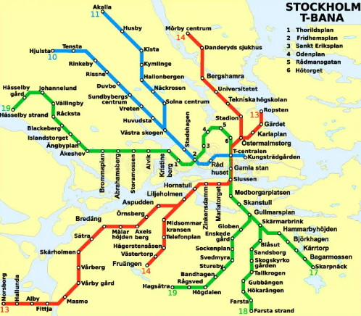

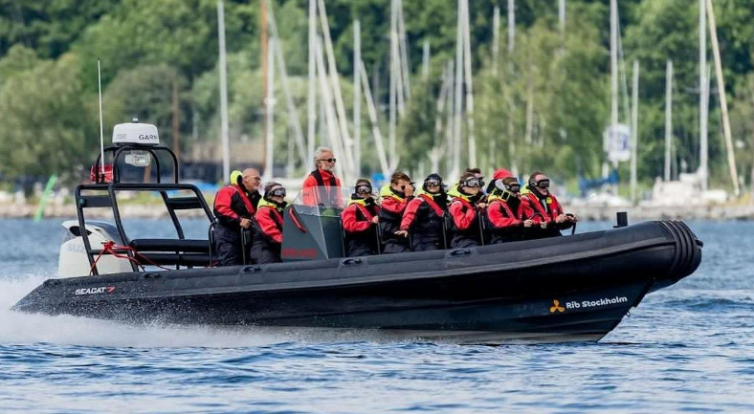

------------------------------------- Oslo, Norway  -------------------------------------------
“Deep Viking Roots / Seafaring Tradition and Nordic Design”

Oslo-Gardermoen main airport 24 miles north of city. Take train to city – regular train or Express. There are two trains one that goes direct to Central Oslo station or to Drammen with stops in between.
Airport Express train -Flytoget 20 minto city $20 pp. Orange ticket machines.

Oslo-
2 ½ days/ 3 nights Fri 6/19 – Mon 6/22 Same time as Stockholm/6 hours ahead of DC
Temp – 70ish day / 53ish night / low chance rain / sunrise 3:55a - 11:11p “sunset” = 20 hrs sunshine Civil Twilight – all night

Hotel –

Hotel Christiania Teater - Superior Room #603/604 City View top 6th floor

King, Breakfast , early check in 12p ,

Oystein Nustad Front Desk Mgr Oystein.nustad@christianiateater.com Oystein created the reservation
Stortingsgaten 16, Oslo, 0161 Norway Tel: 47 (21) 043800
Hotel Christiania Teater | A boutique hotel in the heart of Oslo - Hotel Christiania Teater

-----------------------------------------------------------------------

Fri 6/19 - Fly to Oslo, Norway arrive 10:10a
Oslo– Private City Tour, Hidden Gems and Highlights 3 hr WithLocals Ihor +47 96746268
1:00p-4:00p Meeting point – Oslo Cathedral main entrance
Ultimate Highlights & Hidden Gems of Oslo with a Local Expert - Withlocals

- Karl Johans Gate – Lively main street of Oslo/pedestrian only. Runs from the main train station to the Royal Palace and the National Theatre.
- Grand Hotel - winner of Noble Peace prize waves to crowd. Visit for drink rooftop bar or glass domed bar
- Damstredet & Telthusbakken– Old world Oslo Neighborhood located a few blocks behind Grand Hotel.
- Grand Café- historic café - playwright Henrik Ibsen(Hedda Gabler) artist Munch (the Scream) were regulars
- Oslo Cathedral – 1694, Classic Scandinavian style

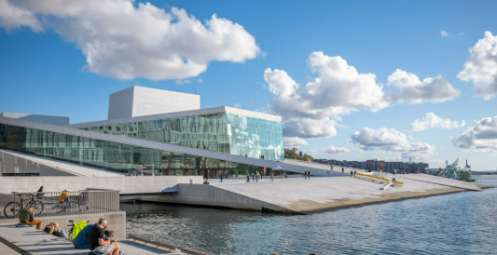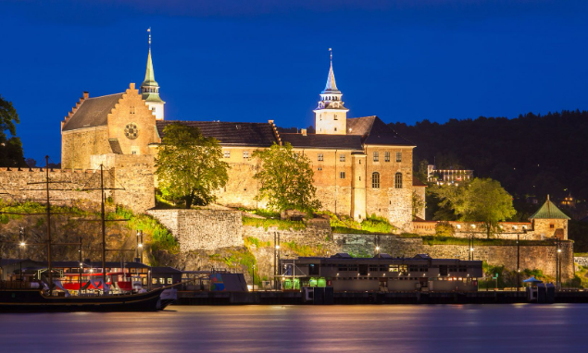

Sat 6/20
The Royal Palace/Castle tour- 12p – 1p arrive 11:30 security- no backpacks/handbags, check in lockers. Entrance in back facing Palace Yard. First day of summer tours. Active Royal/King residence. Ministers Salon & Council Chambers/State rooms/Bird room/Grand Ballroom.
1:30p is Changing of Guard 40 minutes

Aker Brygge Harbor Front Promenade –OSLO Fjord City Walk: See the Opera House, Barcode & Aker Brygge (Waterfront Guide) start walk at Tjuvholmen #5
- Nobel Peace Center #6 (Oslo Pass) on harbor
- Untuned Bell- bell to used to hang in city hall bell tower. step on peddle ring it.
- Oslo Opera House #10 – next to train stations tunning architecture. Go up the marble ramps on the unique roof great views. open 24/7
- Munch Museum #11 (Oslo Pass)- Iconic painting Edvard Munch’s The Scream, since these are drawings on paper (three versions-painting/drawing/print) they are more fragile and only one is shown at a time and change every hour. Largest museum in Europe dedicated to one artist . $15
- Akershus Fortress #7 (Oslo Pass) – later afternoon Military and Resistance Museum. $10 to enter – free walk grounds. Resistance Museum. Deportation Chair monument front of fortress- Jews deported WW2
- Akershusstranda – walk along harbor front of the Akershus Fortress- restaurants in old fishing sheds.
- Floating Saunas in harbor across from museum.
- Historical Museum – Viking artifacts moved from the Viking ship museum since it closed for renovation
- **Fjaer Konfekt – Anniversary Dessert Celebration. 12-6p Drammensveien 153B next Skoyen train station -Oslos Central station take local train (VY) to Skoyen 5 min or Tram #13 city center -Skoyen 10-1

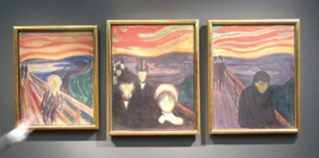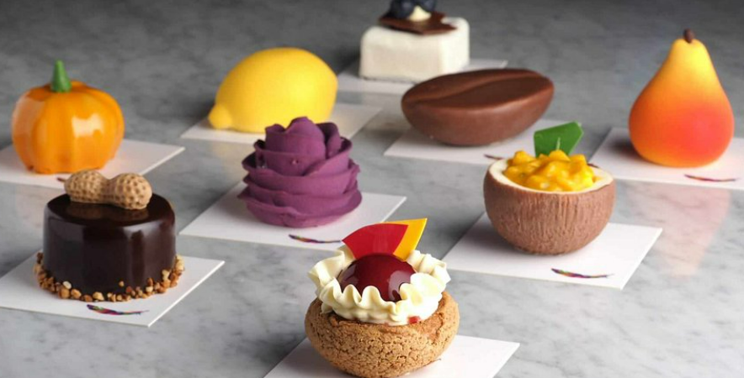

Sun 6/21
- *Fram Museum 1 ½ hr (Oslo Pass) – Original arctic and Antarctic expedition ship used by famed explorer Roald Edmunson first person to south pole. Interactive and immersive experience. Ferry to Bygdoy /Museum Island (Oslo Pass) - bus #30 or Ferry to Bygdoy Penninsula
- Kon Tiki / RA 2 Museum 1 ½ hr (Oslo Pass)– - next door to Fram museum
- Hollmenkollen (Oslo Pass) - Olympic ski tower. View platform great views from top of Oslo. International Ski museum-4,000 year history. Can see what ski jumpers experience and then zip line down like the ski jumpers! take metro line #1 to station Holmenkollen and follow signs.
- Vigeland (Frognerparken) Sculpture Park - 200 sculptures Gustav Vigeland each depicting people at different stages of life. One of most popular sites in Oslo. Open 24/7. Take tram #12 to Vigelandsparken station or any metro line to Majorstuen then 5 minute walk.
- SALT – Art Project and space – food and entertainment
.

Restaurants/Coffee/Dessert/Bars
- *Mathallen (Mathyallen)Food Hall – great vibe, explore various food stalls with vegetarian options
- Trattoria Popolare – Classic Italian, located in old brewery
- Happolati- vegetarian sushi and Asian fusion cuisine
- *Nordvegan- Nordvegan | Oslo's Award-Winning Vegan Restaurantpopular vegan spot in the city, Fresh salads, warm plant based mains
- Café Sara – pub-like atmosphere and backyard garden
- Dattera til Hagen – clorolful ecletic bar/café and beer garden. Pasta, salads, tapas
- Haralds Vaffles – Oslo Grunerlokka neighborhood eat it with your hands not utensils
- Freddy Fuego – known for amazing selection marinade burritos
- Gronland(Greenland) Oslo restaurant area
- Vippa – Lunch at Oslo food market ocean containers. Local food vendors

Norwegian Food
- Traditional Norwegian Waffle- Jam/Sour Cream/Brown Cheese (Norwegian cheese)
- Skoleboller (also called skolebrød) are Norwegian “school buns” (or school bread) made with a sweet cardamom dough, filled with vanilla custard in the center, and then coated in icing and dipped in coconut flakes.

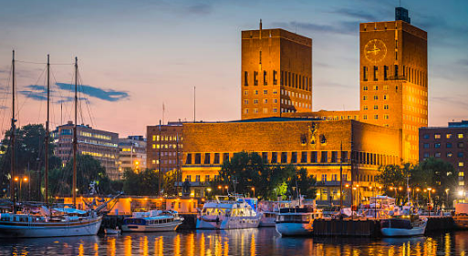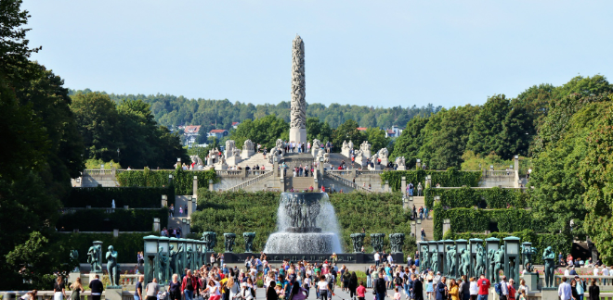

Travel
Oslo Pass 24hr or 48 hr - Unlimited public transport within Oslo included with Pass as well as 30 museums plus other discounts. Airport Train. €49 24hr/ €72 48hr
- Purchase on OsloPass app or VisitOslo website Oslo, Norway - Official travel guide
- There is a metro/underground/ T-bane in Oslo
- Oslo City Bike pass – 3 days for $10
- Tram system connects city center great way to see city- Line #12 passes many attractions
- Ruter App – Public transit

General Info
- Currency: Norwegian Krone (NOK). Basically, cashless country.
- Weather is unpredictable – rain jacket and umbrella!
- Tipping - is not mandatory when dining out, as the bill usually includes service charges. However, it’s customary to round up the bill or leave a small tip as a gesture of appreciation.
- “Vimpel” – Narrow flag version. Norwegian wind tatters flags.

-----------------------------------------------------------------------------------------------------

Mon 6/22
Across Norway -Aurlandsfjord/Songenfjord/Nærøy Valley --- Oslo to Myrdal-Flam-Bergen
fjordtours sognefjord in a nutshell reviews youtube - Search Scenic tours in Norway with Fjord Tours

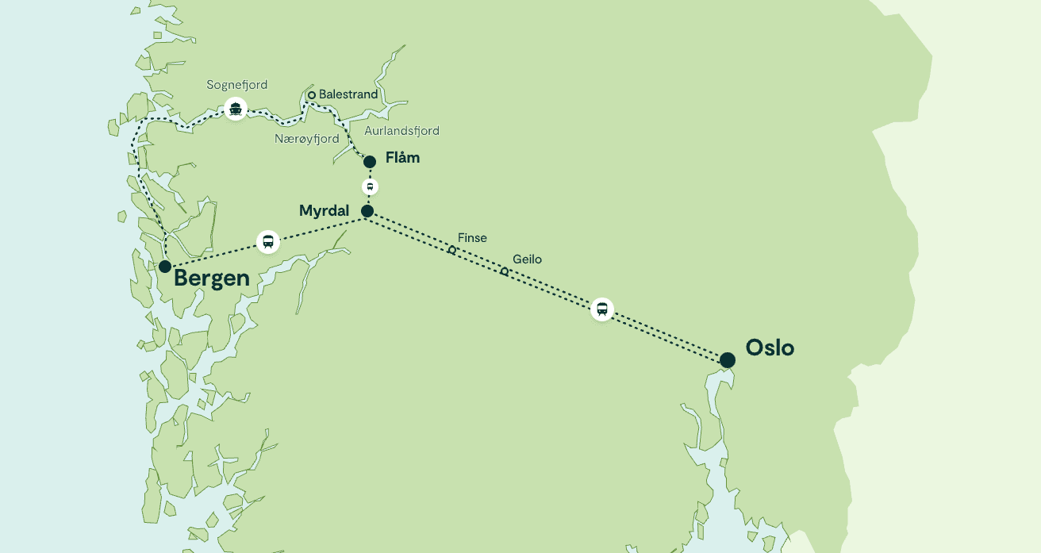
My Page - Fjord Tours Confirm # EWZTA1

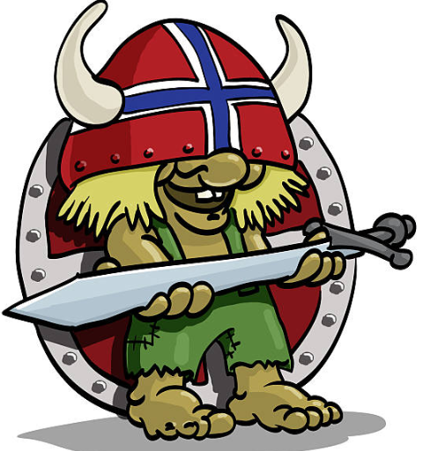

Oslo 6:25a - Myrdal 11:15a –
Pluss class - Car #1 Seats 23,24,27,28 Facing seats with table - Oslo - Myrdal
The Bergen Railway vy.no is known as one of the world's most scenic train journeys. This iconic railway offers passengers a mesmerizing ride through rugged mountains, lush valleys, and pristine fjords.
- Vy Pluss (First Class): Offers more comfort, bigger seats, extra legroom, complimentary coffee/tea, and a quieter carriage with panoramic windows—great for enjoying the long scenic journey.

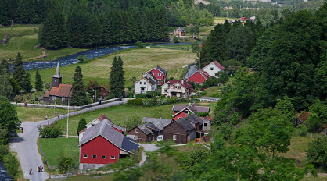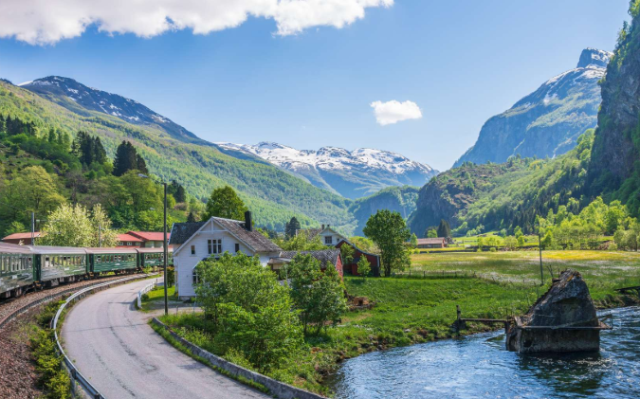

Myrdal 12:06p – Flam 1:04p –
Flåm Railway Practical Guide
Change trains between the Bergen and Flåm Railway. Flåmsbana Railway flamsbana.no is one of the most incredible railway journeys in the world. The scenic railway one of the steepest in the world- 12 mile/3,000 ft descent, journeys with unrivaled views of cascading waterfalls, deep ravines, and lush, serene landscapes along the way. 10 min photo stop at Kjosfossen waterfall, lookout for the seductive troll Huldra
- Open seating, try to sit on the right side of the train from Myrdal to Flåm for the best fjord views. One class, large windows for sightseeing.

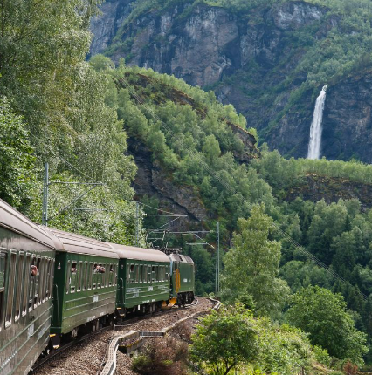

Stegastein Viewpoint – Private Tour 1:15 – 2:30
Electric mini bus El-Tour Booking #3097 Voucher# - yoGNkw8NLO
Scenic narrow winding road up the mountains from Flam to the panoramic viewpoint high above the Aurlandsfjord. Walk over 100 ft out from the mountainside and be over 2,000 ft (taller than the World Trade Center) above the fjord. A very thrilling Norwegian experience.

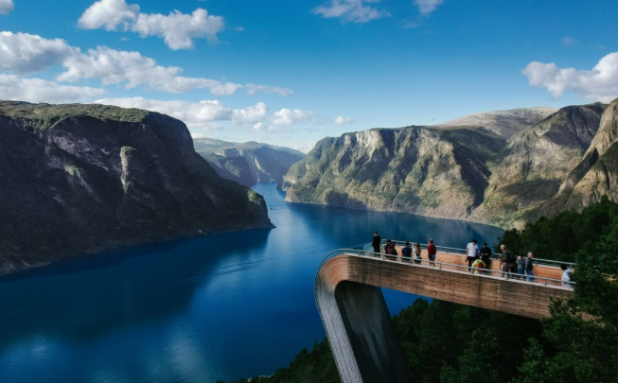

Aurland Shoe Factory 2:35 – 3:00
Home of the Aurland shoe aka the Penny Loafer created by local shoemaker Nils Tveranger. Watch the local craftsmen at work observing craft traditions in historical context.

Flam 3:30p – Bergen 8:45p - The UNESCO Aurlandsfjord & Sognefjord(Norways longest fjord) cruise is a remarkable boat ride through the awe-inspiring beauty of the Nærøyfjord, a designated World Heritage site. The stunning fjord, breathtaking views of towering cliffs, waterfalls and charming Nordic villages.
***One stop Balestrand 4:50p***
- Arrive early for prime spots, go to top level for best indoor seating views. Have seats 3 x3 facing each other with table. Electric outlets. Also, front and rear outdoor deck for panoramic fjord views.

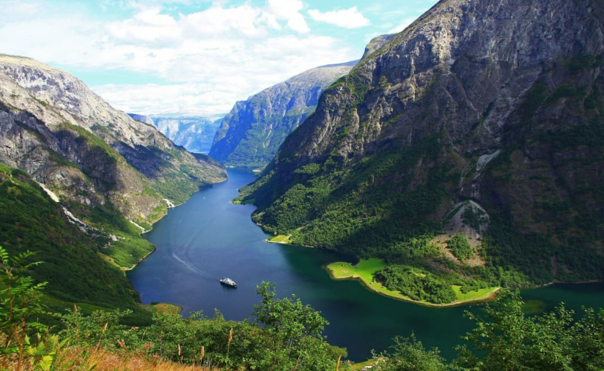

--------------------------------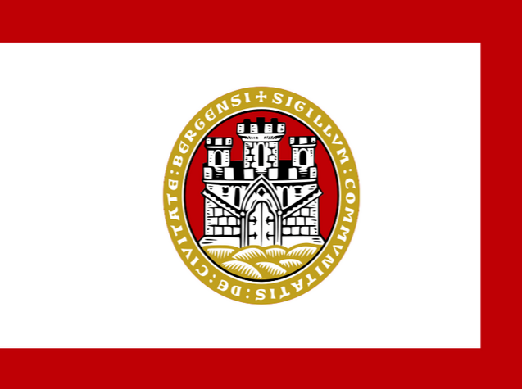 Bergen, Norway ---------------------------------------
“Gateway to the Fjords / Colorful Historic Harbor & Medieval Charm”

Bergen -
2½ days/ 3 nights Mon 6/22 – Thu 6/25
Temp – 65ish day / 50ish night / rain 200 days year rainiest city in Europe / sunrise 4:11a-11:09p = 19 hrs sunshine
https://en.visitbergen.com/

Cruise ships in port-
6/23 Costa Diadema – 10:30a -8:30pm / Silver Dawn 8a-6p
6/24 AIDAnova – 8a – 4:30p / Seabourn Ovation 8a – 5p

-----------------------------------------------------------------------

Hotel Admiral - Deluxe Room, Balcony, Harbor /Bryggen Wharf view top 5th floor

Queen, Breakfast, late check in Eirin/Maria Ms. Solvi Solmunde GM Solvi.Solmunde@strawberry.no
Clarion Hotel® Admiral | Bergen | Strawberry

-----------------------------------------------------------------------

Tue 6/23 -
Bergen History Walking Tour 2hr TripAdvisor Ref #: 1349328525
10-12p Meeting point – 9:50a Bradbenken 1, a brick office building next to the entrance to the fortress
2026 Walking Tour in Bergen of the Past and Present - with Trusted Reviews
Journey through Bergen’s colorful history at the Bergen Fortress and walk through the city’s historic streets. Learn about how people lived in this important fishing port over the centuries, and how Bergen’s modern community and the architecture have changed. Bergen’s famous wooden houses, the Bryggen wharf and the fish market. Learn about the city’s heritage and famous residents as you wander the picturesque streets.

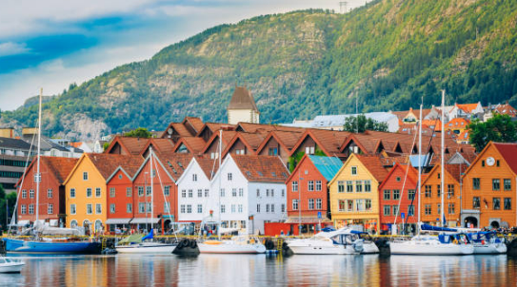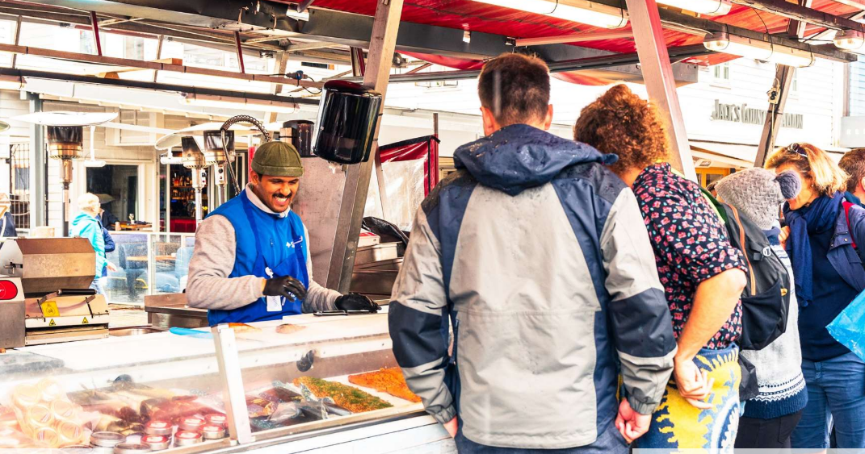

- Bryggen Wharf – Vagen Harbor Bergen’s most famous area. A series of colorful wooden buildings that once housed the trading offices of the Hanseatic League. UNESCO World Heritage site. The narrow passages behind the facades hide small shops, galleries, and small museums, making it a place to spend hours exploring. The classic Bergen/Norwegian picture
- Sandviken neighborhood - wooden houses and cobbled streets
- Hanseatic Maritime Museum- oldest building very authentic feel. Powerful guild of European merchants from 14th-18th century. Historic maritime gateway
- Old Bergen Museum - Interactive museum that allows a glimpse into what life was like in Bergen in the 18th and 19th centuries. With over 50 reconstructed wooden houses, historic cobblestone streets, and actors in period costumes, the museum brings Bergen’s history back to life in an engaging way. Checkout the homes of merchants and craftsmen, explore the old schoolhouse, chat with a “local” from the 1800s.
- Fejellskal Fisketorget – 10a-6p Fish Market continual use 800 years meeting place merchants/fisherman.
- Mt Ulriken – highest mountain around Bergen, great panoramic views
- Mt Floyen – Get to the summit on the iconic Fløibanen funicular, which takes you up in just a few minutes. panoramic views over the city and fjords. Take the easy hiking path (1 1/2 m 30 min) back down.
Prices and ticket types - Fløyen Take picture at Floyin directional signpost. Go after 5p when cruise leaves. Two lines for tickets- left line charge extra. Ticket machine on right or online a Floibanen app roundtrip $15
Granbakken Lake on Floyen – Free canoe rentals. 8 minute walk from Floyen viewpoint.
- Bergenhus Fortress - tours $10 - one of Norway's oldest and best-preserved stone fortifications. Large stone Banquet hall royal medieval feasts. Along Vagen Harbor. 13th century
- No Stress Bar - hidden gem on backstreet, best cocktails in town. Last Monkey or Zachariasbryggen
- Sjoboden – live music on Bryggen. pub how it would have been for drinkers in Bergan’s olden days.
- Det Lille Kaffekompiniet - one of the cities best coffee shops for a caffeine hit and cinnamon roll
- Godt Brod – Award winning bakery, bread and sandwiches, Daily Pot – popular vegan restaurant

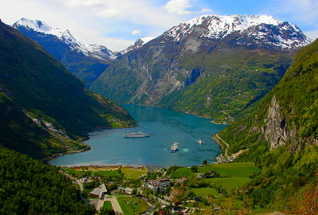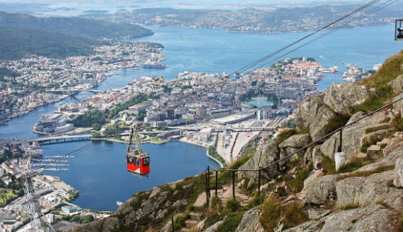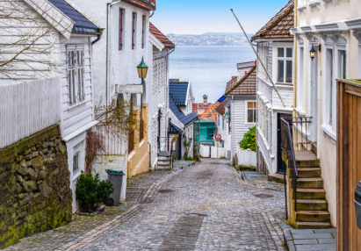

Wed 6/24 *** Open Day ***
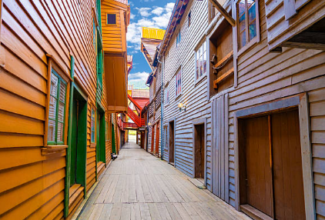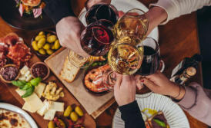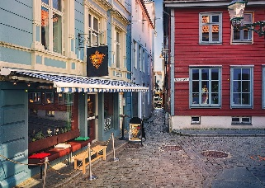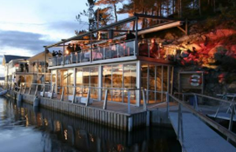
https://en.visitbergen.com/food-and-drink/pubs-and-bars https://en.visitbergen.com/food-and-drink/restaurants/international

Transportation-
- Bergen Card 24 hr $42 / 48hr $54 - which offers free public transport (buses and light rail/some ferry) and free or discounted entry to many museums and attractions. Get at Bergen Tourist info Center or https://en.visitbergen.com/bergen-card
- Download SKYSS ticket app (don’t need if have Bergen Card) buy train and bus tickets save up to 20%

-----------------------------------------------------------------------

Thu 6/25
Free Morning – Leave for airport 12p

Bergen Airport Transport
- Take Bybanen Light Rail (Line#1)takes 50 minutes cost $4.50 or Flybussen express bus 20 min $13.80 booked in advance or 16.50 bought on bus. Taxis $45-$60
- Skyss App – buy train/bus tix save 20%

Bergen Lounge – Airside between Upper Crust and Near Gate E26- International flights only.

Depart - Icelandair
Flight reference A65PBU
# FI335 - Bergen Flesland (BGO) 3:20pm CESTCentral European Summer Time
Travel time: 2h 30m
Reykjavik Keflavik Intl. (KEF) 3:50pm GMTGreenwich Mean Time
Aircraft Airbus A321-200neo Distance 917 mi
Reykjavik LAYOVER 1 H – Icelandair Saga Lounge
# FI645 - Reykjavik Keflavik Intl. (KEF) 4:50pm GMTGreenwich Mean Time
Travel time: 6h 30m
Washington Dulles Intl. (IAD) 7:20pm EDTEastern Daylight Time
Thu, Jun 18Thu, Jun 18
Aircraft Boeing 737 MAX 9 Distance 2800 mi

