# 可汗笔记

## 随机变量

离散随机变量:值是有限的

连续随机变量：值有无限多个

概率密度函数: $\int_{0}^{∞}{f\left(x\right)=1}$

概率密度函数下方面积必然等于１

随机变量的期望值其实也就是总体的均值

期望值E(x)=n*p

泊松过程：p(x=k)= $\frac{}{k!}$

当n趋于 $∞$ 时，样本均值趋于总体样本



正态分布

C:\Users\lacey\AppData\Roaming\Tencent\Users\421280849\QQ\WinTemp\RichOle\44QI1Q`[CR%(J62QF~~Y1[A.png

## 均值与方差公式

(总体均值)=

（样本均值）=

(总体方差)

（样本方差）

Eg.2 2 3 3

均值=(2+2+3+3)/4=2.5

总体方差＝



=

=

=-2+

=-

## 二项式及正态分布

二项式概率:p(x=k)=

二项分布期望值：E(x)==np

n:试验次数，p:每次成功的概率

随机变量的期望值其实也就是总体的均值

标准正态分布:

经验法则：68-95-99.7，即均值左右一个标准差的概率是68%，两个标准差是95%,3个标准差内是99.7%

Z分数：表示离均值有多少个标准差，Z分数既可以用在正态分布，也可以用在非正态分布

尾部向正，为正偏态分布，尾部向负，为负偏态分布。

如果峰度为正，尾部会较肥，同时峰值为较尖，负峰态则尾部较小，中间更平滑

Eg:the 2007 AP Statistics examination scores were not mormlly distributed,with ,What is the approximate z-scre that corresponds to an exam score of 5(the scores range from 1-5)

解： $\frac{5-2.8}{1.34}$ =1.64

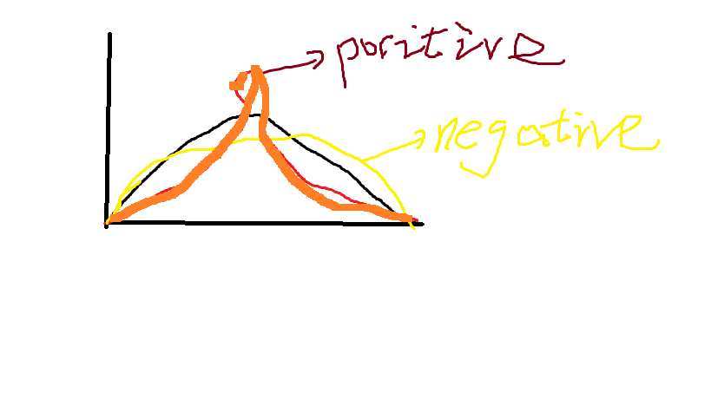

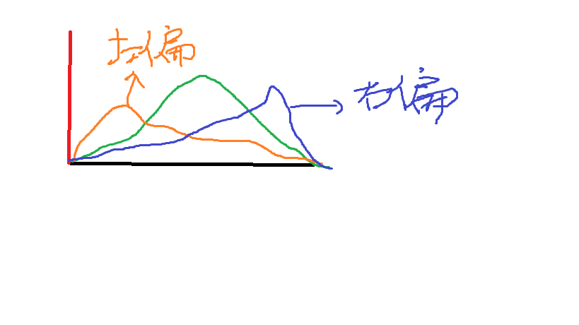

负偏态向左

每个样本均值容量越大，标准差越小

随着样本容量增大，会发生两件事，一是更接近正态分布，二是标准差更小

标准误差（样本标准差）：

Eg:The average male drinks 2L of water when active outdoors(with a standard deviation of 0.7L).You are planning a full day nature trip for 50 men and will bring 110 L of water.What is the probability that you will run out?

解：P(average water use per man is >2.2L/m)





==0.099

Z分数= $\frac{2.2-2}{0.099}$ =2.02

P( will be more water 2.02 std. deviation above the mean)＝1-0.9783=2.17%

查阅Z表格2.02对应值为0.9783，它是小于该Z分数处的面积

## 伯努利分布均值和方差公式实例

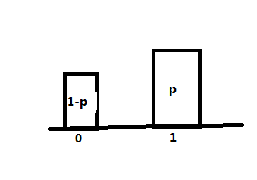

=(1-p)*0+p*1=p

=(1-p)(0-p)2+p(1-p)2

=(1-p)p2+p(1-2p+p2)

=p2-p3+p-2p2+p2

=p-p2

eg.In a local teaching district a technology grant is available to teachers in order to install a cluster of four computers in their classrooms.From the 6250 teachers in the district,250 were randomly selected and asked if they felt that computers were an essential teaching tool for their classroom.Of those selexted,142 teachers felt that comuters were an essential teaching tool.

1. Calculate a 99% confidence interval for the proportion of teachers who felt that computers are an essential teaching tool
2. How could the survey be changed to narrow the confidence interval but to maintain the 99% confidence interval?

250 sampled:142 good=1 108 not good=0

样本均值：= $\frac{1*142+0*108}{250}$ =0.568

样本方差：S2=＝0.246

样本标准差：S=0.50

Confident that:抽样分布标准差近似于样本标准差除以根号下样本容量： 

99%的一半是0.495

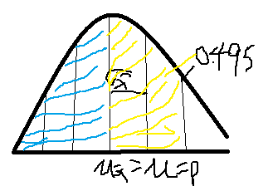

0.5+0.495=0.995即上面绿色和黄色部分和，为所求

查询0.995对应的Z分数为2.58

99% chance that a random  is within 2.58  of p(样本均值落在抽样分布均值左右2.58个标准差范围内)

“confident”99% chance that (0.568) is within 2.58*0.031=0.08 of the population

也就是：“confident”99% chance that p is within 0.08 of the 0.568

上限:0.568+0.08=0.648

下限:0.568-0.08=0.488

答案1：The true percentage of teachers that like the computers is between 48.8% and 64.8%

实际上有48.8%到64.8%的老师认为计算机是必备的

答案2：增大样本容量,标准差越小，而置信区间是加减一定倍数的标准差，范围自然也就会减小

Eg:7 patients’s blood pressures have been measured after having been given a new drug for 3 months.They had blood pressure increases of 1.5,2.9,0.9,3.9,3.2,2.1 and 1.9.Construct a 95% confidence interval for the true expected blood pressure increase for all patients in a population

=2.34

S=1.04

使用样本标准差s来估计总体标准差s=1.04(这里的标准差s not good,n is small,In general,this is considered a bad estimate if n is less than 30.n小于30通常被认为是糟糕的估计)

t分布一般为小样本容量时置信区间的更好估计所设计的，它为正态分布差不多，不过，尾部较肥

查询t表格，自由度为6=n-1在95%对应的数据为2.447,它对应两侧2.447个标准差，即距离均值2.447个标准差



要求抽样分布上包含95%面积的这个区域，我们需要用0.39*2.447=0.96

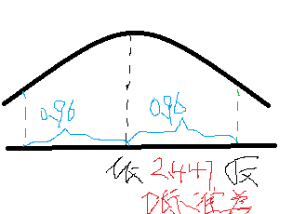

有95%几率2.34在抽样分布实际均值周围0.96范围内，即95%几率均值在样本均值2.34周围0.96范围内

置信区间下限是2.34-0.96=1.38

上限2.34+0.96=3.3

所以置信区间是1.38到3.3

Eg.A neurologist is testing the effect of a drug on response time by injecting 100 rats with a unit dose of the drug,subjecting each to neurological stimulus,and recording its response time.The neurologist knows that the mean response time or rats not injected with the drug is 1.2 seonds.The mean of the 100 injected rats’ response times is 1.05 seconds with a sample standard deviation of 0.5 seonds.Do you think that the drug has an effect on response time?

H0:Drug has no effect=0 =1.2s

H1:Drug has an effect=0 1.2s when the drug is given



标准差估计值=0.05

想想，得到1.05秒的概率是多少？或者说1.05秒离抽样分布均值有多少个标准差远，以及均值周围这么多标准差远之内的概率是多少，首先求这离均值有多少个标准差远，这其实就是求一个z分数,z统计量离均值有多远呢

Z= $\frac{均值-1.05}{标准差估计值}$ ＝ $\frac{1.2-1.05}{0.05}$ =3

3个标准差内的置信区间为99.7%,那么1-99.7%=0.3%,下面蓝色部分即为所求，0.3%＝0.003概率非常小，<0.05，所以拒绝零假设，所以药物是有效果的

上面的为双测检验,即正负两边

Eg.单侧检验，只检验一边

H0:Drug has no effect , =1.2s

H1:Drug lowers response , <1.2s

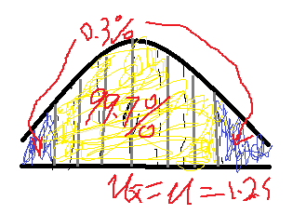

ok