WIREFRAME

SITE MAP

HOME

Sandwiches

Cold Drinks

Warm Drinks

Digital Printing

Binding

Laminating

Cutting

Wire

Heated Spine

Saddle Stitch

Borderless

Ink

Paper Stock

Menu

Services

Index

Contact

About

COLOR PALETTE



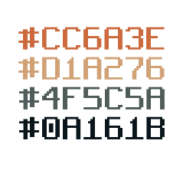

COMPANY NAME



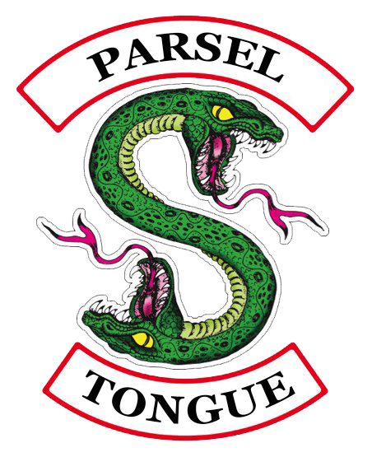GROUP NAME

DEMOGRAPHIC

* 14 – 30 years
* Tweens, Teens, Young Adult
* Male

IMAGES USED