DEEPVERIFY
Development Blueprint
Production-level engineering, ML research, backend, frontend, testing, deployment and Antigravity workflow

FORMATTED EDITION
Formatting note
The supplied blueprint text is preserved as the source content. Markdown headings, emphasis, code blocks and ASCII diagrams have been converted into native Word formatting; architecture and flow diagrams have been redrawn as proper visual diagrams for readability.

Contents
Tip: In Microsoft Word, right-click the table of contents and choose “Update Field” to populate page numbers.

Yes. Since you're starting DeepVerify development now, I would treat this as a real software/ML product rather than a college prototype.

And because you're using Google Antigravity, we can take advantage of its agentic workflow while putting strong guardrails around it. Antigravity is designed to let agents operate across the editor, terminal, browser, and produce implementation artifacts; importantly, its current docs support persistent AGENTS.md/rules and planning/review modes. Antigravity

Your project brief gives us the ML architecture and constraints: EfficientNet-B0 spatial model, frequency-domain classifier, Grad-CAM, video aggregation, FastAPI, React, and datasets including 140k Real/Fake, CIFAKE and FaceForensics++. Project-Brief Project-Brief

DeepVerify — Development Blueprint

0. First principle

Do NOT tell Antigravity:

"Build DeepVerify."

That's how you end up with a huge amount of AI-generated code that technically runs but becomes impossible to debug.

Instead:

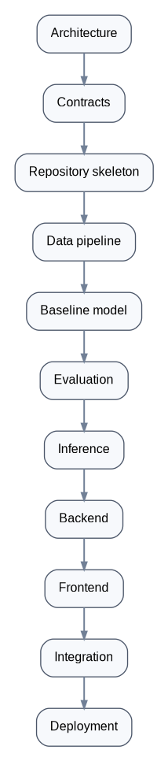
Development sequence

Every layer must have a working checkpoint before the next one is built.

1. The architecture I want you to build

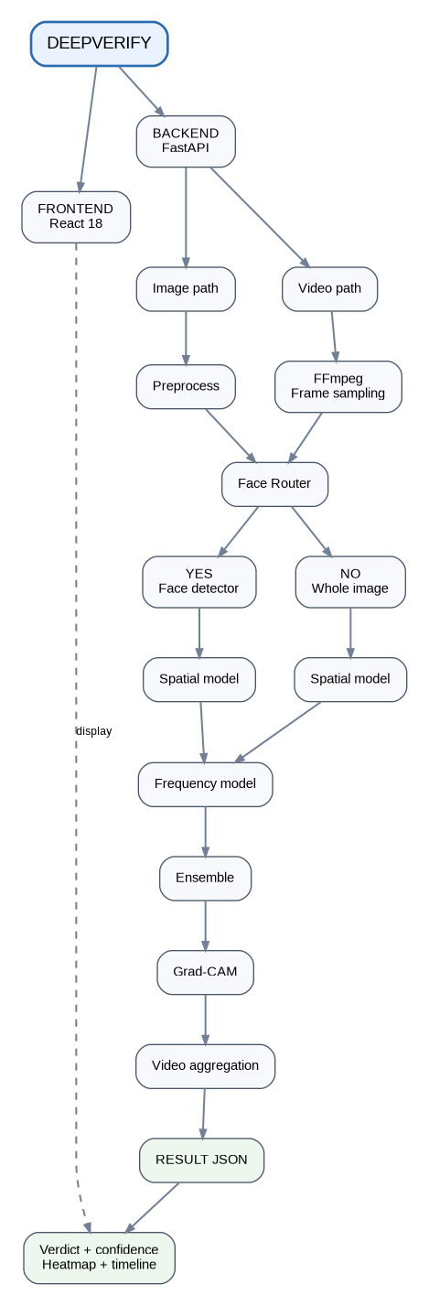
DeepVerify system architecture

This follows the core architecture in your project document. Project-Brief

2. Repository structure

I strongly recommend one monorepo.

deepverify/
│
├── README.md
├── LICENSE
├── CONTRIBUTING.md
├── CHANGELOG.md
├── .gitignore
├── .env.example
├── Makefile
├── docker-compose.yml
│
├── docs/
│ ├── architecture/
│ │ ├── system.md
│ │ ├── ml-pipeline.md
│ │ ├── inference.md
│ │ └── deployment.md
│ │
│ ├── api/
│ │ └── openapi.yaml
│ │
│ ├── decisions/
│ │ ├── ADR-001-monorepo.md
│ │ ├── ADR-002-model-versioning.md
│ │ ├── ADR-003-inference-hosting.md
│ │ └── ...
│ │
│ └── research/
│ ├── datasets.md
│ ├── experiments.md
│ └── limitations.md
│
├── frontend/
│ ├── src/
│ │ ├── components/
│ │ ├── pages/
│ │ ├── features/
│ │ │ ├── upload/
│ │ │ ├── analysis/
│ │ │ └── history/
│ │ ├── api/
│ │ ├── hooks/
│ │ ├── types/
│ │ ├── utils/
│ │ └── App.tsx
│ │
│ ├── public/
│ ├── tests/
│ ├── package.json
│ └── tsconfig.json
│
├── backend/
│ ├── app/
│ │ ├── main.py
│ │ │
│ │ ├── api/
│ │ │ ├── routes/
│ │ │ │ ├── health.py
│ │ │ │ ├── analysis.py
│ │ │ │ └── results.py
│ │ │ └── dependencies.py
│ │ │
│ │ ├── core/
│ │ │ ├── config.py
│ │ │ ├── logging.py
│ │ │ └── security.py
│ │ │
│ │ ├── schemas/
│ │ │ ├── analysis.py
│ │ │ └── results.py
│ │ │
│ │ ├── services/
│ │ │ ├── analysis_service.py
│ │ │ ├── video_service.py
│ │ │ └── storage_service.py
│ │ │
│ │ └── infrastructure/
│ │ └── ...
│ │
│ ├── tests/
│ │ ├── unit/
│ │ ├── integration/
│ │ └── fixtures/
│ │
│ ├── requirements.txt
│ └── Dockerfile
│
├── ml/
│ ├── README.md
│ │
│ ├── configs/
│ │ ├── spatial_baseline.yaml
│ │ ├── spatial_v1.yaml
│ │ └── ensemble_v1.yaml
│ │
│ ├── src/
│ │ └── deepverify_ml/
│ │ ├── data/
│ │ ├── models/
│ │ ├── training/
│ │ ├── evaluation/
│ │ ├── inference/
│ │ ├── explainability/
│ │ └── utils/
│ │
│ ├── scripts/
│ │ ├── prepare_dataset.py
│ │ ├── train_spatial.py
│ │ ├── train_frequency.py
│ │ ├── evaluate.py
│ │ └── export_model.py
│ │
│ ├── notebooks/
│ │ ├── 01_dataset_exploration.ipynb
│ │ ├── 02_baseline.ipynb
│ │ └── 03_error_analysis.ipynb
│ │
│ ├── tests/
│ │
│ └── artifacts/
│ └── .gitkeep
│
├── datasets/
│ └── README.md
│
├── experiments/
│ ├── README.md
│ └── registry.csv
│
├── .agents/
│ ├── rules/
│ │ ├── architecture.md
│ │ ├── python.md
│ │ ├── frontend.md
│ │ ├── ml.md
│ │ ├── testing.md
│ │ └── security.md
│ │
│ └── skills/
│ ├── train-model/
│ ├── evaluate-model/
│ ├── backend-feature/
│ └── release/
│
└── .github/
└── workflows/
├── backend-ci.yml
├── frontend-ci.yml
└── ml-validation.yml

You don't need every file on day one. Create the architecture first, then populate it.

3. Antigravity should have rules BEFORE coding

This is probably the most important thing for your development process.

Antigravity supports workspace rules through .agents/rules, AGENTS.md, or GEMINI.md; these are automatically discovered and injected into the agent's context. Antigravity

Create:

.agents/rules/

and make these rules.

architecture.md

Tell Antigravity:

- DeepVerify is a monorepo.
- Frontend must never contain ML inference logic.
- Backend owns orchestration.
- ML package owns model implementation.
- Training code must never be imported into production inference.
- No circular dependencies.
- API contracts must be versioned.
- Do not change architecture without documenting an ADR.

ml.md

- All experiments must have a configuration.
- Never hardcode hyperparameters.
- Always record random seeds.
- Always save validation metrics.
- Never evaluate on training data.
- Dataset splitting must happen before augmentation.
- Video frames from the same source video must never cross train/test boundaries.
- Model checkpoints must include model version and configuration.
- Never claim generalisation beyond evaluated datasets.

That last point is particularly important because your project itself warns about cross-generator generalisation. Project-Brief

security.md

- Never commit secrets.
- Never hardcode API keys.
- Never expose model storage credentials to frontend.
- Validate uploaded file type.
- Validate file size.
- Never trust uploaded filenames.
- Store uploads outside executable paths.
- Sanitize all user-controlled paths.

4. Don't let Antigravity run everything automatically

Antigravity has command execution controls ranging from review-before-execution to automatic execution. Antigravity

For this project, use:

Request Review

especially for:

rm
sudo
pip
npm install
git
docker
database migrations
deployment
environment changes

Do not give an agent unrestricted terminal access and then say "build my project."

Agentic development is powerful precisely because the agent can act. That also means you need boundaries.

5. Use Planning Mode for architecture/features

Antigravity currently supports a Planning mode that produces structured implementation plans/artifacts before modifying the code. Antigravity

For major work:

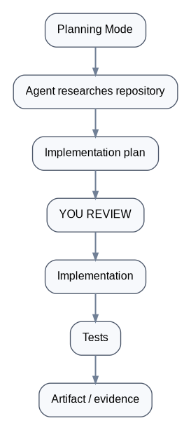
Planning Mode workflow

For tiny changes:

Fast mode

is fine.

6. Don't use giant prompts

Bad:

Build the entire DeepVerify system.

Good:

Implement the dataset abstraction only. Do not implement training, inference, API or frontend. Add unit tests. Do not modify files outside ml/src/deepverify_ml/data and related tests.

This dramatically reduces agent drift.

7. ML development must be experiment-driven

This is where student projects often become messy.

Never have:

train.py

with 50 hardcoded values.

Instead:

model:
name: efficientnet_b0
pretrained: true
num_classes: 2

training:
epochs: 10
batch_size: 32
learning_rate: 0.0001
optimizer: adamw

data:
image_size: 256
dataset: 140k_real_fake

seed: 42

Then:

python train_spatial.py \
--config configs/spatial_v1.yaml

8. Every experiment gets an ID

Example:

EXP-001
EXP-002
EXP-003

Record:

Experiment: EXP-004
Model: EfficientNet-B0
Dataset: 140k Real/Fake
Dataset version: v1
Image size: 256
Epochs: 10
Batch size: 32
Learning rate: 1e-4
Optimizer: AdamW
Seed: 42

Accuracy: ...
Precision: ...
Recall: ...
F1: ...
ROC-AUC: ...

Checkpoint:
deepverify-spatial-v1

Your Chapter 8 then becomes dramatically easier to produce.

Your project brief already proposes experiments around overall metrics, spatial vs frequency vs ensemble, compression, frame/video accuracy and cross-generator generalisation. Project-Brief

9. DATASET MANAGEMENT — extremely important

Never do:

datasets/
140k/
everything

and commit it.

Your Git repo should contain:

datasets/
README.md

and nothing huge.

Your README should document:

Dataset
Source
URL
License/terms
Version
Download instructions
Expected directory structure
SHA256/checksum if available
Preprocessing
Train/val/test split

For FF++ especially, retain its terms and access information.

Your raw videos should never enter Git.

10. Prevent data leakage

This is one of the most important ML rules in your entire project.

For video:

VIDEO A
├── frame 001
├── frame 002
├── frame 003
└── frame 004

Those frames must all belong to one split.

Wrong:

frame 001 → train
frame 002 → validation
frame 003 → test

That produces artificially inflated results.

Your project document explicitly calls this out: split by source video, not by individual frame. Project-Brief

11. Version the model separately from the code

Use:

DeepVerify Spatial v0.1
DeepVerify Spatial v0.2
DeepVerify Spatial v1.0

Don't just have:

model_final_final2_reallyfinal.pth

😂

Instead:

models/
spatial/
v1.0/
model.pth
config.yaml
metrics.json
README.md

The model should always be reproducible from:

model weights
+
configuration
+
dataset version
+
code commit

12. Keep training and inference completely separate

Training:

ml/training/

Inference:

ml/inference/

Production backend should never execute:

train.py

Production should only do:

model = load_model(...)
prediction = model.predict(...)

13. Build the spatial model first

Don't start with:

EfficientNet
+
FFT
+
Face detection
+
video
+
GradCAM
+
ensemble

all at once.

Start:

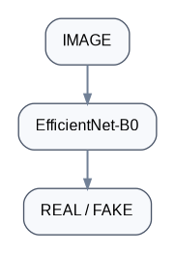
Baseline model path

Get this working.

Then:

EfficientNet
+
Grad-CAM

Then:

Frequency model

Then:

Ensemble

Then:

Video

This ordering is critical.

14. Your first milestone should be ridiculously small

M0 — Baseline

One image:

real.jpg

returns:

{
"label": "REAL",
"probability": 0.91
}

Then:

fake.jpg

returns:

{
"label": "FAKE",
"probability": 0.94
}

No frontend.

No video.

No database.

No fancy UI.

Just prove:

model → inference → prediction

15. Then build the inference contract

Freeze this early.

For example:

{
"request_id": "uuid",
"media_type": "image",
"model_version": "spatial-v1.0",
"verdict": "LIKELY_AI_GENERATED",
"confidence": 0.94,
"scores": {
"spatial": 0.95,
"frequency": 0.91,
"ensemble": 0.94
},
"explanation": {
"heatmap_url": "...",
"regions": []
},
"processing_time_ms": 1420
}

This becomes the contract between:

React ↔ FastAPI

Freeze it.

Then frontend and backend can develop independently.

Your project brief explicitly recommends freezing the API/data contract early so teams can work in parallel. Project-Brief

16. API endpoints

Start simple:

GET /health
GET /api/v1/health

POST /api/v1/analyze/image
POST /api/v1/analyze/video

GET /api/v1/results/{request_id}

Later:

GET /api/v1/models

Don't create 30 endpoints nobody needs.

17. API versioning from day one

Use:

/api/v1/

not:

/api/

Because eventually:

v1 → v2

will happen.

18. Upload security

This is a media-upload application, so take uploads seriously.

Never trust:

filename.mp4

Validate:

- MIME type
- extension
- actual file signature
- file size
- number of frames
- video duration
- resolution
- decompression limits

Reject ridiculous inputs.

For example:

MAX_IMAGE_SIZE = 10 MB
MAX_VIDEO_SIZE = 100 MB
MAX_VIDEO_DURATION = 60 sec
MAX_FRAMES = 300

These are starting values, not sacred numbers.

19. Never expose your model storage credentials

Frontend:

❌ HuggingFace token
❌ database password
❌ backend secret
❌ storage credentials

Frontend only knows:

NEXT_PUBLIC_API_URL

or equivalent.

Backend owns secrets.

20. .env

Create:

.env.example

Example:

APP_ENV=development

DATABASE_URL=

MODEL_REPOSITORY=
MODEL_VERSION=

MAX_UPLOAD_MB=100

LOG_LEVEL=INFO

Actual:

.env

must be:

.gitignore

21. Database

Don't overbuild the database.

For MVP:

analyses
────────────
id
request_id
media_type
model_version
verdict
confidence
processing_time
created_at

Later:

analysis_frames
----------------
id
analysis_id
frame_number
probability
timestamp
heatmap_path

Your project brief specifies result storage and asynchronous handling as part of the backend layer. Project-Brief

22. Frontend structure

Don't put everything in:

App.jsx

Use feature-oriented organization:

features/
upload/
analysis/
results/
history/

Components:

UploadDropzone
AnalysisProgress
VerdictCard
ConfidenceBreakdown
HeatmapViewer
FrameTimeline
ModelInfo
ErrorState

23. UX states

Your UI must handle:

IDLE
UPLOADING
VALIDATING
PROCESSING
ANALYZING
GENERATING_EXPLANATION
COMPLETED
FAILED

Don't just show a spinner.

Your project story specifically includes frame extraction, face detection and analysis progress, so this is worth making visible. Project-Brief

24. Confidence ≠ truth

This is extremely important.

Don't display:

FAKE — 99.8% CERTAIN

unless you've actually calibrated and validated that interpretation.

Prefer:

LIKELY AI-GENERATED

Confidence: 91%

Model evidence:
Spatial: 93%
Frequency: 88%

And clearly explain:

Confidence reflects model output, not factual certainty.

Your project brief itself emphasizes honest limits rather than universal claims. Project-Brief

25. Explainability

Grad-CAM should be treated as evidence of where the model's representation was activated, not as proof that a specific region "caused" the image to be fake.

UI:

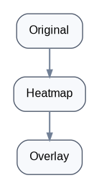
Explainability flow

Allow:

Original | Heatmap | Overlay

26. Video processing

Do not process:

every frame

by default.

Your project proposes sampling frames. Project-Brief

Example:

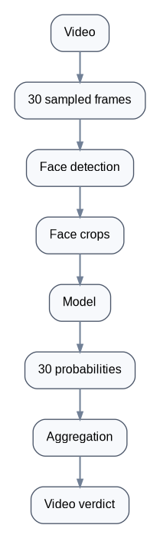
Video processing flow

Store:

frame_probability[]

Then render:

Probability
1.0 | ███
0.8 | █████████
0.6 | █████████████
0.4 | ███████████████
+------------------
1 5 10 15 20 30

27. Aggregation must be an experiment

Don't arbitrarily decide:

video_score = max(frame_scores)

Test:

mean
median
top-k mean

Your project brief specifically proposes comparing these approaches. Project-Brief

That's research.

28. Testing pyramid

You need:

Unit tests

test_face_crop()
test_fft_features()
test_video_sampling()
test_prediction_schema()
test_confidence_mapping()

Integration tests

upload image
↓
API
↓
model
↓
result

End-to-end

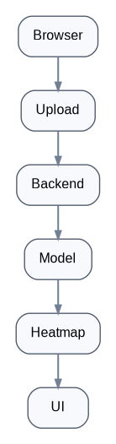
End-to-end application flow

ML tests

model loads
input shape correct
output range [0,1]
checkpoint compatible
preprocessing identical

29. The biggest ML testing mistake

Never let preprocessing differ between training and inference.

Training:

Resize
Normalize

Inference:

Resize
Normalize

must use the same implementation/configuration.

Ideally:

ml/src/.../preprocessing.py

is shared.

30. Reproducibility

Every training run should record:

Git commit
Dataset version
Seed
Python version
PyTorch version
CUDA version
Model version
Config
Hyperparameters
Metrics

Create:

{
"experiment_id": "EXP-007",
"git_commit": "...",
"dataset": "140k-real-fake-v1",
"seed": 42,
"model": "efficientnet_b0",
"epochs": 10,
"batch_size": 32,
"learning_rate": 0.0001
}

This is what separates ML engineering from "I ran a notebook once."

31. Your Colab notebook should NOT contain the whole project

Bad:

DeepVerify.ipynb

with 5,000 lines.

Instead:

notebooks/
01_dataset_exploration.ipynb
02_baseline.ipynb
03_error_analysis.ipynb

and actual logic lives in:

ml/src/

Colab simply executes the package.

32. The Colab environment

Your Colab notebook should basically do:

git clone <repo>
cd deepverify

pip install -r ml/requirements.txt

python ml/scripts/prepare_dataset.py

python ml/scripts/train_spatial.py \
--config ml/configs/spatial_v1.yaml

Then:

checkpoint
metrics
logs

are produced.

That means Antigravity remains your development environment, while Colab remains your GPU execution environment.

33. Model artifact storage

Do not commit:

*.pth
*.pt
*.onnx

to Git.

Use model storage.

For your zero-cost target, Hugging Face is a reasonable candidate for model artifacts.

Structure:

deepverify-spatial-v1
deepverify-frequency-v1

Include:

model card
dataset used
training configuration
evaluation results
limitations
license/usage information

34. CI/CD

Eventually GitHub should automatically run:

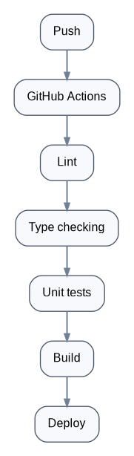
CI/CD pipeline

Frontend:

ESLint
TypeScript
Vitest
Build

Backend:

Ruff
Pytest
MyPy (optional)

ML:

import tests
shape tests
preprocessing tests
model-load test

Do not train the full model on every Git push.

Training is an experiment, not CI.

35. Docker

Containerize backend inference:

backend/
Dockerfile

Conceptually:

Python
+
FastAPI
+
PyTorch
+
OpenCV
+
FFmpeg
+
DeepVerify inference

This makes deployment much easier.

36. Deployment architecture

Given your ₹0 constraint:

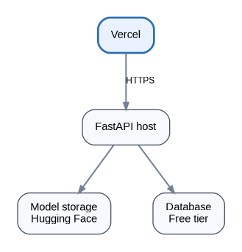
Deployment architecture

But remember:

Free infrastructure is not production-grade infrastructure.

For your university demo, we optimize for:

₹0
+
reliability during demo
+
simple deployment

rather than millions of users.

37. Logging

Every inference should have:

request_id
timestamp
model_version
media_type
processing_time
status
error_code

Example:

2026-10-03T18:20:13
request=abc123
model=spatial-v1.0
media=image
latency=1.42s
status=success

Never log:

passwords
tokens
private credentials

And be careful logging uploaded media.

38. Error handling

Never return:

{
"error": "something went wrong"
}

Instead:

{
"error": {
"code": "UNSUPPORTED_MEDIA_TYPE",
"message": "The uploaded file format is not supported.",
"request_id": "abc123"
}
}

Useful error codes:

INVALID_FILE
FILE_TOO_LARGE
UNSUPPORTED_FORMAT
VIDEO_TOO_LONG
FACE_NOT_DETECTED
PROCESSING_FAILED
MODEL_UNAVAILABLE
INTERNAL_ERROR

39. Observability

At minimum:

Request count
Success rate
Failure rate
Average latency
P95 latency
Model version

For ML:

prediction distribution
confidence distribution

Later:

model drift

40. ADRs — Architecture Decision Records

Whenever you make an important decision:

docs/decisions/ADR-001.md

Example:

# ADR-003: Use FastAPI for inference API

Status: Accepted

Context:
We need a Python API for PyTorch inference.

Decision:
Use FastAPI.

Why:
- Native Python ecosystem
- Pydantic validation
- Async support
- OpenAPI generation

Alternatives:
- Flask
- Django
- Vercel Python functions

Consequences:
...

This will be gold for your report and viva.

41. Git strategy

Don't let six people work directly on main.

Use:

main
develop
feature/*
fix/*
experiment/*

Example:

feature/spatial-model
feature/upload-ui
feature/video-processing
feature/gradcam
fix/preprocessing

PR:

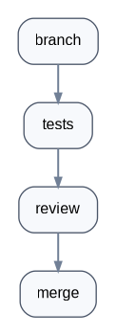
Branch-to-merge workflow

42. Commit formatting

Use Conventional Commits:

feat: add image analysis endpoint
feat: implement efficientnet inference
fix: correct face crop normalization
test: add video sampling tests
refactor: isolate model loading
docs: add FF++ dataset documentation
chore: update dependencies

Avoid:

final changes
update
changes
new
working
fixed

43. Dependency management

Pin versions.

Don't let:

torch
opencv
numpy
timm

randomly update halfway through your project.

Have:

requirements.txt

with pinned versions where appropriate.

Also record:

Python version
CUDA version
PyTorch version

because ML dependencies can be sensitive.

44. Documentation

Your README should eventually answer:

What is DeepVerify?
Architecture
Features
Supported media
Installation
Development
Training
Evaluation
Inference
API
Deployment
Datasets
Limitations
Ethical considerations
License

A new teammate should be able to clone the repo and understand it without asking you.

45. Your ML README should answer a different set of questions

What dataset?
Why?
How downloaded?
How split?
What preprocessing?
What augmentation?
What model?
What pretrained weights?
What loss?
What optimizer?
What hyperparameters?
What metrics?
What experiments?
What limitations?

46. Dataset lineage

For every dataset:

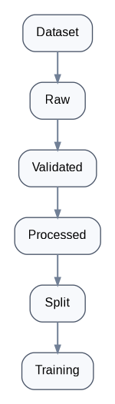
Dataset lineage

Never overwrite raw data.

data/
raw/
interim/
processed/

But these should generally be ignored by Git.

47. Experiment naming

Use:

EXP-001-baseline
EXP-002-efficientnet-finetune
EXP-003-frequency
EXP-004-ensemble
EXP-005-compression
EXP-006-cross-generator
EXP-007-video

Now your Chapter 8 basically writes itself.

48. Your actual research progression

I recommend this exact sequence:

Phase 1 — Foundation

Repository
Antigravity rules
CI
Docker
API contract
Frontend skeleton
Backend skeleton

Phase 2 — Spatial baseline

140k dataset
EfficientNet-B0
fine-tuning
metrics
checkpoint

Phase 3 — Explainability

Grad-CAM
heatmap
overlay

Phase 4 — Frequency model

FFT/DCT
features
classifier
evaluation

Phase 5 — Ensemble

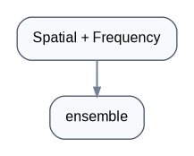
Ensemble research path

Phase 6 — FF++

download
frame extraction
face detection
face crops
face manipulation training/evaluation

Phase 7 — Video

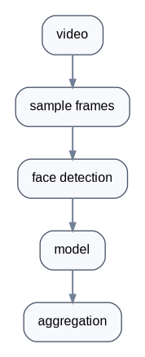
Video research path

Phase 8 — Product

FastAPI
React
upload
progress
results
heatmap
timeline

Phase 9 — Deployment

Docker
Vercel
free backend
model storage
HTTPS

Phase 10 — Hardening

tests
security
error handling
logging
performance
documentation
demo

49. Antigravity-specific development strategy

This is where I would use Antigravity differently from normal coding.

Give it roles.

Agent 1 — Architect

Analyze the repository and produce an implementation plan.
Do not modify code.

Agent 2 — ML

Implement the dataset/model/training component.
Only modify ml/.

Agent 3 — Backend

Implement the API according to docs/api/openapi.yaml.
Do not modify ML implementation.

Agent 4 — Frontend

Implement the UI against the frozen API contract.
Do not modify backend.

Agent 5 — QA

Review the implementation.
Do not modify code.
Find bugs, security issues, missing tests and contract violations.

Antigravity supports parallel agents, artifacts and agent-driven work across the development environment. Antigravity

This is where your team can get enormous leverage.

50. One correction about Antigravity workflows

Current Antigravity documentation says Workflows are being deprecated in favor of Agent Skills by November 1, 2026. Since today is October 3, 2026, I'd avoid building your project around a large collection of workflows. Use Rules + Skills as the long-term structure. Antigravity

So:

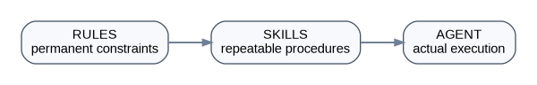
Rules, Skills and Agent relationship

That's the architecture I'd use.

51. Your .agents setup

I'd start with:

.agents/
├── rules/
│ ├── architecture.md
│ ├── ml.md
│ ├── backend.md
│ ├── frontend.md
│ ├── testing.md
│ └── security.md
│
└── skills/
├── train-model/
├── evaluate-model/
├── implement-api/
├── run-tests/
└── release/

Rules should contain invariants.

Skills should contain procedures.

That distinction is also how Antigravity's current documentation describes Rules versus Skills. Antigravity

52. Your first Antigravity prompt

Don't ask it to code yet.

Give it this:

You are the lead software architect for DeepVerify.

Read the entire repository and the project specification before modifying anything.

The system is an academic but production-engineered AI media analysis platform.

Architecture:
- React frontend
- FastAPI backend
- PyTorch ML subsystem
- EfficientNet-B0 spatial detector
- frequency-domain detector
- Grad-CAM explainability
- image and video analysis
- model artifact versioning
- Google Colab for training
- GitHub for source control
- Hugging Face for model artifacts

First, do NOT write application code.

Create:
1. repository architecture
2. module boundaries
3. API contract
4. ML/data boundaries
5. model versioning strategy
6. testing strategy
7. deployment architecture
8. security model
9. development phases
10. architecture decision records

Identify ambiguities and risks in the current specification.

Do not silently invent requirements.

Produce a structured implementation plan and wait for approval before modifying code.

That's the first interaction I'd have with Antigravity.

53. Then establish your Definition of Done

Every feature is complete only when:

[ ] Code implemented
[ ] Tests written
[ ] Tests passing
[ ] Error handling implemented
[ ] Logging added where appropriate
[ ] Security considered
[ ] Documentation updated
[ ] API contract updated if needed
[ ] No secrets committed
[ ] Lint/type checks passing
[ ] Git diff reviewed
[ ] Agent explains what changed

For ML:

[ ] Dataset documented
[ ] Split validated
[ ] Experiment ID created
[ ] Seed recorded
[ ] Config saved
[ ] Metrics recorded
[ ] Checkpoint saved
[ ] Evaluation completed
[ ] Error analysis performed
[ ] Limitations documented

54. The biggest rule for your team

Never let AI-generated code become something you don't understand.

You don't have to manually write everything.

But if Antigravity creates:

model.py

you should know:

What is EfficientNet?
What is pretrained?
What is frozen?
What is fine-tuning?
What is the classifier head?
What is the output?
What loss?
Why?

Same for:

FastAPI
Docker
React
PostgreSQL
Grad-CAM
FFT
video aggregation

Because the university isn't grading Antigravity.

They're grading your system and your understanding of it.

55. The project should have three separate definitions of "working"

Engineering working

Application doesn't crash.

ML working

Model produces measurable discrimination.

Research working

We can explain:
what it detects,
where it works,
where it fails,
and why.

Your project brief is particularly strong on that third dimension: it explicitly frames cross-generator generalization, compression, and model comparisons as experiments rather than hiding limitations. Project-Brief

56. Your ultimate project structure

The end state should look roughly like:

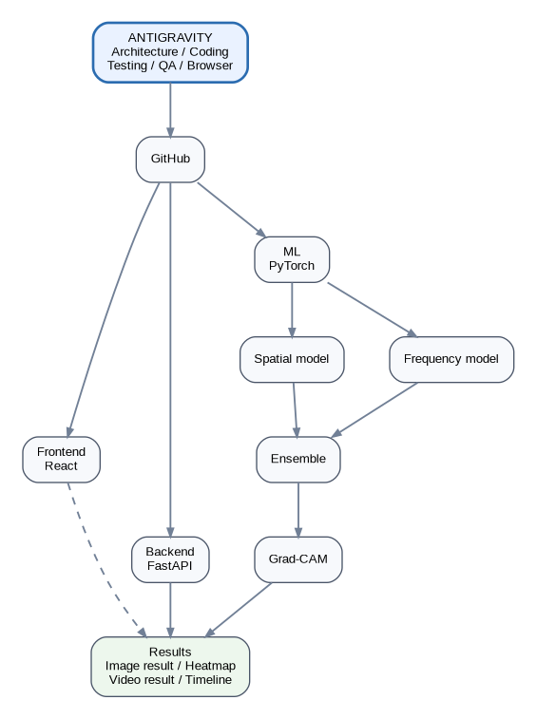
Ultimate DeepVerify project structure

And your data pipeline:

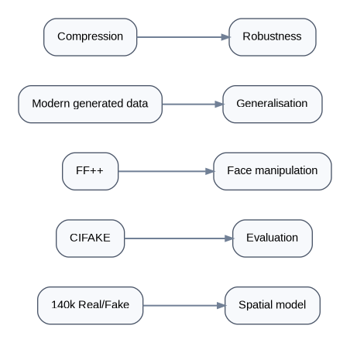
Data pipeline

That gives you a real ML system, a real software architecture, reproducible experiments, a defensible research story, and a deployable demo—without turning a 5th-semester project into an unnecessarily massive production platform.

The immediate order

Do these in this exact order:

01 Create GitHub repo
02 Create monorepo skeleton
03 Create .agents/rules
04 Put project specification in docs/
05 Have Antigravity architect the repo
06 Freeze API contract
07 Build ML dataset pipeline
08 Run ONE baseline training experiment
09 Save first checkpoint + metrics
10 Build standalone inference
11 Add Grad-CAM
12 Build frequency model
13 Ensemble
14 FF++ processing
15 Video inference
16 FastAPI
17 React
18 Integration
19 Testing/security
20 Deploy
21 Demo hardening
22 Documentation/report

Do not start by building the beautiful React dashboard. Your own project brief warns that the platform can consume the project while the actual technical core is the model/evaluation work. Project-Brief

The first thing I would have Antigravity do today is the architecture/repository/rules setup—not the model.

Document integrity noteThis formatted edition was generated directly from the supplied “Pasted text.txt” source. The wording and section sequence are retained; presentation-only changes include Word heading styles, code formatting, hyperlinks, page layout, and redrawn visual diagrams.

