Designing Enterprise Retrieval-Augmented Generation Systems
A Technical Research Report on Architecture, Retrieval, and Reliability

1. Introduction
Retrieval-Augmented Generation (RAG) has become the standard way enterprises connect large language models to their own data. Rather than retraining a model every time internal knowledge changes, a company keeps the model frozen and retrieves the most relevant information at query time, feeding it into the prompt as grounding context. This keeps answers current, auditable, and far cheaper to maintain than continuous fine-tuning.
Most companies hold huge volumes of unstructured knowledge in wikis, PDFs, tickets, and contracts that a general-purpose model has no visibility into. RAG closes that gap by pairing the model with a search layer built on the company's own documents, so answers stay grounded in verifiable sources rather than what the model memorized in training. This report covers the core design decisions behind a production RAG system: architecture, embeddings, chunking, retrieval, prompt construction, vector databases, hallucination reduction, and future directions.

2. Architecture
An enterprise RAG system is really two pipelines: an offline ingestion pipeline that prepares the knowledge base, and an online query pipeline that answers questions in real time. Keeping these separate matters for scale — indexing is heavy batch work, while answering a question needs to happen in a second or two.
On ingestion, documents are pulled from sources like SharePoint or Confluence, cleaned, chunked, embedded, and written to a vector database with metadata. On the query side, the question is embedded with the same model, the vector database returns the closest chunks, a re-ranker trims that list, and the result is inserted into a prompt template before generation.
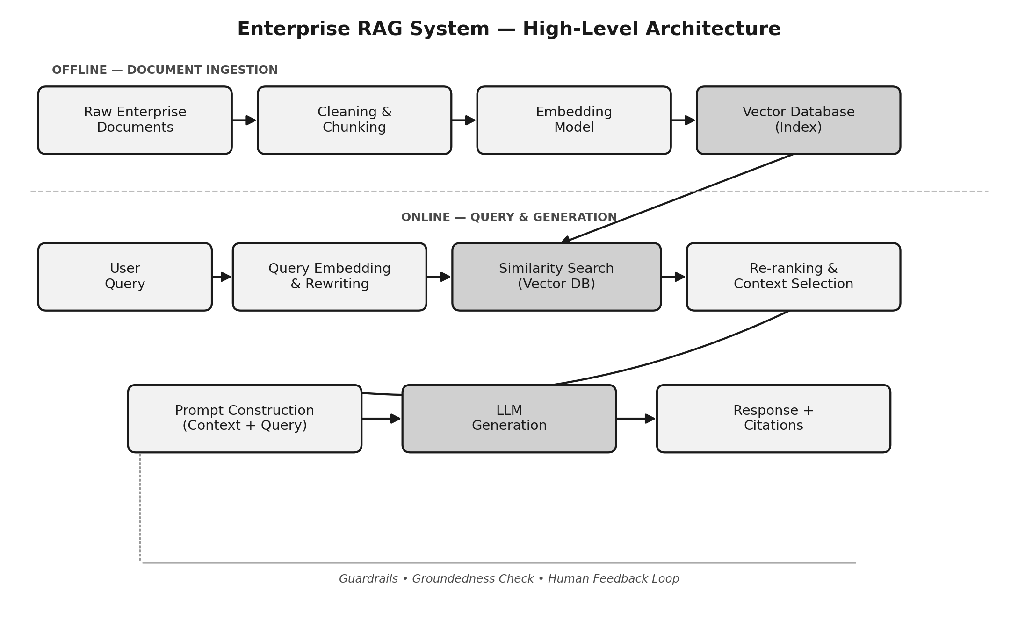
Figure 1. Offline ingestion versus the online query and generation path.
Two details matter most: the same embedding model must be used at ingestion and query time, or similarity search breaks; and an access-control layer must sit on retrieval so a search never surfaces a chunk the user isn't permitted to see. Most teams also add an orchestration layer (LangChain, LlamaIndex, or custom) to manage retries, caching, and logging, and keep the full round trip under two to three seconds.

3. Embeddings
Embeddings are the numerical backbone of the system. An embedding model converts text into a dense vector (typically 384–3072 dimensions) positioned so that semantically similar text sits close together, which lets retrieval work on meaning rather than exact keywords.
- Domain fit — general models (OpenAI, Cohere) suit broad content; domain-specific models retrieve better on legal, medical, or financial vocabulary.
- Hosted vs. self-hosted — APIs are easy but send data externally; self-hosted models (BGE, E5) keep data in-house but need GPU infrastructure.
- Consistency — normalize embeddings and use one distance metric (cosine or dot product) across ingestion and query time; mixing metrics quietly degrades retrieval.

4. Chunking
Chunking breaks long documents into smaller pieces before embedding, and it affects retrieval quality more than most people expect. Chunks that are too large dilute the embedding with unrelated ideas; chunks that are too small lose the surrounding context the model needs to interpret them.
- Fixed-size with overlap — 300–800 token blocks with 10–20% overlap so ideas spanning a boundary aren't lost.
- Semantic / structure-aware — splitting on headings and paragraphs rather than arbitrary token counts.
- Table- and figure-aware — keeping tables and code blocks intact as single chunks.
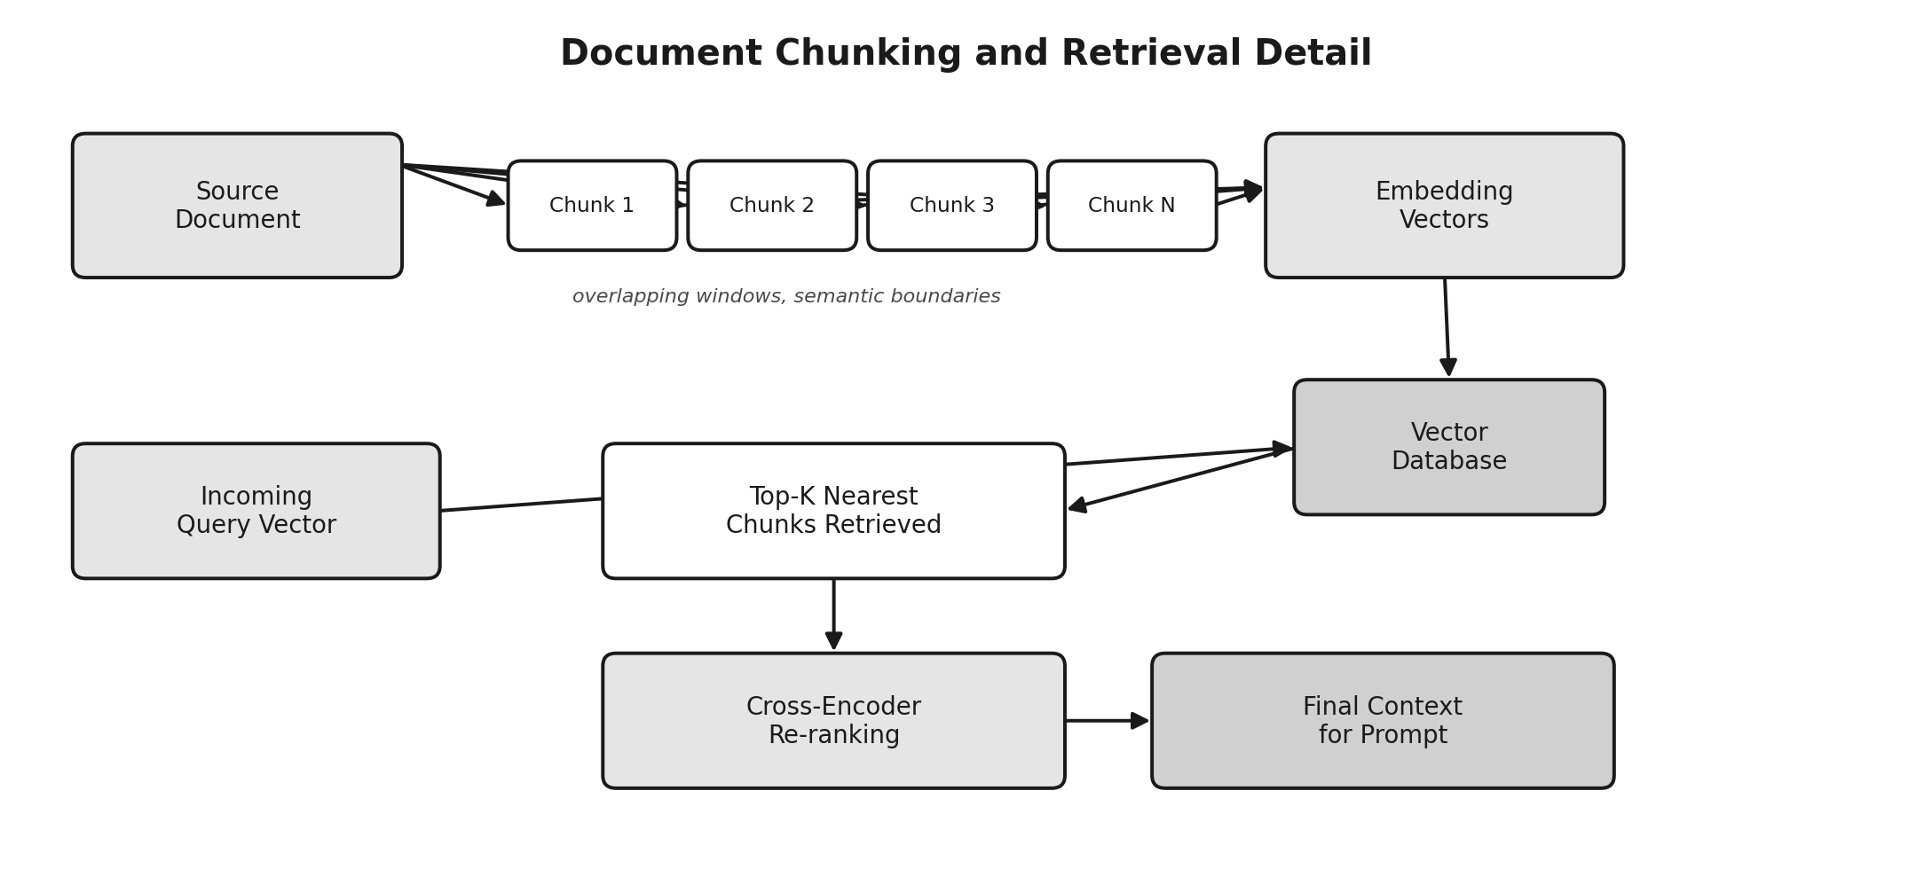
Figure 2. Chunks are embedded, indexed, then retrieved and re-ranked before reaching the prompt.
Every chunk should carry metadata — source title, section, date — so answers can cite sources and stale documents can be filtered out before search runs.

5. Retrieval
Retrieval turns a question into a short list of candidate chunks. Pure dense vector search alone can miss exact matches on product codes or names, so most pipelines combine it with other techniques:
- Hybrid search — dense vector search plus keyword search (BM25), merged, to catch both semantic and exact matches.
- Metadata filtering — narrowing by document type, department, or permission before similarity search runs.
- Re-ranking — scoring the top candidates with a precise cross-encoder and keeping only the best few for the prompt.
Quality is measured with recall@k and mean reciprocal rank against a labeled evaluation set — without one, it's hard to tell whether a retrieval change actually helped.

6. Prompt Construction
Retrieved chunks still need to be assembled into a prompt the model can reason over cleanly; poor prompt construction is a common cause of wrong answers even when retrieval worked correctly. A solid template includes a system instruction, clearly labeled source chunks, the user's question, and explicit instructions for missing information — without that last part, models tend to guess instead of admitting uncertainty.
- Source labeling — tagging each chunk (e.g. [Source 3]) so the model can cite what supported its answer.
- Context ordering — placing the most relevant chunks first or last, since models weight the middle of long prompts less.
- Instruction to abstain — telling the model to answer only from context and say when the answer isn't present.

7. Vector Databases
Vector databases make fast similarity search possible at scale using approximate nearest-neighbor indexes (HNSW, IVF) that trade a little accuracy for large gains in speed. Enterprise teams generally pick between dedicated vector databases (Pinecone, Weaviate, Milvus, Qdrant), vector-enabled extensions of existing databases (pgvector, Elasticsearch), or managed cloud offerings (Azure AI Search, Vertex AI).
What matters most in evaluation: metadata filtering alongside vector search, horizontal scalability, hybrid search support, data residency for compliance, and the ability to update the index incrementally rather than requiring a full rebuild every time content changes.

8. Hallucination Reduction
RAG reduces hallucination but doesn't eliminate it — a model can still ignore retrieved context or answer confidently from weak matches. Enterprise systems treat this as a layered problem:
- Groundedness checking — verifying after generation that each claim is actually supported by the retrieved context.
- Citation enforcement — requiring a source reference for every factual claim.
- Confidence thresholds — declining to answer when retrieved chunks score below a similarity threshold.
- Human review — routing high-stakes answers (legal, financial, medical) through a reviewer, especially early on.
Setting the expectation early that RAG lowers hallucination risk rather than removing it tends to prevent trust problems once real users rely on the system.

9. Future Improvements
- Agentic retrieval — letting the model issue multiple searches and decide when it has enough context.
- Graph-augmented RAG — combining vector search with knowledge graphs for explicit entity relationships.
- Adaptive chunking — adjusting chunk strategy dynamically based on document structure and query type.
- Retriever fine-tuning — using real usage feedback to keep improving embedding and re-ranking models.
These directions point toward RAG systems that behave less like a fixed pipeline and more like an adaptive assistant that decides how to search and checks its own answers.

10. Conclusion
Building a production RAG system means making a series of connected decisions rather than picking one clever technique. Chunking determines what retrieval can find, embeddings determine how well meaning is captured, retrieval and re-ranking determine what reaches the prompt, and prompt construction determines whether the model uses that context faithfully — with hallucination reduction as a continuous discipline layered on top. Teams that treat each stage seriously, and measure quality with real evaluation data, end up with systems people can actually trust.

