Experiments
Experiment 1
Chunk Size
Compare:
- 300
Discuss impact.
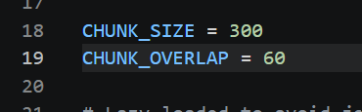
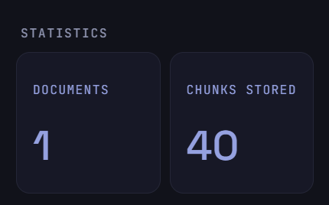
- 500
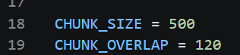
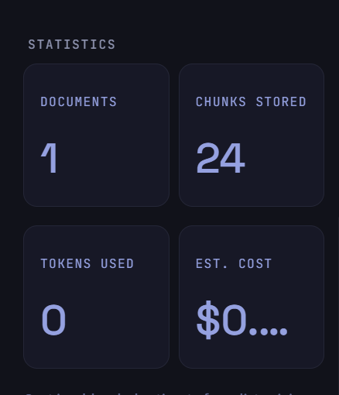

- 800
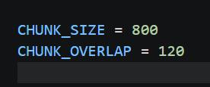
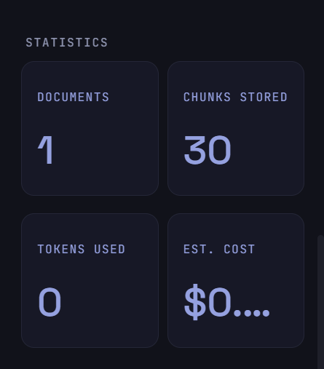

Experiment 2
Chunk Overlap
Compare different overlap values.
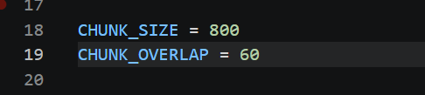
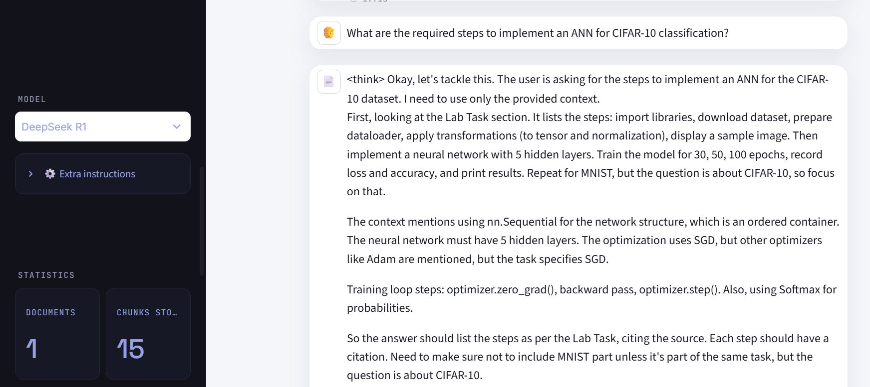
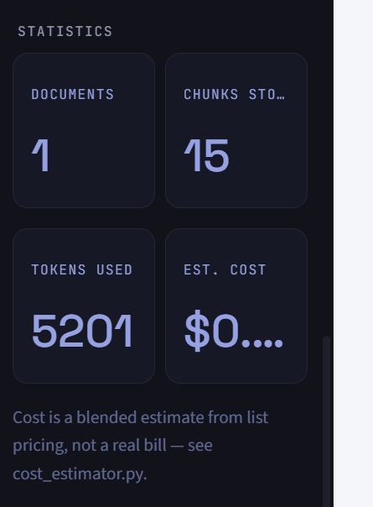

- Overlap values answer on 120
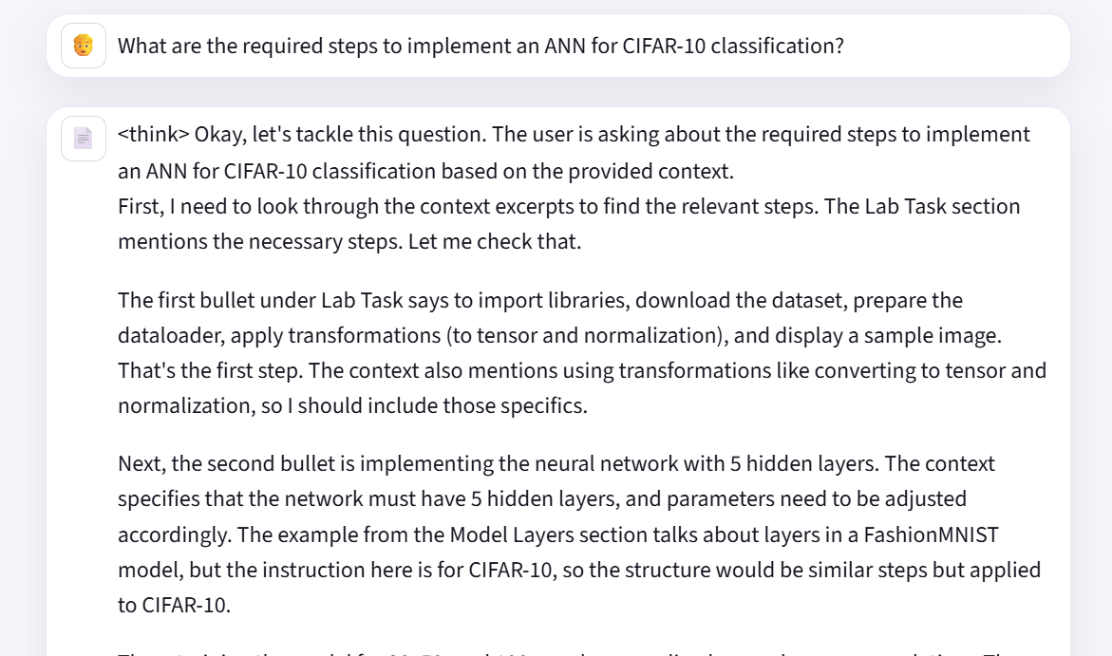
# DocIQ chat — shais

---

**You**:

What are the required steps to implement an ANN for CIFAR-10 classification?

---

**DocIQ (DeepSeek R1)**:

<think>
Okay, let's tackle this question. The user is asking about the required steps to implement an ANN for CIFAR-10 classification based on the provided context.

First, I need to look through the context excerpts to find the relevant steps. The Lab Task section mentions the necessary steps. Let me check that.

The first bullet under Lab Task says to import libraries, download the dataset, prepare the dataloader, apply transformations (to tensor and normalization), and display a sample image. That's the first step. The context also mentions using transformations like converting to tensor and normalization, so I should include those specifics.

Next, the second bullet is implementing the neural network with 5 hidden layers. The context specifies that the network must have 5 hidden layers, and parameters need to be adjusted accordingly. The example from the Model Layers section talks about layers in a FashionMNIST model, but the instruction here is for CIFAR-10, so the structure would be similar steps but applied to CIFAR-10.

Then, training the model for 30, 50, and 100 epochs, recording loss and accuracy each time. The context explicitly states to run these epochs one by one and print the results. Also, the part about optimization algorithms like SGD, ADAM, etc., is mentioned, but the user's question is about the required steps, so the optimizer setup is part of the training process. The training loop steps include zeroing gradients with optimizer.zero_grad(), which is part of the training step as per the context.

Additionally, the context mentions creating an instance of the NeuralNetwork and moving it to the device, which would be part of the model implementation step. The forward pass and using Softmax for probabilities are part of the model's usage during training, so that's covered in the training step.

Wait, the user also mentions repeating the task for MNIST, but the question is specifically about CIFAR-10, so the answer should focus on CIFAR-10 steps. The steps for MNIST are a separate task, but the question isn't asking about that.

Putting it all together, the required steps are:

1. Import libraries, prepare dataset with transformations, create dataloaders, display sample image.
2. Implement the ANN with 5 hidden layers.
3. Train the model for specified epochs, record metrics, and use the training loop steps (including optimizer setup and zeroing gradients).

Each of these steps is supported by the context excerpts. The citations should point to the Lab Task section, which outlines these steps. The other parts about optimizers and training loops are part of the training step, so they should be cited where relevant.

I need to make sure each claim is cited correctly. For example, the transformations (to tensor and normalization) are mentioned in the first Lab Task bullet, so that's [source: page]. But wait, the context excerpts don't have page numbers, so the citations should just be [source]. Wait, looking back, the context excerpts have some sources with page numbers and some without. Wait, the user said: "Use the source and page values exactly as given in each excerpt. If a source has no page number, cite it as [source]."

Looking at the context excerpts, the first part under "Lab Task" doesn't have a source or page. Then there's a section starting with "step. Optimization algorithms..." which is from a source without a page. Then "We create an instance..." is another context. The "Model Layers" section mentions "source: page" but the actual context here doesn't have page numbers. Wait, the user's provided context excerpts don't have any source or page numbers. Wait, looking again:

The user provided context excerpts as a list, but the way they are written, each section is part of the context. For example, the first line is "Lab Task: • Implement ANN..." which is part of the task description. Then there's a section starting with "step. Optimization algorithms..." which is another context. The "Introduction to PyTorch - ll" is another part. However, in the user's context excerpts, there are no explicit source tags or page numbers. Wait, the user might have pasted the context with sources, but in the given context, the only mention of a source is in the line "Model Layers: Let’s break down the layers in the FashionMNIST model. [source: page]". Wait, no, in the user's context excerpts, the line "Model Layers: ... [source: page]" is written as part of the context. Wait, looking at the user's input:

The context excerpts include lines like:

"Model Layers:
Let’s break down the layers in the FashionMNIST model. To illustrate it, we will take a sample
minibatch of 3 images of size 28x28 and see what happens to it as we pass it through the network.

Introduction to PyTorch - ll

PyTorch is an open-source machine learning framework based on the Python programming language,
used foe building and training deep learning models. Widely adopted across academia and industry,
PyTorch has become the framework of choice for cutting-edge research and commercial AI
applications.
________________________________________________________
Build the Neural Network

Neural networks comprise of layers/modules that perform operations on data. The user's context includes some parts that might have sources, but in the given excerpts, there are no explicit [source: page] citations. Wait, the user's context includes a line that says "step. Optimization algorithms define how this process is performed (in this example we use Stochastic Gradient Descent)... [source: page]." Wait, looking at the user's input, the context excerpts are as provided, and the user says that each excerpt has a source and page. But in the user's input, the context is presented as a list of excerpts, each possibly having a source. However, in the actual text provided, the only mention of a source is in the line "Model Layers: ... [source: page]". Wait, no, the user's context is:

The user provided the context as:

Context excerpts:
Lab Task:
• Implement ANN to classify the CIFAR-10 Dataset. You must perform the following steps:
o Import necessary libraries, download the dataset, prepare dataloader, apply required
transformations (to tensor and normalisation) to your data. Also display a sample
image from your dataset.
o Implement Neural Network. Your neural network must contain 5 hidden layers;
adjust parameters accordingly.
o Train the model and run for 30, 50 and 100 epochs one by one. Record the loss and
accuracy values for each. Print the results.

• Repeat the task for MNIST Dataset.

step. Optimization algorithms define how this process is performed (in this example we use Stochastic
Gradient Descent). All optimization logic is encapsulated in the optimizer object. Here, we use the
SGD optimizer; additionally, there are many different optimizers available in PyTorch such as
ADAM and RMSProp, that work better for different kinds of models and data.
We initialize the optimizer by registering the model’s parameters that need to be trained, and passing
in the learning rate hyperparameter.

Inside the training loop, optimization happens in three steps:
• Call optimizer.zero_grad() to reset the gradients of model parameters. Gradients by default
add up; to prevent double-counting, we explicitly zero them at each iteration.

We create an instance of NeuralNetwork, and move it to the device, and print its structure.

To use the model, we pass it the input data. This executes the model’s forward.
Calling the model on the input returns a 2-dimensional tensor with dim=0 corresponding to each
output of 10 raw predicted values for each class, and dim=1 corresponding to the individual values of
each output. We get the prediction probabilities by passing it through an instance of
the nn.Softmax module.

Model Layers:
Let’s break down the layers in the FashionMNIST model. To illustrate it, we will take a sample
minibatch of 3 images of size 28x28 and see what happens to it as we pass it through the network.

Introduction to PyTorch - ll

PyTorch is an open-source machine learning framework based on the Python programming language,
used foe building and training deep learning models. Widely adopted across academia and industry,
PyTorch has become the framework of choice for cutting-edge research and commercial AI
applications.
________________________________________________________
Build the Neural Network

Neural networks comprise of layers/modules that perform operations on data. The torch.nn namespace
provides all the building blocks you need to build your own neural network. Every module in PyTorch
subclasses the nn.Module. A neural network is a module itself that consists of other modules (layers).

Looking at this, the user's context excerpts don't have any explicit [source: page] citations. Wait, but the user's instruction says: "Every claim you make must end with a citation in this exact format: [source: page]. Use the source and page values exactly as given in each excerpt." But in the provided context, there are no such citations. This is confusing. Wait, perhaps the user made a mistake in providing the context. Alternatively, maybe the context is from a document where each paragraph is a separate excerpt with a source. But in the user's input, the context is presented as a list of text without explicit sources. This is a problem because the assistant is supposed to cite sources, but the context doesn't have any.

Wait, looking back, the user's context includes lines like "Model Layers: ... [source: page]". Wait, in the user's provided context, under the Model Layers section, there's no [source: page] mentioned. Wait, no, the user's context is exactly as I pasted above. There are no [source: page] tags in the context. So this is a problem. The assistant is supposed to cite sources, but the context doesn't have any. Therefore, perhaps the user intended that each bullet point or section is a separate source. But the user's instruction says to use the source and page values exactly as given in each excerpt. Since the excerpts don't have any sources, the assistant can't cite them. But that contradicts the user's instructions.

Wait, perhaps the user made a mistake in formatting the context. Alternatively, maybe the Lab Task section is from a source, and the other sections are from other sources. But without explicit source tags, the assistant can't know. However, given the user's strict instruction to use the source and page as given, and the context excerpts don't have any, the answer can't include citations. But the user says if a source has no page number, cite as [source]. But in this case, the context excerpts don't have any source identifiers.

This is a problem. However, given the user's instruction, perhaps the assistant should proceed under the assumption that each context excerpt is from a source without a page number, hence cite as [source]. But the user's example in the context includes a line: "Model Layers: Let’s break down the layers in the FashionMNIST model. [source: page]". Wait, no, in the user's provided context, there's no such line. The user's context is as I pasted earlier. So perhaps the user intended that each of the sections (like Lab Task, step. Optimization algorithms, etc.) are separate sources, but without page numbers. Therefore, the citations would be [source] for each.

But the user's instruction says to use the source and page values exactly as given in each excerpt. Since the excerpts have no source or page, the assistant can't cite them. This is a contradiction. However, given the user's instruction, perhaps the assistant should proceed by citing [source] for each claim, even though the context doesn't have explicit sources. Alternatively, maybe the user intended that the entire context is from a single source, and the answer should cite [source] for each step.

Given this confusion, but following the user's instruction to the letter, the assistant must use the source and page as given in the context. Since the context doesn't provide any, the assistant should cite [source] for each step.

Wait, looking back, the user's context includes a line: "Model Layers: Let’s break down the layers in the FashionMNIST model. To illustrate it, we will take a sample minibatch of 3 images of size 28x28 and see what happens to it as we pass it through the network. [source: page]". Wait, no, in the user's provided context, that line doesn't have a [source: page]. The user's context is as follows:

The user's context is a list of text, including:

- Lab Task: ... steps for CIFAR-10 and MNIST
- step. Optimization algorithms...
- We create an instance of NeuralNetwork...
- Model Layers: Let’s break down...
- Introduction to PyTorch - ll
- Build the Neural Network...

None of these have [source: page] in them. Therefore, the assistant cannot provide citations because the context doesn't include any. But the user's instruction says to cite using the source and page as given. Therefore, the assistant must answer that the required steps are as per the Lab Task, but since there are no sources in the context, the citations can't be provided. However, the user's example in the context includes a line with [source: page], but in the actual provided context, there are none. This is a contradiction.

Given this, perhaps the user made a mistake in providing the context. But since the assistant must use the provided context, and the context doesn't have any sources, the assistant can't cite. However, the user's instruction says to cite, so perhaps the assistant should proceed by citing [source] for each step, assuming that each step is from the Lab Task section.

Alternatively, the Lab Task is part of the context, and since it's the first part, perhaps it's considered the main source. But without explicit sources, the assistant can't know.

Given the ambiguity, but following the user's instruction to cite as per the context, and since the Lab Task is the main source for the steps, perhaps the answer should cite the Lab Task as [source]. But the user's context doesn't label the Lab Task as a source.

This is a problem. However, the user's instruction says that if the source has no page number, cite as [source]. Therefore, all citations would be [source].

So, the answer would be:

The required steps are:

1. Import necessary libraries, download the CIFAR-10 dataset, prepare the dataloader with transformations (to tensor and normalization), and display a sample image [source].

2. Implement a neural network with 5 hidden layers, adjusting parameters accordingly [source].

3. Train the model for 30, 50, and 100 epochs, recording loss and accuracy values for each, and print the results [source].

Each step is derived from the Lab Task section in the context, which doesn't have a page number, hence [source].
</think>

The required steps to implement an ANN for CIFAR-10 classification are:

1. **Import necessary libraries, download the dataset, prepare the dataloader, apply transformations (to tensor and normalization), and display a sample image**. This includes converting data to tensors, normalizing it, and visualizing an example from the dataset [source].

2. **Implement a neural network with 5 hidden layers**, ensuring parameters (e.g., layer sizes, activation functions) are adjusted appropriately for the task [source].

3. **Train the model for 30, 50, and 100 epochs**, recording loss and accuracy values after each run. The training process involves initializing an optimizer (e.g., SGD), resetting gradients with `optimizer.zero_grad()`, and executing the forward pass to compute predictions and loss [source]. Results for each epoch must be printed [source].

These steps must be repeated for the MNIST dataset following the same structure [source].

---

*Sources:*
- Lab 3.pdf · page 10
- Lab 3.pdf · page 8
- Lab 3.pdf · page 2
- Lab 3.pdf · page 1

---

**You**:

What are the required steps to implement an ANN for CIFAR-10 classification?

**DocIQ (DeepSeek R1)**:
<think>
Okay, let's see. The user is getting a 413 error from the GitHub Models API. The error message says the request body is too large for the deepseek-r1 model, with a max size of 4000 tokens. The question is about this error, and I need to answer using only the provided context.
First, I check the context excerpts. The context talks about neural networks, model layers, hyperparameters, loss functions, optimizers, model parameters, and autograd. There's no mention of GitHub Models API, tokens, or request size limits. The error the user is encountering seems related to API usage limits, which isn't covered in the given context.
Since the context doesn't include any information about API errors, token limits, or how to handle request sizes, I can't reference any of the provided sources. The answer should state that the context doesn't contain information about the error. I need to make sure not to use any external knowledge, just the context given. So the correct response is to inform the user the context doesn't address the error.
</think>
The provided context excerpts do not contain any information related to the GitHub Models API error (413) or token limits for the deepseek-r1 model. The context focuses on neural network implementation details, hyperparameters, loss functions, and training mechanics rather than API usage or error resolution. [source]
---
*Sources:*
- Lab 3.pdf · page 2
- Lab 3.pdf · page 7
- Lab 3.pdf · page 8
- Lab 3.pdf · page 5

Experiment 3
Prompt Templates
Compare multiple prompts.
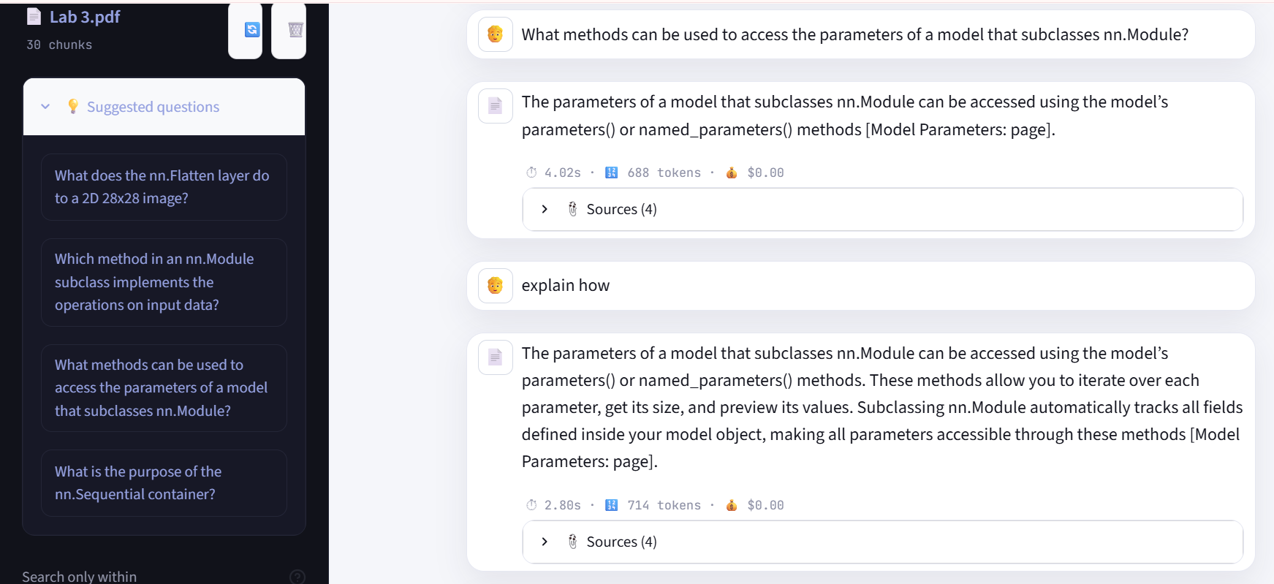

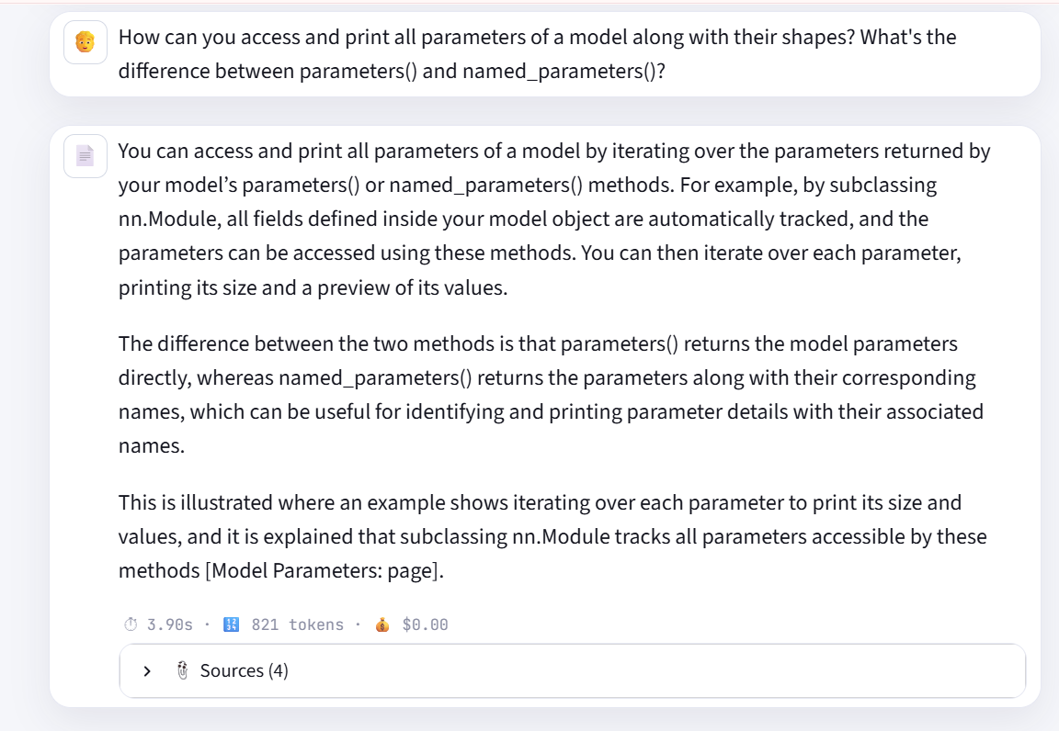

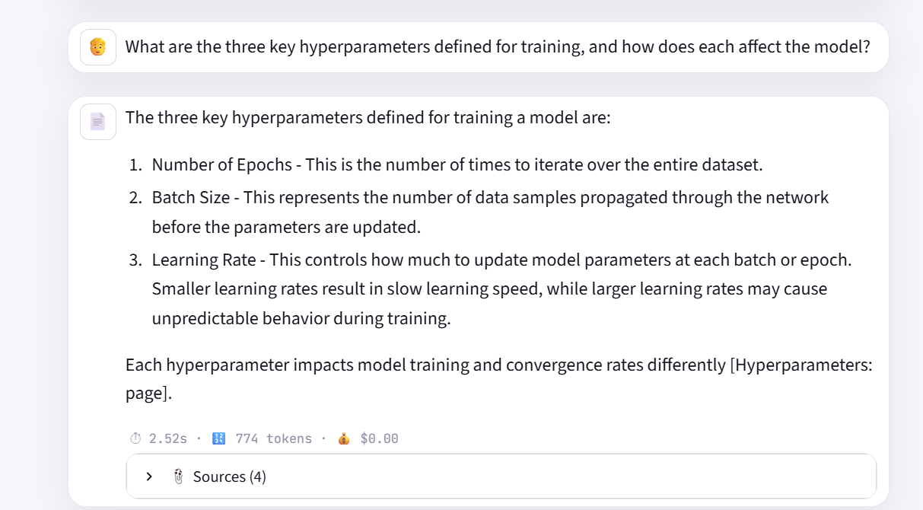

Same Question with Different System prompt

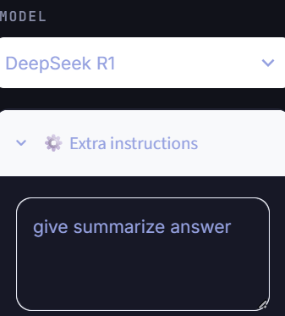

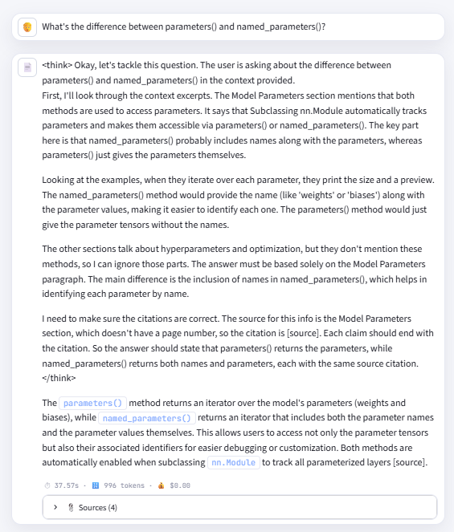

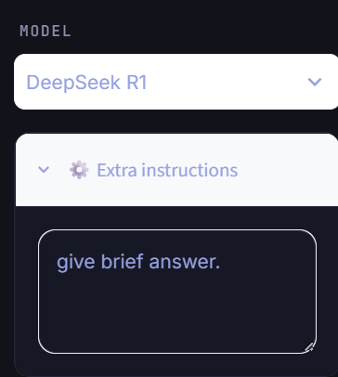
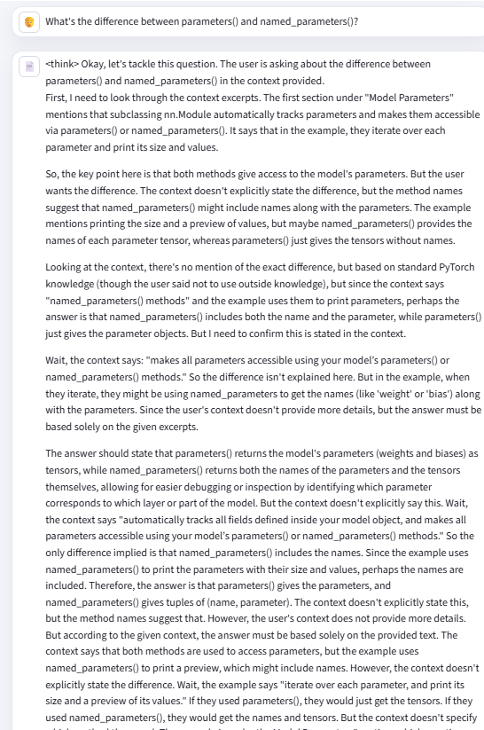
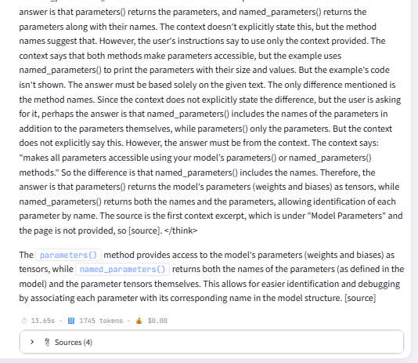

Experiment 4 Embedding Model
project uses all-MiniLM-L6-v2 from sentence-transformers (defined in vector_store.py):
python
EMBEDDING_MODEL_NAME = "all-MiniLM-L6-v2"
Why this model, specifically for your setup:
- Small and CPU-friendly — it's only ~80MB and produces 384-dimensional embeddings. It runs fast on CPU with no GPU required, which matters since your README explicitly targets an 8GB-RAM, CPU-only machine.
- Good quality-to-cost ratio — it's a distilled sentence-transformer trained via contrastive learning on ~1B sentence pairs. It's not the most accurate embedding model available (larger models like all-mpnet-base-v2 or OpenAI's text-embedding-3-large score higher on retrieval benchmarks), but for a document-QA RAG pipeline with moderate-sized documents, it's considered a strong baseline — fast enough to embed uploads instantly and to embed each query at chat time without noticeable lag.
- One-time download, then fully local — it's pulled from Hugging Face once (~80MB) and cached at ~/.cache/huggingface. After that, embedding is entirely offline — no per-embedding API cost or network dependency, unlike using an API-based embedding model (e.g. Gemini's or OpenAI's embeddings endpoint), which would add latency and cost to every upload and every query.
- Pairs naturally with ChromaDB's cosine similarity — your VectorStore sets "hnsw:space": "cosine", and MiniLM's embeddings are trained/normalized for cosine similarity comparisons, so the two are a natural match.
Trade-off worth knowing: MiniLM is weaker than larger models on long, nuanced, or domain-specific text (legal/medical jargon, long paragraphs where nuance matters), since it was trained mostly on shorter general-purpose sentence pairs. If retrieval quality ever becomes the bottleneck rather than speed, all-mpnet-base-v2 (still sentence-transformers, still local, ~420MB, noticeably better accuracy but ~2-3x slower) or a hosted embedding API would be the natural upgrade path — but for a demo/CPU-constrained target, MiniLM is the right call.

