Designing Enterprise Retrieval-Augmented Generation Systems

1.Architecture
An enterprise RAG system is essentially made of two pipelines that share a vector store. The ingestion pipeline works offline whenever a new document is added: it extracts the text, cleans it, splits it into chunks, converts those chunks into embeddings, and stores both the embeddings and metadata in a vector database. The query pipeline works online when a user asks a question: it finds the most relevant chunks, builds a grounded prompt, and sends it to the language model. Separating these two stages makes the system easier to scale and prevents document indexing from slowing down live answers.
Two other design choices matter in production. First, a provider-agnostic layer that can work with multiple LLM backends, such as Gemini, DeepSeek, or Llama, gives teams flexibility to switch models based on cost, speed, or performance without changing the retrieval logic. Second, conversation memory should be part of the architecture, because each new question depends not only on the retrieved text but also on the earlier chat history.
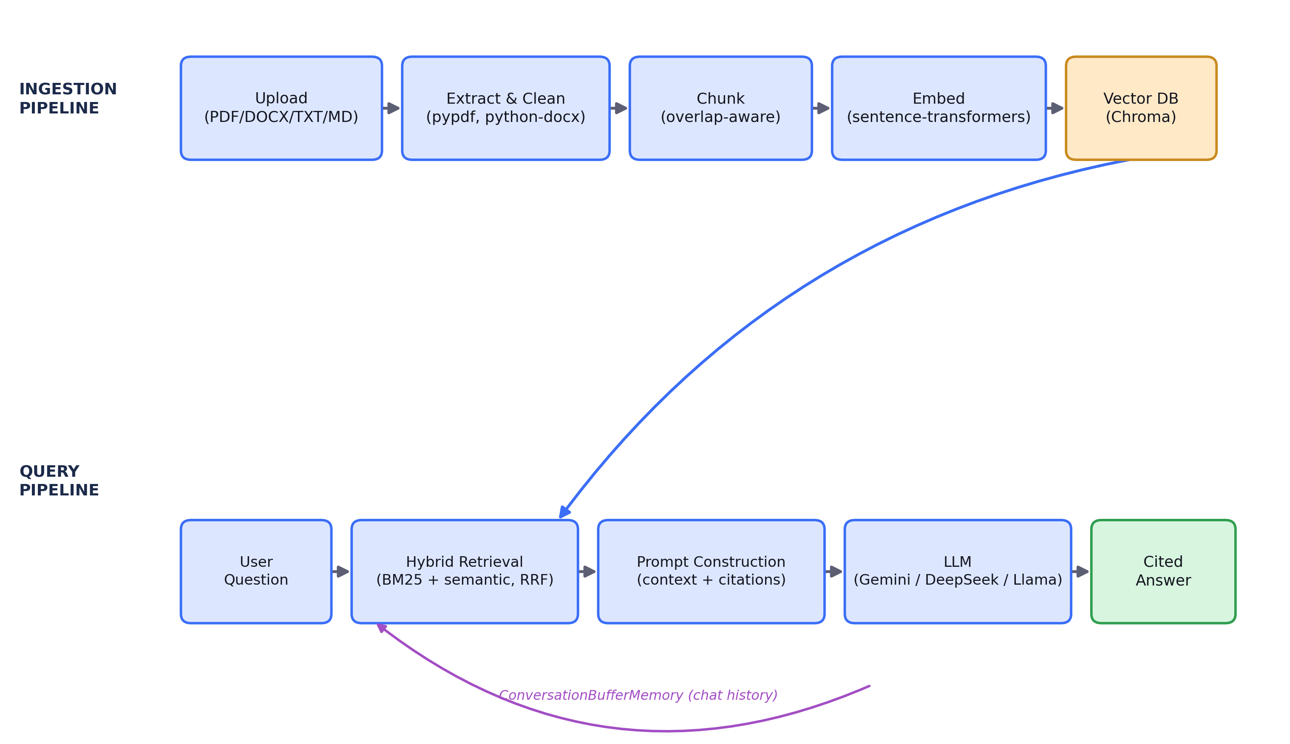

2. Embeddings
Embeddings turn text chunks into numeric vectors so that similar meanings appear close together in vector space. Choosing the right embedding model is a practical trade-off, not a one-size-fits-all decision. Small self-hosted models are cheap, fast, and easy to run locally, but they may not perform as well on specialized or complex enterprise language. Hosted embedding APIs usually give better retrieval quality, especially for technical or jargon-heavy text, but they add cost, latency, and dependence on an external service.
A good starting point for many enterprise systems is a small self-hosted model, with a plan to upgrade later if real user queries show that retrieval quality is not good enough. If the organization has highly specific vocabulary, fine-tuning on internal terminology can also improve performance.

3. Chunking
Before documents can be embedded, they must be split into smaller chunks. This is necessary because embedding an entire document as one vector usually makes it too broad to match a specific question well. Smaller chunks improve precision, but they can also split related ideas apart. Larger chunks preserve more context, but they can make retrieval less accurate and increase token costs.
A common solution is to use overlap between chunks so that important sentences are not cut off at the boundary. In an enterprise system, each chunk should also keep metadata such as the source filename, page number, and position in the document, because that information is what later allows the system to cite sources properly.
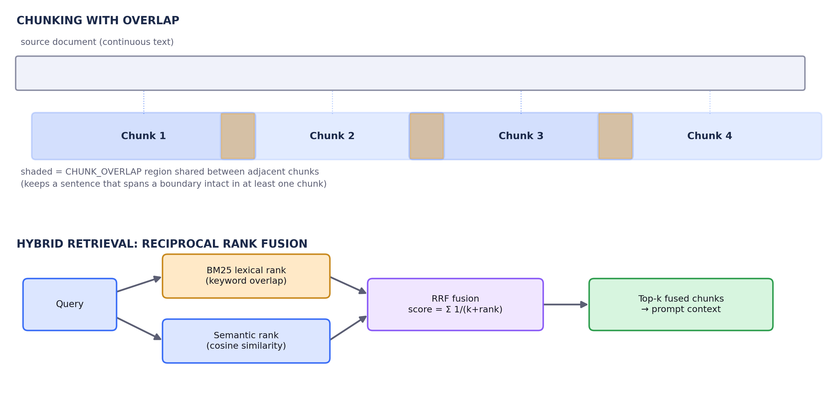

4. Retrieval
Semantic search alone is not enough because it can miss exact terms like product IDs, names, or codes. Keyword search alone also has a weakness because it may fail when the user phrases a question differently from the source text. Hybrid retrieval combines both methods and merges the rankings so the system can handle both paraphrased questions and exact matches more reliably.
In practice, two additional factors matter: how many chunks are passed into the model, and whether retrieval is filtered by metadata such as document type, department, or access level. These controls help balance answer quality, cost, and security in enterprise environments.

5. Prompt Construction
Retrieval by itself does not prevent hallucinations. The prompt must clearly instruct the model to use only the provided context and to admit when the information is not enough. A strong RAG prompt should also require citations in a fixed format and separate the system instructions, retrieved context, chat history, and user question so the model does not confuse them.
Context size also matters. If too many chunks or too much history are included, the prompt can exceed the model’s context window. In that case, the system should keep the most relevant information and reduce older or less important chat history first.

6. Vector Databases
The choice of vector database affects both performance and flexibility. Local options like Chroma or FAISS are simple and good for smaller deployments. Managed systems like Pinecone, Weaviate, Milvus, and Qdrant are better suited for larger-scale, distributed, or multi-tenant setups.
For enterprise use, metadata filtering is essential, because users should only retrieve documents they are allowed to access. Multi-tenancy can be handled by separating collections for each tenant or by using one shared index with strict filters. Backup and persistence also matter, because an index that exists only in memory or on temporary storage cannot be relied on for long-term use.

7. Hallucination Reduction
No single method can fully eliminate hallucinations, so enterprise systems usually combine several safeguards. Better retrieval is the first defense, because if the model sees irrelevant or weak context, it is more likely to give a weak answer. Prompt constraints are the second defense, especially when they tell the model to answer only from the retrieved sources and to say “I don’t know” when needed.
Other useful techniques include lowering temperature for factual answers, adding citations after each claim, reranking results before generation, and checking whether citations are actually supported by the retrieved text. For high-stakes use cases, human review is still important because RAG reduces risk, but it does not eliminate it.
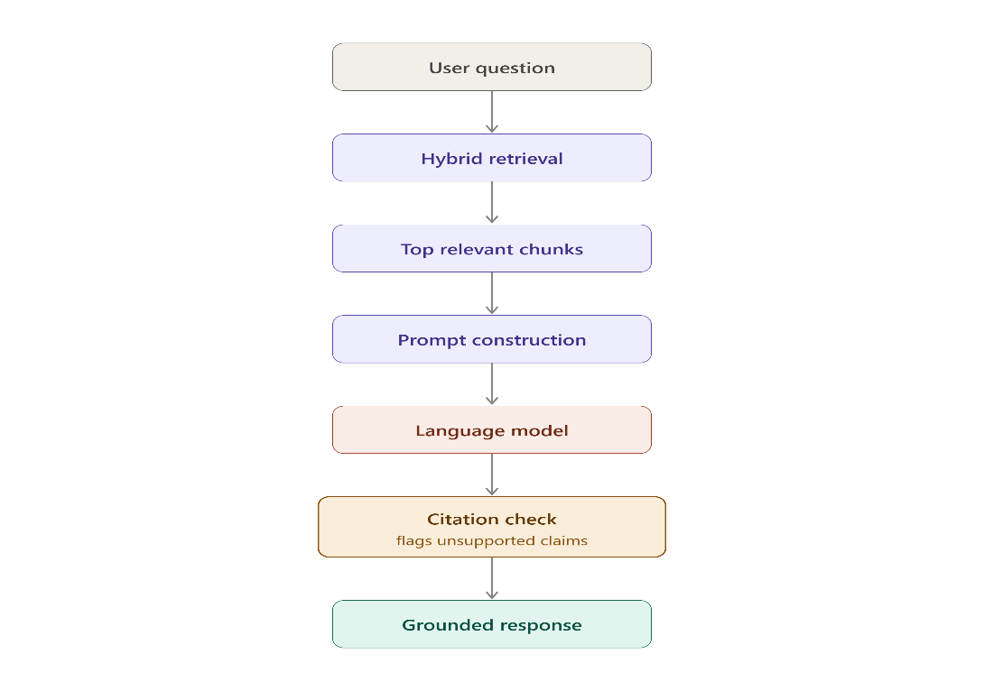

8. Future Improvements
Several upgrades often become useful once a RAG system is already in production. Cross-encoder reranking can improve precision, evaluation tools can measure faithfulness and answer quality, and semantic chunking can work better than fixed-size splitting for messy documents. Streaming responses can improve user experience, and automated groundedness checks can make citations more trustworthy.
Agentic multi-step retrieval is another promising direction. Instead of trying to answer from one retrieval pass, the system can ask follow-up retrieval questions when the first set of results is not enough.

Conclusion
The main lesson is that RAG works best when every part of the pipeline supports the others. Chunking affects retrieval, retrieval affects prompt quality, and the vector database determines how well metadata filtering and access control can work. The best practical approach is to start with sensible defaults, test the system on real questions, and then improve the parts that cause the most errors, usually retrieval quality or citation faithfulness.
