# ________________________________________

**Lesson Title: Introduction to Java**  **Materials:**

**Lesson Objectives:** Student Activity Sheets

At the end of the lesson, you shoud be able to: **References:**

1. understand the basics of Java programming language; Daniel, Liang. Introduction to Java
2. know the different primitive data types in Java; Programming 7th Edition.
3. run a simple Java program. Java Tutorial

@www.w3schools.com

|  |
| --- |
| Productivity Tip:  ***“Eat a healthy breakfast”*** |

## A. LESSON PREVIEW/REVIEW

1. Introduction (2 mins)

Have a brand new day. Today, our lesson is about Introduction to Java Programming Language. Since ITE 189 – Computer Programming 3 focuses about Object Oriented Programming, we will be learning Java because it is an object oriented programming language. It is best to learn Java because is designed to be easy to use and is therefore easy to write, compile, debug, and learn than other programming languages. Besides, Java's secure feature enables us to develop virus-free, tamper-free systems. Since, it is object-oriented, Java allows us to create modular programs and reusable code. Therefore, at the end of this lesson, you should be able to:

1. understand the basics of Java programming language; 2. comprehend the concept of class hierarchy.

1. Activity 1: What I Know Chart, Part 1 (3 mins)

I am writing three questions on the second column related to the topic for the day. I would like you to write in the first column whay you know about the question. Just left the third column blank at this time.

|  |  |  |
| --- | --- | --- |
| What I Know | Questions: | What I Learned (Activity 4) |
| James Gosling | 1. Who initiated the Java language? |  |
| byte, short, int, long, float etc. | 2. What are examples of Java primitive data types? |  |
| Yes, java is a case sensitive, even the slight difference in naming indicates different objects. | 3. Is Java a case – sensitive programming language? |  |

# ________________________________________

## B.MAIN LESSON

1)

Act

ivity 2: Content Notes

(

45

mins

)



**History of**

**Java**

James Gosling initiated Java language project in June 1991 for use in one of his many

set

-

top box projects. The language, initially called „Oak‟ after an oak tree that stood outside

Gosling's office, also

went by the name „Green‟ and ended up later b

eing renamed as Java, from

.

a list of random words

**Java Quickstart**

In Java, every application begins with a class name, and that class must match the

filename.

Let's create our first Java file, called MyClass.java, which can be done in any text

editor (l

ike Notepad).

The file should contain a "Hello World" message, which is written with

the following code:

public class MyClass{

public static void main(String[] args){

System.out.println(“Hello World”);

}

}

Don't worry if you don'

t understand the code above

-

I

will discuss

it in detail

.

For now,

focus on

**how**

to run the code above.

Save the code in Notepad as "MyClass.java". Open

Command Prompt (cmd.exe), navigate to the directory where you saved your file, and type

"javac MyClass

.java":

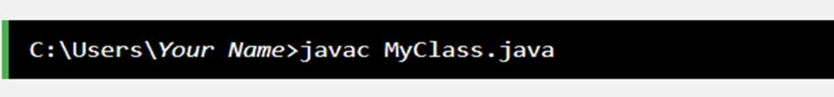

This will compile your code. If there are no errors in the code, the command prompt will

take you to the next line. Now, type "java MyClass" to run the file:

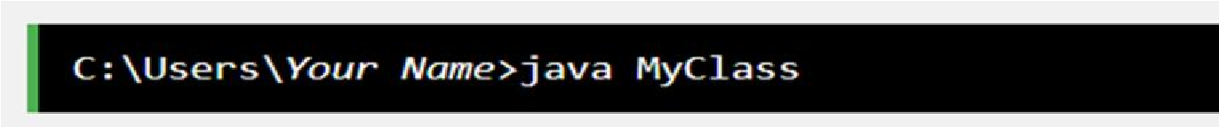

# ________________________________________

The output should read:

You have many options in running the example program. You can use the installer I had given to you or you can use any online Java compiler and search it through using search engine.

## Basic Syntax

About Java programs, it is very important to keep in mind the following points.

* **Case Sensitivity** − Java is case sensitive, which means identifier **Hello** and **hello** would have different meaning in Java.
* **Class Names** − For all class names the first letter should be in Upper Case. If several words are used to form a name of the class, each inner word's first letter should be in Upper Case.

**Example:** *class MyClass*

* **Method Names** − All method names should start with a Lower Case letter. If several words are used to form the name of the method, then each inner word's first letter should be in Upper

Case.

**Example:** *public void myMethodName()*

* **Program File Name** − Name of the program file should exactly match the class name.

When saving the file, you should save it using the class name (Remember Java is case sensitive) and append '.java' to the end of the name (if the file name and the class name do not match, your program will not compile).

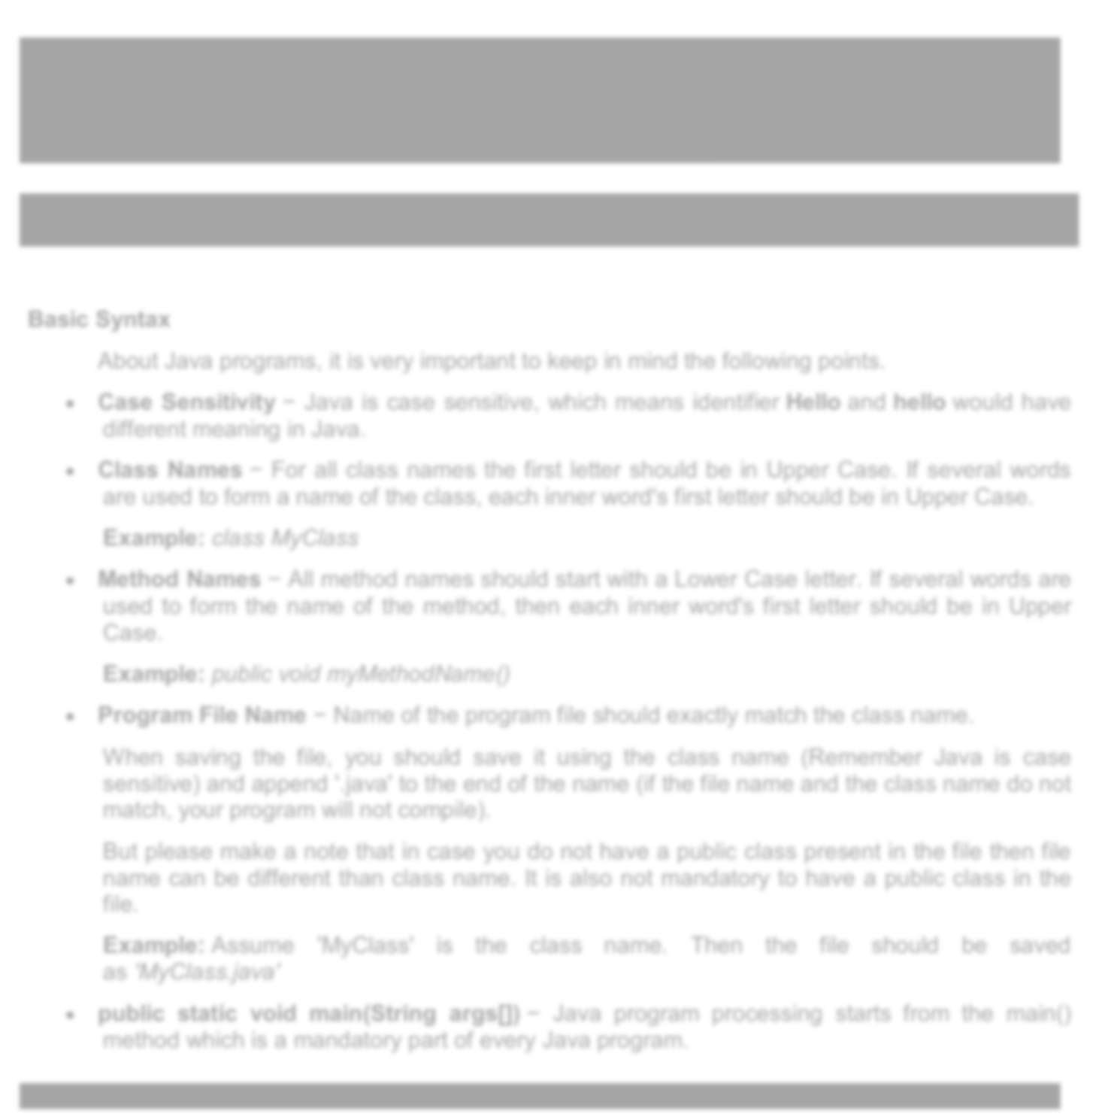

But please make a note that in case you do not have a public class present in the file then file name can be different than class name. It is also not mandatory to have a public class in the file.

**Example:** Assume 'MyClass' is the class name. Then the file should be saved as *'MyClass.java'*

* **public static void main(String args[])** − Java program processing starts from the main() method which is a mandatory part of every Java program.

# ________________________________________

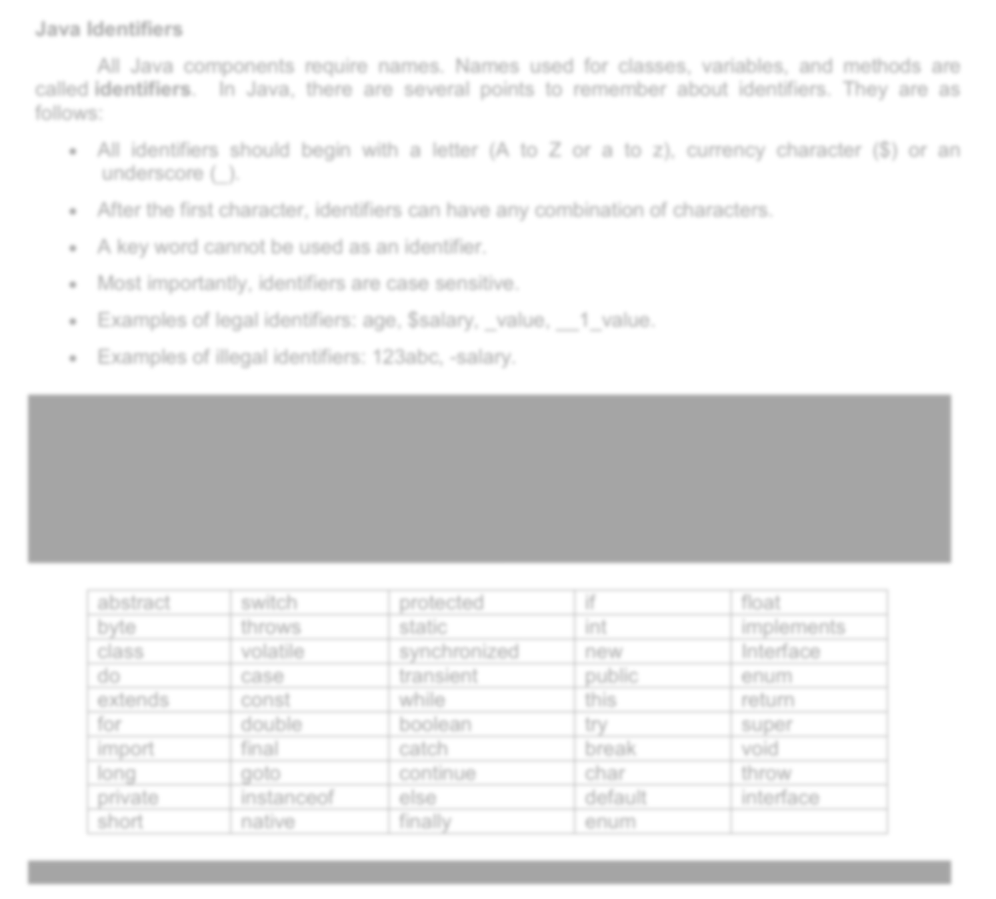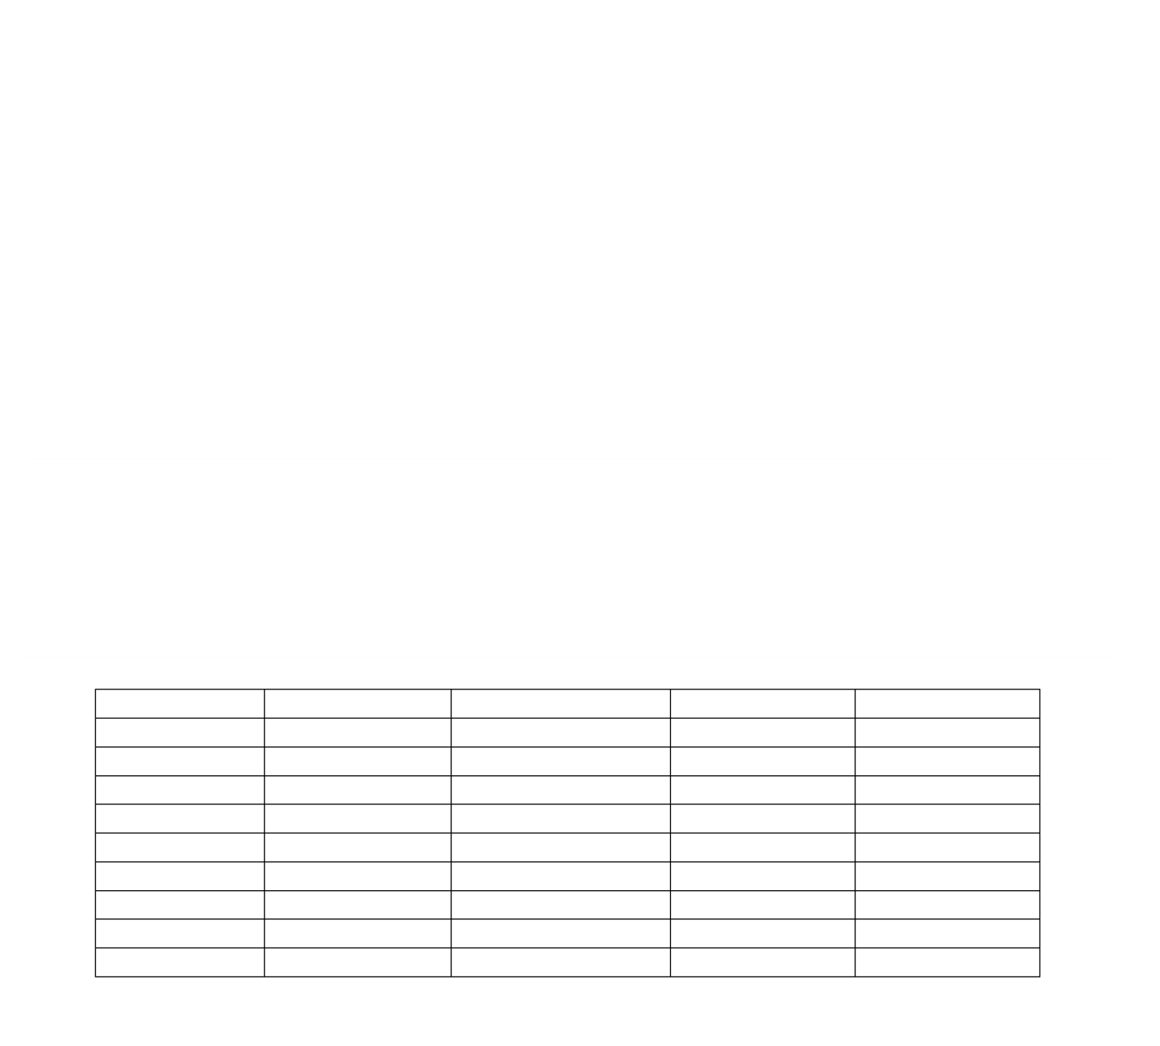

**Java Identifiers**

All Java components require names. Names used for classes, variables, and methods are

called

**identifiers**

.

In Java, there are several points to remember

about id

entifiers. They are as

follows

:

•

All identifiers should begin with a letter (A to Z or a to z), currency character ($) or an

underscore (_).

•

After the first character, identifiers can have any combination of characters.

•

A key word cannot be used as

an identifier.

•

Most importantly, identifiers are case sensitive.

•

Examples of legal identifiers: age, $salary, _value, __1_value.

•

Examples of illegal identifiers: 123abc,

-

salary.

**Java Reserved Words**

The following list shows the reserved words

in Java.

These reserved words may not be used

as constant or variable or any other identifier names.

abstract

switch

protected

if

float

byte

throws

static

int

implements

class

volatile

synchronized

new

Interface

do

case

transient

public

enum

extends

const

while

this

return

for

double

boolean

try

super

import

final

catch

break

void

long

goto

continue

char

throw

private

instanceof

else

default

interface

short

native

finally

enum

# ________________________________________



**Java Comments**

Java provides 3

styles of comments:

1

.

/* This can be a multi

-

line

comment */

2

.

// This is a single

-

line comment

.

3

/** This is a multi

-

line javadoc

comment*/

**Java Primitive Data Types**

Please take note that

:

byte, short, int & long

–

s

mber

stores whole nu

float, double

–

stores fr

actional number

s

char

–

stores characters

boolean

–

stores true or fals

e

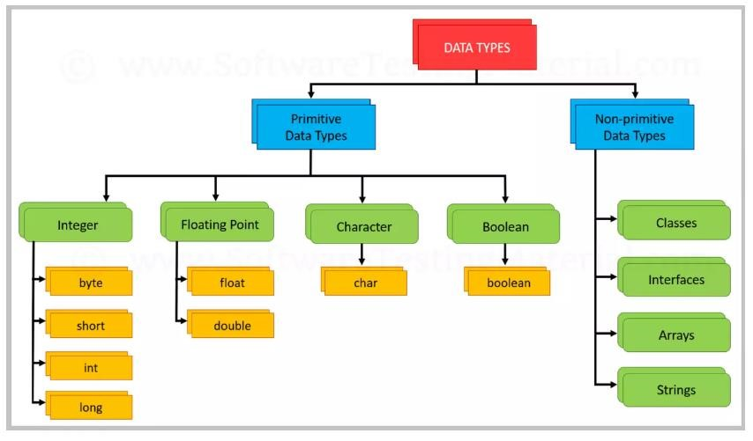

# ________________________________________



**Declaring Variables**

Syntax:

<

data type> <variable name> = <value>;

Example 1

:

Create a variable called

**name**

of type

String

and assign it the value "

**John**

":

String name = “John”;

Example 2

:

Create a variable called

**myNum**

of type

int

and assign it the value

15.

int mynum=15;

You can also declare a variable without assigning the value, and assign the value later:

int myNum

;

myNum=15

;

A declaration of how to declare variables of different types:

int myNum=5

;

float

;

myFlo

atNum=5.99

char mi=‟T‟

;

boolean ans=true

;

**Displaying Variables**

The

println()

method is often used to display variables.

To combine both text and a variable,

use the

+

:

character

Example:

String name=”John”

;

System.out.println(“ Hello “

+

name)

;

# ________________________________________

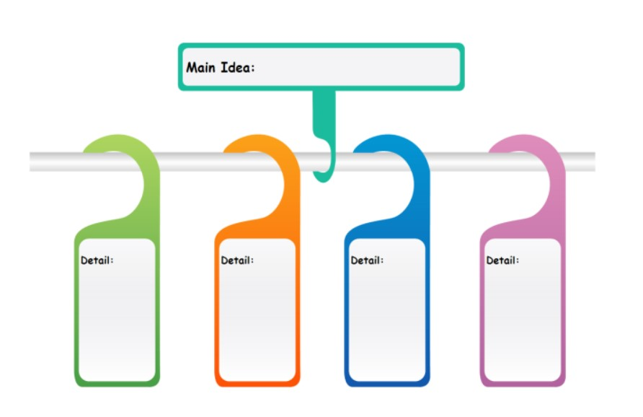

**Java Operators**



**Arithmetic**

**+**

**%**

**-**

**++**

**\***

**-**

**-**

**/**



**Relatonal**

**>**

**=**

**>**

**<**

**<**

**=**

**!**

**=**

**=**

**=**



**Assignment**

**=**

**=**

**+**

**-**

**=**

**\* =**

**/ = %=**



**Logical**

**&&**

**||**

**!**

You can use the different Java operators when you are performing an operation in programming. Let us say for example, you want to compute the area of a square, you can have these lines of codes:

int side=5;

int area_square = side * side;

Moreover, when you want to compute the area of a circle, you will have the following statements:

float r=2.5;

float area_circle =3.1416 * r * r;

# ________________________________________

2) Activity 3: Skill-building Activities (25 mins + 5 mins checking)

Test I. Write the word LEGAL if the given variable is a correct identifier, otherwise write “ILLEGAL”.

___LEGAL____1. C2

__ILLEGAL____2. 01K

___LEGAL____3. age

__ILLEGAL____4. ~happy

___LEGAL____5. tuition_fee

__ILLEGAL____6. public

__ILLEGAL____7. total bill

___LEGAL____8. $grosspay

__ILLEGAL____9. void

___LEGAL____10. b1

Test II. Add the correct data type for the following variables:

1. ____int______ myNum1=10;
2. ____char____ myLetter=‟A‟;
3. ___boolean__ myAnswer=true;
4. ___float_____ myNum2=5.2;
5. ___string____ myText=”Hello”;

Test III. Give five examples of Java reserved words.

_____new________ _____double_____ _______void_____

_____else________ _____class______

When you are done answering the self – assessment, please check your answers against the Key to Corrections found at the end of this Student Activity Sheets. Write your score on your paper.

# ________________________________________

1. Activity 4: What I Know Chart (3 mins)

Let us monitor how far you have learned in this lesson by reviewing the questions in the What I Know Chart from Activity 1. Please write your answers to the questions based on what you **now** know in the third column of the table.

|  |  |  |
| --- | --- | --- |
| What I Know | Questions: | What I Learned (Activity 4) |
|  | 1. Who initiated the Java language? | James Gosling |
|  | 2. What are examples of Java primitive data types? | Byte,short, int, long, float ect. |
|  | 3. Is Java a case – sensitive programming language? | Yes, java is a case sensitive, even the slightest difference of naming. |

1. Activity 5: Check for Understanding (70 mins including hands – on + 7 mins checking)

Test I. Write the correct formula by using variables, sample values and operators. Be sure to include variable declarations in each item.

1. Area of triangle

float c = 7, d =14;

float area = (c * d ) /2;

1. Volume of cylinder

float c = 3.5, d = 4.0;

float vol = 3.1416 * c * c* d;

1. Perimeter of rectangle

int L = 7, w = 14;

int p = 2L + 2w;

1. Perimeter of Square

int s = 7;

int p = 6 * s;

# ________________________________________

Test II. Programming

Make a Java program that would print your name, course and year and contact number.

Ans.

**public class ourAnswer{**

**public static void main(String[] args)**

**System.out.printIn("Melrose Baking");**

**System.out.printIn("BSIT-2");**

**system.out.printIn("09614850292");**

**}**

**}**

When you are done answering, please check your answers against the Key to Corrections found at the end of this Student Activity Sheets. Write your score on your paper.

## C. LESSON WRAP-UP

1) Activity 6: Thinking about Learning (5 mins)

1. Work Tracker

You are done with this session! Let‟s track your progress. Shade the session number you just completed.



1. Think about your Learning

1. What was the most useful or the most meaningful thing you learned on this topic?

________The most meaningful in this topic for me is the introduction of java and I think this is most important of all.

1. In today‟s lesson, what was least clear to you?

_______So far there’s none, Everything was clear to me.______________________________

## FAQs

1. What happens if I do not declare a variable in Java?

If you do not declare a variable in Java, the compiler will throw an error. Therefore, all variables should be declared before they can be accessed.

1. Should a main () method be compulsorily declared in all Java programs?

**main() method** is not mandatory to **declare in all** the **java** classes but It **must** be created in the classes which you want to be executable or say the classes from where your application will execute. The classes with **main() method** works as the entry point for an application.

## KEY TO CORRECTIONS

Activity 3

Test I. Write the word LEGAL if the given variable is a correct identifier, otherwise write “ILLEGAL”.

|  |  |
| --- | --- |
| **LEGAL** | 1. C2 |
| **ILLEGAL** | 2. 01K |
| **LEGAL** | 3. age |
| **ILLEGAL** | 4. ~happy |
| **LEGAL** | 5. tuition_fee |
| **ILLEGAL** | 6. public |
| **ILLEGAL** | 7. total bill |
| **LEGAL** | 8. $grosspay |
| **ILLEGAL** | 9. void |
| **LEGAL** | 10. b1 |

Test II. Add the correct data type for the following variables:

1. **int____________** myNum1=10;
2. **char__________** myLetter=‟A‟;
3. **boolean_______** myAnswer=true;
4. **float__________** myNum2=5.2;
5. **String________** myText=”Hello”;

# ________________________________________

Test III. Give five examples of Java reserved words.

*<<Answers may vary; please refer to content notes>>*

**______public__________** **_______class_________** **_______int_________**

**______void__________** **_____static___________**

Activity 5

*Test I. Take note that answers are considered correct as long as the correct formula is followed even if the sample values are not the same.*

1. Area of triangle

float b = 5, h = 10;

float area = (b * h ) /2;

1. Volume of cylinder

float r = 2.5, h = 3.0;

float vol = 3.1416 * r * r * h;

1. Perimeter of rectangle

int L = 5, w = 10;

int p = 2L + 2w;

1. Perimeter of Square

int s = 5;

int p = 4 * s;

# ________________________________________

Test II. Make a Java program that would print your name, course and year and contact number.

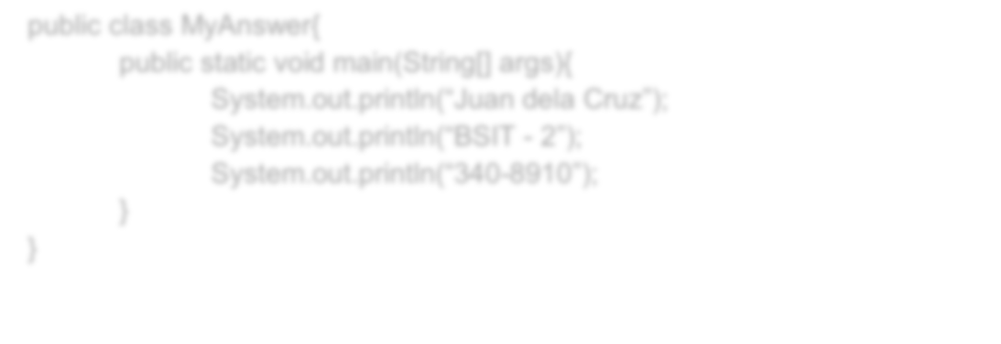

public class MyAnswer{

public static void main(String[] args){

System.out.p

rintln(“Juan dela Cruz”);

System.out.p

rintln(“BSIT

-

”);

2

System.out.p

rintln(“340

-

8910”)

;

}

}