|  |  |  |
| --- | --- | --- |
| **Lesson Title: Repetition Control Structures Lesson Objectives:**  At the end of the lesson, you shoud be able to:   1. understand the step – by – step process of looping during program execution; 2. write repetition programs using the Java programming language. |  | **Materials:**  Student Activity Sheets **References:**  Daniel, Liang. Introduction to Java Programming 7th Edition.  Java Tutorial  @www.w3schools.com |

|  |
| --- |
| Productivity Tip:  ***“***Schedule doing practice drills similar to the ones in this module two more times this week. Spacing your practice time will help you master the process!***.”*** |

# A. LESSON PREVIEW/REVIEW

1. Introduction (2 mins)

Have a blessed day. Let us consider this day as another golden opportunity to learn something new. There are situations in our lives that we need to do actions repeatedly. Same with programming, there are instances that we need to execute block of codes several number of times. Just imagine when we need to print a sentence 50 times on your screen. Well, we can do it by using the print() statement 50 times (without using loops). How about you need to print a sentence one million times? In this case, we need to use loops. With loops, we can simply write the print() statement one time and run it for any number of times. Therefore, at the end of this lesson, you should be able to:

* 1. understand the step – by – step process of looping during program execution;
  2. write repetition programs using the Java programming language.

1. Activity 1: What I Know Chart, Part 1 (3 mins)

I am writing three questions on the second column related to the topic for the day. I would like you to write in the first column whay you know about the question. Just left the third column blank at this time.

|  |  |  |
| --- | --- | --- |
| What I Know | Questions: | What I Learned (Activity 4) |
| for, while & do-while | 1. What are the three types of loops in Java? |  |
| do-while loop | 2. What type of loop that executes at least once regardless if the condition is true or false? |  |
| For loop can also be used to perform a fixed number of iterations. | 3. What loop will be used if the number of iterations is fixed? |  |



# B.MAIN LESSON

1. Activity 2: Content Notes (45 mins)



**Loops in Java**

Loops can execute a block of code as long as a specified condition is reached.

Loops

are handy

because they save time, reduce errors, and they make code more readable.

There are three types of loops in Java: for loop, while loop and do

–

while loop.

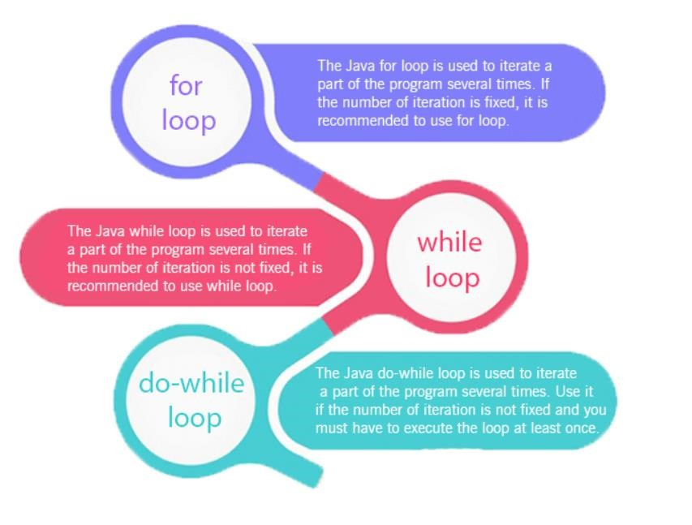

|  |  |  |  |
| --- | --- | --- | --- |
|  |  | |  |
| **Comparison** | **for loop while loop** | | **do while loop** |
|  |  | |  |
| Introduction | The Java for loop is a control flow statement that iterates a part of  the [programs](https://www.javatpoint.com/java-programs) multiple times. | The Java while loop is a control flow statement that executes a part of the programs repeatedly on the basis of given boolean condition. | The Java do while loop is a control flow statement that executes a part of the programs at least once and the further execution depends upon the given boolean condition. |
| When to use | If the number of iteration is fixed, it is recommended to use for loop. | If the number of iteration is not fixed, it is recommended to use while loop. | If the number of iteration is not fixed and you must have to execute the loop at least once, it is recommended to use the do-while loop. |
| Syntax | for(init;condition;incr/decr){  // code to be executed  } | while(condition){ //code to be executed  } | do{  //code to be executed  }while(condition); |
| Example  Prints numbers from 1 to 10. | //for loop  for(int i=1;i<=10;i++){  System.out.println(i);  } | //while loop int i=1; while(i<=10){  System.out.println(i);  i++;  } | //do-while loop  int i=1; do{  System.out.println(i);  i++;  }while(i<=10); |
| Syntax for infinitive loop | for(;;){  //code to be executed  } | while(true){  //code to be executed  } | do{  //code to be executed  }while(true); |



Example 1

:

Write a program to calculate the sum of first 10 natural number.

Solution:

Output:

Please take note the syntax in using the for

loop, taking the example program above:

for(

int i=1;

i<=10;

i++

)

initialization condition inc/dec

Always remember that there is no semi

–

colon at the end of the

for

loop and your program

should come with a pair of begin

(

{

).

)

and end ( }

If the number of iteration is fixed, it is

recommended to use for loop.



public class SumNumbers

{

public static void main(String[] args

)

{

int sum = 0;

; i

)

++

or(int i=1; i

f

<=10

{

sum += i

;

}

;

System.out.println("Sum: " + sum)

}

}



Example 2:

Write a program that prompts the user to input a positive integer. It should then print the

multiplication table of that number.

Sample

Output:

Solution:



import java.util.Scanner;

public class Tabl

e

{

public static void main(String[] args

)

{

;

r s = new Scanner(System.in)

Scanne

int num

;

System.out.print(

"Enter any positive integer: ");

num = s.nextInt();

System.out.println("Multiplication Table of " + num);

f

or(int i=1; i<=10; i++)

{

System.out.println(num

+

" x " + i + " = " + (num*i) )

;

}

}

}

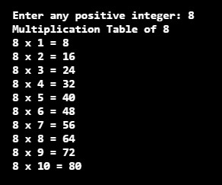

Example

3

:

Write a program that reads a set of integers, and then prints the sum of

.

the even and odd integers

Sample

Output:

Solution:



import java.util.Scanner;

public class ReadSetIntegers

{

public static void main(String[] args)

{

Scanner console = new Scanner(Syst

em.in);

int number

,

evenSum=0, oddSum=0

;

ar

ch

choice

;

d

o

{

System.out.print("Enter the

number ")

;

;

number = console.nextInt()

)

if( number % 2 == 0

evenSum += number

;

els

e

oddSum += number

;

System.out.print("Do you want to continue y/n? ")

;

choice = console.next().charAt(0);

}

;

while(choice=='y' || choice == 'Y')

;

System.out.println("Sum of even numbers: " + evenSu

m)

System.out.println("Sum of odd numbers: " + oddSum)

;

}

}

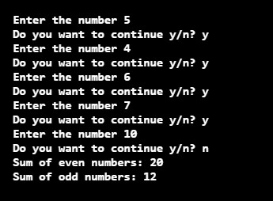

Example 4:

Two numbers are entered through the keyboard. Write a program to find the value of

one number raised to the power of another.

Do not use Java

(

built

-

in method

)

Sample Output:

Solution:

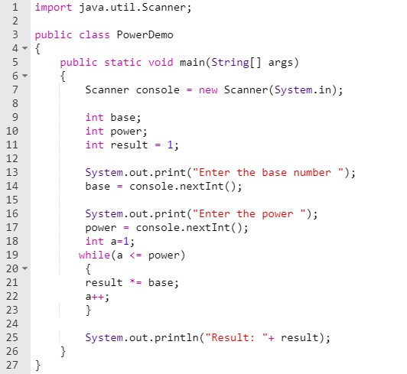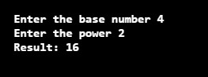

1. Activity 3: Skill-building Activities (25 mins + 5 mins checking)

Multiple Choice. Encircle the letter that corresponds to the best answer.

* 1. What is a Loop in Java programming language?
* A
  1. Choose an invalid loop name in Java below.
* C
  1. Every loop in Java has a condition that should be ___ in order to proceed for execution.
* B
  1. Choose the correct syntax of the WHILE loop in Java below.
* A
  1. Choose the correct Syntax of FOR loop in Java below.
* A
  1. Choose the correct syntax of the DO WHILE loop in Java below.
* A
  1. A WHILE loop in Java executes the statements at least once even the condition is not satisfied.
* A
  1. A loop in Java generally contains a Loop-Counter variable. State TRUE or FALSE.
* B
  1. An Increment operator "++" and/or a Decrement operator "--" are used along with a Loop-Counter variable in Java. (TRUE / FALSE).
* B
  1. What is the main difference between a WHILE and a DO-WHILE loop in Java?
* B

When you are done answering the self – assessment, please check your answers against the Key to Corrections found at the end of this Student Activity Sheets. Write your score on your paper.

* 1. Activity 4: What I Know Chart (3 mins)

Let us monitor how far you have learned in this lesson by reviewing the questions in the What I Know Chart from Activity 1. Please write your answers to the questions based on what you **now** know in the third column of the table.

|  |  |  |
| --- | --- | --- |
| What I Know | Questions: | What I Learned (Activity 4) |
|  | 1. What are the three types of loops in Java? | for, while & do-while |
|  | 2. What type of loop that executes at least once regardless if the condition is true or false? | do-while loops |
|  | 3. What loop will be used if the number of iterations is fixed? | For loop can also be used to perform a fixed number of iterations |

* 1. Activity 5: Check for Understanding (77 mins including hands – on + 10 mins checking)

Test I. Multiple Choice. Encircle the letter that corresponds to the best answer.

1. What is the output of the below Java program?

int a=1; while(a<4)

{

System.out.print(a + " ");

a++;

}

* B

2. What is the output of the below Java program?

String str="FOX"; int i=0;

while(i<str.length())

{

System.out.print(str.charAt(i));

i++;

}

* B

3. What is the main difference between a WHILE and a DO-WHILE loop in Java?

* B

4. What is the value of "age" in the below Java program with a DO-WHILE loop?

int age=20;

do

{

age++;

}while(age<20);

System.out.println(age);

* B

5. What is the output of the below java program that implements nesting of loops?

int i=1, j=1; while(i<3)

{

do

{

System.out.print(j + ",");

j++;

}while(j<4);

i++;

}

* B
  1. What is the output of the below Java program?

int time=50;

do

{

System.out.print(time + ","); time++;

}while(time < 53)

* B

* 1. What is the output of the below Java program with FOR loop?

f o r ( i n t j = 0 ; j < 5 ; j + + ; ) System.out.print(j + ",");

* C

8. Choose rules for naming a Label in Java below.

* D

9. A Loop in Java language may contain ___.

* D

10. Any loop can be nested inside any loop in Java. (TRUE/FALSE).

* B

Test II Programming. Write your code on the space provided.

1. Write a program to enter the numbers till the user wants and at the end it should display the count of positive, negative and zeros entered.

Public class CountingNumbers

{

Public static void main(String[] args)

{

Scanner console = new Scanner(System.in);

Int number,

countPositive = 0,

countNegative = 0,

countZero = 0;

char choice;

do

{

System.out.print(“Enter the number”);

Number = console.nextIn();

If(number > 0)

{

countPositive++;

}

Else if(number < 0)

{

countNegative++;

}

Else

{

countZero++;

}

System.out.print(“Do you want to continue y/n?”);

Choice = console.next().charAt(0);

}while(choice ==’y’ || choice ==’Y’);

System.out.printIn(“Positive numbers: “ + countPositive);

System.out.printIn(“Negative numbers: “ + countNegative);

System.out.printIn(“Zero numbers: “ + countZero);

}

m

1. Write a program to print Fibonacci series of n terms where n is input by user:

0 1 1 2 3 5 8 13 24

Import java.util.Scanner;

Public class FibonacciSeries

{

Public static void main(String[] arg)

{

Scanner console = new Scanner(System.in);

int number; // To hold number of terms

int firstTerm = 0,

secondTerm = 1;

thirdTerm;

System.out.print("Enter number if terms series : ");

number = console.nextIn();

System.out.print(firstTerm + " " + secondTerm + " " );

for(int i = 3; i <= number; i++)

{

thirdTerm = firstTerm + secondTerm;

System.out.print(thirdTerm + " ");

firstTerm = secondTerm;

secondTerm = thirdTerm;

}

}

}

# LESSON WRAP-UP

1) Activity 6: Thinking about Learning (5 mins)

1. Work Tracker

You are done with this session! Let’s track your progress. Shade the session number you just completed.



1. Think about your Learning

1. What was the most useful or the most meaningful thing you learned on this topic?

* The most meaningful thing that I’ve learned on this topic is all about looping and there are three types if loop.

1. In today’s lesson, what was least clear to you?

* So far I understand everything.____________

## FAQs

1. What is charAt () in Java?

The **Java** String **charAt**(int index) method returns the character at the specified index in a string. The index value that we pass in this method should be between 0 and (length of string-1). For example: s. **charAt**(0) would return the first character of the string represented by instance.

1. Which loop is best in Java?

The only difference between a for loop and a while loop is the syntax for defining them. There is no performance difference at all between the three types of loop.

**KEY TO CORRECTIONS**

## Activity 3

3) Activity 3: Skill-building Activities

1. A) A Loop is a block of code that is executed repeatedly as long as a condition is satisfied.
2. C) repeat until
3. B) TRUE
4. A) while(condition) { //statements }
5. A) for(initialization; condition; increment-or-decrement) { //statements } 6. A) do { //statements }while(condition);
6. A) FALSE
7. B) TRUE
8. B) TRUE
9. B) DO-WHILE loop executes the statements inside of it at least once even if the condition is false.

## Activity 5: Check for Understanding

1. B) 1 2 3
2. B) FOX
3. B) DO-WHILE loop executes the statements inside of it at least once even if the condition is false.
4. B) 21
5. B) 1,2,3,4,
6. B) 50,51,52,
7. C) Compiler error //No semi – colon after the change of state
8. D) All
9. D) All
10. B) TRUE

Test II. Programming

|  |  |
| --- | --- |
| Write a program to enter the numbers till the user wants and at the end it should display the count of | |
| positive, negative and zeros entered. |  |

1.



s

public class CountNumber

{

)

public static void main(String[] args

{

;

Scanner console = new Scanner(System.in)

int number,

ve = 0,

countPositi

countNeg

,

tive

a

= 0

;

countZero

0

=

char choice

;

do

{

number ")

System.out.print("Enter the

;

number = console.nextInt()

;

)

f(number > 0

i

{

;

countPositive++

}

else if(number < 0)

{

countNegative++

;

}

els

e

{

countZero++

;

}

System.out.print("Do you want to

continue y/n? ");

choice = console.next().charAt(0)

;

}

while(choice=='y' || choice == 'Y');

;

System.out.println("Positive numbers: " + countPositive)

;

Negative)

System.out.println("Negative numbers: " + count

System.out.println("Zero numbers: " + countZero)

;

}

}

2. Write a program to print Fibonacci series of n terms where n is input by user:

8 13 24 .....

1 1 2 3 5

0



import java.util.Scanner;

public

class FibonacciSerie

s

{

)

public static void main(String[] args

{

;

Scanner console = new Scanner(System.in)

int number; // To hold number of terms

,

int firstTerm = 0

,

rm = 1

secondTe

thirdTerm;

System.out.print("Enter nu

mber of terms of series : ")

;

;

number = console.nextInt()

System.out.print(firstTerm + " " + secondTerm + " ");

for

(

int i = 3; i <= number; i

++

)

{

thirdTerm = firstTerm

erm

;

secondT

+

rm + " ");

System.out.print(thirdTe

;

firstTerm = secondTerm

secondTerm = thirdTerm

;

}

}

}